Automation Test Failure Report

test_empty_email
Execution Time : 2026-07-07 16:54:19.235177
Expected Result : Refer Test Case
Actual Result : Assertion Failed
Failure Reason : Message:
Stacktrace:
msedgedriver!GetHandleVerifier [0x7ff7e3447135+e415]
msedgedriver!GetHandleVerifier [0x7ff7e3447194+e474]
msedgedriver!GetHandleVerifier [0x7ff7e3ac6756+68da36]
msedgedriver!(No symbol) [0x7ff7e2e40762]
msedgedriver!(No symbol) [0x7ff7e2e409d5]
msedgedriver!(No symbol) [0x7ff7e2e7e5e7]
msedgedriver!(No symbol) [0x7ff7e2e373b7]
msedgedriver!(No symbol) [0x7ff7e2e7c2a8]
msedgedriver!(No symbol) [0x7ff7e2e36bfc]
msedgedriver!(No symbol) [0x7ff7e2e35e56]
msedgedriver!(No symbol) [0x7ff7e2e36a23]
msedgedriver!(No symbol) [0x7ff7e3070d51]
msedgedriver!(No symbol) [0x7ff7e306d16f]
msedgedriver!(No symbol) [0x7ff7e307dff9]
msedgedriver!GetHandleVerifier [0x7ff7e3462821+29b01]
msedgedriver!GetHandleVerifier [0x7ff7e346b026+32306]
msedgedriver!GetHandleVerifier [0x7ff7e344ec94+15f74]
msedgedriver!GetHandleVerifier [0x7ff7e344edb5+16095]
msedgedriver!GetHandleVerifier [0x7ff7e343b1d3+24b3]
KERNEL32!BaseThreadInitThunk [0x7ffaabca259d+1d]
ntdll!RtlUserThreadStart [0x7ffaacc0af78+28]
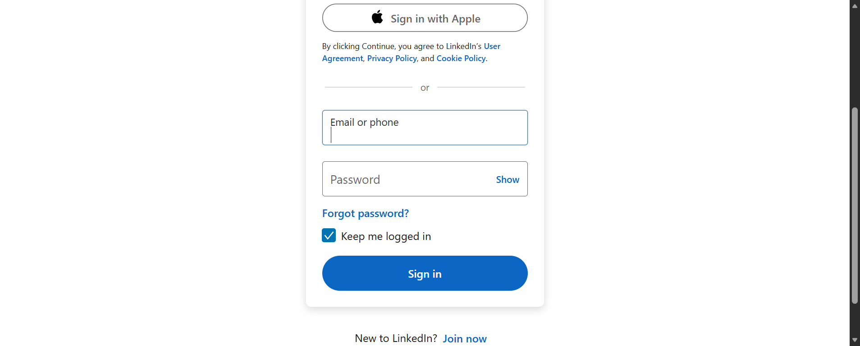

test_invalid_email_format[admin]
Execution Time : 2026-07-07 16:54:52.534714
Expected Result : Refer Test Case
Actual Result : Assertion Failed
Failure Reason : Message:
Stacktrace:
msedgedriver!GetHandleVerifier [0x7ff7e3447135+e415]
msedgedriver!GetHandleVerifier [0x7ff7e3447194+e474]
msedgedriver!GetHandleVerifier [0x7ff7e3ac6756+68da36]
msedgedriver!(No symbol) [0x7ff7e2e40762]
msedgedriver!(No symbol) [0x7ff7e2e409d5]
msedgedriver!(No symbol) [0x7ff7e2e7e5e7]
msedgedriver!(No symbol) [0x7ff7e2e373b7]
msedgedriver!(No symbol) [0x7ff7e2e7c2a8]
msedgedriver!(No symbol) [0x7ff7e2e36bfc]
msedgedriver!(No symbol) [0x7ff7e2e35e56]
msedgedriver!(No symbol) [0x7ff7e2e36a23]
msedgedriver!(No symbol) [0x7ff7e3070d51]
msedgedriver!(No symbol) [0x7ff7e306d16f]
msedgedriver!(No symbol) [0x7ff7e307dff9]
msedgedriver!GetHandleVerifier [0x7ff7e3462821+29b01]
msedgedriver!GetHandleVerifier [0x7ff7e346b026+32306]
msedgedriver!GetHandleVerifier [0x7ff7e344ec94+15f74]
msedgedriver!GetHandleVerifier [0x7ff7e344edb5+16095]
msedgedriver!GetHandleVerifier [0x7ff7e343b1d3+24b3]
KERNEL32!BaseThreadInitThunk [0x7ffaabca259d+1d]
ntdll!RtlUserThreadStart [0x7ffaacc0af78+28]
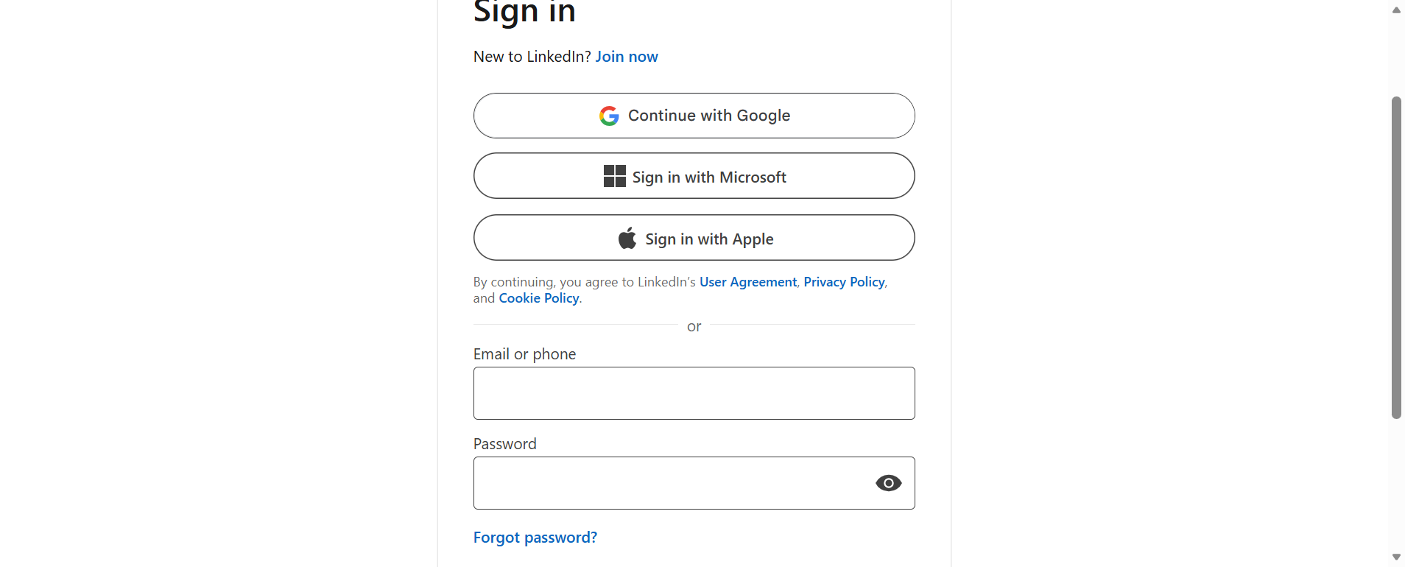

test_invalid_email_format[admin.com]
Execution Time : 2026-07-07 16:55:35.619660
Expected Result : Refer Test Case
Actual Result : Assertion Failed
Failure Reason : Message:
Stacktrace:
msedgedriver!GetHandleVerifier [0x7ff7e3447135+e415]
msedgedriver!GetHandleVerifier [0x7ff7e3447194+e474]
msedgedriver!GetHandleVerifier [0x7ff7e3ac6756+68da36]
msedgedriver!(No symbol) [0x7ff7e2e40762]
msedgedriver!(No symbol) [0x7ff7e2e409d5]
msedgedriver!(No symbol) [0x7ff7e2e7e5e7]
msedgedriver!(No symbol) [0x7ff7e2e373b7]
msedgedriver!(No symbol) [0x7ff7e2e7c2a8]
msedgedriver!(No symbol) [0x7ff7e2e36bfc]
msedgedriver!(No symbol) [0x7ff7e2e35e56]
msedgedriver!(No symbol) [0x7ff7e2e36a23]
msedgedriver!(No symbol) [0x7ff7e3070d51]
msedgedriver!(No symbol) [0x7ff7e306d16f]
msedgedriver!(No symbol) [0x7ff7e307dff9]
msedgedriver!GetHandleVerifier [0x7ff7e3462821+29b01]
msedgedriver!GetHandleVerifier [0x7ff7e346b026+32306]
msedgedriver!GetHandleVerifier [0x7ff7e344ec94+15f74]
msedgedriver!GetHandleVerifier [0x7ff7e344edb5+16095]
msedgedriver!GetHandleVerifier [0x7ff7e343b1d3+24b3]
KERNEL32!BaseThreadInitThunk [0x7ffaabca259d+1d]
ntdll!RtlUserThreadStart [0x7ffaacc0af78+28]
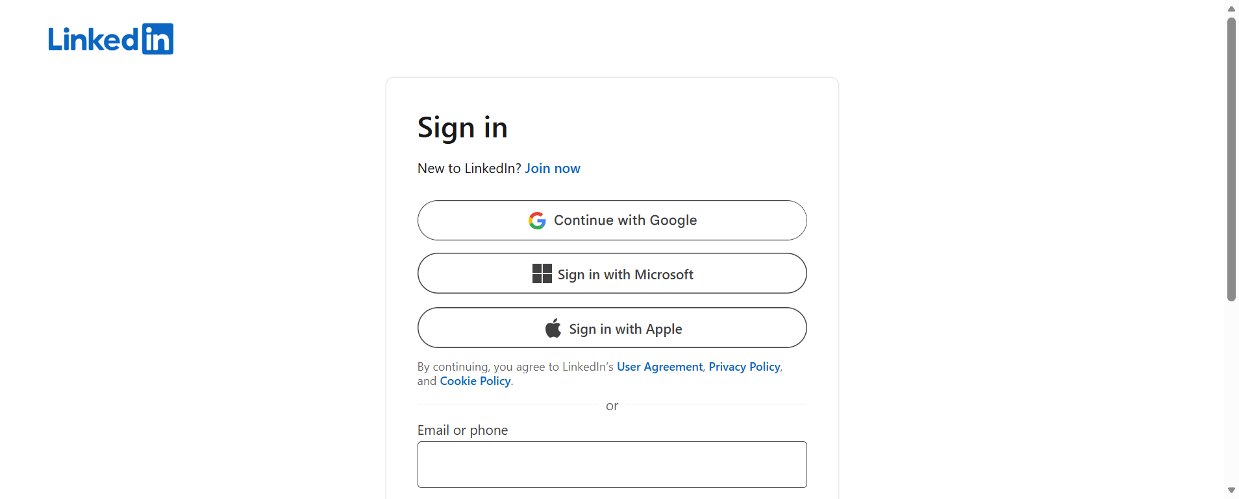

test_password_hidden
Execution Time : 2026-07-07 16:56:28.270871
Expected Result : Refer Test Case
Actual Result : Assertion Failed
Failure Reason : Message: no such element: Unable to locate element: {"method":"css selector","selector":"[id="«R2nvl3ksopa55j6»"]"}
(Session info: MicrosoftEdge=150.0.4078.48); For documentation on this error, please visit: https://www.selenium.dev/documentation/webdriver/troubleshooting/errors#nosuchelementexception
Stacktrace:
msedgedriver!GetHandleVerifier [0x7ff7e3447135+e415]
msedgedriver!GetHandleVerifier [0x7ff7e3447194+e474]
msedgedriver!GetHandleVerifier [0x7ff7e3ac6756+68da36]
msedgedriver!(No symbol) [0x7ff7e2e40762]
msedgedriver!(No symbol) [0x7ff7e2e409d5]
msedgedriver!(No symbol) [0x7ff7e2e7e5e7]
msedgedriver!(No symbol) [0x7ff7e2e373b7]
msedgedriver!(No symbol) [0x7ff7e2e7c2a8]
msedgedriver!(No symbol) [0x7ff7e2e36bfc]
msedgedriver!(No symbol) [0x7ff7e2e35e56]
msedgedriver!(No symbol) [0x7ff7e2e36a23]
msedgedriver!(No symbol) [0x7ff7e3070d51]
msedgedriver!(No symbol) [0x7ff7e306d16f]
msedgedriver!(No symbol) [0x7ff7e307dff9]
msedgedriver!GetHandleVerifier [0x7ff7e3462821+29b01]
msedgedriver!GetHandleVerifier [0x7ff7e346b026+32306]
msedgedriver!GetHandleVerifier [0x7ff7e344ec94+15f74]
msedgedriver!GetHandleVerifier [0x7ff7e344edb5+16095]
msedgedriver!GetHandleVerifier [0x7ff7e343b1d3+24b3]
KERNEL32!BaseThreadInitThunk [0x7ffaabca259d+1d]
ntdll!RtlUserThreadStart [0x7ffaacc0af78+28]
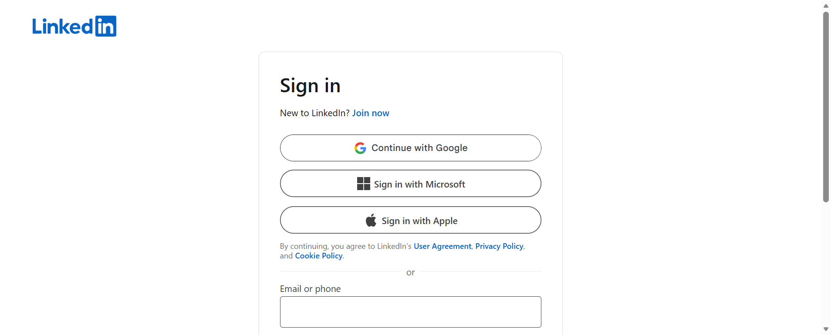

test_valid_login
Execution Time : 2026-07-07 16:56:44.892093
Expected Result : Refer Test Case
Actual Result : Assertion Failed
Failure Reason : Message:
Stacktrace:
msedgedriver!GetHandleVerifier [0x7ff7e3447135+e415]
msedgedriver!GetHandleVerifier [0x7ff7e3447194+e474]
msedgedriver!GetHandleVerifier [0x7ff7e3ac6756+68da36]
msedgedriver!(No symbol) [0x7ff7e2e40762]
msedgedriver!(No symbol) [0x7ff7e2e409d5]
msedgedriver!(No symbol) [0x7ff7e2e7e5e7]
msedgedriver!(No symbol) [0x7ff7e2e373b7]
msedgedriver!(No symbol) [0x7ff7e2e7c2a8]
msedgedriver!(No symbol) [0x7ff7e2e36bfc]
msedgedriver!(No symbol) [0x7ff7e2e35e56]
msedgedriver!(No symbol) [0x7ff7e2e36a23]
msedgedriver!(No symbol) [0x7ff7e3070d51]
msedgedriver!(No symbol) [0x7ff7e306d16f]
msedgedriver!(No symbol) [0x7ff7e307dff9]
msedgedriver!GetHandleVerifier [0x7ff7e3462821+29b01]
msedgedriver!GetHandleVerifier [0x7ff7e346b026+32306]
msedgedriver!GetHandleVerifier [0x7ff7e344ec94+15f74]
msedgedriver!GetHandleVerifier [0x7ff7e344edb5+16095]
msedgedriver!GetHandleVerifier [0x7ff7e343b1d3+24b3]
KERNEL32!BaseThreadInitThunk [0x7ffaabca259d+1d]
ntdll!RtlUserThreadStart [0x7ffaacc0af78+28]
