
AKSHEYAA COLLEGE OF ARTS ANDS CIENCE-1703
(Affiliated to University of Madras) PULIDIVAKKAM, MADURANTHAGAM(TK), CHENGALPATTU (District) - 603 314



Department of Computer Science

2023-2026
BATCH

VI –Semester

NM ID : SWTID-2026-5511
Class : III Year B.Sc (Computer Science)

Social Mood Matcher
AI-Powered Social Media Caption & Hashtag Generator

Team ID : SWTID-2026-5511
Team Size : 5
Team Leader : V.LINGESHWARAN
Team member : S.SATHISH
Team member : R.SHAM
Team member : S.YOGAVEL
Team member : V.MANOJKUMAR

Project Description
Creating engaging social media content with appropriate captions and trending hashtags is time-consuming for content creators, marketers, and social media managers. Users often spend significant time crafting the perfect caption, researching relevant hashtags, and ensuring content fits within platform character limits across different social media platforms.

Social Mood Matcher addresses this challenge through a GenAI-powered social media content generation platform that delivers personalized, sentiment-aware captions and trending hashtags optimized for different platforms. Using advanced image analysis with BLIP for image captioning, DistilBERT for sentiment analysis, and optionally Google Gemini 2.5 Flash for enhanced quality, the platform analyzes uploaded images to detect mood and visual context.

The platform helps content creators generate engaging captions in multiple styles (casual, aesthetic, professional, playful), provides curated 2024 trending hashtags organized by category and sentiment, and ensures all content fits within platform-specific character limits for Twitter/X (280 chars), Instagram (2,200 chars), and Facebook (63,206 chars). Social Mood Matcher transforms social media content creation into an intelligent, efficient process through its smart sentiment detection, adaptive caption generation, and multi-platform export capabilities.

Use Case Scenarios

Scenario 1: Food Photography with Mood Detection
A food blogger uploads a cozy photo of a homemade soup. The AI analyzes the image using BLIP to understand the visual content ("bowl of soup on wooden table") and DistilBERT to detect the sentiment ("cozy", "warm"). The system generates a caption in the user's selected style (e.g., "Nothing beats a warm bowl of homemade soup on a chilly evening") and suggests relevant hashtags (#FoodPhotography #CozyVibes #Homemade #ComfortFood). Content is auto-formatted for the selected platform (Twitter) and fits within the 280-character limit.

Scenario 2: Travel Content with Multi-Style Options
A travel influencer uploads a sunset beach photo. The platform detects the mood as "peaceful" and "aesthetic". Using the Gemini-enhanced mode, the system generates multiple caption variants: aesthetic ("Golden hour whispers stories only the ocean knows"), punchy ("Sunset state of mind"), and casual ("Beach sunsets hit different"). The user can preview all variants, select their favorite, and get platform-optimized hashtags (#TravelPhotography #SunsetVibes #BeachLife #GoldenHour) with smart truncation to fit Instagram's format.

Scenario 3: Brand Content with Character Limiting
A marketing professional uploads a product photo for a luxury brand. The AI detects "luxury" and "elegant" sentiments. The system generates a professional-style caption with no emojis, suggests premium hashtags (#LuxuryLifestyle #Premium #Elegance), and applies smart character limiting for Twitter. When the combined caption and hashtags exceed 280 characters, the platform intelligently truncates hashtags while preserving the full caption message, ensuring the most important content is retained.

Architecture Overview
Social Mood Matcher is an intelligent, modular platform designed to generate personalized, sentiment-aware social media content. It integrates a Streamlit frontend with multiple AI models including BLIP for image captioning, DistilBERT for sentiment analysis, and optionally Google's Gemini 2.5 Flash for enhanced quality outputs

Core Technologies
- Streamlit: Frontend framework for interactive UI and real-time content generation
- BLIP (Salesforce): Image captioning model for understanding visual content
- DistilBERT: Sentiment analysis model for mood detection
- Gemini 2.5 Flash (Optional): Enhanced AI for superior caption quality and visual intelligence
- Python-DOCX: Export captions to Word documents
- ReportLab: PDF generation with professional formatting
- Pillow (PIL): Image processing and manipulation
- Transformers (Hugging Face): AI model integration and inference
Got you Let’s clean this up and turn it into a proper, presentation-ready table.
Here’s your Component-Wise Architecture in structured table format:
Component | Description
Frontend UI | Streamlit-based interface with image upload, style selection, platform targeting, and real-time result display. Features include sentiment badges, caption variants, and export options.
Image Sentiment Detector | Analyzes uploaded images using BLIP for scene understanding and DistilBERT for sentiment classification. Detects moods like happy, cozy, aesthetic, calm, luxury, adventurous, energetic, peaceful, romantic, and nostalgic.
Caption Generator | Creates engaging captions based on detected sentiment, selected style (casual, aesthetic, professional, playful), and image category (food, travel, nature, lifestyle). Uses template-based generation or Gemini API for enhanced quality.
Hashtag Engine | Recommends trending 2024 hashtags organized by category and sentiment. Supports priority-based selection using sentiment scores and filters by length for optimal platform compatibility.
Character Limiter | Ensures content fits platform limits (Twitter: 280, Instagram: 2,200, Facebook: 63,206 characters). Intelligently truncates captions and hashtags while preserving message integrity.
Gemini AI Layer (Optional) | Processes images using Gemini 2.5 Flash for enhanced sentiment analysis, multiple caption generation, and improved contextual understanding.

Pre-requisites
1. Python 3.10+: Download from https://python.org
2. Streamlit Framework: See https://docs.streamlit.io
3. Google AI Studio Account (Optional): For Gemini API access at
https://makersuite.google.com
4. Required Python Libraries: Listed in requirements.txt
5. System Requirements: 4GB+ RAM for AI model inference
6. Internet Connection: For model downloads and optional Gemini API

Project Workflow
The Social Mood Matcher project follows a structured 5-milestone development process, from initial setup to production deployment. Each milestone builds upon the previous one to create a complete, production-ready application

1. Environment Setup & Configuration
• Set up project structure and file organization
• Configure environment variables and API keys
• Install dependencies and verify installations
• Test AI model connectivity (local and Gemini

2. Core Services Development
• Implement Image Sentiment Detector service
• Build Caption Generator with multiple styles
• Create Hashtag Engine with 2024 trends
• Develop Character Limiter for platform optimization
• Integrate optional Gemini service layer

3. Backend Implementation
• Design modular Flask-style architecture in Streamlit
• Create utility functions for image and text processing
• Implement session state management
• Build error handling and logging systems

4. UI Development
• Design responsive Streamlit interface
• Create image upload and preview functionality
• Build sidebar controls for style and platform selection
• Implement tabbed results display
• Add export and download features

5. Testing & Optimization
• Perform comprehensive testing across all feature
Optimize AI model performance and caching
• Validate character limiting accuracy
• Test multi-platform compatibility
• Prepare deployment configuration

MILESTONE 1: Environment Setup & Configuration
In this foundational stage, the objective is to establish the development environment and configure all necessary tools, libraries, and AI services required for Social Mood Matcher

Activity 1.1: Project Structure Setup
Create the project directory structure with proper organization for services, utilities,configuration, and tests
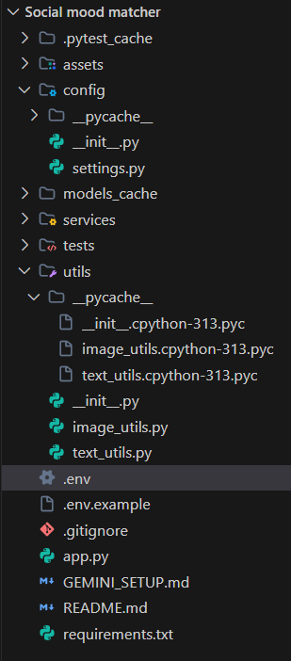

Activity 1.2: Install Dependencies
Install all required Python packages using pip. The requirements.txt includes Streamlit,
Transformers, PyTorch, Pillow, and optional Gemini API support
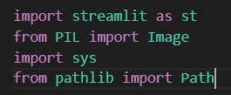

Activity 1.3: Configure Environment Variables
Set up the .env file with necessary configurations. This includes optional Gemini API key,
model cache directory, and debug settings.
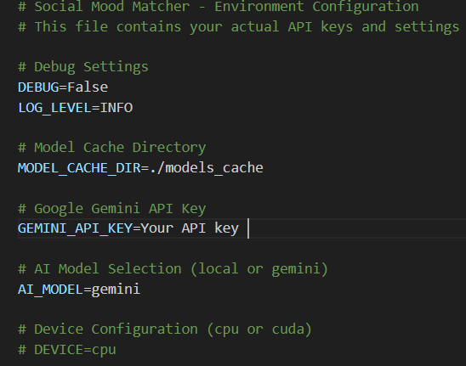
Activity 1.4: Optional Gemini Setup
1. Visit Google AI Studio: https://makersuite.google.com/app/apikey

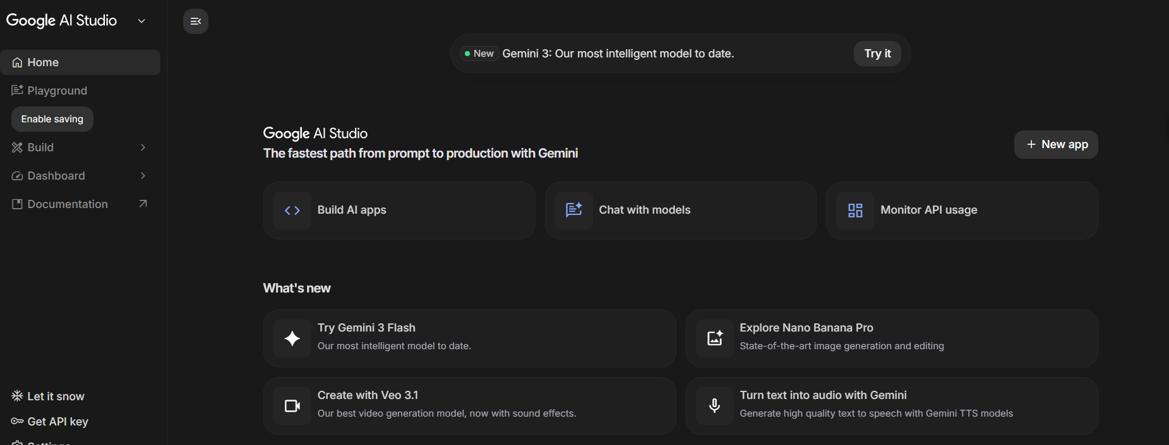
2. Sign in with Google account

3. Click 'Create API Key' and copy the generated key
4. Add key to .env file: GEMINI_API_KEY=your_key_here

5. Set AI_MODEL=gemini in .env to enable enhanced mode
6. Install google-generativeai package (included in requirements.txt)

MILESTONE 2: Core Services Development
This milestone focuses on building the core AI-powered services that form the backbone of Social Mood Matcher. Each service is designed as an independent, testable module with clear Responsibilities.

Activity 2.1: Image Sentiment Detector Service
Create the image_sentiment.py service that uses BLIP for image captioning and DistilBERT
for sentiment analysis. This service is the first step in the content generation pipeline.
Key Features:
• Load and cache BLIP image captioning model
• Load and cache DistilBERT sentiment analysis model
• Process images to extract visual descriptions
• Analyze sentiment from image captions and visual cues
• Classify into 10 mood categories (happy, cozy, aesthetic, calm, etc.)
• Detect image categories (food, travel, nature, lifestyle)
• Return confidence scores for all detected sentiments

Activity 2.2: Caption Generator Service
Develop the caption_generator.py service that creates engaging captions based on sentiment, style preferences, and image context.
Supported Styles:

Style | Characteristics | Emoji Usage
Casual | Friendly, relaxed tone | Moderate (2-3)
Aesthetic | Poetic, artistic language | Minimal (0-1)
Professional | Polished, informative | None
Playful | Fun, energetic tone | High (3-5)

Activity 2.3: Hashtag Engine Service

Build the hashtag_engine.py service that provides curated, trending hashtags organized bycategory and sentiment. Includes 2024's most popular hashtags for maximum engagement.
Hashtag Categories:
• Food: #FoodPhotography, #Foodie, #InstaFood, #FoodLover, #Delicious
•Travel: #TravelPhotography, #Wanderlust, #TravelGram, #Explore, #Adventure
•Nature: #NaturePhotography,#NatureLover, #Landscape, #Scenic, #OutdoorLife
• Lifestyle: #LifestylePhotography, #DailyLife, #Moments, #Inspiration, #Aesthetic

Activity 2.4: Character Limiter Service
Implement the character_limiter.py service that ensures all generated content fits within platform-specific character limits while maintaining message integrity

Platform | Character Limit | Truncation Strategy
Twitter/X | 280 | Prioritize caption, truncate hashtags
Instagram | 2,200 | Rarely needed, full content usually fits
Facebook | 63,206 | Almost never needed

Activity 2.5: Optional Gemini Service Integration
Create the gemini_service.py for users who want enhanced AI capabilities. This service provides superior caption quality, multiple variants, and visual intelligence features.

  - Enhanced sentiment detection with higher accuracy
  - Multiple caption variants (aesthetic, punchy, descriptive)
  - Visual intelligence: dominant colors, detected objects
  - Composition tips for better photography
  - More creative and contextually relevant captions

MILESTONE 3: Backend Implementation
This milestone integrates all services into a cohesive backend architecture within the Streamlit application. Focus on proper session state management, error handling, and efficient caching.
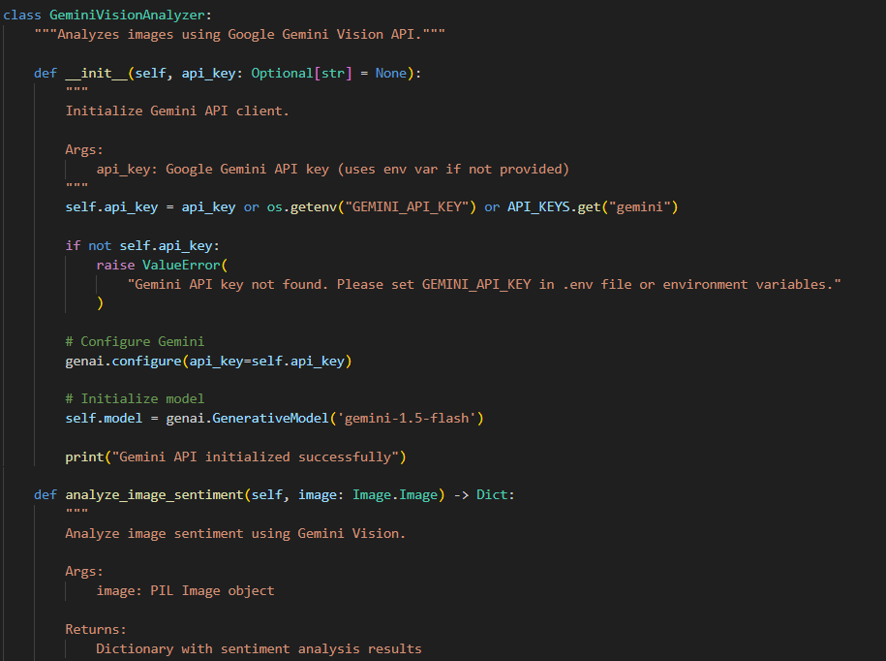

Activity 3.1: Session State Management
Implement proper Streamlit session state initialization to maintain user selections, generated content, and application state across reruns.

  - generated_caption: Current generated caption
  - generated_hashtags: Current hashtag list
  - sentiment_result: Detected sentiment and metadata
  - caption_variants: Multiple caption options (Gemini mode)
  - visual_analysis: Visual intelligence data (Gemini mode)
  - history: List of previous generations
  - use_gemini: Toggle for Gemini vs local models
  - gemini_analyzer: Cached Gemini service instance

Activity 3.2: Service Initialization and Caching
Use Streamlit's @st.cache_resource decorator to load AI models once and reuse across sessions. This significantly improves performance by avoiding repeated model loading.

  - ImageSentimentDetector: BLIP and DistilBERT models (~2GB)
  - CaptionGenerator: Template-based generation system
  - HashtagEngine: Curated hashtag database
  - CharacterLimiter: Platform rules and truncation logic
  - GeminiAnalyzer (Optional): Gemini API client

Activity 3.3: Error Handling and Validation
Implement comprehensive error handling for file uploads, model inference, and API calls. Provide clear error messages and fallback mechanisms.

1.Invalid file format: Show supported formats (JPG, PNG, WEBP)

- File size too large: Display max upload size (10MB)
- Model loading failure: Show retry option or use cached models
- Gemini API error: Automatically fall back to local models
- Empty generation: Retry with adjusted parameters

Activity 3.4: Image and Text Processing Utilities
Implement utility functions in utils/ directory for common image and text operations used throughout the application.

image_utils.py: validate_image(),resize_image(),preprocess_for_model(), create_thumbnail()
text_utils.py: clean_text(), format_hashtags(), truncate_text(), smart_truncate_with_hashtags()

MILESTONE 4: UI Development
Create an intuitive, visually appealing Streamlit interface with responsive design, clear navigation, and real-time feedback during content generation.

Activity 4.1: Main Layout Design
Design a two-column layout with image upload on the left and results display on the right. Include custom CSS for enhanced visual appeal.

  - Header with gradient title and subtitle
  - Sidebar for settings (style, platform, hashtag count, Gemini toggle)
  - Left column: Image upload with preview
  - Right column: Tabbed results (Content, Visual Pro, History)
  - Custom color scheme matching brand (purple gradient)
  - Responsive design for mobile and desktop
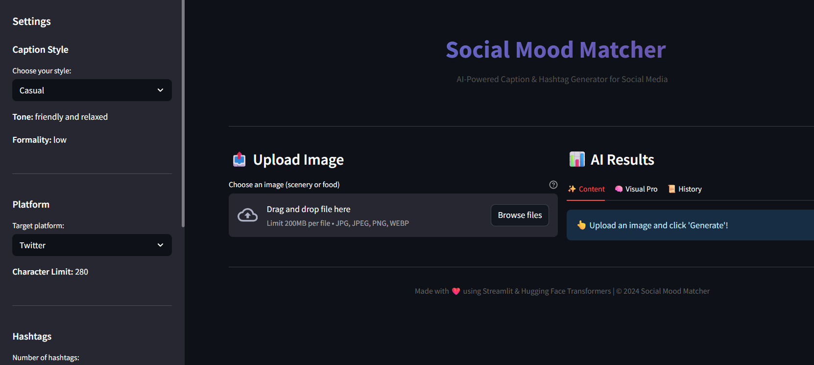

Activity 4.2: Sidebar Controls
Implement sidebar with user controls for customizing generation parameters.

  - Caption Style: Select from Casual, Aesthetic, Professional, Playful
  - Platform: Choose Twitter/X, Instagram, or Facebook
  - Number of Hashtags: Slider from 3 to 15
  - Use Gemini API: Toggle for enhanced vs local mode
  - About Section: App description and features

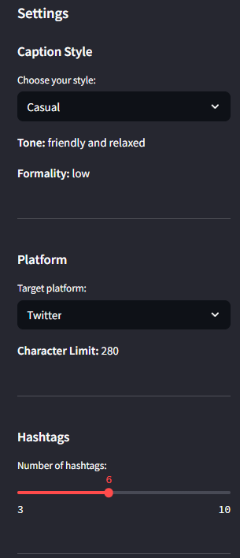

Activity 4.3: Results Display
Create tabbed interface for displaying different types of results:

Content Tab: Sentiment badge, caption variants selector (Gemini), generated caption, hashtags, character count
Visual Pro Tab: Visual intelligence (Gemini only): dominant colors, detected objects, composition tips
  - History Tab: Previous 5 generations with sentiment and timestamp

Activity 4.4: Export Functionality
Add download button for exporting generated content as a text file. Content includes caption and hashtags formatted for easy copy-paste.

MILESTONE 5: Testing & Optimization
Comprehensive testing ensures reliability, accuracy, and performance. This milestone includes unit tests, integration tests, and performance optimization.

Activity 5.1: Unit Testing
Test individual components using pytest framework. Each service should have comprehensive test coverage.

  - TestImageProcessor: Image validation, resizing, preprocessing
  - TestTextProcessor: Text cleaning, hashtag formatting, truncation
  - TestCaptionGenerator: Caption generation for all styles and sentiments
  - TestHashtagEngine: Hashtag retrieval, filtering, priority-based selection
  - TestCharacterLimiter: Platform limits, smart truncation, edge cases

Activity 5.2: Integration Testing
Test the complete pipeline from image upload to final content generation.

  - Upload image → Sentiment detection → Caption generation → Hashtag retrieval →
Character limiting
  - Test with multiple image types: food, travel, nature, lifestyle
  - Verify all caption styles produce appropriate outputs
  - Validate character limits for all platforms
  - Test Gemini fallback when API fails

Activity 5.3: Performance Optimization
Optimize application performance for faster response times and better user experience.

  - Use @st.cache_resource for model loading (prevents reloading)
  - Implement image resizing before model inference (faster processing)
  - Add loading spinners during AI operations (better UX)
  - Cache Gemini API client to avoid repeated initialization
  - Optimize session state updates to minimize reruns

Expected Performance Metrics:

Operation | First Run | Subsequent Runs
Model Loading | 30-60 seconds | Instant (cached)
Image Analysis | 3-5 seconds | 2-3 seconds
Caption Generation | 1-2 seconds | 1-2 seconds
Gemini API Call | 2-4 seconds | 2-4 seconds
Total (Local Mode) | ~35-70 sec first | ~5-8 sec
Total (Gemini Mode) | ~5-10 sec | ~4-6 sec

Deployment Guide
Social Mood Matcher can be deployed on multiple platforms. This section covers Streamlit Cloud, and cloud platforms (AWS/GCP/Azure).

Option 1: Streamlit Cloud (Recommended)
- Push code to GitHub repository
- Visit https://share.streamlit.io and sign in
- Click 'New app' and select your repository
- Configure main file path (app.py) and Python version (3.10)
- Add secrets: Go to Advanced Settings → Secrets
- Deploy and wait for build completion (~5 minutes)

Option 2: Cloud Platforms (AWS/GCP/Azure)
Deploy on cloud platforms for production-grade scalability and reliability. Use managed container services like AWS ECS, Google Cloud Run, or Azure Container Instances.

Troubleshooting Guide

Issue: Models not loading
- Check internet connection for first-time download
- Verify MODEL_CACHE_DIR has write permissions
- Ensure sufficient disk space (~2GB)
- Try clearing cache: rm -rf models_cache/

Issue: Gemini API errors
- Verify API key is correct in .env file
- Check API quota at Google AI Studio
- Ensure google-generativeai package is installed
- Application automatically falls back to local models

Issue: Session state issues
- Clear browser cache and reload page
- Check for proper session state initialization
- Verify all session variables are defined

Issue: Character limit not working
- Verify platform selection matches expected limit
- Check smart_truncate_with_hashtags() logic
- Test with different caption/hashtag combinations

Issue: Image upload failures
- Check file format (JPG, PNG, WEBP only)
- Verify file size is under 10MB
- Ensure image is not corrupted
- Try different image or resize before upload

Conclusion
Social Mood Matcher revolutionizes social media content creation by delivering intelligent, AI-driven captions and hashtags tailored to image sentiment and user preferences. By combining BLIP for image understanding, DistilBERT for sentiment analysis, and optionally Gemini 2.5 Flash for enhanced quality, the system processes visual content and generates engaging, platform-optimized social media posts.

From modular service architecture to intelligent content generation and responsive UI design, Social Mood Matcher has been built with focus on usability, reliability, and content creator needs. The Streamlit interface ensures intuitive interaction, while the robust backend handles model inference, error scenarios, and performance optimization.

Each component—from sentiment detection to character limiting—is designed to save content creators time while maintaining high-quality standards. Whether creating a quick Instagram post or crafting the perfect Twitter caption, Social Mood Matcher acts as an intelligent content assistant, automating the creative process while preserving authenticity and engagement potential.

Future Enhancements
- Support for video content analysis
- Multi-language caption generation
- A/B testing for caption variants
- Social media analytics integration
- Batch processing for multiple images
- Custom hashtag training based on user preferences
- Direct posting to social media platforms
- Brand voice customization
- Collaborative features for team accounts

