Week 01

**Question 1:**

**The program must accept a positive integer N and print the digit in the tenth position**.

|  |  |
| --- | --- |
| **Status** | **Finished** |
| **Started** | **Monday, 23 December 2024, 5:33 PM** |
| **Completed** | **Friday, 25 October 2024, 12:50 PM** |
| **Duration** | **59 days 4 hours** |

**Top of Form**

**Bottom of Form**

**Input Format:**  
**The first line denotes the value of N.**

**Program:**

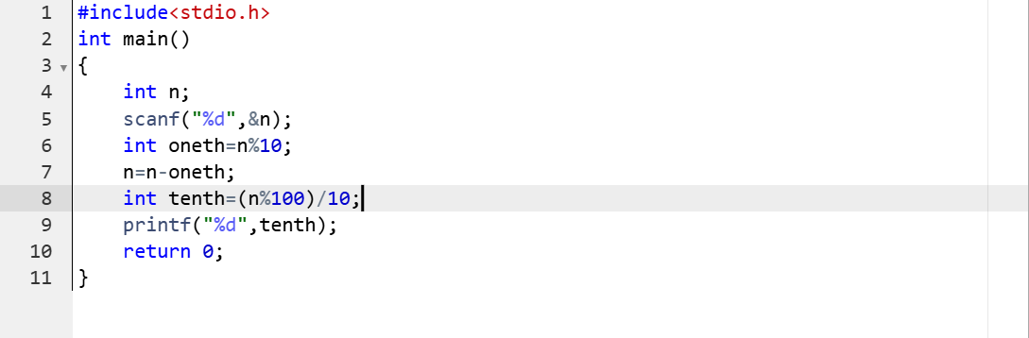

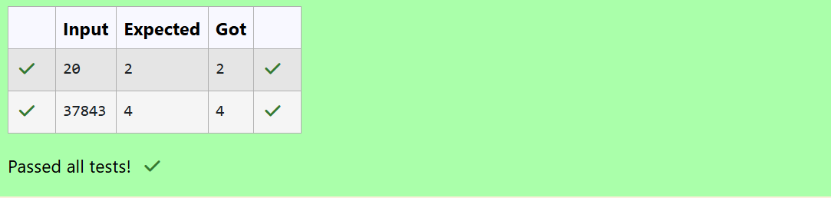

**Question 2:**

**Write a C Program to calculates the area (floating point number with two decimal places) of a**

**Circle given it’s radius (integer value). The value of Pi is 3.14.**

|  |  |
| --- | --- |
| **Status** | **Finished** |
| **Started** | **Monday, 23 December 2024, 5:33 PM** |
| **Completed** | **Tuesday, 22 October 2024, 9:47 AM** |
| **Duration** | **62 days 7 hours** |

**Top of Form**

**Bottom of Form**

**Program:**

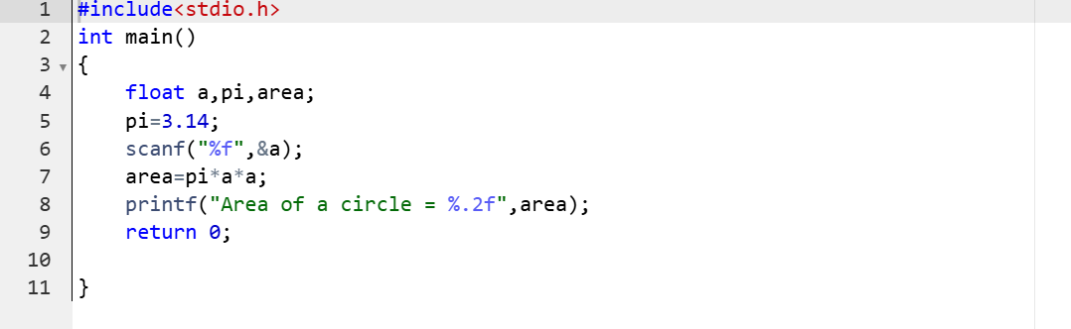

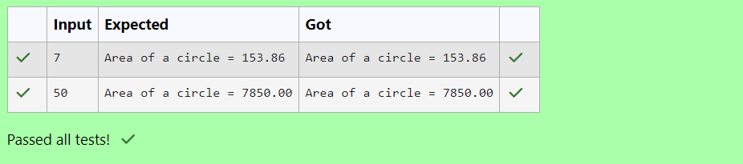

**Question 3:**

**Develop a 'C' program to**[**swap**](http://www.rajalakshmicolleges.org/moodle/mod/quiz/view.php?id=326)**two numbers (using three variables).**

|  |  |
| --- | --- |
| **Status** | **Finished** |
| **Started** | **Monday, 23 December 2024, 5:33 PM** |
| **Completed** | **Friday, 25 October 2024, 12:44 PM** |
| **Duration** | **59 days 4 hours** |

**Program:**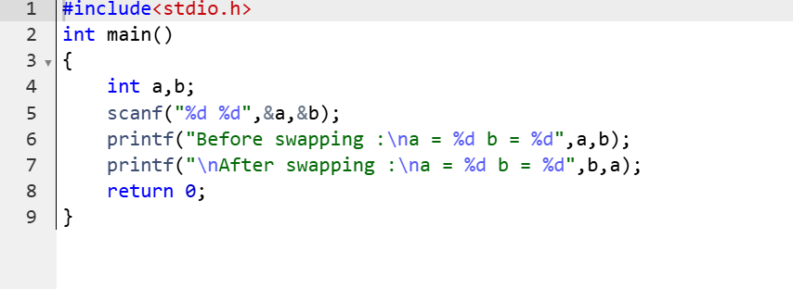

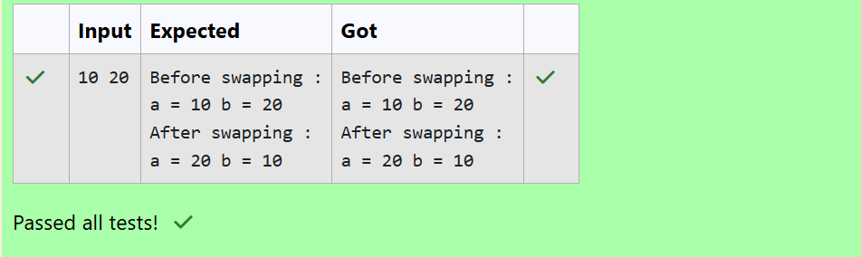

**Question 4:**

**Write a program to print the**[**ASCII value**](http://www.rajalakshmicolleges.org/moodle/mod/quiz/view.php?id=327)**of the given character.**

|  |  |
| --- | --- |
| **Status** | **Finished** |
| **Started** | **Monday, 23 December 2024, 5:33 PM** |
| **Completed** | **Friday, 25 October 2024, 12:06 PM** |
| **Duration** | **59 days 5 hours** |

**Program:** 