**Week 02**

**Question 1:**

**Each Sunday, a newspaper agency sells X copies of a certain newspaper for Rs.A per copy. The cost to the agency of each newspaper is Rs.B . The agency pays a fixed cost for storage, delivery and so on of Rs.100 per Sunday.**[**The newspaper agency**](http://www.rajalakshmicolleges.org/moodle/mod/quiz/view.php?id=54)**wants to calculate the profit obtained on Sundays. Can you please help them out by writing a C program to compute the profit given X, A and B.**

|  |  |
| --- | --- |
| **Status** | **Finished** |
| **Started** | **Monday, 23 December 2024, 5:33 PM** |
| **Completed** | **Tuesday, 29 October 2024, 8:18 AM** |
| **Duration** | **55 days 9 hours** |

**Top of Form**

**Bottom of Form**

**Program:**

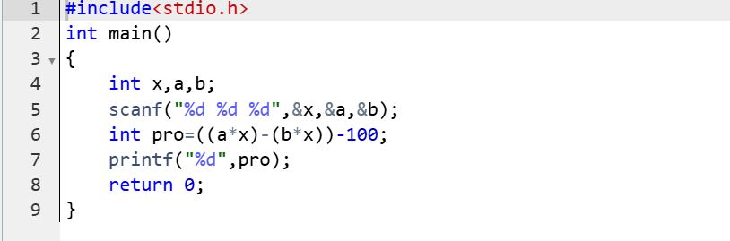

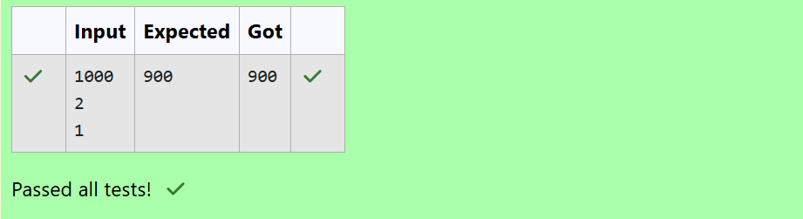**Question 2:**

**Baba is very kind to beggars and every day Baba donates half of the amount he has when ever a beggar requests him. The money M left in Baba's hand is passed as the input and the number of beggars B who received the alms are passed as the input. The program must print the money Baba had in the beginning of the day.**

|  |  |
| --- | --- |
| **Status** | **Finished** |
| **Started** | **Monday, 23 December 2024, 5:33 PM** |
| **Completed** | **Tuesday, 29 October 2024, 8:24 AM** |
| **Duration** | **55 days 9 hours** |

**Top of Form**

**Bottom of Form**

**Program:**

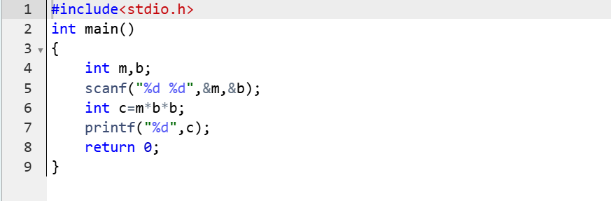



**Question 3:**

**The CEO of company ABC Inc wanted to encourage the employees coming on time to the office. So he announced that for every consecutive day an employee comes on time in a week (starting from Monday to Saturday), he will be awarded Rs.200 more than the previous day as "Punctuality Incentive". The incentive I for the starting day (ie on Monday) is passed as the input to the program. The number of days N an employee came on time consecutively starting from Monday is also passed as the input. The program must calculate and print the "Punctuality Incentive" P of the employee.**

|  |  |
| --- | --- |
| **Status** | **Finished** |
| **Started** | **Monday, 23 December 2024, 5:33 PM** |
| **Completed** | **Tuesday, 29 October 2024, 9:27 AM** |
| **Duration** | **55 days 8 hours** |

**Program:** 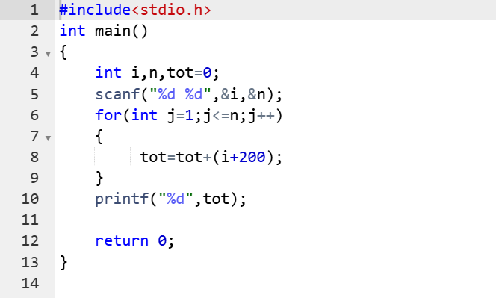

**Question 4:**

**Bajan Lal distributes C chocolates to school N students every Friday. The C chocolates are distributed among N students equally and the remaining chocolates R are given back to Bajan Lal.**

**As an example if C=100 and N=40, each student receives 2 chocolates and the balance 100-40*2 = 20 is given back.**

**If C=205 and N=20, then each student receives 10 chocolates and the balance 205-20*10 = 5 is given back.**

**Help the school to calculate the chocolates to be given back when C and N are passed as input.**

|  |  |
| --- | --- |
| **Status** | **Finished** |
| **Started** | **Monday, 23 December 2024, 5:33 PM** |
| **Completed** | **Friday, 1 November 2024, 7:14 PM** |
| **Duration** | **51 days 22 hours** |

**Program:**

