Week 03

Question 1:

Write a C program to find the eligibility of admission for a professional course based on the following criteria:

Marks in Maths >= 65

Marks in Physics >= 55

Marks in Chemistry >= 50

Or

Total in all three subjects >= 180

Program:

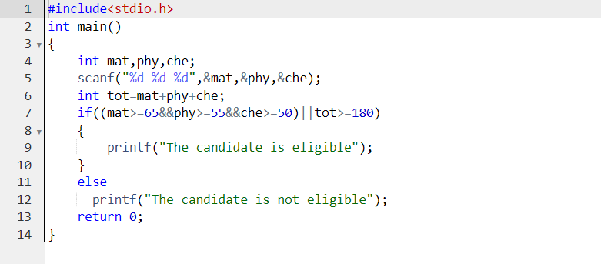

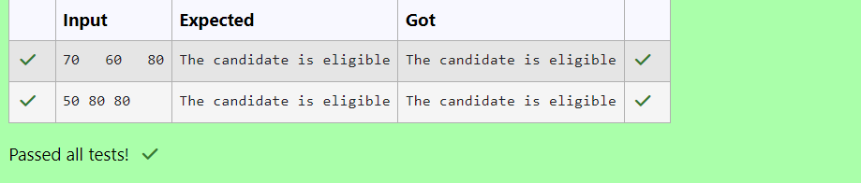Question 2:

Complete the calculator program with Basic operations (+, -, \*, /, %) of two numbers using switch statement.

 Program:

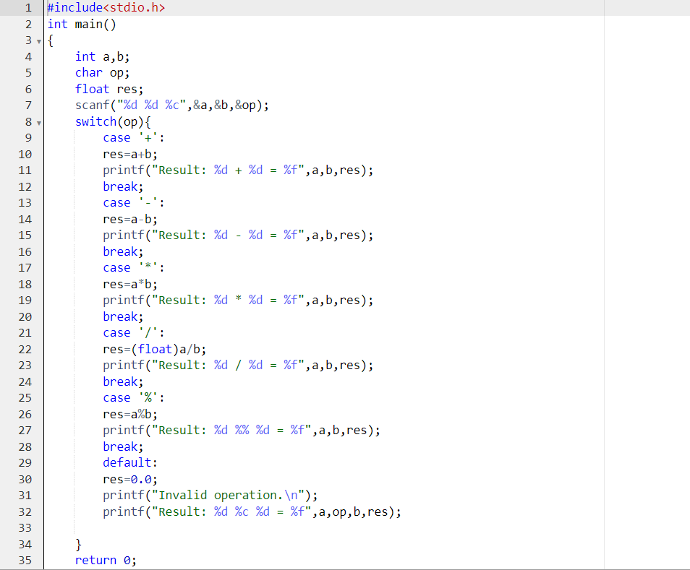

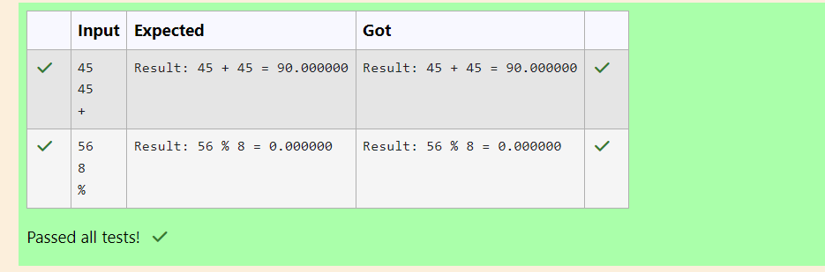

Question 3:

You are given a sequence of integers as input, terminated by a -1. (That is, the input integers may be positive, negative or 0. A -1 in the input signals the end of the input.)

-1 is not considered as part of the input.

Find the second largest number in the input. You may not use arrays.

Program:

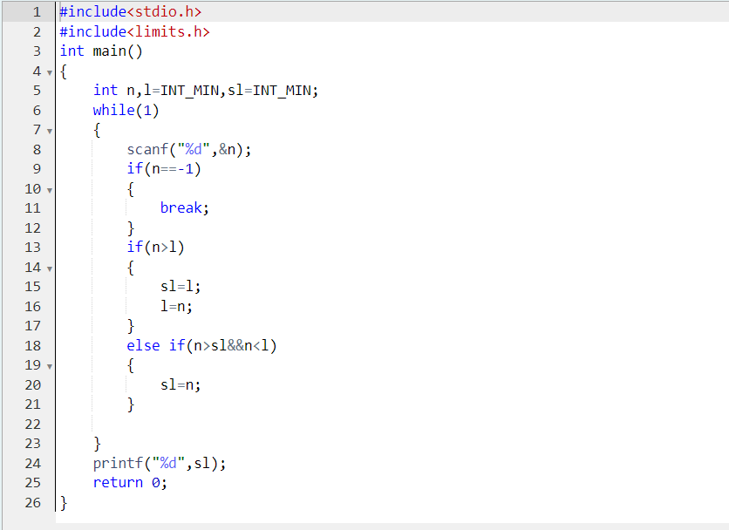

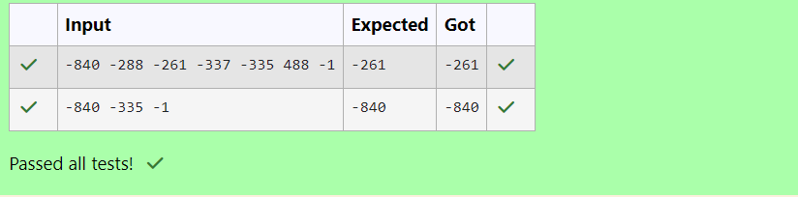Question 4:

The lengths of the sides of a triangle X, Y and Z are passed as the input. The program must print the smallest side as the output.

Program:

