Week 04

**Question 1:**

**Write a program that accepts the marks in 3 subjects of a student, calculates the average mark of the student and prints the student's grade. If the average mark is greater than or equal to 90, then the grade is 'A'. If the average mark is 80 and between 80 and 90, then the grade is 'B'. If the average mark is 70 and between 70 and 80, then the grade is 'C'. If the average mark is 60 and between 60 and 70, then the grade is 'D'. If the average mark is 50 and between 50 and 60, then the grade is 'E'. If the average mark is less than 50, then the grade is 'F'.**

|  |  |
| --- | --- |
| **Status** | **Finished** |
| **Started** | **Monday, 23 December 2024, 5:33 PM** |
| **Completed** | **Tuesday, 12 November 2024, 8:25 AM** |
| **Duration** | **41 days 9 hours** |

**Program:**

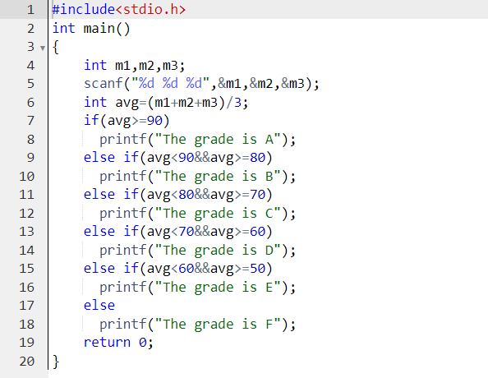**:**

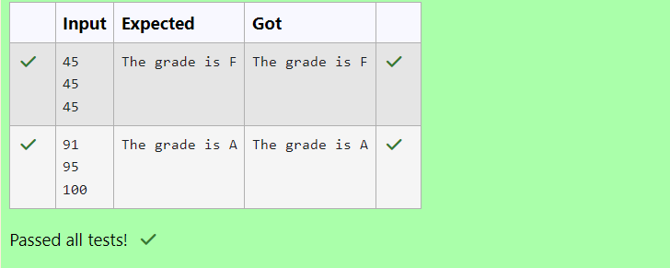

**Question 2:**

**Write a program to determine the type of berth when the seat / berth number in the train is given.**

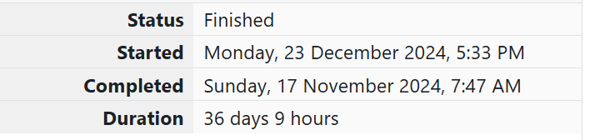

**Program:**

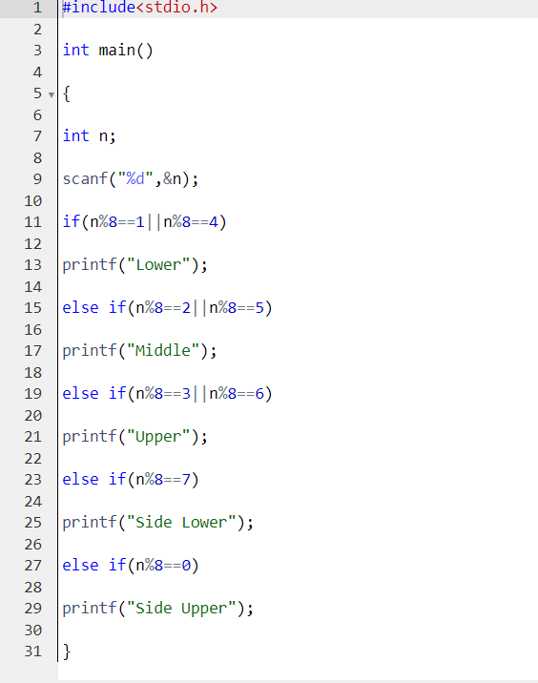

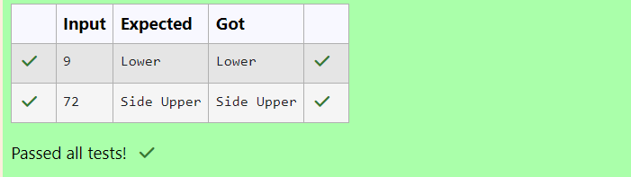

**Question 3:**

**Write a C program to simulate a basic**[**calculator**](http://www.rajalakshmicolleges.org/moodle/mod/quiz/view.php?id=85)**. [+,-,*,/,%]. Use switch statement.**

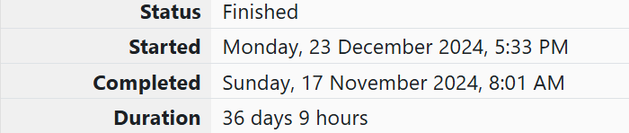

**Program:**

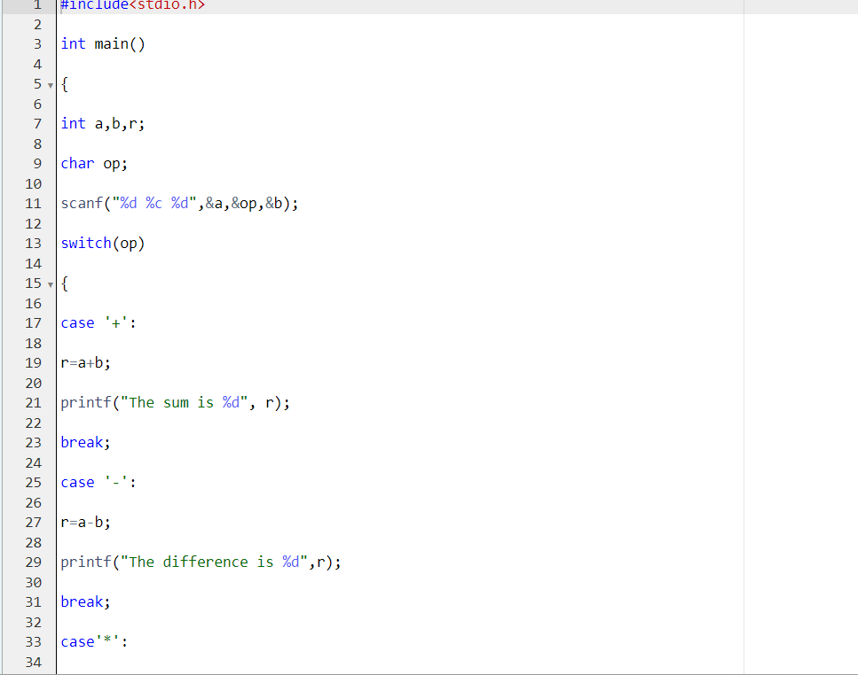

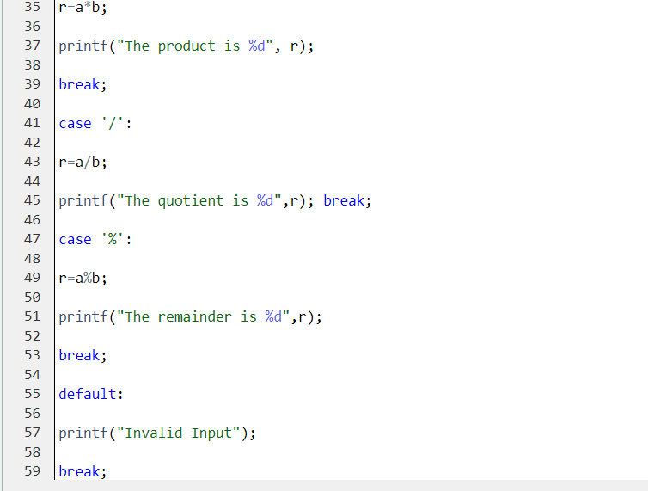

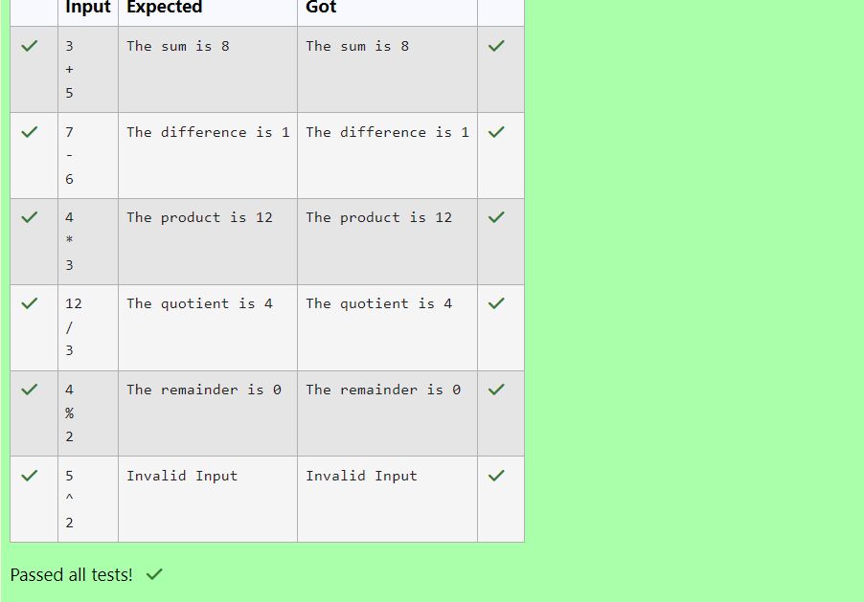

**Question 4:**

**In london, every year during dasara there will be a very grand doll show. People try to invent new new dolls of different varieties. The best sold doll's creator will be awarded with cash prize. So people broke their head to create dolls innovatively. Knowing this competition, Mr.Lokpaul tried to create a doll which sings only when a even number is pressed and the number should be not be zero and greater than 100.**

**So write a program to help Mr.Lokpaul to win.**

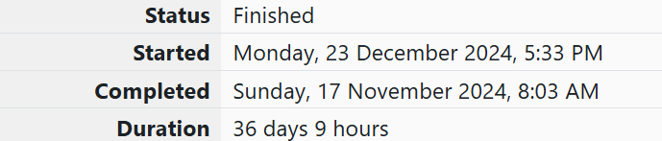

**Program:**



