**Week 05**

**Question 1:**

**Write a C program to count total number of digits of an Integer number (N).**

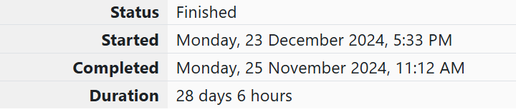

**Program:**

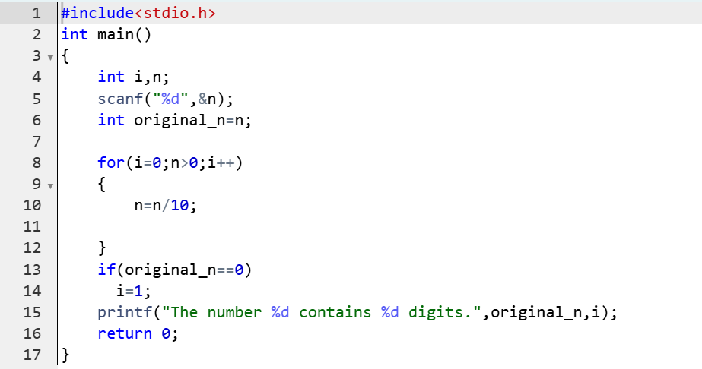

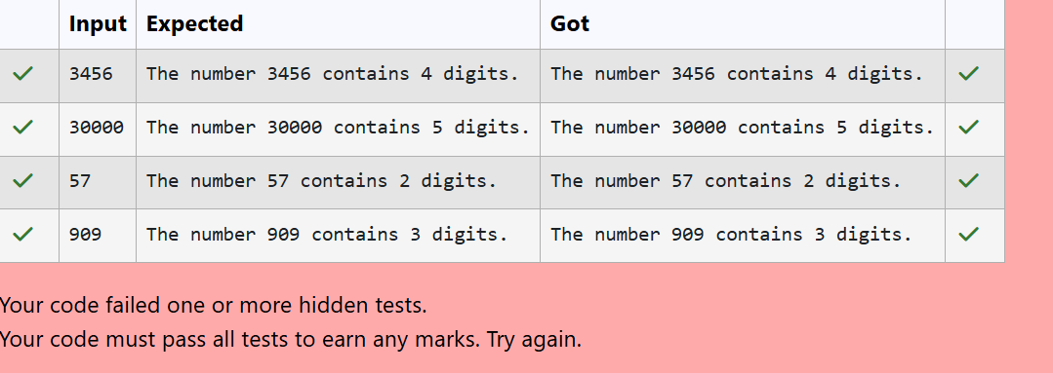

**Question 2:**

**Write a C program to check whether the given number(N) can be expressed as Power of Two (2) or not.**

**Program:**

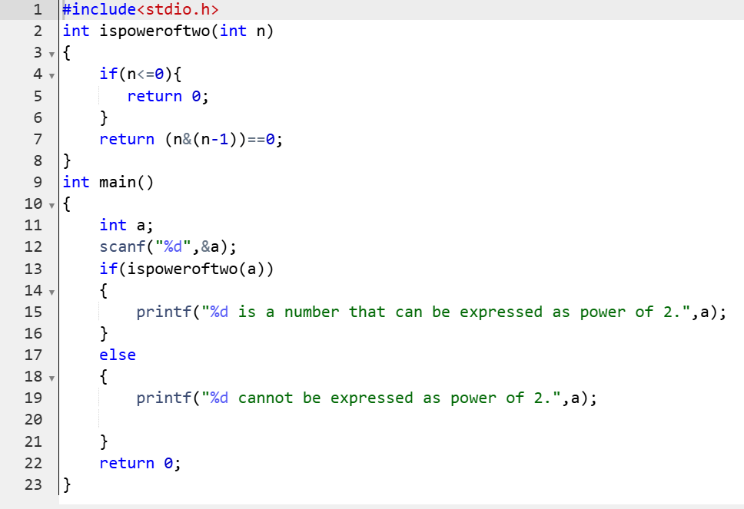

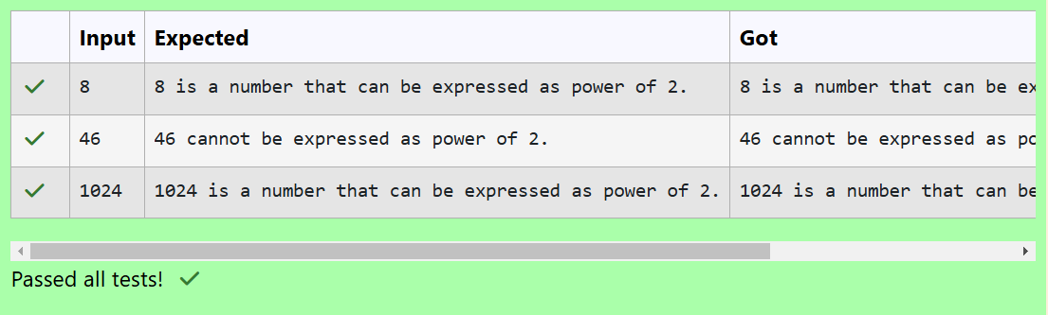

**Question 3:**

**Write a program in C to find the sum of the series 1 +11 + 111 + 1111 + . . . + n terms (n will be given as input from the user and sum will be the output)**

**Program:**

