**Week 07**

**Question 1:**

**Take a number, reverse it and add it to the original number until the obtained number is a palindrome.**

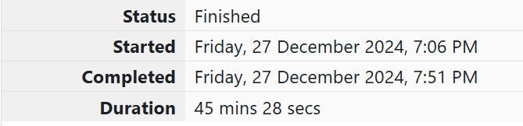

**Program:**

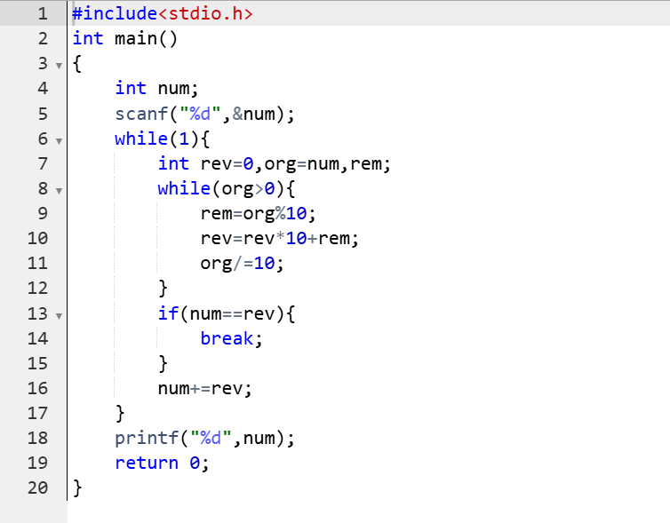

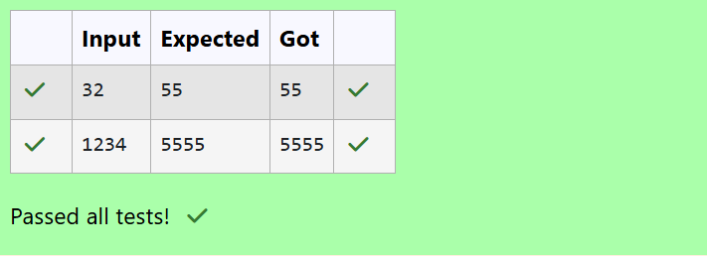

**Question 2:**

**Write a program to find if a given number N can be expressed as a sum of two prime numbers.**

**Note: YOU MUST OPTIMIZE the logic to find whether a number is prime or not, as very large prime numbers are provided as input. If the logic is not optimized your program will NOT get executed within the given time limit.**

**Program:**

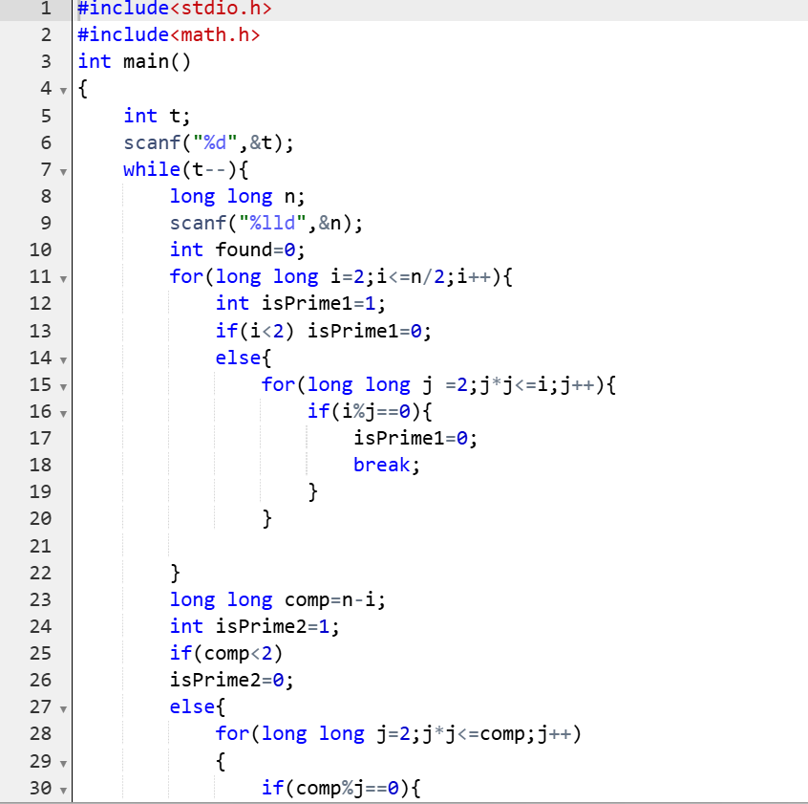

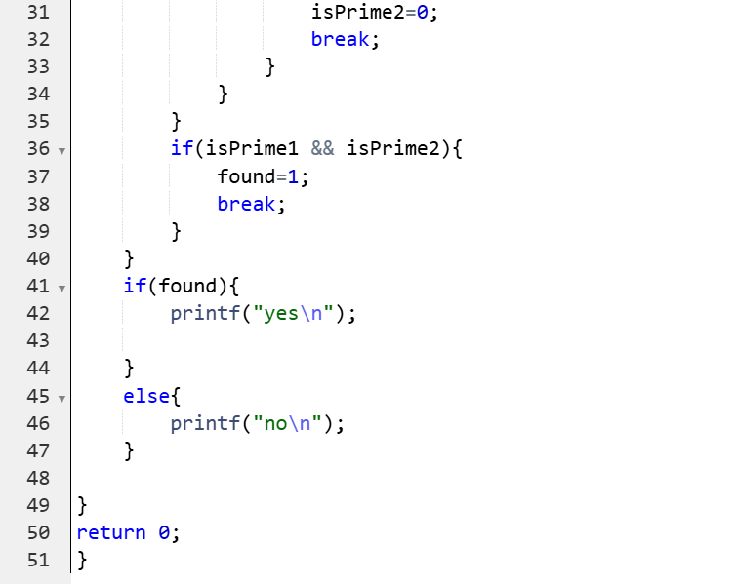

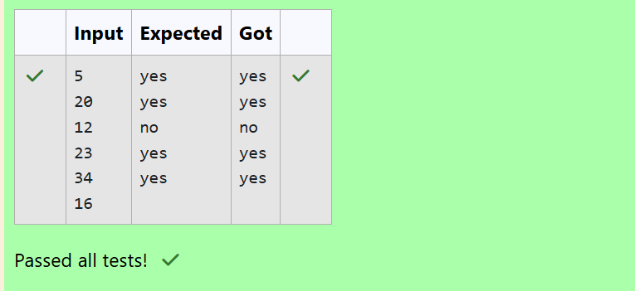**Question 3:**

**Write a C program that given an integer ‘n’, prints the number of integers that are less than or equal to ‘n’ and co-prime to ‘n’**

**Two integers a and b are said to be relatively prime or co-prime if the only positive integer that evenly divides both of them is 1. That is, the only common positive factor of the two numbers is 1. This is equivalent to their greatest common divisor being 1.**

**Program:**

