**Week 12**

**Question 1:**

**A binary number is a combination of 1s and 0s. Its nth least significant digit is the nth digit starting from the right starting with 1. Given a decimal number, convert it to binary and determine the value of the the 4th least significant digit.**

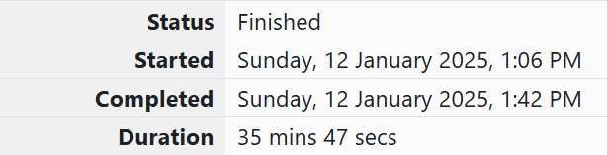

**Program:**

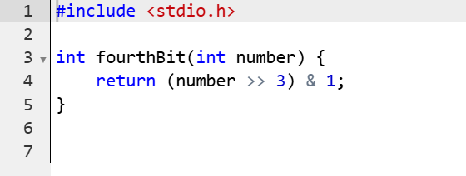

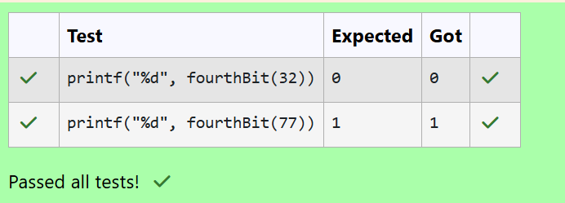

**Question 2:**

**Determine the factors of a number (i.e., all positive integer values that evenly divide into a number) and then return the pth element of the list, sorted ascending. If there is no pth element, return 0.**

**Program:**

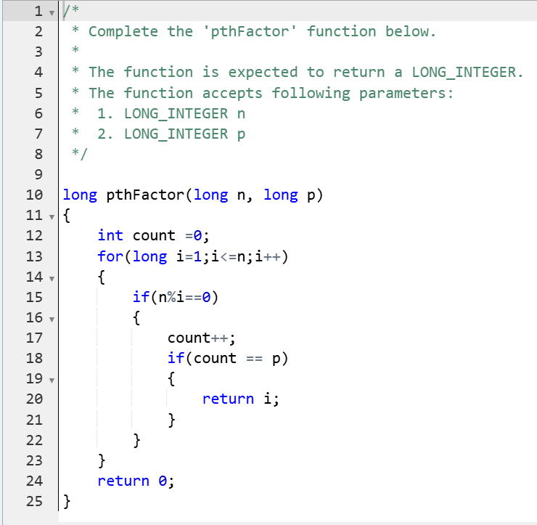

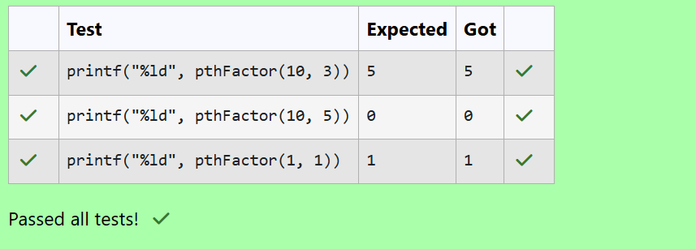

**Question 3:**

**You are a bank account hacker. Initially you have 1 rupee in your account, and you want exactly *N* rupees in your account. You wrote two hacks, first hack can multiply the amount of money you own by 10, while the second can multiply it by 20. These hacks can be used any number of time. Can you achieve the desired amount *N* using these hacks.**

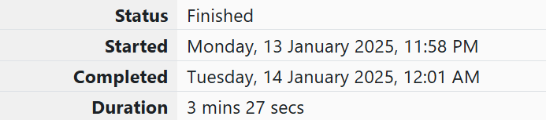

**Program:**

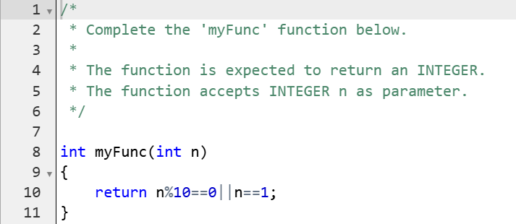

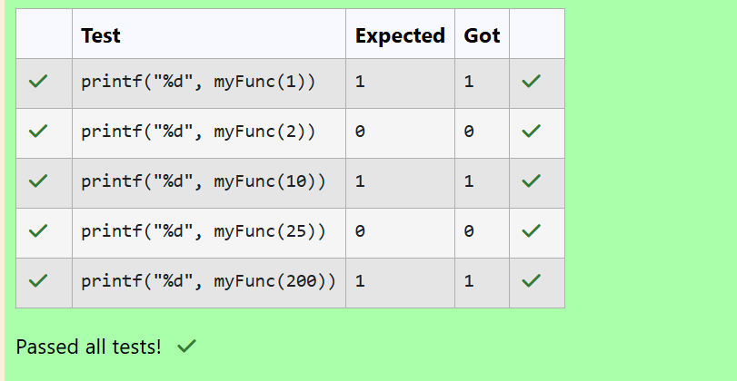

**Question 4:**

**Find the number of ways that a given integer, *X*, can be expressed as the sum of the *Nth* powers of unique, natural numbers.**

**Program:**

