**Week 13**

**Question 1:**

**Given an array of numbers, find the index of the smallest array element (the pivot), for which the sums of all elements to the left and to the right are equal. The array may not be reordered.**

|  |  |
| --- | --- |
| **Status** | Finished |
| **Started** | Tuesday, 14 January 2025, 6:16 AM |
| **Completed** | Tuesday, 14 January 2025, 6:29 AM |
| **Duration** | 13 mins 5 secs |

Program:

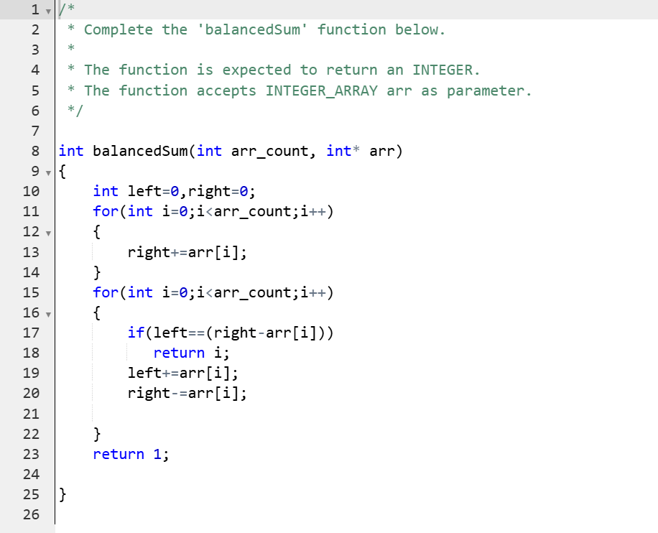

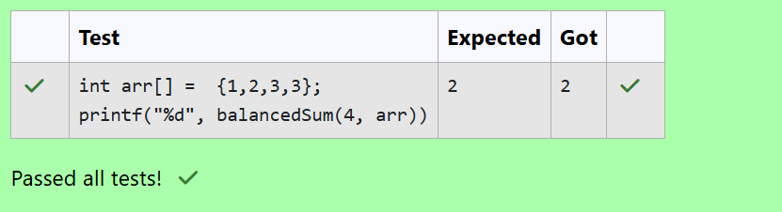

**Question 2:**

**Calculate the sum of an array of integers**.

Program:

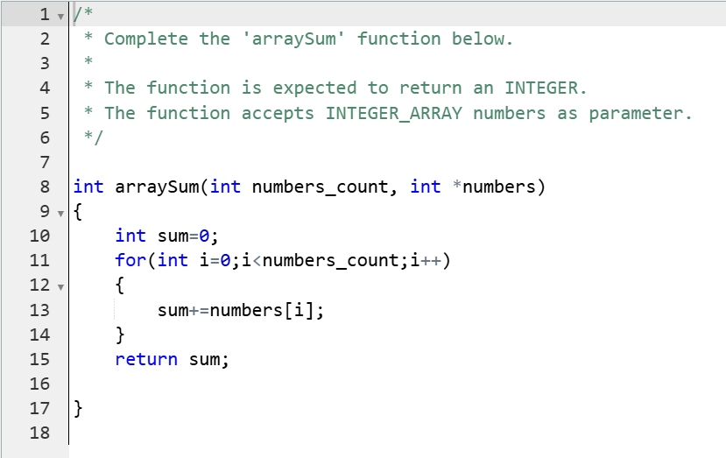

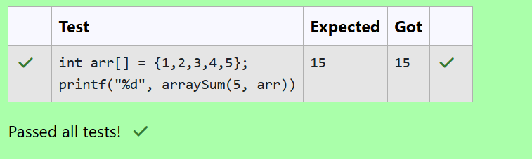

**Question 3:**

**Given an array of n integers, rearrange them so that the sum of the absolute differences of all adjacent elements is minimized. Then, compute the sum of those absolute differences. Example n = 5 arr = [1, 3, 3, 2, 4] If the list is rearranged as arr' = [1, 2, 3, 3, 4], the absolute differences are |1 - 2| = 1, |2 - 3| = 1, |3 - 3| = 0, |3 - 4| = 1. The sum of those differences is 1 + 1 + 0 + 1 = 3. Function Description Complete the function minDiff in the editor below. minDiff has the following parameter: arr: an integer array Returns: int: the sum of the absolute differences of adjacent elements Constraints 2 ≤ n ≤105 0 ≤ arr[i] ≤ 109, where 0 ≤ i < n Input Format For Custom Testing The first line of input contains an integer, n, the size of arr. Each of the following n lines contains an integer that describes arr[i] (where 0 ≤ i < n) .**

**Problem:**

