**Week 14**

**Question 1:**

**You are transporting some boxes through a tunnel, where each box is a parallelepiped, and is characterized by its length, width and height.**

**The height of the tunnel *41* feet and the width can be assumed to be infinite. A box can be carried through the tunnel only if its height is strictly less than the tunnel's height. Find the volume of each box that can be successfully transported to the other end of the tunnel. Note: Boxes cannot be rotated.**

|  |  |
| --- | --- |
| **Status** | Finished |
| **Started** | Tuesday, 14 January 2025, 6:34 AM |
| **Completed** | Tuesday, 14 January 2025, 6:55 AM |
| **Duration** | 20 mins 45 secs |

**Program:**

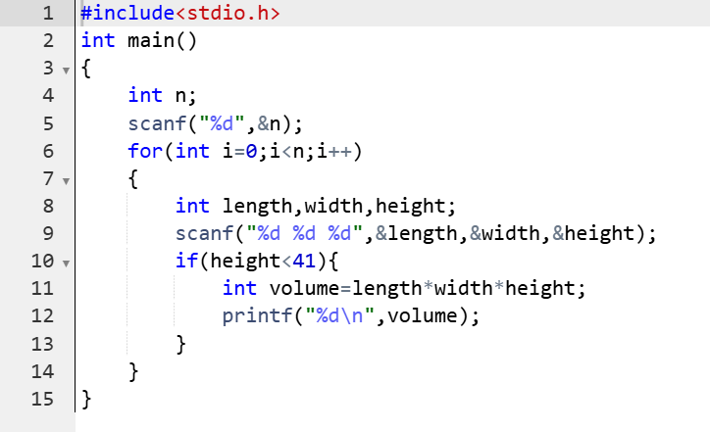

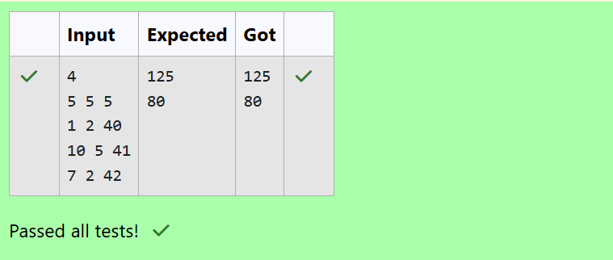

**Question 2:**

**You are given *n* triangles, specifically, their sides *ai*, *bi* and *ci*. Print them in the same style but sorted by their areas from the smallest one to the largest one. It is guaranteed that all the areas are different.**

**The best way to calculate a volume of the triangle with sides *a*, *b* and *c* is Heron's formula:**

***S = Ö p * (p – a) * (p - b) * (p – c)* where *p = (a + b + c) / 2*.**

**Program:**

