**Week 15**

**Question 1:**

**Given an array of integers, reverse the given array in place using an index and loop rather than a built-in function.**

|  |  |
| --- | --- |
| **Status** | Finished |
| **Started** | Tuesday, 14 January 2025, 7:08 AM |
| **Completed** | Tuesday, 14 January 2025, 7:16 AM |
| **Duration** | 7 mins 22 secs |

**Program:**

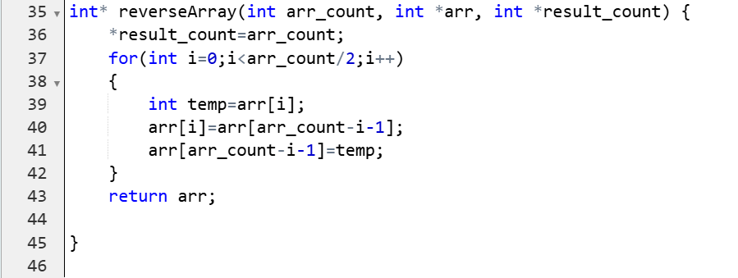

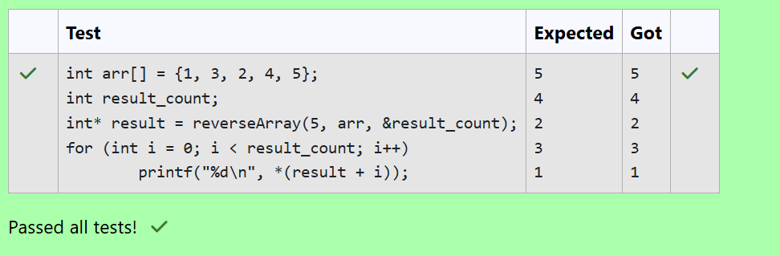

**Question 2:**

**An automated cutting machine is used to cut rods into segments. The cutting machine can only hold a rod of *minLength* or more, and it can only make one cut at a time. Given the array *lengths[]* representing the desired lengths of each segment, determine if it is possible to make the necessary cuts using this machine. The rod is marked into lengths already, in the order given.**

**Program:**

