

Department of Computer Science

University of Gujrat

AI Based Medical Laboratory



Session: BSCS 2020-2024

Project Advisor: Zafar Mahmood Khattak

Submitted By:

Abdul Wahab | 20021519-066
Nafeesa Shehzadi | 20021519-074

STATEMENT OF SUBMISSION

This is certify that Mr. Abdul Wahab Roll No. 20021519-066 and Nafeesa Shehzadi Roll No. 20021519-074 has successfully completed the final year project named as AI MedLab at the Department of Computer Science, University of Gujrat, to fulfill the requirement of the degree of Bachelor of science in Computer Science.

______________________ _____________________
Project Supervisor Project Coordination Office
Faculty of C&IT -UOG

______________________
Chairperson
Department of Computer Science

Acknowledgement

We truly acknowledge the cooperation and help make by ________________, Chairman, Department of Computer Science, University of Gujrat. He has been a constant source of guidance throughout the course of this project. We would also like to thank _____________________ for his help and guidance throughout this project. We are also thankful to our friends and families whose silent support led us to complete our project.

Date:

Abstract

AI-based medical laboratory is a project that aims to use artificial intelligence (AI), machine learning (ML) to improve the quality and efficiency of laboratory medicine. There are three modules like customer or local person, doctor and lab assistant.
Pros: The project can enhance the precision and speed of laboratory medicine, reduce human errors and costs, and improve patient outcomes and satisfaction.
Cons: The project can face challenges such as data quality and availability, computing power, trust, acceptance, and education. The project can use various tools and technologies for AI/ML, such as Python, R, TensorFlow, PyTorch, scikit-learn, pandas, NumPy, matplotlib, seaborn.

Table of Contents
Chapter 1: Project Feasibility Report 7
1.1. Introduction 8
1.2. Project/Product Feasibility Report 8
1.2.1. Technical Feasibility 8
1.2.2. Operational Feasibility 8
1.2.3. Economic Feasibility 8
1.2.4. Schedule Feasibility 9
1.2.5. Specification Feasibility 9
1.2.6. Information Feasibility 9
1.2.7. Motivational Feasibility 9
1.2.8. Legal & Ethical Feasibility 9
1.3. Project/Product Scope 9
1.4. Project/Product Costing 9
1.5. Task Dependency Table 9
1.6. CPM - Critical Path Method 10
1.7. Gantt chart 11
1.8. Allocation of Members to Activities 11
1.9. Tools and Technology with reasoning 12
1.10. Vision Document 12
1.11. Product Features/ Product Decomposition 13
Chapter 2: Software Requirement Specification (For Object Oriented Approach) 13
2.1 Introduction: 14
2.2 Systems Specifications 15
2.2.1. Identifying External Entities 15
2.2.2. Context Level Data Flow Diagram: 15
2.2.3. Capture "shall" Statements: 15
2.2.4 Allocate Requirements: 16
2.2.5. Prioritize Requirements (If Any): 17
2.3. Existing Systems / Literature Review: 20
2.3.1. Existing System 20
2.4. Usecase Diagram of Your Project: 21
2.4.1. Usecase Description 23
Chapter 3: Design Document (For Object Oriented Approach) 24
3.1. Introduction: 25
3.2. Domain Model 25
3.3. Design Class Diagram 26
3.4. Sequence Diagram 28
3.5. State chart diagram 29
3.6. Collaboration Diagram 29
a. Contents of Collaboration Diagrams 30
Chapter 4: User Interface Design 30
4.1. Introduction 33

4.2. Site Maps 32
4.3. Story boards 33
4.4. Navigational maps: 35
Chapter 5: Software Testing 36
5.1 Introduction: 37
5.2. Test plan 37
5.2.1. Purpose 37
5.2.2. Outline 37
5.3. Test design specification 38
5.3.1. Purpose 38
5.3.2. Outline 38
5.4. Test Case Specification 39
5.4.1. Purpose 39
5.4.2. Outline 39
5.5. Test procedure specification 40
5.5.1. Purpose 40
5.5.2 Outline 40
5.6. Test item transmittal report 41
5.6.1. Purpose 41
5.6.2. Outline 41
5.7. Test log 42
5.7.1. Purpose 42
5.7.2. Outline 42
5.8. Test incident report 43
5.8.1. Purpose 43
5.8.2. Outline 43
5.9. Test summary report 44
5.9.1. Purpose 44
5.9.2. Outline 44
Chapter 6: Results 52
Chapter 7: User Manual 53
Chapter 8: Conclusion and Future Work 56

Chapter 1: Project Feasibility Report

1.1.INTRODUCTION
A project called AI-based medical laboratory (AI-MedLab) attempts to develop a smart medical laboratory system for various users. The system makes use of AI to provide diagnosis and treatment recommendations in addition to an accurate and insightful interpretation of lab data. In addition to lowering expenses and human error, the project can improve patient outcomes and satisfaction, expedite research and development, and increase laboratory medicine's accuracy and speed.
In a poll performed by Roche's Strategic Advisory Network, it was found that 15.6% of participants said their firms now employ AI, while 66.4% said they may in the future1. In the medical industry, artificial intelligence (AI) is widely used for financial analytics, risk assessment, patient risk profiles, and diagnostics.
The laboratory community will require training on the technology and its use, as well as research into producing clinical proof and resolving implementation issues, to apply AI in the medical field. These days, well-defined activities can be entirely or partially automated by AI-based systems, and their performance metrics can match those of skilled human operators. As a result, AI/ML-based technologies are being included into applicable processes in many areas of the healthcare industry. Leading the way in this wave are laboratory medicine and in vitro diagnostics (IVD), since artificial intelligence (AI) is being used more and more in business intelligence tools, FDA-approved equipment, and tests created in laboratories.
Artificial intelligence (AI) in laboratory medicine has the potential to save healthcare costs, increase patient quality of care, and provide access to superior insights. The diagnostic workup of many, if not most, disorders now heavily rely on laboratory medicine due to advances in our understanding of biology, disease, and molecular medicine.

1.2. Project/Product Feasibility

1.2.1. Technical Feasibility
The technical feasibility of the AI MedLab project is high, driven by a well-chosen technology stack including Python for machine learning model training, React for the front-end, and Node.js with Express.js and MongoDB for the backend. These technologies provide a robust foundation, ensuring the system is scalable through careful architecture, database optimization, and load balancing. Security is prioritized with data encryption, secure communication, and robust authentication mechanisms. Real-time communication features are implemented enhancing the responsiveness of AI MedLab by ensuring that users receive immediate updates and can interact with the system in real-time, which is essential for effective healthcare delivery. Seamless integration with electronic health records (EHRs) and other external APIs facilitates comprehensive access to patient data and medical devices. Cross-platform compatibility ensures consistent performance across different devices and operating systems. Rigorous testing, skilled development resources, and continuous improvements further reinforce the project's technical feasibility.

1.2.2. Operational Feasibility

The operational feasibility of the AI MedLab project is ensured by its practical implementation and sustainability within the existing organizational framework and resources. User acceptance is prioritized through an intuitive interface and simple workflows, minimizing the need for extensive training. Feedback mechanisms, such as surveys and beta testing, are in place to gather input and refine the system. Organizational readiness is supported by effective change management strategies, including clear communication plans, training programs, and comprehensive support systems. The project leverages existing skilled personnel and necessary infrastructure, ensuring smooth implementation and operation. Compatibility with existing systems is maintained to prevent disruptions, and the system’s architecture allows for scalability to meet evolving needs. A thorough cost-benefit analysis evaluates the financial viability of the project, considering implementation costs, operational expenses, and anticipated benefits. Adherence to legal and regulatory requirements ensures compliance, while robust security measures protect sensitive data. Reliable vendor support for the technologies used ensures prompt issue resolution and regular updates, further enhancing operational feasibility.

1.2.3. Economic Feasibility
Economically our Project is beneficial. Economic Feasibility have two types:

Cost Estimation:
Estimated cost for developing and implementing AI MedLab involves various expenses. The initial software development cost may range from Rs.1K to Rs.2K for servers, hosting, and networking equipment. Licensing fees for third-party tools and APIs might add another Rs1.5K to Rs2.5K.

Maintenance and Operation:
Cost around Rs.15K to Rs.25K per year. This includes server maintenance, security updates, software enhancements, and regular system maintenance.

Benefit Estimation:
The benefit estimation for AI MedLab is based on various potential gains.

Tangible Benefits:
During the initial phase, our services will be provided free of charge, with a focus on simplifying the user experience. Subsequently, a fee structure will be implemented.
Cost Savings: Automation of disease prediction processes and reduction in manual analysis can result in cost savings estimated at Rs. 20,000 per year.
Medical Efficiency: Enhanced medical decision-making through accurate disease prediction may lead to additional cost savings and improved resource allocation within healthcare systems.

Intangible Benefits:
Enhanced Patient Satisfaction: Improved accuracy in disease prediction can enhance patient satisfaction and trust in medical services, fostering a positive reputation for the healthcare provider.
Strengthened Healthcare Partnerships: Intangible benefits such as improved collaboration between medical professionals and healthcare institutions can lead to new research opportunities and partnerships, enriching the healthcare landscape. Automation of the ordering process and reduced manual labor can lead to cost savings of approximately Rs.15,000 per year.
Supply Chain Efficiency: Improved supply chain management may lead to another Rs.10,000 in cost savings annually.

1.2.4. Schedule Feasibility
The AI MedLab project demonstrates high schedule feasibility, as outlined in the Gantt chart and project estimation. The planned activities align with the scheduled timeline, facilitating timely completion. Adjustments will be made as necessary to maintain adherence to the established timeline. The project's structured approach, evident in the Critical Path Method (CPM) analysis, ensures efficient utilization of resources and timely delivery of milestones.

Activity  Name | Activity Details | Start  Date | End  Date | Duration (Days)
A | Project Selection | 2-Nov | 18-Nov | 15
B | Proposal | 2-Dec | 31-Dec | 29
C | Feasibility report | 1-Jan | 25-Jan | 17
D | Analysis | 26-Jan | 4-Feb | 7
E | Project Prototype | 5-Feb | 21-Feb | 15
F | Model Training, Database design and implementation | 21-Feb | 20-Mar | 30
G | API development | 21-Mar | 15-Apr | 13
H | Frontend designing | 16-Apr | 4-May | 17
I | API integration with frontend | 5-May | 15-May | 10
J | Testing | 15-May | 30-May | 15
K | Deployment | 31-May | 10-Jun | 10
Table 1: Detailed Schedule Feasibility

1.2.5. Specification Feasibility
The specification feasibility of AI MedLab encompasses various technical aspects, including functionality, performance, integration, user experience, security, data management, real-time communication, scalability, cross-platform compatibility, and testing requirements. These aspects are evaluated against the chosen technology and development capabilities to ensure practical implementation. By adhering to stringent assessment criteria, the project aims to create a successful and effective platform that meets the specified requirements and fulfills the needs of its users.

1.2.6. Information Feasibility
All the information regarding the project will be on hand and assessed according to the planned activities. The output of each step is tested according to the expected result to ensure its reliability.
1.2.7. Motivational Feasibility
Introducing our AI MedLab project will undoubtedly revolutionize the way users diagnose and manage their health concerns. In today's era, technological automation is paramount, making it incredibly convenient for users to access accurate medical insights based on their symptoms and test values. This innovation will not only save time but also empower individuals with limited resources to establish their personalized health management platform. Furthermore, being pioneers in this domain instills a profound sense of motivation, as we are trailblazing a path that has yet to be explored.

1.2.8. Legal & Ethical Feasibility
Ethics and legality form the cornerstone of our AI MedLab project. We adhere strictly to ethical guidelines and ensure that our application operates within the boundaries of legality. There are no ethical concerns or infringements associated with our platform. Upholding professionalism and integrity, we prioritize the confidentiality of user data. The credibility and trustworthiness of our platform, as we do not engage in any data sharing with third parties.

Project/Product Scope
The primary objective of the AI MedLab project is to revolutionize the healthcare landscape by providing a seamless and efficient platform for diagnosing disease prediction based on symptoms and providing medication, workout, precaution and diets recommendations. Seven prevalent diseases based on value of test analysis. Our project streamlines the diagnostic process, empowering users to make informed decisions about their health. By leveraging Python for model training and development, coupled with a sophisticated frontend built on React and a robust backend supported by Node.js, MongoDB, and Express.js, we ensure a comprehensive and user-friendly experience. This initiative facilitates seamless interactions between users and medical insights, offering a plethora of benefits including accurate diagnosis, improved healthcare management, enhanced communication between patients and healthcare providers.

Project/Product Costing

Project Cost Estimation by Function Point Analysis
Information domain values | Low value | Average value | High value | FP count
No. of External Inputs | 3*3=9 | 5*4=20 | 10*6=60 | 69
No. of External Outputs | 2*4=8 | 4*5=20 | 6*7=42 | 70
No. of User Inquiry | 4*3=12 | 7*4=28 | 1*6=6 | 46
Internal Logical Files | 5*7=35 | 8*10=80 | 3*15=45 | 160
External Interface Files | 1*5=5 | 3*7=21 | 1*10=10 | 36
TOTAL |  |  |  | 381
Table 2: Project Cost Estimation by Function Point Analysis
Project Cost estimation by Functional Point Analysis following are five information domain characteristics are determined and counts are provided in here as:
A. Count of total external inputs=69
B. Count of total External Outputs=70
C. Count of total user’s inquiry= 46
D. Count of total Logical files=160
E. Count Of total Interface Files=36
The following table will give the detailed calculation for total count:

Factors | Values (0-5)
Data Communication | 3
Distributed Data Processing | 3
Performance | 3
Heavily used Configuration | 3
Online Data Entry | 3
End User Efficiency | 3
Online Update | 3
Complex Processing | 3
Reusability | 3
Installation ease | 3
Multiple sites | 3
Facilitate change | 3
Table 3: Factor Values of Cost Analysis
Total= sum of Fi= 42
Calculate Function Point
FP est. = Count Total*[0.65+0.01(sum of Fi)]
FP est. = 381*[0.65+0.01(42)]
FP est. = 407.67

1.5. Task Dependency Table
Activity | Immediate Predecessor | Duration (Weeks)
A | None | 2
B | A | 1
C | A, B | 1
D | C | 2
E | D | 4
F | E | 3
G | F | 4
H | E | 4
I | G, H | 3
J | I | 3
K | J | 4
Table 4: Task Dependencies

1.6. CPM - Critical Path Method
To create CPM of this project, following are the activities:

- Project Selection (A)
- Proposal (B)
- Feasibility report (C)
- Analysis (D)
- Project Prototype (E)

- Model Training, Database design and implementation (F)
- API development (G)
- Frontend designing (H)
- API integration with frontend (I)
- Testing (J)
- Deployment (K)

Activity | Immediate Predecessor | Duration (Weeks)
A | None | 2
B | A | 1
C | A, B | 1
D | C | 2
E | D | 4
F | E | 3
G | F | 4
H | E | 4
I | G, H | 3
J | I | 3
K | J | 4
Table 5: Critical Path Method
Network Diagram
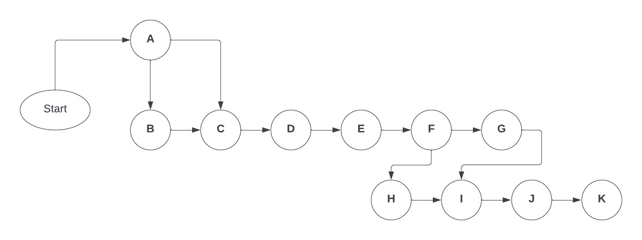
Figure 1: Network Diagram Project Activities

Activity | Duration | ES | EF | LS | LF | SL
A | 2 | 0 | 2 | 0 | 2 | 0
B | 1 | 2 | 3 | 2 | 3 | 0
C | 1 | 3 | 4 | 3 | 4 | 0
D | 2 | 4 | 6 | 4 | 6 | 0
E | 4 | 6 | 10 | 6 | 10 | 0
F | 3 | 10 | 13 | 10 | 13 | 0
G | 4 | 13 | 17 | 13 | 17 | 0
H | 4 | 10 | 14 | 13 | 17 | 3
I | 3 | 17 | 20 | 17 | 20 | 0
J | 3 | 20 | 23 | 20 | 23 | 0
K | 4 | 23 | 27 | 23 | 27 | 0
Table 6: Activity Duration Details
The critical path is
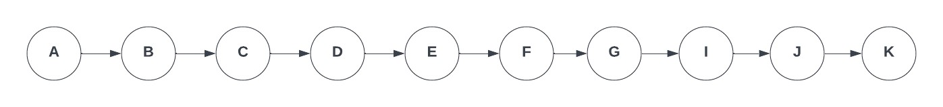
Figure 2: Critical Path (Activity Based)

1.7. Gantt Chart

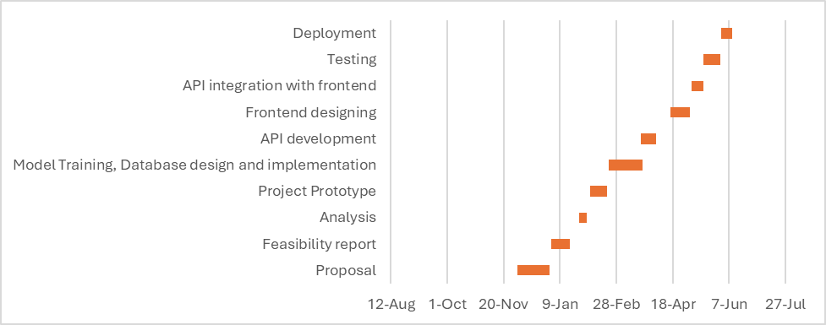

1.8. Allocation of Members to Activities
Introduction to Team Members
Members | Tasks
M1: Abdul Wahab | Database designing, Api development, Deployment Api, Model Training, Frontend, Documentation, Testing
M2: Nafeesa Shehzadi | Front End Development, API integration with front End, Model Training, Documentations, Testing
Table 7: Introduction of FYP-Team Members

Task | Engineers
T1 | Nafeesa Shehzadi, Abdul Wahab
T2 | Abdul Wahab
T3 | Nafeesa shehzadi
T4 | Nafeesa Shehzadi, Abdul Wahab
T5 | Abdul Wahab
T6 | Abdul Wahab
T7 | Nafeesa Shehzadi, Abdul Wahab
T8 | Nafeesa Shehzadi, Abdul Wahab
T9 | Abdul Wahab
T10 | Nafeesa Shehzadi
T11 | Abdul Wahab
Table 8: Task Assignment to Team Members

1.9. Tools and Technology with reasoning
• Python
Python is a versatile programming language appreciated for its simplicity and readability, making it a popular choice across various domains. Python boasts a rich ecosystem of libraries and frameworks specifically designed for machine learning and data science. Libraries such as NumPy, Pandas, and SciPy provide powerful tools for data manipulation and analysis, while scikit-learn offers a wide range of machine learning algorithms and tools for model training and evaluation.
• React
Developed by Facebook has transformed frontend development through its component- based architecture and efficient rendering model? By breaking UIs into reusable components, react simplifies maintenance, enhances productivity, and enables the creation of dynamic web interfaces with ease. Its modular structure promotes code reusability, streamlines development, and empowers developers to build interactive user interfaces.
• Visual Studio Code
An Integrated Development Environment (IDE), such as Visual Studio Code provides a workspace for writing, testing and debugging code.
• JIRA or Trello
A project management tool, such as JIRA or Trello, to track progress, assign tasks and manage resources during the development process.
• Selenium
Test automation tools allow developers to automate the testing process, which can be particularly useful for an iterative development process where multiple tests may need to be run. We will use Selenium as it is one of the best automation tools.
• MongoDB
MongoDB is a popular open-source, NoSQL (Not Only SQL) database management system. It is designed for handling large amounts of unstructured or semi-structured data, making it suitable for a wide range of applications, including web applications, mobile apps, real-time analytics, and more.
• Node JS
Node.js is an open-source, server-side JavaScript runtime environment that allows developers to run JavaScript code on the server side, outside of a web browser, enabling them to build scalable, high-performance network applications.
• Budget Design
$10 (includes fees for Figma Pro)
Platforms: $35 (includes fees for hosting and play console) Total budget: $45
Above mentioned cost is only limited to the tools required to develop and deploy it as a prototype. It includes design and development costs being a student's team project.
• Time Constraints
Product Development Cycle: 6 Months Testing and QA: 2 Weeks Deployment: 3 Days

1.10. Vision
Ai MedLab envisions a future where traditional healthcare boundaries dissolve, replaced by a dynamic ecosystem of direct connections, seamless interactions, and limitless advancements. In the current landscape, healthcare providers and patients face challenges due to fragmented communication and limited access to medical resources. Ai MedLab emerges as the catalyst for change, revolutionizing how healthcare is delivered and accessed. By leveraging cutting-edge AI technology and innovative digital solutions, Ai MedLab aims to empower healthcare including medical professionals, researchers, and patients, to collaborate effectively and access critical medical insights. Our platform offers user-friendly interfaces, comprehensive medical data repositories, real-time communication channels, secure data exchange, and data-driven analytics. By eliminating barriers and intermediaries, Ai MedLab redefines healthcare collaboration, enabling medical breakthroughs, and improving patient outcomes. Key features include predictive disease diagnosis, personalized treatment recommendations, seamless patient-doctor communication, secure data sharing, and scalability for evolving healthcare needs. This transformative approach leads to tangible benefits: medical professionals gain insights, patients receive personalized care, researchers accelerate discoveries, and the entire healthcare landscape undergoes a paradigm shift. Driven by cutting-edge technologies such as Python for model training and react for frontend development, NodeJS to run JavaScript on server side and express js. Ai MedLab embodies innovation, reflecting our commitment to quality, continuous improvement, and the realization of our vision: a borderless healthcare realm where connections are strengthened, healthcare delivery is optimized, and medical advancements flourish. Ai MedLab propels healthcare into an era of boundless possibilities, catalyzing success in the modern digital healthcare landscape.

1.11. Product Features/ Product Decomposition
Here are some key product features that are included:
- Disease Prediction:
We offer specialized services for detection heart disease, diabetes, breast cancer, malaria, pneumonia, liver disease, and kidney disease. After preliminary diagnosis, users can choose from a list of available doctors.
- Appointment Booking
The platform allows users to book appointments directly with their selected doctor.
- HealthPredict Feature:
Our HealthPredict tool is an innovative feature that predicts diseases based on the symptoms provided by users.
It offers personalized recommendations for precautionary measures, medications, diets, and workouts, helping users take proactive steps towards better health.
- User Management:
The web app allows Admin/AI Lab Assistant to manage their patients & doctors such as. Adding or removing doctors, viewing all bookings.

Chapter 2: Software Requirement Specification (SRS)

2.1 Introduction
A project called AI-based medical laboratory (AI-MedLab) attempts to develop a smart medical laboratory system for various users. The system makes use of AI to provide diagnosis and treatment recommendations in addition to an accurate and insightful interpretation of lab data. In addition to lowering expenses and human error, the project can improve patient outcomes and satisfaction, expedite research and development, and increase laboratory medicine's accuracy and speed.
In a poll performed by Roche's Strategic Advisory Network, it was found that 15.6% of participants said their firms now employ AI, while 66.4% said they may in the future1. In the medical industry, artificial intelligence (AI) is widely used for financial analytics, risk assessment, patient risk profiles, and diagnostics.
The laboratory community will require training on the technology and its use, as well as research into producing clinical proof and resolving implementation issues, to apply AI in the medical field. These days, well-defined activities can be entirely or partially automated by AI-based systems, and their performance metrics can match those of skilled human operators. As a result, AI/ML-based technologies are being included into applicable processes in many areas of the healthcare industry. Leading the way in this wave are laboratory medicine and in vitro diagnostics (IVD), since artificial intelligence (AI) is being used more and more in business intelligence tools, FDA-approved equipment, and tests created in laboratories.
Artificial intelligence (AI) in laboratory medicine has the potential to save healthcare costs, increase patient quality of care, and provide access to superior insights. The diagnostic workup of many, if not most, disorders now heavily rely on laboratory medicine due to advances in our understanding of biology, disease, and molecular medicine.

2.2 Systems Specifications
The following are the clauses that must be included when describing the system specifications.

2.2.1. Identifying External Entities
The Identification of External Entities.
Login:
The "Login" entity serves as the gateway for users—customers, doctors, lab assistants, and possibly administrators—to access the AI-Med Lab system. It facilitates secure authentication and authorization processes, ensuring that only authorized individuals can interact with the system's functionalities.
Patient Module:
- User-friendly dashboard for accessing results and health tips.
- Secure login functionality for user authentication.
Doctor Module:
- Comprehensive reports with AI-based treatment recommendations.
- Secure access for authorized medical professionals.
Lab Assistant Module:
- Database management system for organizing patient records securely.
- Access control mechanisms to ensure data confidentiality.
Database:
The "Database" entity serves as the central storage and management system for all data within the AI-Med Lab ecosystem. It stores various types of information vital to the system's functionality and operations, ensuring data integrity, accessibility, and security.
HIPAA Compliance Authority:
Especially relevant for healthcare systems to ensure data security and privacy compliance.
2.2.2. Context Level Data Flow Diagram:

Admin
AI-MEDLAB

Doctor

Patient

2.1.6. Capture "shall" Statements

Para # | Initial Requirements
1.0 | A patient “shall” predict specific disease.
1.0 | A patient "shall" register within the system to access healthcare services
1.0 | CA “shall” accept, reject and temporarily waive the requests on the basis of credentials provided.
1.0 | Patients "shall" be able to log in to the system and modify their passwords for security purposes.
1.0 | Patients "shall" place requests for diagnostics or treatment recommendations through the system.
1.0 | the AI system "shall" process various types of diagnostic requests, such as image analysis, lab test interpretations, and personalized treatment suggestions.
1.0 | The system "shall" present patients with the outcomes of the diagnostic analysis for verification.
1.0 | System administrators “shall” have access to audit logs and user activity tracking for security purposes.
2.0 | Users “shall” be able to upload medical data, including test results, medical
 | history, and lifestyle information.
2.0 | The AI engine “shall” analyze uploaded data and provide accurate diagnostic interpretations.
2.0 | The system “shall” present analyzed data in a clear and user-friendly format for easy understanding.
2.0 | Users “shall” have the option to share their data with healthcare professionals for further consultation.
2.0 | The system “shall” protect user data privacy and comply with relevant healthcare data regulations.
3.0 | The AI engine “shall” generate personalized treatment recommendations based on analyzed data
3.0 | The system “shall” provide information and resources about recommended treatments and medications.
3.0 | Users “shall” have the option to discuss AI-generated recommendations with healthcare professionals.
3.0 | The system “shall” facilitate communication between users and healthcare providers through secure messaging or telehealth features.
3.0 | The system “shall” offer educational materials and resources to empower users to manage their health proactively.

Table 9: Shall Statements

2.1.7. Allocate Requirements

Para | Initial Requirements | Use Case Name
1.0 | AI lab assistant “Shall” predicts diseases based on patient input and medical data. | UC_Predict _Disease
1.0 | A User “shall” register himself to the system | UC_Registration_Request
1.0 | CA “shall” accept, reject and temporarily waive the requests on the basis of credentials provided. | UC_Process_ User _Request
1.0 | A patient and Doctor “shall” login to the system and can change his password | UC_Login
1.0 | System “shall” updates patient or doctor requests (e.g., personal details, status upgrades). | UC_Update_Request
1.0 | System “shall” processes various updates like patient details, doctor statuses. | UC_Change_Status
1.0 | A User “shall” view his details for  verification purposes | UC_View_ User _Details
1.0 | System “shall” search any customer details | UC_Search_ User
1.0 | CA “shall” accept, reject, and temporarily waive the requests on the basis of credentials provided. | UC_Accept_ User _Request  UC_Reject_ User _Request  UC_View_ User _Request
2.0 | Doctor “shall” interact with patients through the system for consultations and review of predicted diseases. | UC_Doctor_Patient_Interaction s:
2.0 | AI lab assistant “will” interact with doctors to provide disease predictions and insights. | UC_AI_Assistant_Doctor_Inter actions:
2.0 | User “shall” view the status of their request for specific doctor. | UC_Serach_Number
2.0 | Patients “shall” interact with the AI lab assistant for disease predictions and information. | UC_Patient_AI_Interactions
2.0 | User “shall” place the request for change the doctor or request for other disease prediction. But all these updating and cancellation requests are to be viewed by the Lab Assistant to accept, reject, or waive them. | UC_Change_Doctor _Details,  UC_Change_Status,  UC_Change_Personal_Details
3.0 | System generates action events for administrators based on patient-doctor interactions or AI predictions. | UC_Create_Action,
3.0 | Corresponding administrator “shall ” view his Action List containing different actions, and correspondingly process these pending actions | UC_View_Action,

2.1.8. Priorities Requirements

Para # | Rank | Initial  Requirements | Use  Case  ID | Use Case Name
1.0 | Highest | A patient “will” request for  disease prediction | UC_1 | UC_Predict _Disease
1.0 | Highest | A User “shall” register himself to the system | UC_2 | UC_Registration_Request
2.0 | Highest | patient “will” | UC_3 | UC_Pay_For_Consultation

 |  | make payment. in case of He consult to doctor for further consultation.
1.0 | Highest | System “will” generate invoice, confirmation receipt for going to doctor. | UC_4 | UC_Invoice_Generation,
2.0 | Medium | Every user “will” request for  prediction | UC_5 | UC_Place_Request
2.0 | Medium | The System  “shall” generate an action event for a  corresponding administrator when a request is placed for updating of customer details etc. | UC_7 | UC_Create_Action
2.0 | Medium | CA “shall” accept, reject and temporarily  waive the requests on the basis of credentials provided. | UC_8  UC_9  UC_10 | UC_Accept_ User _Request  UC_Reject_ User _Request  UC_View_ User _Request
2.0 | Medium | System “shall” update the User Request | UC_11 | UC_Update_Request
2.0 | Medium | System “shall” process different types of updating e.g. updating of his personal details or upgrading of his status from registered to  privileged | UC_12  UC_13  UC_14 | UC_Change_Consultation_Det ails,  UC_Change_Status,  UC_Change_Personal_Details

 |  | customer or updating of his Doctor consultation.
2.0 | Medium | A User “shall” view his details for verification purposes | UC_15 | UC_View_User _Details
2.0 | Medium | System “shall” search any User  details | UC_16 | UC_Search_ User
2.0 | Medium | User “shall” view the status of their patient no by providing the patient Number | UC_17 | UC_Serach_Orders
2.0 | Medium | User “shall” place the request for the updating  doctor consultation. | UC_18 | UC_Update_Request
3.0 | Lowest | A user “shall” login to the system and can change his  password | UC_22  UC_23 | UC_Login,
3.0 | Lowest | Corresponding administrator “shall ” view his  Action List  containing different actions, and correspondingly process these  pending actions | UC_24 | UC_View_Action,
3.0 | Lowest | When the action processing is completed or if the action is just a notification message then administrator  “shall” delete | UC_25 | UC_Delete_Action
these actions from the action
list

2.3. Existing Systems / Literature Review

2.3.1. Existing System
The existing system has solved the most common problem related to online products sale. But we are solving the problem in context of scalability, and we are providing the software as a service. The given table provides the comparative analysis of existing system with proposed system.

System Name | Web app |  | User  Review | Disease Diagnosis  On symptom | Recommendation diets/workout
  Disease Diagnosis
AIMedLab (Proposed System) | ✔ | ✔ | ✔ | ✔ | ✔
IEEE xplore | ✔ | ✔ | ❌ | ❌ | ❌
Springle | ✔ | ✔ | ✔ | ✔ | ❌
Manual | ❌ | ✔ | ❌ | ✔ | ✔
IBM watson | ✔ | ✔ | ✔ | ✔ | ❌
Table 10: Proposed System Comparison with Existing Systems

2.4. Use Case

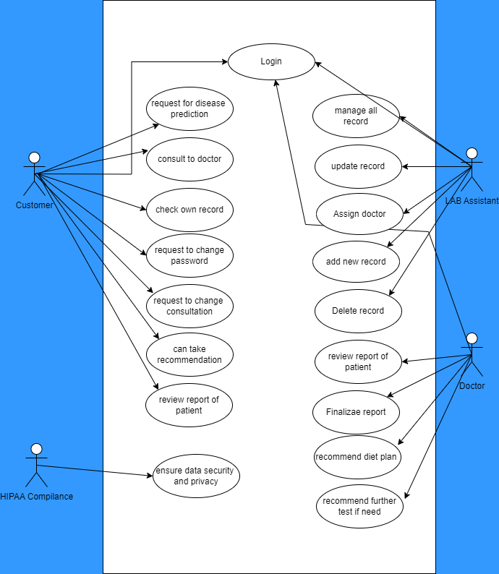

2.4.1. Use Case Description

Actors:
- Patients: Seek medical advice and services.
- Doctors: Provide diagnoses, consultations, and treatment recommendations.
- Lab Assistants: Conduct tests, manage records, and update results.
- HIPAA Compliance Authority: Ensures data privacy and security.
UseCase:
Patients:
- Predict Diseases: AI Analyzes Data for Predictions.
- Access Records: View Personal Medical History.
- Manage Account: Update Password & Reschedule Consultations.
- Follow Recommendations: Receive & Act on Treatment/Lifestyle Suggestions. Doctors:
- Analyze Data: Review Patient Information, AI Predictions, & Test Results.
- Order Tests: Request Additional Clarification if Needed.
- Recommend Diet Plans: Tailor Nutritional Guidance for Better Health.
- Finalize Reports: Complete & Approve Patient Documents. Lab Assistants:
- Manage Patients: Assign Doctors, Create Records, Update Information.
- Remove Records: Archive Outdated Data (with Authorization).
- Verify Results: Ensure Test Accuracy & Report Completion. HIPAA Compliance:
- Secure Data: Enforce Regulations to Protect Patient Privacy.
Pre & Post Conditions:
Preconditions represent the conditions that must be true or satisfied before a use case is initiated, while postconditions represent the expected state or result after the use case has been executed.
Patient:
- Request Disease Prediction:
  - Preconditions: Logged in, current health info.
  - Postconditions: System provides disease predictions.
- Predict Disease: Login, health info → System predicts.
- Consult Doctor: Login, doctor chosen → System connects.
- View Records: Login → View records.
- Change Password: Login → Updated password.
- Manage Consultations: Login, scheduled consultation → Details updated.
- Act on Recommendations: Received → View and act.
- Review Other Records (if authorized): Authorization → View other reports.
- Lab Assistants:
- Assign Doctor: Login, patient needs assignment → Assigned doctor.
- Manage Records: Login → Add, delete, review records.
- Doctors:
- Finalize Reports: Login, ready report → Marked finalized.
- Recommend Diet Plans: Reviewed health → System generates plan.
- HIPAA Compliance:
- Ensure Data Security: Access, system running → Monitored measures.

Chapter 3: Design (Object Oriented Approach

3.1. Introduction
In the context of our AI-based medical laboratory project, let's relate the project overview and its components to the concept of domain modeling:

AI-Based Medical Laboratory (AI-MedLab):
Scope for the Domain:
The project focuses on developing a smart medical laboratory system powered by AI. It aims to provide diagnosis, treatment recommendations, and insightful interpretations of lab data.
Information or Objects:
The essential components are the Patient Module, Doctor Module, and Module for Lab Assistants. These modules represent key entities in the medical domain, such as patients, doctors, and lab assistants.
Features or Use Cases, Including Factors that Lead to Variation:
Use cases include obtaining test results, tracking health patterns, receiving tailored health
Advice (Patient Module), generating thorough AI-driven reports and drug recommendations (Doctor Module), and efficient patient record management (Lab Assistant Module).

Operational/Behavioral Characteristics:

The system's operational characteristics include AI-driven analysis for diagnosis and treatment recommendations. It emphasizes efficiency, accuracy, accessibility, and preventive health care practices.

. Domain Model of System
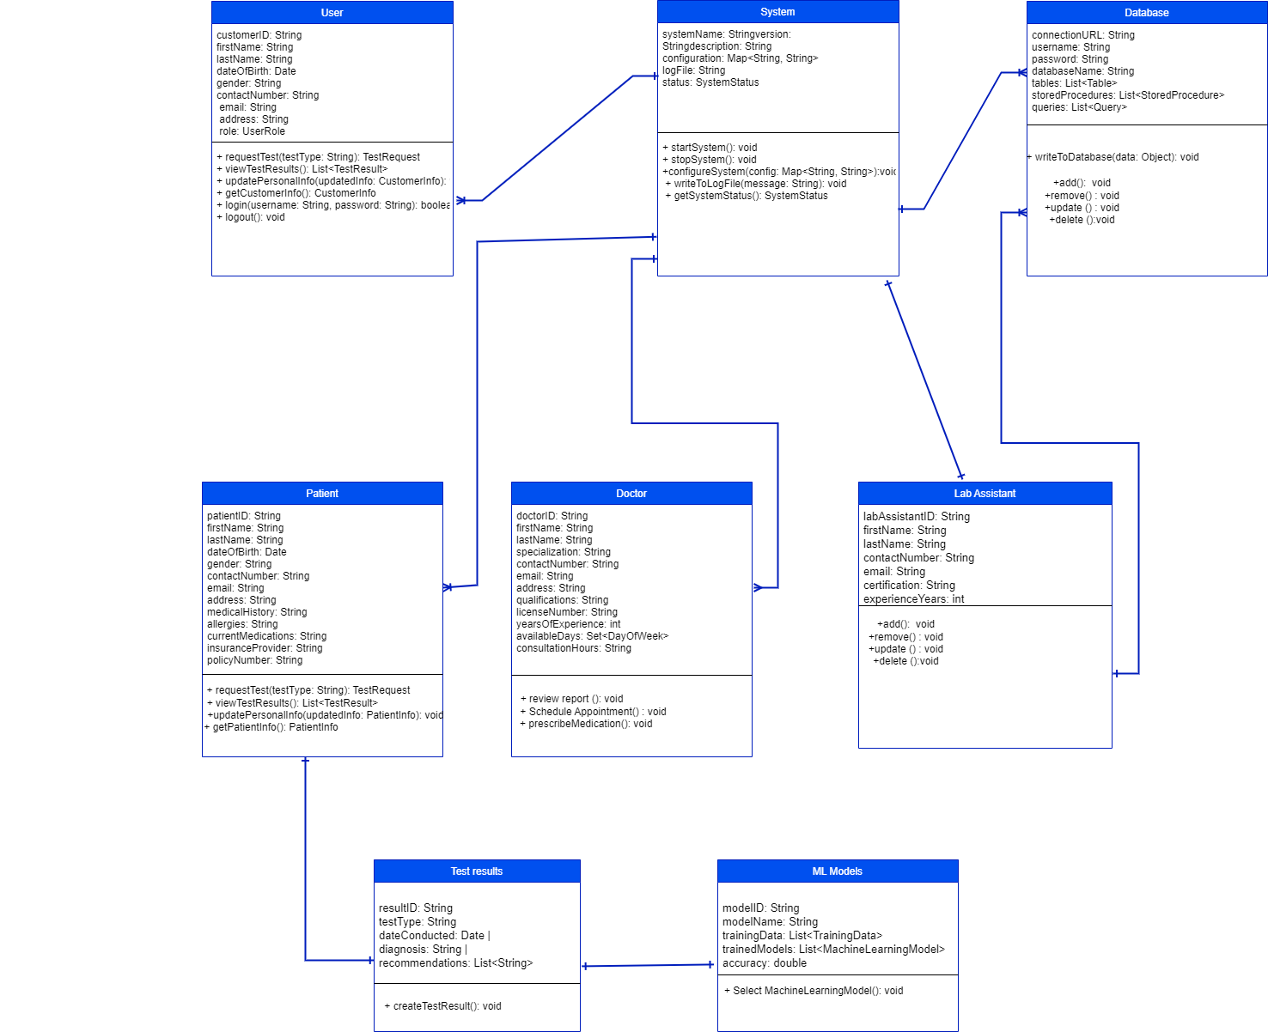

3.3. System Sequence Diagram
A sequence diagram illustrates the interactions and messages exchanged among various actors or objects in a system over a specific scenario or use case. Below is a simplified sequence diagram for the interactions involving the actors Patient, System, Doctor, ML Model, Database, and Lab Assistant in the context of our AI-based medical laboratory project?
Sequence Diagram: Patient Requests and Receives Test Results

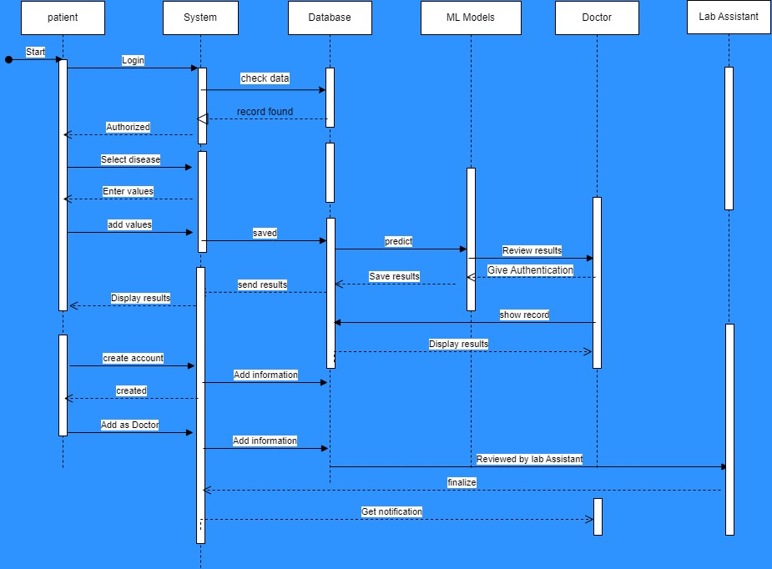

3.4. Collaboration Diagram
A collaboration diagram, also known as a communication diagram, visualizes the interactions and relationships between objects or actors in a system. In our scenario, let's create a collaboration diagram to illustrate the communication flow between the Patient, System (Server), Database, ML Models, and Doctor entities during the disease prediction and doctor consultation process.

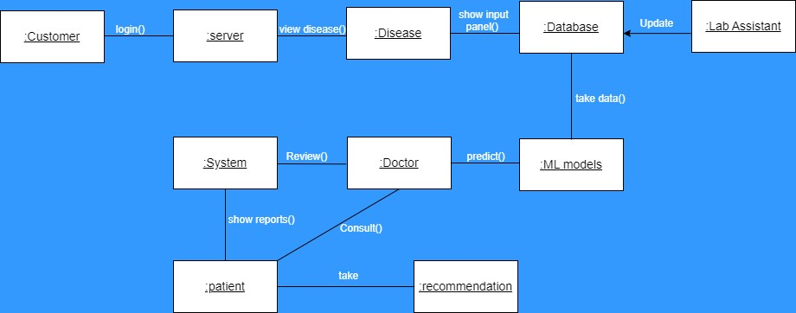

3.5. Class Diagram
A class diagram is a type of diagram in the Unified Modeling Language (UML) that represents the structure and relationships of the classes in a system. It provides a visual representation of the system's entities, their attributes, and how they interact with each other.

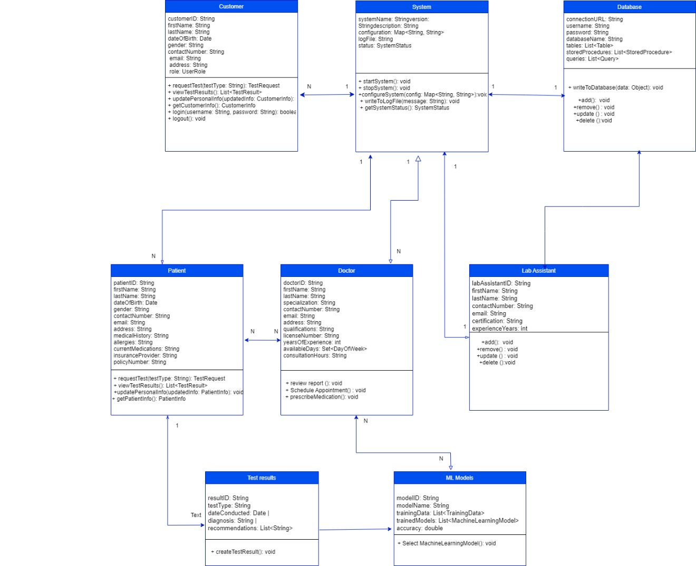

3.6. State chart diagram
The state chart diagram illustrates the different states and transitions within the AI-based medical laboratory system. Let's break down the workflow for each participant: the Patient, Doctor, and Lab Assistant.

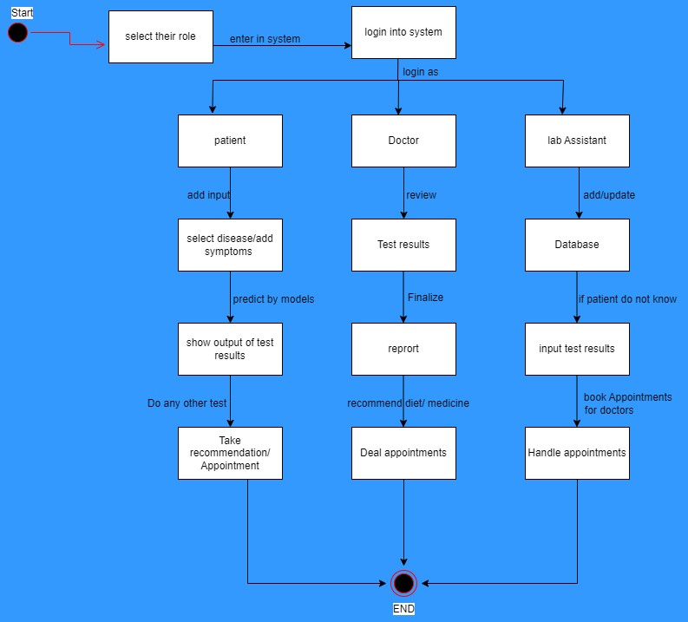

Chapter 4: User Interface Design

4.1. Introduction
AI MedLab page elements are visualized on paper before building them in the computer. The purpose of this chapter is to help all users for better understanding of AI MedLab system interaction. The following artifacts have been included in the User Interface Design chapter.

- Site maps
- Storyboards
- Navigational maps

4.2. Site Maps

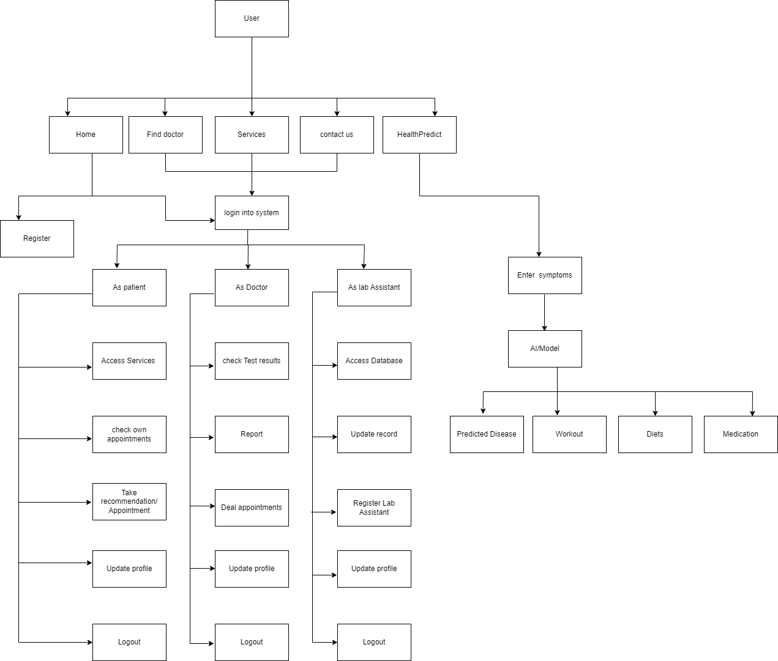

4.3. Story boards
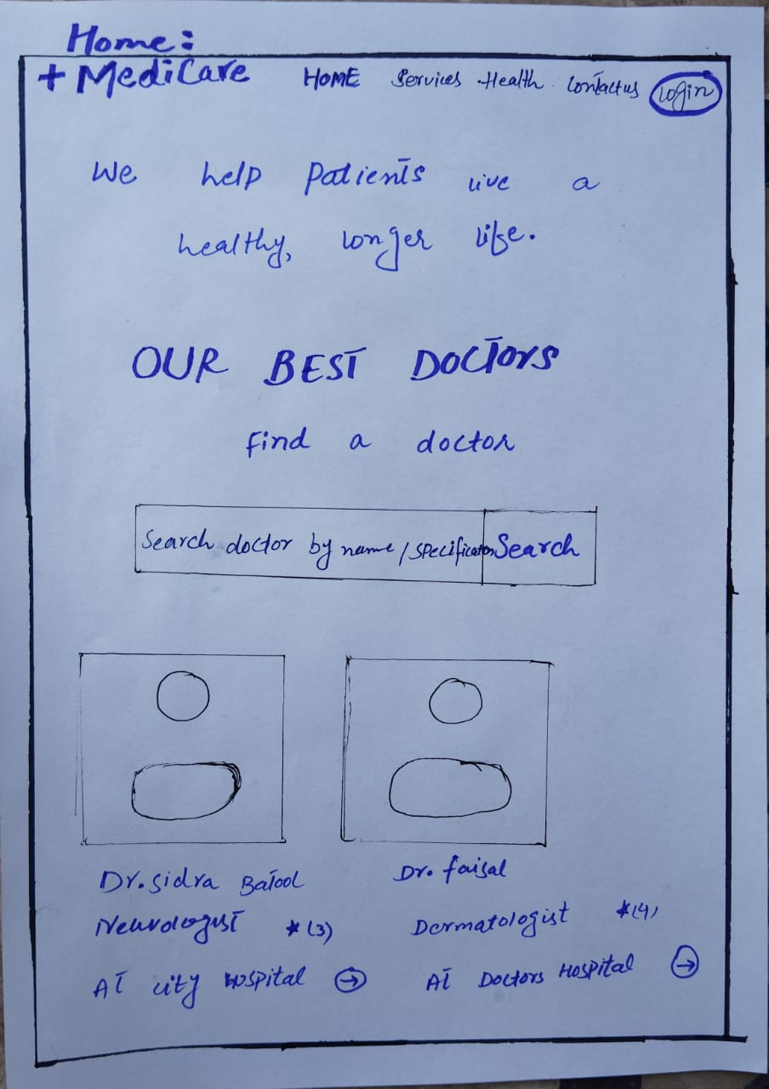 | 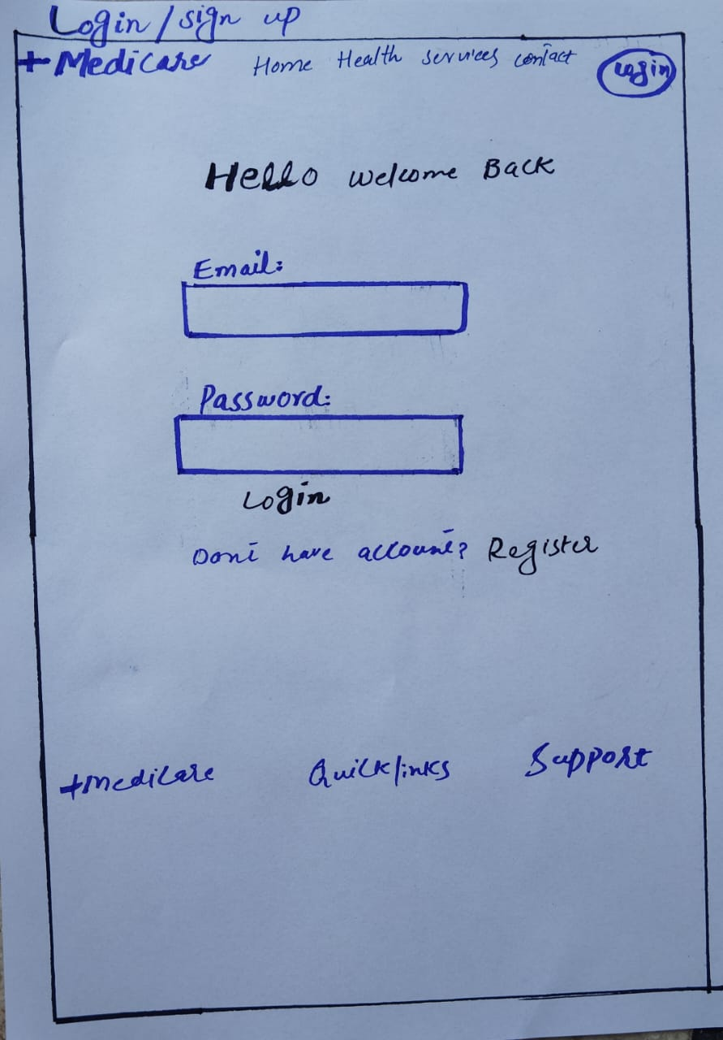

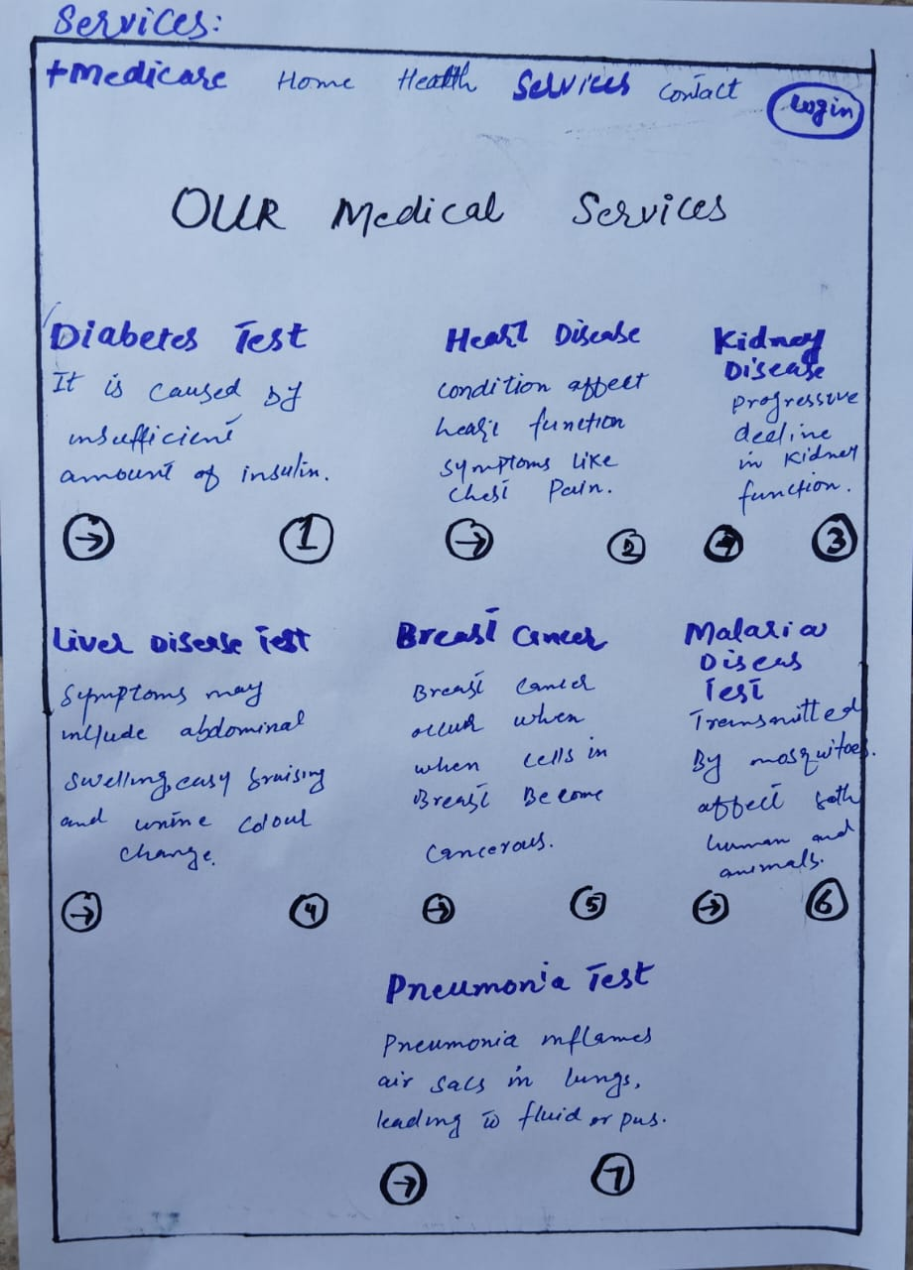 | 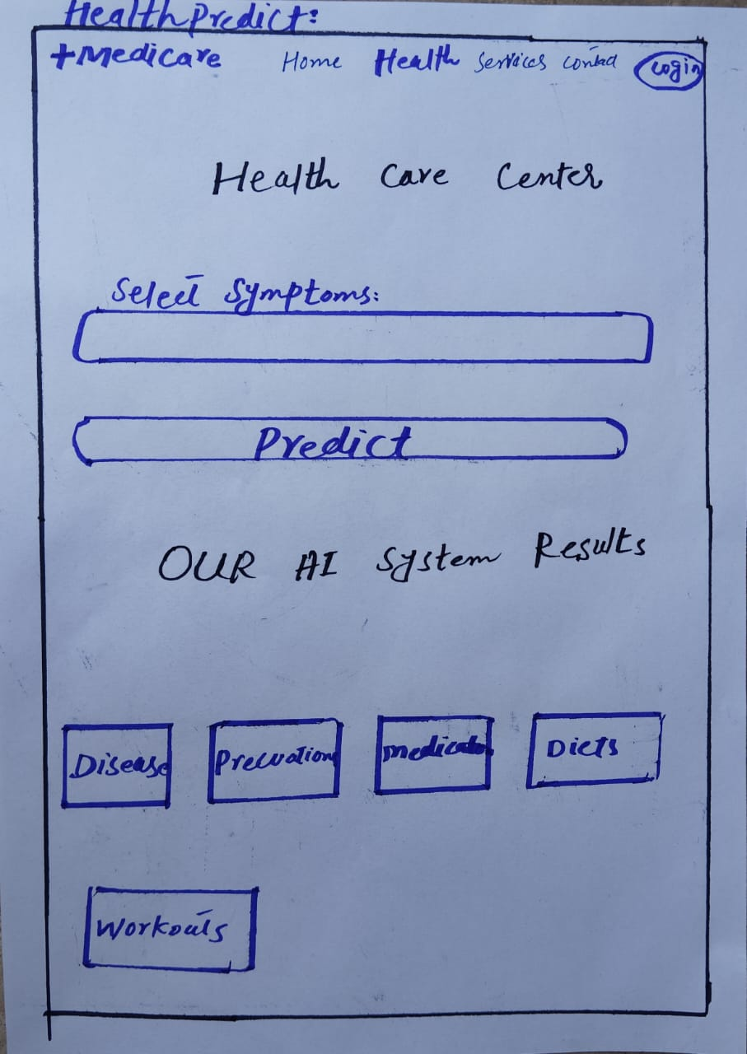

4.4. Navigational maps:

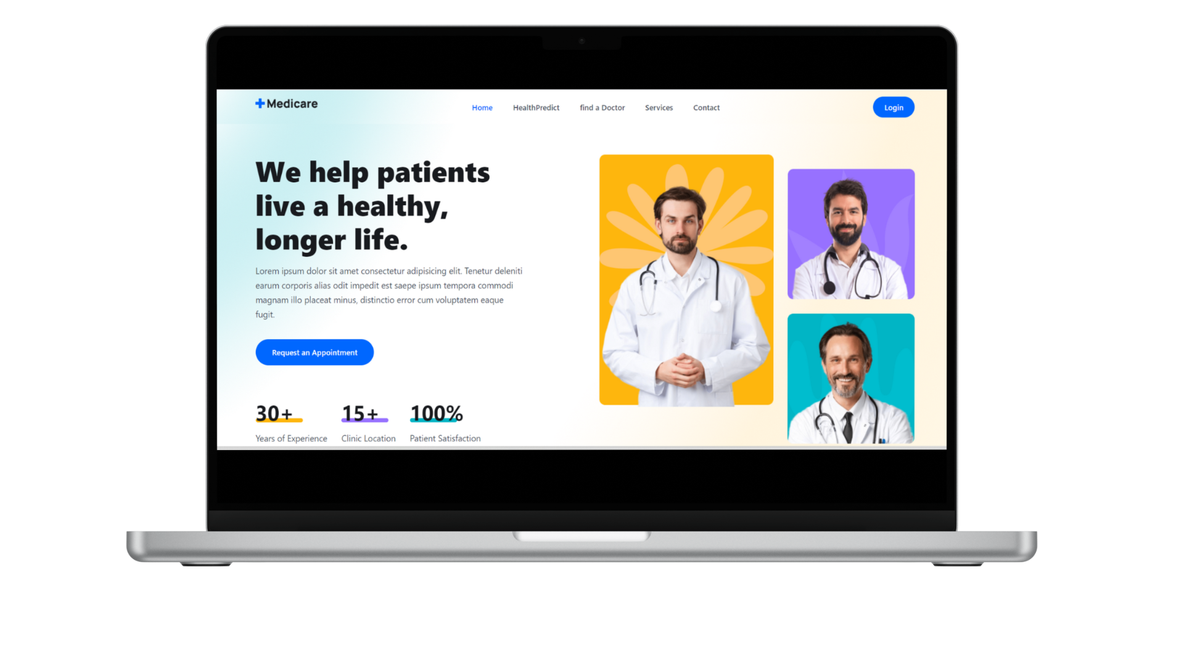 | 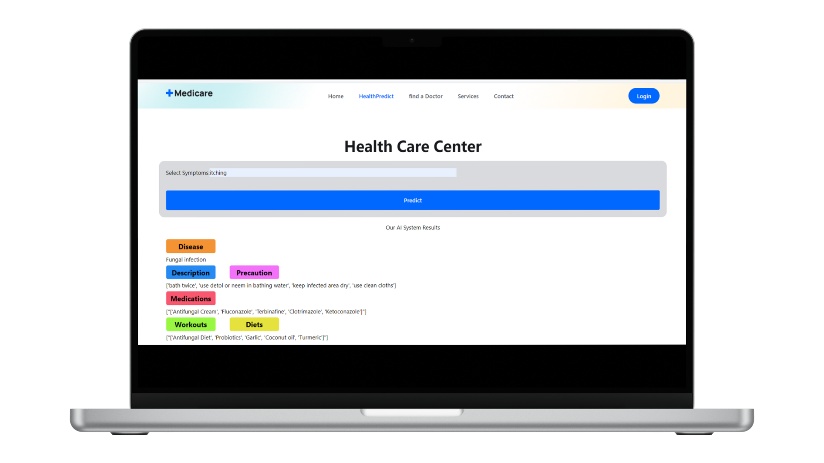
Fig.17: Home & HealthPredict tab (Navigational Maps)

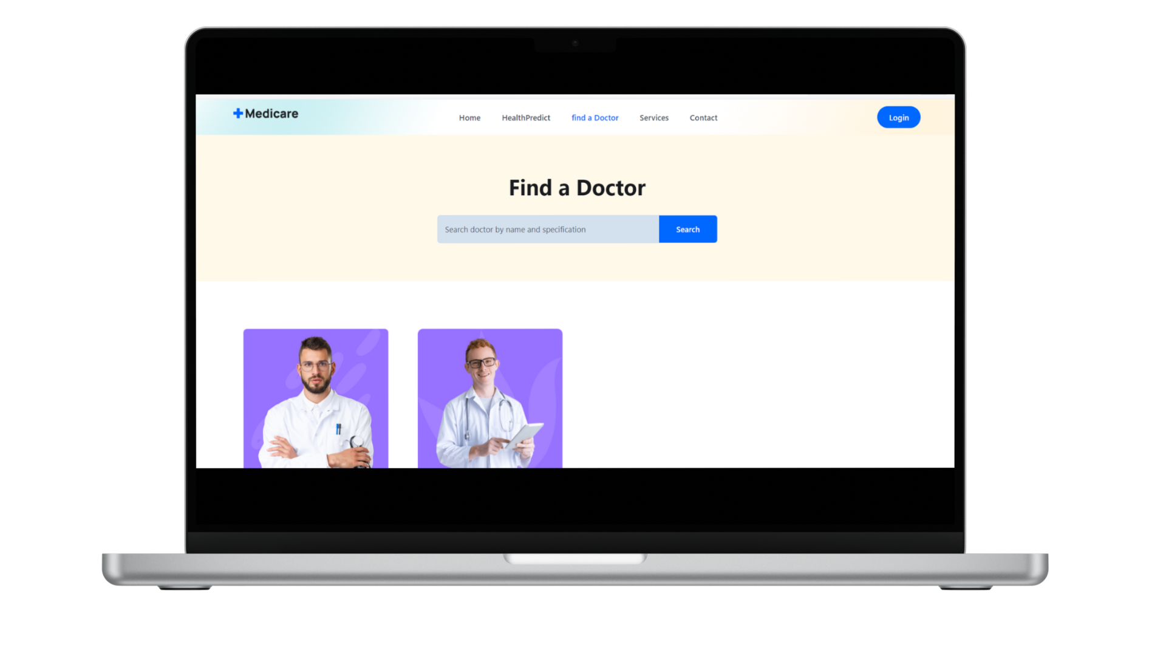 | 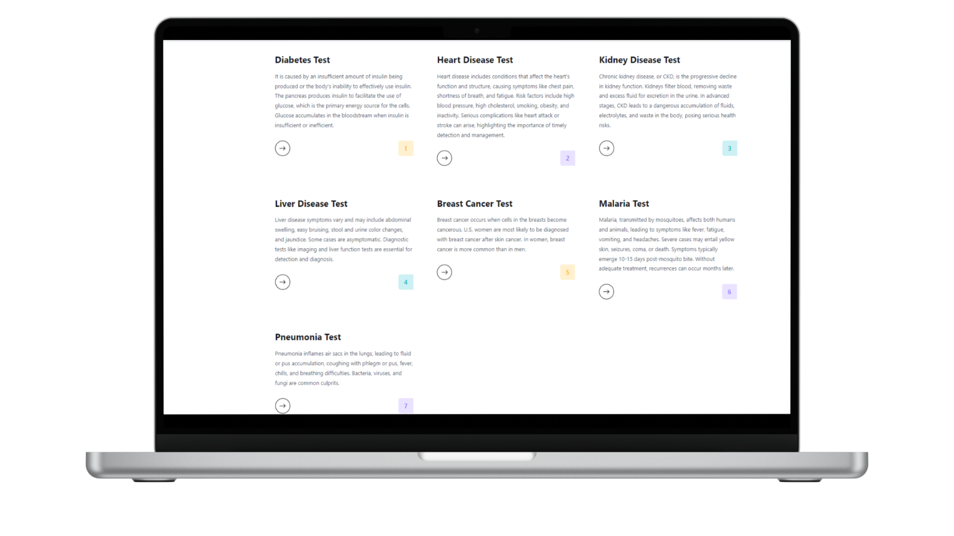

Fig.18: Find doctor & services tab (Navigational Maps)

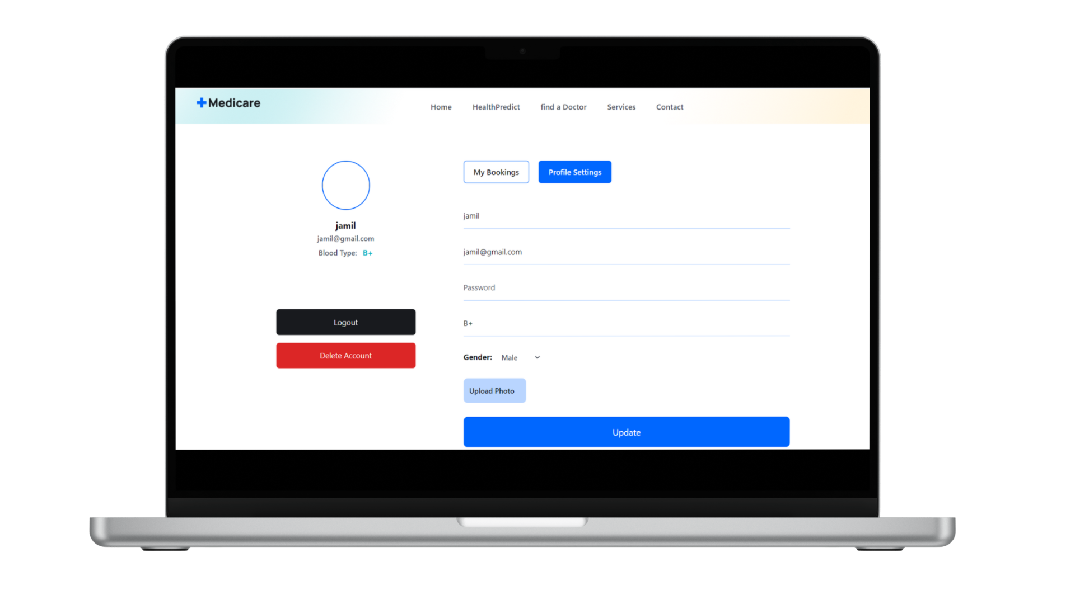 | 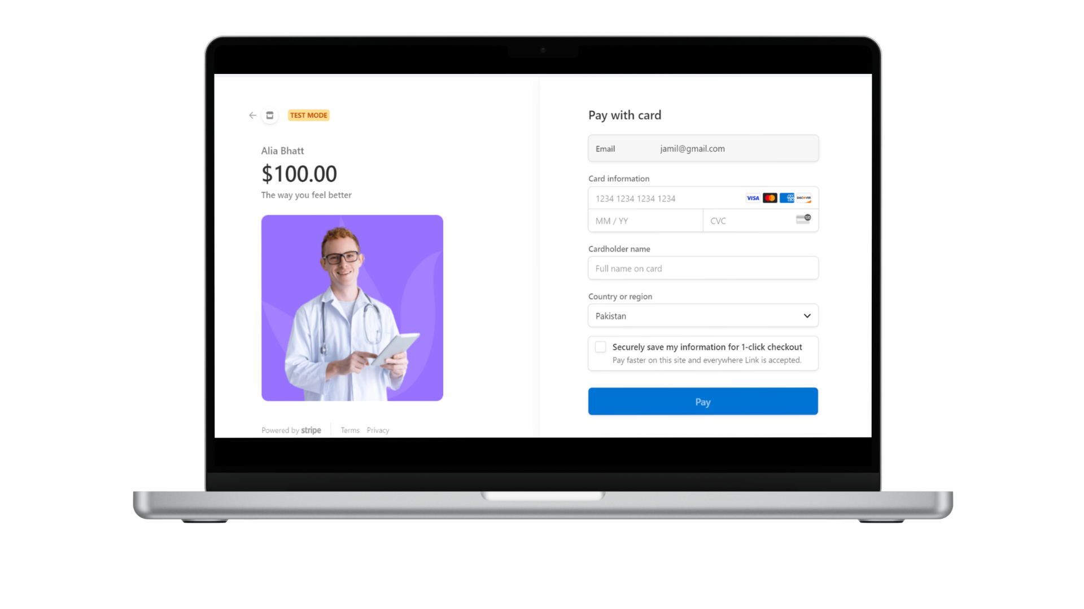

Fig.19: Profile Setting & Payment for online booking tab (Navigational Maps)

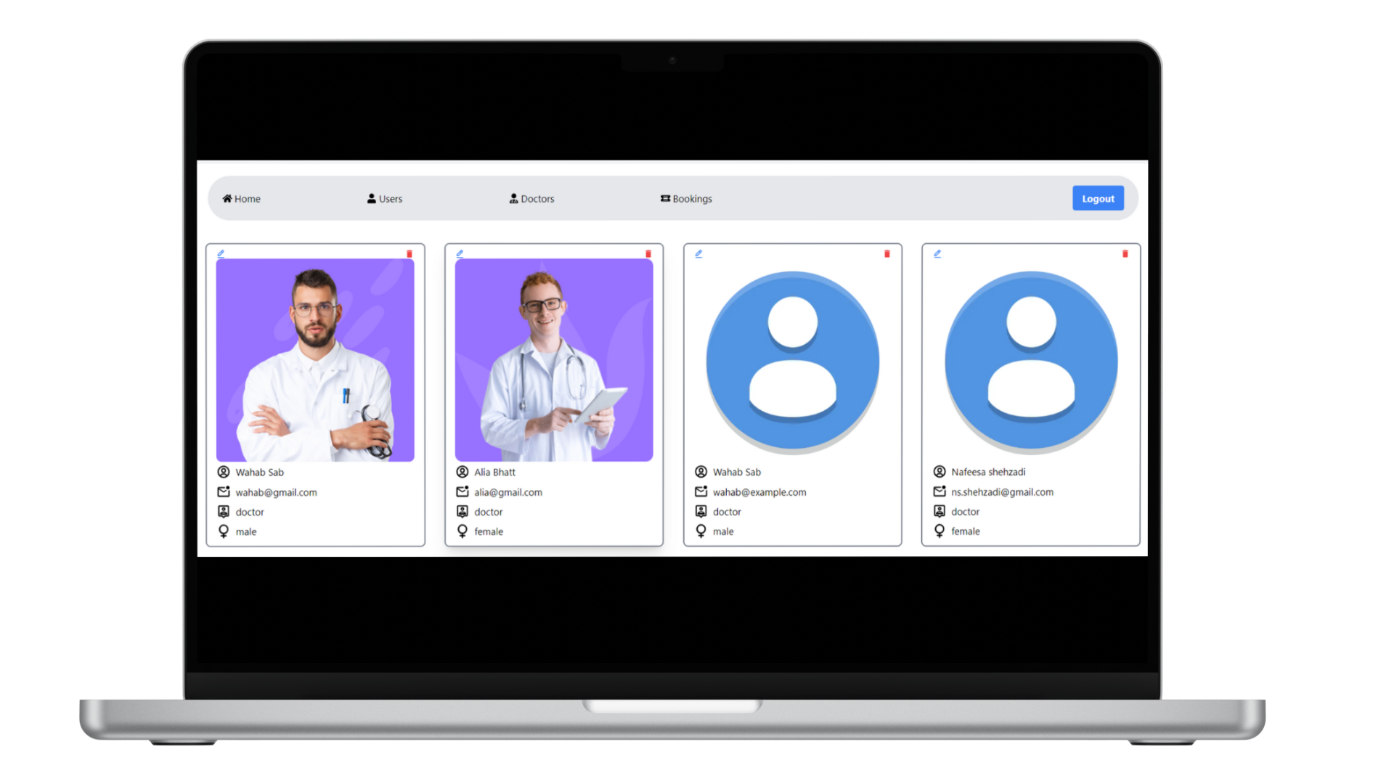

Fig.20: Admin/Lab Assistant profile tab (Navigational Maps)

Chapter 5: Software Testing

This chapter is centered on the IEEE standard for software testing. This particular standard outlines a series of fundamental test documents that pertain to the dynamic facets of software testing, which involve the actual execution of procedures and code. The standard provides clear definitions for the purpose, structure, and content of each of these core documents. Although the documents detailed within the standard primarily pertain to dynamic testing, several of them can also be relevant to other testing activities. For example, the test plan and test incident report could find utility in activities such as design and code reviews. This standard comprehensively addresses the documentation needs for both the initial testing during software development and the subsequent testing phases for software releases.
The subsequent list represents the standardized artifacts that are required to be included within this chapter.

- Test Plan
- Test Design Specification
- Test Case Specification
- Test Procedure Specification
- Test Item Transmittal Report
- Test Log
- Test Incident Report
- Test Summary Report

5.2. Test Plan

5.2.1. Purpose
The purpose of this plan is to test the real-time developed system. To prescribe the scope, approach, resources, and schedule of the testing activities. To identify the items being tested, the features to be tested, the testing tasks to be performed, the personnel responsible for each task, and the risks associated with this plan.

5.2.2. Outline
A test plan shall have the following structure:

- Test plan identifier.
- Introduction
- Test items
- Features to be tested.
- Features not to be tested.
- Approach
- Item pass/fail criteria.
- Suspension criteria and resumption requirements
- Test deliverables
- Testing tasks
- Environmental needs
- Responsibilities
- Staffing and training needs
- Schedule
- Risks and contingencies
- Approvals

5.2.2.1. Test Plan Identifier
Testing Level TP-001

5.2.2.2. Introduction
This test plan encompasses the comprehensive testing of the entire system, comprising modules and features collectively. The assessment of developed system features will be executed manually over a period of 6-9 days. Additionally, the testing process will take place within an environment that is populated with relevant test data.

5.2.2.3. Test Items

- User Registration Module
- Login and Authentication Module
- Doctor Search and Filtering Module
- Doctor Profile Module
- Appointment Booking Module
- Payment Gateway Module
- Payment Processing Module
- Appointment Management Module
- Patient Dashboard Module
- Doctor Dashboard Module
- Admin Dashboard Module
- Reporting and Analytics Module
- HealthPredict Module
- Patient Satisfaction Module
- Integration with Database and Backend APIs
- Compatibility Testing on Various Devices and Browsers
- Performance and Load Testing
- Cross-Browser and Cross-Device Testing
- Localization and Internationalization Testing
- Security Testing (for payment gateway and sensitive patient data)
- Accessibility Testing (for patients with disabilities)

5.2.2.3. Test items
Identify the test items including their version/revision level. Also specify characteristics of their transmittal media that impact hardware requirements or indicate the need for logical or physical transformations before testing can begin (e.g., programs must be transferred from tape to disk).
Supply references to the following test item documentation, if it exists:

a) Requirements specification
b) Design specification
c) Users guide
d) Operations guide
e) Installation guide
Reference any incident reports relating to the test items. Items that are to be specifically excluded from testing may be identified.

5.2.2.4. Features to be tested
- User Registration Module
- Login and Authentication Module
- Doctor Search and Filtering Module
- Doctor Profile Module
- Appointment Booking Module
- Payment Gateway Module
- Payment Processing Module
- Appointment Management Module
- Patient Dashboard Module
- Doctor Dashboard Module
- Admin Dashboard Module
- Reporting and Analytics Module
- HealthPredict Module
- Patient Satisfaction Module
- Integration with Database and Backend APIs
- Compatibility Testing on Various Devices and Browsers
- Performance and Load Testing
- Cross-Browser and Cross-Device Testing
- Localization and Internationalization Testing
- Security Testing (for payment gateway and sensitive patient data)
- Accessibility Testing (for patients with disabilities)

5.2.2.5. Features not to be tested
- Integration with External Third-Party Services: Testing the integration with external services beyond the application's control is not within the scope of this testing plan.
- Third-Party Hardware Compatibility: Testing compatibility with specific third-party hardware devices or peripherals is not included in this testing plan.
- Non-Functional Testing of Third-Party Services: Comprehensive performance, security, or compatibility testing of third-party services will not be performed as they fall under the responsibility of the respective service providers.
- Network Infrastructure Testing: Testing the underlying network infrastructure or its components, such as routers, switches, or firewalls, is not part of this testing plan.
- Hardware Reliability: The hardware reliability of devices used to access the application (such as mobile devices or computers) is not within the scope of this testing.
- Operating System Updates: Compatibility testing with new or upcoming operating system updates beyond the current scope is not covered in this plan.
- External Data Sources: Testing the accuracy or reliability of data obtained from external sources (such as weather APIs) is not included in this plan.
- Legal and Regulatory Compliance: Comprehensive testing for legal and regulatory compliance beyond data privacy and security is not part of this testing scope.
- Third-Party Software Integration: In-depth testing of third-party software integrated with the application (unless explicitly specified) is not covered in this plan.
- Business Logic of External Services: Testing the business logic of external services or APIs integrated with the application is not within the scope of this plan.

5.2.2.6. Approach
Individual members will conduct independent testing of the system services. Each member will manually perform the testing of specific features and designate the outcome as either Pass or Fail for each test case. The testers will document both the observed result and any pertinent information. Once all tests have been concluded, the test manager will review the test reports and provide appropriate feedback to the team.

5.2.2.7. Item pass/Fail Criteria
Criteria is set with the help of software requirements specification version 1.0. All testing tasks will be performed within the ratio of 100% in which the passing criteria is 75%. If the test results are less than 75%, it will be considered a failure.
- If the system doesn’t work properly, it will be considered as fail case.
- If expected page of application won't appear then it will be considered as fail case

5.2.2.8. Suspension criteria and resumption requirements
Testing work is performed by the individual to ensure that all the functional activities are working well in the system. If the system experiences any error during the middle of a test case, avoid the system to be shutdown. Instead of it, pause the testing procedure and perform updating to deal with error. So here are some criteria for which we will be paused the test work for the application e.g.
- If any test cases failed.
- If modules are not working well. Resumed the test procedure and checked the results. In case of failure, repeat the cycle until the required results are obtained.

5.2.2.9. Test Deliverables
After completion, the test result will be saved, and the test manager should circulate the complete test report to the team members and other concerned authorities.

5.2.2.10. Testing Tasks
The following activities must be completed:
- Test plan should be prepared.
- Functional specifications written and delivered to the testing team.
- Perform the tests.
- Prepare test summary report.
Task ID | Testing Task | Inter Task Dependencies
TT_001 | Application connectivity with internet | None
TT_002 | Login page | TT_001
TT_003 | Registration | TT_001
TT_004 | Authentication of username and password | TT_002, TT_003
TT_005 | Server availability | TT_001, TT_002, TT_003
TT_006 | Admin CRUD operations | TT_002, TT_003
TT_007 | Application UI testing | TT_005, TT_006
Table 11: Testing Tasks

5.2.2.11. Environmental Needs
The following outlines the fundamental hardware and software prerequisites for the environment required to run our application:
- Internet Access: A stable and reliable internet connection is essential to access and use the application's online features.
- Access to the Application: Users must have authorized access to the Shaudan B2B application, requiring valid login credentials.
- Modern Web Browser: A contemporary web browser that supports the latest web standards is required for optimal performance and functionality. Examples include Google Chrome, Mozilla Firefox, Microsoft Edge, and Safari.
- Compatibility with Various Operating Systems: The application should be compatible with a range of operating systems to ensure users can access it seamlessly regardless of their preferred platform. This includes Windows, macOS, Linux, and mobile operating systems like Android and iOS.
- Minimum Hardware Configuration: The application should be usable on a variety of hardware configurations, including both personal computers and servers. While exact specifications may vary, the application should run smoothly on standard modern hardware.

5.2.2.12. Responsibilities
Since each team member has been assigned specific tasks, they are individually responsible for testing their respective assignments. A designated team member has been chosen to compile all the test results, store them, and distribute them to the relevant parties.

5.2.2.13 Staffing and training needs
There is no need for external staff members to be involved in the testing of this project. All the necessary testing will be conducted by the team members themselves. Each member possesses domain knowledge relevant to their respective fields.

5.2.2.14. Schedule
The testing is expected to span from 6 to 9 days. Certain components and their associated features will require testing over a duration of 12 days.
Testing Task | Time
Unit Testing | 2 Days
Integration Testing | 2 Days
Use Case Testing | 3 Days
User Interface Testing | 1 Day
Table 12: Testing Schedule

5.2.2.15. Risks and Contingencies
The absence of a fundamental understanding of application testing by the tester could potentially lead to delays or inadequate testing execution.
- Effective time management is essential due to the extensive time needed for various types of testing across different levels, making it a critical aspect of this project.
- Insufficient internet connectivity, particularly slow speeds, might result in the application malfunctioning and hinder the acquisition or alteration of the necessary results.
- Failure to identify hidden risks could pose challenges during testing and later stages of the project.
- Inadequate data availability might impede thorough testing and accurate evaluation of the application's performance.

5.2.2.16 Approvals

Name | Title | Signature
Dr. Zafar Mahmood Khattak | Project Manager

5.3. Test design specification

5.3.1. Purpose
It records which design features of a test item are to test, and how successful the test of these features would be recognized. Test design specification ensures all functional and design requirements are implemented as specified in the documentation.

5.3.2. Outline
A test plan shall have the following structure:

- Test plan identifier
- Introduction
- Test items
- Features to be tested.
- Features not to be tested.
- Approach.
- Item pass/fail criteria.
- Suspension criteria and resumption requirements
- Test deliverables
- Testing tasks
- Environmental needs
- Responsibilities
- Staffing and training needs
- Schedule
- Risks and contingencies
- Approvals.

5.3.2.1 Test Plan Identifier
Test design specification identifier is TP_002

5.3.2.2. Introduction
A Test Plan Identifier includes:
- Project Authorization:
The Project was authorized and approved in the context of being created for the Final Year Project.
- Project Plan:
The Goal of this project was to be created for the FYP and also to be used in the future.
- Quality Assurance Plan:
By adhering to industry best practices, and continuously monitoring performance, we aim to deliver a robust and seamless application.
- Configuration Management Plan:
We have tried our level best to ensure that app's development and testing environments are consistent, controlled, and well-documented throughout the project lifecycle.
- Relevant Policies:
We have applied relevant policies, best practices, and standards to ensure that our project aligns with established industry norms and ethical considerations.
- Relevant Standards.
We have applied standards to ensure that our project follows established best practices and meets quality expectations.

5.3.2.3. Test Items
By identifying the test items, we ensure a systematic and thorough assessment of the app's features and capabilities.

- User Frontend
- Backend
- Rest API’s
- Model testing’s
- User Profile
- Database

5.3.2.4. Features to be tested
- As admin/doctor/patient, access the application.
- As admin, login to the admin panel with all admin privileges.
- As admin, view doctors and patients.
- As admin, update the doctors.
- As admin, delete the doctors.
- As admin, view the complaints.
- As admin, logout of admin panel
- As doctor, login to the application.
- As doctor, check patient reports.
- As doctor, recommend medicine
- As doctor, test any disease
- As doctor, logout of application
- As patient, login/register to the website
- As patient, can test any disease on test values.
- As patient, can test on base of symptoms
- As patient, select doctor
- As patient, book appointments
- As patient, update profile
- As patient, logout of application

5.3.2.5. Features not to be tested
- Third Party Services
- Backward Compatibility
- Load Testing for Extreme Conditions
- Connectivity Failures.

5.3.2.6. Approach

The test approach is divided into three main phases: Unit testing, integration testing and system testing. Unit testing focuses on the smallest unit of software design. In this test an individual unit or group of interrelated units are tested. The objective of integration testing is to take unit tested components and build a program structure component that are combined to produce output. Every time a new module is added leads that have been dictated by design. Integration testing is testing in which a group of to changes in program. This type of testing makes sure that the whole component works properly even after adding components to the complete program.

5.3.2.7. Item Passing/Fail Criteria
All core functionality of the application and its features should function as expected result. These criteria are set with the help of software requirements specification version 1.0. All testing tasks will be performed within the ratio of 100% in which the passing criteria is 75%. If the test results are less than 75%, it will be considered a failure.

5.3.2.8. Suspension criteria and resumption requirements
Suspension Criteria:
We suspended Testing activities under the following circumstances:
- If critical defects are identified that significantly impact the functionality or usability of the app.
- If external factors, such as network outages or system downtime, hinder the ability to conduct testing.
- If there are significant changes to the app's scope, architecture, or requirements.
Resumption Requirements:
We resumed testing activities under the following conditions:
- Once critical defects are addressed and verified as resolved, testing will be resumed.
- When essential testing resources become available, activities will be resumed.

5.3.2.9. Test deliverables
Identify the deliverable documents. The following documents should be included:
- Test plan
- Test design specifications
- Test case specifications
- Test procedure specifications
- Test item transmittal reports
- Test logs
- Test incident reports
- Test summary reports

5.3.2.10. Testing tasks
- Test Planning
- Requirements Analysis
- Test Case Design
- Test Data Preparation
- Test Environment Setup
- Test Execution

5.3.2.11. Environmental Needs
- A Windows or Mac Device with minimum 8GB Ram.
- Python
- VS Code
- Node JS
- Npm
- Internet Connection
- Web Browser (Chrome, Edge etc.)

5.3.2.12. Responsibilities
Each member is responsible for requirements, designing, preparing documentation, developing and executing the system properly.

5.3.2.13. Staffing and Training Needs
Each member was able to provide adequate staffing and fulfil training needs.

5.3.2.14. Schedule
Additional test milestones will take more than 15 days.

5.3.2.15. Risks and contingencies
Risks:
- The scope of the app's functionalities might expand during testing.
- Insufficient staffing or lack of testing resources.
- Reliance on external APIs might introduce technical complexities.
- Incomplete or unclear requirements could lead to misunderstandings.
Contingencies:
- Maintain clear communication with supervisors to manage scope changes.
- Manage resources efficiently and consider training team members to solve insufficient staffing.
- Identify backup solutions to solve technical dependencies.
- Engage with supervisors and project team members to clarify requirements.

5.4. Test Case Specification

5.4.1. Purpose
The purpose of test case specification is to provide clear guidance to the end user regarding the utilization of the system and its associated application. It identifies necessary inputs and anticipates the anticipated outcomes. This document offers comprehensive, step-by-step procedures for executing the tests effectively.

5.4.2. Outline
A test case specification shall have the following structure:
- A test case specification shall have the following structure:
- Test case specification identifier
- Test items
- Input specifications
- Output specifications
- Environmental needs
- Special procedural requirements

5.4.2.1. Test Case Specification Identifier
Identifier for this module is TPS 001

5.4.2.2 Test Items
Identify and briefly describe the items and features to be exercised by this test case.
For each item, consider supplying references to the following test item documentation:
- Requirements specification
- Design specification
- Users guide
- Operations guide

5.4.2.3. Input Specifications
Specify each input required to execute the test case. Some of the inputs will be specified by value (with tolerances where appropriate), while others, such as constant tables or transaction files, will be specified by name. Identify all appropriate databases, files, terminal messages, memory resident areas, and values passed by the operating system.
Specify all required relationships between inputs (e.g., timing).

5.4.2.4. Output Specifications
Specify all of the outputs and features (e.g., response time) required of the test items. Provide the exact value (with tolerances where appropriate) for each required output or feature.

5.4.2.5. Environmental Needs

5.4.2.5.1. Hardware
Specify the characteristics and configurations of the hardware required to execute this test case (e.g., 132 characters´ 24-line CRT).
5.4.2.5.2. Software
Specify the system and application software required to execute this test case. This may include system software such as operating systems, compilers, simulators, and test tools. In addition, the test item may interact with application software.
5.4.2.5.3. Other
Specify any other requirements such as unique facility needs or specially trained personnel.

5.4.2.6. Special Procedural Requirements
Describe any special constraints on the test procedures that execute this test case. These constraints may involve special set up, operator intervention, output determination procedures, and special wrap up.

5.4.2.7. Inter Case Dependencies
List the identifiers of test cases that must be executed prior to this test case. Summarize the nature of the dependencies.

5.5. Test procedure specification

5.5.1. Purpose
It will specify how the tester will physically run the test, the physical set-up required, and the procedure steps that need to be followed. It contains a sequence of actions required for the execution of a test.

5.5.2 Outline
A test procedure specification shall have the following structure:
- Test procedure specification identifier
- Purpose
- Special requirements
- Procedure steps

5.5.2.1. Test Procedure Specification identifier
Identifier for this module is TPS _001

5.5.2.2. Purpose
This module describes the testing procedure for the entire testing of a system. All the tests will be performed manually within the specified time constraint. It specifies how to execute the testing procedures of a monitoring system. This procedure executes the following test cases: TC_OOI, TC_002, TC_003, TC_004, TC_005, TC_006 the purpose of the Test Procedure Specification is to specify the steps for executing a set of test cases.

5.5.2.3. Special Requirements
Application is being tested manually no special requirement is needed for testing of this web application.

5.5.2.4. Procedure Steps

5.5.2.4.1. Set Up
1. Website should be working properly.
2. Keep the web app connected with internet.
3. Compile the data correctly.
4. Enter correct id and start testing.

5.5.2.4.2. Start
We need to keep applications connected with internet that is available for registers doctor, patient and lab Assistant.

5.5.2.4.3. Proceed
Run test cases in dependency order: Test cases with no dependencies or solved dependencies first.

5.5.2.4.4. Shut down
Put the server offline and shut down the web application.

5.5.2.4.5. Restart
Turn on the internet and again login the web application.

5.5.2.4.6. Stop
Log out of the site.

5.5.2.4.7. Wrap up!
To wrap up we shall stop the Node JS server, which will shut down the database and close everything.

5.5.2.4.8. Contingencies
We need to submit bug reports. The test manager will use that information to create incident reports.

5.6. Test Item Transmittal Report

5.6.1. Purpose
The purpose of Test Items Transmittal Report is to identify the test items being transmitted for testing. This identifies a software item being given to the software group for testing.

5.6.2. Outline
A test item transmittal report shall have the following structure:
- Transmittal report identifier
- Transmitted items
- Location
- Status
- Approvals

5.6.2.1. Transmittal Report Identifier
The transmittal report identifier is TR_001

5.6.2.2. Transmitted Items
The site is transmitted to the targeted person for use. It is the essential part of this project to perform reasonable testing. All group members were responsible for its transmittal and its use.

5.6.2.3. Location
The developed system is online application model. It is for patients and doctors. Users can use some modules only after registration.

5.6.2.4. Status
- The status of all test items being transmitted is passed.
- All the test items are in working state and functioning properly.
- The actual result is the same as expected in the test plan.
- The required system is achieved.

5.6.2.5. Approvals
Name | Title | Signature
Dr.Zafar Mehmood Khattak | Project Manager

5.7. Test log

5.7.1. Purpose
The purpose of the test log is to provide a sequential record of relevant details about the execution of tests. This log represents the results of testing of the whole system.

5.7.2. Outline
A test log shall have the following structure:
- Test log identifier.
- Description.
- Activity and event entries.

5.7.2.1. Test Log Identifier

The test log identifier is TL_001

5.7.2.2. Description

All the items are tested. The testing of Website and Mobile view is conducted manually there occurred few errors but that were fixed, and later website and Mobile view was properly working.

5.7.2.3. Activity and Event Entries
Activity | Authorization | Date
Server availability | Nafeesa Shehzadi | 15-04-2024
Application registration and login | Abdul Wahab | 17-04-2024
Search Nearby with location | Abdul Wahab | 18-04-2024
Application UI testing | Abdul Wahab | 19-04-2024
Model testing | Abdul Wahab | 23-04-2024
Admin crud operations | Nafeesa, Abdul Wahab | 24-04-2024
Authentication of username and password | Nafeesa Shehzadi | 10-05-2024
Table 13: Activity and Event Entries

5.7.2.3.1. Execution Description

All the tests are performed by the team members as listed above. This testing will be completed within 4 weeks. The whole testing process was supervised by Dr.Zafar Mehmood Khattak, the project supervisor.

5.7.2.3.2. Procedure Results
Test Case ID | Test Case | Result | Status
TT 001 | Application connectivity with internet | Application is connected | Pass
TT 002 | Application login | User successfully login | Pass
`TT 003 | Application UI | The UI is user friendly | Pass
TT 004 | Model Testing | All models giving expected results | Pass
TT 005 | Admin crud operations | Admin can perform crud | Pass
TT 006 | Registration | User can be registered successfully | Pass

5.7.2.3.3. Environmental Information

JRE and Tomcat server are required to run the service of the system. Additionally, Internet and Web browser are compulsory to run the system.

5.7.2.3.4. Anomalous Events

Some anomalous events occurred about server availability but later it was recovered with some modifications in earlier tests. A success status was returned at end of completion of testing.

5.7.2.3.5. Incident Report Identifiers

Test incident report identifier is TIR-001

5.8. Test Incident Report

5.8.1. Purpose
Before performing the actual test, all the test procedures have been designed and it is assured that all the features to be tested well but unexpectedly some sudden incidents happen due to which testing process needs to be stop for the time being taken to recover from such incidents.

5.8.2. Outline
A test incident report shall have the following structure:
- Test incident report identifier
- Summary
- Incident description
- Impact

5.8.2.1. Test Incident Report Identifier
Test incident report identifier is TIR-001

5.8.2.2. Summary
Summarize the incident. Identify the test items involved.
Test Item: Registration
ID: TIR-001

5.8.2.3. Incident Description
This description should include the following items:

- Inputs
- Expected results.
- Actual results
- Anomalies
- Date and time.
- Procedure step.
- Environment.
- Attempts to repeat.
- Testers.
- Observers.

5.8.2.4. Impact

This is the important function provided by Application After the test incident description it was a major impact on test case.

5.9. Test Summary Report

5.9.1. Purpose
Test summary report is a formal document that summarizes the results of all testing that can be performed on features of application. This document explains the various activities performed as part of testing for website and website connectivity.

5.9.2. Outline
A test summary report shall have the following structure:
- Test summary report identifier
- Summary
- Variances
- Comprehensive assessment
- Summary of results
- Evaluation
- Summary of activities
- Approvals

5.9.2.1. Test Summary Report Identifier
Test summary report identifier is TSR _001

5.9.2.2. Summary
All the functionalities of the application are tested as per the test plan. Each test is performed according to its specified plan and test log against each test is prepared accordingly. All components were tested, there were some bugs as expected but later they were fixed. And now, each component is working properly.

5.9.2.3. Variances
Some of the errors come from testing of application from underlying environment. First, server connectivity is not fixed and does no work properly, it takes too much time to connectivity.

5.9.2.4. Comprehensiveness Assessment
The testing process is done exactly as described in the test plan. All the features described in the test plan are tested.

5.9.2.5. Summary of Results
Test Case | Date
Application connectivity with internet | 15-04-2024
Application login | 17-04-2024
Application UI | 18-04-2024
Model Testing | 24-04-2024
Admin crud operations | 5-05-2024
Registration | 10-05-2024
Summary of Test Results

5.9.2.6. Evaluation
The testing process was simple and enough for this phase. Active and comprehensive evaluation of problems found at last phase led us to the conclusion that user able place order easily.

5.9.2.7. Approvals
Name | Title | Signature
Dr.Zafar Mehmood Khattak | Project Manager

Chapter 6: Results
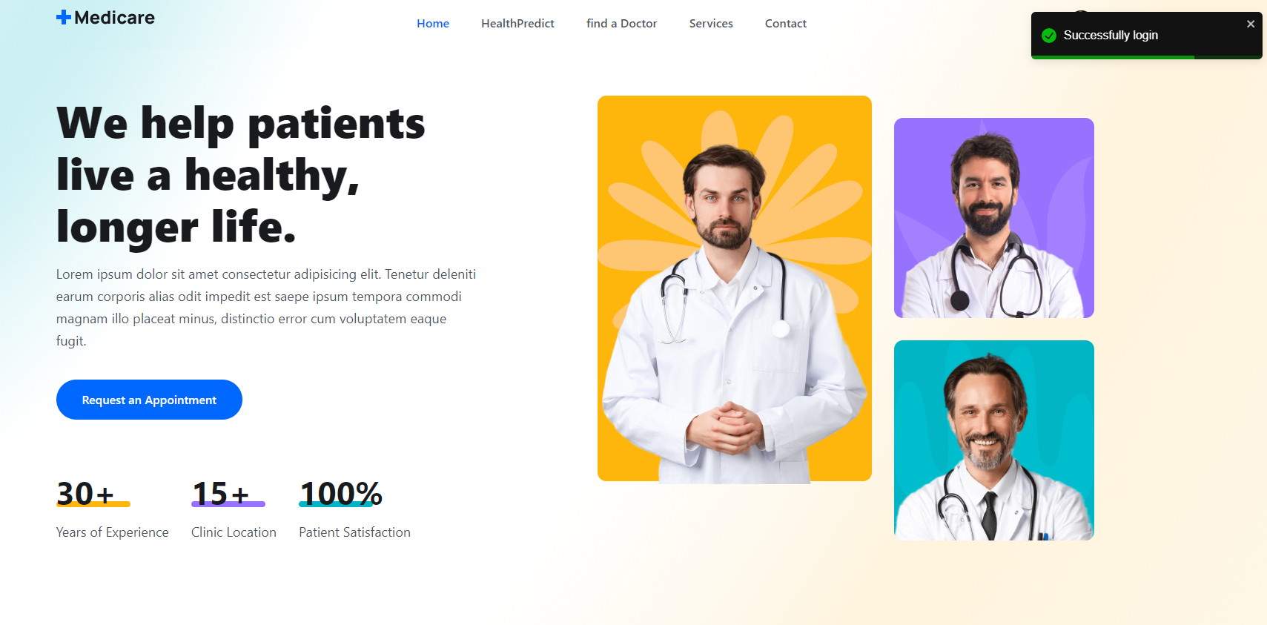 | 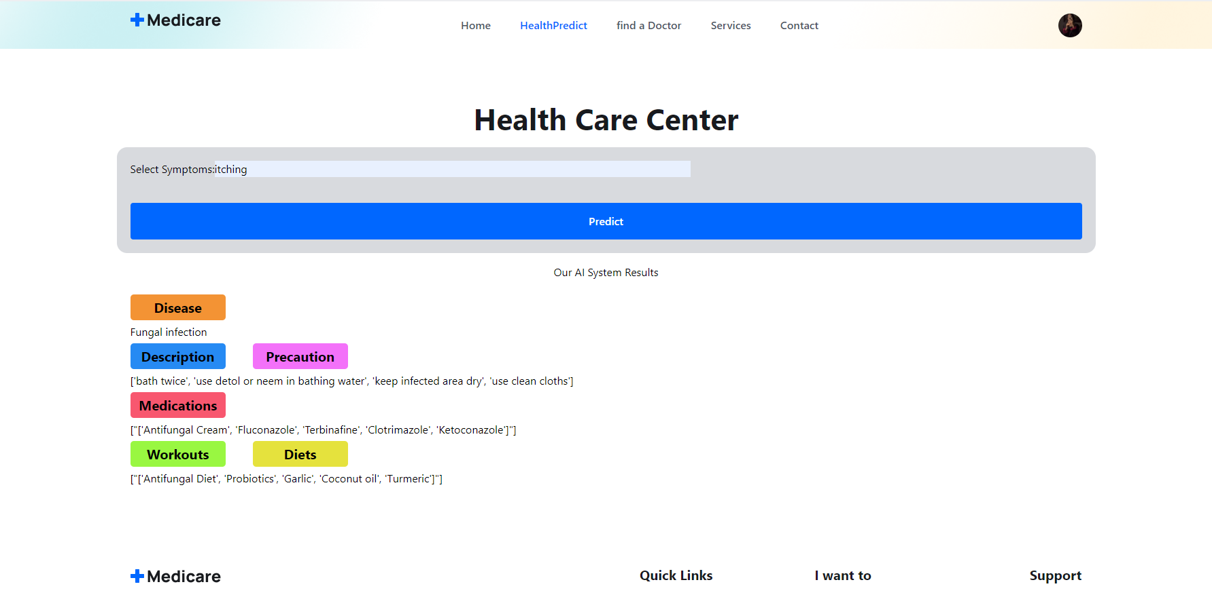

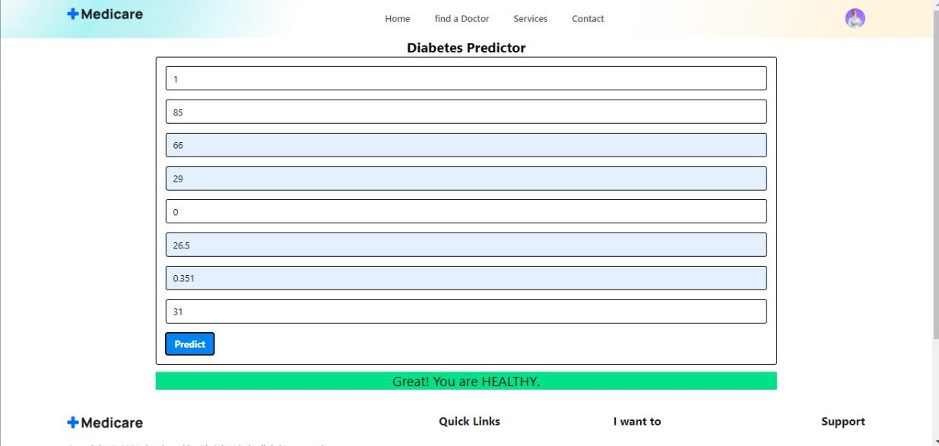 | 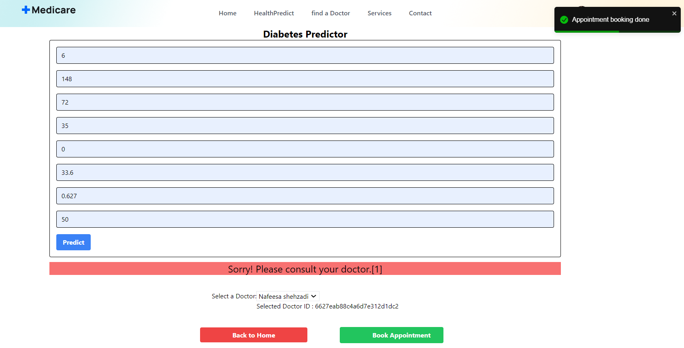

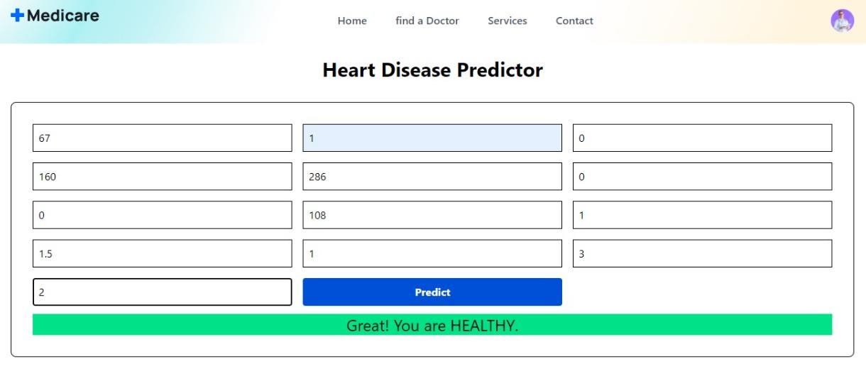 | 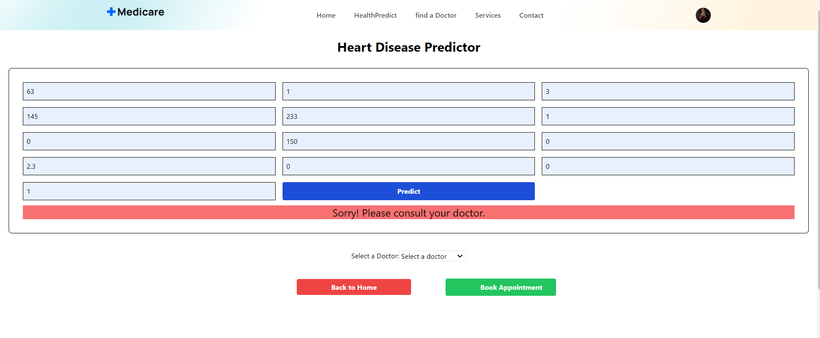

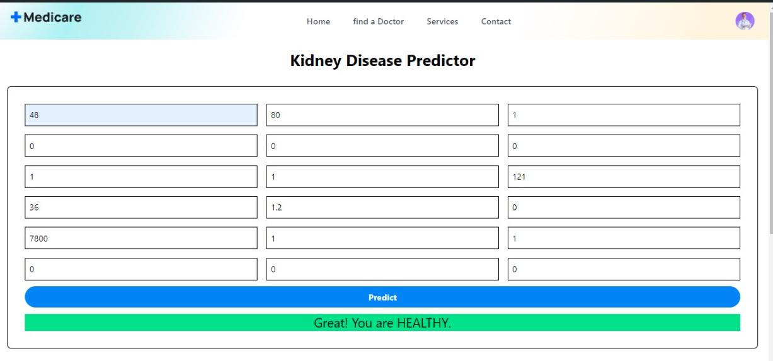 | 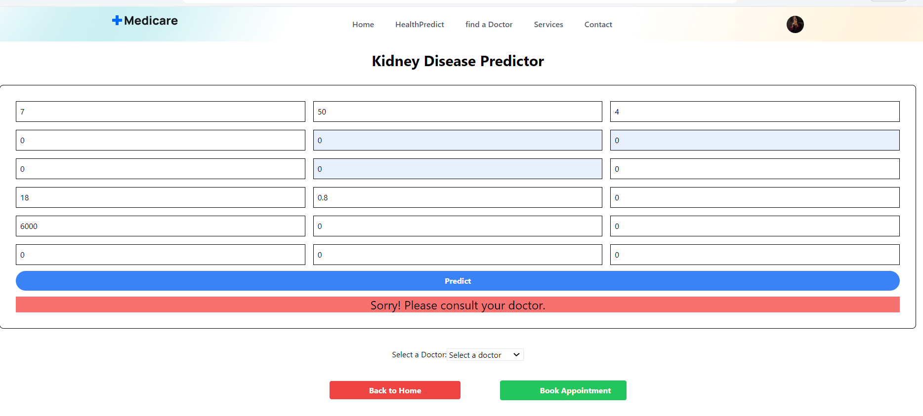

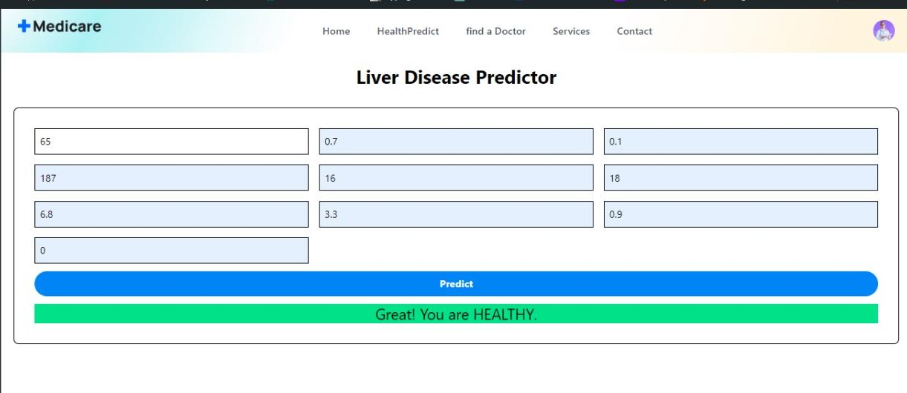 | 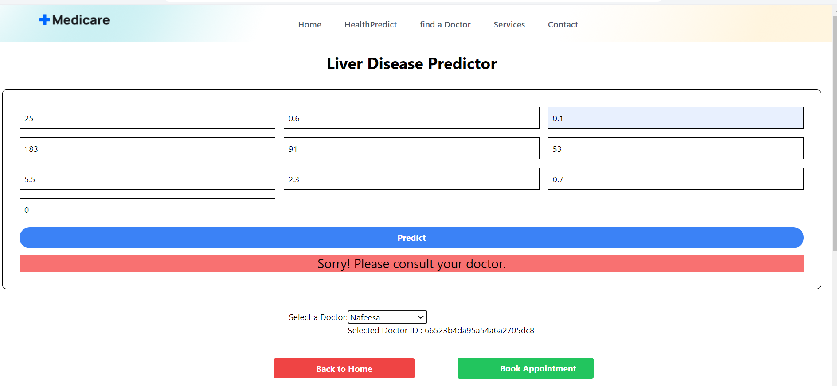

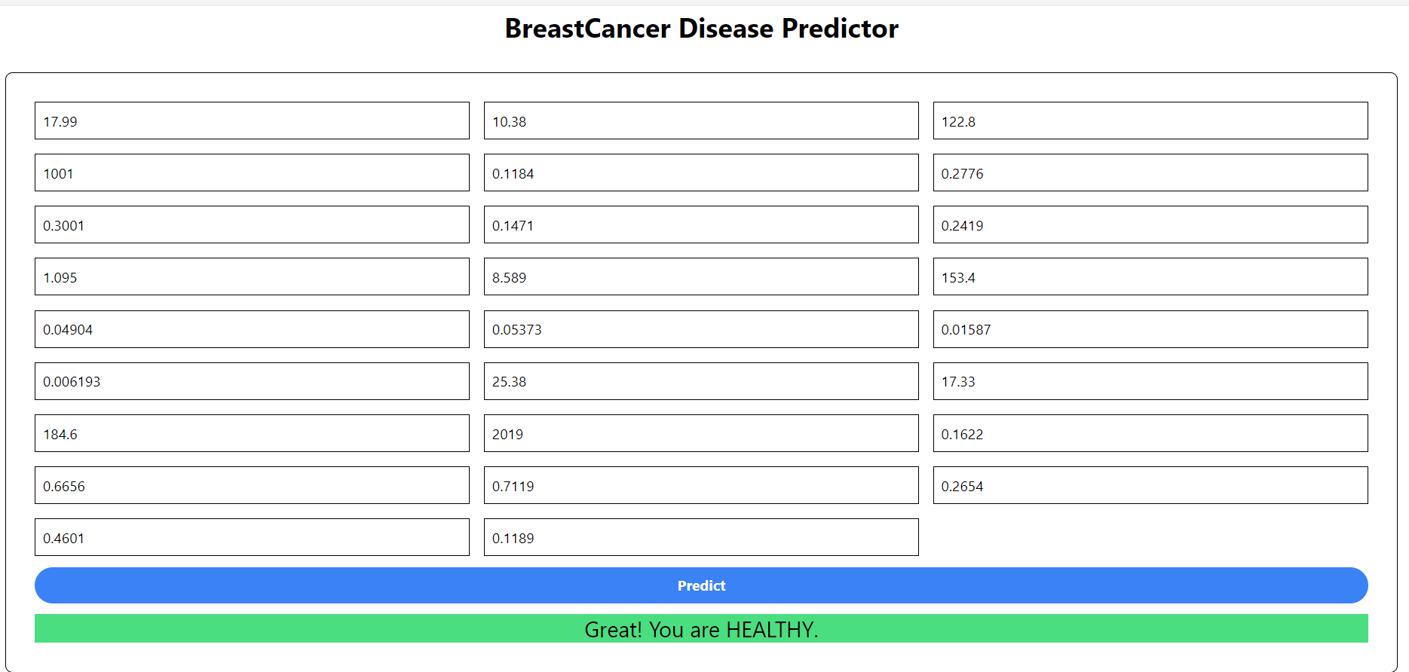 | 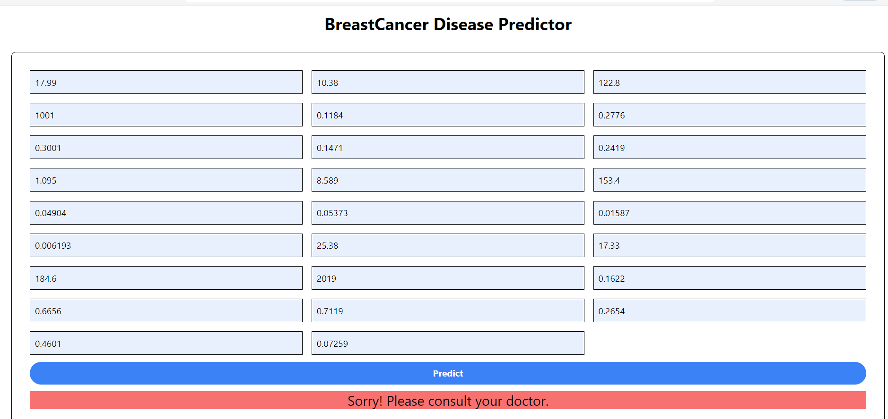

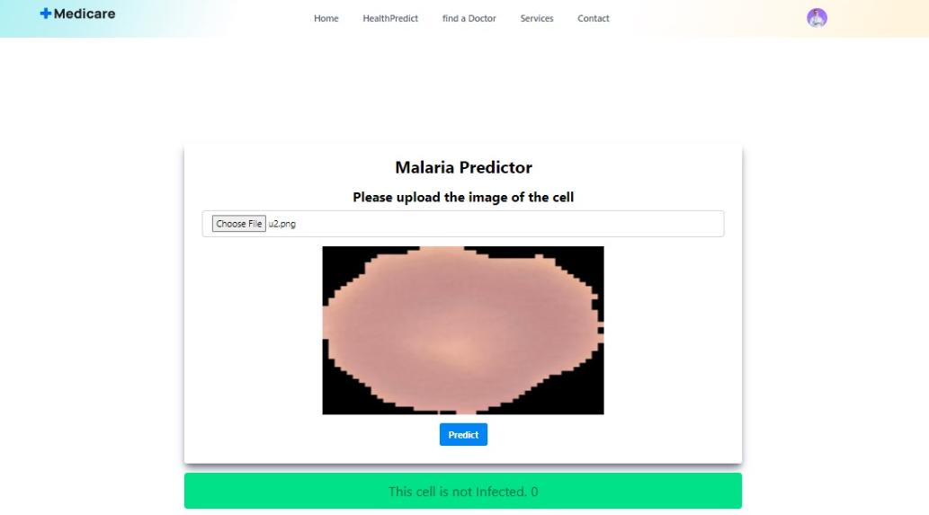 | 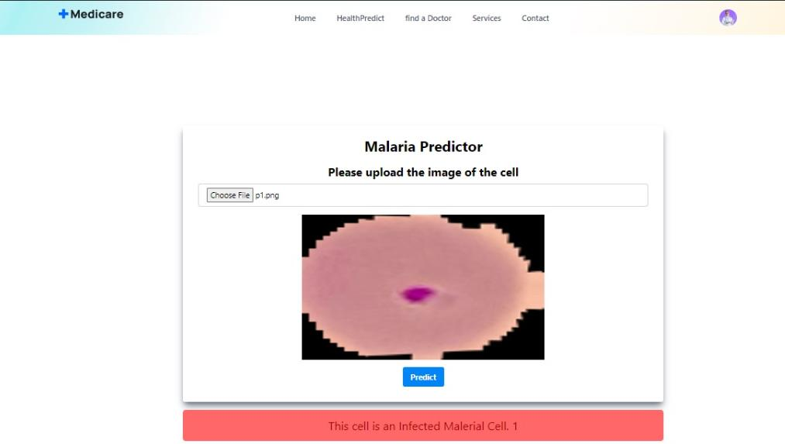

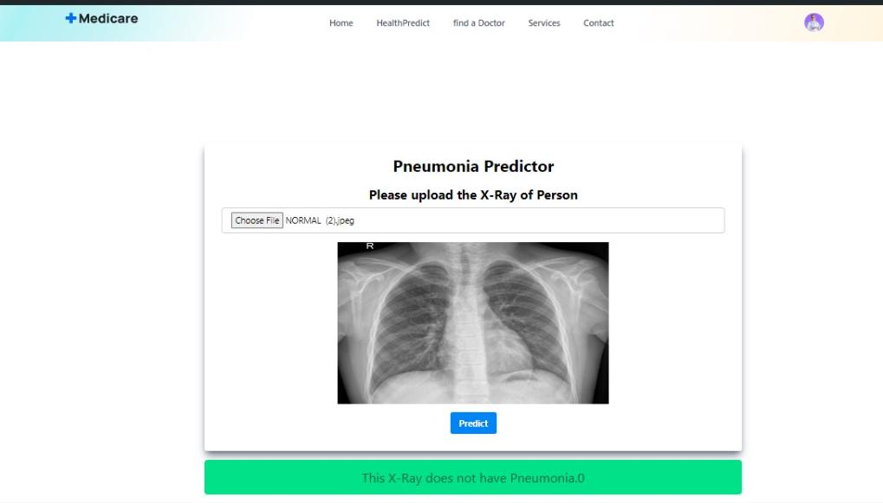 | 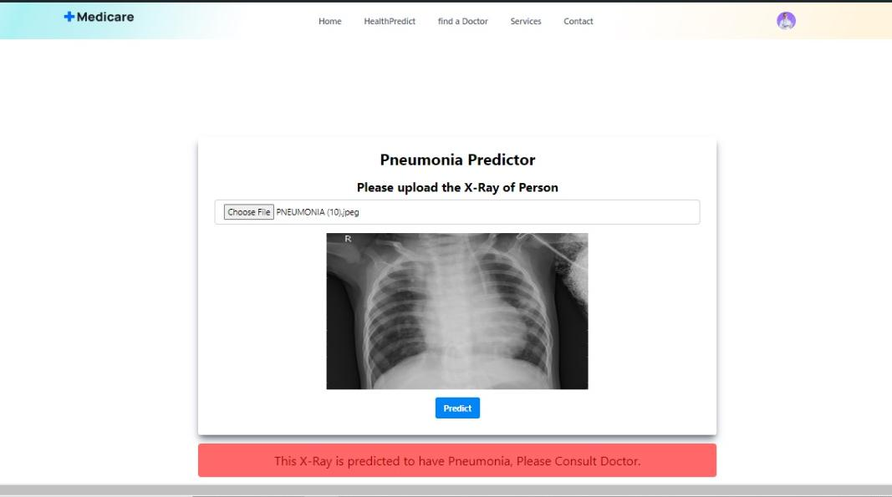

Chapter 7: User Manual

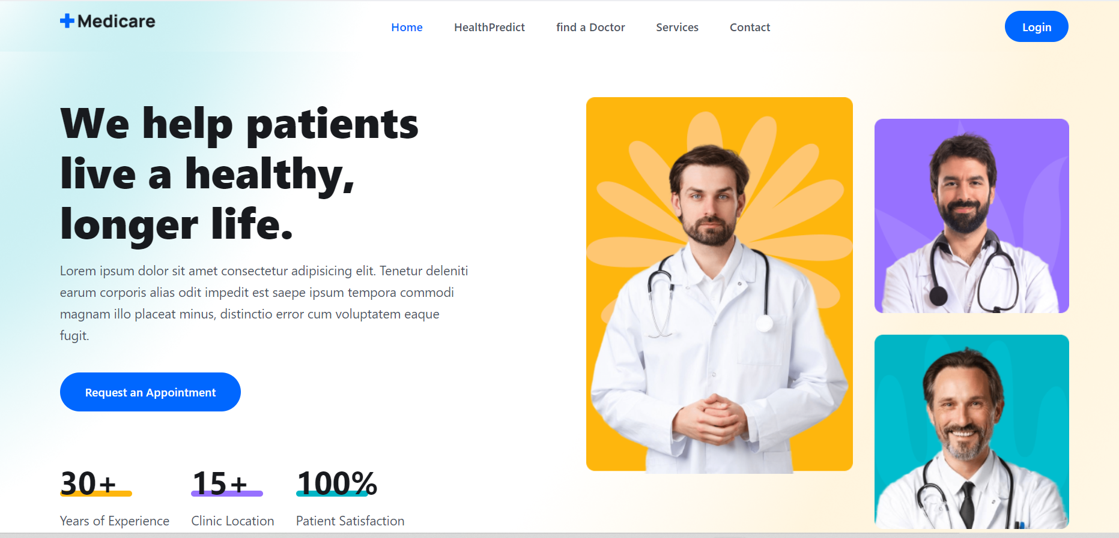

Figure 01: Dashboard of Website (Home page)

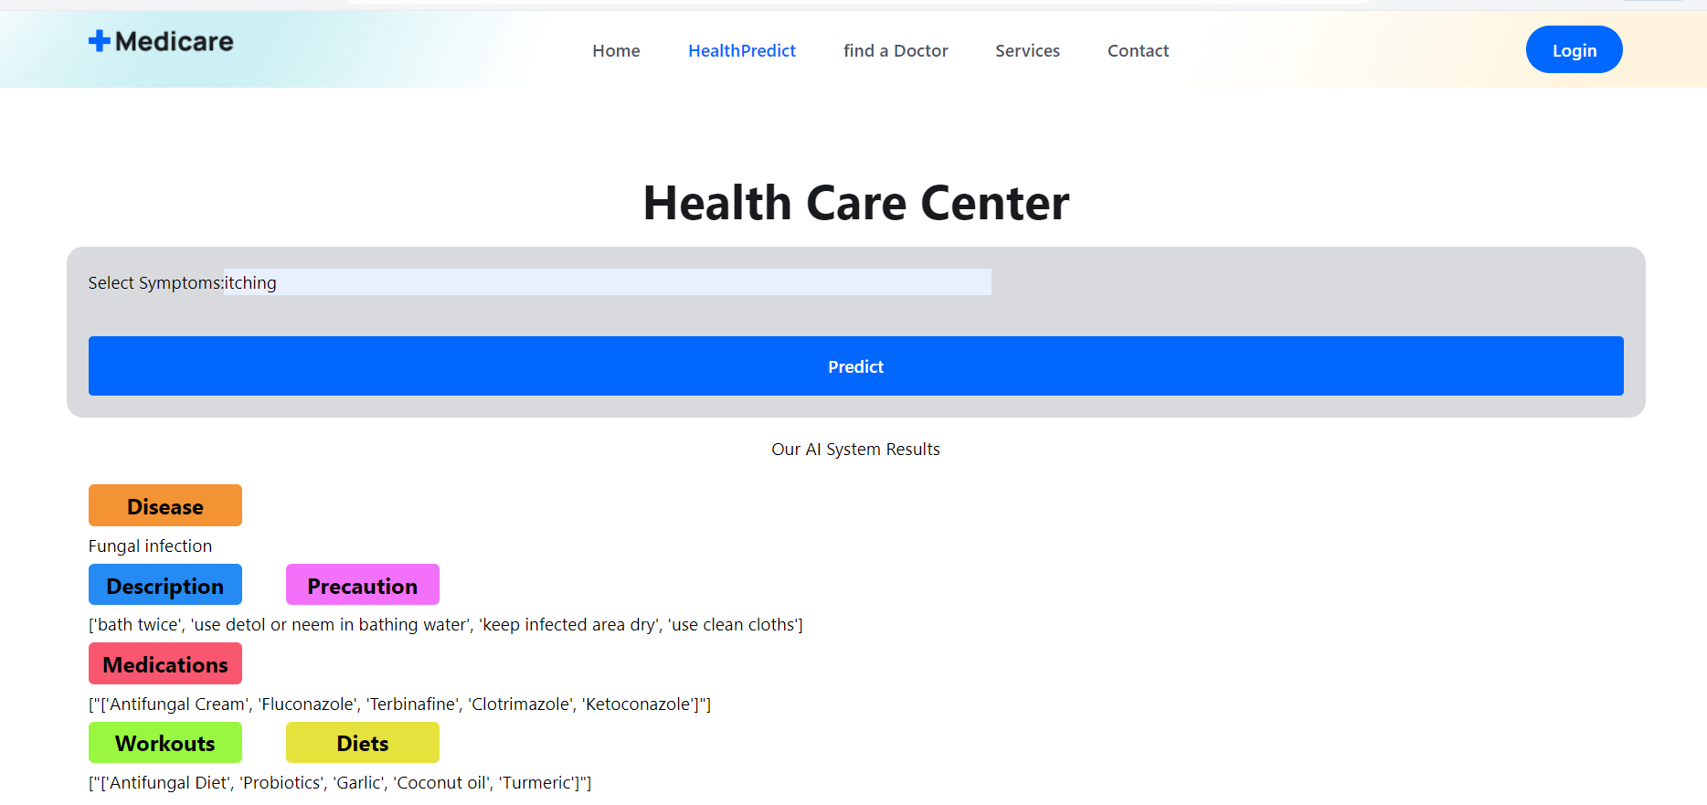

Figure 02: HealthPredict UI

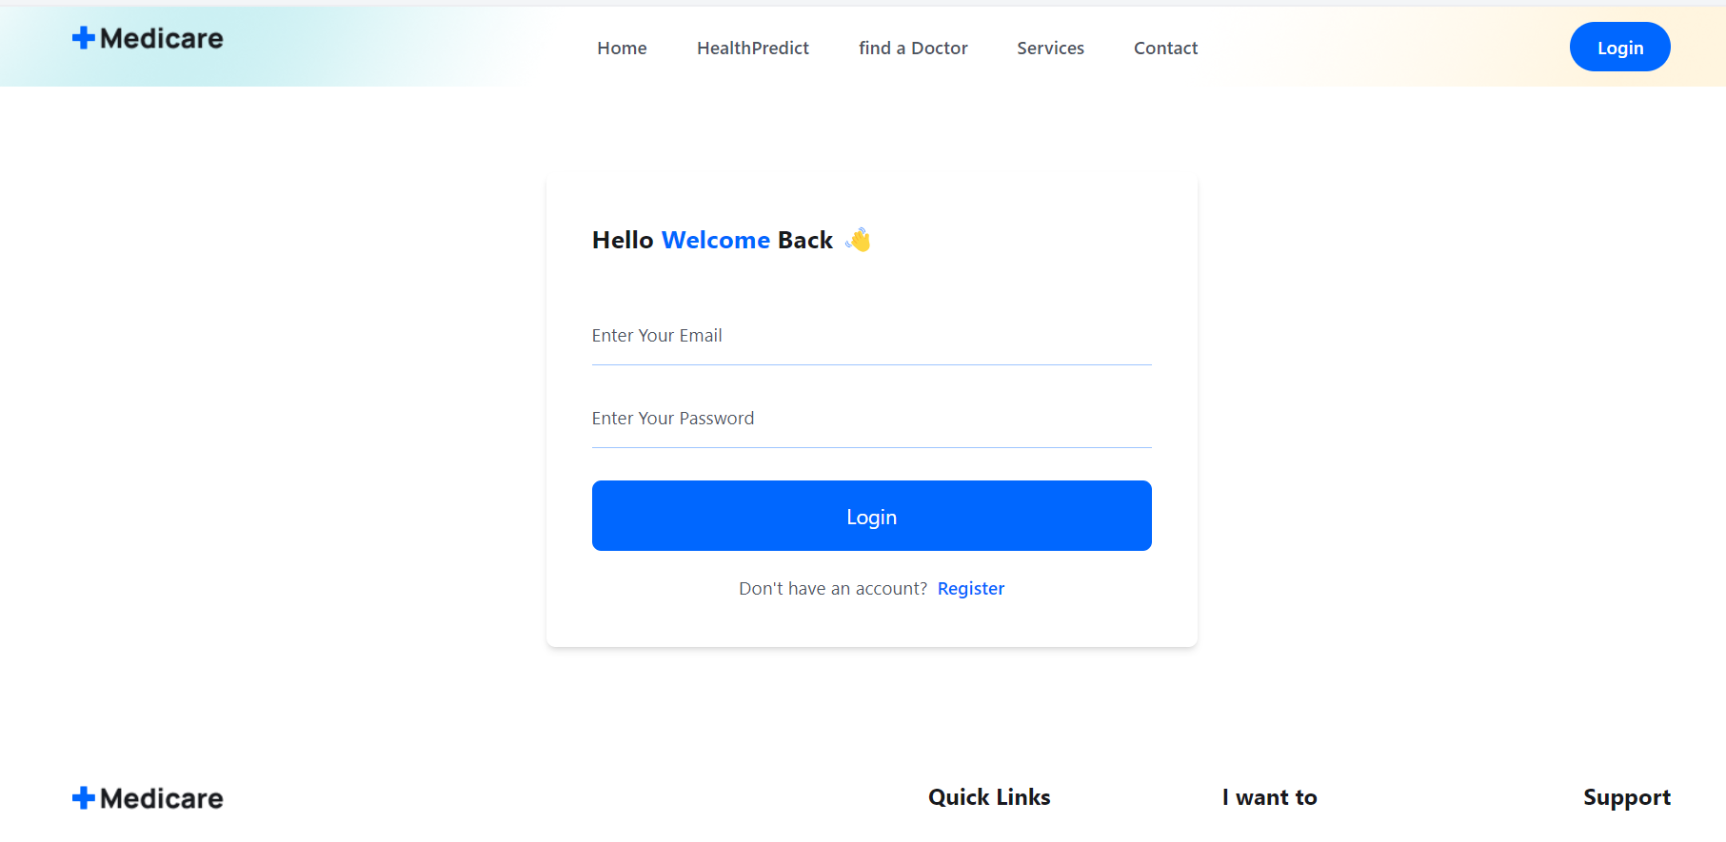

Figure 03: Login Page/Register UI

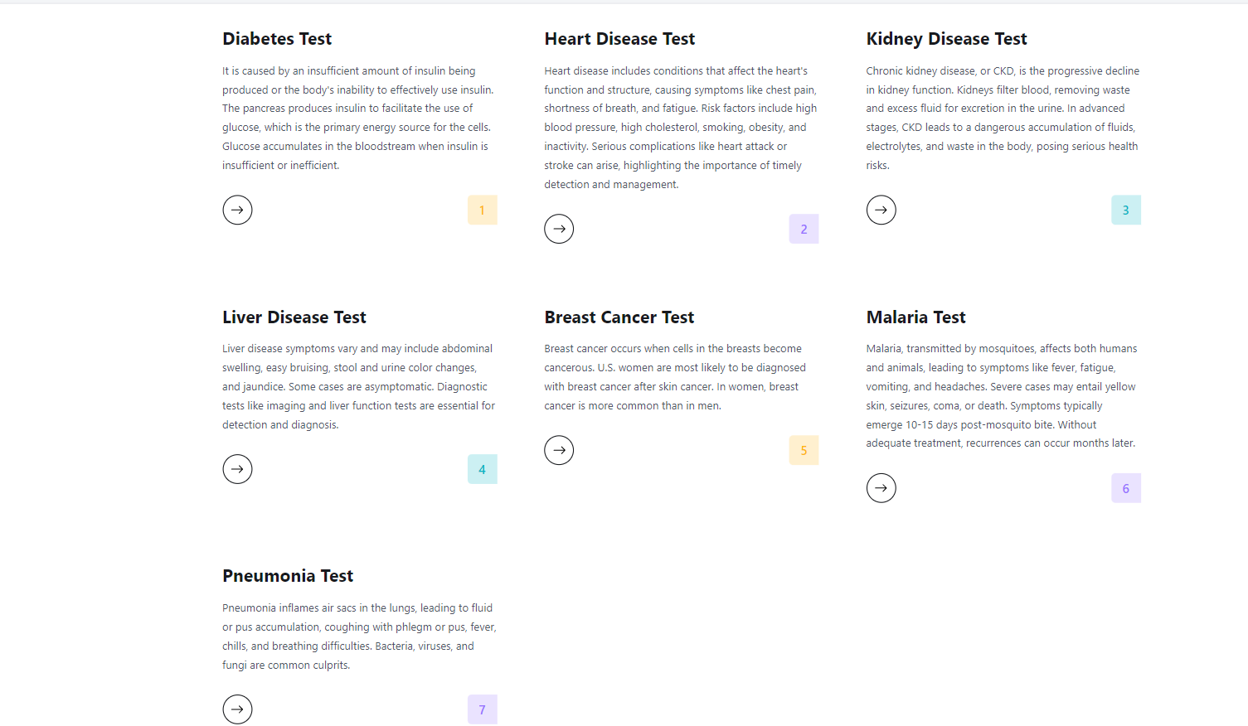

Figure 04: Services UI

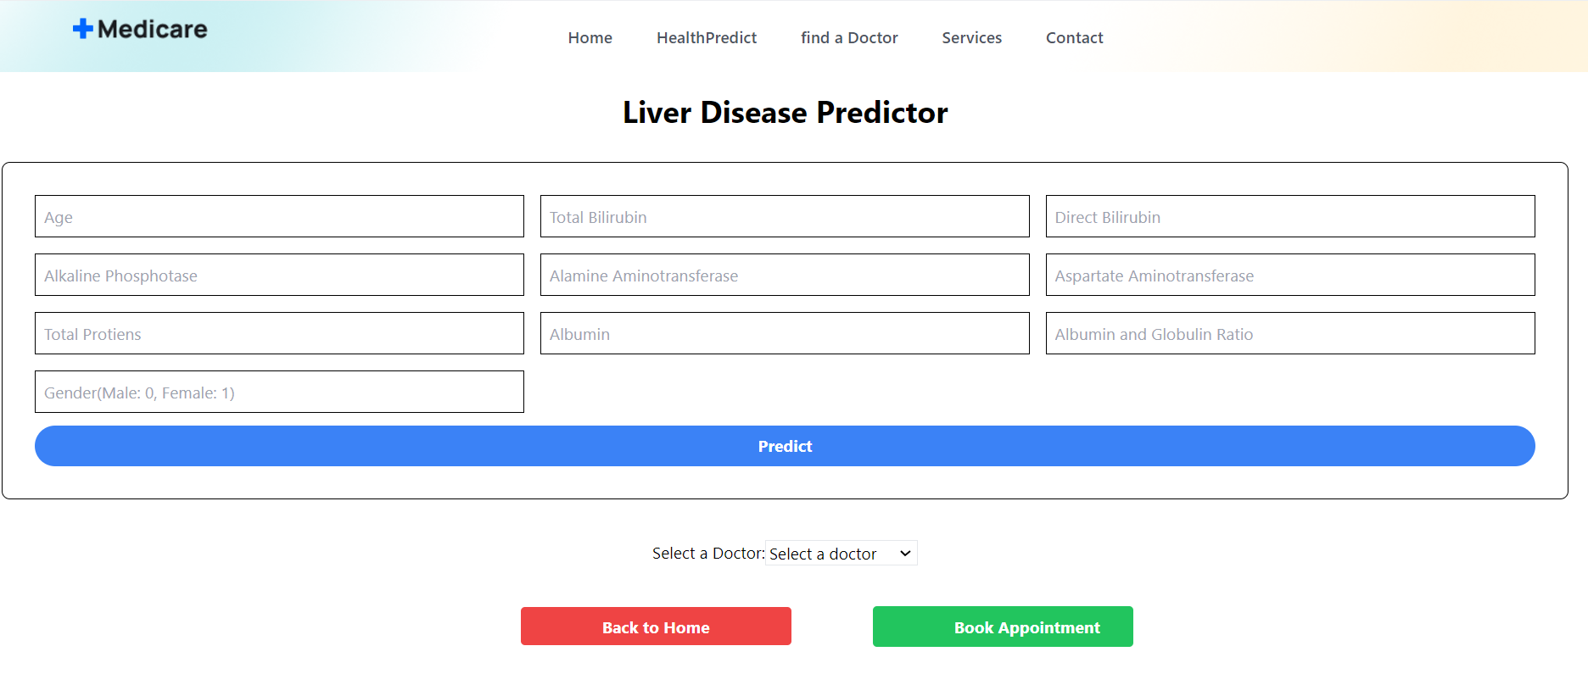

Figure 05: Specific Disease UI

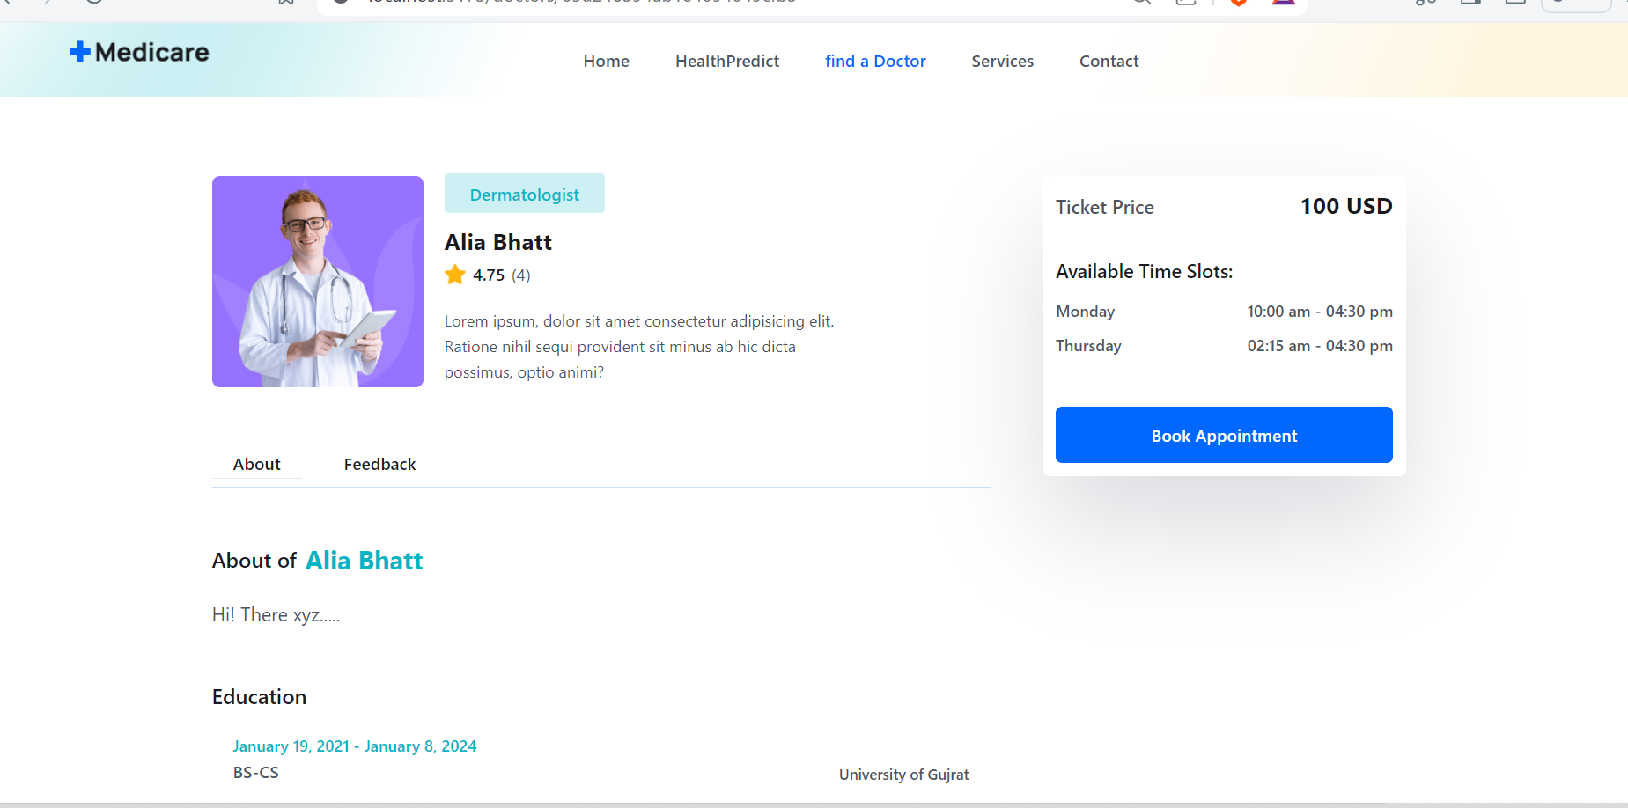

Figure 06: Book Appointment UI

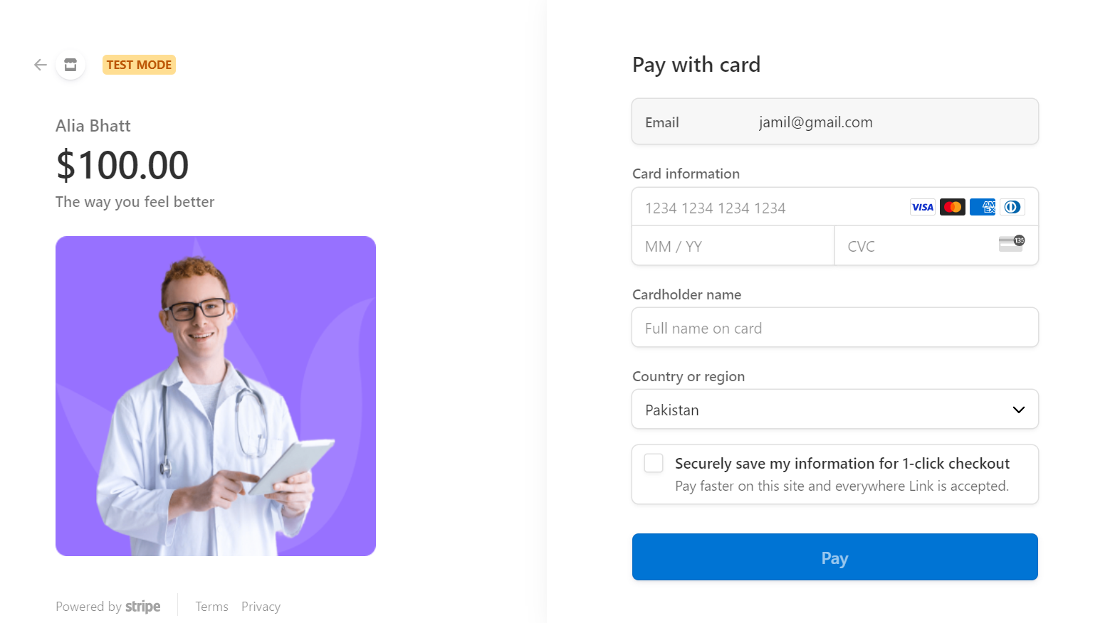

Figure 07: Payment UI

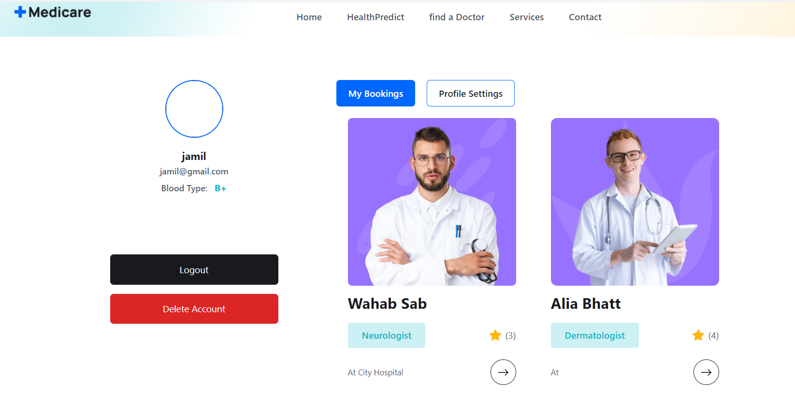

Figure 08: Profile of User (Update profile/Logout)

Chapter 8: Conclusion and Future Work

Conclusion

In this project, we have developed a comprehensive healthcare platform that addresses various critical aspects of patient care. Our services are designed to assist in the diagnosis, treatment, and management of seven major diseases: heart disease, diabetes, breast cancer, malaria, pneumonia, liver disease, and kidney disease. Through our integrated approach, we aim to enhance the overall quality of life for patients by providing timely and accurate medical information, tailored treatment plans, and ongoing support.

Key Achievements:

Disease Detection & Appointment Booking:

- We offer specialized services for detection heart disease, diabetes, breast cancer, malaria, pneumonia, liver disease, and kidney disease.
- After preliminary diagnosis, users can choose from a list of available doctors.
- The platform allows users to book appointments directly with their selected doctor.
HealthPredict Feature:

- Our HealthPredict tool is an innovative feature that predicts diseases based on the symptoms provided by users.
- It offers personalized recommendations for precautionary measures, medications, diets, and workouts, helping users take proactive steps towards better health.

User-Centric Design:

- The platform is designed with a user-friendly interface, making it accessible to a wide range of users, including those with limited technological proficiency.
- We ensure that the information provided is clear, concise, and easy to understand, enhancing user engagement and adherence to medical advice.

Impact on Healthcare:

- By offering a centralized platform for disease management and health prediction, we aim to reduce the burden on healthcare systems and improve patient outcomes.
- Our approach empowers patients to take control of their health by providing them with the necessary tools and information to make informed decisions.
- The platform also supports healthcare professionals by providing them with a reliable resource for patient education and disease management.
Future Work

Looking ahead, we plan to expand and enhance the platform’s capabilities to further improve patient care and health outcome:

- Expand Disease Coverage:

- Include more diseases beyond the current seven, providing detailed information, symptom analysis, and management options for a broader range of conditions.
- Involve collaboration with medical experts to ensure accuracy.

- Advanced AI Integration

- Advanced AI and machine learning algorithms will enhance the accuracy of Medicare.
- Technologies will help refine symptom analysis, disease prediction, and personalized health recommendations.

- Enhanced User Experience

- Simplify the interface as for adding values for Disease prediction and improving navigation will make the platform even more user-friendly.
- Enhancements will focus on video consultation and accessing health information more seamlessly.

- Data Security and Privacy

- Ensuring the highest standards of data security and privacy will remain a top priority.
- Continuously update our security protocols to protect user data and comply with relevant regulations and standards.

- Subscription Method

- We can put some sort of payment method for a particular patient if he/she can pay monthly some sort of pay then they can test their self’s free of cost.
- They also can review their reports free of cost.
- We also make deals with doctors as well like they can use our platform to cure patients and give them feedbacks.

