1.Spring-data-jpa-handson

HandsOn 1

Spring Data JPA - Quick Example

Creating database :
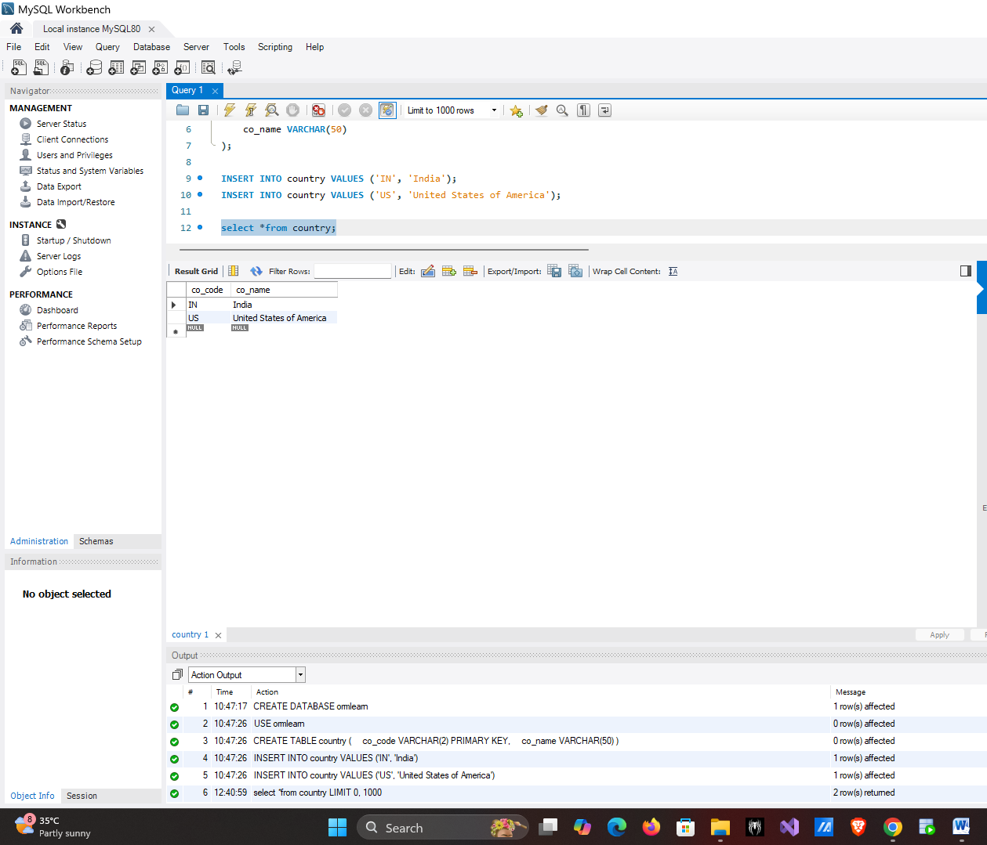
CREATE DATABASE ormlearn;
USE ormlearn;

CREATE TABLE country (
co_code VARCHAR(2) PRIMARY KEY,
co_name VARCHAR(50)
);
INSERT INTO country VALUES ('IN', 'India');
INSERT INTO country VALUES ('US', 'United States of America');
Creating Project in Spring Initializr :

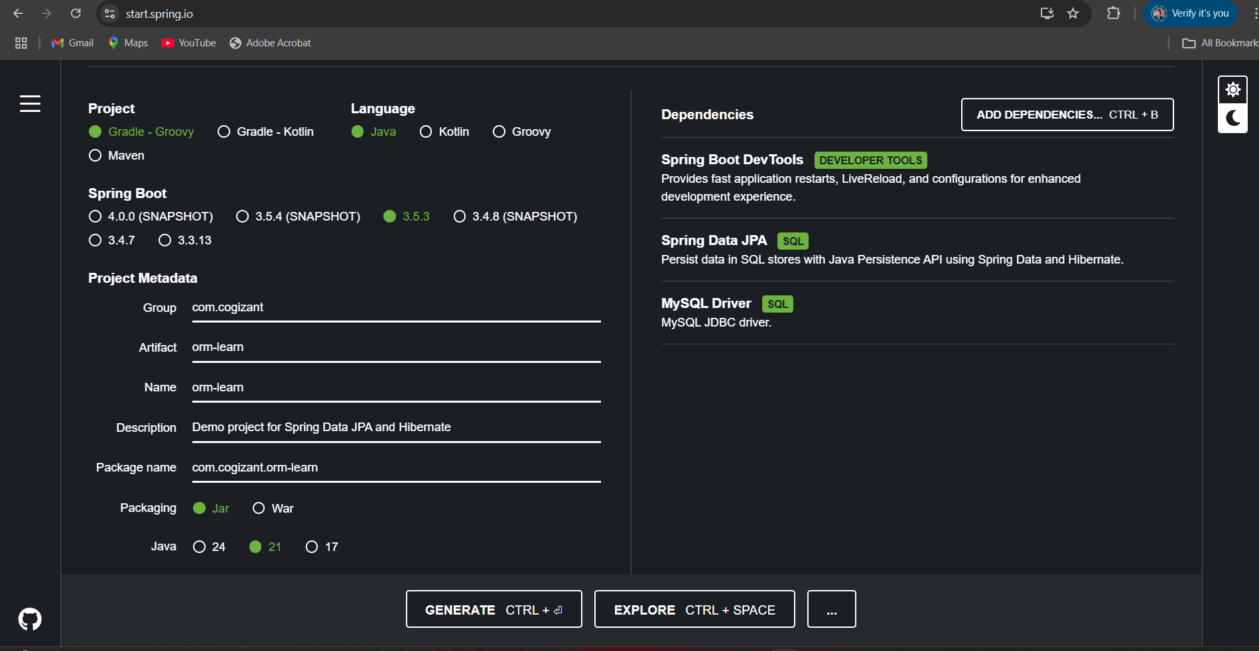

application.properties :
# Logging Configuration
logging.level.org.springframework=INFO
logging.level.com.cognizant=DEBUG
logging.level.org.hibernate.SQL=TRACE
logging.level.org.hibernate.type.descriptor.sql=TRACE
logging.pattern.console=%d{dd-MM-yy} %d{HH:mm:ss.SSS} %-20.20thread %5p %-25.25logger{25} %25M %4L %m%n

# Database Configuration
spring.datasource.driver-class-name=com.mysql.cj.jdbc.Driver
spring.datasource.url=jdbc:mysql://localhost:3306/ormlearn
spring.datasource.username=root
spring.datasource.password=root

# Hibernate Configuration
spring.jpa.hibernate.ddl-auto=validate
spring.jpa.properties.hibernate.dialect=org.hibernate.dialect.MySQL5Dialect

Country.java :
package com.cognizant.orm_learn.model;
import javax.persistence.*;
@Entity
@Table(name = "country")
public class Country {
@Id
@Column(name = "co_code")
private String code;
@Column(name = "co_name")
private String name;
public String getCode() {
return code;
}
public void setCode(String code) {
this.code = code;
}
public String getName() {
return name;
}
public void setName(String name) {
this.name = name;
}
@Override
public String toString() {
return "Country [code=" + code + ", name=" + name + "]";
}
}

CountryRepository.java :
package com.cognizant.orm_learn.repository;
import com.cognizant.orm_learn.model.Country;
import org.springframework.data.jpa.repository.JpaRepository;
import org.springframework.stereotype.Repository;
@Repository
public interface CountryRepository extends JpaRepository<Country, String> {
}

CountryService :
package com.cognizant.orm_learn.service;
import com.cognizant.orm_learn.model.Country;
import com.cognizant.orm_learn.repository.CountryRepository;
import org.springframework.beans.factory.annotation.Autowired;
import org.springframework.stereotype.Service;
import javax.transaction.Transactional;
import java.util.List;

@Service
public class CountryService {
@Autowired
private CountryRepository countryRepository;
@Transactional
public List<Country> getAllCountries() {
return countryRepository.findAll();
}
}

OUTPUT :

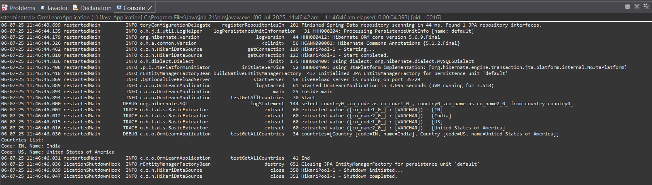

Hands On 4

Difference between JPA, Hibernate and Spring Data JPA
create database :
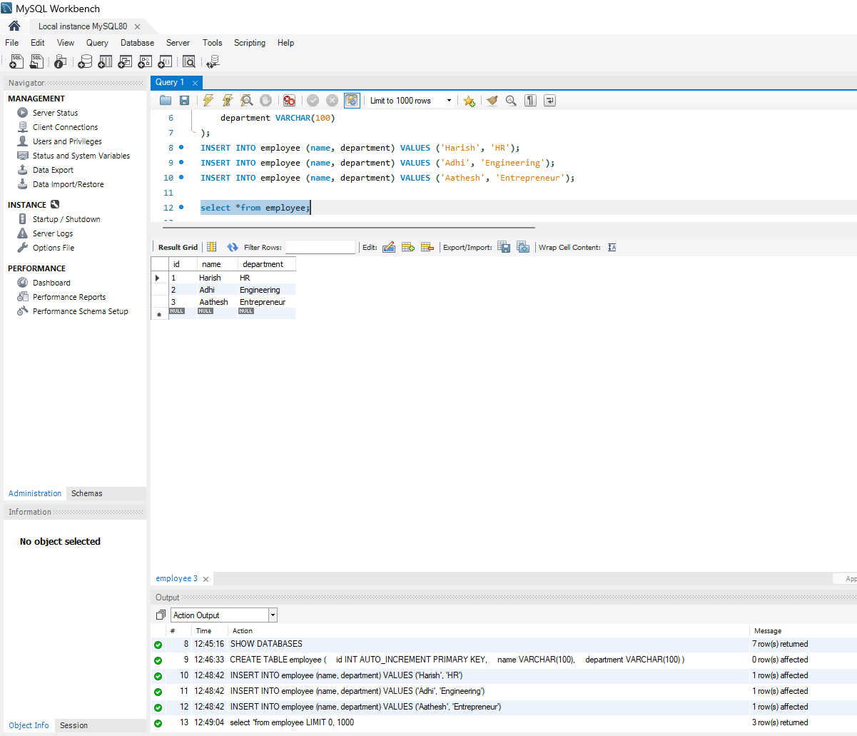
CREATE DATABASE newemployeedb;

CREATE TABLE employee (
id INT AUTO_INCREMENT PRIMARY KEY,
name VARCHAR(100),
department VARCHAR(100)
);
INSERT INTO employee (name, department) VALUES ('Harish', 'HR');
INSERT INTO employee (name, department) VALUES ('Adhi', 'Engineering');
INSERT INTO employee (name, department) VALUES ('Aathesh', 'Entrepreneur');

Creating Project in Spring Initializr :
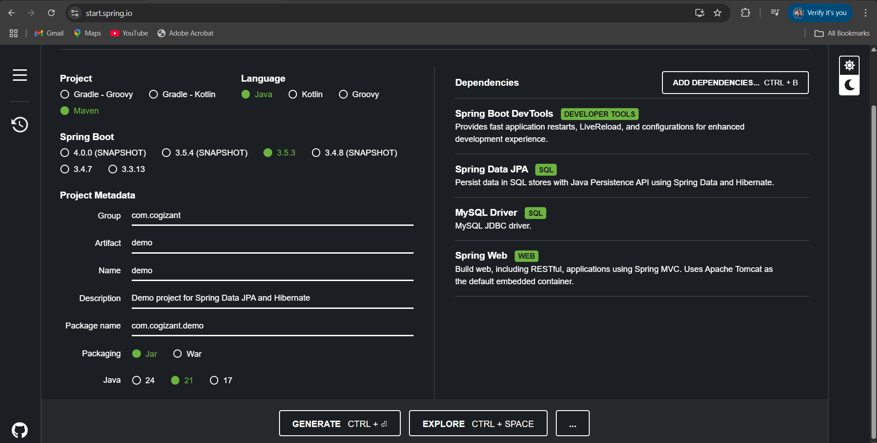

Application.properties :
spring.datasource.url=jdbc:mysql://localhost:3306/newemployeedb
spring.datasource.username=root
spring.datasource.password=root
spring.datasource.initialization-mode=always
spring.sql.init.mode=always
spring.jpa.hibernate.ddl-auto=update
spring.jpa.show-sql=true
spring.jpa.properties.hibernate.dialect=org.hibernate.dialect.MySQL8Dialect

Employee.java :
package com.cogizant.demo.model;
import jakarta.persistence.*;
@Entity
@Table(name = "employee")
public class Employee {
@Id
@GeneratedValue(strategy = GenerationType.IDENTITY)
private int id;
private String name;
private String department;
// Getters and Setters
public int getId() {
return id;
}
public void setId(int id) {
this.id = id;
}
public String getName() {
return name;
}
public void setName(String name) {
this.name = name;
}
public String getDepartment() {
return department;
}
public void setDepartment(String department) {
this.department = department;
}
@Override
public String toString() {
return "Employee [id=" + id + ", name=" + name + ", department=" + department + "]";
}
}

EmployeeRepository.java :
package com.cogizant.demo.repository;
import com.cogizant.demo.model.Employee;
import org.springframework.data.jpa.repository.JpaRepository;
import org.springframework.stereotype.Repository;
@Repository
public interface EmployeeRepository extends JpaRepository<Employee, Integer> {
}

EmpolyeeService.java :
package com.cogizant.demo.service;
import com.cogizant.demo.model.Employee;
import com.cogizant.demo.repository.EmployeeRepository;
import org.springframework.beans.factory.annotation.Autowired;
import org.springframework.stereotype.Service;
import jakarta.transaction.Transactional;
import java.util.List;

@Service
public class EmployeeService {

@Autowired
private EmployeeRepository employeeRepository;
@Transactional
public void addEmployee(Employee employee) {
employeeRepository.save(employee);
}
public List<Employee> getAllEmployees() {
return employeeRepository.findAll();
}
}

EmployeeController.java :
package com.cogizant.demo.controller;
import com.cogizant.demo.model.Employee;
import com.cogizant.demo.service.EmployeeService;
import org.springframework.beans.factory.annotation.Autowired;
import org.springframework.web.bind.annotation.*;
import java.util.List;

@RestController
@RequestMapping("/employees")
public class EmployeeController {
@Autowired
private EmployeeService employeeService;
@PostMapping("/add")
public String addEmployee(@RequestBody Employee employee) {
employeeService.addEmployee(employee);
return "Employee added successfully!";
}

@GetMapping("/all")
public List<Employee> getAllEmployees() {
return employeeService.getAllEmployees();
}
@GetMapping("/{id}")
public Employee getEmployee(@PathVariable int id) {
return employeeService.getEmployeeById(id);
}
@PutMapping("/update/{id}")
public Employee updateEmployee(@PathVariable int id, @RequestBody Employee updated) {
return employeeService.updateEmployee(id, updated);
}
@DeleteMapping("/delete/{id}")
public String deleteEmployee(@PathVariable int id) {
employeeService.deleteEmployeeById(id);
return "Employee deleted successfully!";
}
}

DemoApp.java :
package com.cogizant.demo;

import com.cogizant.demo.model.Employee;
import com.cogizant.demo.service.EmployeeService;
import org.springframework.beans.factory.annotation.Autowired;
import org.springframework.boot.CommandLineRunner;
import org.springframework.boot.SpringApplication;
import org.springframework.boot.autoconfigure.SpringBootApplication;

import java.util.List;

@SpringBootApplication
public class DemoApp implements CommandLineRunner {

@Autowired
private EmployeeService employeeService;

public static void main(String[] args) {
SpringApplication.run(DemoApp.class, args);
}

@Override
public void run(String... args) throws Exception {
System.out.println("Starting demo...");
// Add employee
Employee emp = new Employee();
emp.setName("Mathi");
emp.setDepartment("Full Stack");
employeeService.addEmployee(emp);
System.out.println("Employee saved: " + emp);

// Fetch all employees
List<Employee> employees = employeeService.getAllEmployees();
System.out.println("All Employees:");
employees.forEach(System.out::println);
}
}

OUTPUT :

