Sathishkumar T
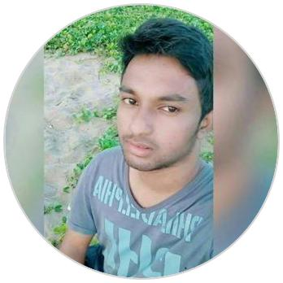

Software Development Team Lead

2 Years and 6 months of professional experience in J2Ee / Struts based Web Applications. Excellent front end and back end development experience in Java. Expert in SQL programming, Stored Procedures, Triggers , Functions using MySQL.


sathish.t.jayan@icloud.com

Bangalore, India

sathish2905.github.io/

facebook.com/sathisht1610

WORK EXPERIENCE

Team Lead
Logisoftware India Private Limited

12/2018 – Present Bangalore,India

RESPONSIBILITIES

Communicate clear instructions to team members, Listening to team members' feedback, Monitor team members' participation to ensure the training they are being provided is being put into use, and also to see if any additional training is needed, Managing the flow of day-to-day operations, Create reports to update the company on the team's progress, Distribute reports to the appropriate personnel

Contact: Ramasamy D – Ramasamy.d@logiwareinc.com

Software Engineer
Logisoftware India Private Limited

12/2017 – 11/2018 Bangalore,India

RESPONSIBILITIES

Requirements gathering and analysis Functional and technical specifications development Prototyping , Design and development of source code Database design and development GUI design and Performance profiling and optimization

Contact: Sathiya Priya S – sathiyapriya.s@logiwareinc.com

Trainee Software Engineer Logiware India Private Limited

06/2016 – 11/2017 Bangalore,India Contact: Sathiya Priya S – sathiyapriya.s@logiwareinc.com

CERTIFICATES

Star Performer

In Recognition of outstanding performance during the period of July 2018 to September 2018 by Logisoftware India Private Limited

EDUCATION

B Tech (ECE)
BIHER Bharath University, Tambaram

2011 – 2015 First Class

(+91) 9629087764

25 May, 1994

sathish.kumar910

github.com/sathish2905

SKILLS

Java J2Ee Hibernate Struts JS JQuery

Mysql JAXB Bootstrap CSS Ajax

PROJECTS

Logiware ERP (Logistics) Logisotware India Private Limited

Description

Logiware ERP is the operational software for international shipping, including Ocean Shipments Exports Full Container Loads (FCL), Air Shipments and Imports Less Than Container Loads (LCL). The flow follows Standard Operating Procedures by Quotes , Bookings/Warehouse Receipts , Bills of Lading, Air Waybills and Arrival Notices .

Automated Export System(AES) will generate an Electronic filing of Shipper's Export Declaration (SEDs) with US Customs prior to departure. Electronic Data Interchange(EDI) for tracking the status of the Goods with respective carriers. Automated System For Custom Data(ASYCUDA), US Customs prior to departure. Rate management module that allows our customers to make their shipments with feasible rates.

CLIENTS

Vector Global Logistics, Aurora, Argos-Express, Trans-border, USA Cargo, Troy Lines, Eagle-Freight, Econocaribe Consolidators Inc. ECU Worldwide, OTI Cargo.

PERSONAL DETAILS

Sathishkumar T

Software Development Team Lead

DOB :25/05/1194

Father : Thananjayan S

Mother : Shanthi T

Experience: 2 Year(s) and 7 Months

Notice Period : 60 days (Negotiable)

Current Organization : Logisoftware India Private Ltd.,

Current CTC : 5 LPA

HSE

AKT Academy Matriculation Higher Secondary School, Kallakuruchi

2009 – 2011 74.75%

LANGUAGES


English

10 th | Tamil
Jawahar Higher Secondary School(CBSE) , Neyveli | Tamil

2008 – 2009 52.8%

