**Phase 4: Development Part2**

The problem statement is sentiment analysis for marketing. The goal is analysed the dataset and produced the result as follows; Positive, Negative, Neural.

**PROBLEM DEFINITION:**

The objective of this project is to perform sentiment analysis on customer feedback related to competitor products in order to extract valuable insights that can inform business decisions. By understanding customer sentiments towards competing products, our aim is to identify both strengths and weaknesses, enabling us to improve our own offerings and gain a competitive advantage in the market.

**DESIGN THINKING:**

1.Data Collection

2. Data Preprocessing

3. Sentiment Analysis Techniques

4. Feature Extraction

5. Visualization

6. Insights Generation

**Architecture diagram:**

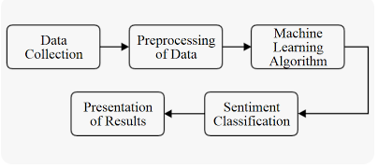

**Before preprocessed dataset**

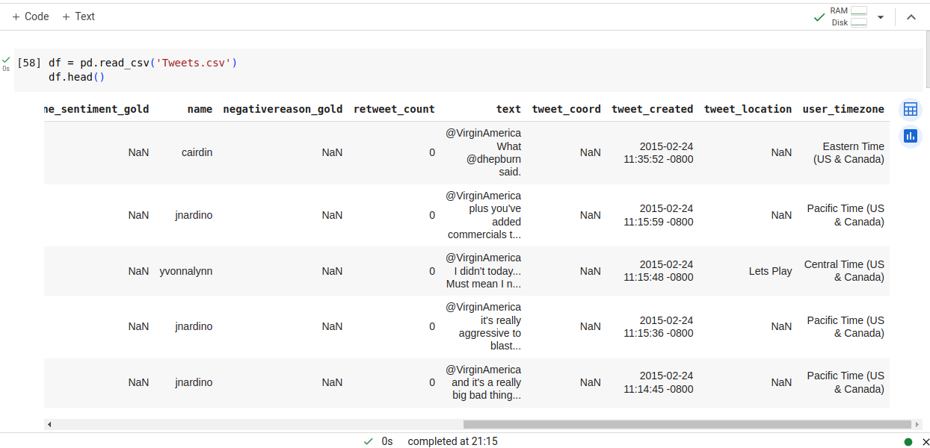

**Feature Engineering**

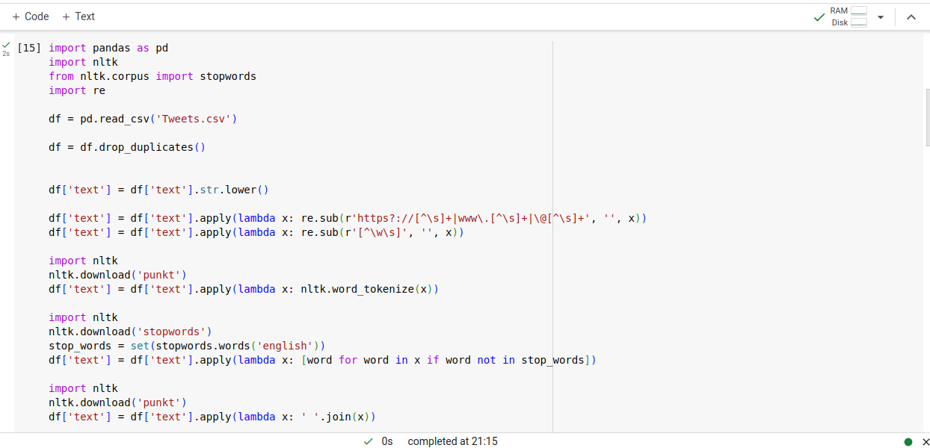

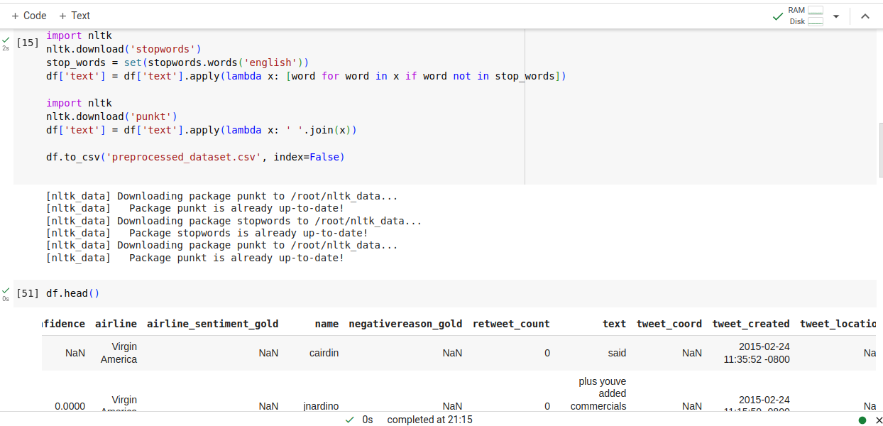

**Model Training**

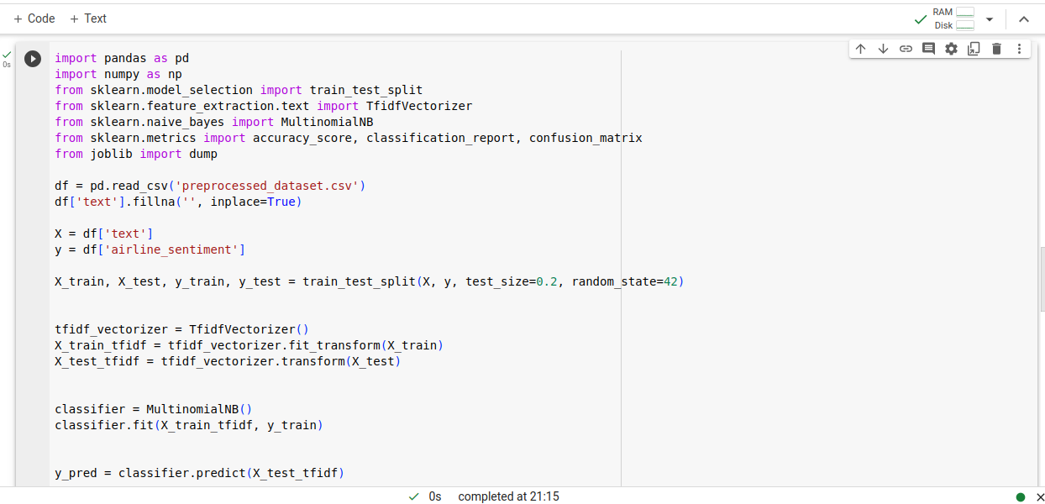

**Evaluation the model**

