Currency Convertor Documentation

Table of Contents

Introduction 1

Required software’s 1

Architecture 1

Currency Convertor 1

Home Page 1

View Logs 2

# Introduction

This document explains on how to use the currency convertor

# Required software’s

1. Visual studio with .net core 2.2
2. SQL Server 2012

# Architecture



# Currency Convertor

## Home Page

Below is the screenshot of home page.

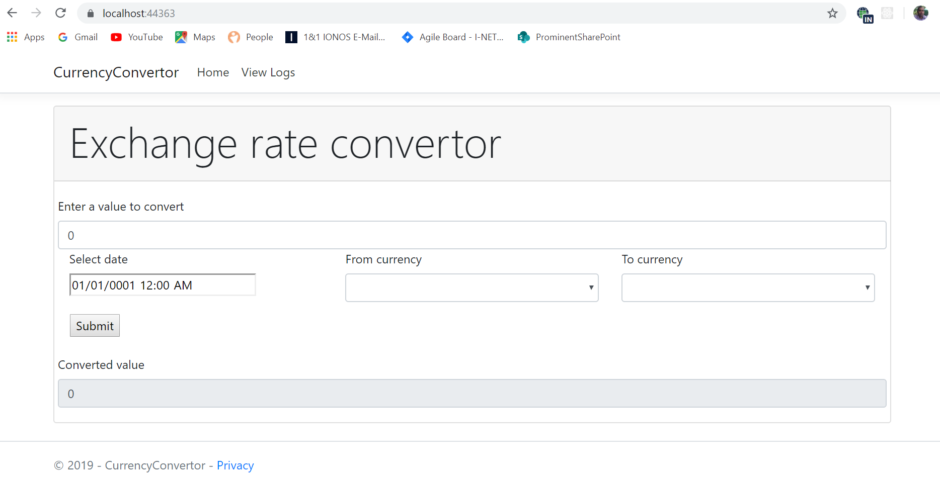

To use the convertor follow the below steps:

1. Enter a number in the text box “Enter a value to convert”
2. Select a date. For testing purposes the dummy data has only data for 1st, 2nd and 3rd Dec 2019 dates. Select one of these dates.
3. Select a value in FromCurrency drop down list. For testing purposes only GBP data is available.
4. Select a value in ToCurrecny dropw down list. For testing purposes on AUD, USA and EUR data is available. Select one of these currencies.
5. Click on submit to display converted value.

## View Logs

Click on “View Logs” option in the top menu. Below is the views log screenshot

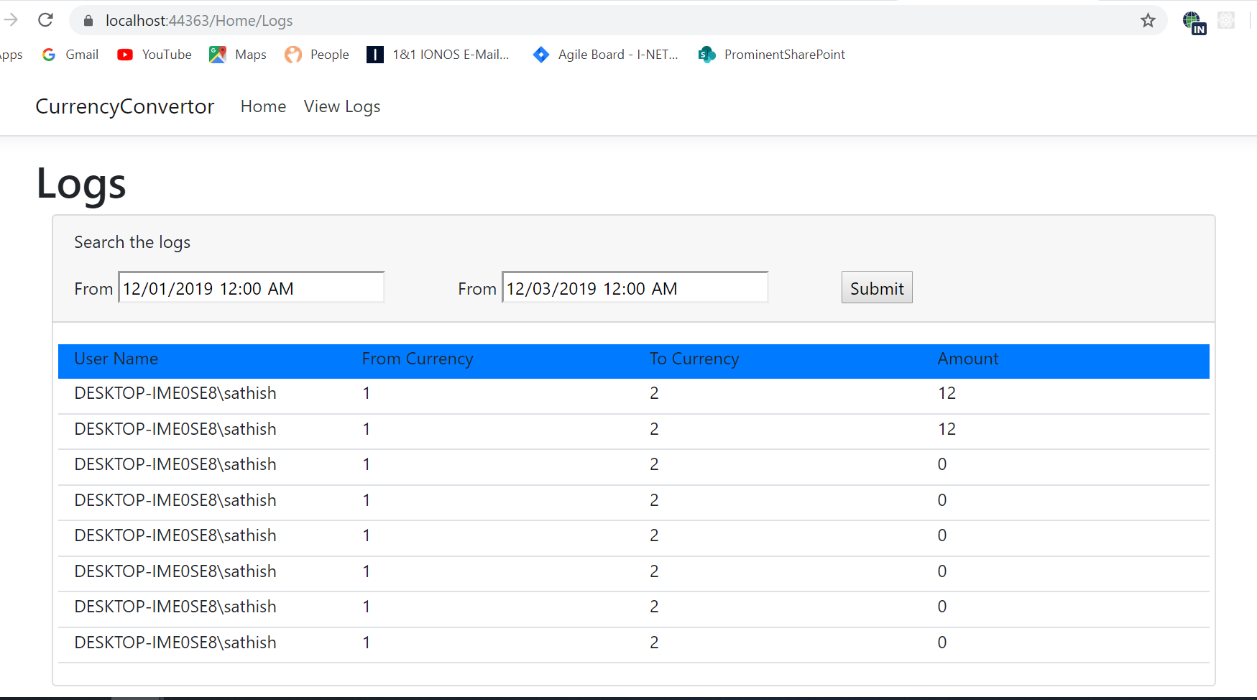

To view the logs follow the below steps:

1. Select from date and to date. The date should be in mm/dd/yyyy format.
2. Click on submit button.