1. **Pushing the code files through Visual Studio Code to Github using git tool.**

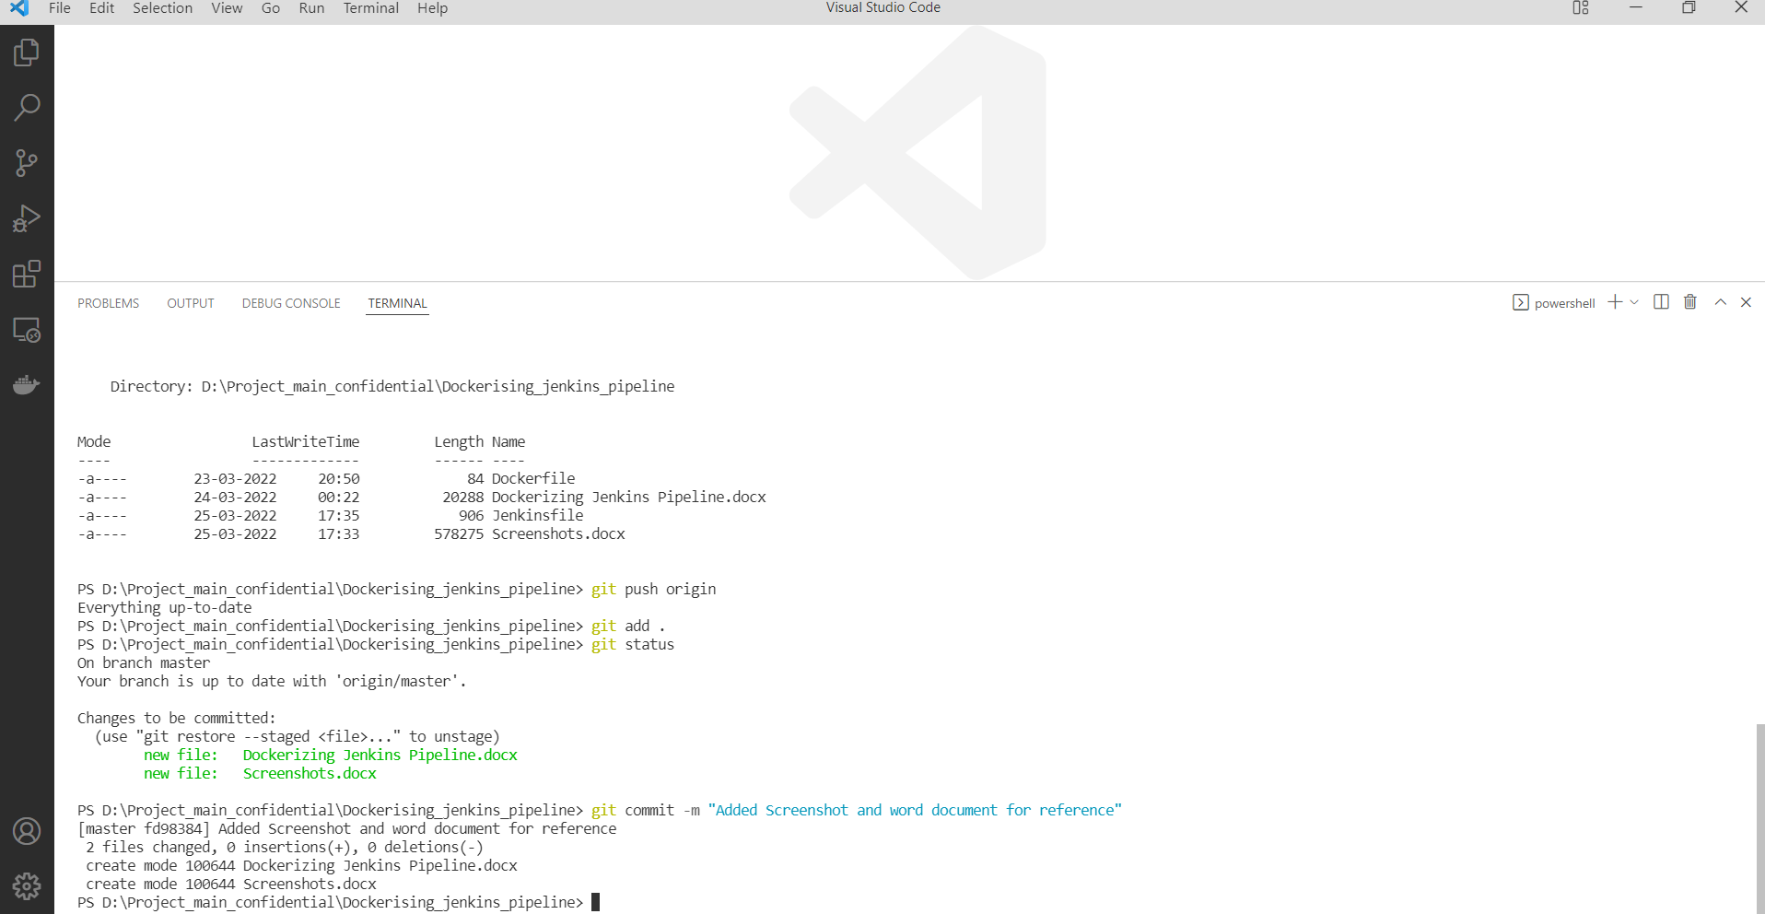

1. **Jenkin CI pipeline for building and pushing the image to docker hub.**

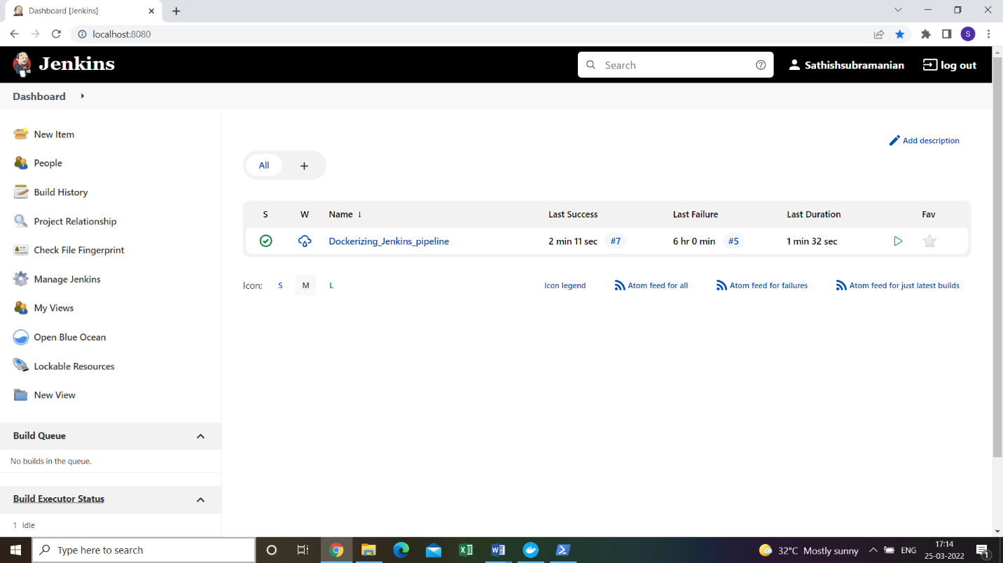

1. **CI pipeline at the time of execution.**

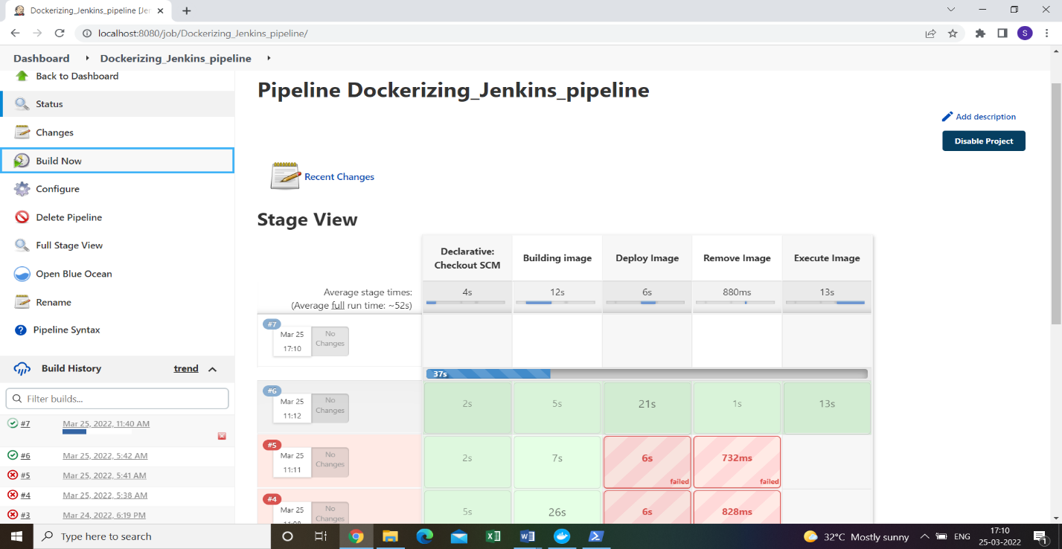

1. **CI pipeline executing the command “echo Hello” Inside the container.**

