**FlyAway (An Airline Booking Portal) Project-Phase 2**

## **Table of contents**

* General info
* Using the application
* Technologies
* Setup

## **General info**

A simple dynamic java web application project runs under Tomcat 9.0 Server using Servlets and JSP. For database requirement we are using My SQL server.

## **Using the application**

We need to deploy the project in tomcat server 9.0 as shown in screenshot below

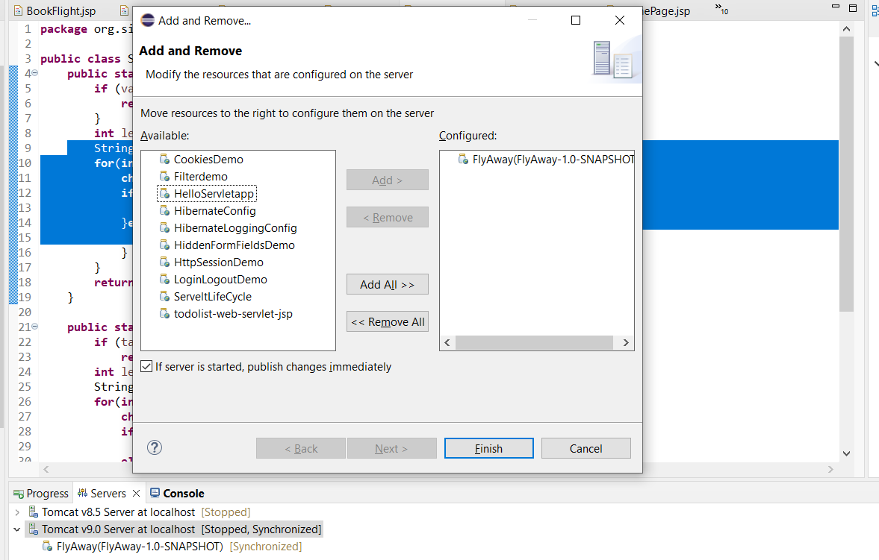

Once the tomcat server is in running state then user can use the application by pasting the url <http://localhost:8080/FlyAway/UserPage.jsp>

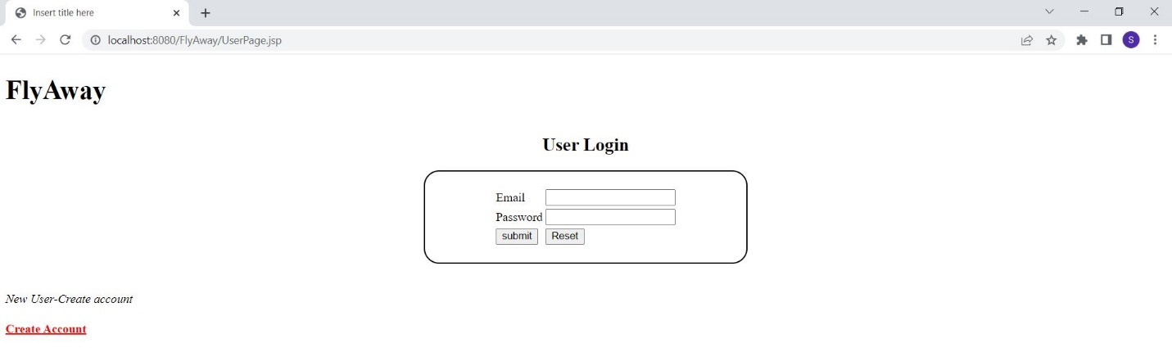

If user is not registered can use create account link to create user email and password as shown in below screenshot

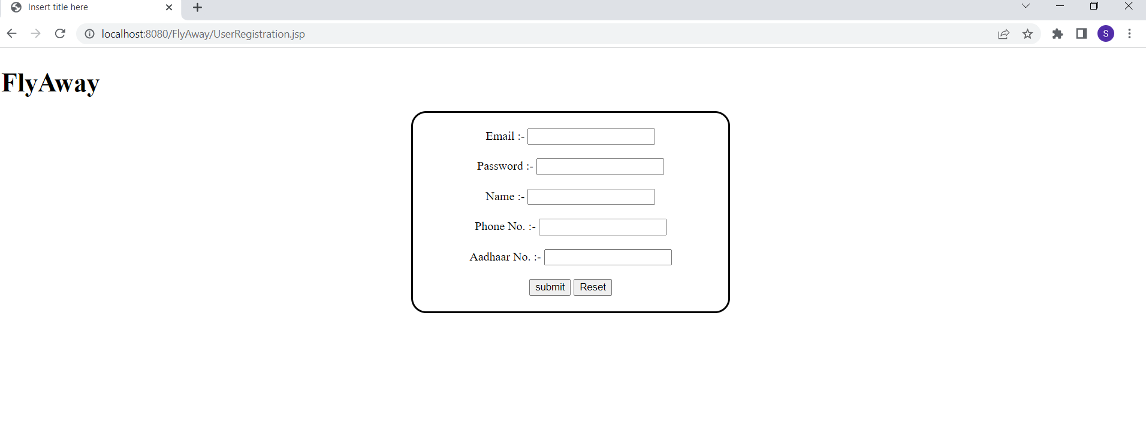

Once the user is logged in can check for available flights by providing all the details below in the form

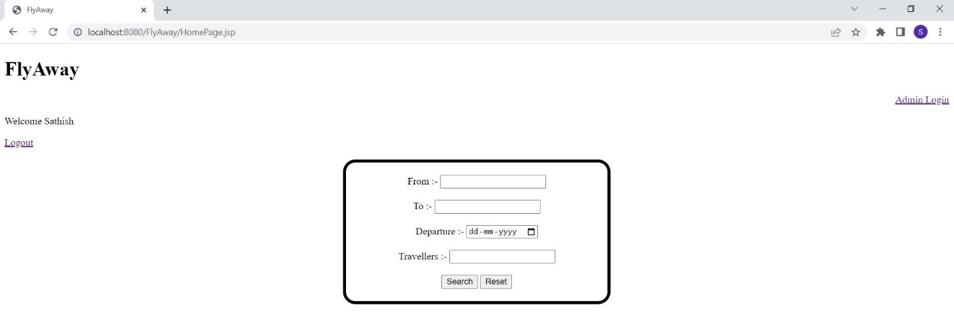

If the flight is available, user will be asked for a booking confirmation and if yes then the success prompt will be shown as per the screenshots below

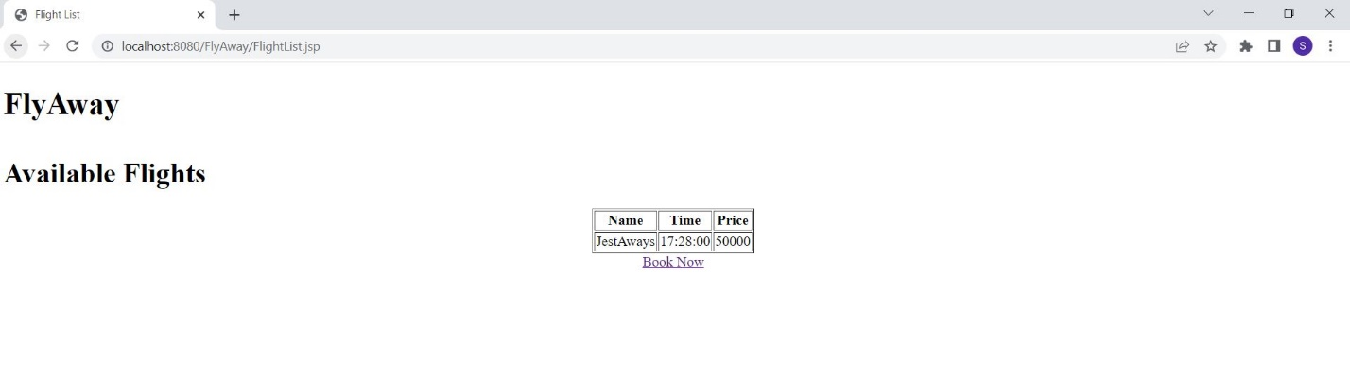

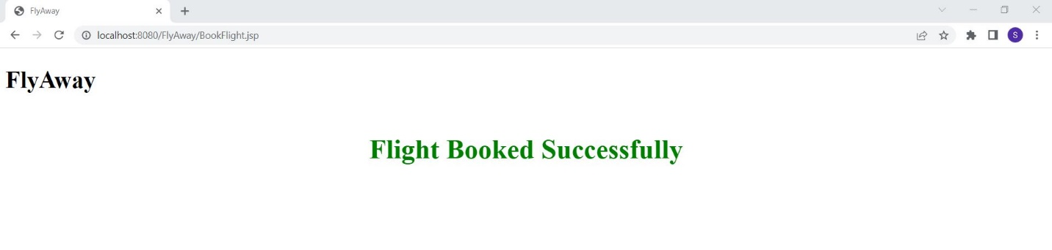

Admin can able to login and insert flight details with price for booking as shown in screenshots below

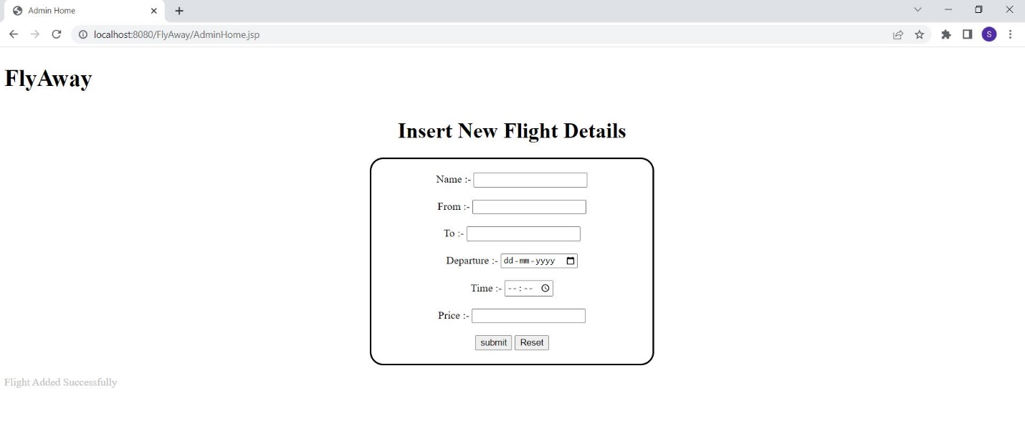

## **Technologies**

Project is created with:

* Java Version 1.8
* Tomcat server 9.0
* MySQL Version 8.0
* Servlet(Controller)
* JSP(view part)
* Eclipse IDE

## **Setup**

Run this as a Java project on Tomcat Server 9.0.

Paste the url with respective jsp page as shown in pic below

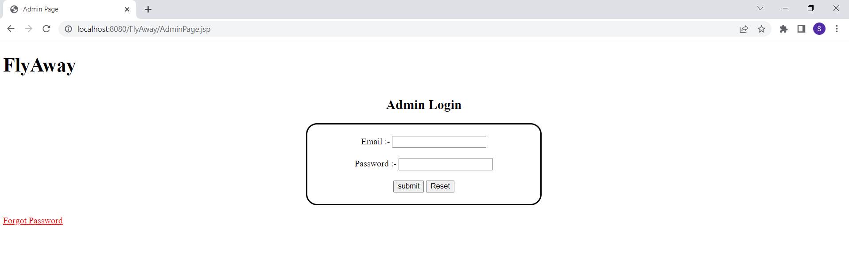

## **Github Url** <https://github.com/SathishSubramanian9/FlyAway.git>