**Sporty Shoes Project - Phase 3**

## **Github Url**

## **Table of contents**

* General info
* Using the application
* Technologies
* Setup

## **General info**

A simple Spring MVC web application project using Spring boot framework as backend and thymeleaf as frontend. For database requirement we are using My SQL server.

## **Using the application**

Initially, developer needs to create sql database schema and tables in order to run the project. The schema and table creation queries are provided with the attachments.

Once we run the project we can see the login page as below with username and password.

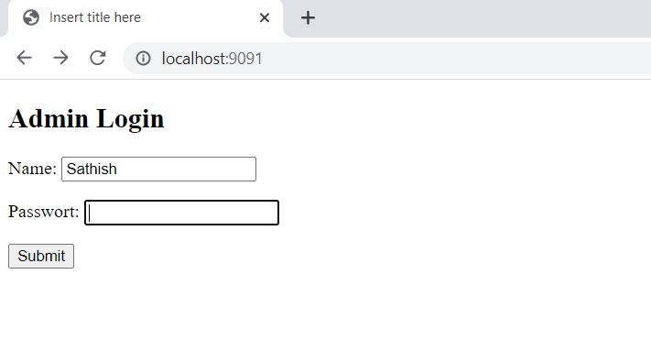

After logging, user will be greeted with welcome page where,

* User can change the password if required.

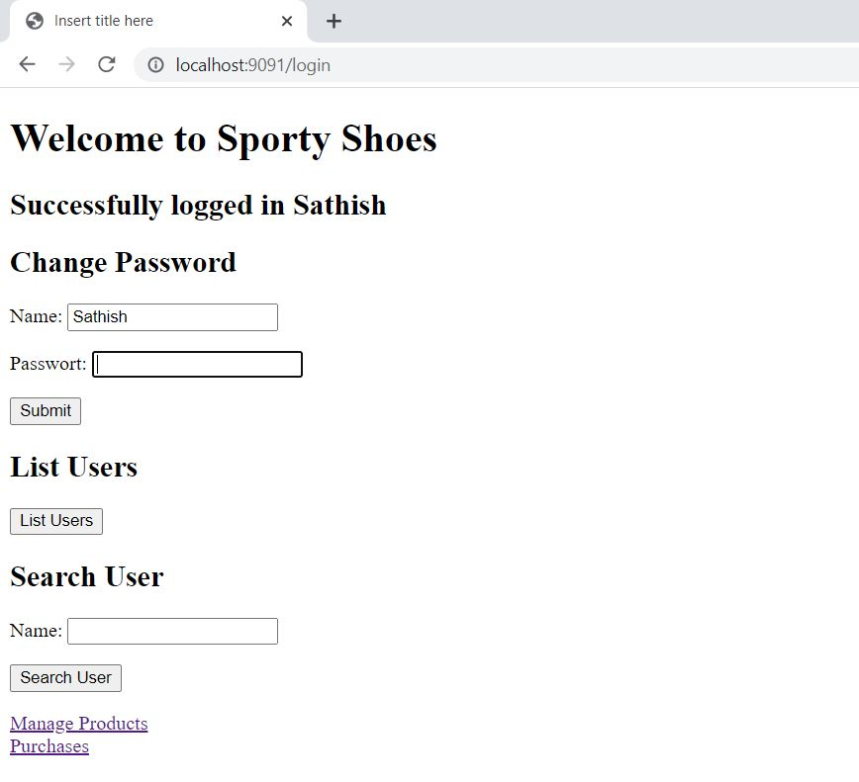

* Check the user list.
* Search for user whether they exist or not.

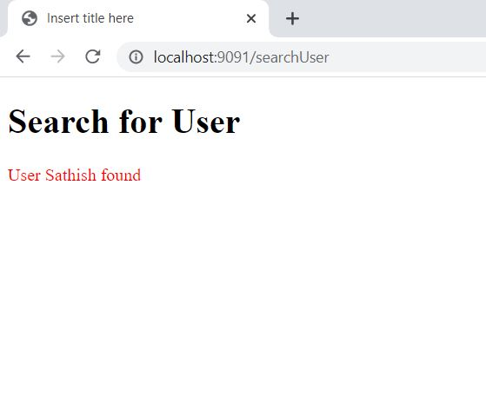

* User can manage the products (By adding or deleting) as per their requirements and also list the products which are available.

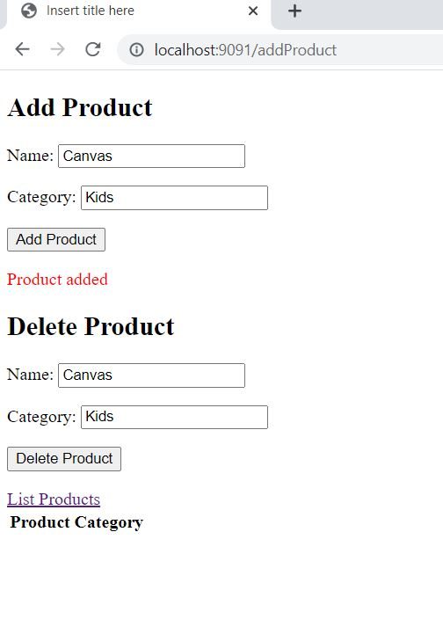 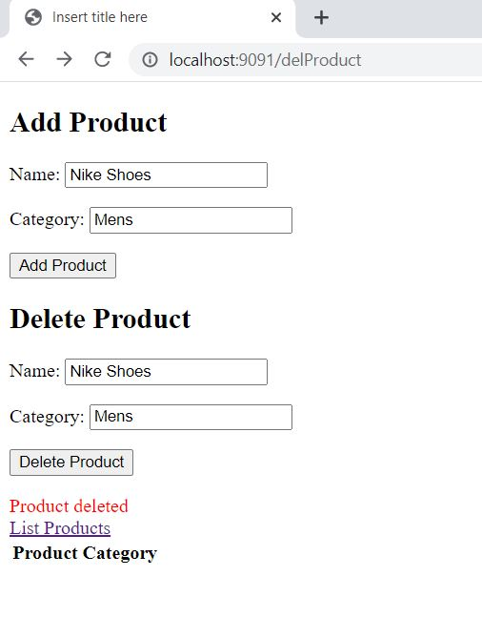

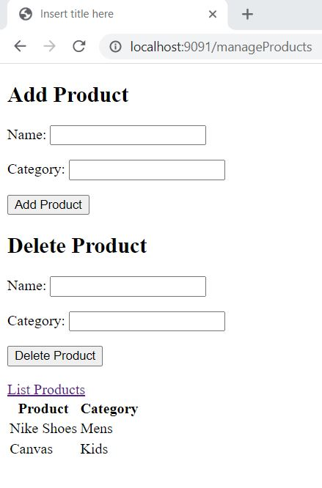

## **Technologies**

Project is created with:

* Java Version 1.8
* Spring Intializr portal (for creating spring-boot application)
* MySQL Version 8.0
* Model View Controller (MVC methodology)
* Thymeleaf (view part)
* Eclipse IDE (To run the project)

## **Setup**

Run this project as maven build with following command spring-boot:run

(Or)

Open the spring application java class & run as java application.