|  |
| --- |
| Difference Between NAAC & NBA Accreditation - Haq Se EngineerPREC LONIJai Shriram Engineering College (@JSREC09) / Twitter**JAI SHRIRAM ENGINEERING COLLEGE**  **TIRUPPUR – 638 660**  Approved by AICTE, New Delhi & Affiliated to Anna University, Chennai  Recognized by UGC & Accredited by NAACandNBA (CSE and ECE) |

**DEPARTMENT OF**

**ELECTRONICS AND COMMUNICATION ENGINEERING**

**IBM - Naan Mudhalvan**

**Internet of Things**

**Group 3**

**Phase 2 - Project Submission**

**NAME : SATHISHKUMAR.D**

**NM ID : AU711221106030**

**YEAR : III**

**Line Charts:**

Line charts are useful for showing trends over a continuous interval or time span. You can plot historical temperature and humidity data on the y-axis against time on the x-axis. This can help identify patterns and trends over different periods.

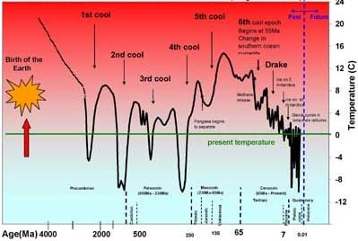

**Area Charts:**

Area charts are similar to line charts, but the area below the line is filled with color. This can be helpful when you want to emphasize the magnitude of the temperature and humidity trends over time.

**Heat Maps:**

Heat maps can be used to represent both temperature and humidity data simultaneously. Time can be represented on one axis, and the other two axes can represent different data points. For example, the x-axis can represent months, the y-axis can represent years, and the color intensity can represent temperature or humidity levels. This visualization can help identify seasonal patterns and trends.

**Scatter Plots:**

Scatter plots can be useful to visualize the relationship between temperature and humidity. Each data point represents a specific time, with temperature on one axis and humidity on the other. You can use different colors or shapes to represent different years or months, helping to identify correlations between temperature and humidity.

**Box Plots:**

Box plots can show the distribution and variability of temperature and humidity data. You can create separate box plots for different months or seasons, allowing you to compare the temperature and humidity distributions over time.

**Interactive Visualizations:**

Interactive visualizations, such as those created with D3.js or Plotly, allow users to explore the data interactively. Users can zoom in on specific time periods, hover over data points to view exact values, and switch between different variables (temperature, humidity) or time spans.

**Geographic Maps:**

If your data includes geographic information, you can create geographic maps to visualize temperature and humidity variations across different regions. Color gradients can represent temperature or humidity levels in different areas, providing a clear visual representation of geographical patterns.

Remember, the choice of visualization technique depends on the specific characteristics of your data and the insights you want to convey. Using a combination of these techniques can provide a comprehensive and insightful view of historical temperature and humidity trends.

**Animated Charts:**

If you have data spanning several years or decades, you can create animated charts that show how temperature and humidity patterns evolve over time. This dynamic visualization can make trends and changes more apparent.

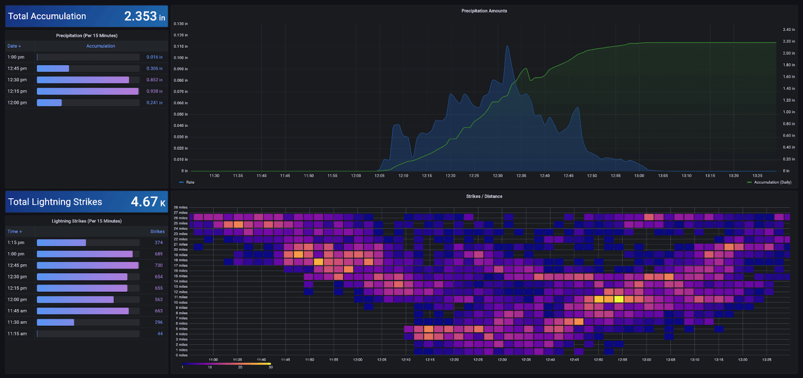

**Tips for Effective Data Visualization:**

* **Use Appropriate Colors:** Choose colors that are easily distinguishable and make sure they are meaningful. For example, you can use warm colors (like red and orange) for high temperatures and cool colors (like blue and green) for low temperatures.
* **Label Axes and Data Points:** Clearly label the axes and data points to provide context and make the visualization easy to understand.
* **Provide Context:** Add titles, legends, and captions to provide context to the data. Explain what the visualization represents and any significant findings.
* **Interactive Visualizations:** If possible, create interactive visualizations that allow users to explore the data on their own. Interactive elements enhance engagement and understanding.

Remember, the choice of visualization technique depends on the specific aspects of the data you want to emphasize and the story you want to tell. Different types of charts can reveal different insights, so consider using a combination of these techniques for a comprehensive analysis of historical temperature and humidity trends.