DESIGN AND IMPLEMENTATION OF A
CLOUD-BASED SNAKE GAME
USING AWS EC2, FLASK REST API AND AMAZON DYNAMODB

CONTENTS
1. Introduction
2. Problem Statement
3. Objectives
4. System Requirements
5. Technologies Used
6. System Architecture
7. Frontend Development
8. Snake Game Implementation
9. Mobile and Laptop Controls & Snake Speed
10. Backend Development Using Flask
11. REST API and Fetch API Integration
12. Amazon DynamoDB and Database Integration
13. Amazon EC2, IAM and Deployment
14. Leaderboard, Testing and Results
15. Conclusion and Future Enhancements

Project Summary
This project develops a cloud-connected Snake Game that combines a responsive web interface with a Flask REST API hosted on Amazon EC2 and a DynamoDB-backed score system. The browser performs the actual gameplay and sends completed scores to the backend. The backend validates and stores each result, then returns a ranked list for the leaderboard.
The implementation is intentionally simple enough for a mini project while still demonstrating the complete flow from browser interaction to cloud compute and persistent data. The supplied screenshots are used throughout the report as evidence of the deployed frontend, running EC2 resources, IAM configuration, API activity and stored DynamoDB items.
The visible game does not use a Game ID as a player feature. An internal unique key may be generated by the backend only to keep score records unique in DynamoDB.

1. INTRODUCTION

1.1 Project Overview
The AWS Snake Game is a browser-based game created to demonstrate cloud application development using familiar web technologies and AWS services. The user interface is built with HTML, CSS and JavaScript. The game logic runs in the browser, while the cloud layer provides an API and persistent storage for scores.
The player enters a name, chooses a game speed and starts the game. During play, the snake moves on a canvas, consumes food and increases its score. When the snake collides with the wall or itself, the game ends and the final score is submitted to the Flask backend using an HTTP POST request.

1.2 Main Features
- Player name entry before the game starts.
- 25%, 50%, 75% and 100% selectable snake speed levels.
- Four large arrow buttons for touch-based control.
- Laptop and desktop keyboard arrow-key support.
- Canvas-based gameplay with score tracking and collision detection.
- REST endpoints for score submission and leaderboard retrieval.
- Cloud persistence through Amazon DynamoDB.
- Top-score leaderboard shown in the browser.

1.3 Project Scope
The project focuses on the practical integration of frontend interaction, API communication, cloud hosting and NoSQL persistence. It is intended for demonstration and learning, but the architecture also provides a clear foundation for later additions such as user accounts, HTTPS, scalable leaderboard queries and production server deployment.

2. PROBLEM STATEMENT

2.1 Existing Situation
A basic browser-only Snake Game can provide gameplay, but completed scores usually remain only in the local page state. When the page is refreshed, there is no shared result history. A client-only implementation also gives little opportunity to demonstrate server-side APIs, cloud deployment or database access.

2.2 Problems Identified
- No persistent cloud-based score storage in a basic client-only game.
- No shared leaderboard for multiple players or sessions.
- Touch-screen users need an easy control method.
- Different players have different preferences for game speed.
- A cloud computing project should demonstrate communication between a client, API, compute service and database.

2.3 Proposed Solution
The solution separates responsibilities. The browser handles presentation and real-time gameplay. A Flask REST API hosted on EC2 receives and returns JSON data. DynamoDB stores the score records. Boto3 connects the Flask application to DynamoDB, and an EC2 IAM role provides the AWS permissions required by the application.

2.4 Expected Result
The finished system should allow a player to start a game, choose a speed, control the snake on a laptop or mobile device, complete a session, store the score in AWS and view an updated leaderboard without manually editing the database.

3. OBJECTIVES

3.1 Primary Objective
To design and implement a cloud-based Snake Game that demonstrates end-to-end integration between a responsive web frontend, a Flask REST API on Amazon EC2 and Amazon DynamoDB.

3.2 Specific Objectives
- Develop a clean and responsive interface using HTML, CSS and JavaScript.
- Implement player-name validation and a clear Start Game workflow.
- Provide four selectable gameplay speeds: 25%, 50%, 75% and 100%.
- Implement four large directional buttons for mobile and touch devices.
- Support keyboard arrow controls on laptops and desktops.
- Track food collection, score growth and collision conditions.
- Build REST endpoints for API testing, score submission and leaderboard retrieval.
- Store player results in DynamoDB using a unique internal record key.
- Configure EC2-to-DynamoDB access through an IAM role.
- Deploy and test the Flask application on an EC2 instance.
- Verify the complete browser → API → EC2 → DynamoDB flow.

3.3 Learning Outcomes
The project provides practical experience in cloud deployment, Linux server operation, REST APIs, JSON communication, NoSQL database storage, IAM permissions, browser Fetch API usage and basic responsive web development.

4. SYSTEM REQUIREMENTS

4.1 Hardware Requirements
- Laptop or desktop computer for development and testing.
- Mobile phone or tablet for touch-control testing.
- Reliable internet connection.

4.2 Software Requirements
- Modern web browser such as Chrome, Edge or Firefox.
- Python 3 on the EC2 server.
- Flask, Flask-CORS and Boto3 Python packages.
- Amazon EC2, Amazon DynamoDB and AWS IAM access.
- Text editor or IDE for source-code editing.

4.3 Network Configuration
For the demonstrated deployment, the Flask process listens on port 5000 and the browser uses the EC2 public IP as the API host. The EC2 security group must allow the required TCP port during testing.
API_URL = "http://YOUR_EC2_PUBLIC_IP:5000"
fetch(API_URL + "/api/scores")

4.4 Data Requirements
Each score record contains an internal unique identifier, player name and numeric score. The unique identifier is an implementation detail for DynamoDB and is not shown to the game player.

4.5 Operational Requirement
The frontend and backend must use the correct EC2 public IP and the correct DynamoDB region and table name. Configuration consistency is essential when the cloud resources are deployed in a specific AWS region.

5. TECHNOLOGIES USED

5.1 Frontend Technologies
HTML provides the page structure, CSS provides the responsive visual design and JavaScript controls the game loop, movement, speed, score, collision detection and API calls. The HTML canvas is used as the game board.

5.2 Backend Technologies
Python provides the application language and Flask provides URL routing and JSON responses. Flask-CORS is used to allow the browser to communicate with the API when the frontend and backend are served from different origins during development.

5.3 AWS Technologies
- Amazon EC2 - cloud compute environment for the Flask application.
- Amazon DynamoDB - managed NoSQL storage for player scores.
- AWS IAM - permissions and trust configuration for EC2.
- Boto3 - Python SDK used by the Flask service to call DynamoDB.

5.4 Browser Communication
The Fetch API sends asynchronous HTTP requests from the browser to the Flask server. JSON is used as the data format for both score submission and leaderboard retrieval.

5.5 Technology Flow
Browser UI
↓ Fetch / HTTP
Flask REST API on EC2
↓ Boto3 + IAM role
Amazon DynamoDB
↓ JSON response
Browser Leaderboard
The selected technologies are lightweight, easy to understand and suitable for a small AWS project where the main goal is to demonstrate integration rather than build a large production platform.

6. SYSTEM ARCHITECTURE

6.1 Two-Tier Application View
The browser represents the client tier. The Flask application on EC2 provides the server-side application logic. DynamoDB is a managed cloud database used by the server tier for persistent score storage. The resulting architecture is simple and clear for a mini project.
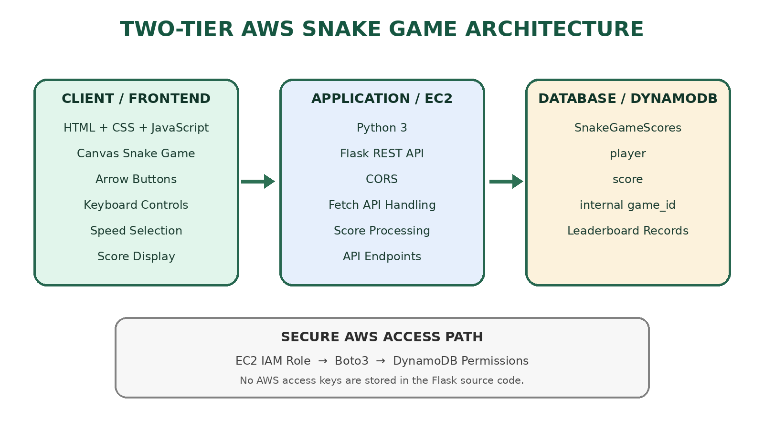
Figure 1. Two-tier AWS Snake Game architecture and secure AWS access path.

6.2 End-to-End Data Flow
- The player opens the game in a browser.
- The player enters a name and selects a speed.
- JavaScript runs the game locally and updates the score.
- At game over, the browser sends player and score to POST /api/score.
- Flask validates the request and writes an item to DynamoDB through Boto3.
- The browser calls GET /api/scores to retrieve leaderboard records.
- JavaScript sorts/displays the returned top scores in the leaderboard.

6.3 Security Concept
The EC2 instance can assume an IAM role with DynamoDB permissions. This avoids storing long-lived AWS access keys inside the Flask source code and makes the permission model easier to manage.

7. FRONTEND DEVELOPMENT

7.1 User Interface
The main frontend is designed with a dark green theme and high-contrast controls. The setup card contains the player-name field, speed buttons and Start Game button. The score is displayed above the canvas, the directional pad is placed below the game area and the leaderboard appears beneath the game controls.
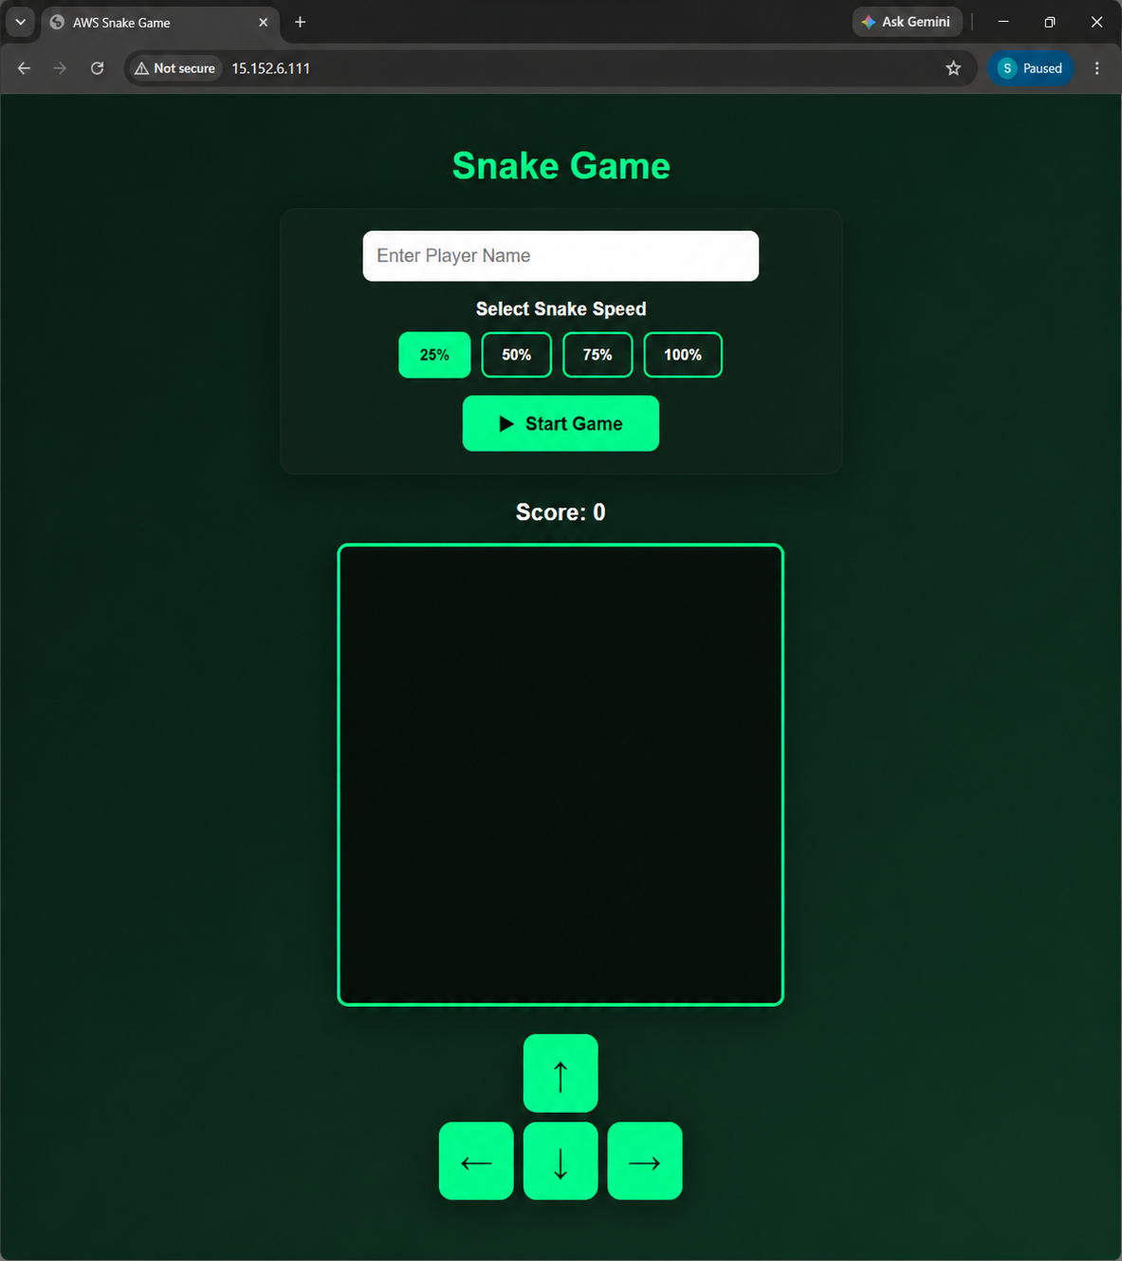
Figure 2. Deployed Snake Game interface before starting a game.

7.2 Responsive Layout
The canvas uses a responsive width on smaller screens. Directional buttons are large enough for touch interaction and use touch-friendly browser behavior. The same movement functions are shared by the mobile buttons and keyboard controls, so the gameplay rules remain consistent.

7.3 Setup Workflow
The user enters a name, selects one speed level and presses Start Game. After the game begins, the setup controls are disabled until the game ends. This prevents accidental speed changes during a running session.

8. SNAKE GAME IMPLEMENTATION

8.1 Game Board
The game uses an HTML canvas with a logical grid. The snake is stored as an array of coordinate objects. Every game tick inserts a new head position and removes the tail unless food has been collected.

8.2 Movement Logic
function moveUp() {
if (!gameRunning) return;
if (dy !== 1) { nextDx = 0; nextDy = -1; }
}

function moveRight() {
if (!gameRunning) return;
if (dx !== -1) { nextDx = 1; nextDy = 0; }
}

8.3 Food and Score
Food is generated at a random grid position that is not occupied by the snake. Each successful food collection increases the score by 10 and extends the snake by one segment.

8.4 Collision Detection
A collision with a board boundary or a snake body segment ends the session. The timer is stopped, the final score is displayed and the score is sent to the cloud backend.

8.5 Game State
The main client-side state consists of snake coordinates, food position, current and next movement directions, score, running state, selected speed and player name. Keeping this state explicit makes the game easier to understand and test.

9. MOBILE AND LAPTOP CONTROLS & SNAKE SPEED

9.1 Four-Direction Touch Controls
The game uses a directional-pad layout: Up is centered above Left, Down and Right. Each button invokes the corresponding JavaScript movement function. This makes the game practical on phones and tablets without requiring a physical keyboard.
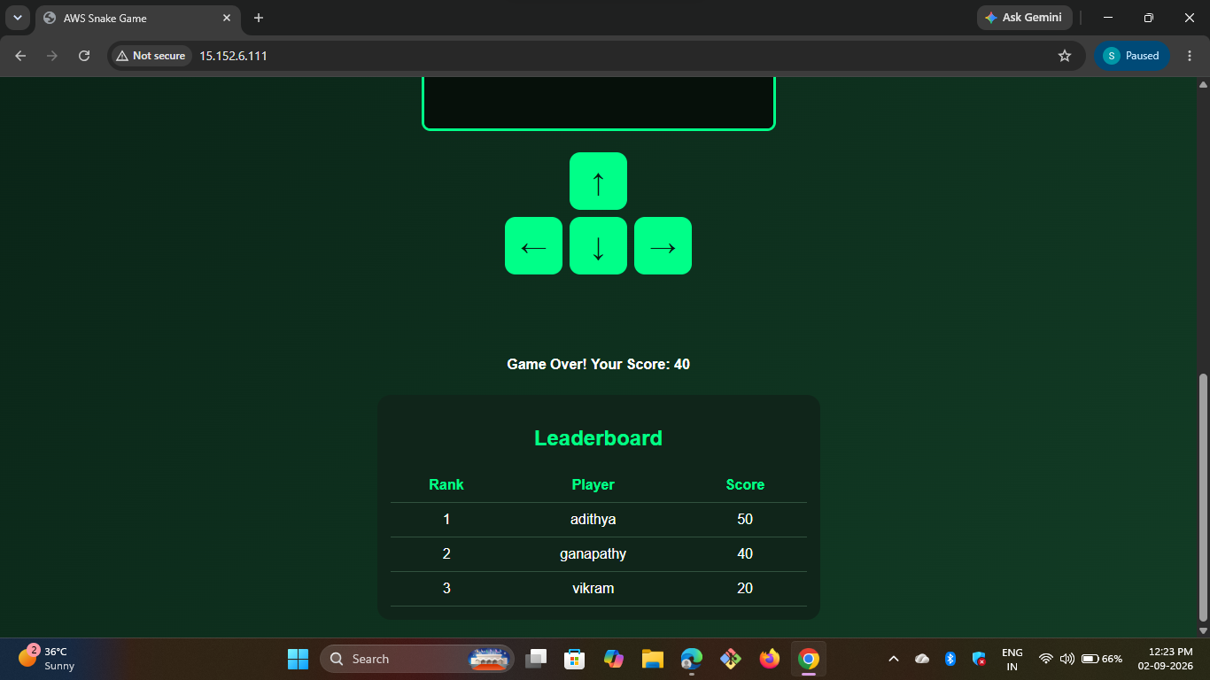
Figure 3. Game-over view showing the four touch controls and leaderboard.

9.2 Laptop Keyboard Controls
The browser keydown event listens for ArrowUp, ArrowDown, ArrowLeft and ArrowRight. Default browser scrolling is prevented while the game is active, and the same movement functions used by the touch buttons are called.

9.3 Speed Selection
Four speed choices are provided before the game starts. The labels are relative gameplay settings, not CPU or network percentages. They change the interval between game-loop updates.
const speedSettings = {
25: 250,
50: 180,
75: 120,
100: 70
};

9.4 Speed Behavior
- 25% - slowest and suitable for beginners.
- 50% - moderate speed for normal play.
- 75% - faster challenge level.
- 100% - fastest setting for advanced play.

10. BACKEND DEVELOPMENT USING FLASK

10.1 Flask Application
The backend is implemented as a Flask application that exposes REST routes. It receives JSON requests, validates player and score data, writes score items to DynamoDB and returns JSON responses to the frontend.
from flask import Flask, request, jsonify
from flask_cors import CORS
import boto3
import uuid

app = Flask(__name__)
CORS(app)
dynamodb = boto3.resource("dynamodb", region_name="ap-northeast-3")
table = dynamodb.Table("scoreboard")

10.2 Save Score Endpoint
@app.route("/api/score", methods=["POST"])
def save_score():
data = request.get_json()
game_id = str(uuid.uuid4())
table.put_item(Item={
"game_id": game_id,
"player": data.get("player"),
"score": int(data.get("score"))
})
return jsonify({"message": "Score saved successfully!"})

10.3 Leaderboard Endpoint
The /api/scores route reads score items, sorts them from highest to lowest and returns the top ten records. This approach is easy to implement and understand for a small demonstration dataset.
The internal game_id is not shown in the game interface. It exists only so each DynamoDB score item can have a unique key.

11. REST API AND FETCH API INTEGRATION

11.1 API Endpoints
Method | Endpoint | Purpose
GET | /api/message | Checks backend connectivity
POST | /api/score | Stores a completed game score
GET | /api/scores | Returns leaderboard records

11.2 Score Submission
const response = await fetch(API_URL + "/api/score", {
method: "POST",
headers: {"Content-Type": "application/json"},
body: JSON.stringify({player: playerName, score: score})
});

11.3 Leaderboard Retrieval
const response = await fetch(API_URL + "/api/scores");
const scores = await response.json();

11.4 Request and Response Flow
The browser creates the JSON payload, sends it to the EC2 public endpoint and waits asynchronously for the result. When the response arrives, JavaScript updates the user interface. The same pattern is used when loading leaderboard records.

11.5 Error Handling
Frontend try/catch blocks handle network errors, while Flask exception handling returns JSON error information. During testing, successful requests return HTTP 200 responses.

12. AMAZON DYNAMODB AND DATABASE INTEGRATION

12.1 Purpose of DynamoDB
DynamoDB provides persistent score storage for the leaderboard. A completed game is written as a database item containing the player name, score and an internal unique key.
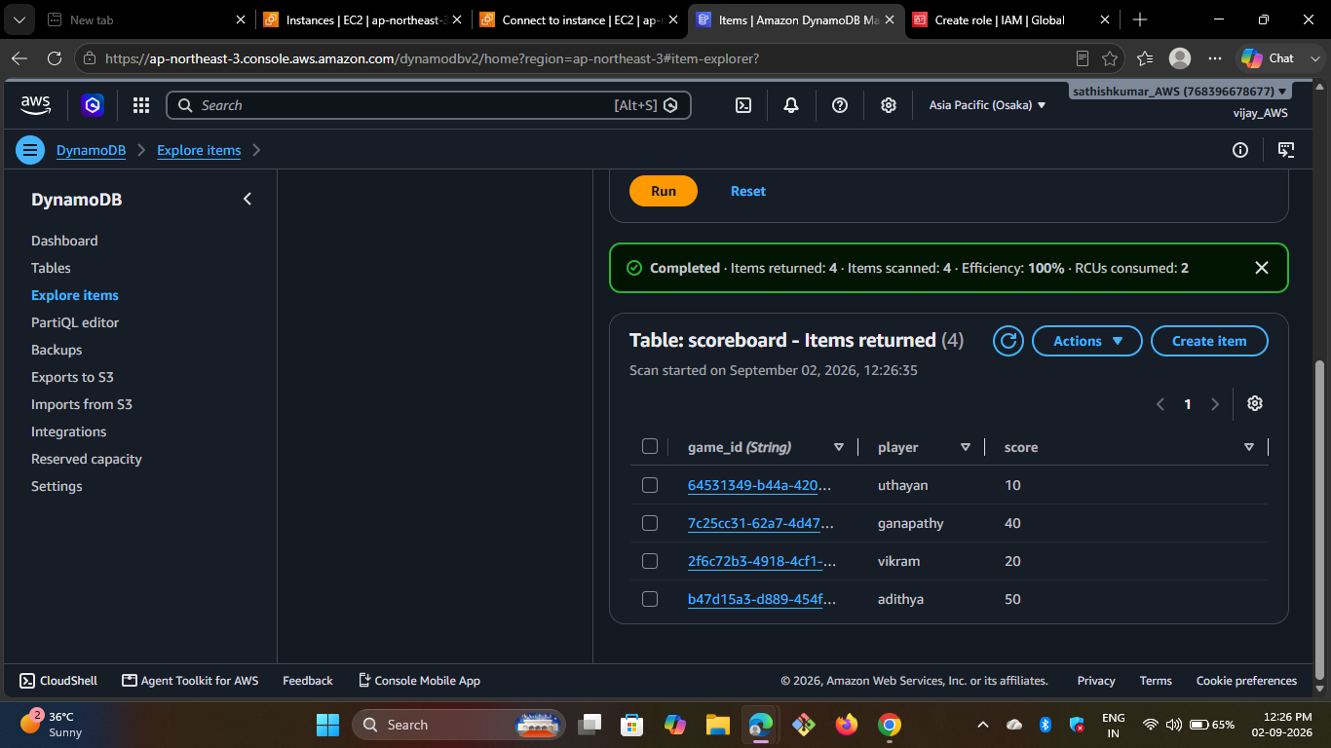
Figure 4. DynamoDB Explore Items view showing stored Snake Game scores.

12.2 Observed Table Structure
- Table shown in the supplied deployment evidence: scoreboard.
- Partition key shown: game_id (String).
- Player attribute: player.
- Score attribute: score.

12.3 Backend-to-Database Access
The Flask backend uses Boto3 to access the table. The EC2 IAM role supplies the AWS permissions. Because the application uses the instance role, AWS secret keys do not need to be embedded in app.py.

12.4 Leaderboard Logic
For this mini project, the backend performs a table scan and sorts the returned items in application memory before taking the first ten scores. This is simple and suitable for a small demonstration dataset, although a larger system should use a more efficient data access pattern.

13. AMAZON EC2, IAM AND DEPLOYMENT

13.1 EC2 Instance
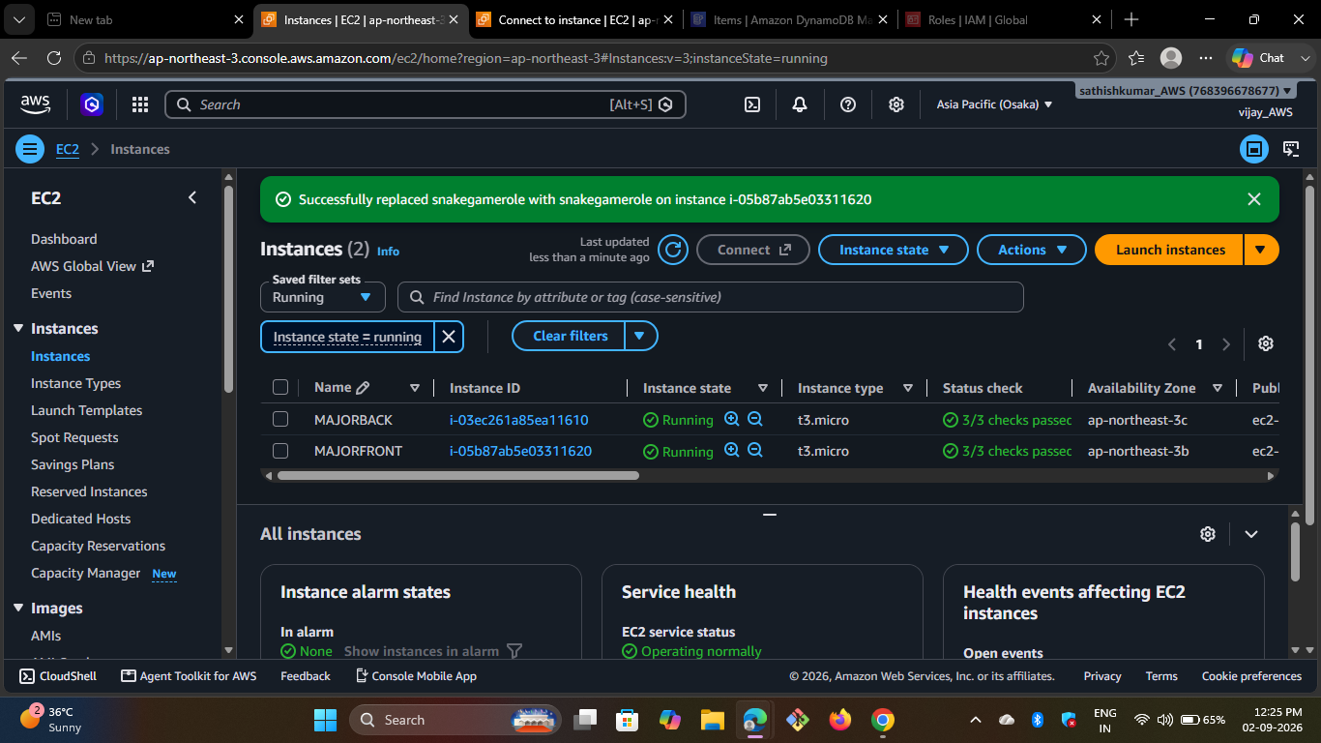
Figure 5. EC2 Instances view showing the running project instance.
The EC2 instance provides the compute environment for the Flask service. The supplied screenshot shows the project instance in the running state with successful status checks.

13.2 Flask Runtime Evidence
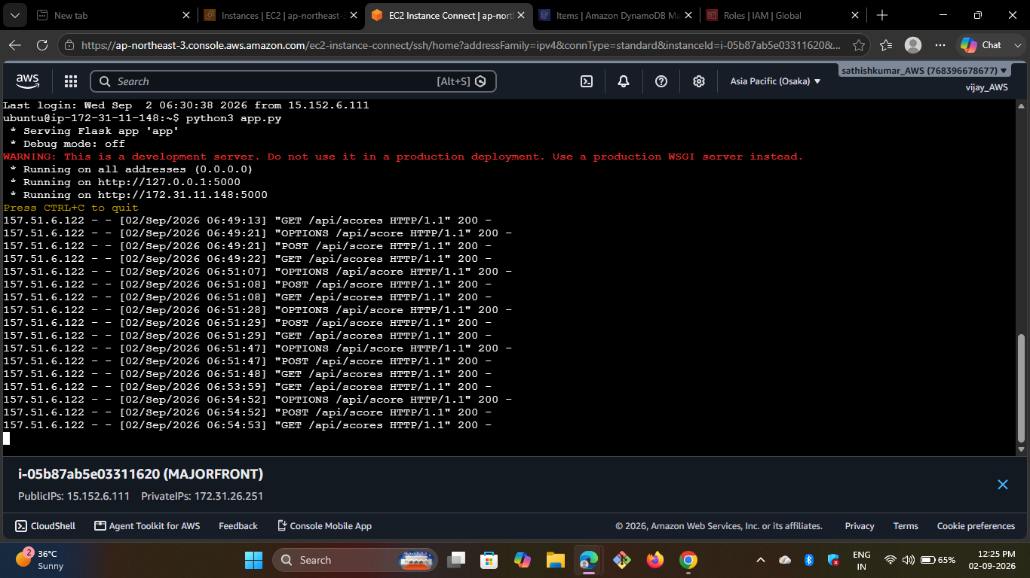
Figure 6. EC2 Instance Connect terminal showing the Flask server and successful API requests.
The terminal shows Flask listening on 0.0.0.0:5000 and receiving GET, POST and OPTIONS requests from the browser.

13.3 Deployment Sequence
- Create or start the EC2 Linux instance.
- Connect using EC2 Instance Connect or SSH.
- Install Python, Flask, Flask-CORS and Boto3.
- Create or upload app.py and configure the DynamoDB region/table.
- Attach an IAM role with the required DynamoDB permissions.
- Allow TCP port 5000 in the security group for project testing.
- Run python3 app.py and update the frontend API_URL with the EC2 public IP.

13. AMAZON EC2, IAM AND DEPLOYMENT - IAM CONFIGURATION

13.4 IAM Role for EC2
IAM controls which AWS actions the EC2 application can perform. The supplied screenshot shows the Create Role workflow with AWS service selected as the trusted entity, which is the appropriate starting point for an EC2-assumed role.
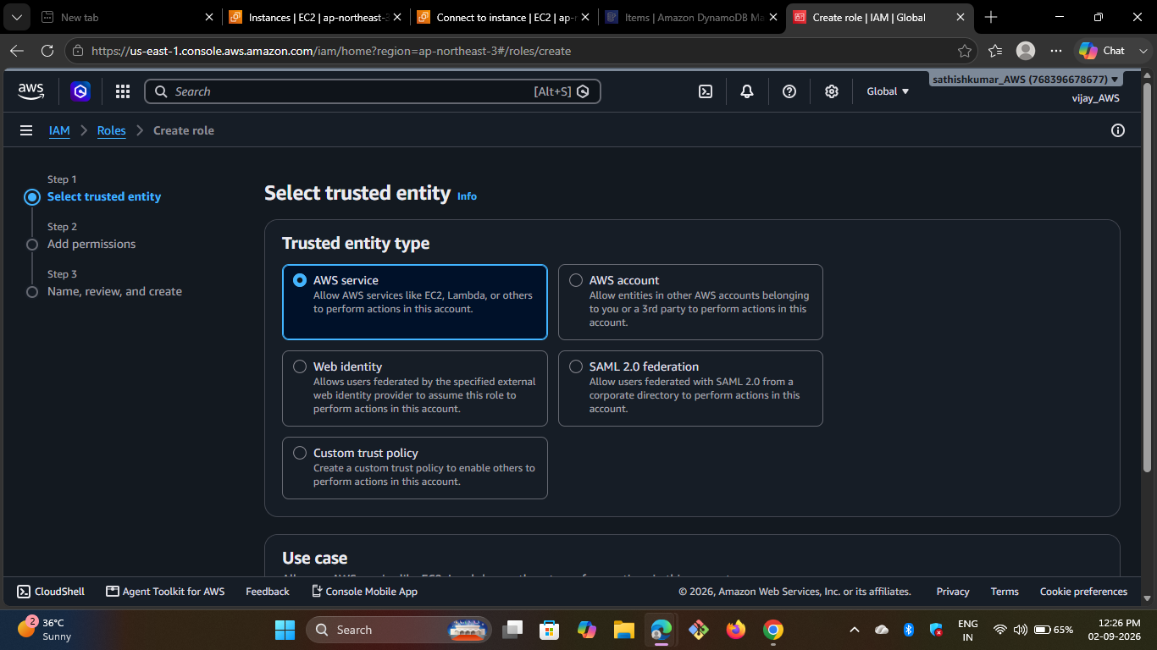
Figure 7. IAM Create Role screen showing AWS service as the trusted entity.

13.5 Permission Scope
For this application, the role should contain only the DynamoDB permissions required for score storage and retrieval. Broad permissions can be reduced later under a least-privilege approach.

13.6 Boto3 Access Pattern
dynamodb = boto3.resource(
"dynamodb",
region_name="ap-northeast-3"
)
table = dynamodb.Table("scoreboard")
Security practice: do not place an AWS access key ID or secret access key directly inside app.py. Use the EC2 IAM role so Boto3 can obtain temporary credentials for the instance.

13.7 Deployment Verification
Successful operation is supported by the combination of the EC2 running-instance evidence, IAM role setup, and terminal request logs. Together they demonstrate compute availability, permissions configuration and active API traffic.

14. LEADERBOARD, TESTING AND RESULTS

14.1 Leaderboard
After game over, the score is submitted to the API and the leaderboard is refreshed. The displayed ranking contains Rank, Player and Score values. The supplied final screenshot shows a populated leaderboard after a completed session.
Figure 8. Final game view showing the leaderboard after a completed session.

14.2 Functional Test Cases
ID | Feature | Action | Expected | Result
TC-01 | Player name | Start without name | Validation message | Pass
TC-02 | Speed | Select 25/50/75/100% | Selected speed applied | Pass
TC-03 | Touch | Tap arrow button | Snake moves | Pass
TC-04 | Keyboard | Press arrow key | Snake moves | Pass
TC-05 | Score | Eat food | Score increases | Pass
TC-06 | Collision | Hit wall/body | Game ends | Pass
TC-07 | API | Finish game | Score stored | Pass
TC-08 | Leaderboard | Load scores | Rankings display | Pass
TC-09 | DynamoDB | Check items | Player/score stored | Pass

14.3 Results
The supplied screenshots show successful integration: the EC2 instance is running, Flask reports successful API calls with HTTP 200, DynamoDB contains multiple score records and the final browser view displays the leaderboard. These observations support successful end-to-end testing of the demonstrated application.

15. CONCLUSION AND FUTURE ENHANCEMENTS

15.1 Advantages
- Simple and intuitive game interface.
- Supports mobile touch buttons and laptop keyboard controls.
- Offers four configurable gameplay speeds.
- Stores scores in a cloud database.
- Demonstrates REST API and Fetch API integration.
- Uses EC2, IAM, Boto3 and DynamoDB in one project.

15.2 Limitations
- Leaderboard retrieval uses a table scan, which is appropriate for a small project but not for large datasets.
- The Flask development server is used for demonstration rather than a production WSGI deployment.
- The current design records individual game sessions rather than maintaining only a player high score.
- The demonstrated API uses HTTP and a public testing port rather than a production HTTPS configuration.

15.3 Future Enhancements
- Use Gunicorn or another production WSGI server.
- Add HTTPS through a reverse proxy or load balancer.
- Design an efficient high-score query or secondary index.
- Add authentication and player accounts.
- Add pause, restart, sound, themes and difficulty modes.
- Store selected speed with each score for better analytics.
- Deploy the frontend through a managed static hosting solution such as S3/CloudFront.

15.4 Conclusion
The AWS Snake Game successfully demonstrates how a familiar browser game can be connected to cloud services. The frontend provides responsive gameplay and configurable speed, while the Flask API on EC2 manages score requests and DynamoDB provides persistent leaderboard storage. IAM and Boto3 connect the application to AWS without embedding long-lived secrets in the source code.
The project therefore serves as a practical example of a two-tier cloud application that combines web development, REST APIs, Linux-based deployment, IAM permissions and NoSQL persistence in one understandable implementation.

