IMPLEMENTATION OF A TWO-TIER STUDENT
REGISTRATION SYSTEM ON AMAZON EC2
PROJECT DOCUMENTATION
Name: Sathishkumar
Course: AWS
Project Type: Mini Project
Cloud Platform: Amazon Web Service (AWS) - EC2
Project Duration: June 2026
A cloud-hosted student registration web application using HTML, CSS, JavaScript and Python Flask on Amazon EC2.

ABSTRACT
This mini project presents a two-tier Student Registration System deployed on Amazon EC2. The system provides a simple browser-based registration interface through which a student can enter basic information such as name, email address, phone number, course, department and academic year. The user interface is developed with HTML and CSS, while JavaScript can be used to collect form values and send them to the backend. The backend is implemented using Python Flask and is responsible for receiving HTTP requests, validating the submitted values, processing the registration request and returning a response to the browser. Amazon EC2 provides the Linux-based cloud environment in which the Flask application runs. The project demonstrates the core ideas of client-server communication, HTTP request and response handling, cloud deployment, security group configuration and practical AWS usage. The architecture keeps the presentation layer separate from the application layer, making the system simple to understand and suitable for an academic mini project.

CONTENTS
1. Introduction - Purpose, background and working concept of the project
2. Problem Statement, Objectives and Scope - Need, goals and project boundaries
3. Proposed System and Two-Tier Architecture - Architecture layers, request flow and component interaction
4. Technologies and Tools Used - Web technologies, Python Flask and AWS EC2
5. System Implementation - Frontend design, backend logic, API communication and workflow
6. AWS EC2 Deployment and Connection - EC2 setup, Linux configuration, security group and application access
7. Testing and Results - Functional testing, workflow verification and screenshots
8. Advantages, Limitations and Future Enhancements - Benefits, current limitations and possible extensions
9. Project Summary - Final project details in line-by-line format
10. Conclusion - Overall result and learning outcome

1. Introduction
Cloud computing has made it possible to host web applications on internet-accessible infrastructure without depending on a local physical server. Amazon Web Services provides a wide range of cloud services that can be used for application deployment, networking, storage, security and monitoring. Amazon EC2 is one of the main compute services in AWS and provides a virtual server environment where application code can be installed, configured and executed.
The Student Registration System developed for this project is a small cloud-based web application intended to demonstrate the basic flow of a real web solution. A student opens the portal using a web browser, enters the required registration details and submits the form. The browser sends an HTTP request to the Flask backend running on the EC2 instance. The backend receives the values, processes the request and sends an HTTP response back to the browser. The result can then be displayed to the student.
The application is deliberately designed with a simple two-tier structure. The first tier is the presentation side, consisting of the browser and the HTML/CSS-based interface. The second tier is the application side, consisting of Python Flask running on the EC2 server. This structure helps a learner understand how frontend and backend components communicate over a network while also gaining practical experience with Linux and AWS deployment.

2. Problem Statement, Objectives and Scope
Traditional student registration may involve paper forms or local software. Such approaches can require manual data entry, repeated effort and physical handling of information. A browser-based registration portal provides a simple digital interface and demonstrates how the same task can be performed through an internet-accessible application hosted in the cloud.
The primary objective of the project is to create a working student registration portal with a clear user interface and a lightweight Python backend. The project also aims to demonstrate client-server communication, HTTP request handling, Flask routing, Linux server administration and deployment of a web application on Amazon EC2.
The current scope focuses on the essential registration workflow. The form includes student name, email, phone number, course, department and year. The backend processes the submitted values and returns the result to the browser. Permanent database storage, authentication, administration and advanced reporting are outside the current scope and can be added later.

3. Proposed System and Two-Tier Architecture
The proposed system separates the user-facing interface from the application processing logic. This separation is the main idea behind the two-tier architecture used in the project. The student interacts with the portal through a browser, while the Flask application running on Amazon EC2 performs the server-side work. The two parts communicate through HTTP requests and responses.
Tier 1 - Presentation Layer: The presentation tier is the browser-based registration page. HTML defines the form structure, CSS controls the appearance and layout, and JavaScript can be used for client-side interaction and fetch-based communication. The user enters the information into the form and starts the registration request by selecting the Register Student button.
Tier 2 - Application Layer: The application tier is the Python Flask service hosted on the EC2 instance. Flask provides URL routes that receive incoming requests. The backend reads the registration data, checks that the expected fields are present, performs the required processing and creates an appropriate HTTP response. The server then returns the result to the browser.
USER / WEB BROWSER
↓
HTML + CSS + JAVASCRIPT
↓
HTTP REQUEST
↓
PYTHON FLASK APPLICATION
↓
AWS EC2
↓
HTTP RESPONSE
↓
WEB BROWSER
The request flow begins when the student submits the form. The frontend collects the entered values and sends them to the backend endpoint. Flask receives the request and processes it. After the processing is complete, the backend generates a response and sends it back through the same network path. This simple flow demonstrates the central concept of a two-tier application and provides a foundation for future enhancements.
The EC2 instance acts as the cloud infrastructure for the second tier. It provides the operating system, network interface, storage and runtime environment required to execute the Flask application. In a future version, a separate database service such as Amazon DynamoDB or Amazon RDS can be added as another layer, turning the design into a three-tier architecture.

4. Technologies and Tools Used
HTML5 - HTML is used to create the structure of the registration page. It provides the form, input elements, selection controls and button required for collecting student details.
CSS3 - CSS is used to create the visual appearance of the portal, including the page background, registration card, field spacing, typography, borders, alignment and button styling.
JavaScript / Fetch - JavaScript can collect form values in the browser and use the Fetch API to send the information to the Flask backend using HTTP. It supports asynchronous communication without requiring a full page reload.
Python - Python is the programming language used for the server-side application logic. It provides the runtime in which the Flask application executes on the EC2 server.
Flask - Flask is a lightweight Python web framework. It defines routes, receives HTTP requests, processes submitted data and returns HTTP or JSON responses.
Amazon EC2 - Amazon EC2 provides the cloud virtual machine where the application is installed and executed. The instance can be reached over the network according to its security group configuration.
Linux - Linux provides the operating environment for the EC2 instance. It is used for package installation, file management, application execution, networking and server administration.
HTTP / HTTPS - HTTP is the communication protocol used between the browser and the backend. HTTPS can be added in a production-style deployment to protect data in transit.
AWS Security Group - The security group controls inbound and outbound traffic for the EC2 instance. It is used to permit administrative access such as SSH and web access on the required port.
Web Browser - The browser is the client through which the student opens the portal, enters information and views the registration result.
Together, these technologies form a lightweight stack that is easy to deploy and explain. The frontend handles presentation and user interaction, Flask handles application logic, and EC2 supplies the cloud server environment. The combination is sufficient to demonstrate the essential stages of a basic cloud-hosted web application.

5. System Implementation
The frontend is implemented as a centered registration form designed for clarity and easy use. The page contains a blue header area, the title Student Registration and form controls for Student Name, Email, Phone Number, Course, Department and Year. The layout uses a clean registration card with consistent spacing so that the user can complete the form without confusion.
The student enters the required information and selects the appropriate values from the dropdown controls. When the Register Student button is clicked, the browser sends the information to the Python Flask backend. In a fetch-based implementation, JavaScript can collect the form fields and submit the values as JSON to a backend endpoint. The Flask route then reads the request data, performs basic validation and creates the registration response.
The backend is responsible for handling application requests rather than the visual presentation. A typical Flask implementation contains an application object, a route for the registration request and response handling logic. The backend can return JSON data for frontend processing or render a result page containing the submitted student details. This separation keeps the project simple and clearly demonstrates the relationship between the two tiers.
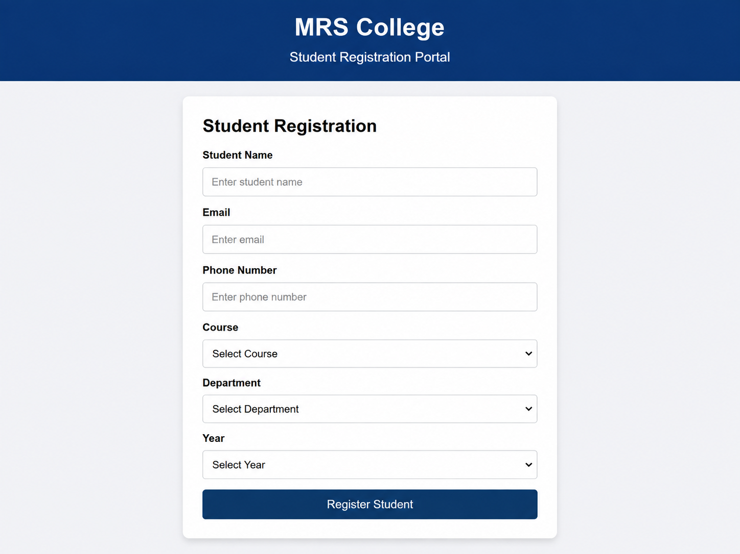
Figure 1. Student Registration Portal - complete registration form

6. AWS EC2 Deployment and Connection
Amazon EC2 is used as the cloud server for the project. A suitable Linux-based instance is launched from the AWS Management Console, and a key pair is configured so that the administrator can connect securely using SSH. After the instance starts, the public IP address or DNS name is used to reach the server over the network.
On the Linux server, the package list is updated and Python with pip is installed. A project directory is created for the Student Registration System, and the required Flask packages are installed. The application files, including the Flask Python program and the HTML templates, are then placed in the project directory. The application is executed on the server and tested locally before external access is enabled.
The EC2 security group is an important part of the connection. SSH access is normally permitted on port 22 for administration, while the web application port is opened according to the chosen deployment method. For a simple academic setup, Flask may listen on port 5000. For a more production-oriented deployment, Nginx and Gunicorn can be placed in front of the application and the service can be exposed through HTTP or HTTPS on the standard web ports.
The connection between the browser and the backend is therefore established through the EC2 public network endpoint. Once the application process is running and the correct port is allowed by the security group, the portal can be opened from a browser. The browser sends requests to the Flask application and receives the registration response from the same EC2-hosted service.

Typical deployment commands
sudo apt update
sudo apt install python3 python3-pip -y
python3 --version
pip3 --version
mkdir student-registration
cd student-registration
pip3 install flask flask-cors
python3 app.py

7. Testing and Results
Testing is performed to confirm that the application loads correctly, accepts the expected registration values, communicates with the backend and returns the expected result. Functional testing is carried out from the point of opening the portal through the final registration response.
First, the portal is opened using the EC2 public endpoint. The registration page should load without missing resources or layout errors. The user then enters a valid student name, email address and phone number and selects the course, department and year. When the Register Student button is pressed, the request should reach the Flask backend and the backend should process the values successfully.
The final test verifies that the submitted information is reflected in the registration result. A successful output confirms that the two tiers are connected correctly and that the server has processed the request. The following screenshot represents the final successful result produced by the project.
Test 1 - Open portal: Registration page loads through the EC2 endpoint.
Test 2 - Enter student details: Name, email, phone, course, department and year accept valid values.
Test 3 - Submit registration: The browser sends the request to the Flask backend.
Test 4 - Process request: Flask receives and processes the submitted values.
Test 5 - Display result: A successful registration response is returned to the browser.
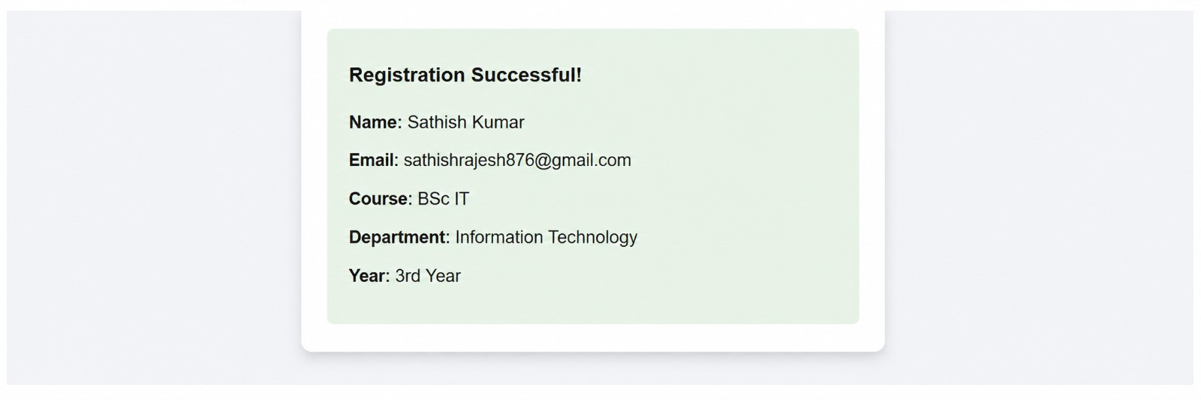
Figure 2. Registration Successful - submitted student details displayed
The successful output demonstrates the complete request-response path: the student enters information in the presentation tier, the application tier receives the request on EC2, the Flask backend performs the processing and the result is returned to the browser. The test confirms that the basic two-tier workflow is functioning as intended.

8. Advantages, Limitations and Future Enhancements

Advantages
The project provides a simple and easy-to-use registration interface that can be accessed through a web browser. It demonstrates practical integration of frontend development, backend programming and cloud deployment within one small application.
Using Amazon EC2 gives practical experience with Linux administration, server configuration, networking and security group management. The two-tier separation also makes the application architecture easy to explain, troubleshoot and extend.

Limitations
The current mini project focuses on form processing and response generation, so it does not provide permanent database storage. There is no dedicated student login, administrator dashboard, role-based access control or advanced reporting. In addition, the simple Flask server setup is suitable for academic demonstration but is not a full production deployment architecture.
The application also depends on the EC2 instance being available and correctly configured. Without a persistent database, submitted details are not stored as a long-term student record system. These limitations are intentional so that the basic two-tier concepts remain easy to understand.

Future Enhancements
A database service such as Amazon DynamoDB or Amazon RDS can be added to store student registrations permanently, which would introduce a separate data tier and create a three-tier architecture. Authentication can be added so that students and administrators have controlled access to the application.
The deployment can also be strengthened using Nginx and Gunicorn, HTTPS with TLS, a domain name, CloudWatch monitoring, automated backups and a load balancer. Search, edit and delete functions, duplicate checking and an administrator dashboard can further transform the mini project into a more complete student management application.
Automated deployment through GitHub Actions or AWS CodePipeline can be introduced later to demonstrate a basic DevOps workflow. These improvements would make the project more scalable, secure and suitable for a real-world environment.

9. Project Summary
Project Title: Implementation of a Two-Tier Student Registration System on Amazon EC2
Name: Sathishkumar
Course: AWS
Project Type: Mini Project
Cloud Platform: Amazon Web Service (AWS) - EC2
Project Duration: June 2026
Frontend: HTML, CSS and JavaScript
Backend: Python Flask
Communication: HTTP request and response
Architecture: Two-tier web architecture
Main Function: Student registration form and backend request processing
Deployment Environment: Linux-based Amazon EC2 instance
Output: Successful registration response displayed in the browser
The project brings together the main concepts required to understand a basic cloud-hosted web application. The browser provides the user interface, the Flask application handles the registration request, and the EC2 instance supplies the cloud server environment. The implementation demonstrates how a small web solution can be developed locally and then deployed to an AWS virtual server for remote access.

10. Conclusion
The Implementation of a Two-Tier Student Registration System on Amazon EC2 successfully demonstrates the design, connection and deployment of a simple cloud-based web application. The system combines a clear HTML/CSS frontend with a Python Flask backend and uses Amazon EC2 as the hosting environment. The student registration workflow is completed through a browser, while server-side processing takes place on the EC2 instance.
The project provides practical experience with frontend development, Python Flask, HTTP communication, Linux commands, AWS EC2 configuration and security group management. It also establishes a strong foundation for future improvements such as database integration, authentication, HTTPS, monitoring, load balancing and automated deployment.
As an academic mini project, the system demonstrates the essential principles of a two-tier application in a simple and understandable form. The completed implementation shows how cloud infrastructure can be used to host and access a web application and provides a useful starting point for learning larger AWS and DevOps-based application architectures.

