TATA CLIQ – DATA ARCHITECTURE & DAX STRATEGY DOCUMENT
E-Commerce Sales, Customer & Product Analytics | Power BI
Purpose: provide a handover-ready architecture reference covering source, tables, facts/dimensions, columns, data types, relationships, schema, ER view, Power BI connectivity, references, and a DAX implementation strategy.

1. Source & Evidence
Item | Observed / documented value | Status
Report | TATA CLIQ Analytics Dashboard | Confirmed
PBIX model tables | FactSales, DimDate, DimCustomer, DimProduct, DimEmployee, DimStore, FactReturns, SalesTargets, RegionTarget, ViewSelector | Confirmed from model layout
Business scope | Sales, profitability, customers, products, returns and delivery | Confirmed
Original physical source | Not exposed in the supplied user guide; PBIX connection metadata does not identify a source such as SQL/Excel in the extracted connection artifact | Needs validation
Storage mode | Not asserted from supplied evidence | Needs validation
The supplied Power BI user guide states that the report tracks sales, profitability, customers and product performance and lists the model tables above.

2. Data Model – Fact vs Dimension
Table | Role | Business purpose
FactSales | FACT | Core sales transactions; sales, profit, orders, returns/delivery-related metrics
FactReturns | FACT | Return transaction/detail data
DimDate | DIMENSION | Calendar attributes: year, month, day
DimCustomer | DIMENSION | Customer, region, state, city
DimProduct | DIMENSION | Product, category, sub-category, brand
DimEmployee | DIMENSION | Employee, department, region
DimStore | DIMENSION | Store and state
RegionTarget | TARGET / DIM-LIKE | Regional target sales and profit
SalesTargets | TARGET | Target values used for target analysis; exact physical relationship requires validation
ViewSelector | HELPER / DISCONNECTED | Likely used for view-selection logic; validate physical relationships
The guide explicitly describes FactSales as the core transaction table and identifies the five main dimensions plus target tables.

3. Column Inventory
Table | Columns / fields identified | Data type classification | Usage
DimDate | Year, Month, Day | Integer / Text / Date (validate exact model types) | Calendar filtering
DimCustomer | CustomerID, CustomerName, Region, State, City | Text / Integer | Customer slicing
DimProduct | ProductID, ProductName, Category, SubCategory, Brand | Text / Integer | Product slicing
DimEmployee | EmployeeID, Department, Region | Text / Integer | Employee analysis
DimStore | StoreID, State | Text / Integer | Store analysis
FactSales | Sales, Cost, Quantity, Order/Delivery fields and keys | Decimal / Integer / Date / Text (validate exact model types) | Measures and transaction analysis
FactReturns | Return-related keys and quantities | Integer / Text / Date (validate exact model types) | Returns analysis
RegionTarget | TargetSales, TargetProfit, Region | Decimal / Text | Target benchmarking
SalesTargets | Target fields | Decimal / Text / Date as applicable | Target analysis; validate columns
ViewSelector | Selector field(s) | Text / Integer | UX / selection logic
The report uses fields including Customer ID/Name, Product ID/Name, Store State/ID, Total Sales and Total Quantity in the Executive Table View.

4. Row-Level Design
Recommended grain documentation: FactSales should be documented as the lowest business transaction grain available in the PBIX. Do not describe it as 'one row per order' unless the physical key confirms that. If an OrderID + ProductID combination is the grain, state that explicitly in the final technical specification.
Object | Required grain / key documentation | Current status
FactSales | Primary/business key and exact grain | Validate in Power BI Model/Data view
FactReturns | Return key and relationship key to sales/order | Validate
DimCustomer | One row per CustomerID | Conceptual expectation; validate duplicates
DimProduct | One row per ProductID | Conceptual expectation; validate duplicates
DimStore | One row per StoreID | Conceptual expectation; validate duplicates
DimEmployee | One row per EmployeeID | Conceptual expectation; validate duplicates
DimDate | One row per calendar date | Conceptual expectation

5. Schema Strategy – Star Schema
The preferred semantic-model pattern is a star schema: dimensions filter facts, while measures are calculated from fact tables. Keep filter direction from dimension → fact wherever possible. Avoid unnecessary many-to-many and bidirectional relationships.
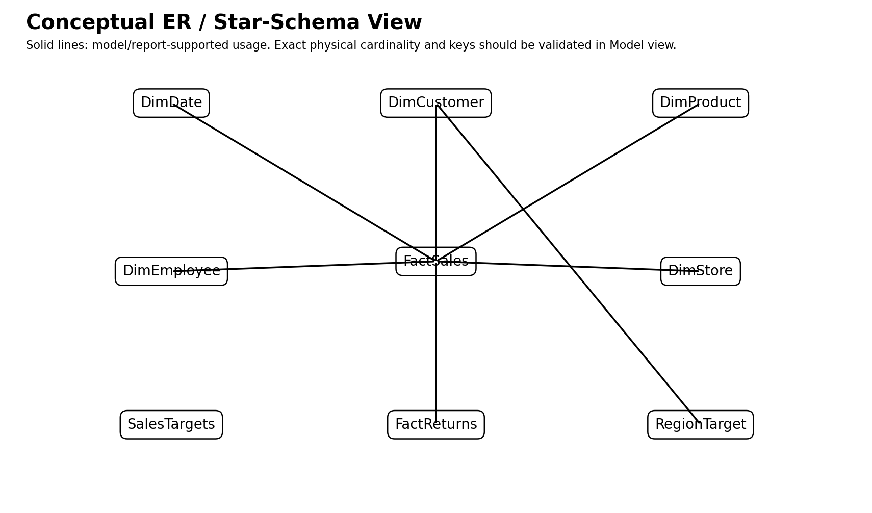
Figure 1. Conceptual ER / star-schema view. Exact physical keys/cardinality must be validated in Power BI Model view.

6. Relationship / Connection Matrix
From | To | Conceptual relationship | Recommended direction | Validation
DimDate | FactSales | Date key → transaction date key | Single: DimDate → FactSales | Confirm active date key
DimCustomer | FactSales | CustomerID → CustomerID | Single: DimCustomer → FactSales | Confirm 1:*
DimProduct | FactSales | ProductID → ProductID | Single: DimProduct → FactSales | Confirm 1:*
DimEmployee | FactSales | EmployeeID → EmployeeID | Single: DimEmployee → FactSales | Confirm 1:*
DimStore | FactSales | StoreID → StoreID | Single: DimStore → FactSales | Confirm 1:*
FactSales | FactReturns | Business return/order key | Prefer shared dimension/bridge where possible | Confirm actual design
DimCustomer | RegionTarget | Region → Region | Single if physically related | Confirm; may be better as shared Region dimension
The supplied report contains visuals that use FactSales together with DimDate, DimProduct and DimCustomer, and the Sales vs Target page uses DimCustomer.Region, FactSales measures and RegionTarget target columns.

7. How to Connect the Model in Power BI
1. Power BI Desktop → Home → Get Data → select the real source (Excel, SQL Server, CSV, etc.).
2. Load or transform source data in Power Query. Standardize column names, nulls, dates, data types and keys.
3. Create dimension tables first: DimDate, DimCustomer, DimProduct, DimEmployee and DimStore.
4. Load FactSales and FactReturns at their documented grain.
5. Create target tables such as RegionTarget/SalesTargets separately.
6. Open Model view and create key relationships. Prefer 1:* with the dimension on the 1-side and fact on the *-side.
7. Set cross-filter direction to Single unless a documented business requirement needs otherwise.
8. Hide technical key columns from report users after relationships are tested.
9. Create a dedicated Measures table if desired, then add DAX measures rather than calculated columns for aggregations.
10. Validate totals against source data before publishing.
For the current supplied report, the guide says the published report is opened from the Power BI Service workspace and that the dataset behind the report can be refreshed manually or by scheduled refresh.

8. KPI / DAX Reference
Measure | Business definition | DAX pattern
Total Sales | Sum of sales value | SUM(FactSales[Sales])
Total Profit | Sales minus cost | [Total Sales] - [Total Cost]
Total Cost | Sum of cost | SUM(FactSales[Cost])
Total Quantity | Sum of quantity | SUM(FactSales[Quantity])
Total Orders | Distinct count of orders | DISTINCTCOUNT(FactSales[OrderID])
Total Customers | Distinct customers | DISTINCTCOUNT(FactSales[CustomerID])
Profit Margin % | Profit / Sales | DIVIDE([Total Profit],[Total Sales])
Return Rate % | Returned orders / total orders | DIVIDE([Returned Orders],[Total Orders])
Avg. Order Value | Sales / orders | DIVIDE([Total Sales],[Total Orders])
Sales Growth % | Current vs prior comparable period | DIVIDE([Total Sales]-[Prior Sales],[Prior Sales])
YTD Sales | Year-to-date sales | TOTALYTD([Total Sales],DimDate[Date])
Late Delivery % | Late deliveries / relevant orders | DIVIDE([Late Deliveries],[Total Orders])
Avg. Delivery Days | Average order-to-delivery duration | AVERAGE(FactSales[DeliveryDays])
The business definitions for Total Sales, Total Profit, Profit Margin %, Total Orders, Return Rate %, Avg. Order Value, Sales Growth %, VIP customers, Late Delivery % and Avg. Delivery Days are documented in the supplied guide.
Important: the exact physical column names such as Sales, Cost, Quantity, OrderID, Date and DeliveryDays must be checked in the PBIX before passing these formulas. The formulas above are implementation patterns, not a claim that every physical column name is exactly this.

9. DAX Strategy Document
DAX layer | Strategy
Layer 1 – Base measures | Create reusable atomic measures first: Sales, Cost, Quantity, Orders, Customers, Returns.
Layer 2 – Profitability | Build Profit and Profit Margin from base measures instead of repeating SUM logic.
Layer 3 – Time intelligence | Use a dedicated marked Date table; build YTD, prior-period and growth measures from the date dimension.
Layer 4 – Ratios | Use DIVIDE() for percentage metrics to avoid divide-by-zero errors.
Layer 5 – Ranking | Use RANKX for Top N products/customers when required.
Layer 6 – Targets | Keep actuals and target measures separate; calculate variance and achievement percentage from them.
Layer 7 – Filter-aware metrics | Use CALCULATE() to intentionally modify filter context; avoid unnecessary ALL() because it can remove slicer context.
Layer 8 – Presentation | Format currency, counts and percentages at the measure level; keep report visuals thin and measure-driven.

10. Target / Variance DAX Patterns
Target Sales = SUM(RegionTarget[TargetSales])
Target Profit = SUM(RegionTarget[TargetProfit])
Sales Variance = [Total Sales] - [Target Sales]
Sales Achievement % = DIVIDE([Total Sales], [Target Sales])
Profit Variance = [Total Profit] - [Target Profit]
Profit Achievement % = DIVIDE([Total Profit], [Target Profit])

11. Report / Visual Reference
Page | Purpose | Key content
Executive Dashboard | Management overview | KPI cards, profit trends, regional/product analysis and slicers
Sales vs Target | Benchmarking | Region-wise actual vs target table, combo chart and map
Executive Table View | Row-level detail | Customer, product, store and sales detail
The user guide documents three report pages and describes their purposes and visuals.

12. Power BI Service / Deployment Checklist
☐ Publish PBIX to the correct workspace.
☐ Confirm semantic model refresh succeeds.
☐ Configure gateway/credentials if the source requires an on-premises gateway.
☐ Set scheduled refresh only after manual refresh is successful.
☐ Validate RLS if security rules are implemented.
☐ Publish the report through an App when business users should consume a controlled navigation experience.
☐ Test report filters, totals and exports in the Service.
The supplied guide describes Share, Create app, navigation/audience, publishing, Refresh now and Scheduled refresh workflows.

13. References & Validation Notes
Primary reference: supplied Power BI User Guide – “TATA CLIQ Analytics Dashboard | Power BI User Guide”. The guide documents the model tables, report pages, KPI definitions, filtering behavior and Power BI Service workflow.
PBIX validation note: the supplied PBIX contains a DataModel artifact and a DiagramLayout containing the model objects. The extracted report metadata confirms the table names and many field/measure references, but the original physical source and exact column data types/cardinality were not reliably exposed by the available extraction path. Those items are therefore marked “validate” rather than invented.

14. Final Architecture Summary
Recommended architecture: Source → Power Query → Star Schema → DAX Semantic Layer → Power BI Report → Power BI Service. Use FactSales/FactReturns for transactional facts, reusable dimensions for filtering, target tables for benchmarking, and a layered measure strategy for maintainability and performance.

