PROJECT No: 06  Date: 14-10-2026 | PERSONAL EXPENSE TRACKER USING R SHINY

PROBLEM STATEMENT:
Tracking everyday income and spending in notebooks or separate files makes it difficult to understand category-wise expenses and monthly savings. Manual totals can be inaccurate and do not provide quick visual summaries.

SOLUTION:
The Personal Expense Tracker is a local web dashboard built with R Shiny. It records income and expense transactions, validates entries, stores records in a CSV file, calculates income, expenses and net savings, displays category and monthly charts, supports filtering, and allows CSV download.
The system uses Shiny inputs and reactive outputs with ggplot2 visualizations. The CSV file acts as a simple local data store so the user can review and continue updating transactions between sessions.

BLOCK DIAGRAM(S):
Proposed solution workflow:
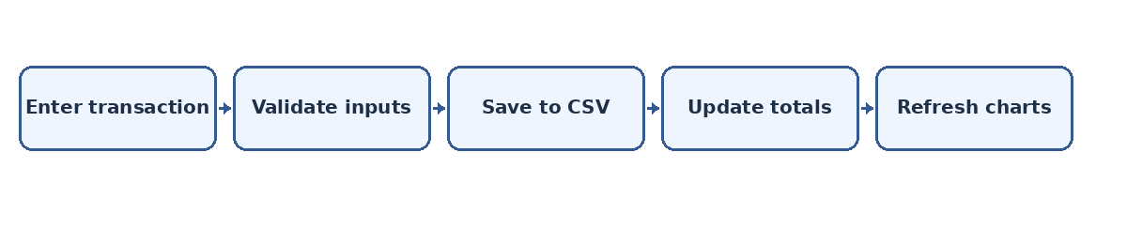
OUTPUT:

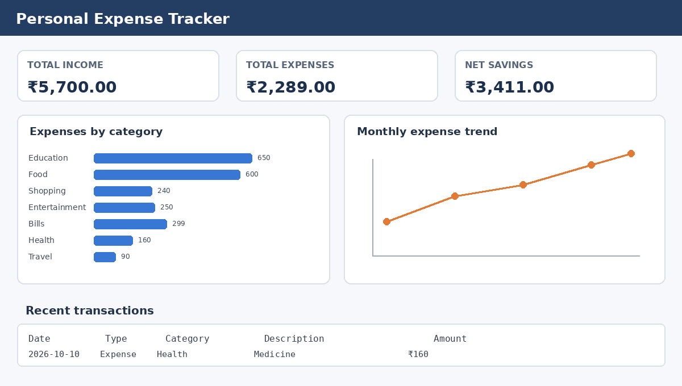
Figure:1
Explanation: The dashboard mock-up illustrates the three financial summary cards, expense category chart, monthly trend chart, and recent transaction table. The running application generates live values from the CSV data.

Figure:2
Explanation: The workflow shows how a transaction is entered, validated, saved to CSV, and reflected in the totals and charts.

GITHUB:
GitHub repository screenshot: add the repository screenshot here after uploading the project to GitHub.

OUTCOME:

The Personal Expense Tracker provides a simple interface to record transactions and understand spending patterns. It combines data entry, persistent CSV storage, reactive summary cards, visual analytics, filtering, and export in one R Shiny application.
Key Outcomes:
- Records income and expense transactions with dates and categories.
- Calculates total income, total expenses, and net savings.
- Visualizes category-wise expenses using a bar chart.
- Displays monthly expense trends using a line chart.
- Filters transaction records and exports data to CSV.
- Demonstrates Shiny UI/server structure, reactive programming, and ggplot2.

