**Experiment 1 : Confusion Matrix Using Python**

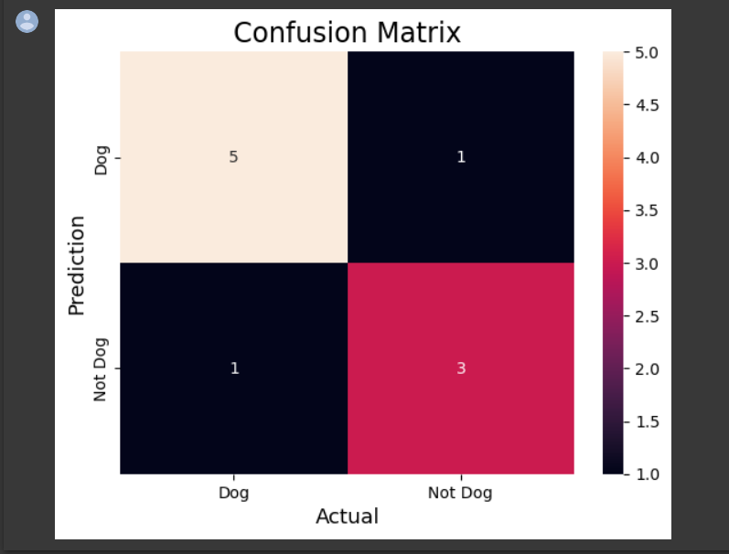

**Experiment 2 : 2 Class Confusion Matrix**

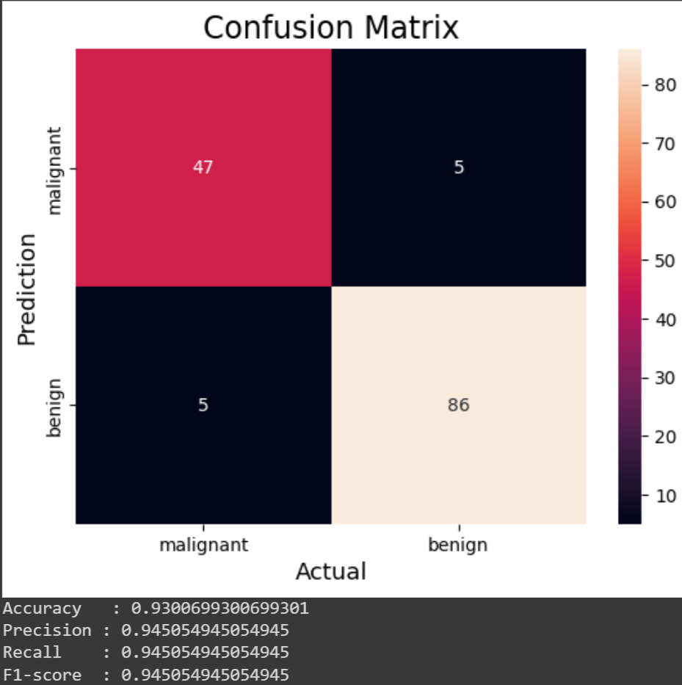

**Experiment 3 : Verify the performance of Multi Class Confusion Matrix using choosen Dataset**

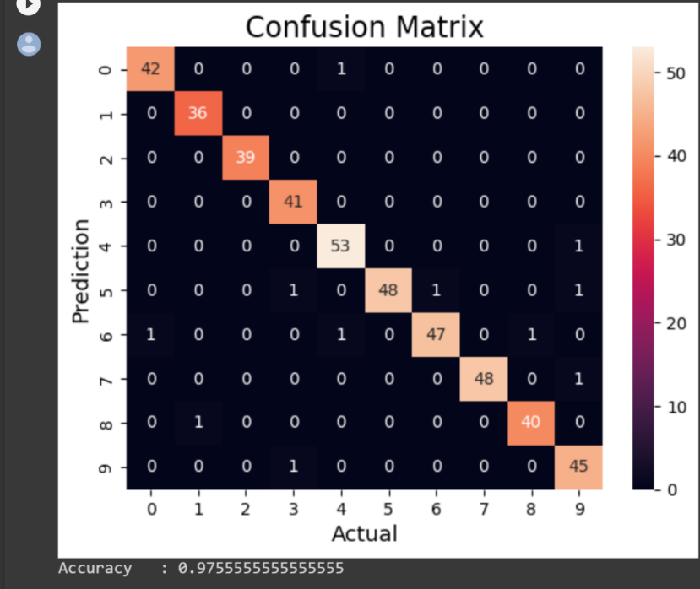

**Experiment 4 : Performance of Over Fitting using Chosen Dataset**

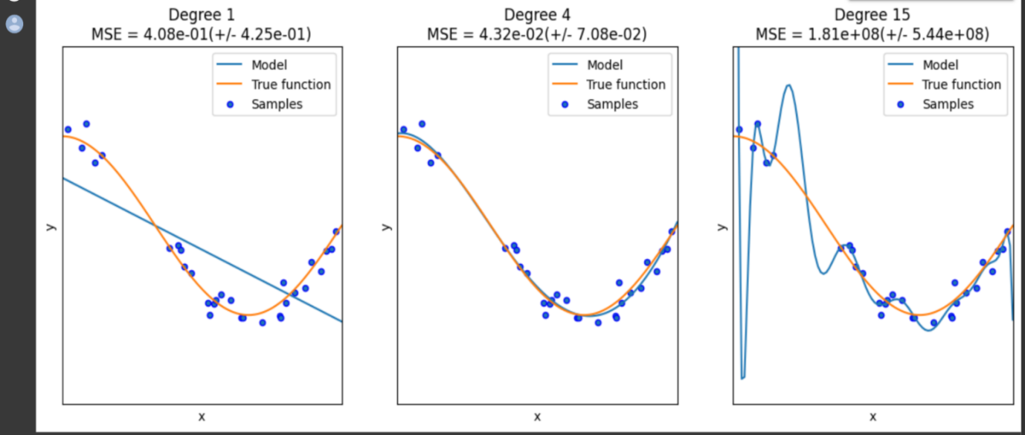

**Experiment 5 : Performance of Linear Regression**

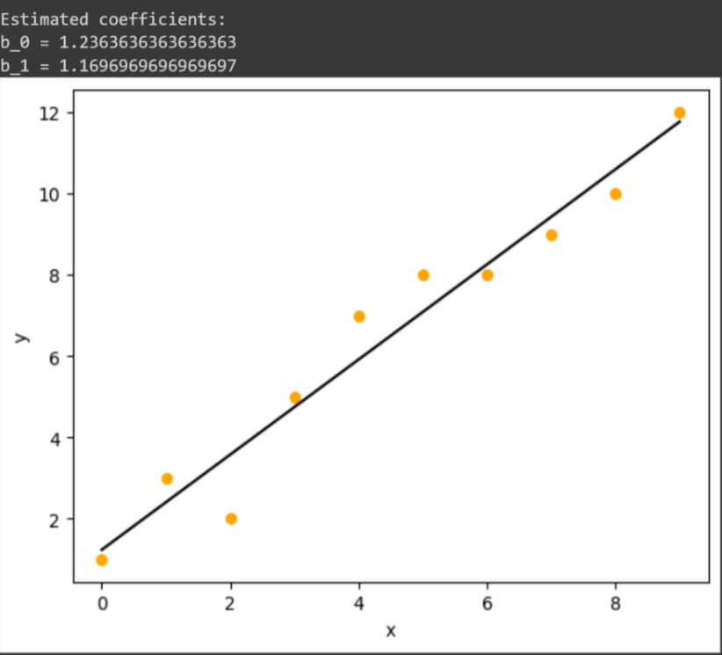

**Experiment 6 : Performance of Logistic Regression**

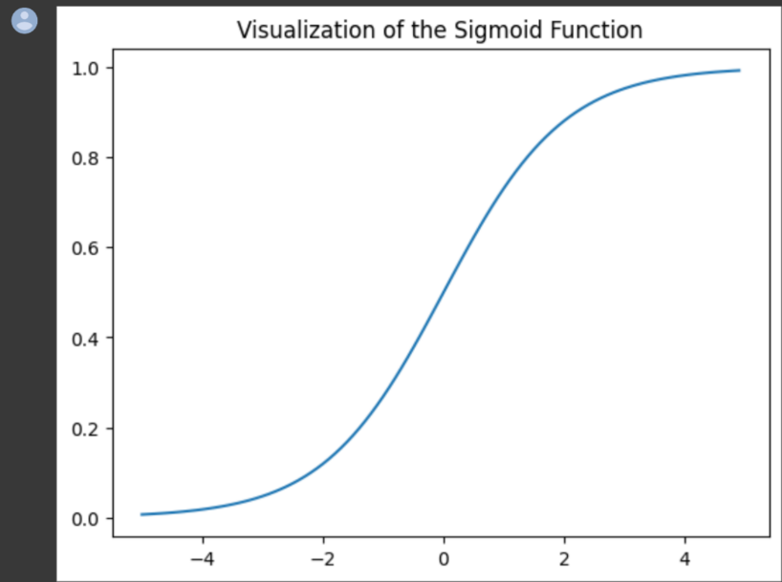

**Experiment 7 : Accuracy using KNN Algorithm**

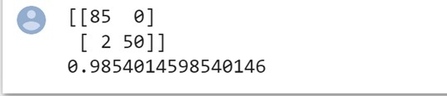

**Experiment 8 : Accuracy using Naïve Bayes Algorithm**

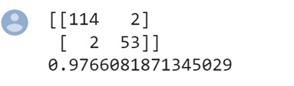

**Experiment 9 : Accuracy using Logistic Regression**

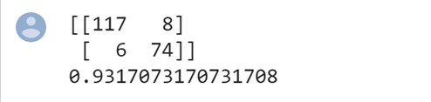

**Experiment 10 : Accuracy using Decision Tree**

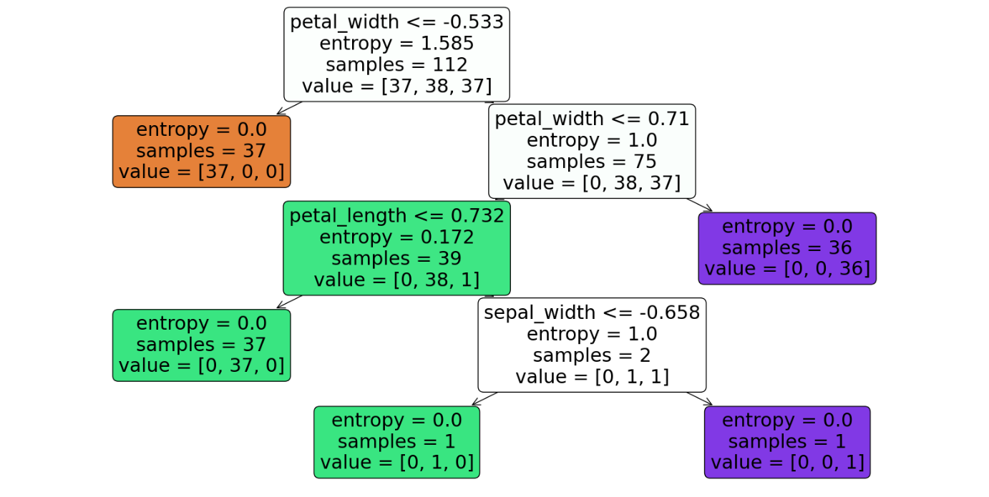

0.8947368421052632

[[13 0 0]

[ 0 11 1]

[ 0 3 10]]

**Experiment 11 : Accuracy using SVM**

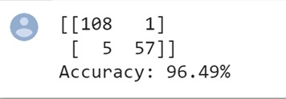

**Experiment 12 : Accuracy using Random Forest**

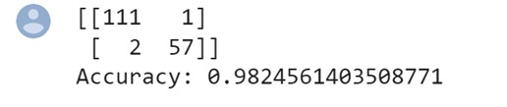

**Experiment 13 : Gradient Descent Using Actual Data**

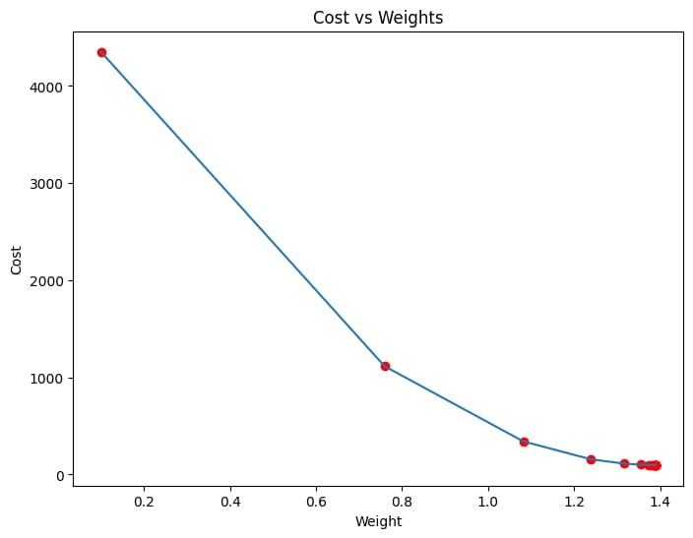

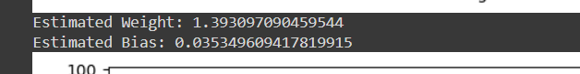

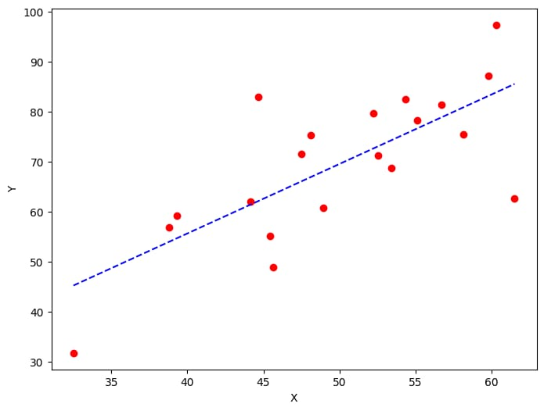

**Experiment 14 : Gradient Descent Using Modified Data**

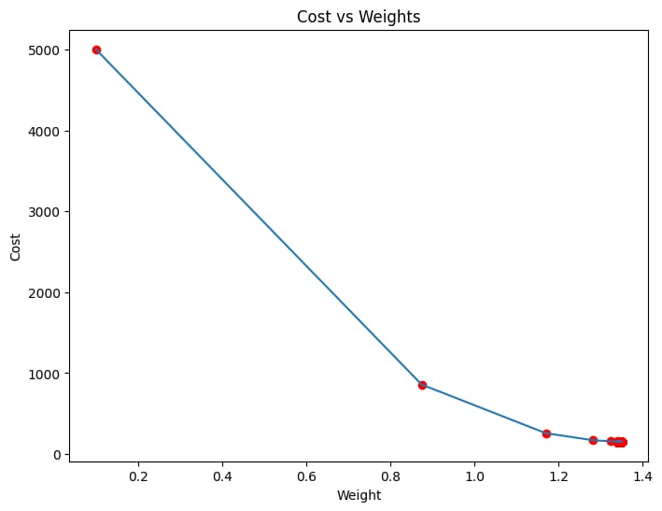



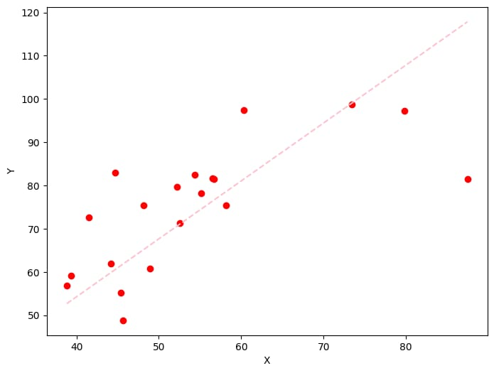

**Experiment 15 : Verify performance of image processing using chosen database**

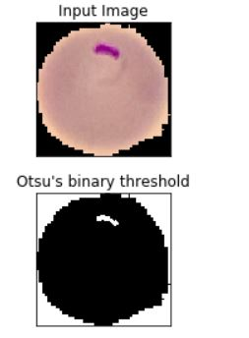

**Experiment 16 : Verify performance of image processing using Water Shed Database**

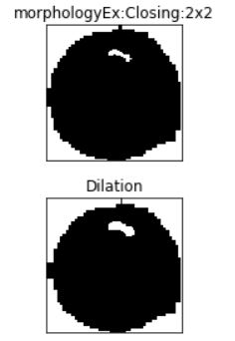

**Experiment 17 : Neural Network Analysis using TANH Activation Function**

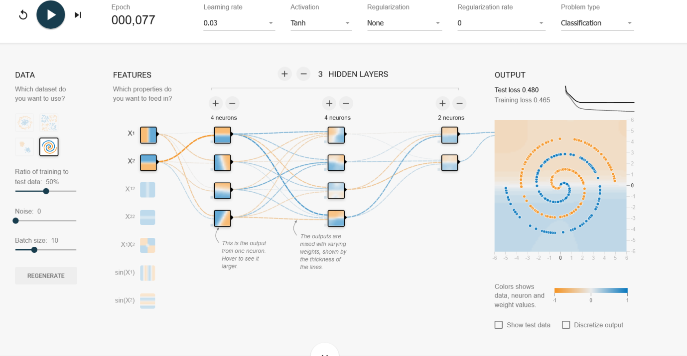

**Experiment 18 : Neural Network Analysis using SIGMOID Activation Function**

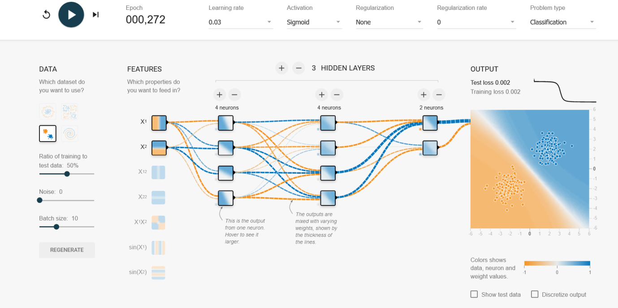

**Experiment 19 : Neural Network Analysis using LINEAR Activation Function**

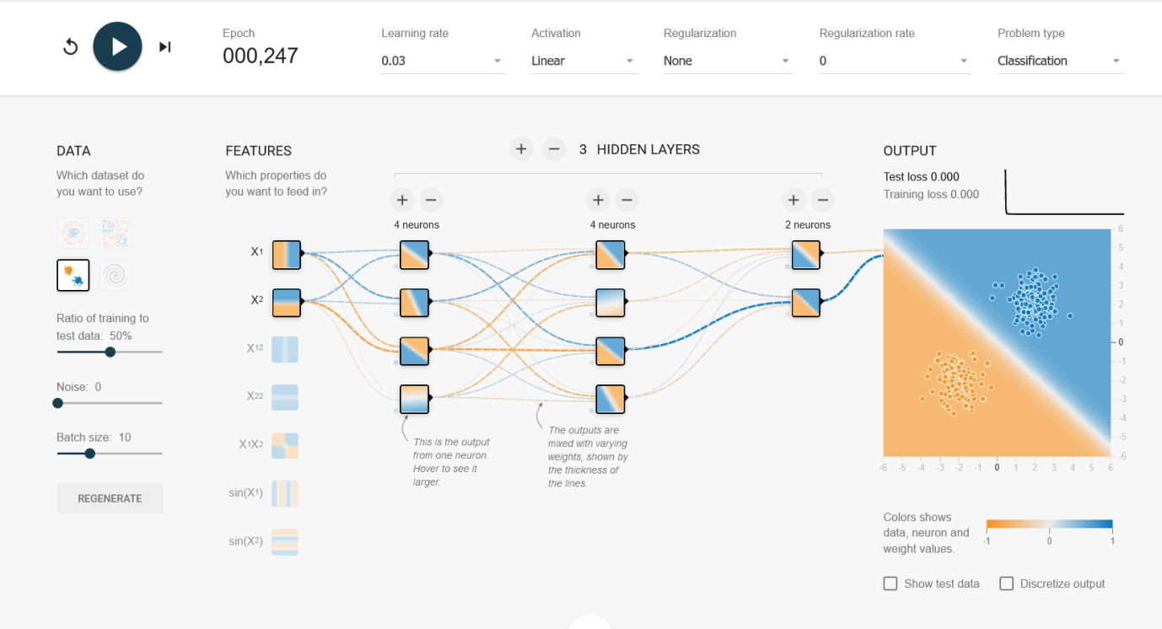

**Experiment 20 : Neural Network using ReLU Activation Function**

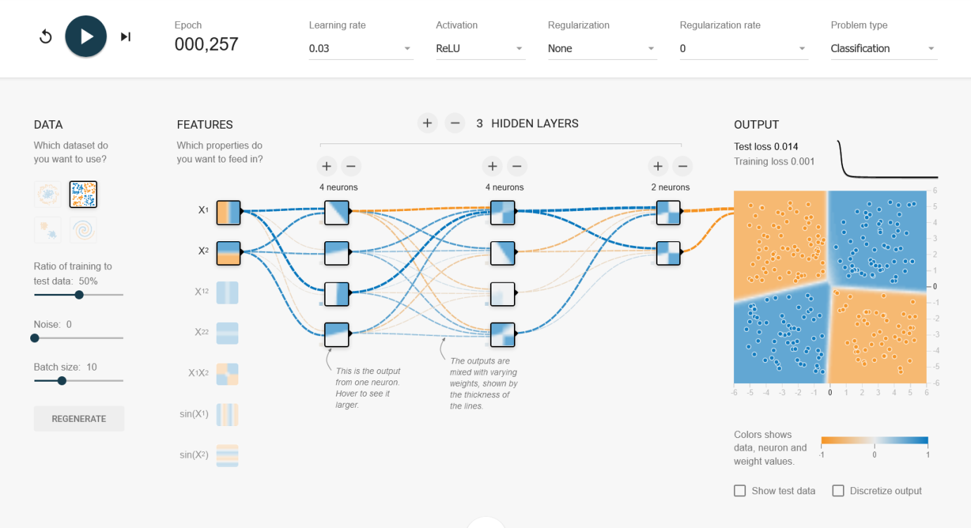

**Experiment 21 : Demonstration of Linear Separability**

