===========================================
Sample Blog:
===========================================

Why Nursery Teacher Training Is the Right Start for a Career in Early Childhood Education
A good teacher doesn’t just teach children — they help shape how children see the world.
The early years of a child’s life are filled with curiosity, discovery and rapid development. This makes early childhood education one of the most important stages of learning — and it also creates a growing need for well-trained, patient and confident preschool educators.
If you are planning to start or restart your career in teaching, a Nursery Teacher Training (NTT) course can be a meaningful first step.
What Is Nursery Teacher Training?
A Nursery Teacher Training course is designed to help aspiring educators understand how young children learn, communicate and develop.
At SNTTI, the 1-year Nursery Teacher Training programme focuses on building practical understanding of teaching methodologies and early childhood education, helping learners develop the skills required to work with children at the nursery and early-primary levels.
Why Is Early Childhood Education Important?
Children learn much more than alphabets and numbers during their early years.
They develop:
- Communication skills
- Social and emotional abilities
- Creativity and imagination
- Motor skills
- Confidence and independence
- Curiosity and problem-solving abilities
A trained early-years educator understands these developmental needs and creates learning experiences that are engaging, supportive and age-appropriate.
The first classroom experience can influence a child's attitude towards learning for years to come.

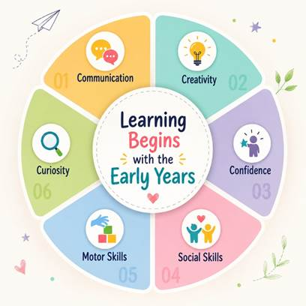
At the centre:
“Learning Begins with the Early Years”
This would make the blog much more visually engaging and also work well as a shareable social-media graphic.
Who Can Pursue an NTT Course?
A Nursery Teacher Training programme can be suitable for:
- Aspiring preschool and nursery teachers
- Graduates looking to enter the teaching profession
- Parents interested in understanding early childhood education
- Individuals returning to their careers after a break

- Professionals looking to transition into education
The right training can help learners build confidence while developing a stronger understanding of children and effective teaching practices.
Why Choose SNTTI for Nursery Teacher Training?
SNTTI, based in Bengaluru, Karnataka, focuses on early childhood education and teacher development.
The institute offers its teacher training programme through online and offline learning modes, making it accessible to learners from different locations. SNTTI also provides career guidance and placement assistance as part of its broader learner support.



Is Nursery Teacher Training a Good Career Choice?
If you enjoy working with children, have patience, creativity and a genuine interest in education, early childhood teaching can be a rewarding career path.
The journey can begin with the right knowledge, practical exposure and confidence.

And sometimes, the teacher who inspires a child today becomes the reason that child believes in themselves tomorrow.
Start Your Journey in Early Childhood Education
Whether you are starting your first career, returning after a career break, or looking for a meaningful transition into teaching, Nursery Teacher Training can be your first step towards becoming a confident early childhood educator.
Explore the SNTTI Nursery Teacher Training Course and take your first step towards a rewarding journey in education.
SNTTI – Bengaluru, Karnataka
Online, Offline & Hybrid Learning
1-Year Nursery Teacher Training Programme
Ready to begin your teaching journey? Enquire with SNTTI today.

Signoff / Approval:
Approved by (Name)
Approved On
Content / Image Edited/changed - YES / NO

