7. Write a Servlet program to store a user's preferences (like theme or language) using cookies. Retrieve and display these preferences on
subsequent visits.

AIM
To develop a Java Servlet-based web application that stores user preferences (such as theme and language) using cookies and retrieves them on subsequent visits to personalize the weather information webpage.

ALGORITHM
- Create a Dynamic Web Project in Eclipse or any IDE.
- Add Servlet API library (Apache Tomcat server).
- Create an HTML form to accept user preferences: Theme (Light/Dark)
Language (English/Tamil/etc.)
- Develop a Servlet (PreferenceServlet): Read user inputs from the form.
Store preferences using cookies.
- Develop another Servlet (DisplayServlet): Retrieve cookies.
Display saved preferences along with weather info.
- Configure web.xml (if not using annotations).
- Run the project on server (Tomcat).
- Test in browser:
First visit → set preferences.
Next visit → preferences auto-loaded.

SOURCE CODE

HTML Page (index.html)

<!DOCTYPE html>

<html lang="en">

<head>

<meta charset="UTF-8" />

<meta name="viewport" content="width=device-width, initial-scale=1.0"/>

<title>🏆 Tournament Registration</title>

<link href="https://fonts.googleapis.com/css2?family=Bebas+Neue&family=Outfit:wght@300;400;600;700&display=swap" rel="stylesheet"/>

<style>

/* KEEPING YOUR ORIGINAL DESIGN */

*, *::before, *::after { box-sizing: border-box; margin: 0; padding: 0; }

:root {

--gold:#FFD700;

--orange:#FF6B1A;

--dark:#0A0C10;

--card:#13161E;

--border:#2A2F3D;

--text:#E8EAF0;

--muted:#6B7280;

}

body {

min-height: 100vh;

background: var(--dark);

display:flex;

align-items:center;

justify-content:center;

font-family:'Outfit',sans-serif;

color:var(--text);

}

/* Card */

.card {

background: var(--card);

border:1px solid var(--border);

border-radius:20px;

padding:40px;

width:100%;

max-width:420px;

box-shadow:0 40px 80px rgba(0,0,0,0.6);

}

.logo-wrap { text-align:center; margin-bottom:30px; }

.logo-title {

font-family:'Bebas Neue';

font-size:32px;

background:linear-gradient(135deg,var(--gold),var(--orange));

-webkit-background-clip:text;

-webkit-text-fill-color:transparent;

}

.form-group { margin-bottom:18px; }

label {

font-size:12px;

color:var(--muted);

margin-bottom:5px;

display:block;

}

input, select {

width:100%;

padding:12px;

border-radius:8px;

border:1px solid var(--border);

background:#020617;

color:white;

}

input:focus, select:focus {

border-color:var(--gold);

outline:none;

}

.btn {

width:100%;

padding:12px;

margin-top:10px;

border:none;

border-radius:8px;

background:linear-gradient(135deg,var(--gold),var(--orange));

font-family:'Bebas Neue';

font-size:18px;

cursor:pointer;

}

</style>

</head>

<body>

<div class="card">

<div class="logo-wrap">

<div class="logo-title">Tournament Registration</div>

</div>

<!-- FORM CONNECTED TO SERVLET -->

<form action="ParkingServlet" method="post">

<div class="form-group">

<label>Team Name</label>

<input type="text" name="team" placeholder="Enter team name" required>

</div>

<div class="form-group">

<label>Select Sport</label>

<select name="sport">

<option>Cricket</option>

<option>Football</option>

<option>Badminton</option>

</select>

</div>

<button class="btn" type="submit">Register</button>

</form>

</div>

</body>

</html>

PreferenceServlet.java

package com.example;

package com.example;

import java.io.IOException;

import java.net.URLEncoder;

import java.net.URLDecoder;

import javax.servlet.ServletException;

import javax.servlet.annotation.WebServlet;

import javax.servlet.http.*;

@WebServlet("/ParkingServlet")

public class ParkingServlet extends HttpServlet {

private static final long serialVersionUID = 1L;

// 🔹 SAVE REGISTRATION

protected void doPost(HttpServletRequest request, HttpServletResponse response)

throws ServletException, IOException {

String team = request.getParameter("team");

String sport = request.getParameter("sport");

// ✅ Encode (fix cookie issue)

String encodedTeam = URLEncoder.encode(team, "UTF-8");

String encodedSport = URLEncoder.encode(sport, "UTF-8");

Cookie teamCookie = new Cookie("team", encodedTeam);

Cookie sportCookie = new Cookie("sport", encodedSport);

teamCookie.setMaxAge(24 * 60 * 60);

sportCookie.setMaxAge(24 * 60 * 60);

response.addCookie(teamCookie);

response.addCookie(sportCookie);

response.setContentType("text/html");

response.getWriter().println(

"<!DOCTYPE html>" +

"<html><head>" +

"<title>Success</title>" +

"<link href='https://fonts.googleapis.com/css2?family=Bebas+Neue&family=Outfit&display=swap' rel='stylesheet'>" +

"<style>" +

"body{margin:0;font-family:'Outfit',sans-serif;background:#0A0C10;color:#E8EAF0;" +

"display:flex;justify-content:center;align-items:center;height:100vh;}" +

".card{background:#13161E;padding:40px;border-radius:20px;" +

"border:1px solid #2A2F3D;text-align:center;width:400px;" +

"box-shadow:0 30px 70px rgba(0,0,0,0.7);}" +

"h2{font-family:'Bebas Neue';color:#FFD700;letter-spacing:2px;}" +

".info{margin:15px 0;font-size:16px;color:#E8EAF0;}" +

".btn{display:inline-block;margin-top:20px;padding:12px 24px;" +

"background:linear-gradient(135deg,#FFD700,#FF6B1A);" +

"color:#000;border-radius:10px;text-decoration:none;font-weight:bold;" +

"transition:0.3s;}" +

".btn:hover{transform:scale(1.05);}" +

"</style>" +

"</head><body>" +

"<div class='card'>" +

"<h2>Registration Successful</h2>" +

"<div class='info'>Team: " + URLDecoder.decode(encodedTeam, "UTF-8") + "</div>" +

"<div class='info'>Sport: " + URLDecoder.decode(encodedSport, "UTF-8") + "</div>" +

"<a class='btn' href='ParkingServlet'>View Details</a>" +

"</div>" +

"</body></html>"

);

}

// 🔹 VIEW REGISTRATION

protected void doGet(HttpServletRequest request, HttpServletResponse response)

throws ServletException, IOException {

Cookie[] cookies = request.getCookies();

String team = "Not Registered";

String sport = "Not Selected";

if (cookies != null) {

for (Cookie c : cookies) {

if (c.getName().equals("team")) {

team = URLDecoder.decode(c.getValue(), "UTF-8");

}

if (c.getName().equals("sport")) {

sport = URLDecoder.decode(c.getValue(), "UTF-8");

}

}

}

response.setContentType("text/html");

response.getWriter().println(

"<!DOCTYPE html>" +

"<html><head>" +

"<title>Your Registration</title>" +

"<link href='https://fonts.googleapis.com/css2?family=Bebas+Neue&family=Outfit&display=swap' rel='stylesheet'>" +

"<style>" +

"body{margin:0;font-family:'Outfit',sans-serif;background:#0A0C10;color:#E8EAF0;" +

"display:flex;justify-content:center;align-items:center;height:100vh;}" +

".card{background:#13161E;padding:40px;border-radius:20px;" +

"border:1px solid #2A2F3D;text-align:center;width:400px;" +

"box-shadow:0 30px 70px rgba(0,0,0,0.7);}" +

"h2{font-family:'Bebas Neue';color:#FFD700;letter-spacing:2px;}" +

".info{margin:15px 0;font-size:16px;}" +

".btn{display:inline-block;margin-top:20px;padding:12px 24px;" +

"background:linear-gradient(135deg,#FFD700,#FF6B1A);" +

"color:#000;border-radius:10px;text-decoration:none;font-weight:bold;" +

"transition:0.3s;}" +

".btn:hover{transform:scale(1.05);}" +

"</style>" +

"</head><body>" +

"<div class='card'>" +

"<h2>Your Registration</h2>" +

"<div class='info'>Team: " + team + "</div>" +

"<div class='info'>Sport: " + sport + "</div>" +

"<a class='btn' href='index.html'>Register Again</a>" +

"</div>" +

"</body></html>"

);

}

}

OUTPUT :
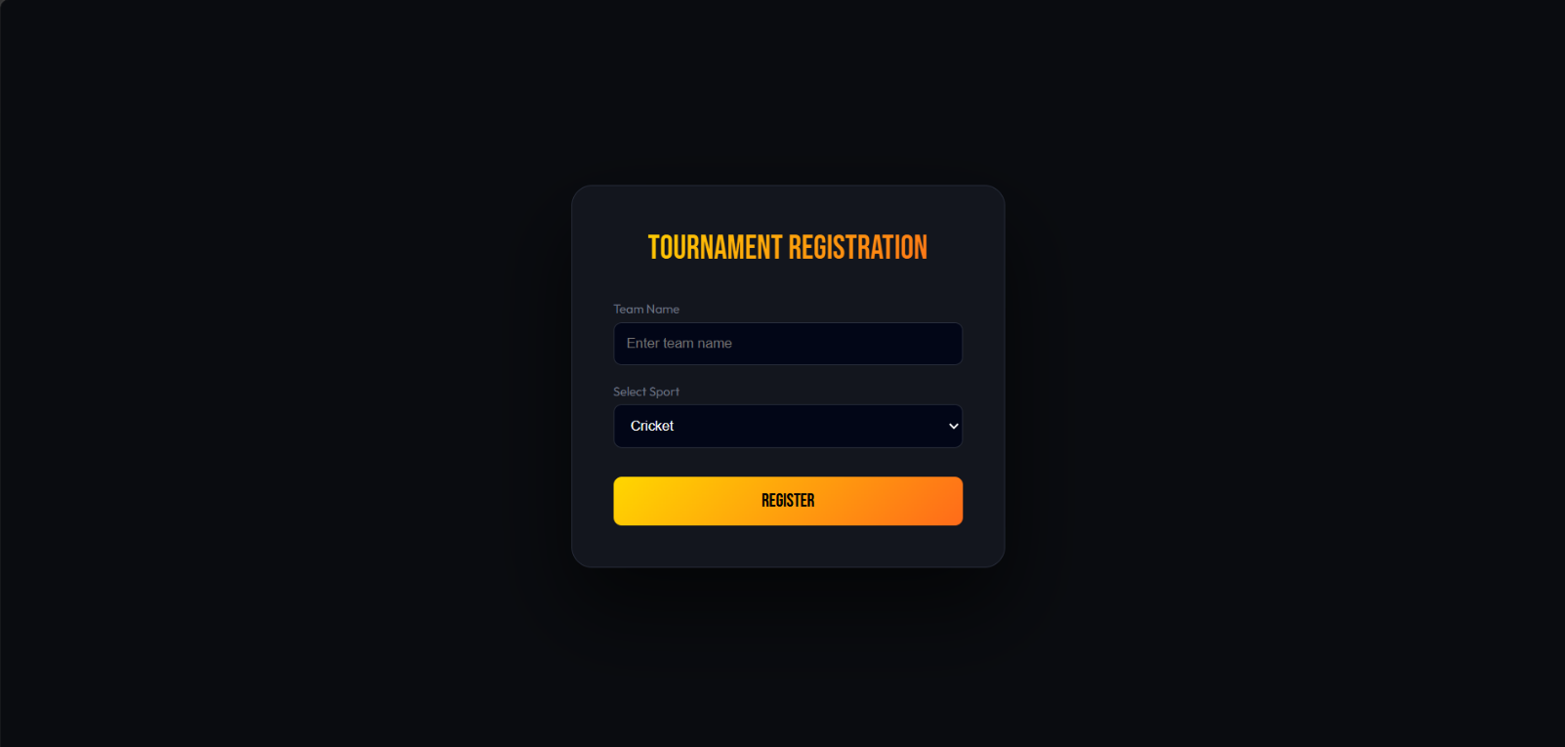

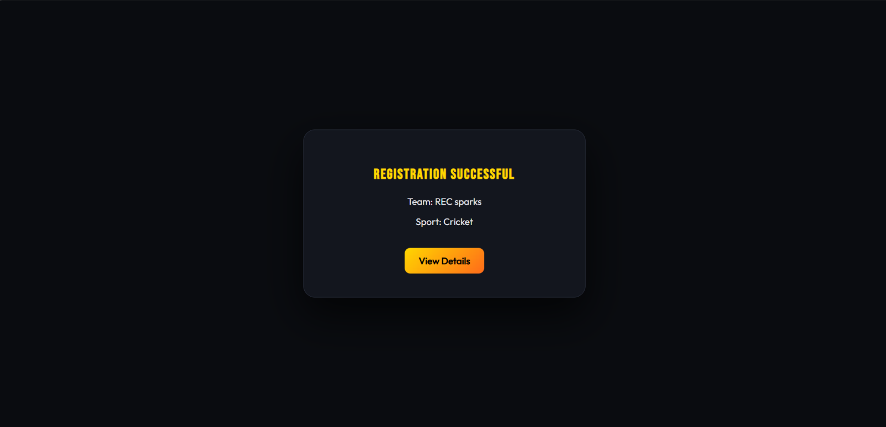

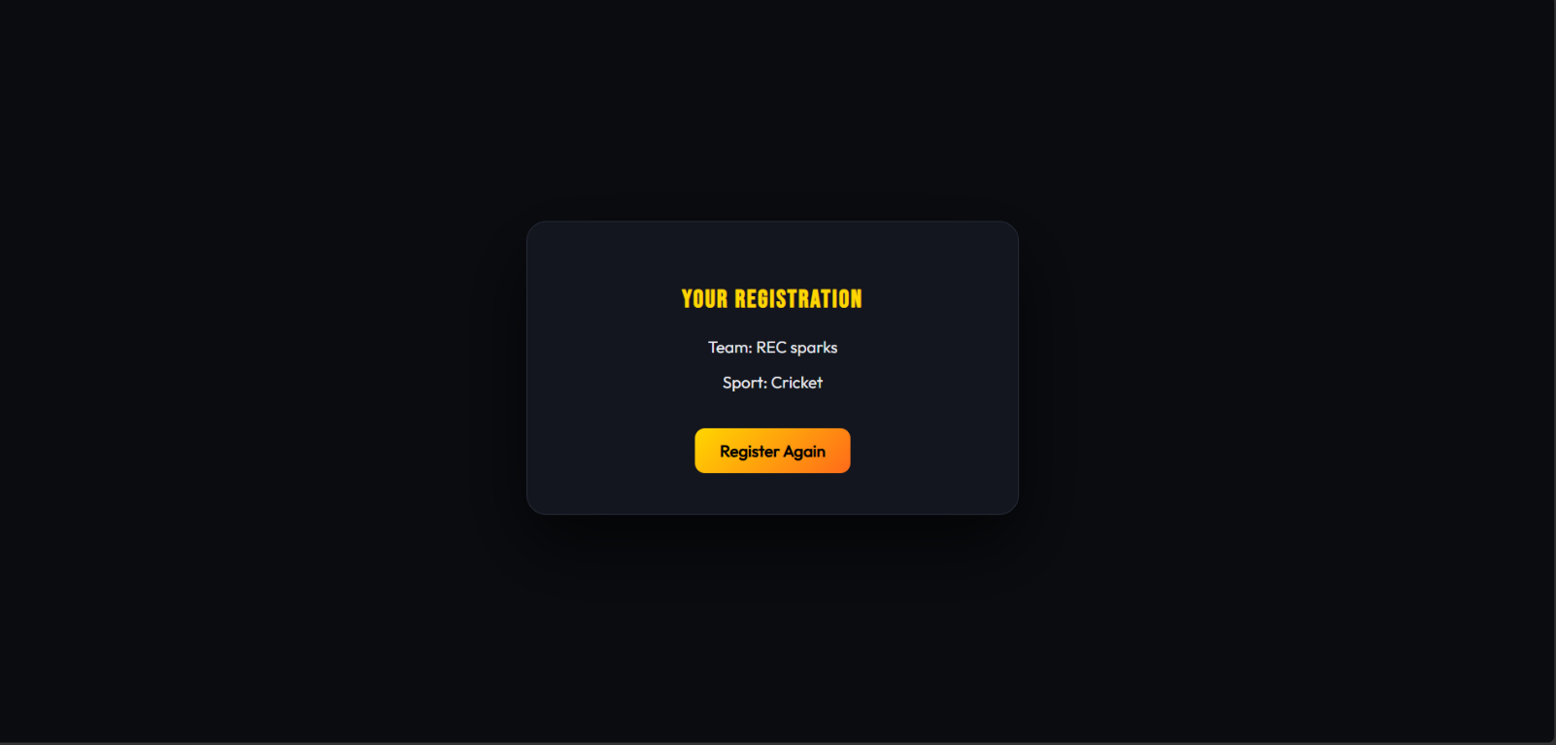

Result:
The experiment was successfully completed.User preferences (theme and language) were stored using cookies and retrieved on subsequent visits, allowing the weather webpage to provide a personalized user experience.

