EXP.NO: 2 Write JavaScript Programme to validate the following fields of the HTML
Registration Page.

AIM:
To write JavaScript code to validate user input in a registration form. The validation will
ensure that the data entered by the user meets specific criteria for each field. This will help in maintaining data integrity and prevent invalid submissions.

ALGORITHM:
1. Input:
• The user fills in the following fields: First Name, Password, E-mail, Mobile
Number, Last Name, and Address.
2. Validation Steps:
1. Validate First Name:
o Check if the first name contains only alphabets.
o Ensure the length of the First Name is at least 6 characters.
o If any of these conditions fail, display an error message indicating the required
input.
2. Validate Password:
o Check if the password is at least 6 characters long.
o If it is less than 6 characters, display an error message.
3. Validate E-mail:
o Use a regular expression to check if the email follows the standard pattern:
name@domain.com.
o Ensure that the email contains no invalid characters and matches the required
pattern.
o If it doesn&#39;t match, display an error message indicating an invalid email
format.

4. Validate Mobile Number:
o Check if the mobile number contains exactly 10 digits.
o Ensure there are no alphabets or special characters.
o If the number is invalid, display an error message indicating the correct
format.
5. Validate Last Name:
o Ensure the Last Name field is not empty.
o If it is empty, display an error message.
6. Validate Address:
o Ensure the Address field is not empty.
o If it is empty, display an error message.

CODE:
Login page:
<!DOCTYPE html>
<html>
<head>
<title>Login - Sports Tournament</title>
<style>
body{
margin:0;
font-family:"Segoe UI",Arial;
background:
linear-gradient(rgba(15,32,39,0.85), rgba(15,32,39,0.85)),
url("https://img.freepik.com/free-photo/close-up-baseball-field_23-2150885211.jpg?semt=ais_hybrid&w=740&q=80");
background-size:cover;
background-position:center;
color:white;
display:flex;
justify-content:center;
align-items:center;
height:100vh;
}

.card{
background:rgba(255,255,255,0.15);
padding:40px;
border-radius:20px;
width:350px;
color:white;
}
h2{text-align:center;color:#00ffcc;}
input{
width:100%;
padding:12px;
margin:12px 0;
border-radius:8px;
border:none;
}
button{
width:100%;
padding:12px;
background:#00ffcc;
border:none;
font-weight:bold;
border-radius:10px;
cursor:pointer;
}
</style>
</head>
<body>

<div class="card">
<h2>User Login</h2>
<input id="username" placeholder="Username">
<input id="password" type="password" placeholder="Password">
<button onclick="loginUser()">Login</button>
</div>

<script>
function loginUser(){
const u = document.getElementById("username").value;
const p = document.getElementById("password").value;

if(u==="" || p===""){
alert("Please enter all details");
return;
}

localStorage.setItem("user",u);
window.location.href="index.html";
}
</script>

</body>
</html>

Index page:
<!DOCTYPE html>
<html>
<head>
<title>Home - Sports Tournament</title>
<style>
body{
margin:0;
font-family:Segoe UI;
background:
linear-gradient(rgba(44,83,100,0.9), rgba(15,32,39,0.9)),
url("https://goqii.com/blog/wp-content/uploads/6-Health-Benefits-of-Playing-Sports-1024x683.jpg");
background-size:cover;
background-position:center;
color:white;
}
header{
padding:25px;
text-align:center;
font-size:28px;
color:#00ffcc;
}
.container{
display:grid;
grid-template-columns:repeat(auto-fit,minmax(200px,1fr));
gap:25px;
padding:40px;
}
.box{
background:rgba(255,255,255,0.1);
padding:30px;
text-align:center;
border-radius:20px;
transition:0.3s;
}
.box:hover{
background:#00ffcc;
color:black;
transform:translateY(-8px);
}
.box a{
text-decoration:none;
color:inherit;
}
.box h3{color:#00ffcc;}

.bottom-image{
margin:40px 60px;
height:260px;
border-radius:25px;
overflow:hidden;
box-shadow:0 25px 45px rgba(0,0,0,0.6);
position:relative;
}

.bottom-image img{
width:100%;
height:100%;
object-fit:cover;
opacity:0.85;
}

.bottom-image .overlay{
position:absolute;
inset:0;
background:linear-gradient(
rgba(0,0,0,0.5),
rgba(0,0,0,0.7)
);
display:flex;
align-items:center;
justify-content:center;
font-size:28px;
color:#00ffcc;
text-align:center;
font-weight:600;
}
</style>
</head>
<body>

<header>
Sportz Tournament Management
<br>
<span id="welcome"></span>
</header>

<div class="container">
<div class="box"><a href="register.html">Register Game</a></div>
<div class="box"><a href="location.html">REC Ground</a></div>
<div class="box"><a href="results.html">Match Results</a></div>
<div class="box"><a href="#" onclick="logout()">Logout</a></div>
</div>

<script>
const user = localStorage.getItem("user");
if(!user){
window.location.href="login.html";
}else{
document.getElementById("welcome").innerHTML="Welcome, "+user;
}

function logout(){
localStorage.removeItem("user");
window.location.href="login.html";
}
</script>
<div class="bottom-image">
<img src="https://goqii.com/blog/wp-content/uploads/6-Health-Benefits-of-Playing-Sports-1024x683.jpg" alt="Sports Ground">
<div class="overlay">
Rajalakshmi Engineering College<br>
Sports Tournament Arena
</div>
</div>

</body>
</html>

Register page:
<!DOCTYPE html>
<html>
<head>
<title>Register Game</title>
<style>
body{
margin:0;
font-family:Segoe UI;
background:linear-gradient(rgba(0,0,0,0.7),rgba(0,0,0,0.7)),
url("https://img.freepik.com/free-photo/close-up-baseball-field_23-2150885211.jpg?semt=ais_hybrid&w=740&q=80");
background-size:cover;
display:flex;
justify-content:center;
align-items:center;
height:100vh;
}
.card{
background:rgba(255,255,255,0.15);
padding:40px;
border-radius:20px;
width:350px;
color:white;
}
input,select{
width:100%;
padding:12px;
margin:12px 0;
border:none;
border-radius:8px;
}
button{
width:100%;
padding:12px;
background:#00ffcc;
border:none;
font-weight:bold;
border-radius:10px;
cursor:pointer;
}
</style>
</head>
<body>

<div class="card">
<h2>Register Game</h2>
<input id="team" placeholder="Team Name">
<select id="sport">
<option>Select Sport</option>
<option>Cricket</option>
<option>Football</option>
<option>Badminton</option>
</select>
<button onclick="registerGame()">Submit</button>
</div>

<script>
function registerGame(){
const t=document.getElementById("team").value;
const s=document.getElementById("sport").value;

if(t==="" || s==="Select Sport"){
alert("Fill all details");
return;
}

localStorage.setItem("team",t);
localStorage.setItem("sport",s);

alert("Game Registered!");
window.location.href="location.html";
}
</script>

</body>
</html>

Location page:
<!DOCTYPE html>
<html>
<head>
<title>REC Ground Location</title>
<style>
body{
margin:0;
font-family:Segoe UI;
background:linear-gradient(rgba(0,0,0,0.8),rgba(0,0,0,0.8)),
url("https://img.freepik.com/free-photo/close-up-baseball-field_23-2150885211.jpg?semt=ais_hybrid&w=740&q=80");
background-size:cover;
color:white;
text-align:center;
padding:40px;
}
iframe{
width:80%;
height:350px;
border-radius:20px;
}
button{
margin-top:30px;
padding:12px 25px;
background:#00ffcc;
border:none;
border-radius:10px;
font-weight:bold;
cursor:pointer;
}
</style>
</head>
<body>

<h2>REC Sports Ground</h2>

<iframe src="https://www.google.com/maps?q=Rajalakshmi%20Engineering%20College%20Ground&output=embed"></iframe>

<br>
<button onclick="goNext()">View Match Result</button>

<script>
function goNext(){
window.location.href="results.html";
}
</script>

</body>
</html>

Result page:
<!DOCTYPE html>
<html>
<head>
<title>Match Results</title>
<style>
body{
margin:0;
font-family:Segoe UI;
background:
linear-gradient(rgba(44,83,100,0.9), rgba(15,32,39,0.9)),
url("https://img.freepik.com/free-photo/close-up-baseball-field_23-2150885211.jpg?semt=ais_hybrid&w=740&q=80");
background-size:cover;
background-position:center;
color:white;
padding:40px;
}
table{
width:100%;
border-collapse:collapse;
margin-top:30px;
}
th,td{
padding:15px;
text-align:center;
}
th{
background:#00ffcc;
color:black;
}
tr:nth-child(even){
background:rgba(255,255,255,0.1);
}
button{
margin-top:30px;
padding:12px 25px;
background:#00ffcc;
border:none;
border-radius:10px;
font-weight:bold;
cursor:pointer;
}
</style>
</head>
<body>

<h2>Match Results</h2>

<table>
<tr>
<th>Sport</th>
<th>Team</th>
<th>Opponent</th>
<th>Result</th>
</tr>
<tr>
<td id="sportCell"></td>
<td id="teamCell"></td>
<td>CSE Riders</td>
<td id="resultCell">Pending</td>
</tr>
</table>

<button onclick="declareWinner()">Declare Winner</button>
<button onclick="logout()">Logout</button>

<script>
const team=localStorage.getItem("team");
const sport=localStorage.getItem("sport");

document.getElementById("teamCell").innerHTML=team;
document.getElementById("sportCell").innerHTML=sport;

function declareWinner(){
document.getElementById("resultCell").innerHTML=team+" WON";
}

function logout(){
localStorage.clear();
window.location.href="login.html";
}
</script>

</body>
</html>

OUTPUT:
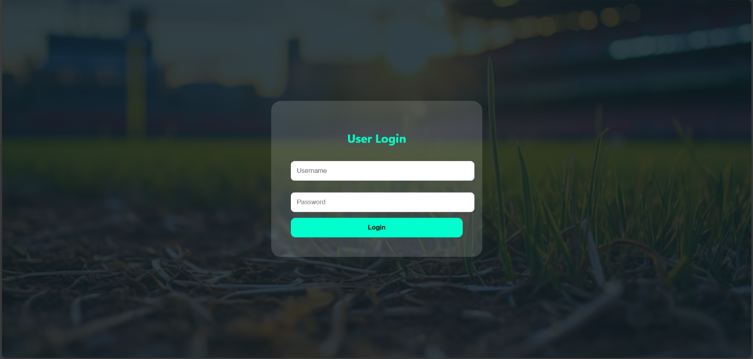
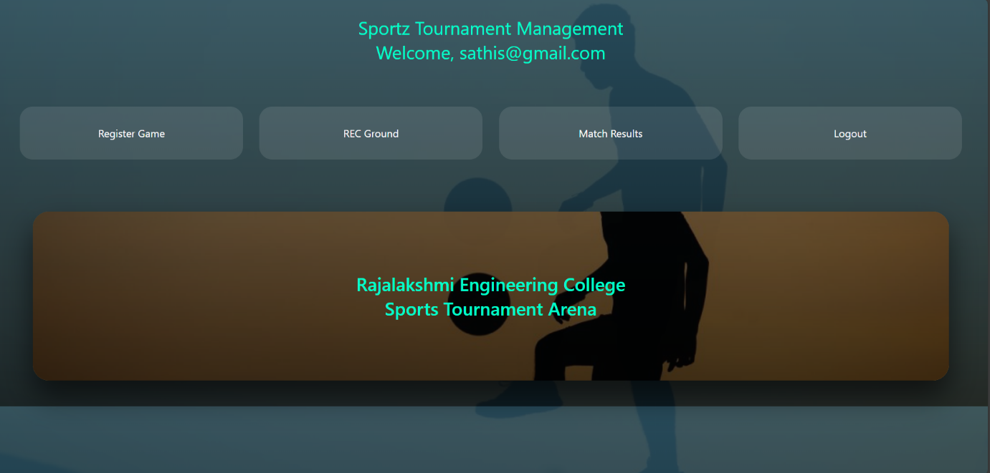
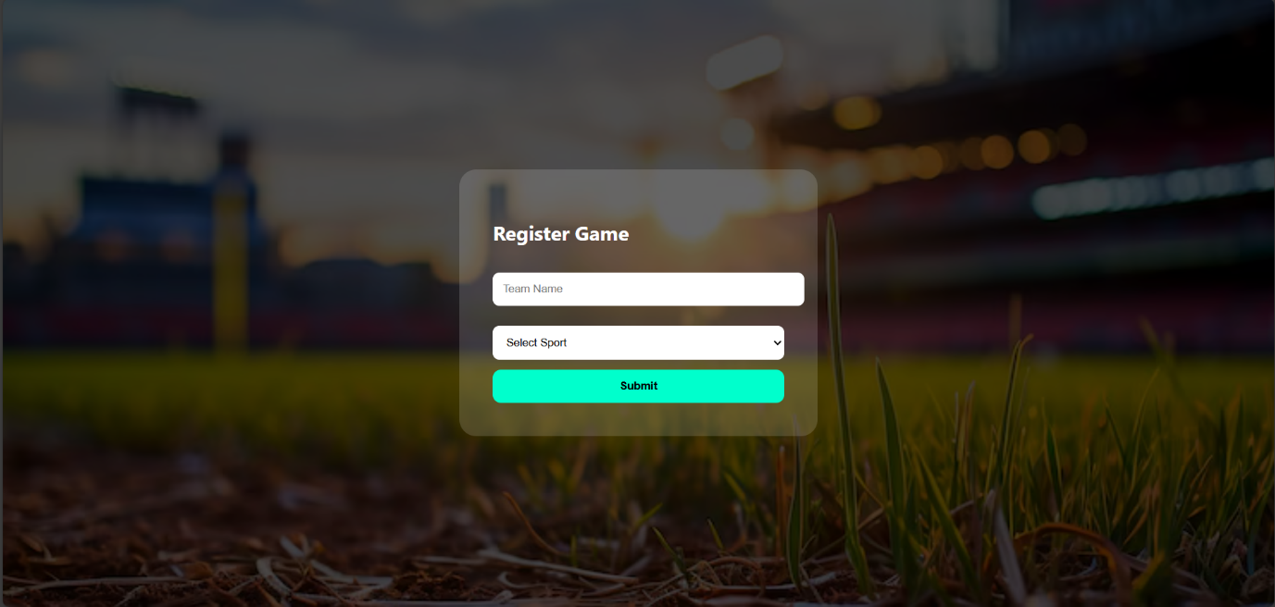
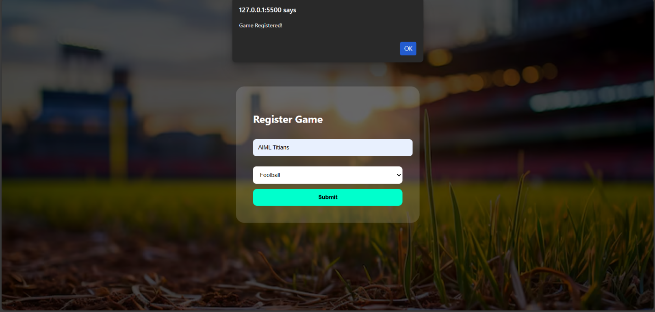
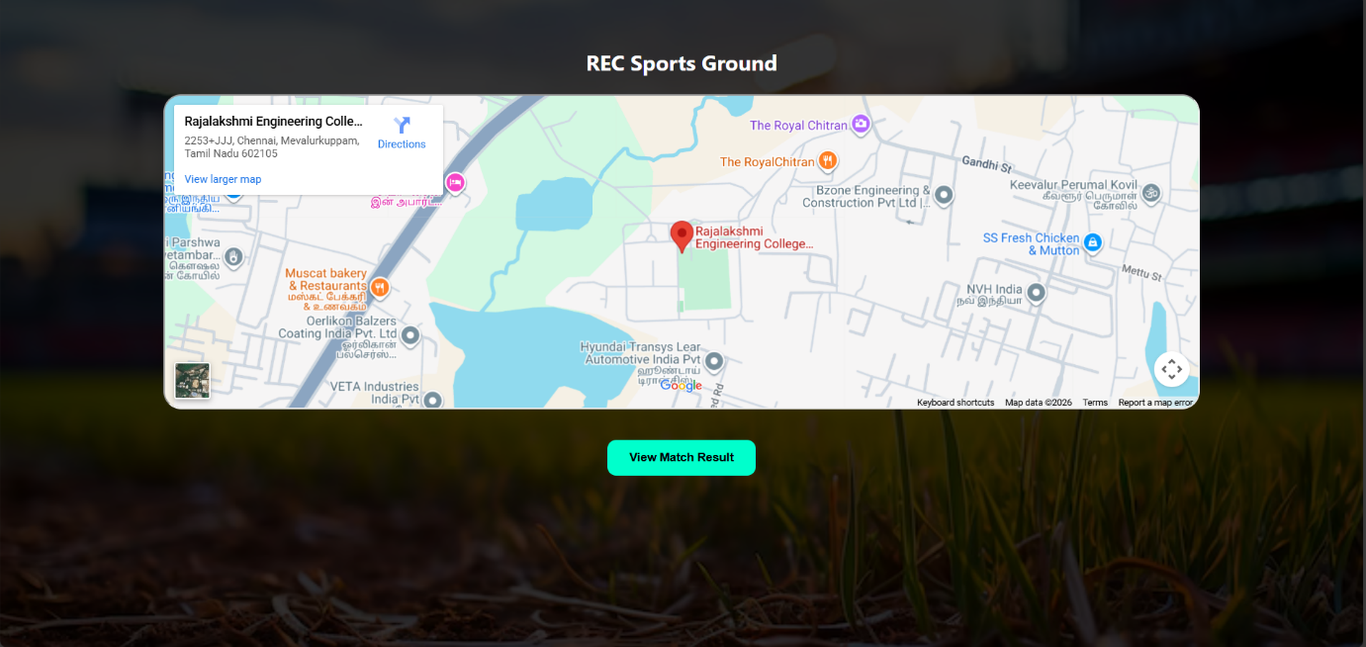
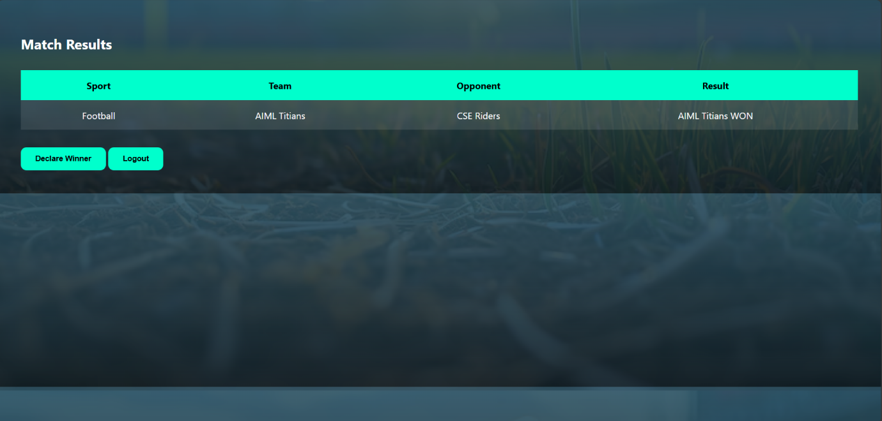

RESULT:
HTML page with Form is created and is validated using Javascript.

