EXP.NO: 10
Develop an application to change the font and color of the text and display toast message when the user press the button
AIM:
To develop an Android application that allows the user to change the font and color of text displayed on the screen and display a Toast message when a button is pressed.

ALGORITHM:
1. Initialize the Android Application:
o Set up a new Android project in Android Studio.
o Create a MainActivity Java file for the main screen of the application.
2. Design the User Interface (UI):
o In the XML layout file, add the following UI components:
TextView: For displaying the text whose font and color will be
changed.
Button: To trigger the change in font and color, and show a Toast
message.
Spinner or Color Picker: To let the user choose a color (optional, or a
simple button for a predefined color change).
RadioButtons or a Dropdown Menu to select different font styles
(optional).
3. Declare Variables:
o Create references for the TextView, Button, Color Picker (if used), and
Radio Buttons (if used to change font style).
o Define variables for the font style, color, and the message to display in the Toast.
4. Set Event Listener for the Button:
o Set an OnClickListener for the Button.
o Inside the onClick() method, write the logic to:
Change the font of the TextView based on the selected font style.
Change the color of the TextView based on the selected color.
Display a Toast message indicating the action has been performed.
5. Implement Font Style Changes:
o Change the TextView’s font using setTypeface() to apply a selected font style
(e.g., bold, italic).
o You can either use predefined styles (like Typeface.BOLD or
Typeface.ITALIC) or let the user choose from a list of font styles.
6. Implement Color Change:
o Change the TextView’s text color by using the setTextColor() method and
applying the selected color (e.g., Color.RED, Color.BLUE, or a color from the
Color Picker).
o If using a color picker or dropdown, get the selected color and set it on the
TextView.
7. Show Toast Message:
o Display a Toast message to the user when the button is clicked, informing
them that the text style or color has changed. You can also show a message
like &quot;Font and color changed!&quot; or any other appropriate message.
8. End the Operation:
o After the changes are made, the application will display the updated TextView
with the new font and color, and the Toast message will appear to provide
feedback.

CODE:
activity_main.xml
&lt;?xml version=&quot;1.0&quot; encoding=&quot;utf-8&quot;?&gt;
&lt;androidx.constraintlayout.widget.ConstraintLayout
xmlns:android=&quot;http://schemas.android.com/apk/res/android&quot;
xmlns:app=&quot;http://schemas.android.com/apk/res-auto&quot;
android:id=&quot;@+id/mainLayout&quot;
android:layout_width=&quot;match_parent&quot;
android:layout_height=&quot;match_parent&quot;
android:padding=&quot;16dp&quot;&gt;
&lt;TextView
android:id=&quot;@+id/sampleText&quot;
android:layout_width=&quot;wrap_content&quot;
android:layout_height=&quot;wrap_content&quot;
android:text=&quot;Hello, World!!!!!!&quot;
android:textSize=&quot;24sp&quot;
android:textColor=&quot;#000000&quot;
android:fontFamily=&quot;@font/roboto_regular&quot;
app:layout_constraintTop_toTopOf=&quot;parent&quot;
app:layout_constraintBottom_toTopOf=&quot;@+id/changeStyleButton&quot;
app:layout_constraintStart_toStartOf=&quot;parent&quot;
app:layout_constraintEnd_toEndOf=&quot;parent&quot;
app:layout_constraintVertical_bias=&quot;0.4&quot;/&gt;
&lt;Button
android:id=&quot;@+id/changeStyleButton&quot;
android:layout_width=&quot;wrap_content&quot;
android:layout_height=&quot;wrap_content&quot;
android:text=&quot;Change Font Style&quot;
app:layout_constraintTop_toBottomOf=&quot;@id/sampleText&quot;
app:layout_constraintStart_toStartOf=&quot;parent&quot;
app:layout_constraintEnd_toEndOf=&quot;parent&quot;
android:layout_marginTop=&quot;20dp&quot;/&gt;
&lt;/androidx.constraintlayout.widget.ConstraintLayout&gt;
MainActivity.java*{
package com.example.font_change;
import android.graphics.Color;
import android.graphics.Typeface;
import android.os.Bundle;
import android.widget.Button;
import android.widget.TextView;
import android.widget.Toast;
import androidx.appcompat.app.AppCompatActivity;
import androidx.core.content.res.ResourcesCompat;
public class MainActivity extends AppCompatActivity {
TextView sampleText;
Button changeStyleButton;
boolean isChanged = false;
@Override
protected void onCreate(Bundle savedInstanceState) {
super.onCreate(savedInstanceState);
setContentView(R.layout.activity_main);
sampleText = findViewById(R.id.sampleText);
changeStyleButton = findViewById(R.id.changeStyleButton);
changeStyleButton.setOnClickListener(v -&gt; {
if (!isChanged) {
sampleText.setTextColor(Color.parseColor(&quot;#FF5722&quot;)); // Orange
Typeface typeface = ResourcesCompat.getFont(this, R.font.roboto_regular);
sampleText.setTypeface(getResources().getFont(R.font.roboto_regular),
Typeface.BOLD_ITALIC);
Toast.makeText(MainActivity.this, &quot;Style Changed!&quot;,
Toast.LENGTH_SHORT).show();
} else {
sampleText.setTextColor(Color.BLACK);
sampleText.setTypeface(Typeface.DEFAULT);
Toast.makeText(MainActivity.this, &quot;Style Reset!&quot;,
Toast.LENGTH_SHORT).show();
}
isChanged = !isChanged;}
OUTPUT:
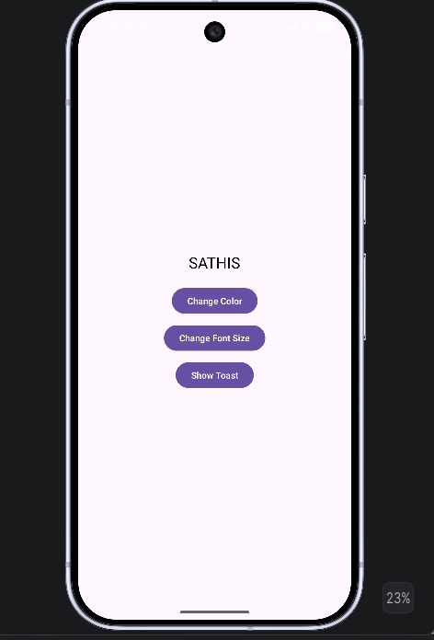

Result:
An mobile application is developed in Android studio to change the font and color of the textand display toast message when the user presses the button..

