EXP.NO: 1
Web Page Creation using HTML

AIM:
To create a web page that embeds a map with hotspots, frames, and links. The web page should be designed using HTML, incorporating embedded, external, and inline CSS for styling. This exercise aims to enhance understanding of integrating multimedia elements like maps, creating interactive hotspots, and organizing content using frames while applying different CSS techniques for styling.

ALGORITHM:

Step 1: Create the HTML Structure
- Create a new HTML file and set up the basic structure using:
  - <!DOCTYPE html>
  - <html>
  - <head>
  - <body>
- Inside the <head> section:
  - Define the <title> of the webpage.
  - Link the external CSS file using the <link> tag.
  - Add metadata if required.
  - Include embedded CSS using the <style> tag.
- Inside the <body> section:
  - Create the required layout structure.
  - Use <iframe> to create frames (since <frameset> is outdated in HTML5).
  - Use the <img> tag to display the map image.
  - Create hotspots using <map> and <area> tags.
  - Add hyperlinks using the <a> tag for navigation
Step 2: Create CSS Styles
- External CSS:
  - Create a separate CSS file.
  - Define common styles such as:
    - Background color
    - Font style
    - Text alignment
    - Layout design
    - Borders and spacing
- Embedded CSS:
  - Inside the <style> tag in the <head> section.
  - Define styles for specific elements like:
    - Map
    - Frames
    - Headings
    - Buttons
- Inline CSS:
  - Use the style attribute within specific HTML tags.
  - Example:
  - <p style="color:blue; font-size:18px;">
  - Apply styles directly to elements when needed.
Step 3: Create Map with Hotspots
- Use the <img> tag to display the map image.
- Add the usemap attribute to connect the image with a <map> tag.
- Use the <map> tag to define the image map.
- Inside <map>, use <area> tags to define clickable regions.
- Specify coordinates using:
- coords="x1,y1,x2,y2"
- Set the href attribute to link each hotspot to a webpage or external site.
Step 4: Create Frames
- Use the <iframe> tag to embed:
  - External webpages
  - Google Maps
  - Internal HTML pages
- Specify attributes such as:
  - src (source URL)
  - width
  - height
  - name
  - target
Step 5: Add Links
- Use the <a> tag to create hyperlinks.
- Provide the destination using the href attribute.
- Use the target attribute to open content in:
  - Same page
  - New tab
  - Specific iframe
Example:
<a href="results.html" target="contentFrame">View Results</a>
Step 6: Test the Webpage
- Open the HTML file in a web browser.
- Check if:
  - Frames load properly.
  - Map hotspots are clickable.
  - Links navigate correctly.
  - Embedded content displays properly.
- Verify that:
  - External CSS is applied.
  - Embedded CSS works.
  - Inline CSS overrides correctly where used.
CODE:
Index.html:
<!DOCTYPE html>
<html>
<head>
<title>Sports</title>
<link rel="stylesheet" href="style.css">
</head>

<body>

<div class="container">

<h1 >Sportz Tournament Management</h1>
<p class="subtitle">Play With Joyful</p>

<div class="image-section">
<img src="https://images.unsplash.com/photo-1612872087720-bb876e2e67d1?q=80&w=1307&auto=format&fit=crop&ixlib=rb-4.1.0&ixid=M3wxMjA3fDB8MHxwaG90by1wYWdlfHx8fGVufDB8fHx8fA%3D%3D"
alt="Sportz Tournament">
</div>

<h2>REC Venue</h2>

<div class="map-section">
<iframe
src="https://www.google.com/maps?q=Rajalakshmi%20Engineering%20College%20Ground&output=embed"
allowfullscreen=""
loading="lazy">
</iframe>
</div>
<br>

<h3 class="blink">Click here for more information</h3>
<div class="buttons">
<a href="https://indianexpress.com/section/sports/">NEWS</a>
<a href="https://onlocationexp.com/sports-schedule">Match Schedule</a>
<a href="https://www.cricbuzz.com/">Results</a>
</div>
</div>
</body>
</html>

Style.CSS:
body {
margin: 0;
font-family: Arial, sans-serif;
color: white;
text-align: center;
position: relative;
z-index: 1;
}

/* Blurred Background */
body::before {
content: "";
position: fixed;
top: 0;
left: 0;
width: 100%;
height: 100%;

background-image: url("https://img.freepik.com/free-photo/close-up-baseball-field_23-2150885211.jpg?semt=ais_hybrid&w=740&q=80");
background-size: cover;
background-position: center;
background-repeat: no-repeat;

filter: blur(8px); /* Blur strength */
z-index: -1;
}

/* Main Content */
.container {
width: 65%;
margin: auto;
padding: 20px;
}

/* Headings */
h1 {
font-size: 40px;
color: #522b2b;
}

.subtitle {
color: #522b2b;
}

/* Image */
.image-section img {
width: 50%;
height: 50%;
display: block;
margin: auto;
}

/* Map */
.map-section iframe {
width: 50%;
height: 300px;
border: none;
margin-top: 20px;
}

/* Buttons */
.buttons {
margin-top: 30px;
}

.buttons a {
display: inline-block;
padding: 12px 25px;
margin: 10px;
background-color: #3949ab;
color: white;
text-decoration: none;
border-radius: 5px;
}

.buttons a:hover {
background-color: #5c6bc0;
}
@keyframes blink {
0% { opacity: 1; }
50% { opacity: 0; }
100% { opacity: 1; }
}

.blink {
animation: blink 3s infinite;
}

OUTPUT:


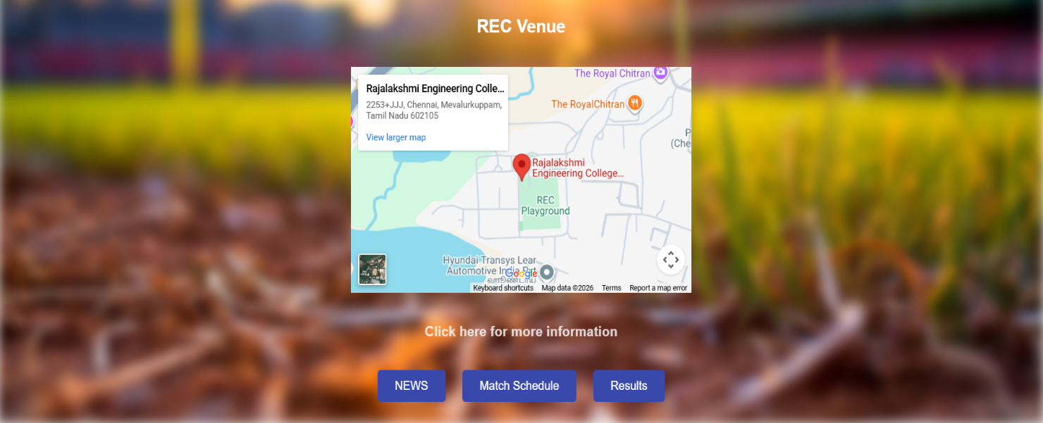

RESULT:
Html Page is created with embedded “REC Chennai” map along with hot spot, frames ,map & links.

