EXP.NO: 5 | Write a Servlet to demonstrate the difference between HTTP GET and POST methods by creating a form and handling requests accordingly.
DATE:13/02/2025

AIM:
To demonstrate the difference between the HTTP GET and POST methods by creating a form in an HTML page and handling the form submissions using two different HTTP methods in a Java Servlet.
ALGORITHM:
1. Input:
- The user fills out a web form with their name and email.
- The form will use both GET and POST methods for data submission.

2. Steps for Creating and Handling the HTTP GET and POST Requests:
- Create an HTML Form:
  - Design an HTML form with two input fields: one for the name and one for the email.
  - Create two buttons to allow the user to submit the form using GET or POST methods.
  - Use the action attribute to define the Servlet URL and specify the form method (either GET or POST).
- Create the Servlet to Handle GET and POST Requests:
  - Write a Java Servlet class that will handle both GET and POST requests.
  - The servlet will have two methods:
    - doGet() to handle the GET requests.
    - doPost() to handle the POST requests.
  - In both methods, retrieve the form data using request.getParameter().
  - In the doGet() method, process and display the data in the URL.
  - In the doPost() method, process and display the data in the HTTP request body.
- Handle GET Requests in the Servlet:
  - In the doGet() method, use request.getParameter() to retrieve the name and email submitted via GET.
  - Output the data as a response, including the name and email in the URL (visible to the user).
- Handle POST Requests in the Servlet:
  - In the doPost() method, use request.getParameter() to retrieve the name and email submitted via POST.
  - Output the data as a response, displaying the name and email without exposing them in the URL (more secure).
- Return the Output:
  - The Servlet should return an HTML page displaying the name and email entered by the user.
  - For the GET method, the output should be visible in the URL.
  - For the POST method, the output should be visible in the response body, not the URL.
- Deploy and Test the Servlet:
  - Compile the Servlet class and deploy it to a Servlet container (like Apache Tomcat).
  - Test the form using GET and POST methods to see the difference in data submission.
- Observe and Compare GET and POST Results:
  - Test the GET method: The form data is sent in the URL.
  - Test the POST method: The form data is sent in the HTTP request body, not visible in the URL.
Code:
userform.java
package com.example;

import java.io.IOException;
import java.io.PrintWriter;
import javax.servlet.ServletException;
import javax.servlet.annotation.WebServlet;
import javax.servlet.http.*;

@WebServlet("/BookingServlet")
public class Sports extends HttpServlet {
private static final long serialVersionUID = 1L;

protected void doPost(HttpServletRequest request, HttpServletResponse response)
throws ServletException, IOException {
processRequest(request, response, "POST");
}

protected void doGet(HttpServletRequest request, HttpServletResponse response)
throws ServletException, IOException {
processRequest(request, response, "GET");
}

private void processRequest(HttpServletRequest request, HttpServletResponse response, String method)
throws IOException {

String name = request.getParameter("name");
String hours = request.getParameter("hours");

response.setContentType("text/html");
PrintWriter out = response.getWriter();

out.println("<html>");
out.println("<head><title>Booking Confirmation</title>");

out.println("<style>");
out.println("body { font-family: -apple-system, BlinkMacSystemFont, 'Segoe UI', Roboto, sans-serif; background:#0b0f19; color:#e5e7eb; display:flex; justify-content:center; align-items:flex-start; height:100vh; margin:0; }");
out.println(".wrapper { margin-top:80px; width:100%; display:flex; justify-content:center; }");
out.println(".container { background:#111827; padding:40px; border-radius:14px; box-shadow:0 20px 40px rgba(0,0,0,0.6); text-align:center; width:420px; }");
out.println("h1 { color:#22c55e; margin-bottom:20px; }");
out.println("p { font-size:16px; margin:10px 0; color:#d1d5db; }");
out.println("span { color:#f9fafb; font-weight:600; }");
out.println("a { display:inline-block; margin-top:25px; text-decoration:none; background:#22c55e; color:#062e16; padding:12px 20px; border-radius:8px; font-weight:600; }");
out.println("a:hover { background:#16a34a; }");
out.println("</style>");

out.println("</head>");
out.println("<body>");

out.println("<div class='wrapper'>");
out.println("<div class='container'>");

out.println("<h1>Booking Successful (" + method + ")</h1>");

out.println("<p>Name: <span>" + name + "</span></p>");
out.println("<p>Booked Hours: <span>" + hours + "</span></p>");

out.println("<p>Your sports slot has been successfully booked.</p>");

out.println("<a href='index.html'>Back</a>");

out.println("</div>");
out.println("</div>");

out.println("</body>");
out.println("</html>");
}
}

index.html

<!DOCTYPE html>
<html>
<head>
<meta charset="UTF-8">
<title>Sports Tournament Booking</title>

<style>
body {
font-family: -apple-system, BlinkMacSystemFont, "Segoe UI", Roboto, sans-serif;
background: linear-gradient(135deg, #0b0f19, #1f2937);
color: #e5e7eb;
margin: 0;
display: flex;
justify-content: center;
align-items: flex-start;
height: 100vh;
}

.wrapper {
margin-top: 70px;
width: 100%;
display: flex;
justify-content: center;
}

.card {
background: #111827;
padding: 40px;
border-radius: 16px;
box-shadow: 0 20px 40px rgba(0,0,0,0.6);
width: 420px;
}

h1 {
text-align: center;
color: #22c55e; /* 👈 sports green */
margin-bottom: 10px;
}

.subtext {
text-align: center;
font-size: 14px;
color: #9ca3af;
margin-bottom: 25px;
}

label {
display: block;
margin-top: 15px;
font-weight: 500;
color: #d1d5db;
}

input[type="text"],
input[type="number"] {
width: 100%;
padding: 12px;
margin-top: 6px;
border-radius: 8px;
border: 1px solid #1f2937;
background-color: #0b0f19;
color: #f9fafb;
transition: 0.2s;
}

input:focus {
border-color: #22c55e;
outline: none;
box-shadow: 0 0 0 2px rgba(34,197,94,0.3);
}

.buttons {
display: flex;
gap: 10px;
margin-top: 20px;
}

input[type="submit"] {
flex: 1;
padding: 12px;
border: none;
border-radius: 8px;
background: #22c55e;
color: #062e16;
font-weight: 600;
cursor: pointer;
transition: 0.2s;
}

input[type="submit"]:hover {
background: #16a34a;
transform: translateY(-1px);
}
</style>
</head>

<body>

<div class="wrapper">
<div class="card">
<h1>Sports Tournament</h1>
<div class="subtext">Book your slot for the event</div>

<form action="BookingServlet" method="post">
<label>Your Name</label>
<input type="text" name="name" required>

<label>Event Number</label>
<input type="number" name="slot" min="1" max="50" required>

<label>Hours / Duration</label>
<input type="number" name="hours" min="1" required>

<div class="buttons">
<input type="submit" value="POST">
<input type="submit" formaction="BookingServlet" formmethod="get" value="GET">
</div>
</form>
</div>
</div>

</body>
</html>

Output:
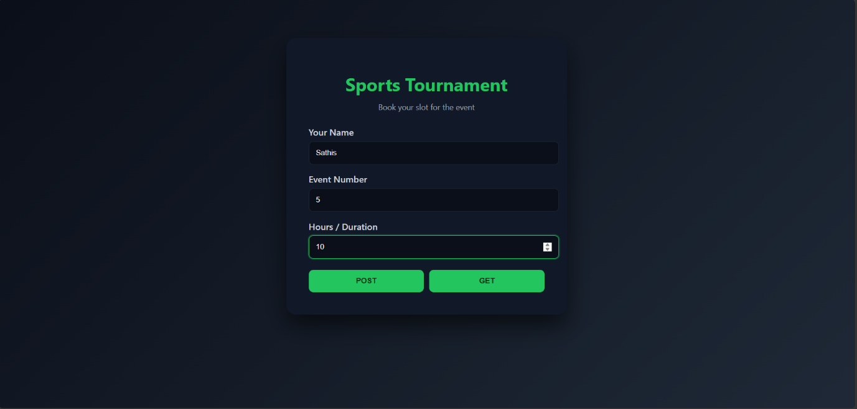
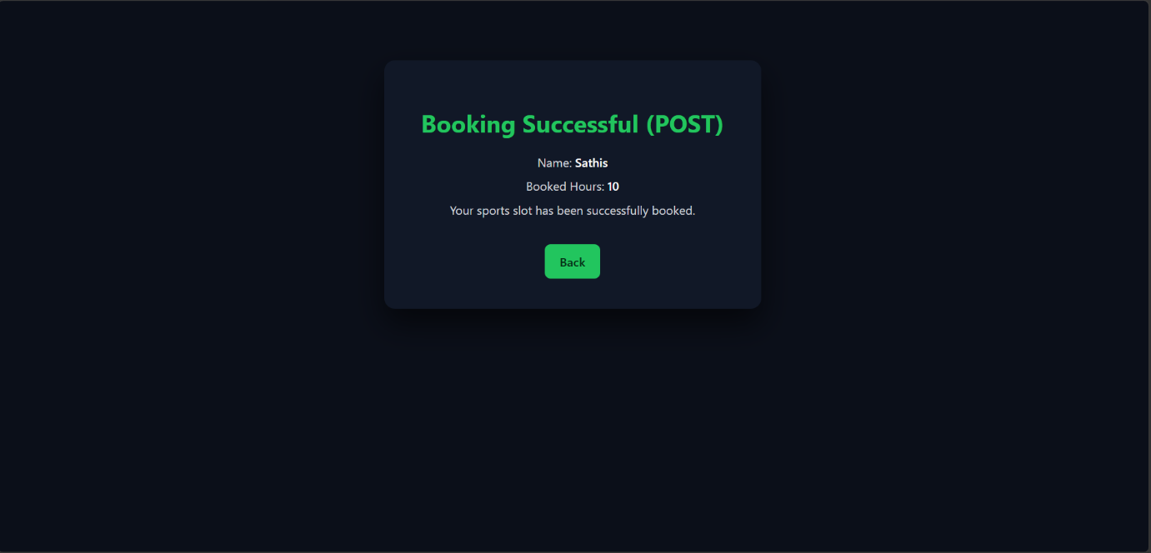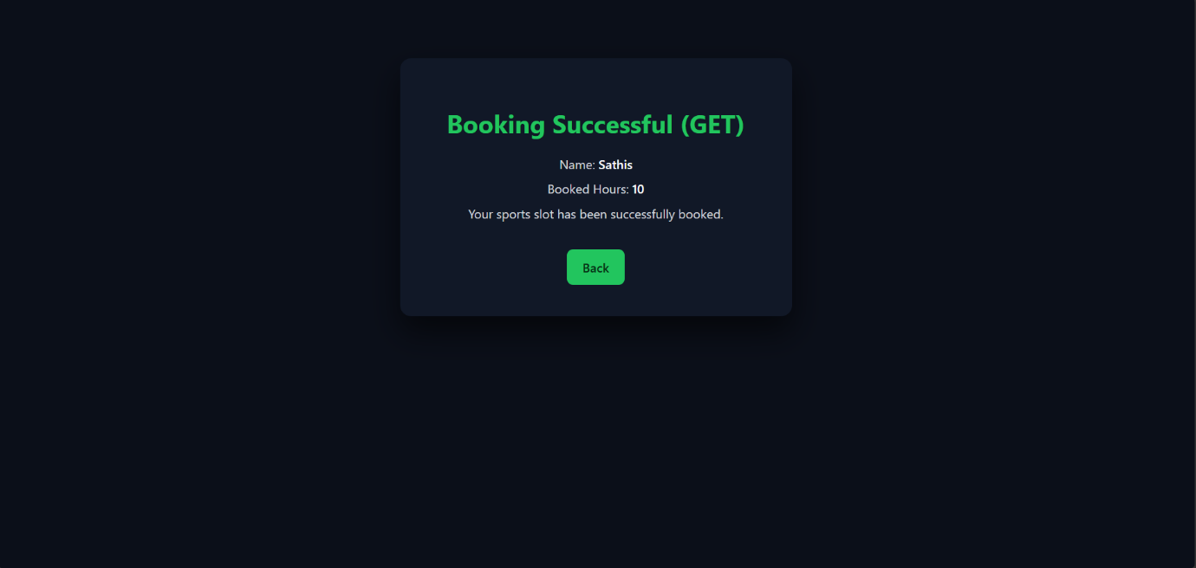

RESULT:
A Servlet is created to demonstrate the difference between HTTP GET and POST methods by creating a form and handling requests accordingly.

