EXP.NO: 6 | Write a Servlet to demonstrate session tracking  using HttpSession.
DATE:24/02/2025

AIM:
To demonstrate session tracking using HttpSession in a Servlet-based web
application. The exercise involves implementing a simple login system where a user can log
in with their username and password, and their session will be tracked throughout their
interaction with the web application.
ALGORITHM:
1. Input:
- The user will enter their username and password in a login form.
- Provide a submit button to send the data to the servlet for authentication.
2. Create the Login Servlet:
  - Write a Java servlet class to handle login requests.
  - Retrieve the username and password from the form.
3.Validate User Credentials:
  - In the servlet, check if the username and password match the expected values.
  - The servlet will have two methods:
    - doGet() to handle the GET requests.
    - doPost() to handle the POST requests.
  - If valid, create a session and store the username in the session.
  - If invalid, redirect the user back to the login page with an error message.
4. Create and Track User Session:
  - Upon successful login, use the HttpSession object to store the session data.
  - Use the session.setAttribute(&quot;username&quot;, username) method to save the username.
. Optionally, set session timeout usingsession.setMaxInactiveInterval(time_in_seconds) to manage session expiration.
5.Deploy and Test the Servlet:
  - After a successful login, the user will be redirected to a protected page (e.g., a
dashboard or home page).
  - The protected page should check if the user is authenticated by checking the
session attribute.
6.Logout and Session Invalidation:
  - Provide a logout feature that invalidates the session using session.invalidate()
when the user logs out.
  - After logout, redirect the user back to the login page.
Code:
index.html
<!DOCTYPE html>
<html lang="en">
<head>
<meta charset="UTF-8" />
<meta name="viewport" content="width=device-width, initial-scale=1.0"/>
<title>🏆 Sports Tournament Portal</title>
<link href="https://fonts.googleapis.com/css2?family=Bebas+Neue&family=Outfit:wght@300;400;600;700&display=swap" rel="stylesheet"/>
<style>
*, *::before, *::after { box-sizing: border-box; margin: 0; padding: 0; }

:root {
--gold: #FFD700;
--orange: #FF6B1A;
--dark: #0A0C10;
--card: #13161E;
--border: #2A2F3D;
--text: #E8EAF0;
--muted: #6B7280;
}

body {
min-height: 100vh;
background: var(--dark);
display: flex;
align-items: center;
justify-content: center;
font-family: 'Outfit', sans-serif;
color: var(--text);
overflow: hidden;
position: relative;
}

/* Animated background grid */
body::before {
content: '';
position: fixed;
inset: 0;
background-image:
linear-gradient(rgba(255,215,0,0.04) 1px, transparent 1px),
linear-gradient(90deg, rgba(255,215,0,0.04) 1px, transparent 1px);
background-size: 48px 48px;
animation: gridMove 20s linear infinite;
z-index: 0;
}

@keyframes gridMove {
0% { background-position: 0 0; }
100% { background-position: 48px 48px; }
}

/* Glowing orbs */
.orb {
position: fixed;
border-radius: 50%;
filter: blur(80px);
opacity: 0.18;
z-index: 0;
animation: float 8s ease-in-out infinite;
}
.orb-1 { width: 400px; height: 400px; background: var(--gold); top: -100px; right: -100px; animation-delay: 0s; }
.orb-2 { width: 300px; height: 300px; background: var(--orange); bottom: -80px; left: -80px; animation-delay: 3s; }

@keyframes float {
0%, 100% { transform: translateY(0px) scale(1); }
50% { transform: translateY(-30px) scale(1.05); }
}

/* Card */
.card {
position: relative;
z-index: 1;
background: var(--card);
border: 1px solid var(--border);
border-radius: 20px;
padding: 48px 44px;
width: 100%;
max-width: 440px;
box-shadow: 0 40px 80px rgba(0,0,0,0.6), 0 0 0 1px rgba(255,215,0,0.06);
animation: slideUp 0.7s cubic-bezier(0.16,1,0.3,1) forwards;
opacity: 0;
transform: translateY(30px);
}

@keyframes slideUp {
to { opacity: 1; transform: translateY(0); }
}

.logo-wrap {
text-align: center;
margin-bottom: 36px;
}

.trophy-icon {
font-size: 52px;
display: block;
margin-bottom: 12px;
animation: pulse 2.5s ease-in-out infinite;
}

@keyframes pulse {
0%, 100% { transform: scale(1); }
50% { transform: scale(1.08); }
}

.logo-title {
font-family: 'Bebas Neue', sans-serif;
font-size: 32px;
letter-spacing: 3px;
background: linear-gradient(135deg, var(--gold), var(--orange));
-webkit-background-clip: text;
-webkit-text-fill-color: transparent;
background-clip: text;
line-height: 1;
}

.logo-sub {
font-size: 12px;
letter-spacing: 2px;
color: var(--muted);
text-transform: uppercase;
margin-top: 6px;
}

.divider {
height: 1px;
background: linear-gradient(90deg, transparent, var(--border), transparent);
margin: 28px 0;
}

.form-group {
margin-bottom: 20px;
}

label {
display: block;
font-size: 11px;
font-weight: 600;
letter-spacing: 1.5px;
text-transform: uppercase;
color: var(--muted);
margin-bottom: 8px;
}

.input-wrap {
position: relative;
}

.input-icon {
position: absolute;
left: 14px;
top: 50%;
transform: translateY(-50%);
font-size: 16px;
pointer-events: none;
}

input[type="text"],
input[type="password"] {
width: 100%;
background: rgba(255,255,255,0.04);
border: 1px solid var(--border);
border-radius: 10px;
color: var(--text);
font-family: 'Outfit', sans-serif;
font-size: 15px;
padding: 13px 14px 13px 42px;
outline: none;
transition: border-color 0.2s, box-shadow 0.2s;
}

input:focus {
border-color: var(--gold);
box-shadow: 0 0 0 3px rgba(255,215,0,0.1);
}

input::placeholder { color: var(--muted); }

.btn {
width: 100%;
padding: 14px;
background: linear-gradient(135deg, var(--gold), var(--orange));
color: #0A0C10;
font-family: 'Bebas Neue', sans-serif;
font-size: 18px;
letter-spacing: 2px;
border: none;
border-radius: 10px;
cursor: pointer;
margin-top: 8px;
transition: transform 0.15s, box-shadow 0.15s, opacity 0.15s;
box-shadow: 0 8px 24px rgba(255,107,26,0.3);
}

.btn:hover { transform: translateY(-2px); box-shadow: 0 12px 32px rgba(255,107,26,0.45); }
.btn:active { transform: translateY(0); opacity: 0.9; }

.footer-note {
text-align: center;
font-size: 12px;
color: var(--muted);
margin-top: 24px;
}

.error-msg {
background: rgba(239,68,68,0.12);
border: 1px solid rgba(239,68,68,0.3);
border-radius: 8px;
color: #F87171;
font-size: 13px;
padding: 10px 14px;
margin-bottom: 18px;
display: none;
}
</style>
</head>
<body>
<div class="orb orb-1"></div>
<div class="orb orb-2"></div>

<div class="card">
<div class="logo-wrap">
<span class="trophy-icon">🏆</span>
<div class="logo-title">Sportz tournament</div>
<div class="logo-sub">Online Sports Tournament Management</div>
</div>

<div class="divider"></div>

<div class="error-msg" id="errMsg">⚠ Invalid credentials. Please try again.</div>

<form action="SessionServlet" method="post" onsubmit="return validateForm()">
<div class="form-group">
<label>Username</label>
<div class="input-wrap">
<span class="input-icon">👤</span>
<input type="text" name="name" placeholder="Enter your username" required />
</div>
</div>

<div class="form-group">
<label>Password</label>
<div class="input-wrap">
<span class="input-icon">🔒</span>
<input type="password" name="password" placeholder="Enter your password" required />
</div>
</div>

<button type="submit" class="btn">Sign in</button>
</form>

<p class="footer-note">Demo credentials &mdash; Username: <strong>admin</strong> &nbsp;|&nbsp; Password: <strong>admin123</strong></p>
</div>

<script>
function validateForm() {
const msg = document.getElementById('errMsg');
msg.style.display = 'none';
return true;
}

// Show error if redirected back with ?error=1
if (new URLSearchParams(location.search).get('error') === '1') {
document.getElementById('errMsg').style.display = 'block';
}
</script>
</body>
</html>

LoginServlet.java

package com.example;
import java.io.*;
import javax.servlet.*;
import javax.servlet.http.*;
import javax.servlet.annotation.WebServlet;

/**
* SessionServlet.java
* Handles login form submission, validates credentials,
* creates an HTTP session, and redirects to the dashboard.
*
* Project : Online Sports Tournament Management
* Author : Your Name
*/
@WebServlet("/SessionServlet")
public class SessionServlet extends HttpServlet {

// Hardcoded credentials for demo – replace with DB lookup in production
private static final String VALID_USERNAME = "admin";
private static final String VALID_PASSWORD = "admin123";

@Override
protected void doPost(HttpServletRequest request, HttpServletResponse response)
throws ServletException, IOException {

response.setContentType("text/html;charset=UTF-8");

String username = request.getParameter("name");
String password = request.getParameter("password");

// Basic null-safety check
if (username == null || password == null ||
username.trim().isEmpty() || password.trim().isEmpty()) {

response.sendRedirect("index.html?error=1");
return;
}

// Validate credentials
if (username.trim().equals(VALID_USERNAME) && password.equals(VALID_PASSWORD)) {

// Create a new session (invalidate old one first for safety)
HttpSession oldSession = request.getSession(false);
if (oldSession != null) {
oldSession.invalidate();
}

HttpSession session = request.getSession(true);
session.setAttribute("user", username.trim());
session.setAttribute("loginTime", System.currentTimeMillis());
session.setMaxInactiveInterval(30 * 60); // 30-minute timeout

// Redirect to the dashboard
response.sendRedirect("DashboardServlet");

} else {
// Invalid credentials – redirect back with error flag
response.sendRedirect("index.html?error=1");
}
}

// Prevent direct GET access to this servlet
@Override
protected void doGet(HttpServletRequest request, HttpServletResponse response)
throws ServletException, IOException {
response.sendRedirect("index.html");
}
}
DashboardServlet.java
package com.example;

import java.io.*;
import javax.servlet.*;
import javax.servlet.http.*;
import javax.servlet.annotation.WebServlet;
import java.text.SimpleDateFormat;
import java.util.Date;

/**
* DashboardServlet.java
* Verifies session and renders the Sports Tournament Management Dashboard.
*
* Project : Online Sports Tournament Management
* Author : Your Name
*/
@WebServlet("/DashboardServlet")
public class DashboardServlet extends HttpServlet {

@Override
protected void doGet(HttpServletRequest request, HttpServletResponse response)
throws ServletException, IOException {

response.setContentType("text/html;charset=UTF-8");
PrintWriter out = response.getWriter();

// ── Session Guard ─────────────────────────────────────────────────────
HttpSession session = request.getSession(false);

if (session == null || session.getAttribute("user") == null) {
// Session expired or not logged in
out.println("<!DOCTYPE html><html><head>");
out.println("<meta http-equiv='refresh' content='3;url=index.html'/>");
out.println("<style>body{font-family:Outfit,sans-serif;background:#0A0C10;color:#E8EAF0;"
+ "display:flex;align-items:center;justify-content:center;height:100vh;}</style>");
out.println("</head><body>");
out.println("<p>⚠ Session expired. Redirecting to login...</p>");
out.println("</body></html>");
return;
}

// ── Session Data ──────────────────────────────────────────────────────
String username = (String) session.getAttribute("user");
long loginTime = (Long) session.getAttribute("loginTime");
String loginDate = new SimpleDateFormat("dd MMM yyyy, hh:mm a").format(new Date(loginTime));

// ── Demo Tournament Data (replace with DB queries) ────────────────────
String[][] tournaments = {
{"T001", "IPL Cricket Championship", "Cricket", "Active", "16", "Apr 20, 2026"},
{"T002", "National Football League", "Football", "Upcoming", "12", "May 05, 2026"},
{"T003", "State Badminton Open", "Badminton", "Active", "8", "Apr 18, 2026"},
{"T004", "Inter-College Basketball Cup","Basketball","Completed", "10", "Apr 01, 2026"},
{"T005", "City Tennis Masters", "Tennis", "Upcoming", "6", "May 12, 2026"}
};

String[][] recentMatches = {
{"Chennai Super Kings", "vs", "Mumbai Indians", "Cricket", "185 / 162", "Apr 14"},
{"FC Bengaluru", "vs", "Hyderabad FC", "Football", "2 – 1", "Apr 13"},
{"P. Kashyap", "vs", "K. Srikanth", "Badminton", "21-18, 19-21, 21-17", "Apr 13"}
};

// ══════════════════════════════════════════════════════════════════════
// ── HTML Output ───────────────────────────────────────────────────────
// ══════════════════════════════════════════════════════════════════════
out.println("<!DOCTYPE html>");
out.println("<html lang='en'>");
out.println("<head>");
out.println(" <meta charset='UTF-8'/>");
out.println(" <meta name='viewport' content='width=device-width, initial-scale=1.0'/>");
out.println(" <title>🏆 TourneyPro Dashboard</title>");
out.println(" <link href='https://fonts.googleapis.com/css2?"
+ "family=Bebas+Neue&family=Outfit:wght@300;400;600;700&display=swap' rel='stylesheet'/>");
out.println(" <style>");
out.println(getDashboardCSS());
out.println(" </style>");
out.println("</head>");
out.println("<body>");

// ── Sidebar ───────────────────────────────────────────────────────────
out.println("<nav class='sidebar'>");
out.println(" <div class='sidebar-logo'>");
out.println(" <span class='trophy'>🏆</span>");
out.println(" <span class='brand'>Sportz tournament</span>");
out.println(" </div>");
out.println(" <ul class='nav-links'>");
out.println(" <li class='active'><a href='DashboardServlet'>📊 Dashboard</a></li>");
out.println(" <li><a href='#tournaments'>🎯 Tournaments</a></li>");
out.println(" <li><a href='#matches'>⚽ Matches</a></li>");
out.println(" <li><a href='#teams'>👥 Teams</a></li>");
out.println(" <li><a href='#players'>🏃 Players</a></li>");
out.println(" <li><a href='#schedule'>📅 Schedule</a></li>");
out.println(" <li><a href='#results'>🥇 Results</a></li>");
out.println(" </ul>");
out.println(" <div class='sidebar-footer'>");
out.println(" <a href='LogoutServlet' class='logout-btn'>🚪 Logout</a>");
out.println(" </div>");
out.println("</nav>");

// ── Main Content ──────────────────────────────────────────────────────
out.println("<main class='main'>");

// Top Bar
out.println(" <header class='topbar'>");
out.println(" <div class='topbar-left'>");
out.println(" <h1>Dashboard</h1>");
out.println(" <span class='subtitle'>Welcome back, <strong>" + username + "</strong>"
+ " &nbsp;·&nbsp; Last login: " + loginDate + "</span>");
out.println(" </div>");
out.println(" <div class='topbar-right'>");
out.println(" <div class='avatar'>" + username.substring(0,1).toUpperCase() + "</div>");
out.println(" </div>");
out.println(" </header>");

// ── Stats Cards ───────────────────────────────────────────────────────
out.println(" <section class='stats-grid'>");
printStatCard(out, "🏆", "Total Tournaments", "5", "+2 this month");
printStatCard(out, "⚽", "Active Matches", "8", "Live now");
printStatCard(out, "👥", "Registered Teams", "62","Across all sports");
printStatCard(out, "🏃", "Total Players", "840","Registered athletes");
out.println(" </section>");

// ── Tournament Table ──────────────────────────────────────────────────
out.println(" <section class='section' id='tournaments'>");
out.println(" <div class='section-header'>");
out.println(" <h2>Tournaments</h2>");
out.println(" <button class='btn-add'>+ New Tournament</button>");
out.println(" </div>");
out.println(" <div class='table-wrap'>");
out.println(" <table>");
out.println(" <thead><tr>");
out.println(" <th>ID</th><th>Tournament Name</th><th>Sport</th>");
out.println(" <th>Status</th><th>Teams</th><th>Start Date</th><th>Actions</th>");
out.println(" </tr></thead><tbody>");

for (String[] t : tournaments) {
String badgeClass = t[3].equals("Active") ? "badge-active"
: t[3].equals("Upcoming") ? "badge-upcoming"
: "badge-done";
out.println("<tr>");
out.println(" <td class='mono'>" + t[0] + "</td>");
out.println(" <td><strong>" + t[1] + "</strong></td>");
out.println(" <td>" + t[2] + "</td>");
out.println(" <td><span class='badge " + badgeClass + "'>" + t[3] + "</span></td>");
out.println(" <td>" + t[4] + "</td>");
out.println(" <td>" + t[5] + "</td>");
out.println(" <td class='actions'>");
out.println(" <button class='act-btn view'>View</button>");
out.println(" <button class='act-btn edit'>Edit</button>");
out.println(" <button class='act-btn del'>Delete</button>");
out.println(" </td>");
out.println("</tr>");
}

out.println(" </tbody></table>");
out.println(" </div>");
out.println(" </section>");

// ── Recent Matches ────────────────────────────────────────────────────
out.println(" <section class='section' id='matches'>");
out.println(" <div class='section-header'><h2>Recent Match Results</h2></div>");
out.println(" <div class='matches-grid'>");

for (String[] m : recentMatches) {
out.println("<div class='match-card'>");
out.println(" <div class='match-sport'>" + m[3] + "</div>");
out.println(" <div class='match-teams'>");
out.println(" <span class='team'>" + m[0] + "</span>");
out.println(" <span class='vs'>" + m[1] + "</span>");
out.println(" <span class='team'>" + m[2] + "</span>");
out.println(" </div>");
out.println(" <div class='match-score'>" + m[4] + "</div>");
out.println(" <div class='match-date'>📅 " + m[5] + "</div>");
out.println("</div>");
}

out.println(" </div>");
out.println(" </section>");

out.println("</main>");
out.println("</body></html>");
}

// ── Helper: stat card ─────────────────────────────────────────────────────
private void printStatCard(PrintWriter out, String icon, String label,
String value, String sub) {
out.println("<div class='stat-card'>");
out.println(" <div class='stat-icon'>" + icon + "</div>");
out.println(" <div class='stat-body'>");
out.println(" <div class='stat-value'>" + value + "</div>");
out.println(" <div class='stat-label'>" + label + "</div>");
out.println(" <div class='stat-sub'>" + sub + "</div>");
out.println(" </div>");
out.println("</div>");
}

// ── CSS String ────────────────────────────────────────────────────────────
private String getDashboardCSS() {
return
"*, *::before, *::after { box-sizing: border-box; margin: 0; padding: 0; }" +
":root {" +
" --gold: #FFD700; --orange: #FF6B1A; --dark: #0A0C10;" +
" --card: #13161E; --border: #2A2F3D; --text: #E8EAF0; --muted: #6B7280;" +
" --sidebar-w: 230px;" +
"}" +
"body { display: flex; font-family: 'Outfit', sans-serif;" +
" background: var(--dark); color: var(--text); min-height: 100vh; }" +
// Sidebar
".sidebar { width: var(--sidebar-w); background: var(--card); border-right: 1px solid var(--border);" +
" display: flex; flex-direction: column; position: fixed; height: 100vh; padding: 24px 0; }" +
".sidebar-logo { display: flex; align-items: center; gap: 10px; padding: 0 20px 24px;" +
" border-bottom: 1px solid var(--border); }" +
".trophy { font-size: 28px; }" +
".brand { font-family: 'Bebas Neue', sans-serif; font-size: 22px; letter-spacing: 2px;" +
" background: linear-gradient(135deg, var(--gold), var(--orange));" +
" -webkit-background-clip: text; -webkit-text-fill-color: transparent; background-clip: text; }" +
".nav-links { list-style: none; margin-top: 16px; flex: 1; }" +
".nav-links li a { display: block; padding: 11px 20px; color: var(--muted); text-decoration: none;" +
" font-size: 14px; font-weight: 500; border-radius: 0 10px 10px 0;" +
" margin-right: 12px; transition: all 0.2s; }" +
".nav-links li a:hover, .nav-links li.active a { color: var(--text);" +
" background: rgba(255,215,0,0.08); border-left: 3px solid var(--gold); padding-left: 17px; }" +
".sidebar-footer { padding: 16px 20px; border-top: 1px solid var(--border); }" +
".logout-btn { display: block; text-align: center; padding: 10px; border-radius: 10px;" +
" background: rgba(239,68,68,0.12); color: #F87171; text-decoration: none;" +
" font-size: 14px; font-weight: 600; transition: background 0.2s; }" +
".logout-btn:hover { background: rgba(239,68,68,0.22); }" +
// Main
".main { margin-left: var(--sidebar-w); flex: 1; padding: 0 32px 48px; }" +
".topbar { display: flex; align-items: center; justify-content: space-between;" +
" padding: 28px 0 20px; border-bottom: 1px solid var(--border); margin-bottom: 28px; }" +
".topbar h1 { font-family: 'Bebas Neue', sans-serif; font-size: 32px; letter-spacing: 2px;" +
" background: linear-gradient(135deg, var(--gold), var(--orange));" +
" -webkit-background-clip: text; -webkit-text-fill-color: transparent; background-clip: text; }" +
".subtitle { font-size: 13px; color: var(--muted); margin-top: 4px; display: block; }" +
".avatar { width: 40px; height: 40px; border-radius: 50%;" +
" background: linear-gradient(135deg, var(--gold), var(--orange));" +
" display: flex; align-items: center; justify-content: center;" +
" font-weight: 700; color: #0A0C10; font-size: 16px; }" +
// Stats
".stats-grid { display: grid; grid-template-columns: repeat(4, 1fr); gap: 18px; margin-bottom: 32px; }" +
".stat-card { background: var(--card); border: 1px solid var(--border); border-radius: 14px;" +
" padding: 22px; display: flex; gap: 16px; align-items: center;" +
" transition: transform 0.2s, box-shadow 0.2s; }" +
".stat-card:hover { transform: translateY(-3px); box-shadow: 0 12px 32px rgba(0,0,0,0.4); }" +
".stat-icon { font-size: 34px; }" +
".stat-value { font-family: 'Bebas Neue', sans-serif; font-size: 36px; letter-spacing: 1px;" +
" background: linear-gradient(135deg, var(--gold), var(--orange));" +
" -webkit-background-clip: text; -webkit-text-fill-color: transparent; background-clip: text; }" +
".stat-label { font-size: 13px; font-weight: 600; color: var(--text); }" +
".stat-sub { font-size: 11px; color: var(--muted); margin-top: 2px; }" +
// Sections
".section { margin-bottom: 36px; }" +
".section-header { display: flex; align-items: center; justify-content: space-between; margin-bottom: 16px; }" +
".section-header h2 { font-family: 'Bebas Neue', sans-serif; font-size: 22px;" +
" letter-spacing: 2px; color: var(--text); }" +
".btn-add { background: linear-gradient(135deg, var(--gold), var(--orange));" +
" color: #0A0C10; font-family: 'Bebas Neue', sans-serif; font-size: 15px;" +
" letter-spacing: 1px; padding: 9px 20px; border: none; border-radius: 8px;" +
" cursor: pointer; transition: transform 0.15s, box-shadow 0.15s; }" +
".btn-add:hover { transform: translateY(-2px); box-shadow: 0 8px 20px rgba(255,107,26,0.35); }" +
// Table
".table-wrap { background: var(--card); border: 1px solid var(--border); border-radius: 14px; overflow: hidden; }" +
"table { width: 100%; border-collapse: collapse; }" +
"thead tr { background: rgba(255,215,0,0.06); }" +
"th { padding: 13px 16px; text-align: left; font-size: 11px; font-weight: 700;" +
" letter-spacing: 1.5px; text-transform: uppercase; color: var(--muted); }" +
"td { padding: 13px 16px; font-size: 14px; border-top: 1px solid var(--border); }" +
"tr:hover td { background: rgba(255,255,255,0.02); }" +
".mono { font-family: monospace; font-size: 12px; color: var(--muted); }" +
".badge { display: inline-block; padding: 3px 10px; border-radius: 20px; font-size: 11px; font-weight: 700; }" +
".badge-active { background: rgba(34,197,94,0.15); color: #4ADE80; }" +
".badge-upcoming{ background: rgba(59,130,246,0.15); color: #60A5FA; }" +
".badge-done { background: rgba(107,114,128,0.15); color: #9CA3AF; }" +
".actions { display: flex; gap: 6px; }" +
".act-btn { padding: 5px 12px; border-radius: 6px; border: none; cursor: pointer;" +
" font-size: 12px; font-weight: 600; transition: opacity 0.15s; }" +
".act-btn:hover { opacity: 0.8; }" +
".act-btn.view { background: rgba(255,215,0,0.12); color: var(--gold); }" +
".act-btn.edit { background: rgba(59,130,246,0.12); color: #60A5FA; }" +
".act-btn.del { background: rgba(239,68,68,0.12); color: #F87171; }" +
// Match Cards
".matches-grid { display: grid; grid-template-columns: repeat(3, 1fr); gap: 18px; }" +
".match-card { background: var(--card); border: 1px solid var(--border); border-radius: 14px;" +
" padding: 20px; transition: transform 0.2s; }" +
".match-card:hover { transform: translateY(-3px); }" +
".match-sport { font-size: 11px; font-weight: 700; letter-spacing: 1.5px; text-transform: uppercase;" +
" color: var(--gold); margin-bottom: 12px; }" +
".match-teams { display: flex; align-items: center; gap: 8px; font-size: 14px; font-weight: 600;" +
" flex-wrap: wrap; margin-bottom: 10px; }" +
".vs { font-size: 11px; color: var(--muted); font-weight: 400; }" +
".match-score { font-family: 'Bebas Neue', sans-serif; font-size: 20px; letter-spacing: 1px;" +
" background: linear-gradient(135deg, var(--gold), var(--orange));" +
" -webkit-background-clip: text; -webkit-text-fill-color: transparent; background-clip: text; }" +
".match-date { font-size: 12px; color: var(--muted); margin-top: 8px; }";
}

@Override
protected void doPost(HttpServletRequest request, HttpServletResponse response)
throws ServletException, IOException {
doGet(request, response);
}
}

LogoutServlet.java:
package com.event;

import javax.servlet.*;
import javax.servlet.http.*;
import javax.servlet.annotation.WebServlet;
import java.io.IOException;

@WebServlet("/LogoutServlet")
public class LogoutServlet extends HttpServlet {

protected void doGet(HttpServletRequest request, HttpServletResponse response)
throws IOException {

HttpSession session = request.getSession(false);

if(session != null) {
session.invalidate();
}

response.sendRedirect("index.html");
}
}

Output:
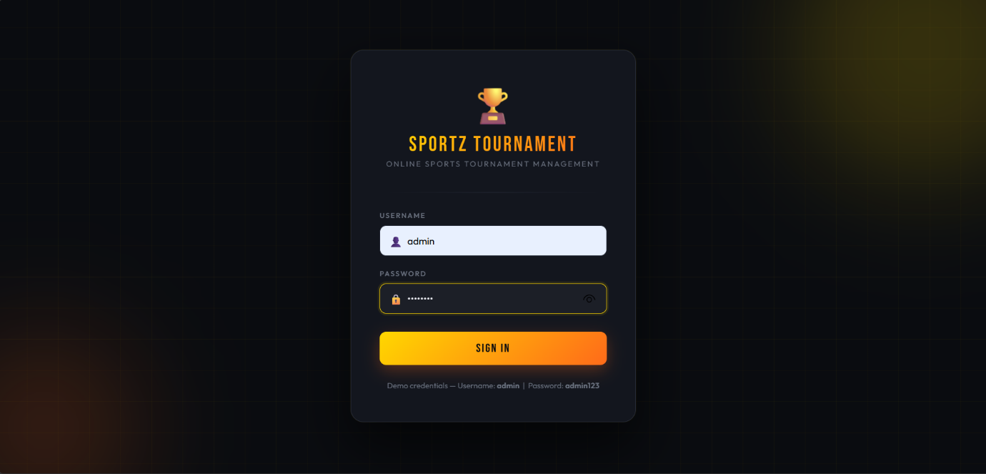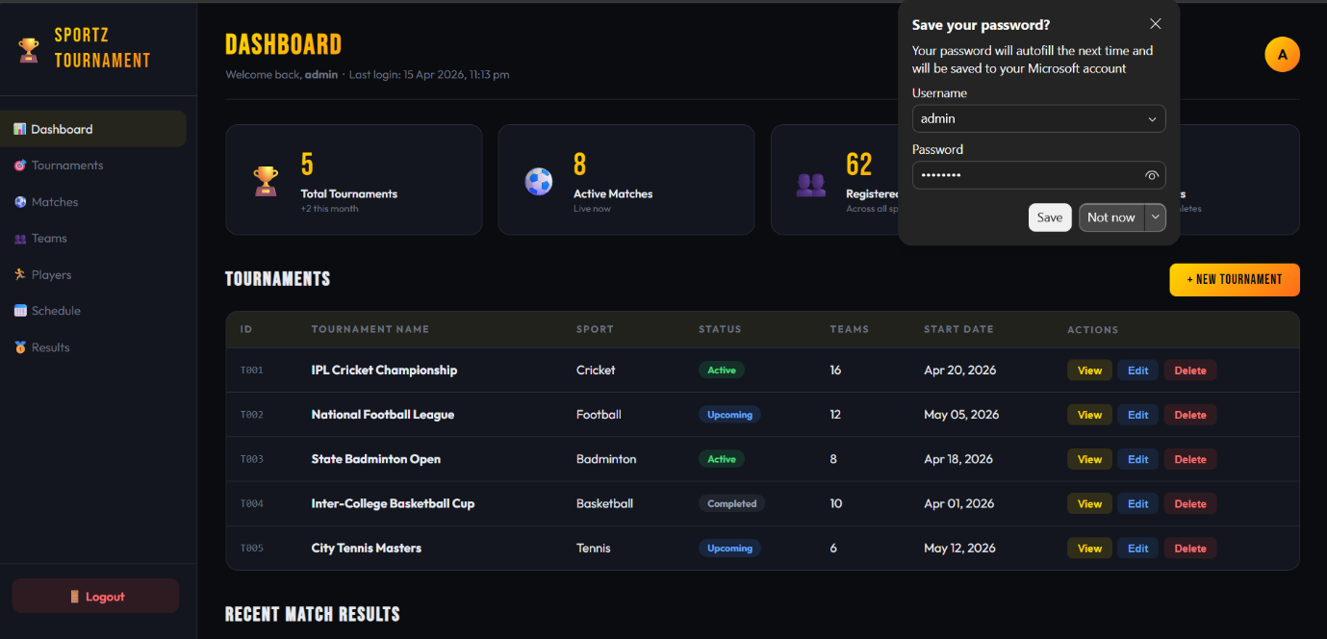

RESULT:
A simple login system is created where the user&#39;s session is tracked by a servlet to
demonstrate session tracking using HttpSession.

