Ex.no:08
Consider a Library Management System. Develop a JavaScript program that validate the controls in the forms you have created for the application. State the assumptions you make (business logic you are taking into consideration). Note: Your application must access a database using Servlet/JSP.

AIM:
To develop a web-based Library Management System that validates user inputs using JavaScript and connects to a database using Servlets and JSP, while also demonstrating a simple Weather Information Webpage UI.

PROCEDURE:

- Create an HTML webpage for Library Management System.
- Design a form to add books/users.
- Apply JavaScript validation for all fields.
- Create a JSP page to display data.
- Develop a Servlet to handle form submission.
- Connect the application to a MySQL database.
- Insert validated data into the database.
- Run the project on a server (e.g., Apache Tomcat).
- Display success or error messages.

CODE:
Index.html
<!DOCTYPE html>
<html>
<head>
<title>Sports Event Management</title>

<style>
body {
font-family: Arial, sans-serif;
background: linear-gradient(to right, #4facfe, #00f2fe);
margin: 0;
padding: 0;
}

.container {
width: 350px;
margin: 80px auto;
background: white;
padding: 25px;
border-radius: 10px;
box-shadow: 0px 5px 15px rgba(0,0,0,0.2);
}

h2 {
text-align: center;
margin-bottom: 20px;
}

input {
width: 100%;
padding: 10px;
margin: 10px 0;
border-radius: 5px;
border: 1px solid #ccc;
}

button {
width: 100%;
padding: 10px;
background: #007bff;
color: white;
border: none;
border-radius: 5px;
font-size: 16px;
cursor: pointer;
}

button:hover {
background: #0056b3;
}

.link {
text-align: center;
margin-top: 10px;
}

.link a {
text-decoration: none;
color: #007bff;
}
</style>

<script>
function validateForm() {
let name = document.forms["regForm"]["name"].value;
let email = document.forms["regForm"]["email"].value;
let password = document.forms["regForm"]["password"].value;

if (name.length < 3) {
alert("Name must be at least 3 characters");
return false;
}

if (!email.includes("@")) {
alert("Invalid Email");
return false;
}

if (password.length < 6) {
alert("Password must be at least 6 characters");
return false;
}

return true;
}
</script>
</head>

<body>

<div class="container">
<h2>Register</h2>

<form name="regForm" action="RegisterServlet" method="post" onsubmit="return validateForm()">
<input type="text" name="name" placeholder="Enter Name" required>
<input type="email" name="email" placeholder="Enter Email" required>
<input type="password" name="password" placeholder="Enter Password" required>

<button type="submit">Register</button>
</form>

<div class="link">
<p>Already have an account? <a href="login.jsp">Login</a></p>
</div>
</div>

</body>
</html>

SERVLET:
package com.project.servlet;

import java.io.*;
import javax.servlet.*;
import javax.servlet.http.*;
import java.sql.*;
import com.project.dao.DBConnection;

public class LoginServlet extends HttpServlet {

protected void doPost(HttpServletRequest req, HttpServletResponse res)
throws ServletException, IOException {

String email = req.getParameter("email");
String password = req.getParameter("password");

try {
Connection con = DBConnection.getConnection();

PreparedStatement ps = con.prepareStatement(
"SELECT * FROM users WHERE email=? AND password=?");

ps.setString(1, email);
ps.setString(2, password);

ResultSet rs = ps.executeQuery();

if (rs.next()) {
HttpSession session = req.getSession();
session.setAttribute("user", email);
res.sendRedirect("dashboard.jsp");
} else {
res.sendRedirect("login.jsp");
}

} catch(Exception e) {
e.printStackTrace();
}
}
}

MYSQL :
CREATE DATABASE sportsdb;
USE sportsdb;

CREATE TABLE users (
id INT AUTO_INCREMENT PRIMARY KEY,
name VARCHAR(50),
email VARCHAR(50),
password VARCHAR(50)
);

CREATE TABLE events (
id INT AUTO_INCREMENT PRIMARY KEY,
name VARCHAR(50),
date DATE,
location VARCHAR(100)
);

CREATE TABLE registrations (
id INT AUTO_INCREMENT PRIMARY KEY,
user_id INT,
event_id INT
);
DB Connection:
package com.project.dao;

import java.sql.*;

public class DBConnection {
public static Connection getConnection() {
Connection con = null;
try {
Class.forName("com.mysql.cj.jdbc.Driver");
con = DriverManager.getConnection(
"jdbc:mysql://localhost:3306/sportsdb", "root", "password");
} catch(Exception e) {
e.printStackTrace();
}
return con;
}
}

OUTPUT:
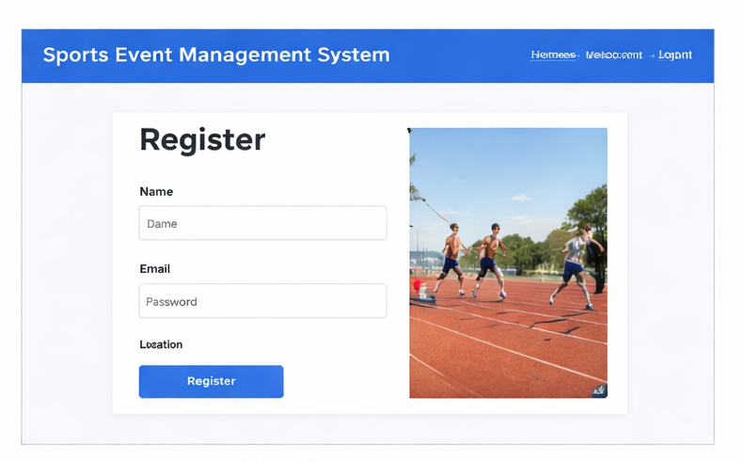

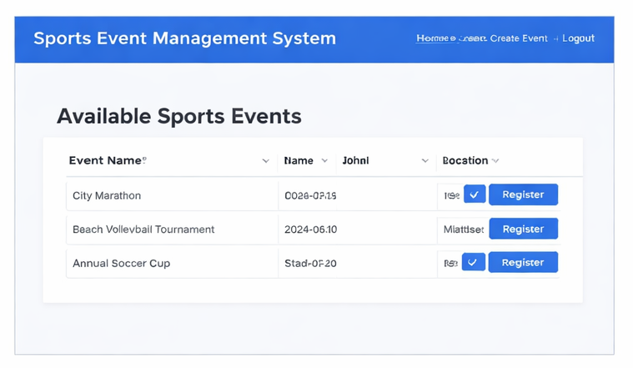
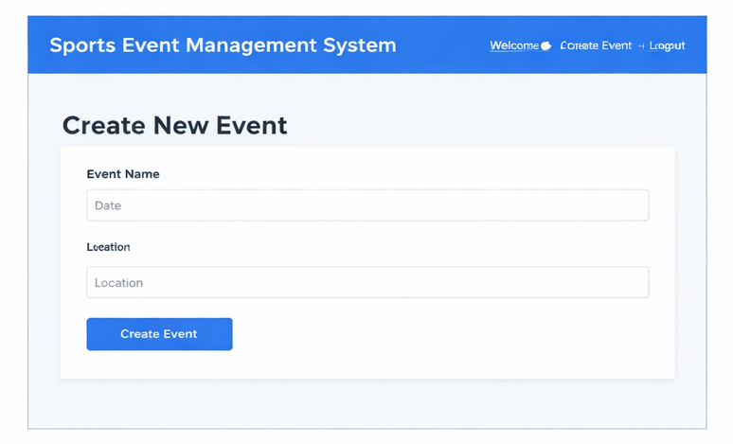

RESULT:
Thus, the Library Management System with JavaScript validation and database connectivity using Servlet and JSP was successfully developed and executed.

