EXP.NO: 2 Write a Servlet program that prints “Hello, World!” when accessed through a
browser
AIM:
To write a basic Servlet program that demonstrates the use of Java Servlets by printing
“Hello, World!” when accessed through a browser.
ALGORITHM:
1. Input:
• The user makes an HTTP request (usually by entering a URL) through a browser.2. 2. Servlet Program Flow:
1. Create a Servlet Class:
o Define a Java class that extends the HttpServlet class.
o Override the doGet() method, which handles HTTP GET requests from the
client (browser).
2. Handle HTTP Request:
o In the doGet() method:
▪ Get the PrintWriter object to write the response to the browser.
▪ Set the response content type to text/html.
▪ Write the &quot;Hello, World!&quot; message to the response.

3. Compile the Servlet Class:
o Compile the Java Servlet file using the javac command to generate a .class
file.
4. Deploy the Servlet:
o Place the compiled servlet class file in the appropriate directory of the web
application (typically in the /WEB-INF/classes folder).
o Configure the servlet in the web.xml file of the web application or use
annotations.

5. Access the Servlet via Browser:
o Start the Apache Tomcat or another servlet container.
o Access the servlet by entering the appropriate URL (e.g.,
http://localhost:8081/Hello/Hello).
CODE:
package com.example;

import java.io.IOException;
import java.io.PrintWriter; // Needed to write output to browser
import javax.servlet.ServletException;
import javax.servlet.annotation.WebServlet;
import javax.servlet.http.HttpServlet;
import javax.servlet.http.HttpServletRequest;
import javax.servlet.http.HttpServletResponse;

/**
* Servlet implementation class Hello
*/
@WebServlet("/Hello")
import java.io.IOException;
import java.io.PrintWriter;

import javax.servlet.ServletException;
import javax.servlet.http.*;
import javax.servlet.annotation.WebServlet;

@WebServlet("/hello")
public class Helloservlet extends HttpServlet {

protected void doGet(HttpServletRequest request, HttpServletResponse response)
throws ServletException, IOException {

response.setContentType("text/html");

PrintWriter out = response.getWriter();

out.println("<html>");
out.println("<body>");
out.println("<h1>Hello, World!</h1>");
out.println("</body>");
out.println("</html>");
}
}
OUTPUT:
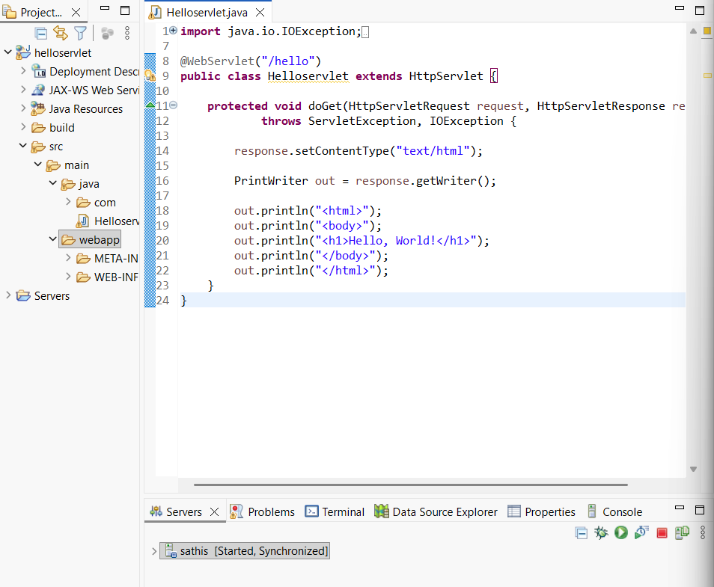

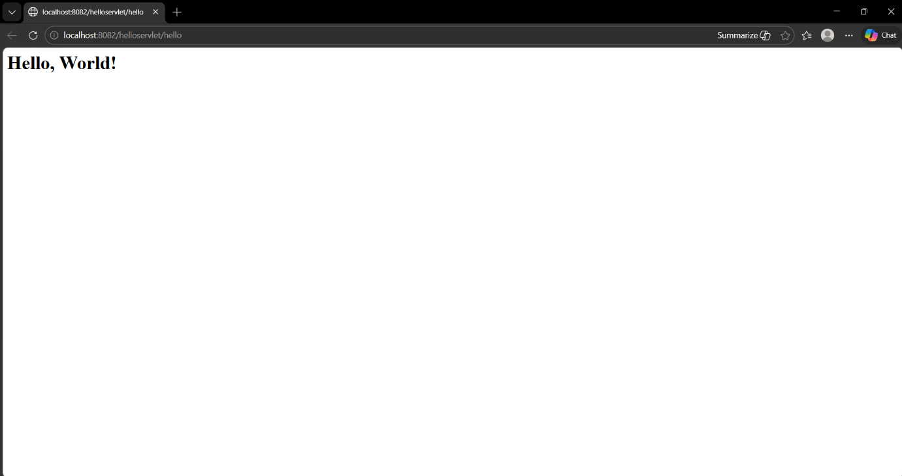

RESULT:
The browser will display the message &quot;Hello, World!&quot; returned by the Servlet.

