mRemedy

website Functional document

Index
- Document Overview
  - Purpose of the Document
  - Scope of the Document
- Site Functionality
  - Home
  - About us
  - Products
  - Support
  - Contact us
  - Log in
  - Download tracker information
  - Reset my password
  - Miscellaneous
- Use cases
- Foreseeable Enhancement
Appendices
- Glossary of Terms

1. Document OVerview
1.1 Purpose of thE document
The purpose of this document is to:
    - Show a detail view of what the software is supposed to do
    - Showcase the technical solution for mRemedy website
If there are any terms that you do not understand, see Appendix Glossary of Terms.
1.2 scope of thE document
This document covers and expounds the previously approved functionality of the mRemedy website site, product and download tracker information.

2. site functionality
This would enable the user to check for axial health app release, latest news, send queries and download their tracker information. The basic flow of the website is to be - user can browse any pages without logging in to the site except the tracker information. User need to log in to download their tracker information. This section explains the font-end functionality of the site like common features, description of every page, screen-shot of some important pages.
2.1 home
This is the opening page once you load the url. Here you can see the axial mobile brand advertisement and latest 3 news excerpt. On clicking the news title user can view the detailed news. User will have a hyperlink to view all latest news/articles. The news is manageable from admin side.
2.2 About Us
This is a static page containing details about the axial team – management team, board of directors and advisory team.
2.3 products
This is one of the main pages of the website to promote the branded mobile applications for health system. This page lists all released health apps. Clicking on each app icon, will bring user to its detailed page. The app branding page will have some screen-shot of health app and description about the app, features and minimum requirement need to download the app. There is also a gallery section to show various screen of the app. User can have download button to download the app from this page.

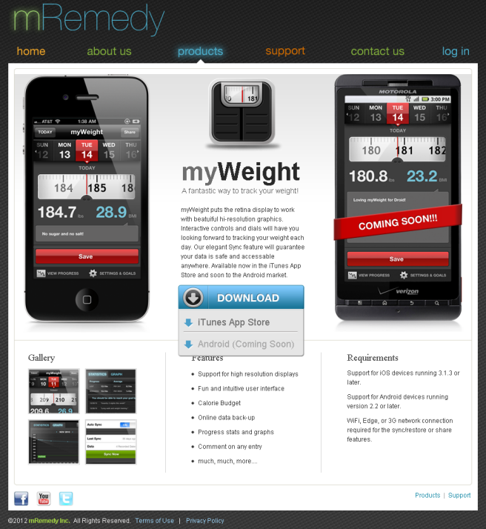

2.4 Support
This page lists the frequently asked questions for each app. User can also send email about their issue if it’s not listed in FAQ. User need to specify following information to report their issue.
Name: Name of the user
Email : email id of the user
Platform : Select the OS type from drop down
App : Select the health app from drop down.
Issue : A small text box where user can specify details about the issue.
All the fields are mandatory to report issue to site owner.

2.5 Contact us
This is another page to allow user to send their queries about mRemedy's products or services to system admin. User need to submit following information to report their issue. All the fields except “How did you hear about us” and “comments” are mandatory.
Name : Name to be addressed
Company : company name
Email Address : contact email address
Phone Number : contact phone number
How did you hear about us : enter information how they heard about mRemedy
Comments : enter details about the issue
Enter security answer : enter captcha code to prove that human is submitting the form
2.6 login
This is the page where user can log in to the website to download the health tracker information. User will be required to enter email and password to log in to the private page of the site. System will allow user to proceed only if the email and password matches with db, else an appropriate message will be displayed.
2.7 Download tracker information
User will be redirected to this page upon successful log in. Here user can view the list of application that they have signed in. User can select one or more application to download the most recently synced data as CSV file. If the site is accessed in iPhone, the synced information will be displayed in tabular representation.
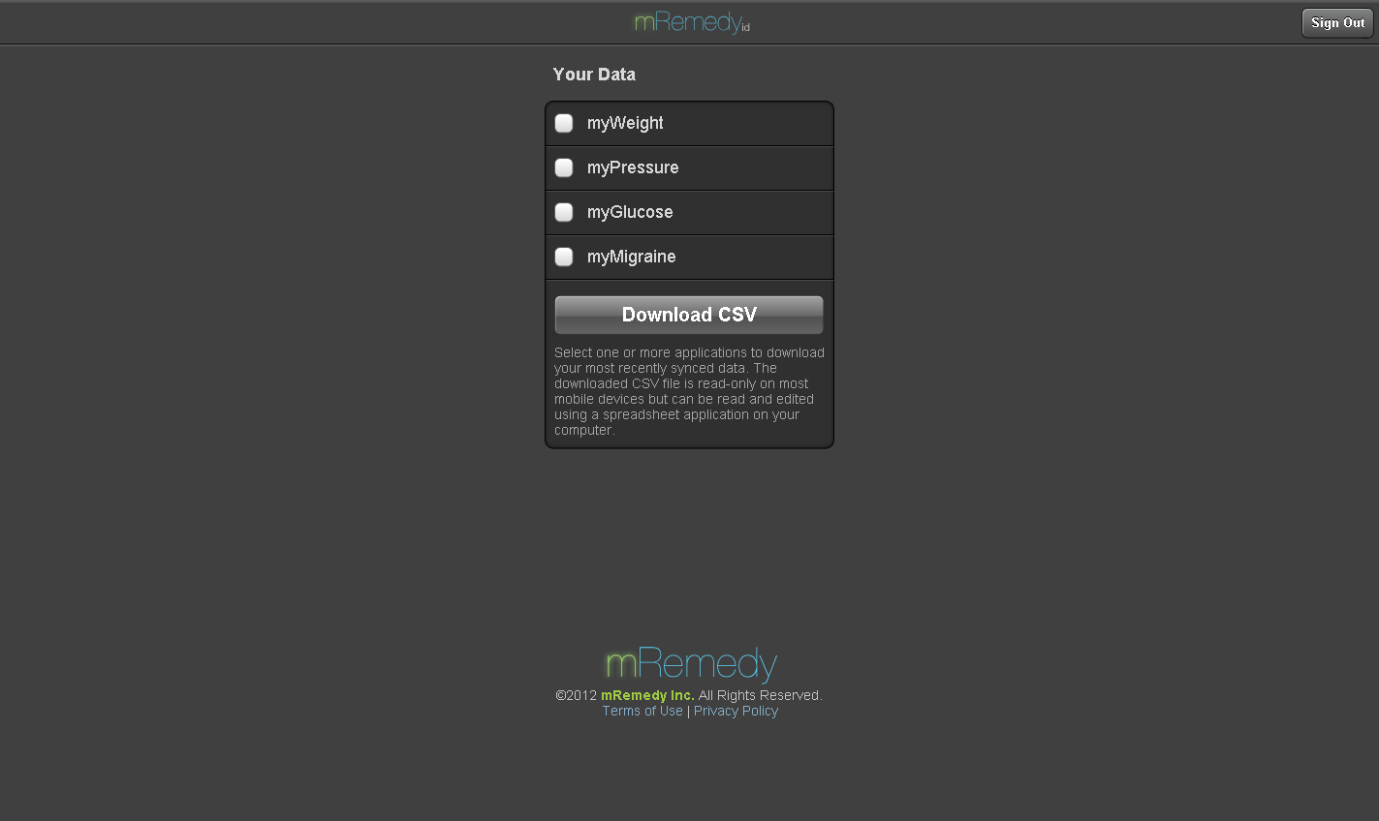

2.8 Reset my password
If the user forgets his/her password, one can click on “Reset my Password” button available on login page. User will be asked to enter their email address to receive password reset instructions. System will perform check for email existence. If the email exists, system will send email message to the given email id. Then, user need to follow the instruction in the email. User needs to click on the link received in the mail to choose a new password. This will bring the user to a screen to enter new password and thereby login to the site with the new password. If they haven’t received reset instruction within 24 hours they can send mail to support@mremedy.com.
2.9 Miscellaneous
This website also has some other pages like Terms of Use, Privacy Policy which explains the terms and privacy policy. The social networking icons like face-book, you-tube and twitter links to corresponding url.

- Use cases
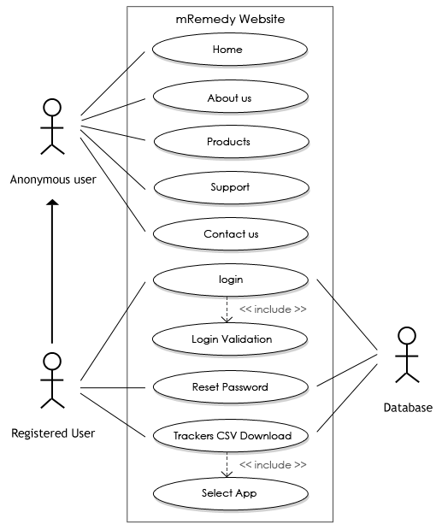
4. foreseeable enhancement
New mobile apps can be added without affecting the existing site.

appendices
i: Glossary of Terms
Captcha: A CAPTCHA is a type of challenge-response test used in computing as an attempt to ensure that the response is generated by a human being.
Application / app: A mobile application (or mobile app) is a software application designed to run on smartphones, tablet computers and other mobile devices.

