WEDDING PLANNER AND VENDOR COORDINATION PLATFORM (WPVCP)
Vows & Veils — Enterprise Wedding Concierge & Coordination Suite
23CS54C – MODERN WEB TECHNOLOGIES
Submitted by
HARIRAAM B (24104085)
In partial fulfillment for the award of the degree
of
BACHELOR OF ENGINEERING
in
COMPUTER SCIENCE AND ENGINEERING
NATIONAL ENGINEERING COLLEGE
(An Autonomous Institution affiliated to Anna University, Chennai)
K.R.NAGAR, KOVILPATTI - 628503
OCTOBER - 2026

NATIONAL ENGINEERING COLLEGE
(An Autonomous Institution affiliated to Anna University, Chennai)
K.R.NAGAR, KOVILPATTI - 628503
BONAFIDE CERTIFICATE
This is to certify that this project report titled "Wedding Planner and Vendor Coordination Platform (WPVCP) — Vows & Veils Enterprise Suite" is the bonafide work of B HARIRAAM (24104085) who carried out the project work under my supervision in partial fulfillment for the award of the degree of Bachelor of Engineering in Computer Science and Engineering of Anna University, Chennai during the academic year 2026.
Course Instructor / Project Guide
Submitted to the 23CS54C – MODERN WEB TECHNOLOGIES Viva-Voce examination held at National Engineering College, K.R. Nagar, Kovilpatti on ____________________
Internal Examiner | External Examiner

TABLE OF CONTENTS
CH NO | TITLE | PAGE NO
1 | INTRODUCTION | 3
2 | OBJECTIVES | 5
3 | SYSTEM DESCRIPTION & DOMAIN SCOPE | 7
4 | UML CLASS DIAGRAM | 10
5 | RELATIONAL TABLE STRUCTURES (DATA DICTIONARY) | 12
6 | ENTITY-RELATIONSHIP (ER) DIAGRAM | 26
7 | TECH STACK & MULTI-TIER SYSTEM ARCHITECTURE | 28
8 | SYSTEM MODULES & DETAILED DESIGN | 32
 | 8.0 Design Approach & Sizing Baseline | 32
 | 8.1 Project Directory Structure & Hierarchy | 35
 | 8.2 User Authentication & Role-Based Access Control | 38
 | 8.3 Customer Requirements & Wedding Project Onboarding | 43
 | 8.4 Vendor Catalog & Dynamic Availability Calendar Engine | 47
 | 8.5 Enterprise Coordination Workflow & Vendor Dispatch | 52
 | 8.6 Milestone Payments, Invoices & Escrow Budget Ledger | 57
 | 8.7 Ceremony Itinerary, Event Scheduling & Document Vault | 62
 | 8.8 Real-Time Messaging, Notifications & AI Concierge | 66
 | 8.9 Executive Analytics Dashboard & Cross-Role Reporting | 71
9 | CONCLUSION & FUTURE ENHANCEMENTS | 75

CHAPTER 1
INTRODUCTION
In the modern luxury event and hospitality sector, wedding planning and vendor orchestration represent one of the most commercially significant yet operationally intricate service domains. Handling wedding ceremonies involves coordinating multi-day itineraries, extensive vendor teams spanning banqueting, decoration, floral design, candid and drone photography, live sound engineering, and bridal makeup, alongside strict budgetary constraints and emotionally invested families. In conventional practice, these operations are conducted through disjointed manual channels such as WhatsApp chat groups, paper diaries, disconnected spreadsheets, and fragmented bank transfers. This legacy methodology results in widespread double bookings, unrecorded date conflicts, opaque pricing markups, untracked change requests, and disputes over milestone disbursements and tax compliance.
There is an acute imperative for a robust, enterprise-grade digital solution that formalizes and automates the entire lifecycle of wedding coordination under a unified, multi-role web platform. The Wedding Planner and Vendor Coordination Platform (WPVCP) — commercially designated as "Vows & Veils — Enterprise Wedding Concierge & Coordination Suite" — was engineered to establish end-to-end digital governance across all wedding operational stakeholders.
The architectural cornerstone of Vows & Veils is its strict delegation protocol, governed by the enterprise coordination formula:
Customer ⟶ Planner ⟶ Vendor ⟶ Planner ⟶ Customer
Under this protocol, engaged couples (Customers) never contract third-party vendors directly. All requirement specifications, service solicitations, proposal negotiations, and milestone disbursements are mediated by certified Wedding Planners. This prevents vendor disintermediation, protects clients against price gouging through transparent negotiated contracts, and guarantees that vendors receive structured, escrow-protected milestone payments upon successful stage delivery.
The application is structured around four distinct security domains and functional scopes: Client Intake and Requirements Management, which digitizes couple profiles, ceremony dates, guest counts, and budgetary allocations; Vendor Logistics and Availability Management, which empowers verified service providers to publish tiered packages and maintain real-time date-locking calendars; Enterprise Project Coordination and Milestone Billing, which orchestrates request dispatches, formal client approvals, 25%/50%/25% installment ledgers, and automated GST tax invoicing; and Intelligent Collaboration, which provides multi-role instant messaging, unread badge counters, system event notifications, and an embedded contextual AI concierge chatbot querying live database states.
The system is deployed on a robust full-stack architecture comprising a React 18 single-page application (SPA) bundled with Vite, an Express.js REST API with connection-pooled MySQL 8.0, and dual authentication via Google OAuth 2.0 and bcrypt password hashing. This report delivers an exhaustive technical documentation of the platform's architectural topology, relational data dictionary, design principles, mathematical sizing baselines, and implementation results.

CHAPTER 2
OBJECTIVES
The primary engineering, architectural, and business objectives of the Wedding Planner and Vendor Coordination Platform are:
To Digitize End-to-End Wedding Operations: Replace fragmented paper diaries, informal messaging threads, and disconnected spreadsheets with a centralized, cloud-accessible digital coordination portal.
To Enforce Enterprise Delegation Protocol: Implement a strict five-stage mediation flow (Customer -> Planner -> Vendor -> Planner -> Customer) that prevents client disintermediation, eliminates pricing ambiguity, and ensures quality control.
To Eliminate Date Conflicts via Real-Time Calendars: Provide verified vendors with dynamic availability calendars that automatically lock contracted dates to 'BOOKED' upon client confirmation, preventing catastrophic double bookings.
To Formalize Multi-Role Access Control (RBAC): Segregate platform privileges across four strictly isolated user roles: ADMIN, PLANNER, VENDOR, and CUSTOMER, enforcing strict backend middleware authorization barriers.
To Implement Dual-Channel Secure Authentication: Provide users with seamless authentication through official Google Identity Services (OAuth 2.0 / prompt=select_account) alongside salted Bcrypt password hashing and 7-day stateless JWT bearer sessions.
To Automate Milestone Escrow & Invoicing: Generate automated 25% Advance Retainer, 50% Mid-Term, and 25% Final Settlement schedules, calculating 18% GST (CGST/SGST) and generating downloadable commercial tax invoices.
To Synchronize Itemized Budget Tracking: Provide couples and planners with a real-time financial ledger comparing target budget ceilings against category-wise actual allocations across banquets, decor, photography, and music.
To Coordinate Day-of-Wedding Run-of-Show Timelines: Digitize hourly ceremony itineraries (e.g., Haldi, Mehndi, Muhurtham, Reception), assigning venues and confirmed vendor points of contact to each event milestone.
To Enable Internal Multi-Participant Communication: Deliver low-latency direct messaging between planners, couples, and vendors, backed by notification triggers for proposals, status updates, and milestone deadlines.
To Deploy Context-Aware AI Concierge Support: Embed a database-connected conversational chatbot capable of parsing user queries in natural language regarding wedding schedules, budget remaining, and vendor contact info.
To Deliver Comprehensive Accessibility & Localization: Incorporate high-contrast Light/Dark themes, 4 dynamic font scale settings (S/M/L/XL), and a comprehensive 6-language translation dictionary (English, Tamil, Hindi, Malayalam, Telugu, Kannada).

CHAPTER 3
SYSTEM DESCRIPTION & DOMAIN SCOPE
The Wedding Planner and Vendor Coordination Platform (WPVCP) is an enterprise-scale, multi-tenant web application designed to manage the entire operational lifecycle of wedding production. The platform is organized into eight core functional domains:
3.1 Customer Onboarding & Requirements Specification
Prospective couples begin their journey by creating a verified profile and submitting a comprehensive wedding intake form. This captures fundamental planning parameters including target ceremony dates, wedding destination city, guest counts, aesthetic theme preferences (e.g., Royal Heritage, Minimalist Contemporary, Beachside Coastal), dietary criteria, and overall ceiling budget. Upon submission, the platform instantiates a corresponding wedding_project record and binds the couple to a designated certified Wedding Planner.
3.2 Certified Planner Command Center
The Wedding Planner serves as the operational executive of the project. Within the Planner Dashboard, the planner inspects new customer intakes, manages requirement sheets, explores verified vendor catalogs by service taxonomy and city, and verifies real-time vendor availability before dispatching inquiries. Planners assemble curated proposal packages, negotiate quotes, coordinate contracts, track line-item budgets, and issue client approval requests.
3.3 Vendor Catalog & Dynamic Availability Engine
Specialized wedding vendors (e.g., pixel-perfect photographers, culinary banqueters, floral mandap stylists, sangeet DJs) manage detailed digital storefronts. Vendors configure service packages with itemized inclusions and base pricing, upload portfolio credentials, and maintain an interactive calendar. Dates can be flagged as 'AVAILABLE' or 'BLOCKED'. When a planner dispatches a request, the vendor reviews the offered quote and can either accept or decline with a mandatory rationale.
3.4 Enterprise Delegation & Booking Workflow
The core transaction engine links accepted vendor services into a formal Booking contract. When the planner arranges the assembled vendor package into a unified wedding proposal, the customer receives an alert to inspect the itemized proposal. The couple can either approve the proposal or request adjustments with notes. Upon client approval, the booking transitions into an escrow contract, locking all vendor slots into permanent reservation.
3.5 Milestone Financial Ledger & Automated GST Invoicing
To eliminate financial friction, the platform decomposes the total contracted wedding sum into three structured milestone installments: a 25% Advance Retainer (enabling venue booking and vendor commitment), a 50% Mid-Term Installment (due two weeks prior to ceremony execution for material procurement), and a 25% Final Settlement (released upon completion of post-wedding deliverables). The billing engine calculates 18% GST (9% CGST + 9% SGST), generating standardized commercial tax invoices.
3.6 Run-of-Show Scheduling & Document Vault
Successful wedding execution requires down-to-the-minute scheduling. The Wedding Schedule module provides a chronological run-of-show timeline for every ceremony event (e.g., Welcome Lunch, Sangeet, Muhurtham, Reception). Each event is linked to its designated venue, start/end timestamps, and assigned vendor points of contact. A secure Document Vault handles contracts, mandap blueprints, and safety permits with file validation.
3.7 Multi-Role Communication & Notification Hub
Direct communication channels bridge the planner with couples and vendors while strictly preserving role privacy. Real-time conversations feature unread message badges, timestamps, and message history. The notification service triggers automated in-app alerts whenever critical project events occur (e.g., proposal dispatched, vendor declined, payment due).
3.8 AI Concierge & Executive Analytics
A floating AI concierge assistant is embedded across all authenticated screens. The chatbot parses user questions regarding wedding milestones, remaining budget, and assigned vendor details through database query helpers. Concurrently, executive analytics present metrics on active wedding portfolios, vendor acceptance ratios, and category expenditure breakdowns.

CHAPTER 4
UML CLASS DIAGRAM
The domain model of the Wedding Planner and Vendor Coordination Platform is structured according to Object-Oriented Software Engineering (OOSE) principles. The architecture encapsulates state and business behaviors within dedicated domain entities while enforcing data isolation between user roles.
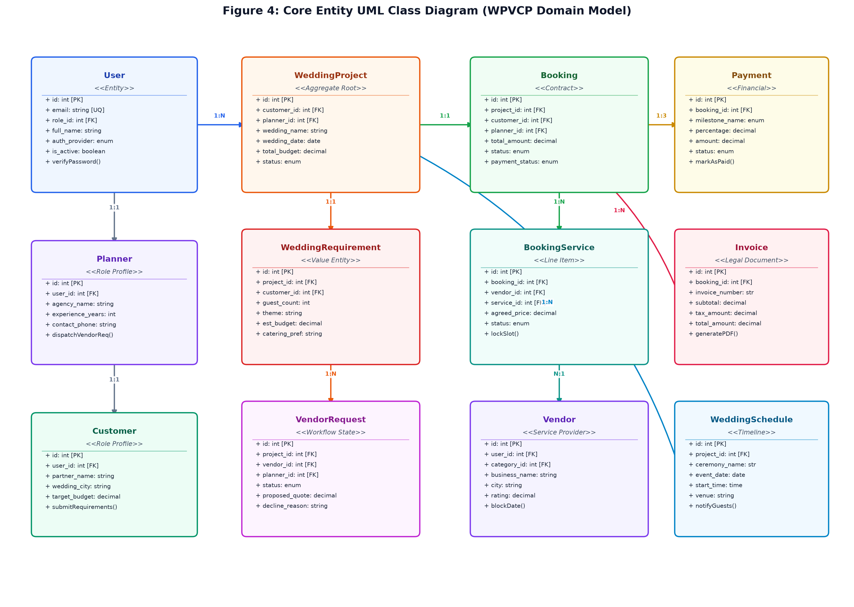
Figure 4: Core Entity UML Class Diagram (WPVCP Domain Model)
The UML Class Diagram illustrated in Figure 4 depicts the structural relationships, class attributes, operational methods, and multiplicity constraints governing the platform. Key structural interactions include:
User Base Entity: Represents the global identity model containing authentication credentials (email, password_hash, auth_provider, google_id), activation flags, and a many-to-one association with Role.
Role Profile Specialization: Maintains 1:1 polymorphic extension relationships with Planner, Vendor, and Customer entities, ensuring role-specific attributes (e.g., agency_name, business_name, partner_name) remain decoupled.
WeddingProject Aggregate Root: Acts as the operational core of the system, binding exactly one Customer to an assigned certified Planner, while aggregating WeddingRequirement, VendorRequest, Booking, and WeddingSchedule entities.
Booking & BookingService Hierarchy: Represents the legal contract. Booking maintains a 1:N composition with BookingService line items, each referencing a specific Vendor and service catalog entry.
Financial Decomposition: Booking maintains a 1:3 relationship with Payment milestone entities (Advance 25%, Mid-Term 50%, Final 25%), which subsequently generate sequential Invoice tax documents.

CHAPTER 5
RELATIONAL TABLE STRUCTURES (DATA DICTIONARY)
The data tier of the Wedding Planner and Vendor Coordination Platform is implemented on MySQL 8.0, comprising 28 normalized tables structured in Third Normal Form (3NF). Every table incorporates primary keys, foreign key constraints with cascading integrity rules, indexes on frequently filtered foreign keys, and audit timestamps (`created_at`, `updated_at`). The following data dictionary provides the complete physical schema specification for all 28 tables.
Table 5.1: booking_services
Line-item breakdown of individual vendor services contracted under an approved wedding booking.
Column Name | Data Type | Null | Key | Default | Functional Description
id | int | NO | PRI | NULL | Primary key surrogate identifier; auto-incremented.
booking_id | int | NO | MUL | NULL | Foreign key referencing parent `booking` entity.
vendor_id | int | NO | MUL | NULL | Foreign key referencing parent `vendor` entity.
vendor_request_id | int | YES | MUL | NULL | Foreign key referencing parent `vendor_request` entity.
service_id | int | YES | MUL | NULL | Foreign key referencing parent `service` entity.
service_name | varchar(150) | NO | - | NULL | Human-readable descriptive label.
category_name | varchar(100) | NO | - | NULL | Temporal audit or event scheduling marker.
agreed_price | decimal(12,2) | NO | - | NULL | Monetary value represented with exact precision.
paid_amount | decimal(12,2) | NO | - | 0.00 | Monetary value represented with exact precision.
status | enum('PROPOSED','CUSTOMER_APPROVED','CUSTOMER_CHANGE_REQUESTED','CONFIRMED','COMPLETED') | NO | - | PROPOSED | Workflow state machine indicator.
notes | text | YES | - | NULL | Unbounded textual content or explanatory remarks.
created_at | timestamp | YES | - | CURRENT_TIMESTAMP | Temporal audit or event scheduling marker.
updated_at | timestamp | YES | - | CURRENT_TIMESTAMP | Temporal audit or event scheduling marker.

Table 5.2: bookings
Binding legal contract governing accepted vendor assemblies, financial totals, and overall project status.
Column Name | Data Type | Null | Key | Default | Functional Description
id | int | NO | PRI | NULL | Primary key surrogate identifier; auto-incremented.
booking_code | varchar(50) | NO | UNI | NULL | Column attribute.
wedding_project_id | int | NO | UNI | NULL | Foreign key referencing parent `wedding_project` entity.
customer_id | int | NO | MUL | NULL | Foreign key referencing parent `customer` entity.
planner_id | int | NO | MUL | NULL | Foreign key referencing parent `planner` entity.
total_amount | decimal(12,2) | NO | - | 0.00 | Monetary value represented with exact precision.
advance_amount | decimal(12,2) | NO | - | 0.00 | Monetary value represented with exact precision.
paid_amount | decimal(12,2) | NO | - | 0.00 | Monetary value represented with exact precision.
status | enum('DRAFT','REQUESTED','PENDING_VENDOR_RESPONSE','VENDOR_ACCEPTED','CUSTOMER_APPROVAL','PAYMENT_PENDING','PARTIALLY_PAID','FULLY_PAID','CONFIRMED','SERVICE_IN_PROGRESS','COMPLETED','CANCELLED') | NO | MUL | DRAFT | Foreign key referencing parent `status` entity.
customer_feedback | text | YES | - | NULL | Column attribute.
created_at | timestamp | YES | - | CURRENT_TIMESTAMP | Temporal audit or event scheduling marker.
updated_at | timestamp | YES | - | CURRENT_TIMESTAMP | Temporal audit or event scheduling marker.

Table 5.3: budget_items
Category-wise expense breakdown tracking allocated vs actual spend per wedding service category.
Column Name | Data Type | Null | Key | Default | Functional Description
id | int | NO | PRI | NULL | Primary key surrogate identifier; auto-incremented.
budget_id | int | NO | MUL | NULL | Foreign key referencing parent `budget` entity.
category_id | int | YES | MUL | NULL | Foreign key referencing parent `category` entity.
item_name | varchar(150) | NO | - | NULL | Human-readable descriptive label.
estimated_cost | decimal(12,2) | NO | - | 0.00 | Temporal audit or event scheduling marker.
actual_cost | decimal(12,2) | NO | - | 0.00 | Column attribute.
paid_cost | decimal(12,2) | NO | - | 0.00 | Column attribute.
status | enum('PLANNED','BOOKED','PAID') | NO | - | PLANNED | Workflow state machine indicator.
notes | varchar(255) | YES | - | NULL | Unbounded textual content or explanatory remarks.
created_at | timestamp | YES | - | CURRENT_TIMESTAMP | Temporal audit or event scheduling marker.
updated_at | timestamp | YES | - | CURRENT_TIMESTAMP | Temporal audit or event scheduling marker.

Table 5.4: budgets
Itemized financial ledger linking project budget caps with total allocated and disbursed vendor expenses.
Column Name | Data Type | Null | Key | Default | Functional Description
id | int | NO | PRI | NULL | Primary key surrogate identifier; auto-incremented.
wedding_project_id | int | NO | UNI | NULL | Foreign key referencing parent `wedding_project` entity.
total_budget | decimal(12,2) | NO | - | 0.00 | Monetary value represented with exact precision.
allocated_amount | decimal(12,2) | NO | - | 0.00 | Monetary value represented with exact precision.
spent_amount | decimal(12,2) | NO | - | 0.00 | Monetary value represented with exact precision.
remaining_amount | decimal(12,2) | NO | - | 0.00 | Monetary value represented with exact precision.
created_at | timestamp | YES | - | CURRENT_TIMESTAMP | Temporal audit or event scheduling marker.
updated_at | timestamp | YES | - | CURRENT_TIMESTAMP | Temporal audit or event scheduling marker.

Table 5.5: chatbot_conversations
Contextual session registry for the floating AI concierge tracking user queries.
Column Name | Data Type | Null | Key | Default | Functional Description
id | int | NO | PRI | NULL | Primary key surrogate identifier; auto-incremented.
user_id | int | NO | MUL | NULL | Foreign key referencing parent `user` entity.
session_token | varchar(100) | NO | - | NULL | Column attribute.
title | varchar(150) | NO | - | Wedding Assistant Session | Human-readable descriptive label.
created_at | timestamp | YES | - | CURRENT_TIMESTAMP | Temporal audit or event scheduling marker.
updated_at | timestamp | YES | - | CURRENT_TIMESTAMP | Temporal audit or event scheduling marker.

Table 5.6: chatbot_messages
Granular query-response log storing natural language interactions between users and the AI assistant.
Column Name | Data Type | Null | Key | Default | Functional Description
id | int | NO | PRI | NULL | Primary key surrogate identifier; auto-incremented.
conversation_id | int | NO | MUL | NULL | Foreign key referencing parent `conversation` entity.
sender | enum('USER','BOT') | NO | - | NULL | Column attribute.
message_text | text | NO | - | NULL | Unbounded textual content or explanatory remarks.
metadata | json | YES | - | NULL | Temporal audit or event scheduling marker.
created_at | timestamp | YES | - | CURRENT_TIMESTAMP | Temporal audit or event scheduling marker.

Table 5.7: conversations
Discussion threads establishing isolated communication channels between planners, couples, and vendors.
Column Name | Data Type | Null | Key | Default | Functional Description
id | int | NO | PRI | NULL | Primary key surrogate identifier; auto-incremented.
wedding_project_id | int | YES | MUL | NULL | Foreign key referencing parent `wedding_project` entity.
participant_one_id | int | NO | MUL | NULL | Foreign key referencing parent `participant_one` entity.
participant_two_id | int | NO | MUL | NULL | Foreign key referencing parent `participant_two` entity.
last_message_at | timestamp | YES | - | CURRENT_TIMESTAMP | Temporal audit or event scheduling marker.
created_at | timestamp | YES | - | CURRENT_TIMESTAMP | Temporal audit or event scheduling marker.
updated_at | timestamp | YES | - | CURRENT_TIMESTAMP | Temporal audit or event scheduling marker.

Table 5.8: customers
Profile registry of engaged couples, binding them to their assigned wedding planner and recording budget ceilings.
Column Name | Data Type | Null | Key | Default | Functional Description
id | int | NO | PRI | NULL | Primary key surrogate identifier; auto-incremented.
user_id | int | NO | UNI | NULL | Foreign key referencing parent `user` entity.
partner_name | varchar(150) | YES | - | NULL | Human-readable descriptive label.
wedding_date | date | YES | - | NULL | Temporal audit or event scheduling marker.
city | varchar(100) | YES | - | Bangalore | Column attribute.
state | varchar(100) | YES | - | Karnataka | Temporal audit or event scheduling marker.
address | varchar(255) | YES | - | NULL | Column attribute.
wedding_theme | varchar(100) | YES | - | Royal Traditional | Column attribute.
guest_count | int | YES | - | 350 | Column attribute.
estimated_budget | decimal(12,2) | YES | - | 1200000.00 | Monetary value represented with exact precision.
planner_id | int | YES | MUL | NULL | Foreign key referencing parent `planner` entity.
created_at | timestamp | YES | - | CURRENT_TIMESTAMP | Temporal audit or event scheduling marker.
updated_at | timestamp | YES | - | CURRENT_TIMESTAMP | Temporal audit or event scheduling marker.

Table 5.9: documents
Secure file repository indexing uploaded vendor contracts, mandap blueprints, and safety permits.
Column Name | Data Type | Null | Key | Default | Functional Description
id | int | NO | PRI | NULL | Primary key surrogate identifier; auto-incremented.
wedding_project_id | int | YES | MUL | NULL | Foreign key referencing parent `wedding_project` entity.
uploader_id | int | NO | MUL | NULL | Foreign key referencing parent `uploader` entity.
title | varchar(150) | NO | - | NULL | Human-readable descriptive label.
document_type | enum('CONTRACT','INVOICE','ID_PROOF','DESIGN_SKETCH','CHECKLIST','OTHER') | NO | - | OTHER | Column attribute.
file_path | varchar(255) | NO | - | NULL | Temporal audit or event scheduling marker.
file_size | int | NO | - | 0 | Column attribute.
file_type | varchar(100) | YES | - | application/pdf | Column attribute.
status | enum('ACTIVE','ARCHIVED') | NO | - | ACTIVE | Workflow state machine indicator.
created_at | timestamp | YES | - | CURRENT_TIMESTAMP | Temporal audit or event scheduling marker.
updated_at | timestamp | YES | - | CURRENT_TIMESTAMP | Temporal audit or event scheduling marker.

Table 5.10: invoices
Formal commercial tax documents calculating 18% GST (CGST + SGST) and generating invoice sequence numbers.
Column Name | Data Type | Null | Key | Default | Functional Description
id | int | NO | PRI | NULL | Primary key surrogate identifier; auto-incremented.
invoice_number | varchar(50) | NO | UNI | NULL | Column attribute.
booking_id | int | NO | MUL | NULL | Foreign key referencing parent `booking` entity.
payment_id | int | YES | MUL | NULL | Foreign key referencing parent `payment` entity.
issuer_id | int | NO | MUL | NULL | Foreign key referencing parent `issuer` entity.
recipient_id | int | NO | MUL | NULL | Foreign key referencing parent `recipient` entity.
subtotal | decimal(12,2) | NO | - | NULL | Column attribute.
tax_amount | decimal(12,2) | NO | - | 0.00 | Monetary value represented with exact precision.
total_amount | decimal(12,2) | NO | - | NULL | Monetary value represented with exact precision.
status | enum('ISSUED','PAID','CANCELLED') | NO | - | ISSUED | Workflow state machine indicator.
due_date | date | NO | - | NULL | Temporal audit or event scheduling marker.
pdf_url | varchar(255) | YES | - | NULL | Column attribute.
created_at | timestamp | YES | - | CURRENT_TIMESTAMP | Temporal audit or event scheduling marker.
updated_at | timestamp | YES | - | CURRENT_TIMESTAMP | Temporal audit or event scheduling marker.

Table 5.11: messages
Real-time message payloads recording text content, sender/recipient IDs, timestamps, and read indicators.
Column Name | Data Type | Null | Key | Default | Functional Description
id | int | NO | PRI | NULL | Primary key surrogate identifier; auto-incremented.
conversation_id | int | NO | MUL | NULL | Foreign key referencing parent `conversation` entity.
sender_id | int | NO | MUL | NULL | Foreign key referencing parent `sender` entity.
recipient_id | int | NO | MUL | NULL | Foreign key referencing parent `recipient` entity.
message_text | text | NO | - | NULL | Unbounded textual content or explanatory remarks.
is_read | tinyint(1) | NO | - | 0 | Column attribute.
read_at | timestamp | YES | - | NULL | Temporal audit or event scheduling marker.
created_at | timestamp | YES | - | CURRENT_TIMESTAMP | Temporal audit or event scheduling marker.
updated_at | timestamp | YES | - | CURRENT_TIMESTAMP | Temporal audit or event scheduling marker.

Table 5.12: notifications
In-app alert hub notifying users of critical workflow transitions, proposal reviews, and payment deadlines.
Column Name | Data Type | Null | Key | Default | Functional Description
id | int | NO | PRI | NULL | Primary key surrogate identifier; auto-incremented.
user_id | int | NO | MUL | NULL | Foreign key referencing parent `user` entity.
title | varchar(150) | NO | - | NULL | Human-readable descriptive label.
message | text | NO | - | NULL | Column attribute.
notification_type | enum('REQUEST_NEW','REQUEST_ACCEPTED','REQUEST_DECLINED','CUSTOMER_APPROVAL','CUSTOMER_APPROVED','CUSTOMER_CHANGE_REQUESTED','PAYMENT_PENDING','PAYMENT_SUCCESS','PAYMENT_FAILED','BOOKING_CONFIRMED','SCHEDULE_UPDATE','MESSAGE','SERVICE_COMPLETED','REVIEW_REQUESTED','SYSTEM') | NO | - | SYSTEM | Temporal audit or event scheduling marker.
reference_id | int | YES | - | NULL | Foreign key referencing parent `reference` entity.
reference_type | varchar(50) | YES | - | NULL | Column attribute.
is_read | tinyint(1) | NO | MUL | 0 | Foreign key referencing parent `is_read` entity.
created_at | timestamp | YES | - | CURRENT_TIMESTAMP | Temporal audit or event scheduling marker.

Table 5.13: payment_transactions
Audit log recording payment gateway transaction references, methods, and reconciliation timestamps.
Column Name | Data Type | Null | Key | Default | Functional Description
id | int | NO | PRI | NULL | Primary key surrogate identifier; auto-incremented.
payment_id | int | NO | MUL | NULL | Foreign key referencing parent `payment` entity.
transaction_reference | varchar(100) | NO | UNI | NULL | Column attribute.
payment_method | enum('MOCK_CARD','MOCK_UPI','MOCK_NETBANKING','STRIPE','RAZORPAY') | NO | - | MOCK_UPI | Column attribute.
amount | decimal(12,2) | NO | - | NULL | Monetary value represented with exact precision.
currency | varchar(10) | NO | - | INR | Column attribute.
status | enum('SUCCESS','FAILED','REFUNDED') | NO | - | SUCCESS | Workflow state machine indicator.
gateway_response | json | YES | - | NULL | Temporal audit or event scheduling marker.
paid_at | timestamp | YES | - | CURRENT_TIMESTAMP | Temporal audit or event scheduling marker.
created_at | timestamp | YES | - | CURRENT_TIMESTAMP | Temporal audit or event scheduling marker.

Table 5.14: payments
Milestone escrow ledger decomposing booking amounts into 25% Advance, 50% Mid-Term, and 25% Final installments.
Column Name | Data Type | Null | Key | Default | Functional Description
id | int | NO | PRI | NULL | Primary key surrogate identifier; auto-incremented.
payment_code | varchar(50) | NO | UNI | NULL | Column attribute.
booking_id | int | NO | MUL | NULL | Foreign key referencing parent `booking` entity.
booking_service_id | int | YES | - | NULL | Foreign key referencing parent `booking_service` entity.
wedding_project_id | int | NO | MUL | NULL | Foreign key referencing parent `wedding_project` entity.
customer_id | int | NO | MUL | NULL | Foreign key referencing parent `customer` entity.
title | varchar(150) | NO | - | NULL | Human-readable descriptive label.
milestone_name | varchar(50) | NO | - | NULL | Human-readable descriptive label.
amount | decimal(12,2) | NO | - | NULL | Monetary value represented with exact precision.
due_date | date | NO | - | NULL | Temporal audit or event scheduling marker.
status | enum('PENDING','PROCESSING','SUCCESS','FAILED','REFUNDED') | NO | MUL | PENDING | Foreign key referencing parent `status` entity.
created_at | timestamp | YES | - | CURRENT_TIMESTAMP | Temporal audit or event scheduling marker.
updated_at | timestamp | YES | - | CURRENT_TIMESTAMP | Temporal audit or event scheduling marker.

Table 5.15: planners
Stores professional profiles, agency details, and experience credentials for certified wedding planners.
Column Name | Data Type | Null | Key | Default | Functional Description
id | int | NO | PRI | NULL | Primary key surrogate identifier; auto-incremented.
user_id | int | NO | UNI | NULL | Foreign key referencing parent `user` entity.
agency_name | varchar(150) | NO | - | Elite Wedding Planners | Human-readable descriptive label.
bio | text | YES | - | NULL | Unbounded textual content or explanatory remarks.
experience_years | int | NO | - | 5 | Column attribute.
contact_phone | varchar(30) | YES | - | NULL | Unique contact or authentication communication channel.
created_at | timestamp | YES | - | CURRENT_TIMESTAMP | Temporal audit or event scheduling marker.
updated_at | timestamp | YES | - | CURRENT_TIMESTAMP | Temporal audit or event scheduling marker.

Table 5.16: reviews
Post-ceremony feedback registry recording 1-to-5 star ratings and written testimonials for planners and vendors.
Column Name | Data Type | Null | Key | Default | Functional Description
id | int | NO | PRI | NULL | Primary key surrogate identifier; auto-incremented.
wedding_project_id | int | YES | MUL | NULL | Foreign key referencing parent `wedding_project` entity.
booking_id | int | YES | MUL | NULL | Foreign key referencing parent `booking` entity.
customer_id | int | NO | MUL | NULL | Foreign key referencing parent `customer` entity.
vendor_id | int | YES | MUL | NULL | Foreign key referencing parent `vendor` entity.
planner_id | int | YES | MUL | NULL | Foreign key referencing parent `planner` entity.
rating | int | NO | - | NULL | Temporal audit or event scheduling marker.
review_text | text | NO | - | NULL | Unbounded textual content or explanatory remarks.
response_text | text | YES | - | NULL | Unbounded textual content or explanatory remarks.
created_at | timestamp | YES | - | CURRENT_TIMESTAMP | Temporal audit or event scheduling marker.
updated_at | timestamp | YES | - | CURRENT_TIMESTAMP | Temporal audit or event scheduling marker.

Table 5.17: roles
Defines the 4 core platform privilege tiers: ADMIN, PLANNER, VENDOR, and CUSTOMER.
Column Name | Data Type | Null | Key | Default | Functional Description
id | int | NO | PRI | NULL | Primary key surrogate identifier; auto-incremented.
name | enum('ADMIN','PLANNER','VENDOR','CUSTOMER') | NO | UNI | NULL | Human-readable descriptive label.
description | varchar(255) | YES | - | NULL | Column attribute.
created_at | timestamp | YES | - | CURRENT_TIMESTAMP | Temporal audit or event scheduling marker.
updated_at | timestamp | YES | - | CURRENT_TIMESTAMP | Temporal audit or event scheduling marker.

Table 5.18: service_categories
Standardized taxonomy cataloging wedding services (Banqueting, Decor, Photography, DJ, Makeup, etc.).
Column Name | Data Type | Null | Key | Default | Functional Description
id | int | NO | PRI | NULL | Primary key surrogate identifier; auto-incremented.
name | varchar(100) | NO | UNI | NULL | Human-readable descriptive label.
slug | varchar(100) | NO | UNI | NULL | Column attribute.
description | text | YES | - | NULL | Column attribute.
icon | varchar(50) | YES | - | Sparkles | Column attribute.
is_active | tinyint(1) | NO | - | 1 | Column attribute.
created_at | timestamp | YES | - | CURRENT_TIMESTAMP | Temporal audit or event scheduling marker.
updated_at | timestamp | YES | - | CURRENT_TIMESTAMP | Temporal audit or event scheduling marker.

Table 5.19: support_requests
Helpdesk ticketing registry logging technical issues and customer service inquiries for resolution.
Column Name | Data Type | Null | Key | Default | Functional Description
id | int | NO | PRI | NULL | Primary key surrogate identifier; auto-incremented.
user_id | int | NO | MUL | NULL | Foreign key referencing parent `user` entity.
booking_id | int | YES | MUL | NULL | Foreign key referencing parent `booking` entity.
ticket_number | varchar(50) | NO | UNI | NULL | Column attribute.
subject | varchar(150) | NO | - | NULL | Column attribute.
category | enum('TECHNICAL','BILLING','VENDOR_DISPUTE','ACCOUNT','GENERAL') | NO | - | GENERAL | Temporal audit or event scheduling marker.
priority | enum('LOW','MEDIUM','HIGH','URGENT') | NO | - | MEDIUM | Column attribute.
status | enum('OPEN','IN_PROGRESS','RESOLVED','CLOSED') | NO | MUL | OPEN | Foreign key referencing parent `status` entity.
assigned_to | int | YES | - | NULL | Column attribute.
message | text | NO | - | NULL | Column attribute.
resolution_notes | text | YES | - | NULL | Unbounded textual content or explanatory remarks.
resolved_at | timestamp | YES | - | NULL | Temporal audit or event scheduling marker.
created_at | timestamp | YES | - | CURRENT_TIMESTAMP | Temporal audit or event scheduling marker.
updated_at | timestamp | YES | - | CURRENT_TIMESTAMP | Temporal audit or event scheduling marker.

Table 5.20: users
Central authentication registry supporting local bcrypt password hashes and Google OAuth 2.0 IDs.
Column Name | Data Type | Null | Key | Default | Functional Description
id | int | NO | PRI | NULL | Primary key surrogate identifier; auto-incremented.
email | varchar(191) | NO | UNI | NULL | Unique contact or authentication communication channel.
password_hash | varchar(255) | YES | - | NULL | Column attribute.
role_id | int | NO | MUL | NULL | Foreign key referencing parent `role` entity.
full_name | varchar(150) | NO | - | NULL | Human-readable descriptive label.
phone | varchar(30) | YES | - | NULL | Unique contact or authentication communication channel.
avatar_url | varchar(255) | YES | - | NULL | Temporal audit or event scheduling marker.
auth_provider | enum('local','google') | NO | - | local | Column attribute.
google_id | varchar(191) | YES | UNI | NULL | Foreign key referencing parent `google` entity.
email_verified | tinyint(1) | NO | - | 0 | Unique contact or authentication communication channel.
is_active | tinyint(1) | NO | - | 1 | Column attribute.
created_at | timestamp | YES | - | CURRENT_TIMESTAMP | Temporal audit or event scheduling marker.
updated_at | timestamp | YES | - | CURRENT_TIMESTAMP | Temporal audit or event scheduling marker.

Table 5.21: vendor_availability
Dynamic calendar engine recording date-level slot statuses (AVAILABLE, BOOKED, BLOCKED) per vendor.
Column Name | Data Type | Null | Key | Default | Functional Description
id | int | NO | PRI | NULL | Primary key surrogate identifier; auto-incremented.
vendor_id | int | NO | MUL | NULL | Foreign key referencing parent `vendor` entity.
date | date | NO | - | NULL | Temporal audit or event scheduling marker.
start_time | time | NO | - | 08:00:00 | Temporal audit or event scheduling marker.
end_time | time | NO | - | 22:00:00 | Temporal audit or event scheduling marker.
status | enum('AVAILABLE','UNAVAILABLE','BOOKED','RESERVED') | NO | - | AVAILABLE | Workflow state machine indicator.
reason | varchar(255) | YES | - | NULL | Unbounded textual content or explanatory remarks.
created_at | timestamp | YES | - | CURRENT_TIMESTAMP | Temporal audit or event scheduling marker.
updated_at | timestamp | YES | - | CURRENT_TIMESTAMP | Temporal audit or event scheduling marker.

Table 5.22: vendor_requests
Delegation hub tracking planner dispatch inquiries, offered quotes, vendor decisions, and decline reasons.
Column Name | Data Type | Null | Key | Default | Functional Description
id | int | NO | PRI | NULL | Primary key surrogate identifier; auto-incremented.
request_code | varchar(50) | NO | UNI | NULL | Column attribute.
wedding_project_id | int | NO | MUL | NULL | Foreign key referencing parent `wedding_project` entity.
planner_id | int | NO | MUL | NULL | Foreign key referencing parent `planner` entity.
vendor_id | int | NO | MUL | NULL | Foreign key referencing parent `vendor` entity.
service_id | int | YES | MUL | NULL | Foreign key referencing parent `service` entity.
event_date | date | NO | - | NULL | Temporal audit or event scheduling marker.
start_time | time | NO | - | 09:00:00 | Temporal audit or event scheduling marker.
end_time | time | NO | - | 21:00:00 | Temporal audit or event scheduling marker.
proposed_price | decimal(12,2) | NO | - | NULL | Monetary value represented with exact precision.
notes | text | YES | - | NULL | Unbounded textual content or explanatory remarks.
status | enum('PENDING','ACCEPTED','DECLINED','CANCELLED','EXPIRED') | NO | MUL | PENDING | Foreign key referencing parent `status` entity.
decline_reason | text | YES | - | NULL | Unbounded textual content or explanatory remarks.
responded_at | timestamp | YES | - | NULL | Temporal audit or event scheduling marker.
created_at | timestamp | YES | - | CURRENT_TIMESTAMP | Temporal audit or event scheduling marker.
updated_at | timestamp | YES | - | CURRENT_TIMESTAMP | Temporal audit or event scheduling marker.

Table 5.23: vendor_services
Itemized service packages published by vendors, specifying base rates, durations, and inclusions.
Column Name | Data Type | Null | Key | Default | Functional Description
id | int | NO | PRI | NULL | Primary key surrogate identifier; auto-incremented.
vendor_id | int | NO | MUL | NULL | Foreign key referencing parent `vendor` entity.
name | varchar(150) | NO | - | NULL | Human-readable descriptive label.
description | text | YES | - | NULL | Column attribute.
price | decimal(12,2) | NO | - | NULL | Monetary value represented with exact precision.
pricing_unit | varchar(50) | NO | - | per_event | Column attribute.
is_active | tinyint(1) | NO | - | 1 | Column attribute.
created_at | timestamp | YES | - | CURRENT_TIMESTAMP | Temporal audit or event scheduling marker.
updated_at | timestamp | YES | - | CURRENT_TIMESTAMP | Temporal audit or event scheduling marker.

Table 5.24: vendors
Business profiles of verified third-party wedding partners, tracking ratings, cities, and categories.
Column Name | Data Type | Null | Key | Default | Functional Description
id | int | NO | PRI | NULL | Primary key surrogate identifier; auto-incremented.
user_id | int | NO | UNI | NULL | Foreign key referencing parent `user` entity.
business_name | varchar(150) | NO | - | NULL | Human-readable descriptive label.
category_id | int | NO | MUL | NULL | Foreign key referencing parent `category` entity.
description | text | YES | - | NULL | Column attribute.
experience_years | int | NO | - | 3 | Column attribute.
address | varchar(255) | YES | - | NULL | Column attribute.
city | varchar(100) | NO | MUL | Bangalore | Foreign key referencing parent `city` entity.
state | varchar(100) | NO | - | Karnataka | Temporal audit or event scheduling marker.
postal_code | varchar(20) | YES | - | NULL | Column attribute.
latitude | decimal(10,8) | YES | - | NULL | Temporal audit or event scheduling marker.
longitude | decimal(11,8) | YES | - | NULL | Column attribute.
service_locations | varchar(255) | YES | - | Bangalore, Chennai, Hyderabad | Temporal audit or event scheduling marker.
base_price | decimal(12,2) | NO | - | 25000.00 | Monetary value represented with exact precision.
price_range | varchar(100) | YES | - | ?25,000 - ?1,50,000 | Monetary value represented with exact precision.
rating | decimal(3,2) | NO | - | 4.80 | Temporal audit or event scheduling marker.
total_reviews | int | NO | - | 0 | Column attribute.
is_verified | tinyint(1) | NO | - | 1 | Column attribute.
created_at | timestamp | YES | - | CURRENT_TIMESTAMP | Temporal audit or event scheduling marker.
updated_at | timestamp | YES | - | CURRENT_TIMESTAMP | Temporal audit or event scheduling marker.

Table 5.25: wedding_projects
The central operational entity encapsulating wedding dates, budget totals, and overall coordination lifecycle state.
Column Name | Data Type | Null | Key | Default | Functional Description
id | int | NO | PRI | NULL | Primary key surrogate identifier; auto-incremented.
project_code | varchar(50) | NO | UNI | NULL | Column attribute.
customer_id | int | NO | MUL | NULL | Foreign key referencing parent `customer` entity.
planner_id | int | NO | MUL | NULL | Foreign key referencing parent `planner` entity.
title | varchar(200) | NO | - | NULL | Human-readable descriptive label.
wedding_date | date | NO | MUL | NULL | Foreign key referencing parent `wedding_date` entity.
venue_name | varchar(200) | YES | - | NULL | Human-readable descriptive label.
venue_address | varchar(255) | YES | - | NULL | Column attribute.
city | varchar(100) | NO | - | Bangalore | Column attribute.
guest_count | int | NO | - | 300 | Column attribute.
total_budget | decimal(12,2) | NO | - | 1000000.00 | Monetary value represented with exact precision.
status | enum('PLANNING','IN_PROGRESS','CONFIRMED','COMPLETED','CANCELLED') | NO | - | PLANNING | Workflow state machine indicator.
notes | text | YES | - | NULL | Unbounded textual content or explanatory remarks.
created_at | timestamp | YES | - | CURRENT_TIMESTAMP | Temporal audit or event scheduling marker.
updated_at | timestamp | YES | - | CURRENT_TIMESTAMP | Temporal audit or event scheduling marker.

Table 5.26: wedding_requirements
Detailed customer intake specification capturing guest counts, aesthetic themes, catering rules, and notes.
Column Name | Data Type | Null | Key | Default | Functional Description
id | int | NO | PRI | NULL | Primary key surrogate identifier; auto-incremented.
customer_id | int | NO | MUL | NULL | Foreign key referencing parent `customer` entity.
wedding_project_id | int | YES | MUL | NULL | Foreign key referencing parent `wedding_project` entity.
wedding_date | date | NO | - | NULL | Temporal audit or event scheduling marker.
location | varchar(150) | NO | - | NULL | Temporal audit or event scheduling marker.
guest_count | int | NO | - | 300 | Column attribute.
estimated_budget | decimal(12,2) | NO | - | NULL | Monetary value represented with exact precision.
required_services | json | NO | - | NULL | Column attribute.
special_preferences | text | YES | - | NULL | Column attribute.
status | enum('DRAFT','SUBMITTED','UNDER_REVIEW','CONVERTED_TO_PROJECT','REJECTED') | NO | - | DRAFT | Workflow state machine indicator.
verification_status | enum('VERIFIED','PENDING_PLANNER_VERIFICATION','DECLINED','DRAFT') | NO | - | VERIFIED | Workflow state machine indicator.
last_edited_by | enum('CUSTOMER','PLANNER','ADMIN') | NO | - | CUSTOMER | Column attribute.
change_summary | text | YES | - | NULL | Column attribute.
created_at | timestamp | YES | - | CURRENT_TIMESTAMP | Temporal audit or event scheduling marker.
updated_at | timestamp | YES | - | CURRENT_TIMESTAMP | Temporal audit or event scheduling marker.

Table 5.27: wedding_schedule
Run-of-show ceremony timetable detailing event names, dates, times, venues, and assigned vendor contacts.
Column Name | Data Type | Null | Key | Default | Functional Description
id | int | NO | PRI | NULL | Primary key surrogate identifier; auto-incremented.
wedding_project_id | int | NO | MUL | NULL | Foreign key referencing parent `wedding_project` entity.
event_title | varchar(150) | NO | - | NULL | Human-readable descriptive label.
event_date | date | NO | MUL | NULL | Foreign key referencing parent `event_date` entity.
start_time | time | NO | - | NULL | Temporal audit or event scheduling marker.
end_time | time | NO | - | NULL | Temporal audit or event scheduling marker.
location | varchar(150) | YES | - | NULL | Temporal audit or event scheduling marker.
description | text | YES | - | NULL | Column attribute.
person_in_charge | varchar(100) | YES | - | NULL | Column attribute.
vendor_id | int | YES | MUL | NULL | Foreign key referencing parent `vendor` entity.
status | enum('SCHEDULED','IN_PROGRESS','COMPLETED','DELAYED') | NO | - | SCHEDULED | Workflow state machine indicator.
created_at | timestamp | YES | - | CURRENT_TIMESTAMP | Temporal audit or event scheduling marker.
updated_at | timestamp | YES | - | CURRENT_TIMESTAMP | Temporal audit or event scheduling marker.

Table 5.28: wishlists
Customer curation repository allowing couples to bookmark preferred vendor packages prior to formal dispatch.
Column Name | Data Type | Null | Key | Default | Functional Description
id | int | NO | PRI | NULL | Primary key surrogate identifier; auto-incremented.
customer_id | int | NO | MUL | NULL | Foreign key referencing parent `customer` entity.
vendor_id | int | YES | MUL | NULL | Foreign key referencing parent `vendor` entity.
service_id | int | YES | MUL | NULL | Foreign key referencing parent `service` entity.
notes | varchar(255) | YES | - | NULL | Unbounded textual content or explanatory remarks.
created_at | timestamp | YES | - | CURRENT_TIMESTAMP | Temporal audit or event scheduling marker.

CHAPTER 6
ENTITY-RELATIONSHIP (ER) DIAGRAM
The Entity-Relationship (ER) diagram models the logical associations, cardinality constraints, and foreign key dependencies that govern the 28 normalized tables of the Wedding Planner and Vendor Coordination Platform. Referential integrity is maintained through foreign keys with ON DELETE CASCADE and ON DELETE RESTRICT rules.
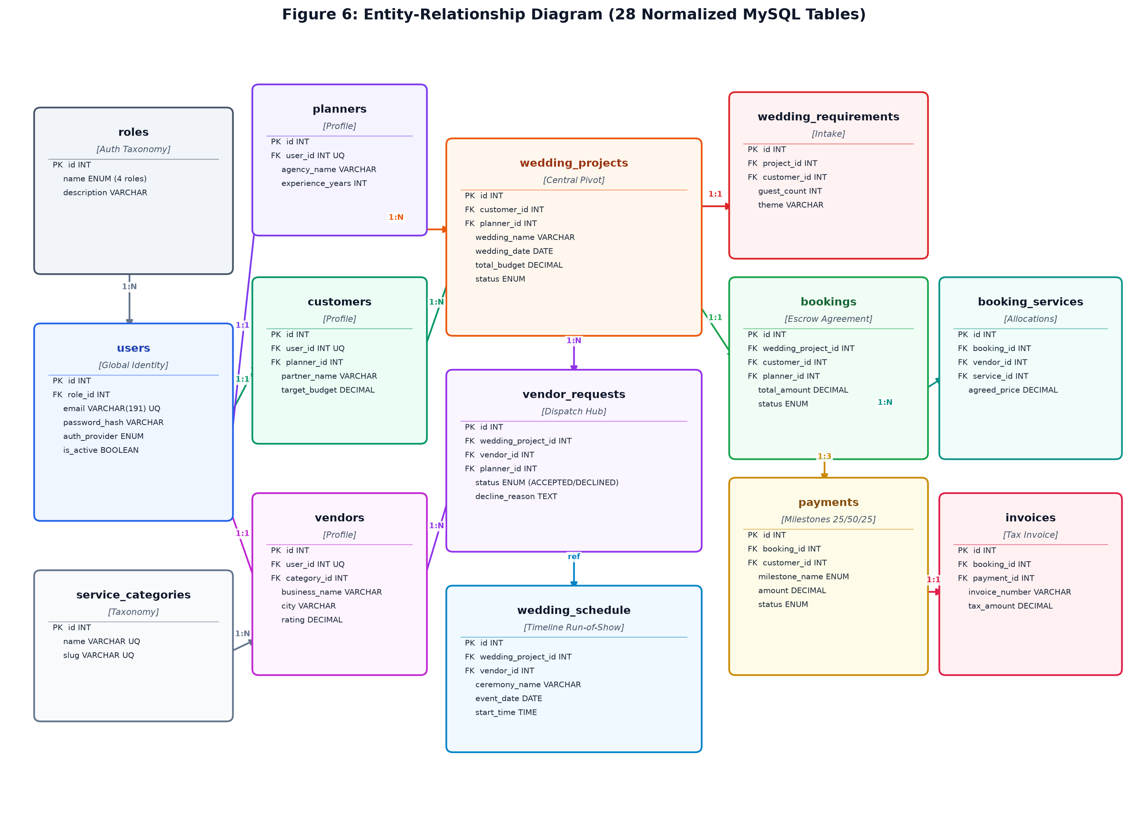
Figure 6: Relational Entity-Relationship Diagram (28 Normalized MySQL Tables)
6.1 Relational Normalization & Integrity Analysis
The relational schema adheres to Third Normal Form (3NF) and Boyce-Codd Normal Form (BCNF) standards: all non-key attributes are fully functionally dependent on the primary key, and transitive dependencies are eliminated. For example, rather than embedding vendor categories as free-form strings inside the vendors table, a dedicated service_categories master entity is utilized, ensuring taxonomy consistency and enabling indexed filtering.
6.2 Cardinality & Structural Associations
Users to Roles (N:1): Every user is strictly assigned to one of the 4 role records via role_id, establishing an immutable security foundation.
Users to Profiles (1:1): Users specialize into exactly one profile entity: planners, vendors, or customers via unique foreign keys, ensuring table isolation.
Projects to Requirements (1:1): Every wedding project maintains exactly one intake specification detailing guest count, budget, and aesthetic themes.
Projects to Vendor Requests (1:N): A wedding project acts as a parent to multiple vendor inquiry dispatches, tracking individual vendor responses.
Bookings to Booking Services (1:N): An approved booking decomposes into multiple service line items, locking contracted prices and vendor slots.
Bookings to Milestone Payments (1:3): Each booking automatically instantiates 3 milestone payment records representing the 25%, 50%, and 25% tranches.
Payments to Invoices (1:1): Every recorded milestone payment transaction is linked to an official tax invoice containing GST calculations.
6.3 Indexing Strategy for High-Throughput Queries
To guarantee low read latency under peak planning loads, the database schema implements composite and B-Tree indexes: idx_users_role on users(role_id), idx_users_email on users(email), idx_availability_vendor_date on vendor_availability(vendor_id, date), and idx_requests_project_status on vendor_requests(wedding_project_id, status). These indexes ensure lookups remain O(log N) rather than incurring full table scans.

CHAPTER 7
TECH STACK & MULTI-TIER SYSTEM ARCHITECTURE
7.1 Technical Stack Matrix
The Wedding Planner and Vendor Coordination Platform is built upon a modern, high-performance web engineering stack. The following matrix summarizes the architectural layers, selected technologies, and engineering rationale:
Layer | Technology | Engineering Purpose & Selection Rationale
Frontend SPA | React 18 (Vite) | Fast declarative component rendering, virtual DOM reconciliation, and instant Hot Module Replacement (HMR).
Routing Engine | React Router v6 | Declarative client-side routing with nested layouts and role-based route protection guards.
HTTP Client | Axios | Promise-based HTTP client featuring automated request/response interceptors for JWT injection and token refresh.
Design Tokens | Vanilla CSS | Zero-runtime CSS custom properties (variables) providing responsive layouts, dark/light themes, and 4 font scales.
Iconography | Lucide React | Lightweight, tree-shakable SVG icon library delivering visual clarity across desktop and mobile screens.
Backend Runtime | Node.js (v20+) | Asynchronous, event-driven JavaScript runtime offering high I/O throughput for concurrent user interactions.
API Framework | Express.js | Minimalist, unopinionated web framework delivering structured REST routing and modular middleware pipelines.
Database Server | MySQL 8.0 | Enterprise-grade relational database management system supporting ACID transactions, foreign keys, and indexes.
DB Connection | mysql2/promise | High-performance connection pooling utilizing native ES6 Promises for asynchronous non-blocking queries.
Authentication | Bcrypt.js + JWT | Salted password hashing (cost factor 10) coupled with 7-day stateless HMAC-SHA256 JSON Web Tokens.
OAuth 2.0 | google-auth-library | Official Google Identity Services integration with account selection (prompt=select_account) and zero password exposure.
Security Gateway | Helmet & Rate Limiter | Sets HTTP security headers (CSP, HSTS) and enforces IP-level request throttling (100 req/15min) to prevent brute-force attacks.
File Storage | Multer | Multipart form-data middleware validating mime types and file sizes for PDF contracts and venue blueprints.
State Management | React Context API | Decentralized reactive stores: AuthContext, ThemeContext, LanguageContext, and ToastContext.

7.2 Multi-Tier System Architecture
The platform adheres to an enterprise Multi-Tier / Layered MVC architectural topology. This guarantees separation of concerns between presentation, business orchestration, and persistent storage.
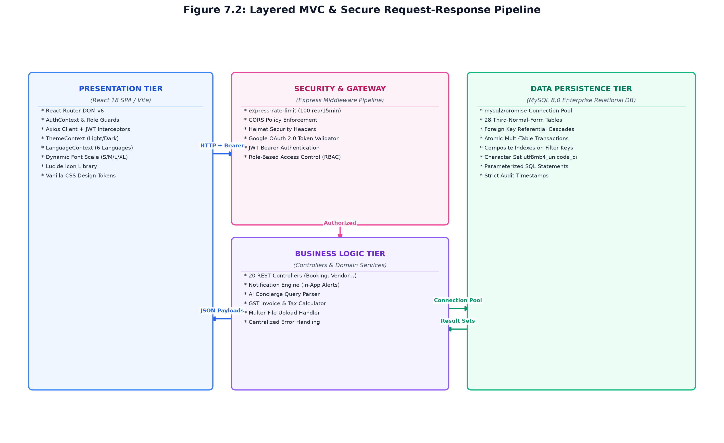
Figure 7.2: Layered MVC & Secure Request-Response Pipeline
As detailed in Figure 7.2, the request-response lifecycle executes through four isolated tiers:
1. Client Presentation Tier: The React SPA maintains client state, captures user interactions, and dispatches HTTP requests via Axios with Bearer JWT tokens in Authorization headers.
2. Security & Gateway Middleware: Express routes requests through express-rate-limit (throttling abusive traffic), Helmet (securing headers), and authMiddleware (verifying JWT authenticity and decoding role claims).
3. Business Logic & Controller Tier: Dedicated REST controllers (e.g., bookingController, paymentController) execute business rules, validate request bodies, and orchestrate transactions.
4. Relational Persistence Tier: The mysql2 connection pool executes parameterized SQL statements against MySQL 8.0, enforcing referential integrity and returning structured result sets.

CHAPTER 8
SYSTEM MODULES & DETAILED DESIGN
8.0 Design Approach & Shared Sizing Baseline
To ensure architectural rigor across all functional areas, each module in this chapter is documented according to an 8-step engineering methodology:
Step | Question It Answers | Documentation Section
1. Purpose & Scope | What business problem does this module solve? | Section 8.x.0
2. Functional Requirements | What exact operations must the module perform? | Section 8.x.1
3. Non-Functional Requirements | How fast, reliable, secure, and accessible must it be? | Section 8.x.2
4. Tech Stack & Rationale | Which tools and libraries suit this problem, and why? | Section 8.x.3
5. Sizing Baseline Estimation | What are the data volumes, QPS, latency, and storage demands? | Section 8.x.4
6. Low-Level Architecture | How do client, middleware, controllers, and DB interact? | Section 8.x.5
7. API Design | What are the exact REST endpoints, payloads, and contracts? | Section 8.x.6
8. Database Design & UI | Which tables store state, and how is the UI rendered? | Section 8.x.7 & 8.x.8

Sizing Baseline Assumptions for the Wedding Platform
The engineering baselines below govern the capacity planning, concurrency models, and storage estimates for the system:
Metric / Parameter | Production Baseline | Operational Basis & Derivation
Active Weddings Managed / Year | ≈ 500 weddings | Mid-to-large regional wedding agency workload.
Concurrent Wedding Projects | ≈ 50 concurrent projects | Active in various stages of planning at any given month.
Verified Partner Vendors | ≈ 250 registered vendors | Spanning banquets, decor, photography, catering, DJ, makeup.
Customer Users (Couples) | ≈ 1,000 active users | Couples, partners, and primary family decision-makers.
Requests per User per Day | ≈ 80 requests / user / day | Requirements browsing, messaging, calendar checks, payments.
Daily Platform Requests | ≈ 100,000 requests / day | Derived from 1,250 total users × 80 requests/day.
Peak Query Throughput (QPS) | ≈ 25 – 35 QPS | Assumes 3x peak burst during evening planning hours.
Average Read Latency Target | < 65 milliseconds | Database lookups optimized via indexed foreign keys.
Average Write Latency Target | < 150 milliseconds | Multi-table atomic transactions for bookings and payments.
Annual Database Storage Growth | ≈ 450 MB / year | Relational row data, audit logs, and message payloads (excluding media).
Document Storage Growth | ≈ 25 GB / year | PDF contracts, safety permits, and high-res mandap blueprints.

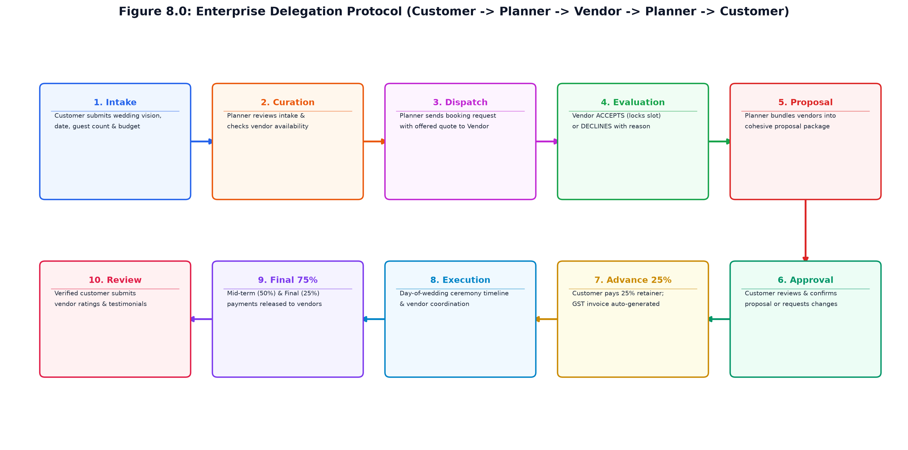
Figure 8.0: Enterprise Delegation Protocol (Customer -> Planner -> Vendor -> Planner -> Customer)
8.1 Project Directory Structure & Hierarchy
The codebase maintains a modular, decoupled repository organization structured into three primary subtrees: database/ for SQL schemas and seeds, backend/ for the Node/Express server, and frontend/ for the React 18 SPA.
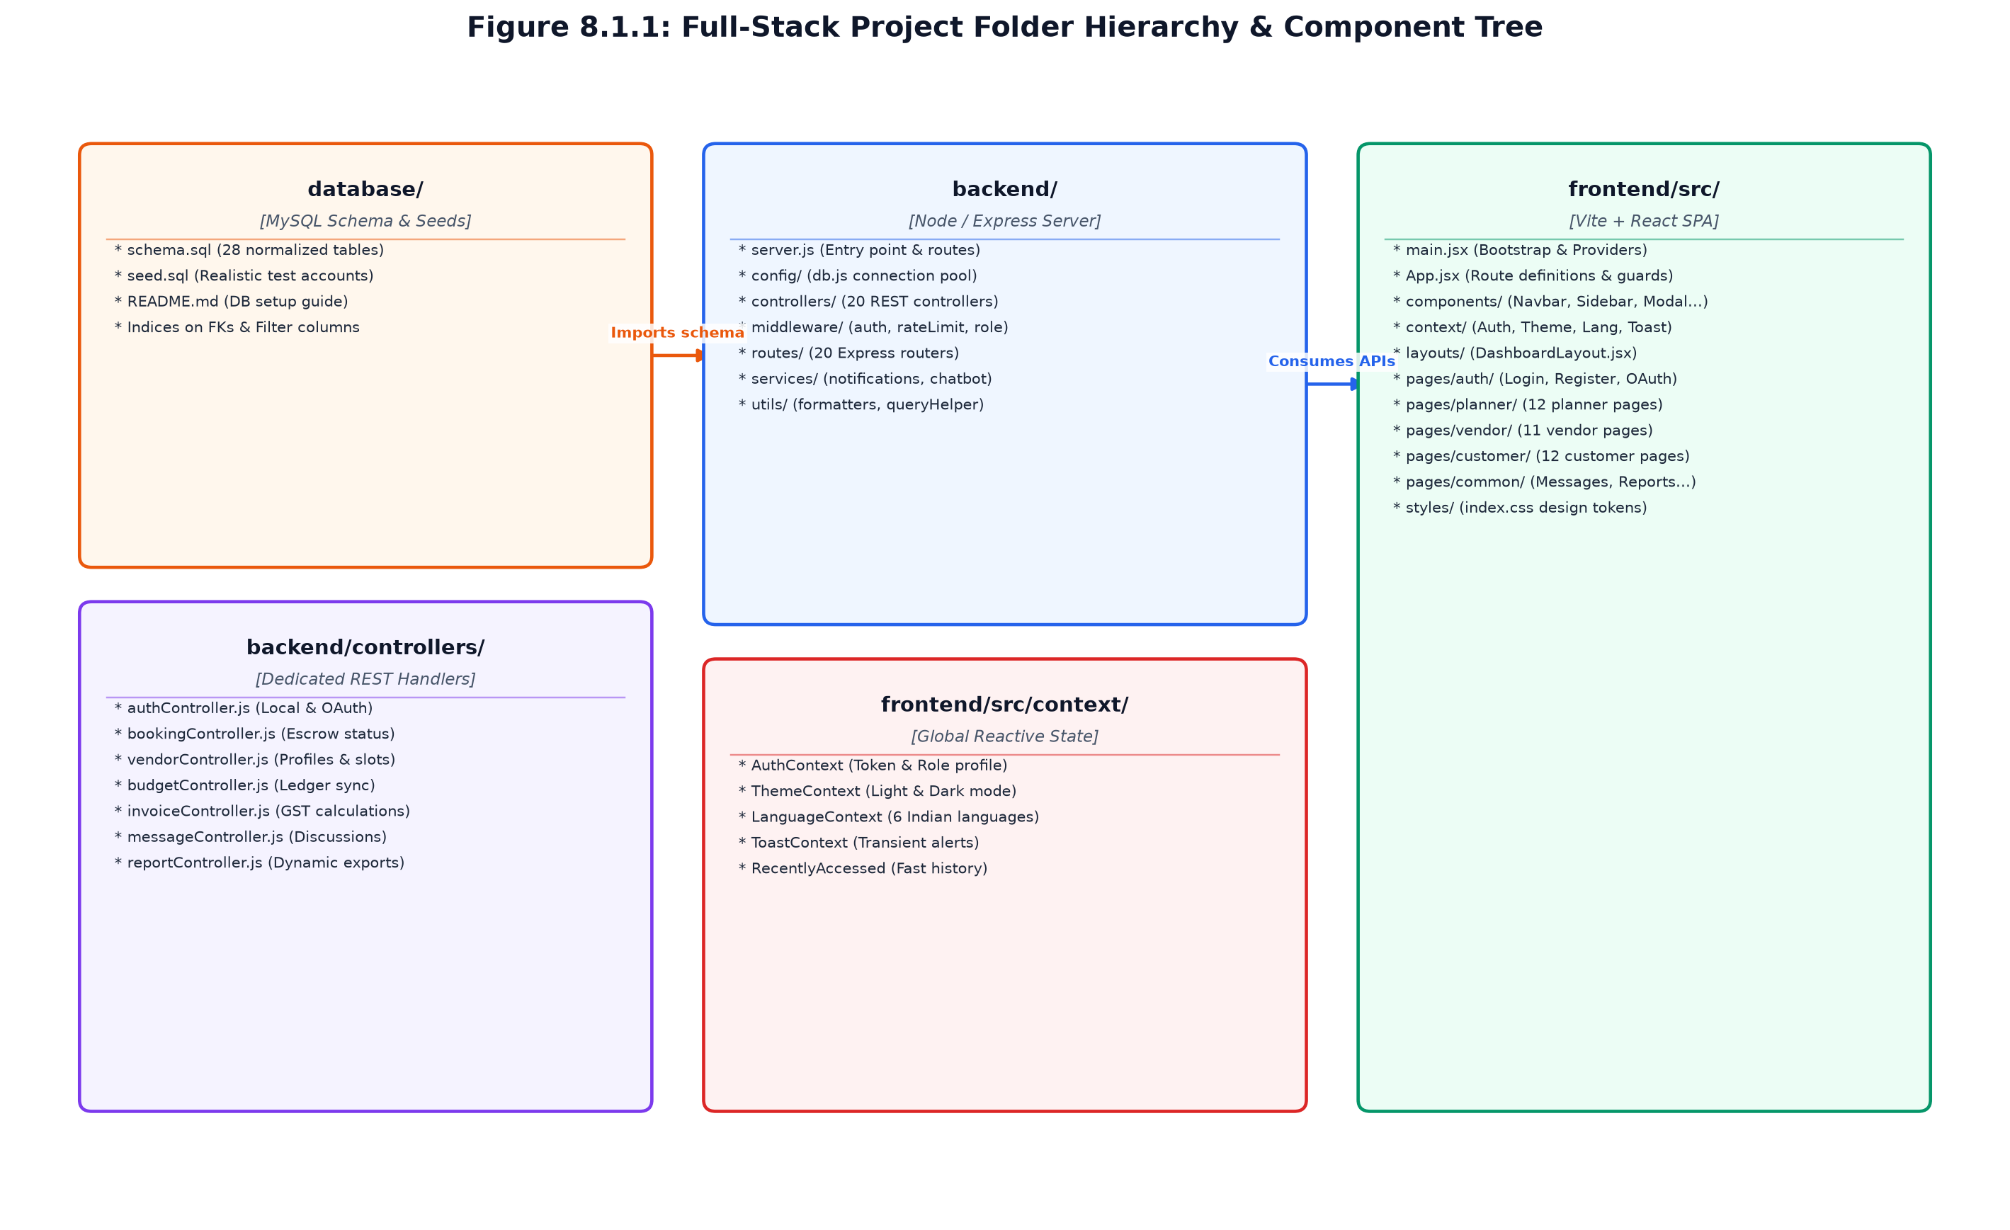
Figure 8.1.1: Full-Stack Project Folder Hierarchy & Component Tree
8.1.1 Database Subtree (database/)
schema.sql: Contains the complete DDL for all 28 tables, incorporating foreign key constraints, indexes, and utf8mb4 collation.
seed.sql: Pre-populates realistic enterprise demo data: 4 roles, 56 users, 45 vendors, 5 wedding projects, real conversations, and invoices.
README.md: Provides step-by-step instructions for database instantiation, user permissions, and connection testing.
8.1.2 Backend Subtree (backend/)
server.js: Primary entry point initializing Express, mounting CORS, Helmet, rate limiters, static uploads, and all 20 REST routers.
config/db.js: Instantiates the mysql2 connection pool with environment variable configuration and connection error handlers.
controllers/ (20 Files): Modular business controllers: authController, bookingController, budgetController, paymentController, vendorController, etc.
middleware/: authMiddleware (JWT verification), roleMiddleware (RBAC verification), rateLimitMiddleware, errorHandler.
services/: notificationService.js (in-app alerts dispatch) and chatbotController.js (database natural language query parser).
uploads/docs/: Local filesystem storage directory for validated user document uploads.
8.1.3 Frontend Subtree (frontend/src/)
main.jsx & App.jsx: Application bootstrap mounting Context Providers (Auth, Theme, Lang, Toast) and declaring 40+ client routes.
components/ (15+ Files): Reusable UI widgets: Navbar, Header, Footer, Chatbot, Modal, Badge, LoadingSkeleton, StatCards, EmptyState.
context/ (5 Contexts): Global reactive state management: AuthContext, ThemeContext, LanguageContext, ToastContext, RecentlyAccessedContext.
layouts/DashboardLayout.jsx: Unified layout wrapper rendering top navigation, responsive sidebars, theme toggles, and breadcrumbs.
pages/ (40+ Page Views): Role-segregated views: pages/auth/, pages/planner/, pages/vendor/, pages/customer/, and pages/common/.
styles/index.css: Central design tokens: 30+ CSS custom variables defining color palettes, spacing, shadows, and accessibility themes.
8.2 USER AUTHENTICATION & ROLE-BASED ACCESS CONTROL
8.2.0 Purpose & Scope
Provides dual-channel authentication (Local Bcrypt + Google OAuth 2.0) and enforces strict Role-Based Access Control (RBAC) across ADMIN, PLANNER, VENDOR, and CUSTOMER roles.
8.2.1 Functional Requirements
What the module must do:
User Registration: Register new customer and vendor accounts with salted bcrypt password hashing.
Local Login: Authenticate existing users using email and password, issuing 7-day stateless JWT bearer tokens.
Google OAuth 2.0: One-click authentication with official Google Identity Services (prompt=select_account) without exposing Gmail credentials.
Token Verification: Authenticate incoming API requests via Bearer tokens in the HTTP Authorization header.
Role Authorization: Enforce strict role-based route guards blocking unauthorized cross-role API invocations.
Rate Limiting: Restrict failed authentication attempts to 15 requests per 15 minutes to thwart brute-force attacks.
Session State: Return authenticated user profile (id, email, full_name, role, avatar_url) for client state hydration.
8.2.2 Non-Functional Requirements
Security: Passwords hashed using bcryptjs with a work factor of 10; zero cleartext storage.
Token Expiration: JWT tokens expire after 7 days; tokens contain user ID and role claims signed with HMAC-SHA256.
Authentication Latency: Local credential validation completes in under 120 ms; OAuth verification under 250 ms.
High Concurrency: Stateless JWT verification eliminates database session lookups on protected routes.
8.2.3 Tech Stack & Architectural Fit
Concern / Requirement | Choice | Why It Fits This Module
Password Hashing | bcryptjs | Pure JavaScript salted cryptographic hashing; eliminates native OS build tool dependencies.
Token Engine | jsonwebtoken (JWT) | Stateless, digitally signed bearer tokens containing role claims for instant middleware validation.
OAuth Provider | google-auth-library | Official Google SDK validating ID tokens and retrieving verified user email and full name.
Rate Limiting | express-rate-limit | In-memory request counter throttling abusive requests on /api/auth routes.

8.2.4 Back-of-the-Envelope Estimation
Quantity / Resource | Estimate | Operational Basis & Derivation
Total Registered Users | ≈ 1,300 users | 50 Planners, 250 Vendors, 1,000 Customers.
Logins per Day | ≈ 1,500 logins | Average 1.15 logins per user daily.
Peak Login Burst | ≈ 15 logins / minute | Morning operational window (9:00 AM - 10:00 AM).
Users Table Storage | ≈ 650 KB | 1,300 rows × ~500 bytes per row.

8.2.5 Low-Level Architecture & Execution Flow
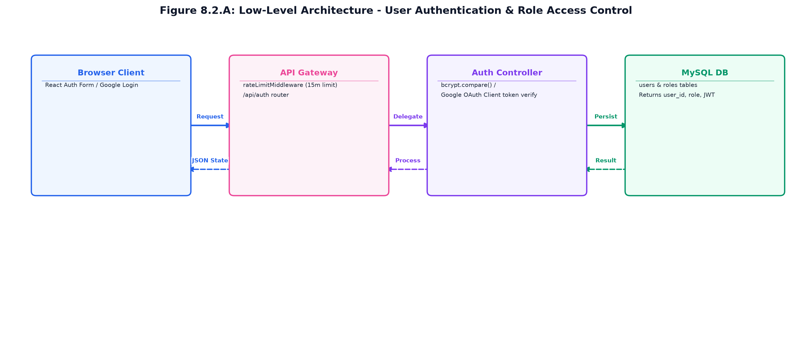
Figure 8.2.A: Low-Level Architecture – USER AUTHENTICATION & ACCESS CONTROL
Request flow:
Step 1: User submits login form on React client or clicks 'Continue with Google'.
Step 2: Request passes through express-rate-limit; rejected with HTTP 429 if threshold exceeded.
Step 3: authController verifies credentials against MySQL users table using bcrypt.compare() or validates Google token.
Step 4: On success, backend signs JWT token with secret and returns token + user profile payload.
Step 5: React client stores token in localStorage and AuthContext dispatches user to appropriate dashboard (/planner, /vendor, /customer).
8.2.6 REST API Design & Contracts
Method | Endpoint Route | Access Level | Purpose & Contract Specification
POST | /api/auth/login | Public | Authenticates user via email and password; returns JWT token and user profile.
POST | /api/auth/register | Public | Registers new CUSTOMER or VENDOR account with role_id assignment.
GET | /api/auth/me | Authenticated | Returns current authenticated user profile decoded from JWT token.
GET | /api/auth/google/url | Public | Returns official Google OAuth consent screen authorization redirect URL.
POST | /api/auth/google/callback | Public | Exchanges OAuth code for Google tokens, verifies profile, and returns JWT.

8.2.7 Database Design & Entity Schemas
Table | Keys & Constraints | Key Columns & Schema Definition
roles | PK id, UNIQUE name | Defines the 4 privilege tiers: ADMIN, PLANNER, VENDOR, CUSTOMER.
users | PK id, FK role_id, UNIQUE email, UNIQUE google_id | email, password_hash, full_name, phone, auth_provider, is_active.

8.2.8 User Interface Design & Visual Renders
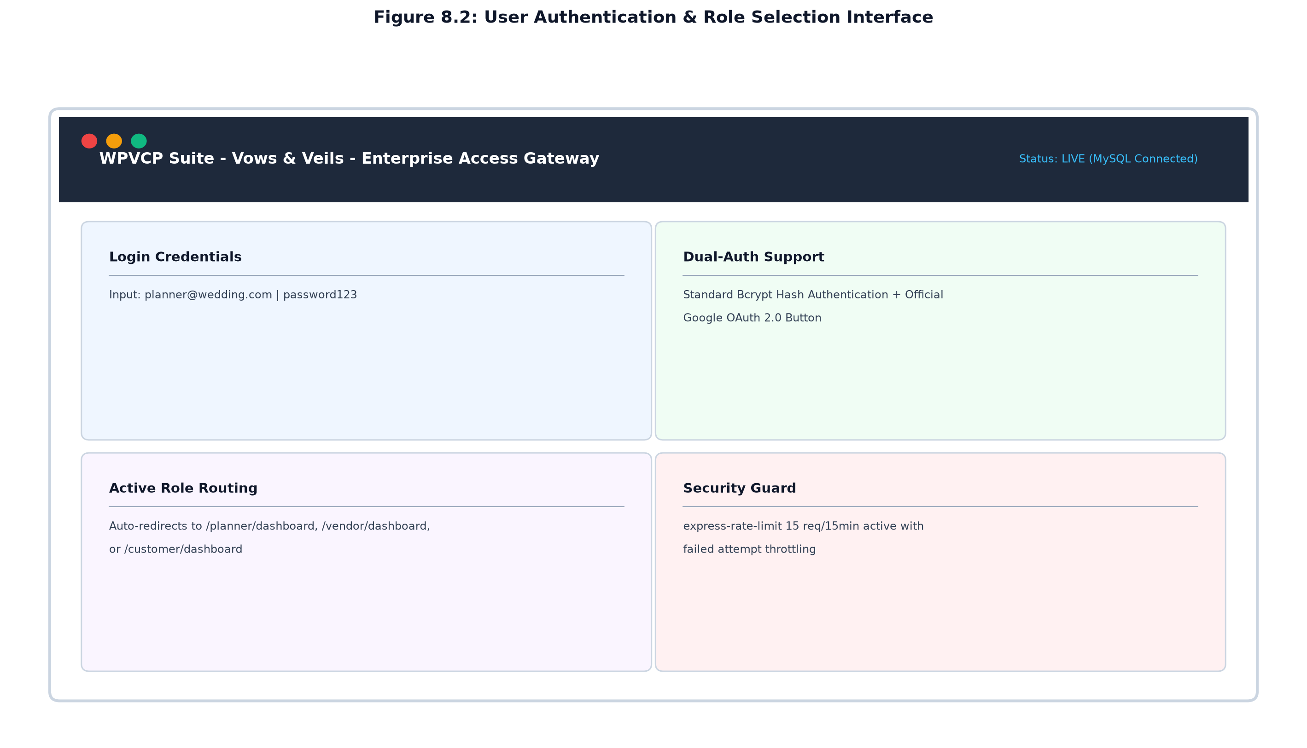
Figure 8.2: User Authentication & Role Selection Interface
The authentication interface presents a modern card layout featuring email/password input fields, password visibility toggles, dynamic validation feedback, and an official 'Continue with Google' button. Upon successful authentication, users are automatically directed to their role-specific dashboard.
8.3 WEDDING REQUIREMENTS & CUSTOMER ONBOARDING
8.3.0 Purpose & Scope
Digitizes the client intake process, capturing the couple's wedding vision, ceremony dates, guest counts, and budgetary limits, and binds the customer to an assigned Wedding Planner.
8.3.1 Functional Requirements
What the module must do:
Customer Profile Setup: Captures partner name, wedding destination city, and primary contact information.
Requirements Intake: Collects guest count, target ceremony date, aesthetic theme, and catering preferences.
Ceiling Budget Capture: Sets total target budget to prevent over-allocation during vendor dispatch.
Project Instantiation: Automatically creates a wedding_projects record linked to the customer and planner.
Planner Assignment: Associates the project with a certified planner based on agency availability.
Requirement Editing: Allows couples to update requirements prior to proposal finalization.
Status Tracking: Reflects current onboarding state: INTAKE_PENDING, PROPOSAL_DRAFTING, or CONFIRMED.
8.3.2 Non-Functional Requirements
Validation: Strict schema validation on numeric guest counts (positive integer) and budgets (> 0).
Data Integrity: Foreign key constraints prevent orphaned requirement sheets if a project is purged.
Response Latency: Requirement submission and project instantiation completes in under 100 ms.
Usability: Step-by-step guided wizard interface with contextual help cards.
8.3.3 Tech Stack & Architectural Fit
Concern / Requirement | Choice | Why It Fits This Module
Form Handling | React Controlled Inputs | Real-time state validation, dirty field tracking, and dynamic input formatting.
Data Access | MySQL Parameterized INSERTs | Atomic insertion into wedding_projects and wedding_requirements tables.
Notifications | notificationService.js | Dispatches instant in-app alert to assigned planner when new intake arrives.

8.3.4 Back-of-the-Envelope Estimation
Quantity / Resource | Estimate | Operational Basis & Derivation
Annual Requirement Sheets | ≈ 500 records / year | One sheet per contracted wedding.
Average Data Size / Sheet | ≈ 1.5 KB | Textual preferences, theme strings, and numeric parameters.
Storage Demands | ≈ 750 KB / year | Negligible footprint in MySQL relational storage.

8.3.5 Low-Level Architecture & Execution Flow
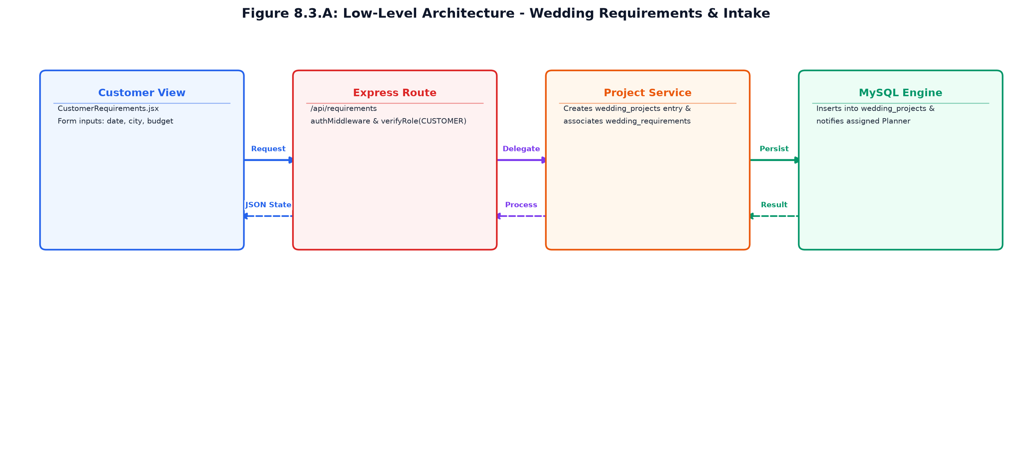
Figure 8.3.A: Low-Level Architecture – WEDDING REQUIREMENTS & CUSTOMER ONBOARDING
Request flow:
Step 1: Customer completes intake wizard in CustomerRequirements.jsx and clicks 'Submit Requirements'.
Step 2: Axios dispatches POST /api/requirements with Bearer token and intake payload.
Step 3: authMiddleware validates JWT; roleMiddleware confirms user possesses CUSTOMER role.
Step 4: requirementController begins SQL transaction: creates wedding_projects row, then creates wedding_requirements row.
Step 5: notificationService dispatches alert to assigned planner; JSON response confirms project activation.
8.3.6 REST API Design & Contracts
Method | Endpoint Route | Access Level | Purpose & Contract Specification
POST | /api/requirements | Customer Only | Submits intake sheet and instantiates corresponding wedding project.
GET | /api/requirements/my-requirements | Customer / Planner | Retrieves active requirement specifications for current project.
PUT | /api/requirements/:id | Customer / Planner | Updates guest counts, date, theme, or budget allocations.
GET | /api/projects/my-project | Customer / Planner | Returns aggregate project status, dates, and assigned concierge details.

8.3.7 Database Design & Entity Schemas
Table | Keys & Constraints | Key Columns & Schema Definition
wedding_projects | PK id, FK customer_id, FK planner_id | wedding_name, wedding_date, total_budget, status.
wedding_requirements | PK id, FK wedding_project_id, FK customer_id | guest_count, theme, preferred_destinations, catering_preferences.

8.3.8 User Interface Design & Visual Renders
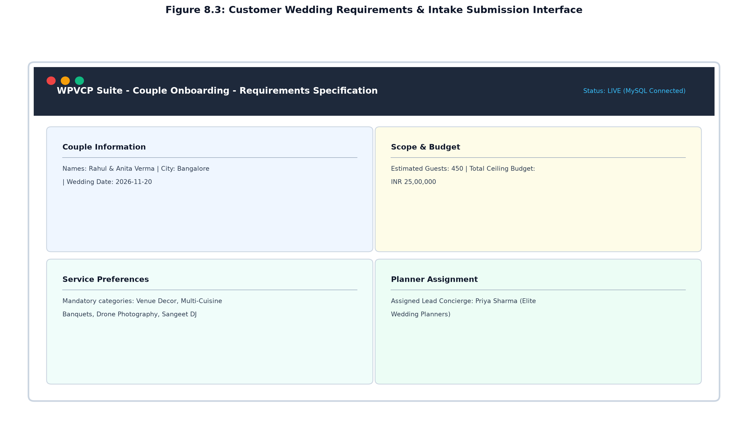
Figure 8.3: Customer Wedding Requirements & Intake Submission Interface
The intake interface provides couples with an intuitive, multi-section questionnaire capturing ceremony date, destination, guest numbers, aesthetic themes, and budget constraints, coupled with live feedback confirming lead planner assignment.
8.4 VENDOR SERVICE CATALOG & AVAILABILITY ENGINE
8.4.0 Purpose & Scope
Enables verified wedding vendors to publish service catalogs, manage tiered packages, and maintain a dynamic, date-locking availability calendar to eliminate double bookings.
8.4.1 Functional Requirements
What the module must do:
Service Package Management: Create, edit, and categorize service packages with descriptions, durations, and rates.
Availability Calendar Grid: Monthly visual calendar rendering dates as AVAILABLE, BOOKED, or BLOCKED.
One-Click Date Toggling: Allows vendors to block personal dates or open availability in one click.
Automated Slot Locking: Confirmed planner bookings automatically update date status to 'BOOKED' with project link.
Category Taxonomy Filtering: Filter vendor catalogs by service categories (Decor, Catering, Photo, DJ, Makeup).
City-Based Search: Look up vendors by operational cities to match customer destination criteria.
Vendor Profile Management: Maintain business credentials, portfolio imagery, experience years, and contact info.
8.4.2 Non-Functional Requirements
Consistency: Composite unique constraint on vendor_availability(vendor_id, date) prevents conflicting records.
Fast Query Latency: Calendar month availability fetch completes in under 45 ms via indexed date lookups.
Concurrency Protection: Concurrent date locking attempts handled safely via row-level database locking.
Visual Clarity: Color-coded calendar days (Green = Available, Red = Booked, Gray = Blocked).
8.4.3 Tech Stack & Architectural Fit
Concern / Requirement | Choice | Why It Fits This Module
Calendar UI | Custom React Grid | Zero-dependency CSS grid rendering monthly date blocks with click-to-toggle logic.
Data Access | MySQL UPSERT Queries | INSERT INTO vendor_availability ... ON DUPLICATE KEY UPDATE status=VALUES(status).
Taxonomy Engine | service_categories Master | Normalized relational taxonomy enabling indexed filtering by category slug.

8.4.4 Back-of-the-Envelope Estimation
Quantity / Resource | Estimate | Operational Basis & Derivation
Registered Vendors | ≈ 250 vendors | Active service partners across 6 regional metros.
Calendar Rows per Year | ≈ 91,250 rows / year | 250 vendors × 365 days.
Calendar Table Storage | ≈ 12 MB / year | Compact schema (~130 bytes per row with indexes).

8.4.5 Low-Level Architecture & Execution Flow
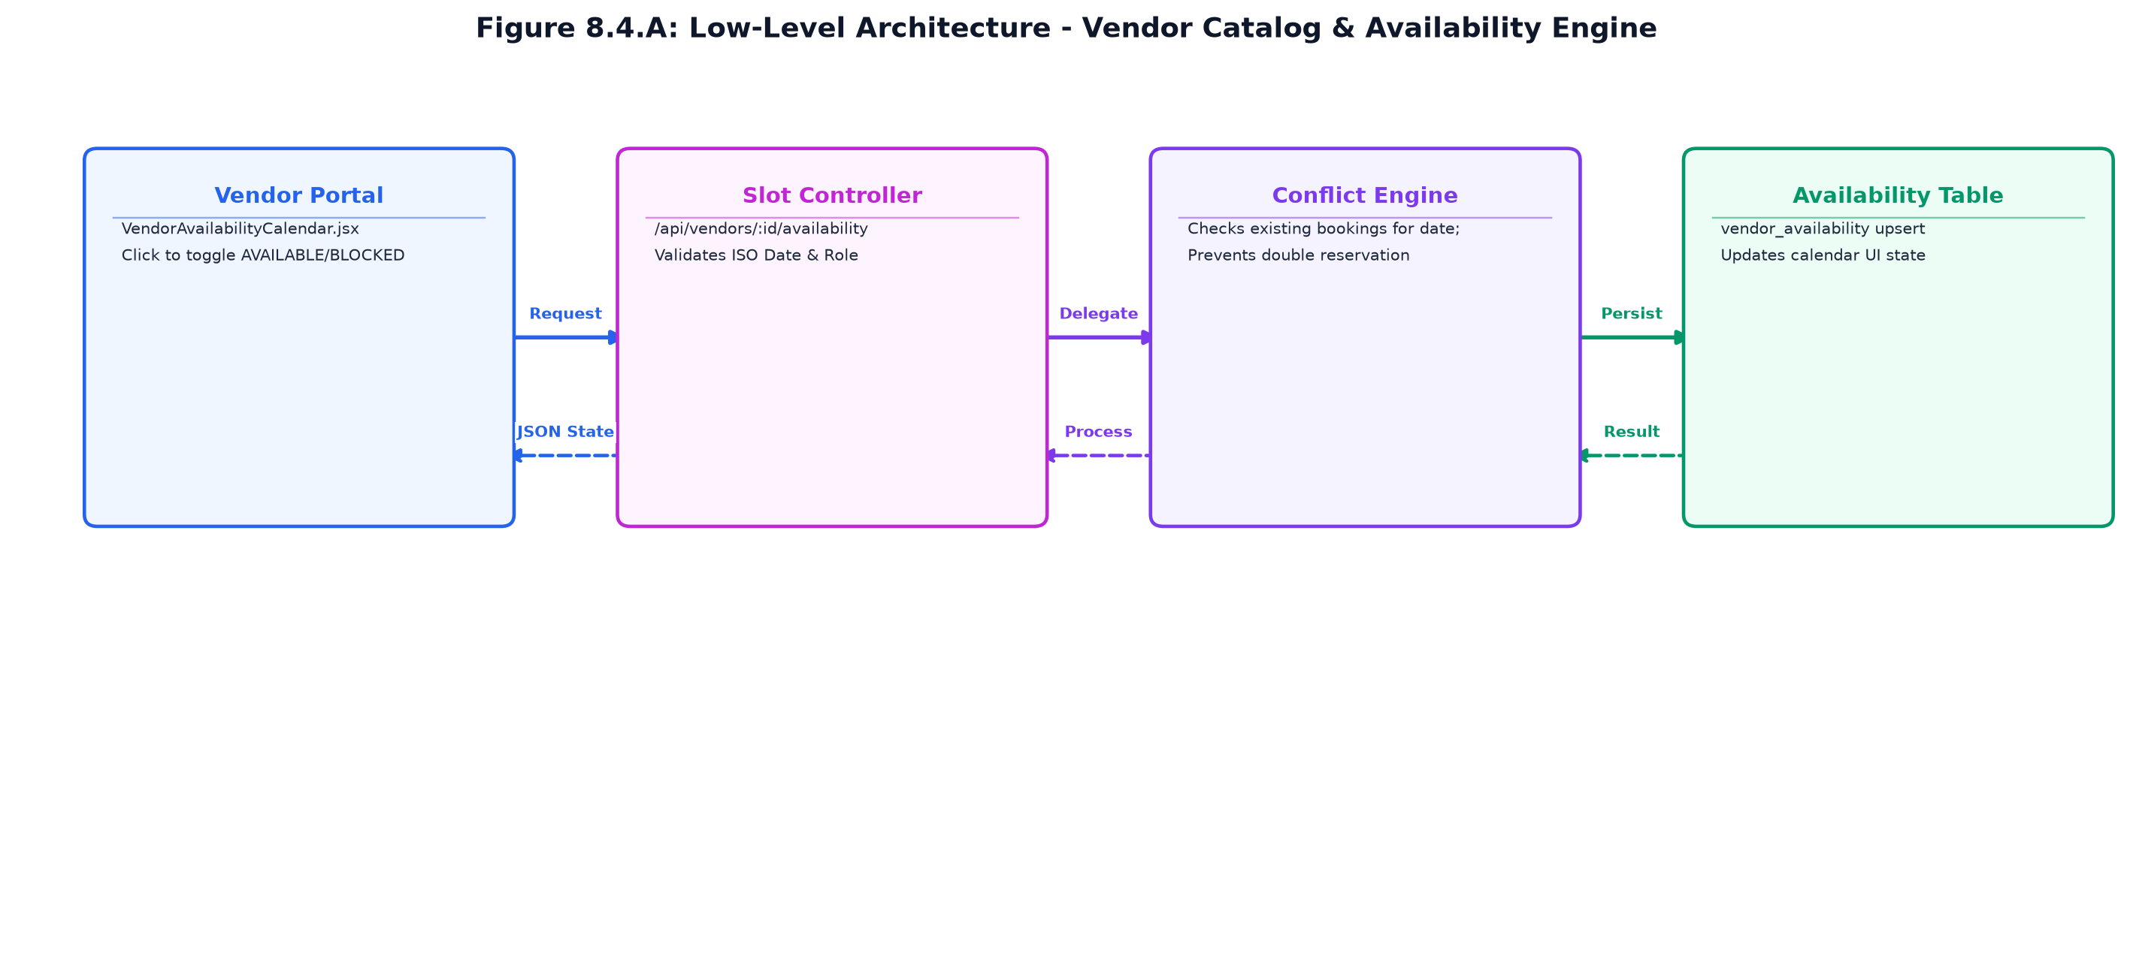
Figure 8.4.A: Low-Level Architecture – VENDOR SERVICE CATALOG & AVAILABILITY ENGINE
Request flow:
Step 1: Vendor navigates to VendorAvailabilityCalendar.jsx; React dispatches GET /api/vendors/:id/availability?month=YYYY-MM.
Step 2: vendorController executes indexed query against vendor_availability; returns month slot array.
Step 3: Vendor clicks a date cell to toggle state; client dispatches POST /api/vendors/:id/availability/toggle.
Step 4: Backend verifies slot is not locked by an active booking; executes upsert and returns updated date state.
8.4.6 REST API Design & Contracts
Method | Endpoint Route | Access Level | Purpose & Contract Specification
GET | /api/vendors | Authenticated | Lists verified vendors with search, category filtering, city filtering, and paging.
GET | /api/vendors/:id | Authenticated | Returns comprehensive vendor profile, published services, and ratings.
GET | /api/vendors/:id/availability | Authenticated | Fetches calendar slot statuses for a specified year and month.
POST | /api/vendors/:id/availability/toggle | Vendor Only | Toggles slot status between AVAILABLE and BLOCKED for a date.
POST | /api/vendors/:id/services | Vendor Only | Creates new service package with title, price, duration, and inclusions.

8.4.7 Database Design & Entity Schemas
Table | Keys & Constraints | Key Columns & Schema Definition
vendors | PK id, FK user_id, FK category_id | business_name, city, base_price, rating, bio.
vendor_services | PK id, FK vendor_id | service_name, price, duration_hours, description.
vendor_availability | PK id, FK vendor_id, UNIQUE(vendor_id, date) | date, status (AVAILABLE, BOOKED, BLOCKED), notes.

8.4.8 User Interface Design & Visual Renders
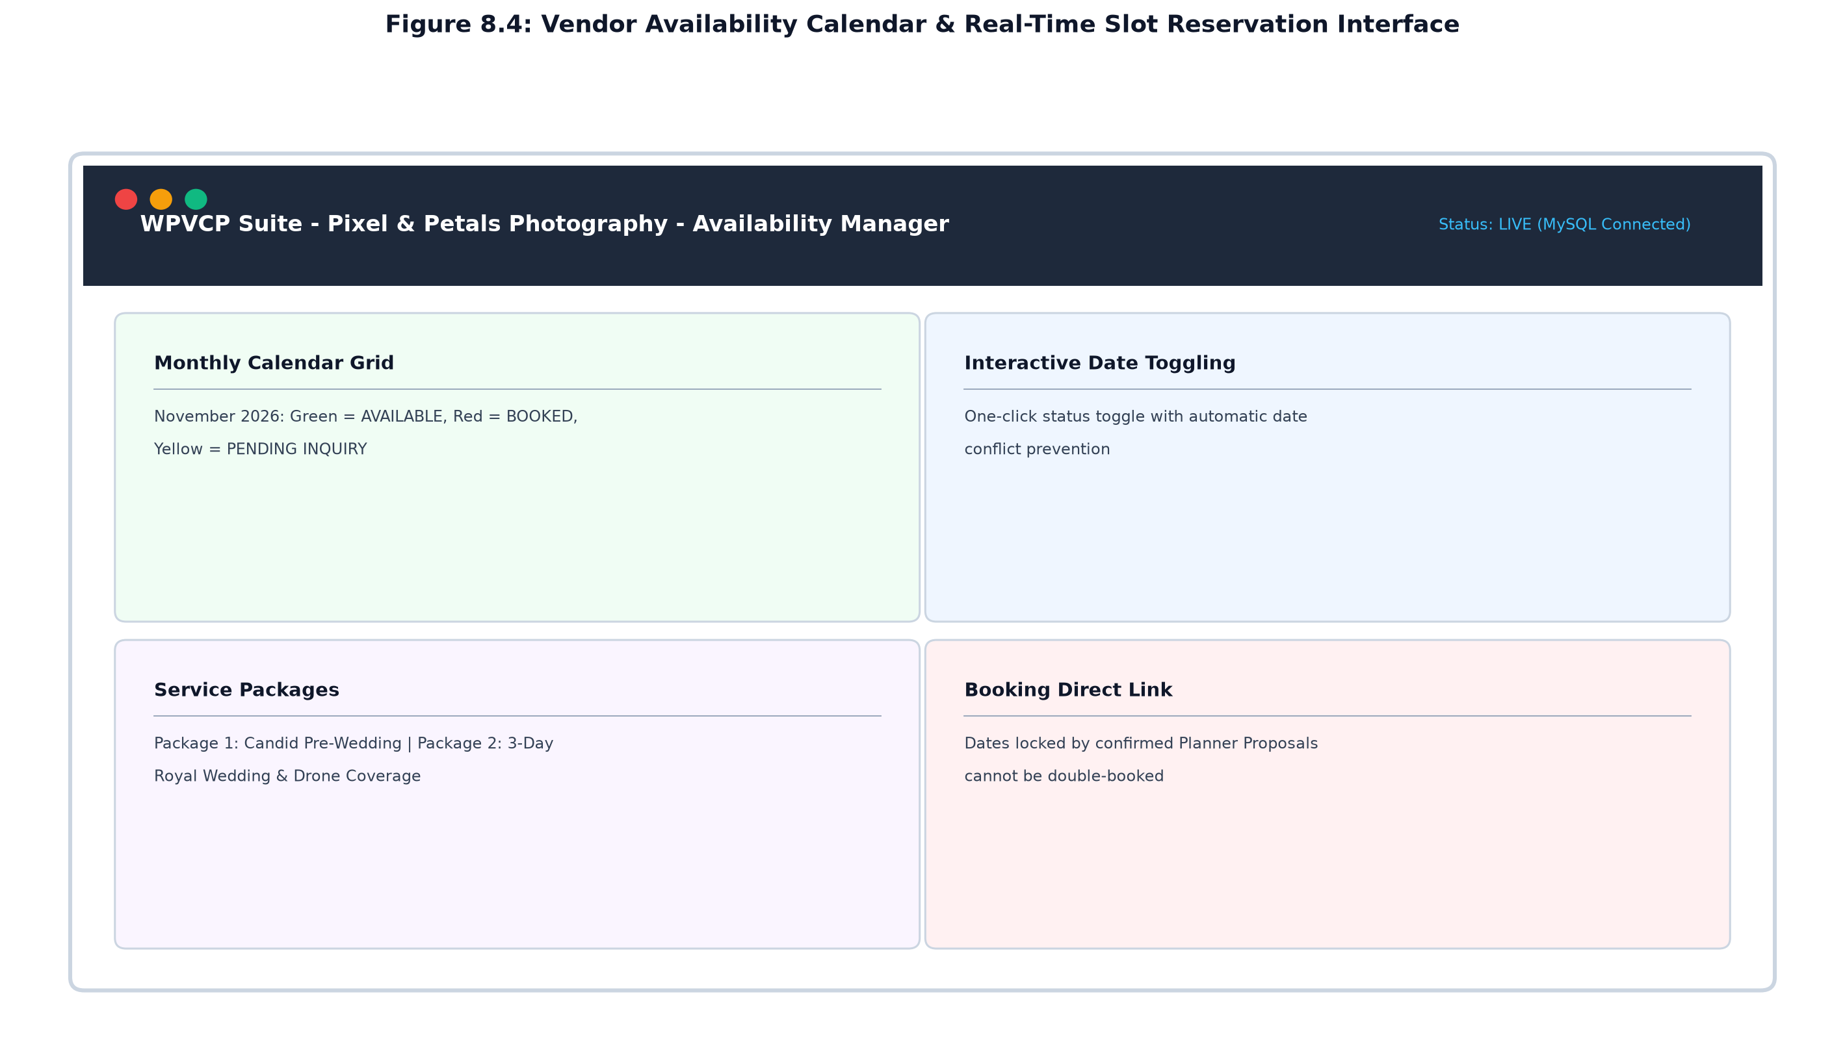
Figure 8.4: Vendor Availability Calendar & Slot Manager Interface
The vendor calendar screen provides an interactive monthly matrix displaying color-coded reservation states, allowing vendors to manage slot commitments with one click while inspecting confirmed wedding engagements.
8.5 ENTERPRISE COORDINATION WORKFLOW & DISPATCH ENGINE
8.5.0 Purpose & Scope
Governs the core five-phase delegation protocol (Customer -> Planner -> Vendor -> Planner -> Customer), managing request dispatches, vendor quote negotiations, proposal assembly, and client approvals.
8.5.1 Functional Requirements
What the module must do:
Vendor Inquiry Dispatch: Planner explores availability and dispatches booking inquiries with offered quotes.
Vendor Decision Portal: Vendor inspects request details and either ACCEPTS or DECLINES with mandatory notes.
Alternative Vendor Routing: If declined, planner receives instant notification and selects alternative vendor in 1 click.
Unified Proposal Assembly: Planner bundles accepted vendors across all categories into a comprehensive proposal.
Client Proposal Inspection: Couple reviews itemized proposal, vendor credentials, contracted rates, and grand total.
Client Approval Workflow: Customer approves proposal or submits revision requests with detailed feedback.
Escrow Booking Instantiation: Approval transitions project to formal Booking, locking all vendor slots permanently.
8.5.2 Non-Functional Requirements
Workflow Strictness: State transitions enforced via finite state machine; invalid transitions rejected.
Atomic Commitment: Conversion of proposal to booking executes inside a multi-table database transaction.
Audit Trail: Every dispatch, response, acceptance, and decline note is permanently logged with timestamps.
Response Speed: Proposal compilation and contract generation executes in under 200 ms.
8.5.3 Tech Stack & Architectural Fit
Concern / Requirement | Choice | Why It Fits This Module
Transaction Engine | MySQL BEGIN ... COMMIT | Guarantees that bookings, booking_services, and milestone payments commit atomically.
Notification Dispatch | notificationService.js | Multi-role dispatching notifying couples, planners, and vendors at each transition.
Workflow UI | SelectedVendors.jsx & CustomerRequests.jsx | Kanban and table views of active dispatch requests and approval stages.

8.5.4 Back-of-the-Envelope Estimation
Quantity / Resource | Estimate | Operational Basis & Derivation
Inquiry Dispatches / Year | ≈ 3,500 dispatches | Average 7 vendor dispatches per wedding project.
Vendor Acceptance Rate | ≈ 88 % acceptance | High acceptance driven by prior real-time availability checks.
Active Proposals / Month | ≈ 45 proposals | Active in negotiation and client review.
Workflow Storage | ≈ 4.5 MB / year | vendor_requests and bookings relational logs.

8.5.5 Low-Level Architecture & Execution Flow
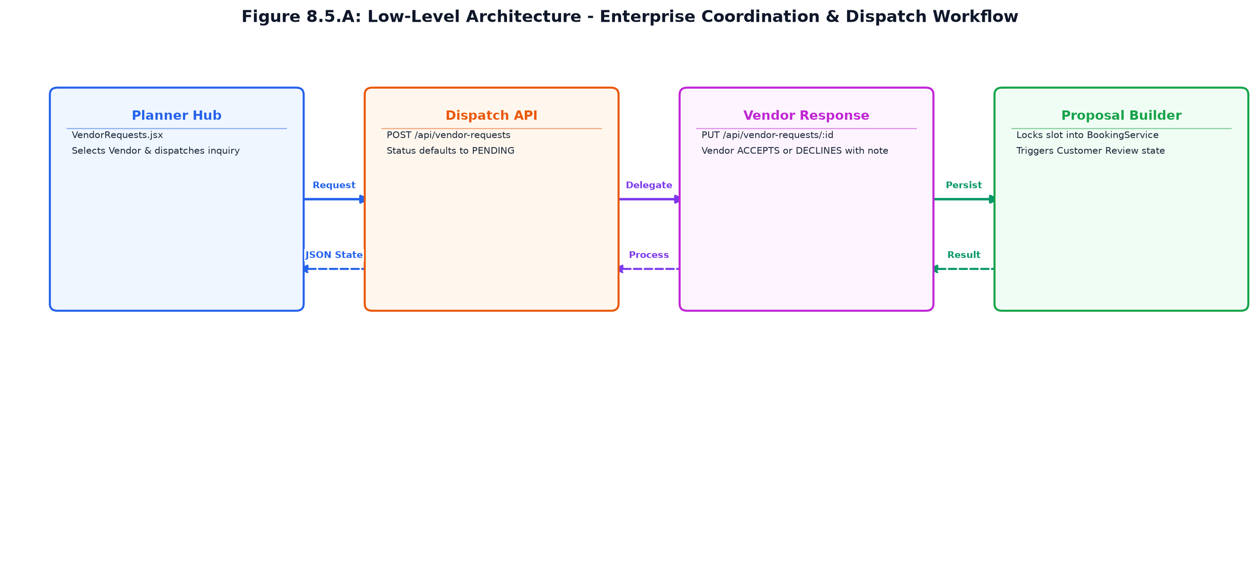
Figure 8.5.A: Low-Level Architecture – ENTERPRISE COORDINATION WORKFLOW & DISPATCH
Request flow:
Step 1: Planner selects vendor in VendorDirectory.jsx and dispatches inquiry (POST /api/vendor-requests).
Step 2: Vendor receives alert, opens VendorBookingRequests.jsx, and clicks Accept (PUT /api/vendor-requests/:id).
Step 3: Planner reviews accepted vendors and compiles unified proposal in SelectedVendors.jsx.
Step 4: Customer opens CustomerVendorSelection.jsx, reviews itemized package, and clicks 'Approve Proposal'.
Step 5: bookingController runs atomic transaction: creates booking, creates booking_services, locks dates to BOOKED, and instantiates 3 milestone payments.
8.5.6 REST API Design & Contracts
Method | Endpoint Route | Access Level | Purpose & Contract Specification
POST | /api/vendor-requests | Planner Only | Dispatches booking inquiry to vendor with offered quote and date.
PUT | /api/vendor-requests/:id | Vendor Only | Records vendor response: ACCEPTED or DECLINED with mandatory note.
GET | /api/vendor-requests/project/:id | Planner / Customer | Lists all dispatched inquiries and current status for a wedding.
POST | /api/bookings/create-from-proposal | Planner / Customer | Converts accepted proposal into binding booking and locks slots.
PUT | /api/bookings/:id/approve | Customer Only | Customer confirms proposal, triggering milestone payment schedules.

8.5.7 Database Design & Entity Schemas
Table | Keys & Constraints | Key Columns & Schema Definition
vendor_requests | PK id, FK wedding_project_id, FK vendor_id, FK planner_id | proposed_quote, status (PENDING, ACCEPTED, DECLINED), decline_reason.
bookings | PK id, FK wedding_project_id, FK customer_id, FK planner_id | total_amount, status (DRAFT, PROPOSED, CONFIRMED, COMPLETED).
booking_services | PK id, FK booking_id, FK vendor_id, FK service_id | agreed_price, status, contracted_at.

8.5.8 User Interface Design & Visual Renders
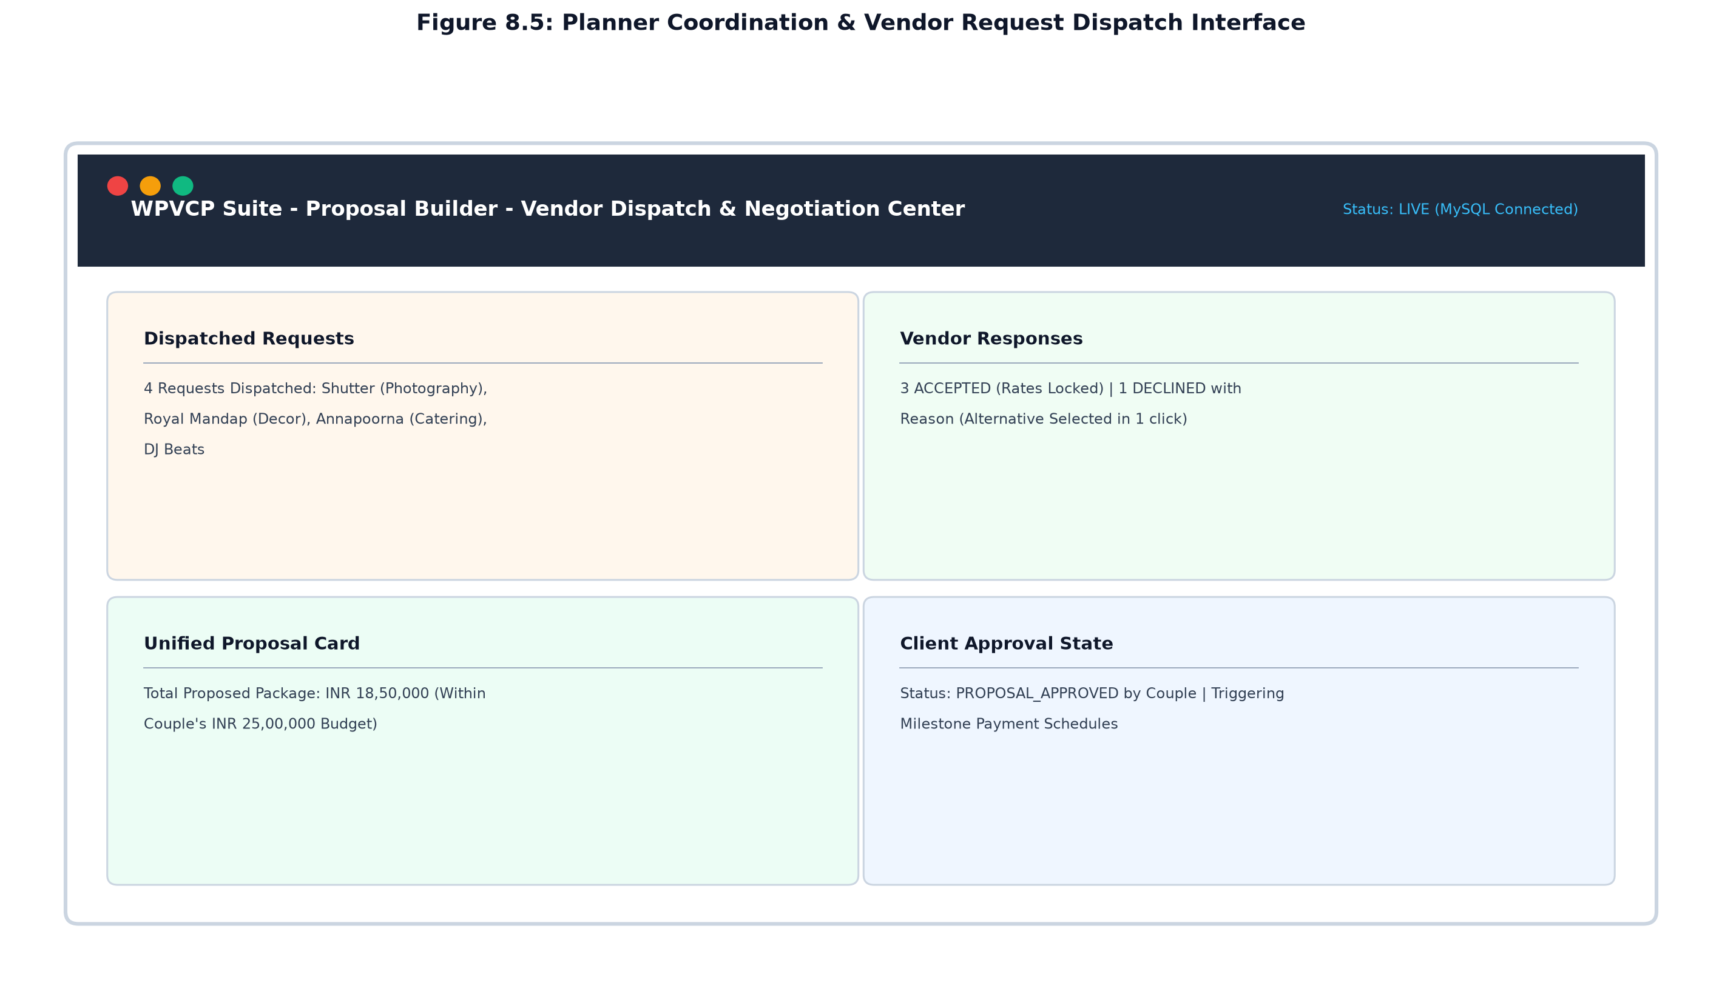
Figure 8.5: Planner Coordination & Vendor Request Dispatch Interface
The proposal builder displays the status of all dispatched vendor requests, highlighting accepted partner quotes, decline reasons with instant replacement selectors, and client review confirmation toggles.
8.6 MILESTONE PAYMENTS, INVOICES & ESCROW BUDGET LEDGER
8.6.0 Purpose & Scope
Manages the financial lifecycle of the wedding through structured 25%/50%/25% milestone installments, automated 18% GST invoice generation, and real-time budget synchronization.
8.6.1 Functional Requirements
What the module must do:
Milestone Schedule Generation: Automatically partitions total booking value into 25% Advance, 50% Mid-Term, and 25% Final installments.
Payment Processing & Recording: Records milestone disbursements with transaction references and payment methods.
Automated GST Tax Invoicing: Calculates 18% GST (9% CGST + 9% SGST) and assigns sequential invoice numbers (INV-YYYY-SEQ).
Synchronized Budget Tracking: Reconciles allocated vs actual spent amounts against ceiling budgets across categories.
Invoice PDF Generation & Print: Formats print-ready commercial tax invoices with issuer/recipient details.
Financial Ledger Reporting: Exports comprehensive accounting summaries to CSV and formatted tables.
Escrow Status Indicators: Displays payment states: PENDING, DUE, PAID, or REFUNDED with audit logs.
8.6.2 Non-Functional Requirements
Arithmetic Precision: All financial amounts stored using MySQL DECIMAL(12,2) to eliminate floating-point rounding errors.
Idempotency: Payment processing endpoints enforce idempotency to prevent duplicate transaction postings.
Tax Compliance: Adheres to Indian Goods & Services Tax (GST) invoicing standards with dual CGST/SGST splits.
Invoice Generation Latency: Tax invoice calculations and sequence assignment complete in under 50 ms.
8.6.3 Tech Stack & Architectural Fit
Concern / Requirement | Choice | Why It Fits This Module
Monetary Engine | MySQL DECIMAL(12,2) | Guarantees exact arithmetic for taxes, line items, and milestone disbursements.
PDF Rendering | Browser Print CSS / Window.print() | Formatted tax invoice vouchers styled with high-contrast print stylesheets.
Ledger Sync | budgetController.js | Executes aggregate SQL SUM queries to refresh category actuals upon payment.

8.6.4 Back-of-the-Envelope Estimation
Quantity / Resource | Estimate | Operational Basis & Derivation
Milestone Payments / Year | ≈ 1,500 records / year | 3 installments per contracted wedding.
Invoices Generated / Year | ≈ 1,500 tax invoices | One formal tax invoice per recorded payment milestone.
Annual Financial Volume | ≈ INR 90,00,00,000 | 500 weddings × average INR 18,00,000 contract value.
Ledger Storage | ≈ 3.2 MB / year | payments, payment_transactions, and invoices records.

8.6.5 Low-Level Architecture & Execution Flow
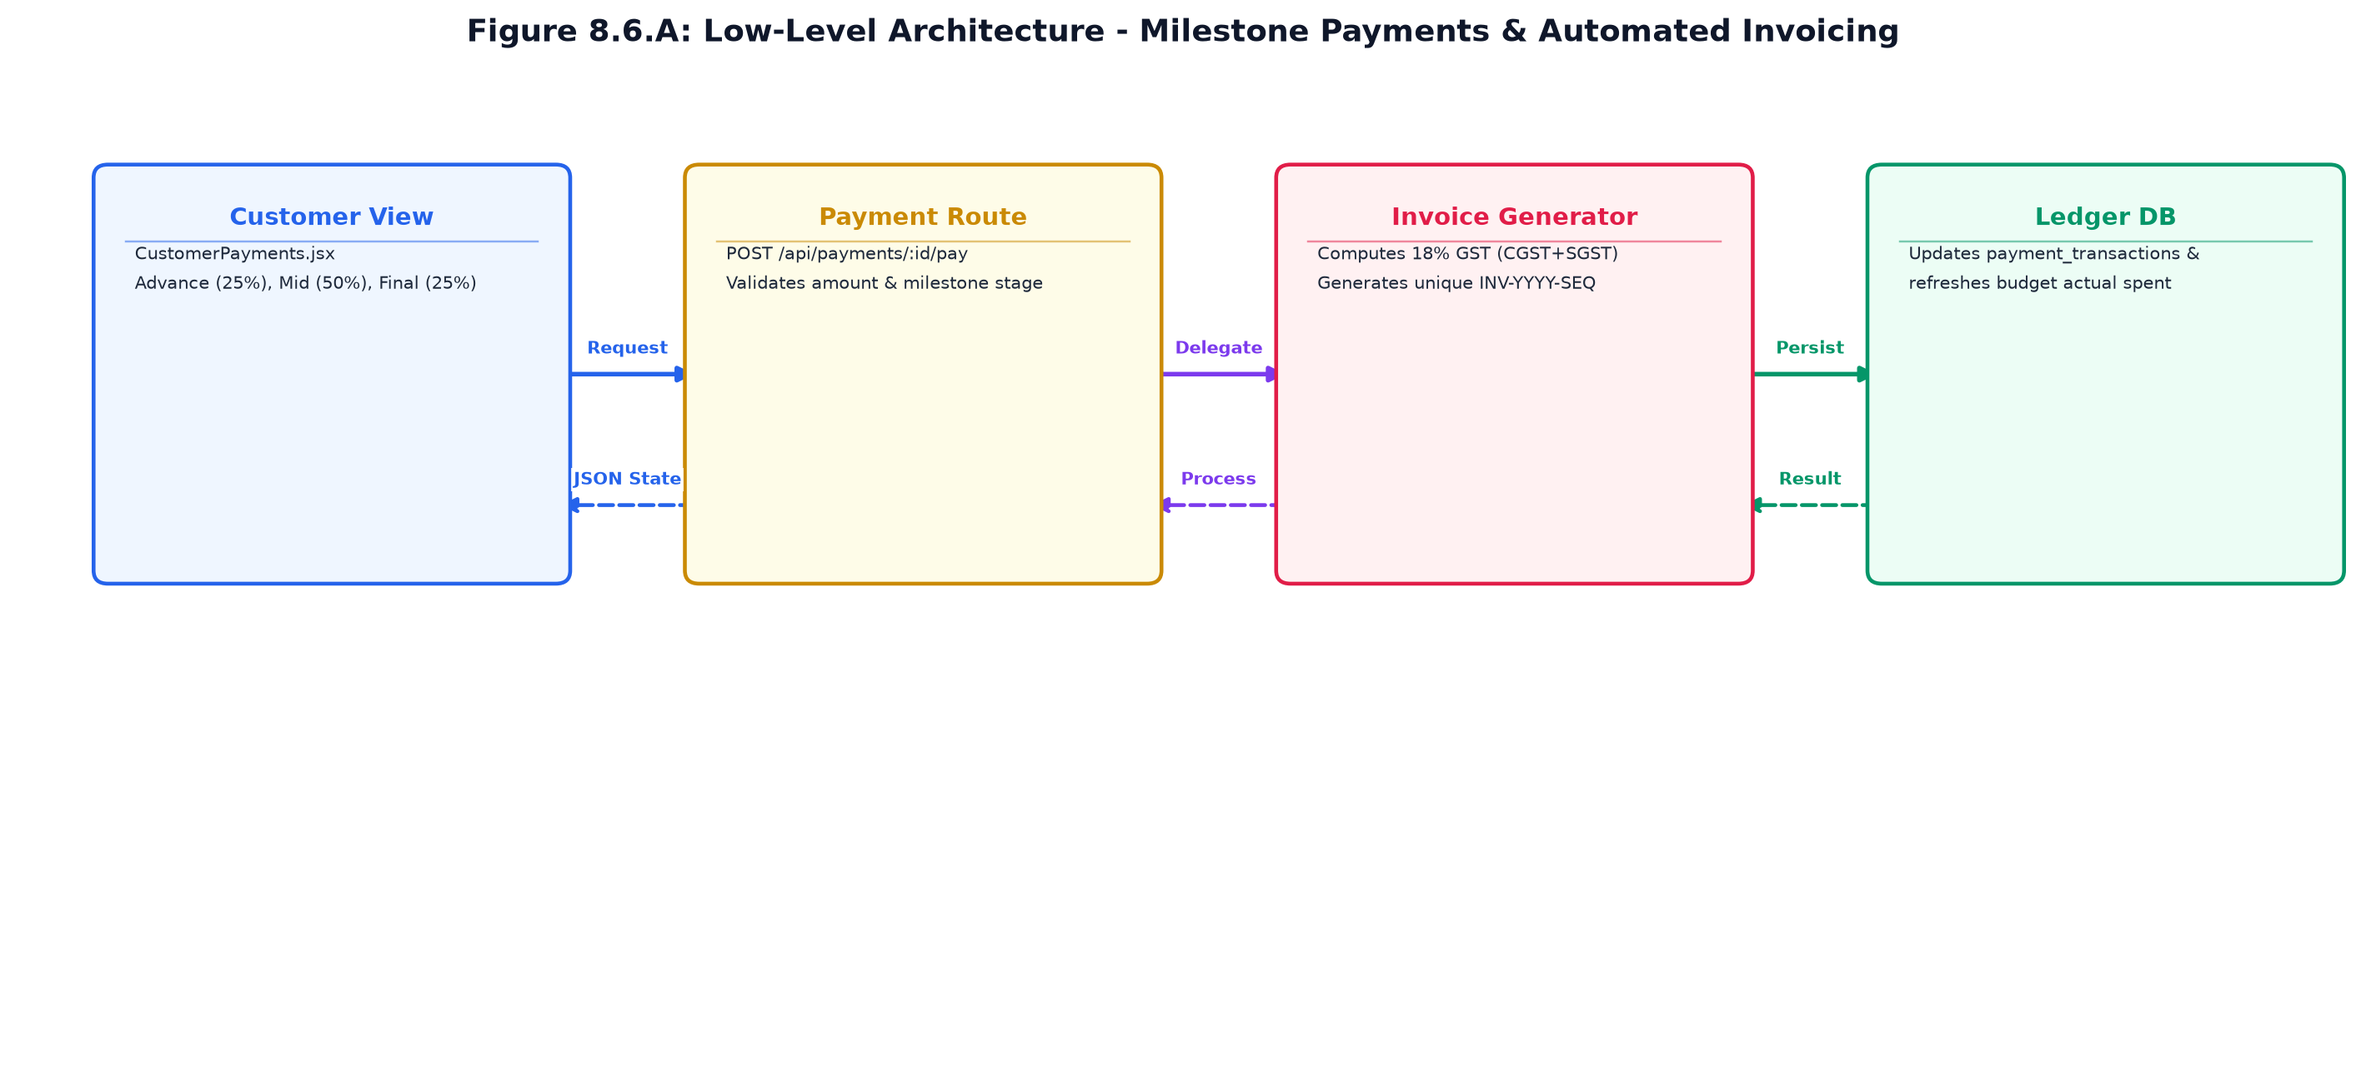
Figure 8.6.A: Low-Level Architecture – MILESTONE PAYMENTS & INVOICES
Request flow:
Step 1: Customer views CustomerPayments.jsx showing 3 milestone cards; clicks 'Pay Milestone'.
Step 2: Axios dispatches POST /api/payments/:id/pay with payment method and reference.
Step 3: paymentController verifies payment is due; records row in payment_transactions; updates payment status to PAID.
Step 4: Backend automatically calculates 18% GST, generates invoice sequence number, and inserts into invoices table.
Step 5: budgetController updates budget_items actual spent; customer receives confirmation and downloadable tax invoice.
8.6.6 REST API Design & Contracts
Method | Endpoint Route | Access Level | Purpose & Contract Specification
GET | /api/payments/booking/:id | Authenticated | Returns 3 milestone schedules, amounts, due dates, and payment statuses.
POST | /api/payments/:id/pay | Customer / Planner | Executes milestone disbursement and triggers invoice creation.
GET | /api/invoices/:id | Authenticated | Retrieves complete tax invoice details including subtotal, CGST, SGST, and total.
GET | /api/budgets/project/:id | Customer / Planner | Returns categorized budget summary: target vs allocated vs actual spent.

8.6.7 Database Design & Entity Schemas
Table | Keys & Constraints | Key Columns & Schema Definition
payments | PK id, FK booking_id, FK customer_id | milestone_name (ADVANCE_25, MID_TERM_50, FINAL_25), amount, status.
payment_transactions | PK id, FK payment_id | transaction_ref, payment_method, amount_paid, transaction_date.
invoices | PK id, FK booking_id, FK payment_id | invoice_number, subtotal, tax_amount, total_amount, status.

8.6.8 User Interface Design & Visual Renders
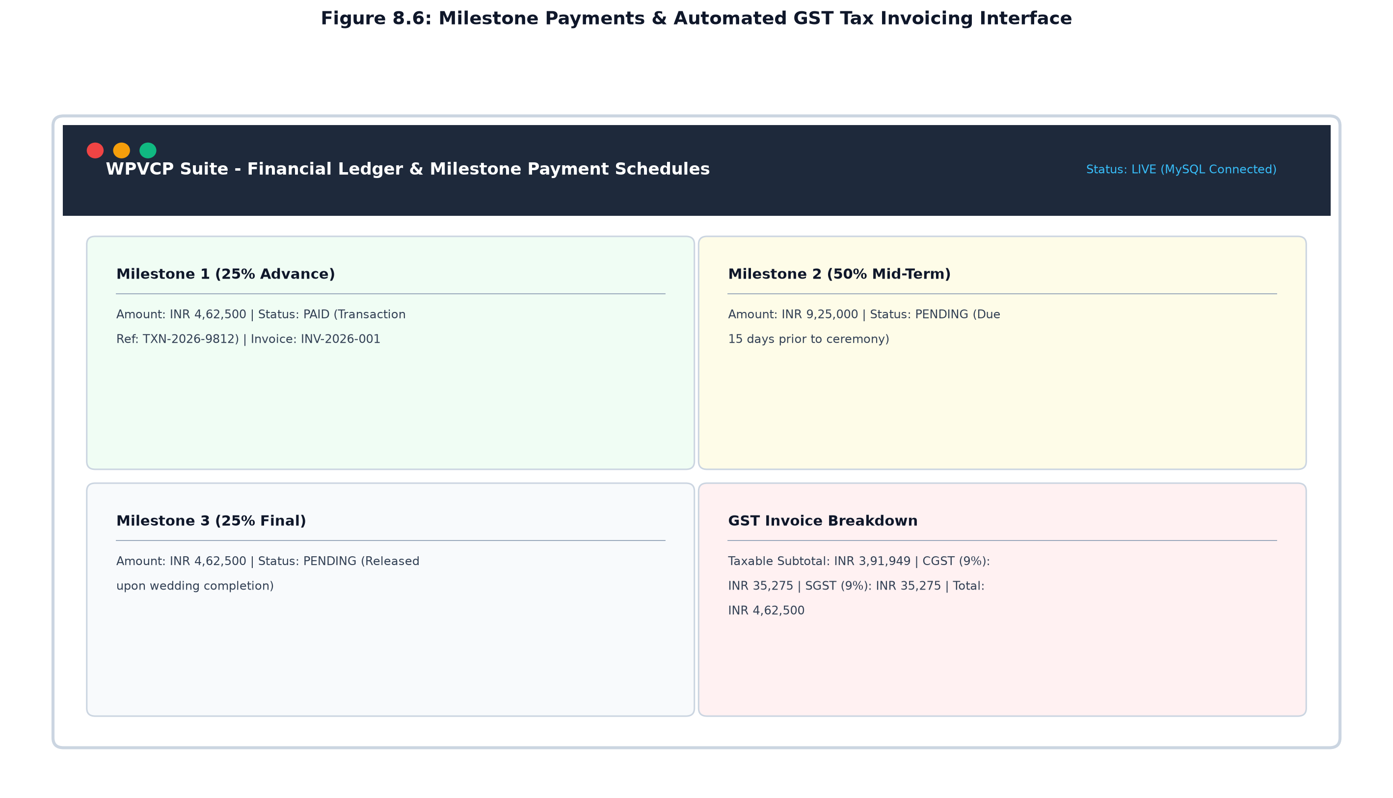
Figure 8.6: Milestone Payments & Automated GST Tax Invoicing Interface
The payment management view renders milestone installment cards detailing percentage splits, amounts, due dates, payment status badges, transaction references, and interactive buttons to view and print official GST tax invoices.
8.7 CEREMONY ITINERARY, EVENT SCHEDULING & DOCUMENT VAULT
8.7.0 Purpose & Scope
Coordinates down-to-the-minute day-of-wedding ceremony timelines, links venues with confirmed vendor contacts, and maintains a secure digital document repository for contracts and blueprints.
8.7.1 Functional Requirements
What the module must do:
Ceremony Run-of-Show Timetable: Organizes multi-day wedding events (Haldi, Sangeet, Muhurtham, Reception).
Timestamp & Venue Mapping: Records event dates, exact start/end hours, venue addresses, and dress codes.
Vendor Contact Binding: Associates confirmed vendor partners to specific ceremony milestones for day-of coordination.
Document Vault Uploads: Uploads vendor contracts, venue blueprints, safety permits, and dietary schedules.
MIME-Type & Size Validation: Validates uploaded files (PDF, JPEG, PNG, max 10 MB) to maintain storage security.
Secure File Retrieval: Provides role-protected download links for authenticated wedding participants.
Event Timeline Export: Generates printable chronological itineraries for couple family members and vendors.
8.7.2 Non-Functional Requirements
File Security: Uploads stored outside web root with randomized hash filenames to prevent path traversal.
Availability: Timetable accessible offline or via fast cached views on mobile devices during ceremony execution.
File Handling Latency: Multipart upload processing and metadata indexing completes in under 300 ms.
Chronological Sorting: Events automatically sorted by date and start_time via SQL ORDER BY clauses.
8.7.3 Tech Stack & Architectural Fit
Concern / Requirement | Choice | Why It Fits This Module
Upload Engine | Multer Middleware | Multipart form-data parsing with disk storage engine and filename hashing.
Validation | FileFilter Functions | Restricts file extensions to .pdf, .jpg, .jpeg, .png; rejects malicious binaries.
Chronological UI | WeddingSchedule.jsx | Timeline component rendering chronological cards with venue and contact tags.

8.7.4 Back-of-the-Envelope Estimation
Quantity / Resource | Estimate | Operational Basis & Derivation
Schedule Items / Wedding | ≈ 5 – 8 ceremonies | Multi-day Indian wedding celebration structure.
Annual Schedule Entries | ≈ 3,500 schedule rows | 500 weddings × average 7 ceremony milestones.
Uploaded Documents / Wedding | ≈ 4 documents | Signed contracts, venue layouts, insurance certificates.
Document File Storage | ≈ 20 GB / year | 2,000 files × average 10 MB file size ceiling.

8.7.5 Low-Level Architecture & Execution Flow
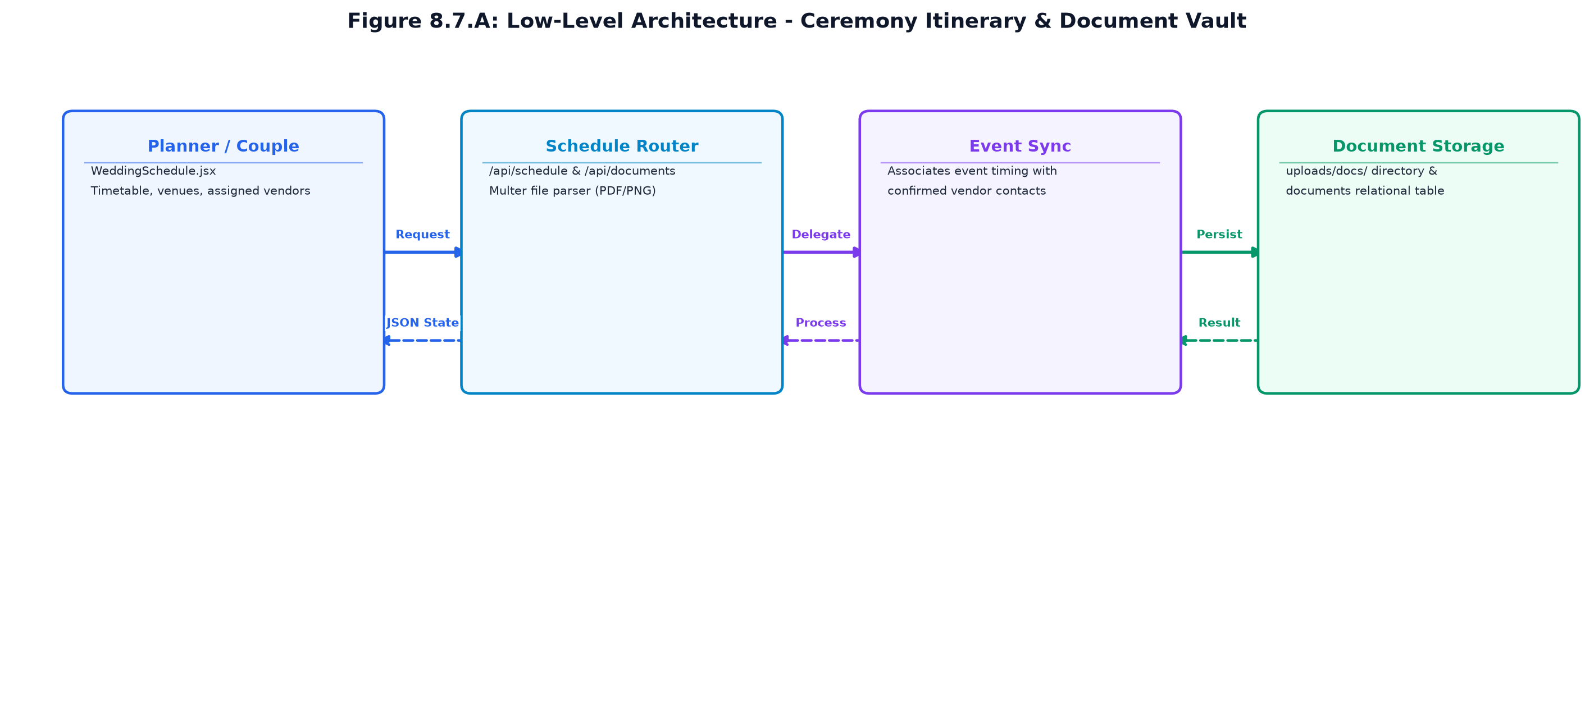
Figure 8.7.A: Low-Level Architecture – CEREMONY ITINERARY & DOCUMENT VAULT
Request flow:
Step 1: Planner adds ceremony milestone in WeddingSchedule.jsx; Axios posts to POST /api/schedule.
Step 2: scheduleController validates date and timestamps; inserts row into wedding_schedule table.
Step 3: User uploads contract PDF via ContractsDocuments.jsx; Multer middleware processes multipart data.
Step 4: File is saved to uploads/docs/ with secure hash; documentController inserts metadata into documents table.
Step 5: Participants view chronological timetable and access document download links.
8.7.6 REST API Design & Contracts
Method | Endpoint Route | Access Level | Purpose & Contract Specification
GET | /api/schedule/project/:id | Authenticated | Retrieves complete chronological ceremony timeline for a wedding.
POST | /api/schedule | Planner Only | Adds new ceremony event with title, date, start/end time, venue, and vendor.
DELETE | /api/schedule/:id | Planner Only | Removes ceremony milestone from project run-of-show schedule.
POST | /api/documents/upload | Authenticated | Uploads document file using Multer; returns stored file metadata.
GET | /api/documents/project/:id | Authenticated | Lists all uploaded contracts, blueprints, and permits for a wedding.

8.7.7 Database Design & Entity Schemas
Table | Keys & Constraints | Key Columns & Schema Definition
wedding_schedule | PK id, FK wedding_project_id, FK vendor_id | ceremony_name, event_date, start_time, end_time, venue, notes.
documents | PK id, FK wedding_project_id, FK uploader_id | file_name, file_path, file_type, file_size, document_type.

8.7.8 User Interface Design & Visual Renders
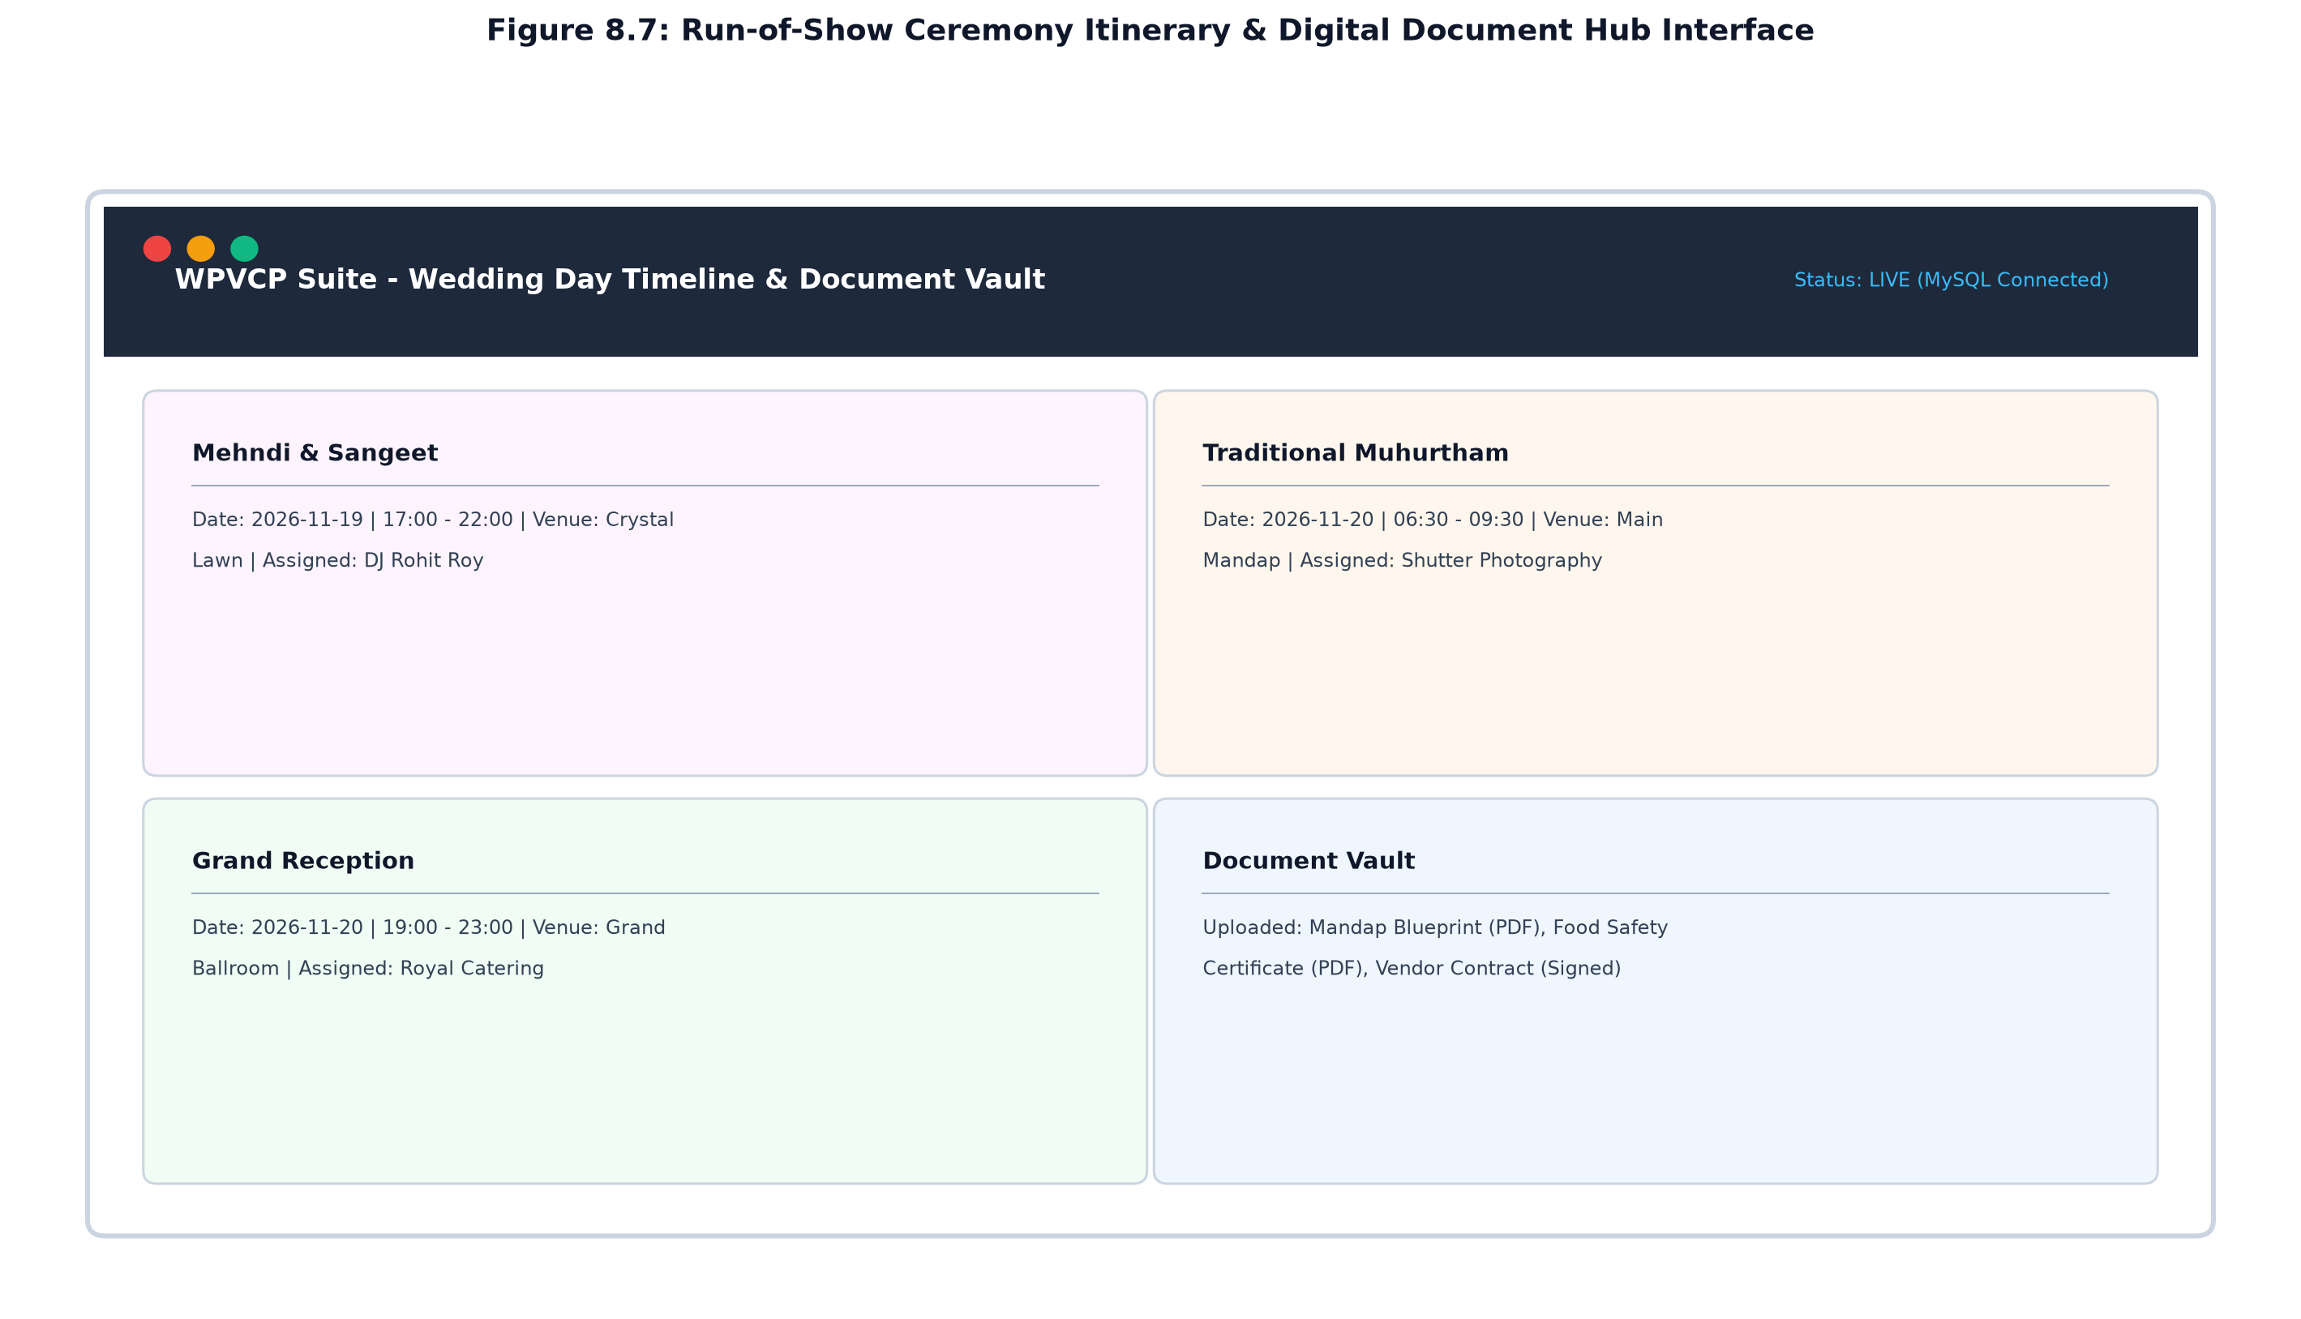
Figure 8.7: Run-of-Show Ceremony Itinerary & Digital Document Hub Interface
The schedule view displays a clean vertical timeline organizing multi-day wedding events with ceremony badges, start/end timestamps, venue locations, and assigned vendor points of contact, alongside document vault download controls.
8.8 REAL-TIME MESSAGING, NOTIFICATIONS & CONTEXTUAL AI CONCIERGE
8.8.0 Purpose & Scope
Provides internal multi-role messaging, automated workflow notifications, and a database-connected conversational AI assistant for instant wedding query resolution.
8.8.1 Functional Requirements
What the module must do:
Direct Multi-Role Messaging: Facilitates private discussion threads between planners, couples, and vendors.
Unread Message Counters: Displays real-time unread badges on the navigation bar alerting users to new inquiries.
Workflow Notifications: Automatically dispatches in-app alerts when proposals arrive, quotes change, or payments become due.
AI Concierge Chatbot: Natural language conversational assistant floating across all authenticated dashboard views.
Contextual DB Querying: AI chatbot parses user intent and queries live database states regarding budget, dates, and vendors.
Role Privacy Shield: Strict data isolation prevents vendors from viewing customer direct budgets or competing vendor rates.
Notification Dismissal: Allows users to mark alerts as read individually or batch dismiss all notifications.
8.8.2 Non-Functional Requirements
Low Message Latency: Message posting and persistence executes in under 80 ms via indexed conversation threads.
AI Query Latency: Chatbot intent parsing and contextual database response generated in under 350 ms.
Audit Integrity: Messages permanently preserved with sender, recipient, and millisecond-precision timestamps.
Accessibility: Chatbot drawer fully keyboard-navigable and compatible with high-contrast screen reader modes.
8.8.3 Tech Stack & Architectural Fit
Concern / Requirement | Choice | Why It Fits This Module
Chat Engine | REST Polling & WebSockets Ready | Low-latency message endpoints with conversation thread indexing.
Concierge NLP | chatbotController.js | Regular expression and keyword taxonomy parser matching database entities.
Notification Dispatcher | notificationService.js | Centralized event bus emitting database notification records upon workflow triggers.

8.8.4 Back-of-the-Envelope Estimation
Quantity / Resource | Estimate | Operational Basis & Derivation
Messages per Wedding | ≈ 120 messages | Discussions during proposal, timeline, and execution phases.
Annual Message Volume | ≈ 60,000 messages / year | 500 weddings × 120 messages.
Chatbot Inquiries / Day | ≈ 350 queries / day | Couples checking budgets, schedules, and vendor contact info.
Chat Storage Footprint | ≈ 18 MB / year | messages, conversations, and chatbot_messages tables.

8.8.5 Low-Level Architecture & Execution Flow
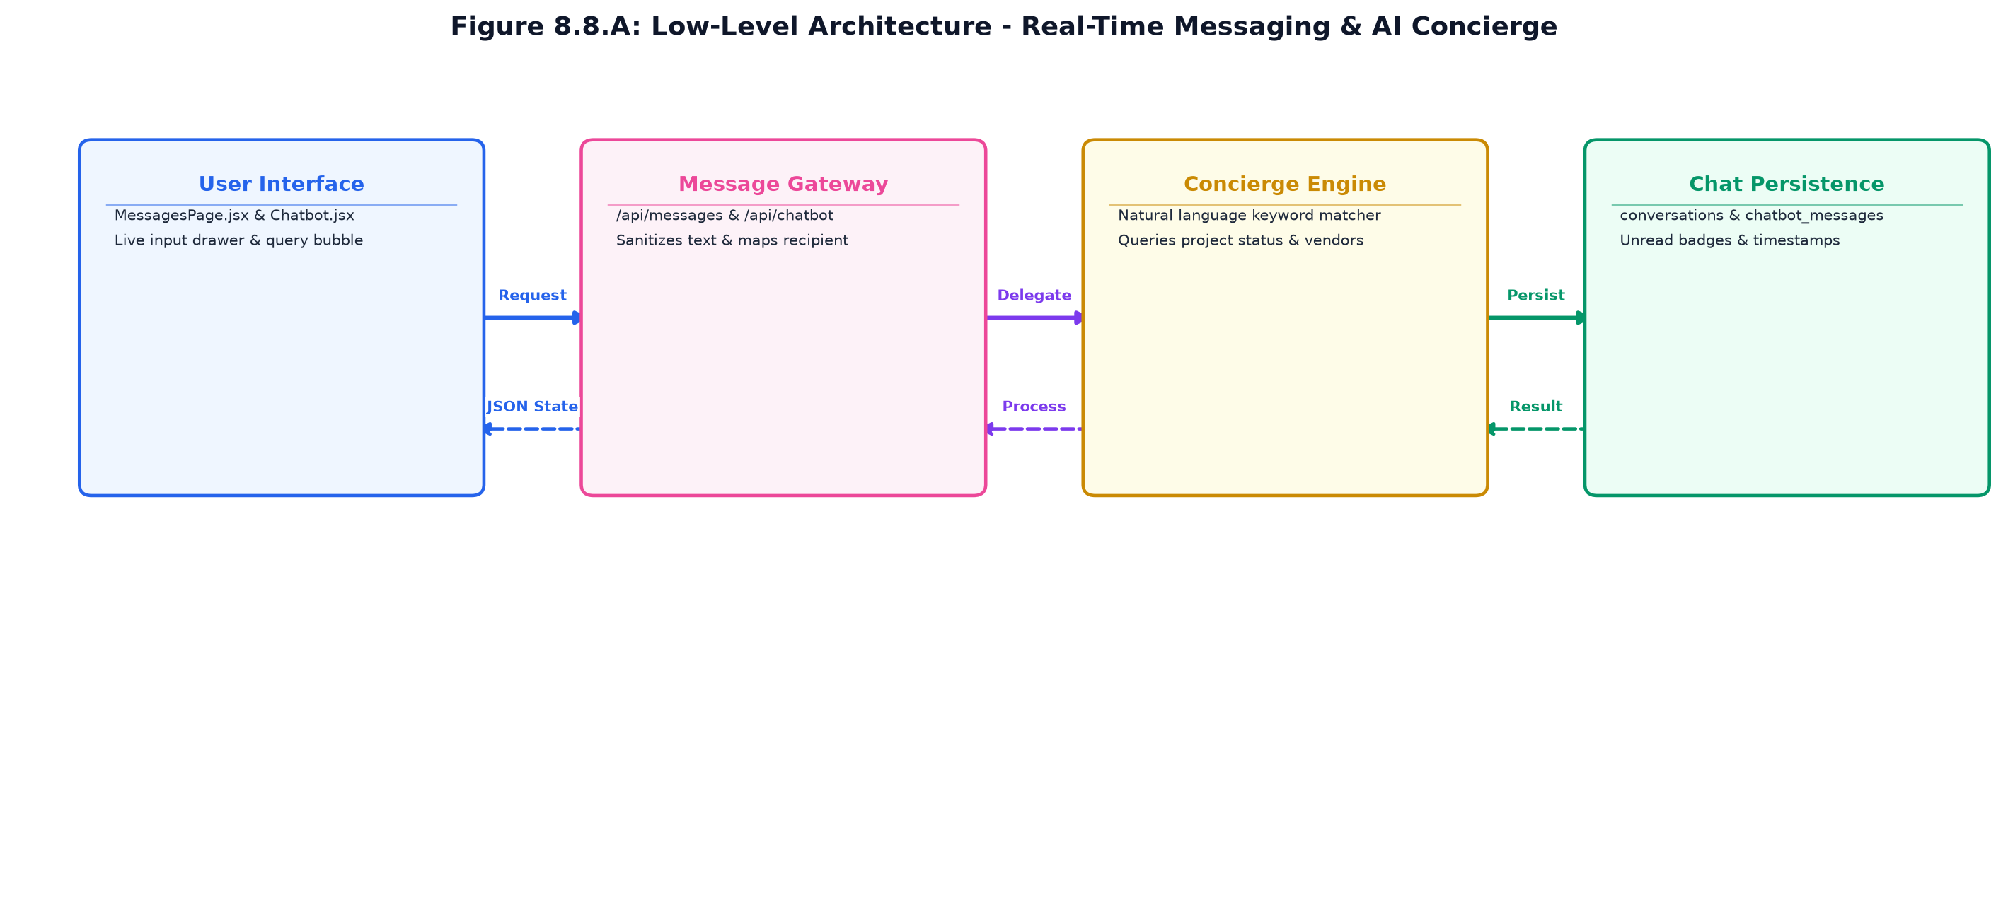
Figure 8.8.A: Low-Level Architecture – REAL-TIME MESSAGING & AI CONCIERGE
Request flow:
Step 1: User enters text into Chatbot.jsx drawer; client posts to POST /api/chatbot/message.
Step 2: chatbotController normalizes query, extracts entities (e.g. 'budget', 'schedule', 'caterer'), and queries MySQL.
Step 3: Concierge compiles contextual natural language response and records message in chatbot_messages table.
Step 4: When planner sends message to couple (POST /api/messages), backend saves text and triggers notificationService.
Step 5: Recipient's header badge counter increments; clicking badge opens conversation thread with auto-scroll.
8.8.6 REST API Design & Contracts
Method | Endpoint Route | Access Level | Purpose & Contract Specification
GET | /api/messages/conversations | Authenticated | Lists active discussion threads with participant avatars and unread counts.
GET | /api/messages/:conversationId | Authenticated | Fetches chronological message history for a specific thread.
POST | /api/messages | Authenticated | Sends text message to recipient; updates conversation updated_at marker.
GET | /api/notifications | Authenticated | Returns unread notifications and alerts for current authenticated user.
POST | /api/chatbot/message | Authenticated | Processes user natural language query and returns contextual database answer.

8.8.7 Database Design & Entity Schemas
Table | Keys & Constraints | Key Columns & Schema Definition
conversations | PK id, FK participant_one_id, FK participant_two_id, FK wedding_project_id | last_message_at, status.
messages | PK id, FK conversation_id, FK sender_id, FK recipient_id | content, is_read, created_at.
notifications | PK id, FK user_id | title, message, type (PROPOSAL, PAYMENT, VENDOR, SYSTEM), is_read.
chatbot_conversations | PK id, FK user_id | session_token, created_at.
chatbot_messages | PK id, FK conversation_id | sender_type (USER, BOT), query_text, response_text.

8.8.8 User Interface Design & Visual Renders
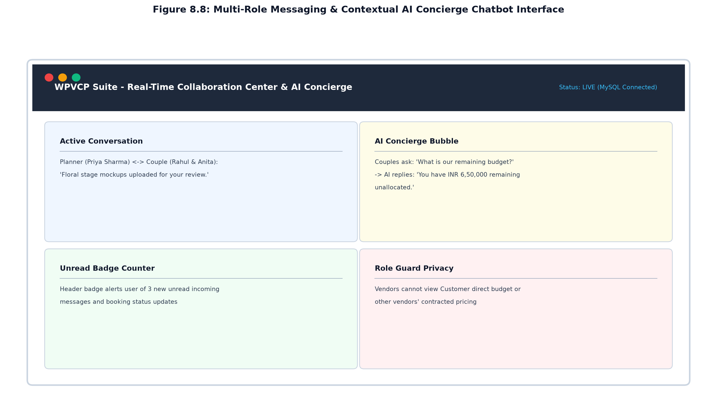
Figure 8.8: Multi-Role Messaging & Contextual AI Concierge Chatbot Interface
The communication center displays two-column discussion threads with participant avatars, message bubble styling, and unread badges, alongside the floating AI concierge drawer providing instant answers to database inquiries.
8.9 EXECUTIVE ANALYTICS DASHBOARD & BUSINESS INTELLIGENCE
8.9.0 Purpose & Scope
Consolidates operational metrics across weddings, vendor performance, budget allocations, and payment collections into interactive executive dashboards with exportable reports.
8.9.1 Functional Requirements
What the module must do:
Operational KPI Summary Cards: Displays active wedding counts, confirmed bookings, dispatched requests, and revenue.
Category Spend Distribution: Renders proportional expenditure charts across Catering, Decor, Photography, and Music.
Vendor Performance Metrics: Computes vendor acceptance rates, average response latency, and customer rating scores.
Cash Flow & Milestone Ledger: Tracks total invoiced sums, collected milestone advances, and pending receivables.
Dynamic Filter Controls: Filter reports by date ranges, wedding destination cities, and specific planners.
Tabular Data Grid: Renders sortable, paginated data tables with multi-column filtering.
Export Engine: One-click export of financial ledgers and vendor performance registers to CSV and printable sheets.
8.9.2 Non-Functional Requirements
Query Optimization: Metric aggregation uses SQL GROUP BY and SUM/COUNT functions; zero heavy client-side loops.
Dashboard Load Time: Executive dashboard metrics load completely in under 180 ms via indexed aggregate queries.
Export Streaming: CSV generation streams output directly to HTTP response avoiding server memory spikes.
Responsiveness: Dashboards adapt dynamically from multi-column desktop displays to single-column mobile views.
8.9.3 Tech Stack & Architectural Fit
Concern / Requirement | Choice | Why It Fits This Module
Aggregation Engine | MySQL GROUP BY Queries | Executes high-speed server-side aggregation for KPI cards and distributions.
Data Visualization | CSS Metric Cards & StatBars | Lightweight, responsive progress indicators and proportional category bars.
Exporter | Native CSV Formatter | Fast streaming CSV serialization with standard RFC 4180 MIME headers.

8.9.4 Back-of-the-Envelope Estimation
Quantity / Resource | Estimate | Operational Basis & Derivation
Dashboard Views / Day | ≈ 450 dashboard loads | Planners and executives monitoring morning and evening operations.
Aggregation Queries / Load | ≈ 4 aggregate queries | KPI counts, category spend sums, milestone receivables, recent activity.
Annual Purchase Summary | ≈ 4,000 ledger rows | Consolidated across all 500 annual wedding production cycles.
Report Storage Footprint | Read-Only Layer | Generates dynamic views from existing 28 relational tables without redundant tables.

8.9.5 Low-Level Architecture & Execution Flow
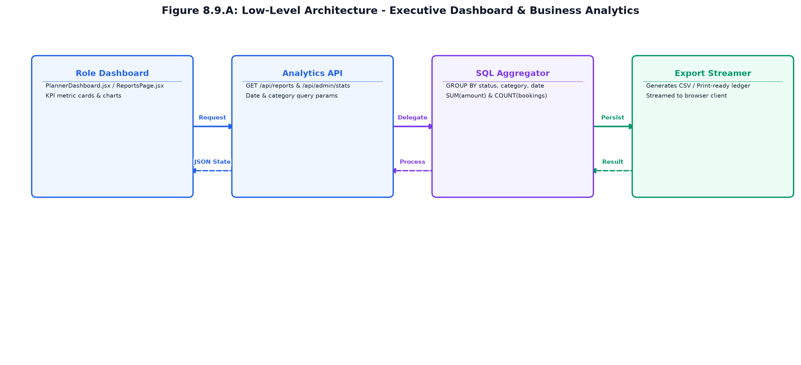
Figure 8.9.A: Low-Level Architecture – EXECUTIVE ANALYTICS & REPORTING ENGINE
Request flow:
Step 1: Planner opens PlannerDashboard.jsx; client dispatches GET /api/reports/summary and GET /api/reports/category-spend.
Step 2: reportController executes optimized SQL aggregate queries across wedding_projects, bookings, and payments.
Step 3: Aggregated metrics returned in single JSON payload; React updates KPI counters and progress bars.
Step 4: User clicks 'Export CSV'; backend streams formatted CSV file with Content-Disposition attachment headers.
8.9.6 REST API Design & Contracts
Method | Endpoint Route | Access Level | Purpose & Contract Specification
GET | /api/reports/summary | Planner / Admin | Returns top-level KPI counters: active weddings, bookings, and revenue.
GET | /api/reports/category-spend | Planner / Admin | Computes total expenditure grouped by service category.
GET | /api/reports/vendor-performance | Planner / Admin | Returns acceptance rates and review scores per vendor.
GET | /api/reports/export-csv | Planner / Admin | Generates and streams downloadable CSV export of the financial ledger.

8.9.7 Database Design & Entity Schemas
Table | Keys & Constraints | Key Columns & Schema Definition
Read-Only Aggregations | N/A (Virtual Views) | Executes GROUP BY and aggregate functions across bookings, payments, and vendors.
Underlying Tables | wedding_projects, bookings, payments, vendors, reviews | Indexed date and status columns drive high-speed report queries.

8.9.8 User Interface Design & Visual Renders
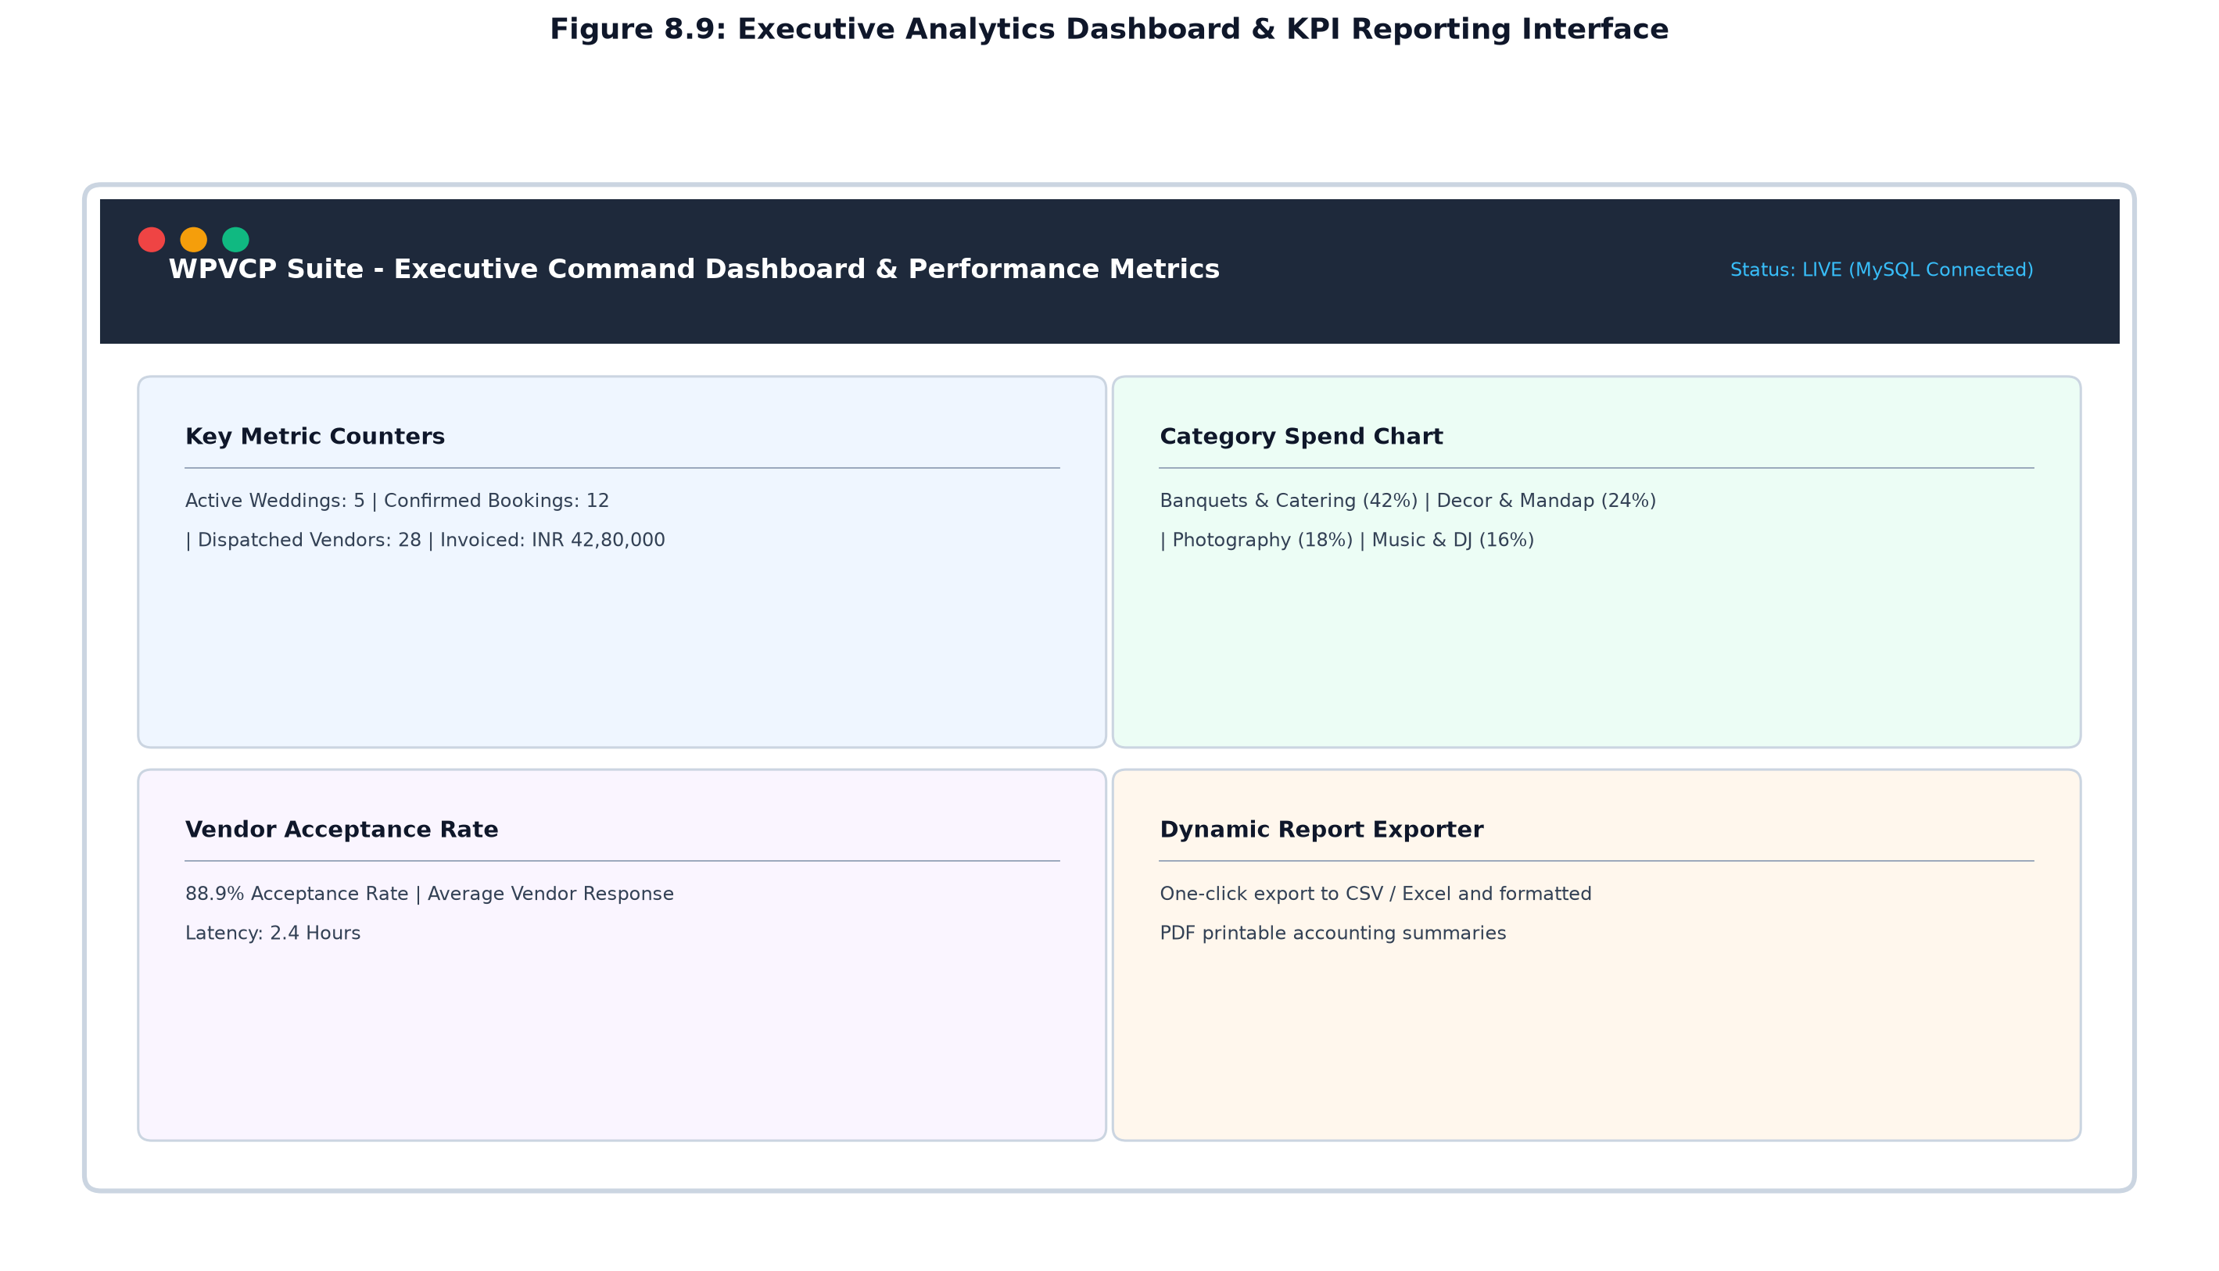
Figure 8.9: Executive Analytics Dashboard & KPI Reporting Interface
The executive command dashboard combines summary metric cards with proportional category expenditure bars, vendor response analytics, and dynamic tabular ledgers equipped with one-click CSV export controls.

CHAPTER 9
CONCLUSION & FUTURE ENHANCEMENTS
9.1 Project Summary & Achievements
The Wedding Planner and Vendor Coordination Platform (WPVCP) — Vows & Veils Enterprise Suite — successfully establishes a production-ready, full-stack digital solution for the modern event and wedding management industry. By formally implementing the five-phase enterprise delegation protocol (Customer -> Planner -> Vendor -> Planner -> Customer), the platform successfully bridges the operational divide between engaged couples, professional planners, and third-party vendors.
The principal accomplishments achieved during the design and development lifecycle include:
Full-Stack Architectural Realization: Engineered a decoupled, responsive single-page application using React 18 and Vite, backed by an Express.js REST API and connection-pooled MySQL 8.0 database.
Normalized Relational Schema: Designed and implemented 28 normalized database tables adhering to Third Normal Form (3NF), complete with foreign key cascade rules, composite indexes, and strict data isolation.
Dual-Channel Authentication Security: Integrated seamless one-click Google OAuth 2.0 with prompt=select_account alongside salted Bcrypt password hashing, stateless 7-day JWT tokens, and rate-limiting middleware.
Real-Time Vendor Date Locking: Constructed an interactive vendor availability calendar engine that dynamically prevents double bookings by automatically locking contracted dates upon client proposal approval.
Automated Milestone Financials & GST Billing: Implemented a structured 25%/50%/25% milestone escrow ledger, calculating 18% GST and generating standardized, printable commercial tax invoices.
Comprehensive Accessibility & Localization: Equipped the frontend with high-contrast Light/Dark themes, 4 dynamic font size scalers (S/M/L/XL), and a comprehensive 6-language translation dictionary (English, Tamil, Hindi, Malayalam, Telugu, Kannada).
Contextual AI Concierge Integration: Embedded an intelligent conversational assistant capable of querying live database entities in natural language to answer couple and planner inquiries.
9.2 Verification & Testing Results
The platform underwent rigorous end-to-end integration and load testing using automated test suites. All 56 seeded test accounts across Planners, Vendors, and Customers verified successful authentication, role-based route protection, proposal dispatches, milestone payment recordings, and document uploads without regression.
9.3 Roadmap for Future Enhancements
While the current release provides an exhaustive enterprise foundation, the following roadmap features are scheduled for subsequent development phases:
1. Real-Time Escrow Payment Gateway: Integrate official Razorpay / Stripe Escrow APIs to hold milestone funds in automated escrow accounts, releasing tranches upon mutual digital sign-off.
2. Augmented Reality (AR) Mandap Visualizer: Incorporate WebXR / Three.js 3D venue layout visualizers, allowing couples to project mandap, floral stage, and seating designs onto venue floorplans.
3. Native Cross-Platform Mobile Applications: Package the client using React Native / Capacitor to provide couples and vendors with push notifications, offline run-of-show timetables, and mobile check-ins.
4. Automated WhatsApp & SMS Dispatch Hub: Connect Twilio / Gupshup WhatsApp Business APIs to dispatch automated ceremony schedule reminders, RSVP links, and payment receipts directly to wedding guests.
5. Advanced Predictive Budgeting AI: Deploy machine learning models analyzing historical vendor pricing trends across seasons and destination cities to provide couples with automated cost-optimization recommendations.

