**NOISE POLLUTION MONITORING**

**AN IOT BASED APPROACH**

**OUTLINE**

* Introduction
* Problem Domain
* Block Diagram
* Components
* Design Description
* Result
* Advantages
* Conclusion

# **INTRODUCTION**

Now a days metropolises cities noise pollution becomes serious issues, Due to high decibels and toxic gases present in the environment which directly effect on human health and thus needs a special attention.

**PROBLEM DOMAIN**

The project involves deploying IOT sensors to measure noise pollution in public areas and providing real-time noise level data accessible to the public through a platform or a mobile app.

The primary objective is to raise awareness about noise pollution.

**BLOCK DIAGRAM**

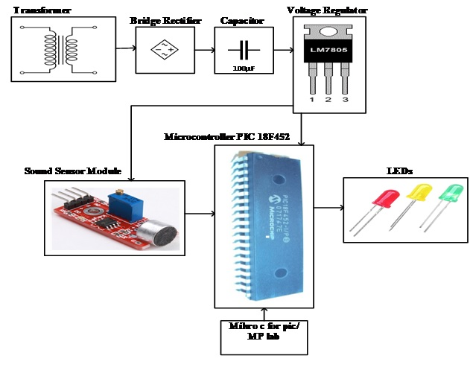

**COMPONENTS**

* Software Components

Python Programming

Crowdsensing Platform

* Hardware Components

Power Supply

Micro controller

Sound sensor

LCD Display

**DESIGN DESCRIPTION**

* The system automatically alerts the user about the Noise Level over IOT and also shows details of Sound in Decibel over the internet.
* Thus the IOT based Noise Pollution tracking system effectively uses internet to monitor Noise level.
* The sensors are connected to a microcontroller to track the status which is in turn interfaced to Wi Fi connection in order to transmit alerts.

**RESULT**

* The project “NOISE POLLUTION MONITORING SYSTEM USING WIFI OVER IOT” has been successfully designed.

**ADVANTAGES**

* Accuracy of recorded data
* Automation and ease of control
* Cost effectiveness

**CONCLUSION**

* It has been developed by integrating features of all the hardware components used. Presence of every module has been reasoned out and placed carefully thus contributing to the best working of the unit.
* Secondly, using highly advanced IC’s and with the help of growing technology the project has been successfully implemented.
* Finally, This Real-time Monitoring System Provides Public-Awareness, It reduce noise and also improve public lifespan.