DSBSC GNU flowchart

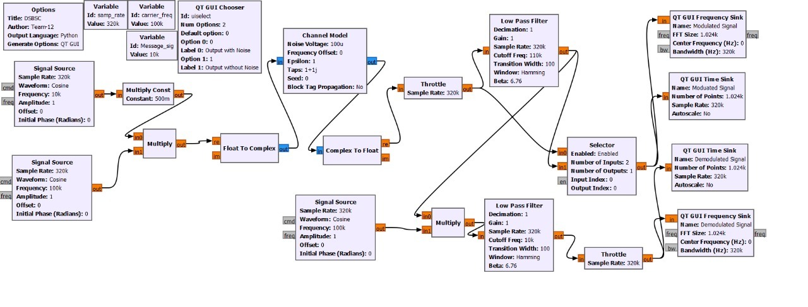

Output

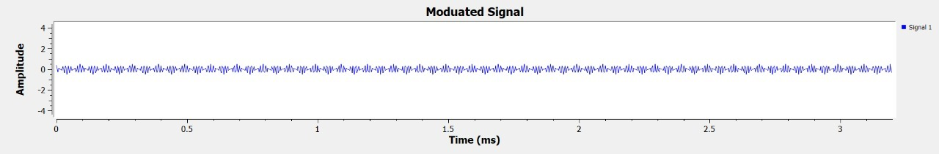

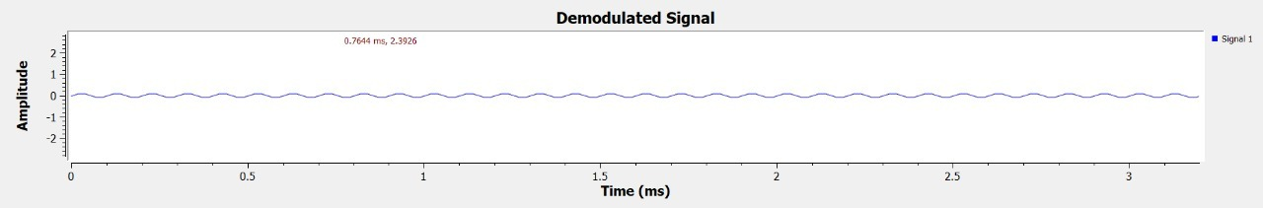

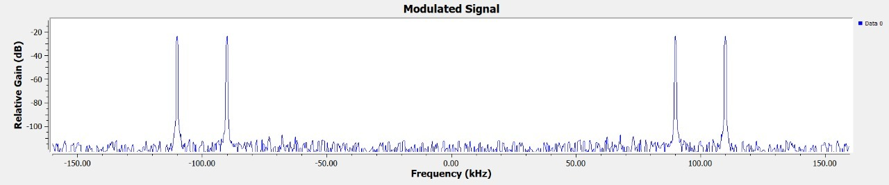

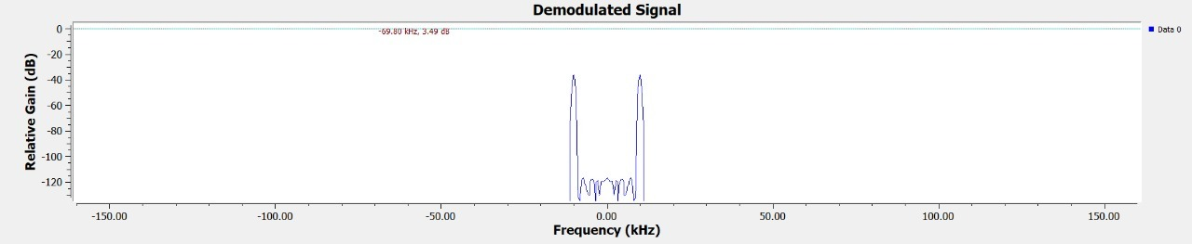

DSBFC GNU Flowchart

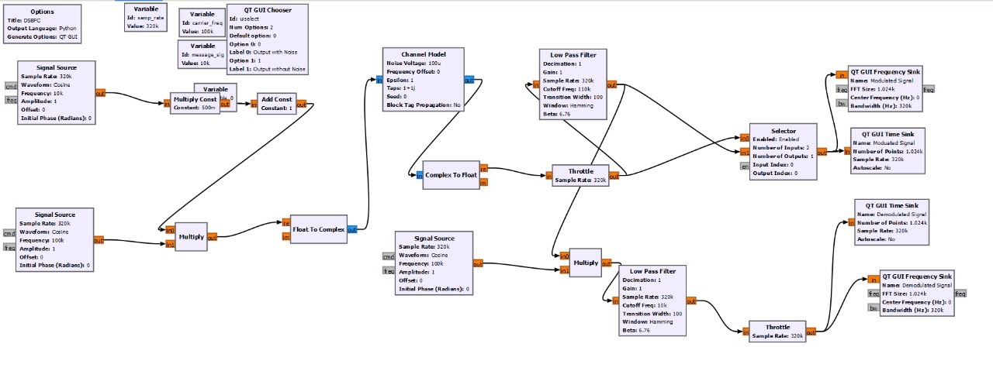

Output

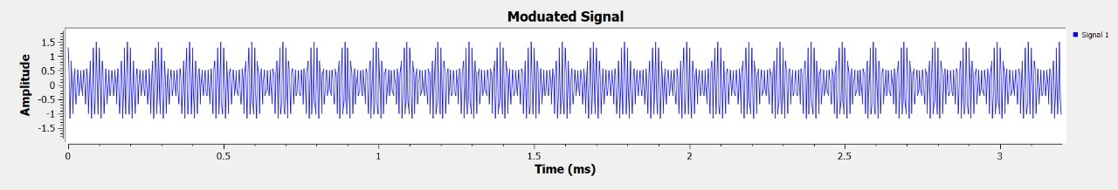

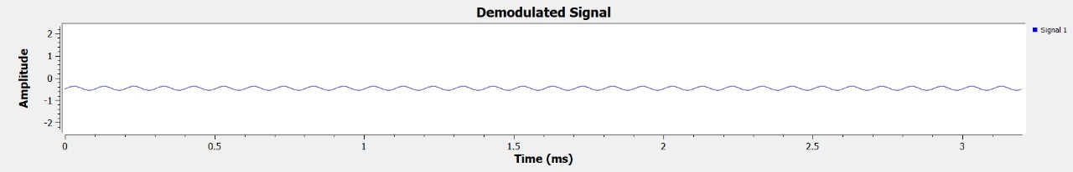

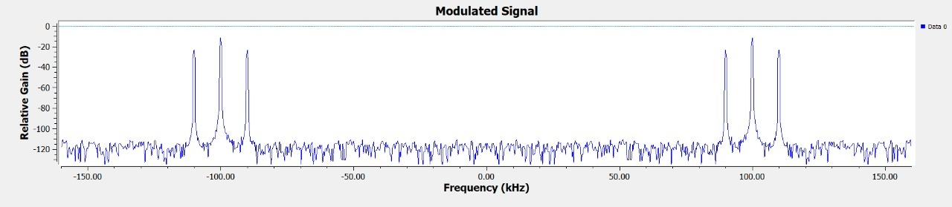

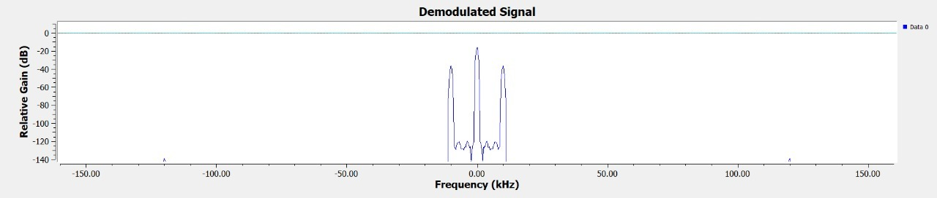

SSB GNU flowchart

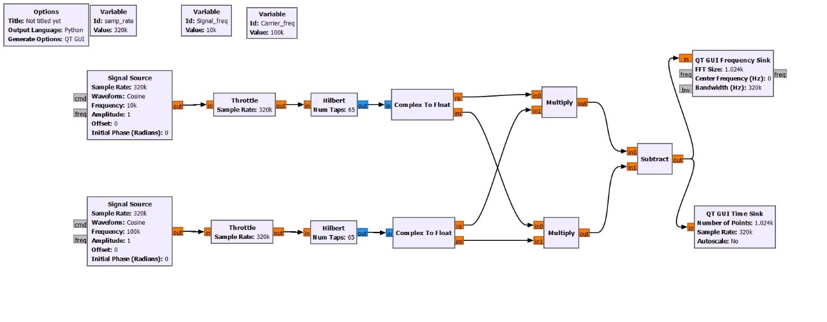

Output

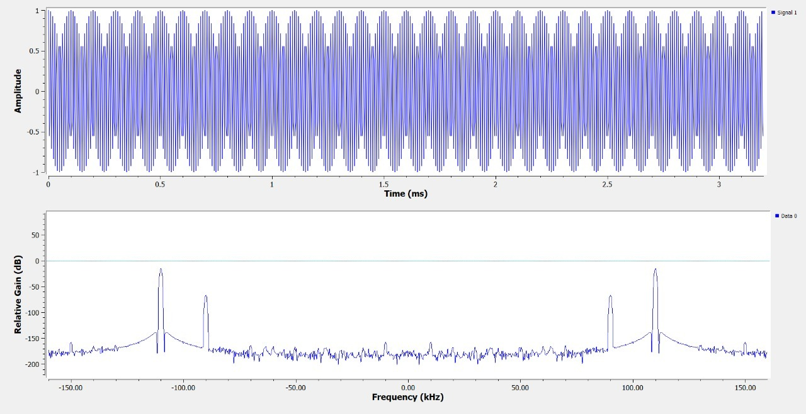

Analysis

Here we have done comparison between DSBSC ,DSBFC and SSB flowcharts in GNU ,

As we can see from the plots that ,in DSBSC the frequency of the modulated signal it has two side bands with full wave where as when we see in the DSBFC it has two side bands and a carrier wave and in SSB we have two side bands but in that one side band is suppressed and other is full.

When we come to the power consumption DSBFC will be needing more power than DSBSC because DSBFC is a full carrier and DSBSC is a suppressed carrier .