Ease Type

Ease Type is an online lightweight text-editor with spell checking and auto corrector functionality.

Usage:

To use need latest version of any Chromium or Firefox browser and at least a decent internet. As this pure JavaScript, this is completely dependent upon client-side internet and their facilities.

Open easetype.html through file explorer.

Default UI of Ease Type webpage:

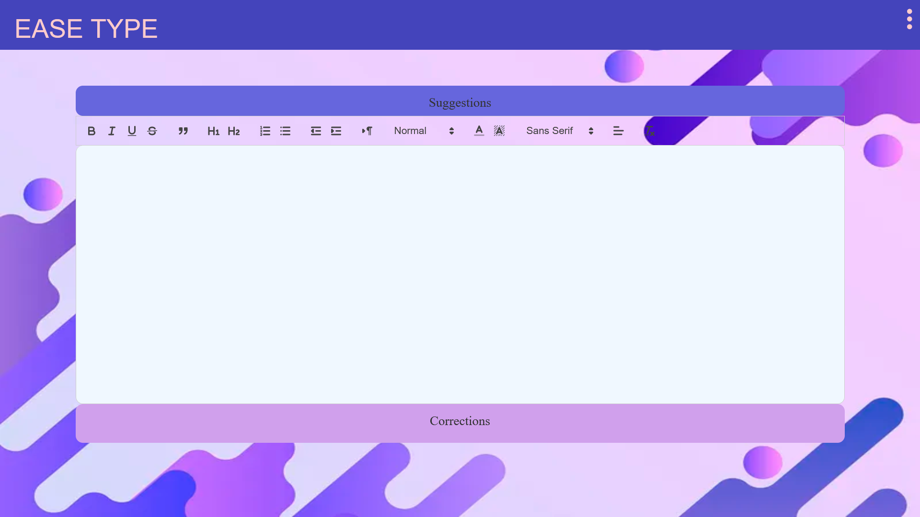

Suggestion box gives you suggestions while typing, you can click on the suggestions or use arrows ↑ and ↓ to navigate through the menu bar.

refer suggestions.gif in zip

Correction box gives you corrections for the wrong words when they are selected by dragging on or by double clicking on the wrong word. You can choose the appropriate word from the correction box below

refer corrections.gif in zip

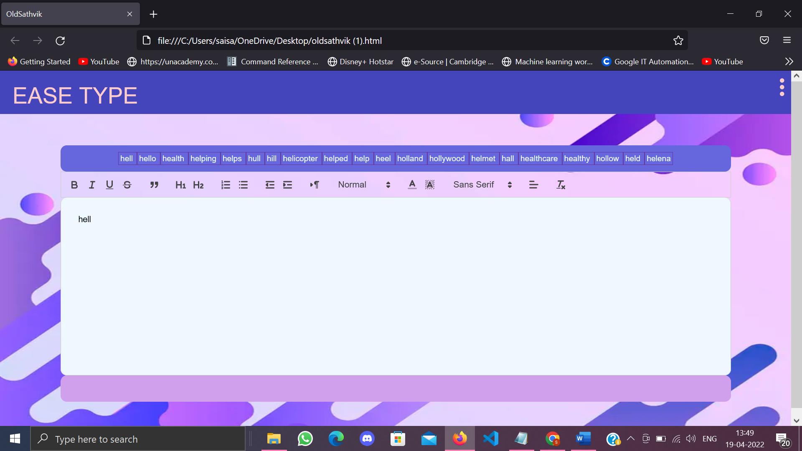

This is the tool bar when a word or a whole string is selected, you can modify it with Bold or Italic or Underline and can be aligned in your preference and size and color with your preferred and suggested font style.

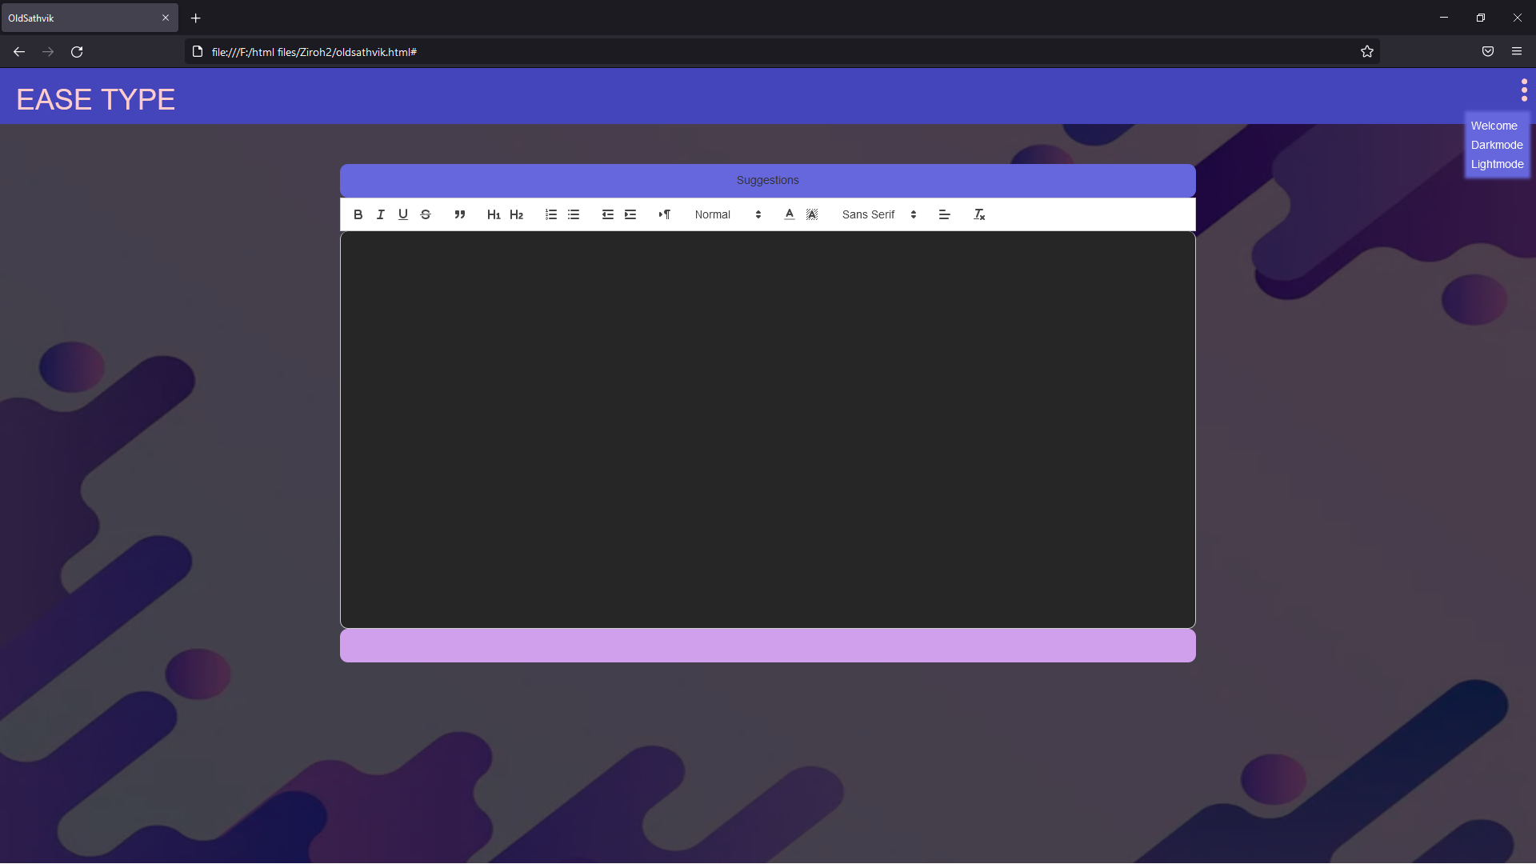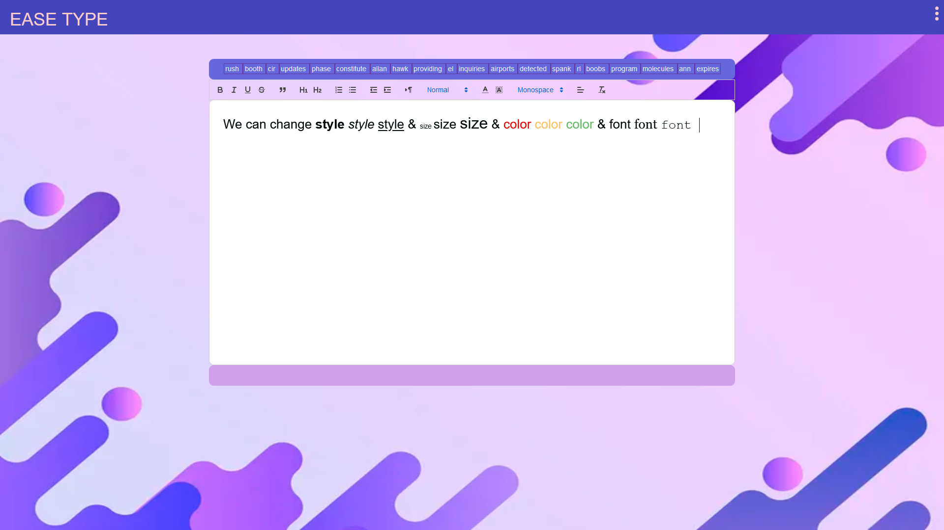

This is a dropdown bar which gives you direction link to welcome page and Dark mode is to darken the UI to make it night time friendly for user. Light mode is to Lighten the UI for most lit environments and for outdoor purposes.

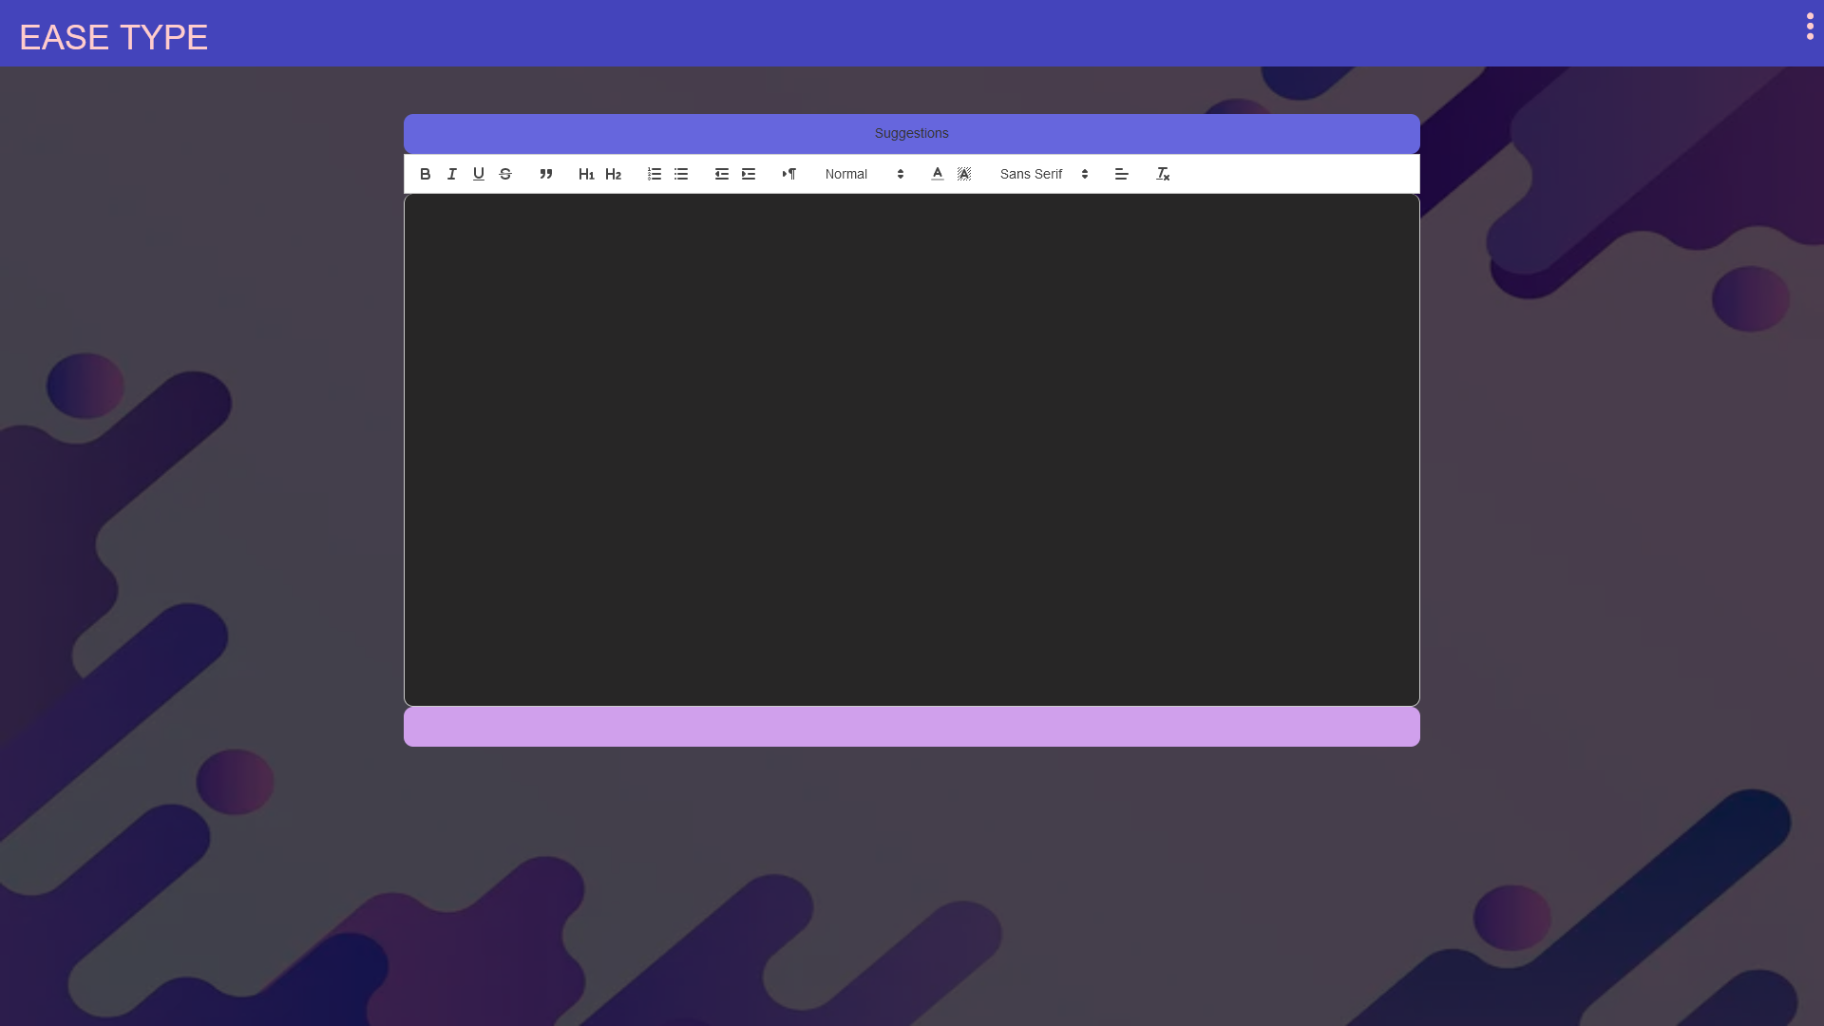

This is the UI at dark mode. Light mode is default UI.

Demo:

Text editor: easetype.html

Files required:

Every file provided

Tools used:

Visual studio code