Fractals

- A curve or geometrical figure, each part of which has the same statistical character as the whole.

- In fractals, similar patterns recur at progressively smaller scales, and in describing partly random or chaotic phenomena such as crystal growth and galaxy formation.

- A fractal has a Hausdorff dimension that is greater than its topological dimension (although this requirement is not met by space-filling curves such as the Hilbert curve).

Hausdorff dimension:

The Hausdorff dimension of the fractal is "log N / log L"

N identical parts that are similar to the entire fractal with the scale factor of L and that the intersection between part is of the Lebesgue measure.

Techniques to generate Fractals:

> Escape time fractals — These are defined by a recurrence relation at each point in a space (such as the complex plane). Examples of this type are the Mandelbrot set, Julia set, the Burning Ship fractal and the Lyapunov fractal.

> Iterated function systems — These have a fixed geometric replacement rule. Cantor set, Sierpinski carpet, Sierpinski gasket, Peano curve, Koch snowflake, Harter-Heighway dragon curve, T-Square, Menger sponge, are some examples of such fractals.

> Random fractals — Generated by stochastic rather than deterministic processes, for example, trajectories of the Brownian motion, Lévy flight, fractal landscapes and the Brownian tree. The latter yields so-called mass- or dendritic fractals, for example, diffusion-limited aggregation or reaction-limited aggregation clusters.

Classification of fractals:

> Exact self-similarity - The fractal appears identical at different scales
> Quasi-self-similarity - The fractal appears approximately (but not exactly) identical at different scales
> Statistical self-similarity - The fractal has numerical or statistical measures which are preserved across scales. statistically self-similar, but neither exactly nor quasi-self-similar.

Example for Mandelbrot Set:

- A Julia set, a fractal related to the Mandelbrot set.

- An interesting example is the Mandelbrot set.

- This set contains whole discs, so it has the "Hausdorff dimension equal to its topological dimension of 2" —but what is truly surprising is that the boundary of the Mandelbrot set also has the Hausdorff dimension of 2 (while the topological dimension of 1), a result proved by M. Shishikura in 1991. A closely related fractal is the Julia set.

Fractals in Heart rate:

- Heart rate in nature is found to be a quasi self-similar fractal (fractals appears to be approximate but not exact) like a mandelbrot set.

- They contain small copies of the entire fractal in distorted and degenerated forms.

- A qualitative appreciation for the self-similar nature of fractal processes can be obtained by plotting their fluctuations at different temporal resolutions

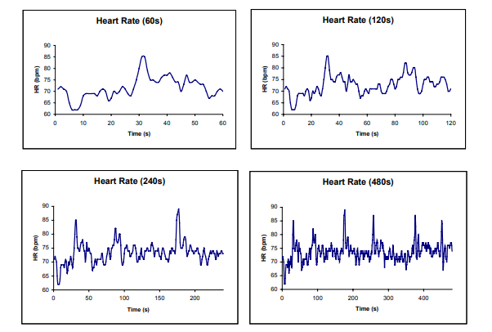

Here, we can prove the HRV is fractal in nature by the following metrics:

- Prove that the Heart Rate is a Quasi Fractal by segmenting the signals with time.
- Use the methods that are used for a mandelbrot set to prove that it is a quasi fractal.
- Relative Dispersion Analysis(RDA) and Detrended Fluctuation Analysis(DFA) of HRV signals are the methods used to prove quasi nature of a fractal.

References:

1. A qualitative appreciation for the self-similar nature of fractal processes can be obtained by plotting their fluctuations at different temporal resolutions by Nadezhda V. Zudilina (Nadiya V. Zudilina). UDC [114:117]::530.1

2. Fractals Analysis of Cardiac Arrhythmias by Mohammad Saeed. https://www.researchgate.net/publication/7606517_Fractals_Analysis_of_Cardiac_Arrhythmias

