Lab 4.pdf
Sathvik Sai Guntha
Jan 15th 2026
x <- 1:50
plot(x,sin(x))
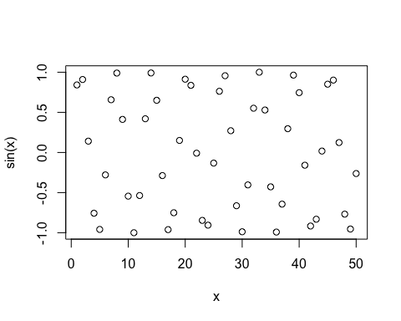
plot(x,sin(x), typ = "l", col="blue", lwd=2)
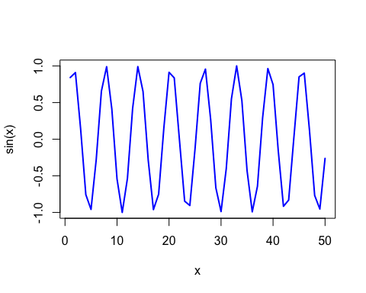
log(10, base = 10)
## [1] 1

