**3.2. MIMO – Multiple-Input and Multiple-Output**

Multiple-input and multiple-output, or MIMO is a method for multiplying the capacity of a radio link using multiple transmission and receiving antennas to exploit multipath propagation. Many modern telecommunications standards, particularly in the consumer space, have adopted MIMO technology because of the significant advantages it provides over similar system utilizing single antenna transceivers (SISO). A basic structure of a MIMO system is shown in Fig x.x (number to be edited later).

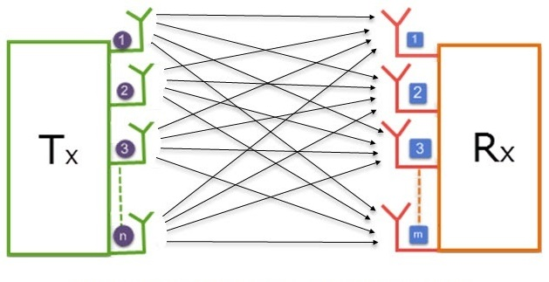

**Fig x.x:** **Basic** **structure of a MIMO system**

In conventional wireless communications, a single antenna is used at the source, and another single antenna is used at the destination. In some cases, this gives rise to problems with multipath effects. When an electromagnetic field is met with obstructions such as hills, canyons, buildings, and utility wires, the wavefronts are scattered, and thus they take many paths to reach the destination. The late arrival of scattered portions of the signal causes problems such as fading, cut-out (cliff effect), and intermittent reception (picket fencing). In digital communications systems such as wireless Internet, it can cause a reduction in data speed and an increase in the number of errors. The use of two or more antennas eliminates the trouble caused by multipath wave propagation, and can even take advantage of this effect.

MIMO has become an essential element of wireless communication standards including IEEE 802.11n (Wi-Fi), IEEE 802.11ac (Wi-Fi), HSPA+ (3G), WiMAX (4G), and Long Term Evolution (4G LTE). More recently, MIMO has been applied to power-line communication for 3-wire installations as part of ITU G.hn standard and HomePlug AV2 specification.

**3.2.1. MIMO Propagation and Channel Modeling**

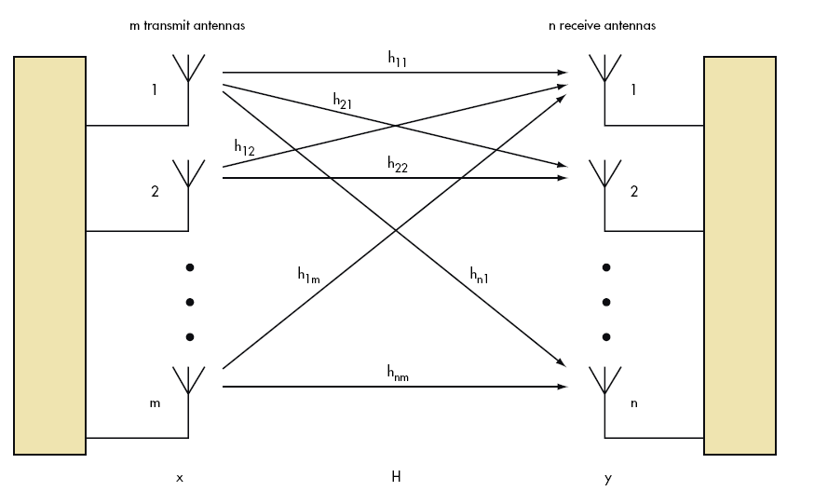

**Fig x.x: MIMO Channel Modeling**

In MIMO systems, a transmitter sends multiple streams by multiple transmit antennas. The transmit streams go through a matrix channel which consists of all *NtNr* paths between the *Nt*  transmit antennas at the transmitter and *Nr* receive antennas at the receiver. Then, the receiver gets the received signal vectors by the multiple receive antennas and decodes the received signal vectors into the original information.

A narrowband flat fading MIMO system is modeled as:

{\displaystyle \mathbf {y} =\mathbf {H} \mathbf {x} +\mathbf {n} } **y = Hx + n**

where **{\displaystyle \mathbf {y} }y** and **{\displaystyle \mathbf {x} }x** are the receive and transmit vectors, respectively, and **{\displaystyle \mathbf {H} }H** and **{\displaystyle \mathbf {n} }n** are the channel matrix and the noise vector, respectively.

The channel matrix **H** is given by



Where *hnm* is the channel co-efficient between *n*th receiving antenna and *m*th transmitting antenna.

**3.2.2. Diversity Schemes**

Diversity scheme refers to a method for improving the reliability of a message signal by using two or more communication channels with different characteristics. Diversity is mainly used in radio communication and is a common technique for combating fading and co-channel interference and avoiding error bursts.

It is based on the fact that individual channels experience different levels of fading and interference. Multiple versions of the same signal may be transmitted and/or received and combined in the receiver. Alternatively, a redundant forward error correction code may be added and different parts of the message transmitted over different channels.

Another important term that is commonly used while discussing diversity is **Diversity Order**. For a system transmitting over frequency selective fading channels, the diversity order can be defined as the number of multi-paths if multi-paths have all equal energy.

Diversity techniques may exploit the multipath propagation, resulting in a diversity gain, often measured in decibels. Some of the diversity techniques are:

**a. Time diversity**: Multiple versions of the same signal are transmitted at different time instants. Alternatively, a redundant forward error correction code is added and the message is spread in time by means of bit-interleaving before it is transmitted. Thus, error bursts are avoided, which simplifies the error correction.

**b. Frequency diversity**: The signal is transmitted using several frequency channels or spread over a wide spectrum that is affected by frequency-selective fading. Later examples include:

* + OFDM modulation in combination with subcarrier interleaving and forward error correction
  + Spread spectrum, for example frequency hopping or DS-CDMA.

**c. Space diversity**: The signal is transmitted over several different propagation paths. In the case of wired transmission, this can be achieved by transmitting via multiple wires. In the case of wireless transmission, it can be achieved by antenna diversity using multiple transmitter antennas (transmit diversity) and/or multiple receiving antennas (reception diversity). A detailed description of Space diversity is given later.

**d. Polarization diversity**: Multiple versions of a signal are transmitted and received via antennas with different polarization. A diversity combining technique is applied on the receiver side.

**e. Multiuser diversity**: Multiuser diversity is obtained by opportunistic user scheduling at either the transmitter or the receiver. Opportunistic user scheduling is as follows: at any given time, the transmitter selects the best user among candidate receivers according to the qualities of each channel between the transmitter and each receiver. A receiver must feed back the channel quality information to the transmitter using limited levels of resolution, in order for the transmitter to implement Multiuser diversity.

**f. Cooperative diversity**: Achieves antenna diversity gain by using the cooperation of distributed antennas belonging to each node.

Multipath propagation: Multipath propagation is an inherent feature of a mobile communications channel, results in a received signal that is dispersed in time. Each path has its own delay and the time dispersion leads to a form of intersymbol interference. The multipath channel is modeled by using channel co-efficient *h*.

MIMO may offer three different benefits, namely:

a. Beamforming gain

b. Spatial diversity

c. Spatial multiplexing

**3.2.2. Beamforming gain**

By beamforming, the transmit and receive antenna patterns can be focused into a specific angular direction by the appropriate choice of complex baseband antenna weights. The more correlated the antenna signals, the better for beamforming. Under Line of Sight (LOS) channel conditions, the Receiver Rx and Transmitter Tx gains may add up, leading to an upper limit of *m · n* for the beamforming gain of a MIMO system (n and m being the number of antenna elements of Rx and of Tx, respectively).

**Eigen-Beamforming** can be done at both the transmit side of a link and the receive side. Classical Beamforming is like using a high gain antenna, but one that need not be reoriented to point in different directions, Eigen-Beamforming achieves the same gain but is insensitive to antenna orientation or scattering elements in the vicinity of the antenna. MIMO Eigen-beamforming converts the signals from all of the antennas into the digital domain where sophisticated *Digital Signal Processing* (DSP) can be used. Eigen-Beamforming can thus in effect be done independently for each of the narrowband subcarriers of an *Orthogonal Frequency Division Multiplexing* (OFDM) system.

Eigen beamforming is not limited to forming a simple beam in three dimensional space. It is not adversely affected by scattering objects or multipath reflections. An Eigen beamformer receiving a signal in a non-line-of-sight (NLOS) situation with multiple reflections may form an effective antenna pattern that increases gain in multiple directions corresponding to the individual reflections. Using Digital Signal Processing, MIMO systems have the ability to adapt these patterns on a packet by packet basis.

**3.2.3. Spatial Diversity**

Spatial diversity used in this narrower sense often refers to transmit and receive diversity. These two methodologies are used to provide improvements in the signal to noise ratio and they are characterized by improving the reliability of the system with respect to the various forms of fading.

Multiple replicas of the radio signal from different directions in space give rise to spatial diversity, which can be used to increases the transmission reliability of the fading radio link. For a spatially white MIMO channel, that is, completely uncorrelated antenna signals, the diversity order is limited to *m · n*. Spatial correlation will reduce the diversity order and is therefore an important channel characteristic.

When multiple receiving antennas are used, a diversity combining technique is applied before further signal processing takes place. If the antennas are far apart, for example at different cellular base station sites or WLAN access points, this is called macrodiversity or site diversity. If the antennas are at a distance in the order of one wavelength, this is called microdiversity. A special case is phased antenna arrays, which also can be used for beamforming, MIMO channels and space–time coding (STC).

In simpler terms, spatial diversity increases the reliability and range since it is unlikely that all paths will be degraded simultaneously.

**3.2.4. Spatial Multiplexing**

This form of MIMO is used to provide additional data capacity by utilizing the different paths to carry additional traffic, i.e. increasing the data throughput capability. MIMO channels can support parallel data streams by transmitting and receiving on orthogonal spatial channels.

The number of usefully multiplexed streams depends on the rank of the instantaneous channel matrix **H**, which, in turn, depends on the spatial properties of the radio environment. The spatial multiplexing gain may reach *min(m, n)* in a sufficiently rich scattering environment. So we have to consider what sufficiently rich scattering means and what its relative importance compared to SNR is.

One of the techniques to achieve spatial multiplexing is by using Singular Value Decomposition (SVD).  Spatial multiplexing takes advantage of the differences in the channels between transmitting and receiving antenna pairs to provide multiple independent streams between the transmitting and receiving antennas, increasing throughput by sending data over parallel streams.  SVD decomposes the channel into multiple streams, where the number is the smaller of the number of transmitting or receiving antennas.  For scenarios such as 2x2 or 4x2 MIMO, for example, SVD can generate two independent streams, while for 4x4 MIMO, it can generate four streams, potentially quadrupling the throughput. In practice, the actual throughput will depend on how high of an SINR can be achieved in each of the streams.

In simpler terms, by using spatial multiplexing we can send independent streams of information in parallel along multiple spatial paths. This technique increases the rate of data transmission, if we can avoid interference.

// later part

**Advantages of a MIMO system:**

* A MIMO system provides better signal strength even without clear line-of-site as they utilize the bounced and reflected RF transmissions.
* The higher throughput allows better quality and quantity of video sent over the network.
* Multiple data streams reduces the number of lost data packets, which results in better video or audio quality.

Reference mimo magazine:

Ernst Bonek, Chapter 2 - MIMO Propagation and Channel Modeling, Editor(s): Alain Sibille, Claude Oestges, Alberto Zanella, MIMO, Academic Press, 2011, Pages 27-54, ISBN 9780123821942, https://doi.org/10.1016/B978-0-12-382194-2.00002-2.