Accessibility Audit Report

Target URL: https://www.brandience.com/connect

Methodology: axe-core baseline + semantic review (RAG).

# Overview

|  |  |  |  |
| --- | --- | --- | --- |
| Bucket | Count | AI Candidates | AI Verdicts |
| Violations | 8 |  |  |
| Incomplete | 2 |  |  |
| Passes | 36 |  |  |
| AI Candidates | 27 |  |  |
| AI Verdicts | 27 |  |  |

# Findings (AI verdicts)

## 1. SC-4.1.1 — duplicate-id

Selector: .form_field-wrapper.is-menu > .form_submit-button-wrapper > .form_arrow.w-embed > svg[height="18"][viewBox="0 0 24 18"][width="24"] > defs > clippath

Verdict: needs-change (confidence 0.8)

Reason: The id attribute 'clip0_2551_20294' is not unique, violating SC 4.1.1. This can lead to confusion in accessibility tools and is flagged by axe diagnostics.

Ref: https://dequeuniversity.com/rules/axe/4.7/duplicate-id?application=axeAPI

Screenshot:

(Could not embed image: — [Errno 13] Permission denied: '.')

Open full-size image

## 2. SC-4.1.1 — duplicate-id

Selector: .position-relative > .button-icon > .icon_pushdown.w-embed > svg[width="22"][height="17"] > defs > clippath

Verdict: needs-change (confidence 0.8)

Reason: The id attribute 'a' is not unique, leading to potential confusion in accessibility. This violates SC 4.1.1 as per axe diagnostics.

Ref: https://dequeuniversity.com/rules/axe/4.7/duplicate-id?application=axeAPI

Screenshot:

(Could not embed image: — [Errno 13] Permission denied: '.')

Open full-size image

## 3. SC-4.1.1 — duplicate-id

Selector: .newsletter-form_heading-wrapper > .newsletter-form_icon.is-footer.w-embed > svg[width="42"][height="42"][viewBox="0 0 42 42"] > defs > clippath

Verdict: needs-change (confidence 0.8)

Reason: The id 'clip0_2551_20926' is not unique, violating SC 4.1.1. This can lead to confusion in accessibility tools and is flagged by axe for duplicate-id.

Ref: https://dequeuniversity.com/rules/axe/4.7/duplicate-id?application=axeAPI

Screenshot:

(Could not embed image: — [Errno 13] Permission denied: '.')

Open full-size image

## 4. SC-4.1.2 — frame-title

Selector: iframe[width="100%"]

Verdict: needs-change (confidence 0.9)

Reason: The iframe lacks an accessible name (title, aria-label, or aria-labelledby), violating SC 4.1.2. AXE diagnostics indicate missing attributes for accessibility.

Ref: https://dequeuniversity.com/rules/axe/4.7/frame-title?application=axeAPI

Screenshot:



Open full-size image

## 5. SC-4.1.2 — input-button-name

Selector: .submit-button

Verdict: needs-change (confidence 0.9)

Reason: The input button has an empty value attribute and lacks an accessible name (aria-label or title), failing SC 4.1.2 requirements for discernible text.

Ref: https://dequeuniversity.com/rules/axe/4.7/input-button-name?application=axeAPI

Screenshot:



Open full-size image

## 6. SC-4.1.2 — input-button-name

Selector: .form_field-wrapper.is-footer > .form_submit-button-wrapper > .form_submit-button.w-button[data-wait=""]

Verdict: needs-change (confidence 0.9)

Reason: The input button has an empty value attribute, resulting in no discernible name, violating SC 4.1.2. AXE diagnostics indicate the element lacks an accessible name.

Ref: https://dequeuniversity.com/rules/axe/4.7/input-button-name?application=axeAPI

Screenshot:



Open full-size image

## 7. BEST_PRACTICE — landmark-no-duplicate-banner

Selector: .navbar_component

Verdict: needs-change (confidence 0.8)

Reason: The document has more than one banner landmark, violating the axe rule for duplicate banners. This indicates a structural issue that needs correction.

Ref: https://dequeuniversity.com/rules/axe/4.7/landmark-no-duplicate-banner?application=axeAPI

Screenshot:



Open full-size image

## 8. BEST_PRACTICE — landmark-one-main

Selector: html

Verdict: needs-change (confidence 0.8)

Reason: The document lacks a main landmark, which is essential for accessibility. This violates the guideline for having a clear main content area.

Ref: https://dequeuniversity.com/rules/axe/4.7/landmark-one-main?application=axeAPI

Screenshot:

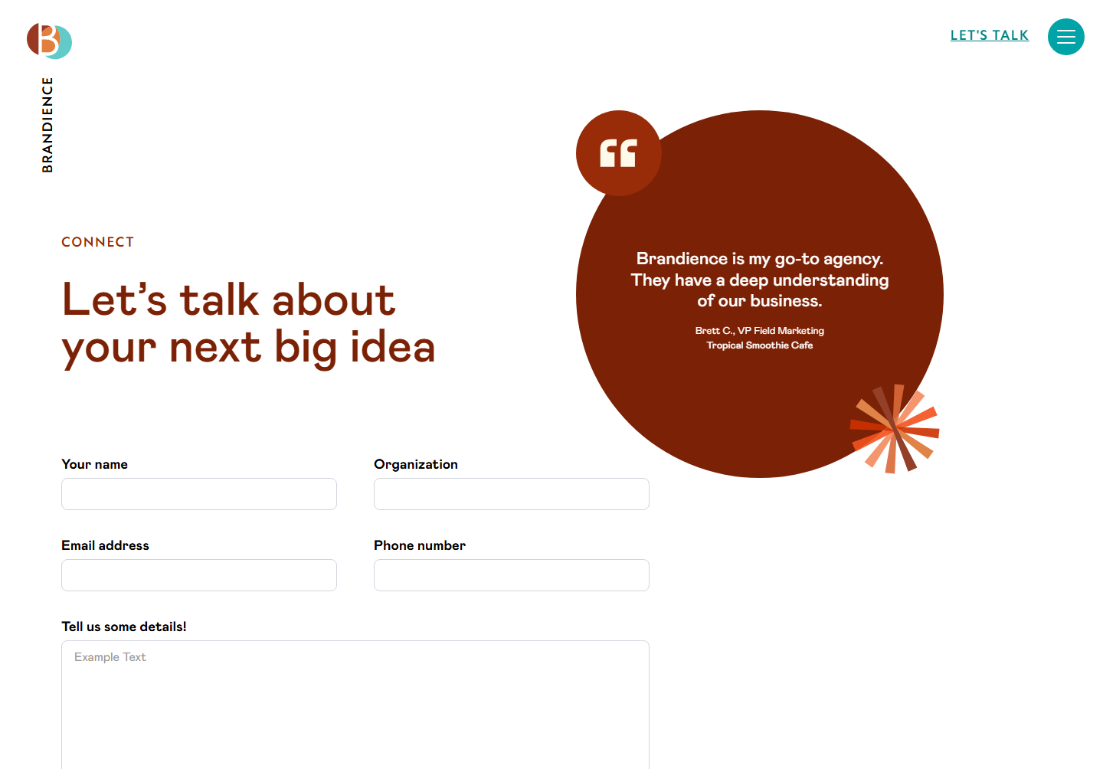

Open full-size image

## 9. BEST_PRACTICE — landmark-unique

Selector: .navbar_component

Verdict: needs-change (confidence 0.8)

Reason: The role 'banner' is not unique; it lacks a unique aria-label, aria-labelledby, or title, violating landmark uniqueness requirements.

Ref: https://dequeuniversity.com/rules/axe/4.7/landmark-unique?application=axeAPI

Screenshot:



Open full-size image

## 10. SC-4.1.2 — link-name

Selector: #w-node-_60edc9dd-e0e3-e27a-fc78-23f8f2b49fab-f2b49f79 > .social_iconlink.w-inline-block:nth-child(1)

Verdict: needs-change (confidence 0.9)

Reason: The link lacks discernible text for screen readers, failing SC 4.1.2. It has no accessible name, as indicated by the empty accessibility snapshot.

Ref: https://dequeuniversity.com/rules/axe/4.7/link-name?application=axeAPI

Screenshot:



Open full-size image

## 11. SC-4.1.2 — link-name

Selector: #w-node-_60edc9dd-e0e3-e27a-fc78-23f8f2b49fab-f2b49f79 > .social_iconlink.w-inline-block:nth-child(2)

Verdict: needs-change (confidence 0.9)

Reason: The link lacks discernible text for screen readers, failing SC 4.1.2. It has no accessible name, as indicated by the empty accessibility snapshot.

Ref: https://dequeuniversity.com/rules/axe/4.7/link-name?application=axeAPI

Screenshot:



Open full-size image

## 12. SC-4.1.2 — link-name

Selector: #w-node-_60edc9dd-e0e3-e27a-fc78-23f8f2b49fab-f2b49f79 > .social_iconlink.w-inline-block[href$="brandience"]

Verdict: needs-change (confidence 0.9)

Reason: The link lacks discernible text for screen readers, as it has no accessible name or aria-label, violating SC 4.1.2.

Ref: https://dequeuniversity.com/rules/axe/4.7/link-name?application=axeAPI

Screenshot:



Open full-size image

## 13. SC-4.1.2 — link-name

Selector: #w-node-_60edc9dd-e0e3-e27a-fc78-23f8f2b49fab-f2b49f79 > .social_iconlink.w-inline-block:nth-child(4)

Verdict: needs-change (confidence 0.9)

Reason: The link lacks an accessible name, as it has no visible text or aria-label, violating SC 4.1.2. AXE diagnostics confirm it is in tab order without accessible text.

Ref: https://dequeuniversity.com/rules/axe/4.7/link-name?application=axeAPI

Screenshot:



Open full-size image

## 14. BEST_PRACTICE — region

Selector: #w-node-cf3ed33f-bae7-cbe3-22b8-584f83498145-342c4d9e

Verdict: needs-change (confidence 0.8)

Reason: The content is not contained by landmarks, which violates the region SC. The div lacks a proper role or landmark designation.

Ref: https://dequeuniversity.com/rules/axe/4.7/region?application=axeAPI

Screenshot:



Open full-size image

## 15. BEST_PRACTICE — region

Selector: section:nth-child(6)

Verdict: needs-change (confidence 0.8)

Reason: The section lacks a proper landmark role, leading to content not being contained by landmarks, which violates SC 2.4.1.

Ref: https://dequeuniversity.com/rules/axe/4.7/region?application=axeAPI

Screenshot:



Open full-size image

## 16. BEST_PRACTICE — region

Selector: section:nth-child(8) > .padding-x-md > .container-large > .w-layout-grid.grid_2up > .image-wrapper

Verdict: needs-change (confidence 0.8)

Reason: The element lacks a meaningful role or accessible name, and it is not contained by landmarks, violating the region SC.

Ref: https://dequeuniversity.com/rules/axe/4.7/region?application=axeAPI

Screenshot:



Open full-size image

## 17. BEST_PRACTICE — region

Selector: #w-node-d43bd073-bb7c-e2db-05ed-864700448a7d-342c4d9e > .max-w-md

Verdict: needs-change (confidence 0.8)

Reason: The div with class 'max-w-md' lacks a landmark role, causing some content to be outside of landmarks, violating the axe rule for region.

Ref: https://dequeuniversity.com/rules/axe/4.7/region?application=axeAPI

Screenshot:



Open full-size image

## 18. BEST_PRACTICE — region

Selector: #w-node-d43bd073-bb7c-e2db-05ed-864700448a7d-342c4d9e > .margin-top-lg

Verdict: needs-change (confidence 0.8)

Reason: The content is not contained by landmarks, which violates the axe rule for region. This affects navigation and accessibility for users relying on assistive technologies.

Ref: https://dequeuniversity.com/rules/axe/4.7/region?application=axeAPI

Screenshot:



Open full-size image

## 19. BEST_PRACTICE — region

Selector: .align-left.button.w--current > .uppercase

Verdict: needs-change (confidence 0.7)

Reason: The element lacks a clear programmatic name and is not contained by landmarks, which violates SC 4.1.2. The opacity style also suggests it may not be perceivable.

Ref: https://dequeuniversity.com/rules/axe/4.7/region?application=axeAPI

Screenshot:



Open full-size image

## 20. SC-1.4.3 — color-contrast

Selector: .link_uppercase

Verdict: needs-change (confidence 0.8)

Reason: Computed contrast ratio for the link text 'LET'S TALK' is below the required threshold due to overlapping elements, as indicated by AXE diagnostics.

Ref: https://dequeuniversity.com/rules/axe/4.7/color-contrast?application=axeAPI

Screenshot:



Open full-size image

## 21. SC-1.4.3 — color-contrast

Selector: .quote_text_1

Verdict: needs-change (confidence 0.8)

Reason: Computed contrast for text in .quote_text_1 is below the required threshold due to overlapping elements, as indicated by AXE diagnostics.

Ref: https://dequeuniversity.com/rules/axe/4.7/color-contrast?application=axeAPI

Screenshot:



Open full-size image

## 22. SC-1.4.3 — color-contrast

Selector: .is-1 > .quote_source > .margin-y-none:nth-child(1)

Verdict: needs-change (confidence 0.8)

Reason: Computed contrast for text 'Brett C., VP Field Marketing' is below the required threshold due to overlapping elements, as indicated by AXE diagnostics.

Ref: https://dequeuniversity.com/rules/axe/4.7/color-contrast?application=axeAPI

Screenshot:



Open full-size image

## 23. SC-1.4.3 — color-contrast

Selector: .is-1 > .quote_source > .margin-y-none:nth-child(2) > strong

Verdict: needs-change (confidence 0.8)

Reason: Computed contrast for 'Tropical Smoothie Cafe' is below the required threshold due to overlapping elements, failing SC 1.4.3.

Ref: https://dequeuniversity.com/rules/axe/4.7/color-contrast?application=axeAPI

Screenshot:



Open full-size image

## 24. SC-1.4.3 — color-contrast

Selector: #Message-2

Verdict: needs-change (confidence 0.8)

Reason: Computed contrast for the placeholder text in the textarea is likely below 4.5:1 due to background obscuration, failing SC 1.4.3.

Ref: https://dequeuniversity.com/rules/axe/4.7/color-contrast?application=axeAPI

Screenshot:

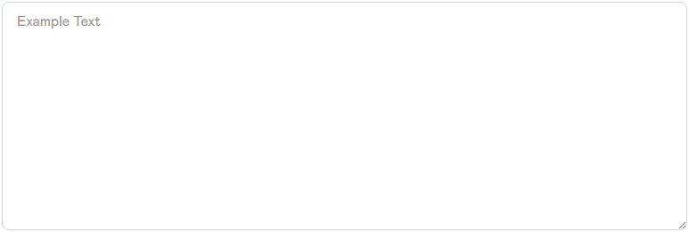

Open full-size image

## 25. SC-1.4.3 — color-contrast

Selector: .position-relative > .uppercase

Verdict: needs-change (confidence 0.7)

Reason: Computed contrast for 'Send Email' cannot be determined due to overlapping elements, likely failing SC 1.4.3.

Ref: https://dequeuniversity.com/rules/axe/4.7/color-contrast?application=axeAPI

Screenshot:



Open full-size image

## 26. BEST_PRACTICE — frame-tested

Selector: iframe[width="100%"]

Verdict: needs-change (confidence 0.8)

Reason: The iframe lacks an accessible name and needs to be tested with axe-core for compliance, indicating potential issues with SC 4.1.2.

Ref: https://dequeuniversity.com/rules/axe/4.7/frame-tested?application=axeAPI

Screenshot:



Open full-size image

## 27. SC-1.1.1 — image-alt

Selector: .image

Verdict: redundant-ok (confidence 0.9)

Reason: The alt text 'brandience logo' duplicates the purpose of the link, which is likely to navigate to the brand's homepage, making it redundant.

Ref: https://dequeuniversity.com/rules/axe/4.7/image-alt?application=axeAPI

Screenshot:



Open full-size image

Embedded screenshots: 24 of 27