Comparative Analysis of Fraud Detection Techniques in Digital Payment Systems
A Mini Project Report Submitted in partial fulfillment of the requirements for the award of the degree of

BACHELOR OF TECHNOLOGY
In

DEPARTMENT OF COMPUTER SCIENCE AND ENGINEERING
By
Nakshitha P. – 2420030025
Kayenat Zabeen – 2420030492
Sathvika P. – 2420030654
Under the Esteemed Guidance of
Dr. K. Swapnika
Project Supervisor, Department of Computer Science and Engineering





K L (Deemed to be) University

DEPARTMENT OF COMPUTER SCIENCE AND ENGINEERING

DECLARATION

The mini-project report entitled “Comparative Analysis of Fraud Detection Techniques in Digital Payment Systems” is a record of bona fide work carried out by Nakshitha P. - 2420030025, Kayenat Zabeen - 2420030492, Sathvika P. - 2420030654 in partial fulfillment of the requirements for the award of the B.Tech degree at K L (Deemed to be) University. The work presented in this report is original to the best of our knowledge, and all datasets, tools, code, and external sources used have been appropriately acknowledged.

Nakshitha P. – 2420030025
Kayenat Zabeen – 2420030492
Sathvika P. – 2420030654

K L (Deemed to be) University

DEPARTMENT OF COMPUTER SCIENCE AND ENGINEERING

CERTIFICATE

This is to certify that the mini-project report entitled “Comparative Analysis of Fraud Detection Techniques in Digital Payment Systems” is a bona fide work carried out by Nakshitha P. - 2420030025, Kayenat Zabeen - 2420030492, Sathvika P. - 2420030654 under the supervision of Dr. K. Swapnika during the academic year 2026–2027, in partial fulfillment of the requirements for the award of the Bachelor of Technology degree at K L (Deemed to be) University.

Signature of the Project Supervisor

Signature of the HOD Signature of the External Examiner

ACKNOWLEDGEMENT
The success of this project would not have been possible without the timely help and guidance of many people. We wish to express our sincere thanks to all those who assisted us in one way or another in completing this project.

Our greatest appreciation goes to our guide, Dr. K. Swapnika, Department of Computer Science and Engineering, whose tremendous support, encouragement and guidance for this project cannot be expressed in words.

We express our gratitude to Dr. P. Venkateshwar, Head of the Department of Computer Science and Engineering, for providing us with adequate facilities, ways and means by which we were able to complete this project-based lab.

We thank all the members of the teaching and non-teaching staff who assisted us directly or indirectly in the successful completion of this project. Finally, we sincerely thank our parents, friends and classmates for their kind help and cooperation during our work.

Nakshitha P. – 2420030025
Kayenat Zabeen – 2420030492
Sathvika P. – 2420030654

TABLE OF CONTENTS

S.No. | Contents | Page no.
1. | Abstract | 6
2. | Introduction | 8
3. | Literature survey | 9
4. | Problem Statement and Objectives | 11
5. | Hardware and Software requirements | 13
6. | Implementation | 14
7. | Results & Discussion | 16
8. | Conclusion & Future Scope | 25
9. | References | 26

ABSTRACT

Digital payment systems process large volumes of transactions, which makes fraud detection challenging because fraudulent transactions are rare, fraud patterns evolve, and transaction characteristics differ across platforms. This project presents a comparative study of machine-learning fraud-detection techniques on three datasets: the Credit Card Fraud dataset, the E-commerce Fraud dataset and the PaySim mobile-money dataset. The implemented workflow covers dataset loading and validation, missing-value, duplicate and target-column checks, preprocessing and feature preparation, and a stratified train-validation-test split in a 60:20:20 ratio. Class imbalance is examined using the original data, class weighting, SMOTE and controlled random undersampling at ratios of 1:20, 1:10, 1:5, 1:2 and 1:1, with resampling applied only to training data to prevent data leakage. Logistic Regression, Decision Tree, Random Forest, XGBoost and LightGBM are evaluated as baseline models, and a proposed stacking hybrid, with Random Forest and LightGBM as base learners and Logistic Regression as the meta-classifier, is compared against them. Decision thresholds are selected on validation data only, and models are assessed on an untouched test set using Precision, Recall, F1-score, PR-AUC, ROC-AUC, Matthews Correlation Coefficient, False Positive Rate, confusion matrices and training and inference time. SHAP-based interpretability, five-fold stability analysis and a Streamlit results dashboard are also implemented. The measured results show that performance and the effect of imbalance handling vary considerably across datasets, and no single model or strategy is declared universally superior.

Team Name: Batch - 15

Team Members and Responsibilities:

- Nakshitha P. - 2420030025: Joint project research, experimentation, analysis, and documentation.
- Kayenat Zabeen - 2420030492: Joint project research, experimentation, analysis, and documentation.
- Sathvika P. - 2420030654: Joint project research, experimentation, analysis, and documentation.
- Project repository: https://github.com/Sathvika45/KLH-CSE-2026-2420030654-Digital-Payment-Fraud-Detection
- Datasets: Credit Card Fraud (creditcard.csv, Kaggle MLG-ULB), E-commerce Fraud (Fraud_Data.csv with IpAddress_to_Country.csv) and PaySim (paysim.csv, Kaggle). Dataset versions, licences and access dates are to be recorded in the dataset documentation.

INTRODUCTION

Digital payment systems support online purchases, banking, money transfers, and other financial activities. Their high transaction volume and speed make manual inspection impractical. Fraudulent transactions usually form a small proportion of total activity, while fraud patterns and transaction characteristics can change across platforms. These conditions make automated and reliable fraud detection an important task.
This project compares machine-learning approaches for detecting fraudulent transactions across three datasets: Credit Card Fraud, E-commerce Fraud and PaySim. The intended users include students, researchers and practitioners studying fraud-detection methods. The input consists of transaction records with dataset-specific attributes and fraud labels; the output is a predicted legitimate or fraudulent class. The implemented pipeline covers dataset validation, preprocessing, class-imbalance handling, baseline model training, evaluation of a proposed stacking hybrid model, validation-based threshold selection, SHAP-based interpretability, stability analysis and a Streamlit dashboard for exploring the saved results. The remaining chapters present related work, objectives, requirements, implementation, results, conclusions and references.
Datasets Used
The project uses exactly three datasets. Their sizes and class distributions below are taken from the dataset-validation reports generated by the project code.
Table 2.1: Summary of the three datasets
Dataset | Source file(s) | Records | Fraud cases | Fraud rate | Remarks
Credit Card Fraud (MLG-ULB) | creditcard.csv | 284,807 | 492 | 0.1727% | 31 attributes (V1–V28 PCA features, Time, Amount, Class); 1,081 duplicate rows; no missing values
E-commerce Fraud | Fraud_Data.csv; IpAddress_to_Country.csv | 151,112 | 14,151 | 9.3646% | 12 attributes after IP-to-country mapping; no missing values or duplicate rows detected in the raw file
PaySim (mobile money, simulated) | paysim.csv | 6,362,620 | 8,213 | 0.1291% | 11 attributes; no missing values or duplicates; a stratified 100,000-record sample is used for model experiments

LITERATURE SURVEY
1. Bodepudi et al. (2025), “Comparative Analysis of Machine Learning Models for Fraudulent Banking Transactions”: Compared Random Forest, Neural Network, and Naive Bayes for banking fraud and considered imbalanced data. Limitation: limited model and dataset coverage.
2. IJERT (2025), “A Comprehensive Survey on Machine Learning for UPI and Telecom Fraud Detection”: Reviewed ML techniques for UPI and telecom fraud and discussed digital-payment fraud challenges. Limitation: mainly survey-based, with limited multi-dataset validation.
3. Springer (2024), “Scalable Fraud Detection in Mobile Payment Transactions”: Investigated ML for mobile-payment fraud with emphasis on scalability and practical use. Gap: computational efficiency and deployment need further evaluation.
4. ScienceDirect (2024), “Comparative Analysis of Machine Learning Algorithms and Data Balancing Techniques for Credit Card Fraud Detection”: Compared Logistic Regression, Decision Tree, SVM, Random Forest, and XGBoost with balancing methods. Limitation: specific dataset and balancing methods.
5. Akinnagbe & Akintayo (2025), “Machine Learning Impact on Digital Payment Fraud Detection”: Investigated ML and anomaly-detection approaches for digital-payment fraud. Gap: limited direct comparison of supervised and anomaly-based methods.
6. Dastidar, Caelen & Granitzer (2024), “A Survey of Machine Learning for Credit Card Fraud Detection”: Reviewed supervised, unsupervised, and hybrid approaches, including imbalance challenges. Limitation: no unified experimental comparison framework.
7. Mohaimin et al. (2024), “Comparative Analysis of Anomaly Detection Techniques for Credit Card Fraud”: Compared XGBoost, KNN, Random Forest, Isolation Forest, and SVM. Limitation: dataset-specific evaluation requires broader validation.
8. Springer (2025), “Comparative Analysis of Random Forest, SVM and ANN for Credit Card Fraud Detection”: Evaluated Random Forest, SVM, and ANN under balanced and imbalanced conditions. Gap: broader ML, ensemble, and deep-learning comparison.
9. ScienceDirect (2025), “An Extensive Experimental Comparison of Machine and Deep Learning Methods for Credit and Bank Fraud Detection”: Compared ML and DL methods across multiple datasets and metrics. Finding: performance varies by dataset and metric, supporting dataset-wise evaluation.
10. IEEE (2025/2026), “Comparative Analysis of Machine Learning Models, Deep Learning Models and Hybrid Models for Fraud Detection in Online Transactions”: Compared conventional ML, DL, and hybrid approaches. Limitation: hybrid models do not consistently outperform individual models.
Research gap: The project addresses limited cross-dataset evaluation, inconsistent analysis of class-imbalance strategies, insufficient unified comparison across model paradigms, and the need to evaluate hybrid models using performance, explainability, ablation, and computational-efficiency measures.

PROBLEM STATEMENT AND OBJECTIVES

Problem Statement:
Digital payment systems generate large volumes of transactions, making fraud detection challenging because of highly imbalanced data, evolving fraud patterns, and varying transaction characteristics across datasets; therefore, a systematic framework is needed to compare detection techniques and evaluate their predictive performance, explainability, and computational efficiency.

Problem Description:
Fraudulent transactions are rare, and a model may appear accurate while failing to detect a meaningful share of fraud cases. Model performance can also vary across datasets. This project studies these challenges through controlled imbalance experiments and cross-dataset evaluation using consistent metrics.

Objectives:
The project objectives are as follows:
- Obtain, validate and inspect three digital-payment fraud datasets (Credit Card Fraud, E-commerce Fraud and PaySim); document their source, size, fields and class distribution.
- Prepare the data through missing-value, duplicate and target-column checks and dataset-specific feature preparation, without introducing data leakage.
- Create stratified 60:20:20 train-validation-test splits and apply imbalance handling (class weighting, SMOTE and controlled random undersampling at 1:20, 1:10, 1:5, 1:2 and 1:1) to training data only.
- Train and compare the baseline models: Logistic Regression, Decision Tree, Random Forest, XGBoost and LightGBM.
- Develop and evaluate a proposed stacking hybrid (Random Forest and LightGBM base learners with a Logistic Regression meta-classifier) and compare it with the baseline models.
- Evaluate models using Precision, Recall, F1-score, PR-AUC, ROC-AUC, MCC, FPR, confusion matrices and training and inference time, with decision thresholds selected on validation data only.
- Analyse explainability (SHAP and feature importance) and stability, discuss errors and limitations, and provide a Streamlit dashboard to explore the saved results.

HARDWARE AND SOFTWARE REQUIREMENTS
Hardware Requirements:
- Computer or laptop with a modern multi-core CPU; 8 GB RAM or more is recommended (the PaySim file is about 470 MB).
- Internet access for downloading datasets and Python packages; a GPU is not required because only classical machine-learning models are used.
- Sufficient disk space for the raw datasets (creditcard.csv about 144 MB, paysim.csv about 471 MB), saved model files and result reports.
Software Requirements:
- Python 3.10 or later, with Visual Studio Code as the development environment.
- Libraries used in the project code: NumPy, Pandas, scikit-learn, imbalanced-learn, XGBoost, LightGBM, SHAP, Joblib, Matplotlib, Seaborn, Plotly and Streamlit. SciPy and pytest are also listed in requirements.txt, but no import of either was found in the supplied scripts.
- Datasets in CSV format (creditcard.csv, Fraud_Data.csv with IpAddress_to_Country.csv, and paysim.csv) placed in data/raw/; source and licence details are recorded in the dataset documentation.
- Git and GitHub for version control. A Streamlit dashboard (dashboard.py) is implemented for exploring saved results; Jupyter Notebook, Google Colab, TensorFlow and PyTorch are not used.

IMPLEMENTATION
- Data and task: Transaction-level binary classification of legitimate and fraudulent activity using the Credit Card Fraud dataset (creditcard.csv, 284,807 records), the E-commerce Fraud dataset (Fraud_Data.csv, 151,112 records, with IP addresses mapped to countries using IpAddress_to_Country.csv) and the PaySim dataset (paysim.csv, 6,362,620 records; a stratified 100,000-record sample is used for the model experiments). All experiments use a stratified 60:20:20 train-validation-test split with random seed 42.
- Data preparation and features: Each dataset is loaded and validated, and missing values, duplicate rows and the target column are checked. Duplicates are removed in memory so the raw files are never modified. Feature preparation is dataset-specific: E-commerce account-age and purchase-time features are derived and raw identifiers, IP addresses and date strings are removed; PaySim customer identifiers and the rule-based isFlaggedFraud field are removed; Credit Card features are kept. Numeric imputation, RobustScaler and categorical encoding are fitted on training data only, and resampling is applied only to training data to avoid leakage.
- Model training and evaluation: Logistic Regression, Decision Tree, Random Forest (100 trees), XGBoost and LightGBM are trained as baselines under the same split and protocol. Imbalance strategies (original data, class weighting, SMOTE and random undersampling at 1:20, 1:10, 1:5, 1:2 and 1:1) are evaluated with Random Forest. The proposed hybrid is a scikit-learn StackingClassifier with Random Forest and LightGBM base learners and a Logistic Regression meta-classifier trained on 3-fold cross-validated predicted probabilities. Decision thresholds are selected on the validation set and applied unchanged to the test set.
- Project workflow and modules
• Data loading and validation (src/data): loader.py loads each dataset and maps E-commerce IP addresses to countries; validator.py validates the target column, counts missing values and duplicates and quantifies class imbalance; analysis.py generates the dataset reports.
• Preprocessing and splitting (src/preprocessing): features.py prepares dataset-specific features; split.py audits duplicates, prepares the data and creates the stratified 60:20:20 split with an integrity check for index overlap and class-ratio preservation.
• Imbalance handling (src/preprocessing/imbalance.py, src/models/imbalance_experiment.py): original data, class weighting, SMOTE and RandomUnderSampler inside imbalanced-learn pipelines, so resampling runs only when the pipeline is fitted on training data.
• Evaluation (src/evaluation/metrics.py): computes Precision, Recall, F1-score, PR-AUC (average precision), ROC-AUC, MCC, FPR and confusion-matrix counts, and selects the threshold on validation predictions.
- Machine-learning implementation
  - Baseline models (src/models/baselines.py, workflow.py): Logistic Regression, Decision Tree, Random Forest, XGBoost and LightGBM are trained with an original-imbalance configuration (no class weighting or resampling) and compared under identical splits and evaluation. These are the baseline models.
    - Proposed hybrid model (src/models/hybrid_workflow.py): a stacking ensemble in which Random Forest and LightGBM are the base learners and Logistic Regression is the meta-classifier. It is evaluated separately from the baselines and compared with them in the Results chapter. Supporting scripts: hybrid_ablation.py, paysim_ablation.py, stability_analysis.py, interpretability.py and the PaySim LightGBM sweep scripts.
  - C. Results dashboard (Streamlit)
    - The Streamlit application (dashboard.py) loads the saved result files and shows five tabs: Baseline Comparison, Imbalance Analysis, Hybrid Analysis, Stability Analysis and Interpretability, with dataset selection and a choice between default and validation-tuned thresholds. No prediction API is implemented.
Implementation Status
Implemented and producing saved results: dataset validation and duplicate analysis; stratified 60:20:20 splitting; class weighting, SMOTE and random undersampling experiments; five baseline models on all three datasets; the stacking hybrid on all three datasets; hybrid ablation (Credit Card and PaySim); five-fold stability analysis; Random Forest feature importance and SHAP analysis on the Credit Card dataset; PaySim LightGBM weighting sweeps; and the Streamlit dashboard.
Not implemented in the current repository: statistical significance testing of the hybrid against the baselines, probability calibration, cross-validated hyperparameter search, SHAP analysis for the E-commerce and PaySim datasets, experiments on the full PaySim file, and a prediction API. These items are treated as future work.

RESULTS AND DISCUSSION
This chapter reports the measured outputs saved by the project code (results/reports). All values are single-run results on a stratified 60:20:20 split with random seed 42; no value has been estimated or edited. Decision thresholds were selected on the validation set and applied unchanged to the test set (“tuned threshold”); results at the default threshold of 0.50 are available in the result files. PR-AUC is computed as average precision. FPR is reported as a percentage. Accuracy is not reported because it is misleading on highly imbalanced data and is not computed by the project code.
7.1 Dataset Summary and Data Splits
Table 2.1 summarises the three datasets. Figures 7.1 to 7.3 show their class distributions, and Table 7.1 gives the stratified split sizes used in the experiments.
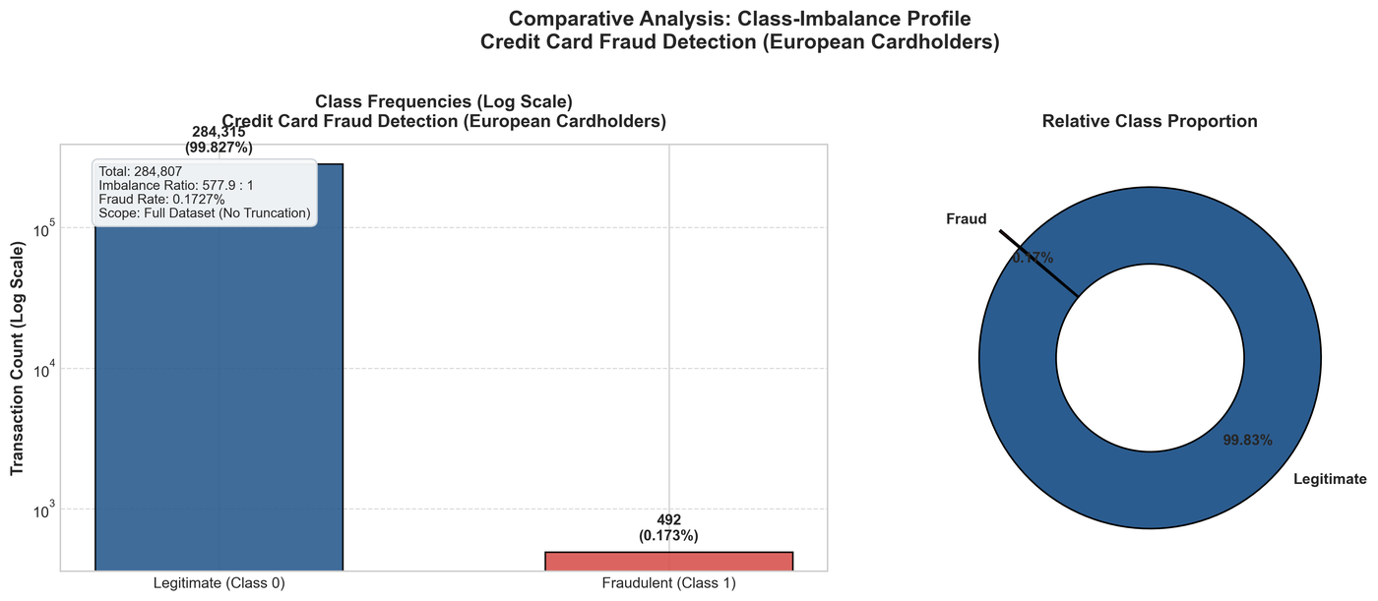
Figure 7.1: Class distribution of the Credit Card Fraud dataset (284,807 records; 492 fraud)
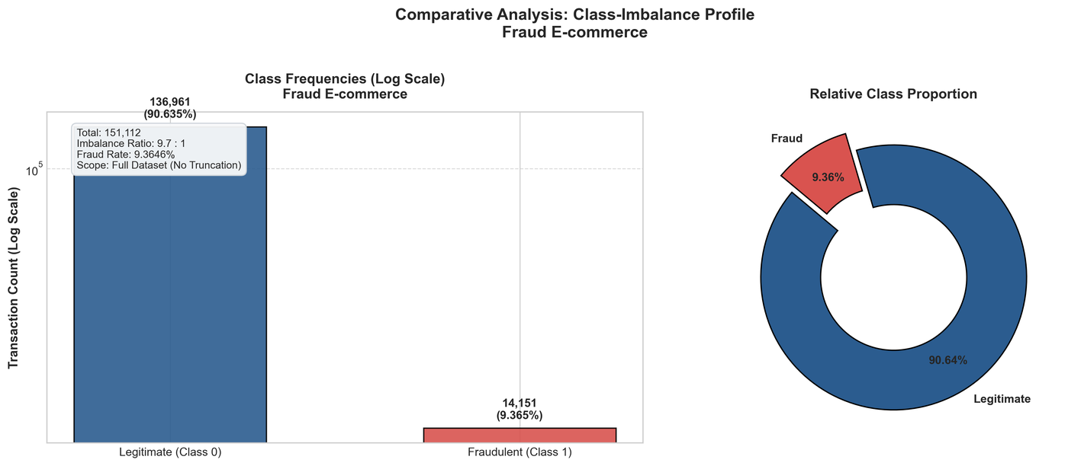
Figure 7.2: Class distribution of the E-commerce Fraud dataset (151,112 records; 14,151 fraud)
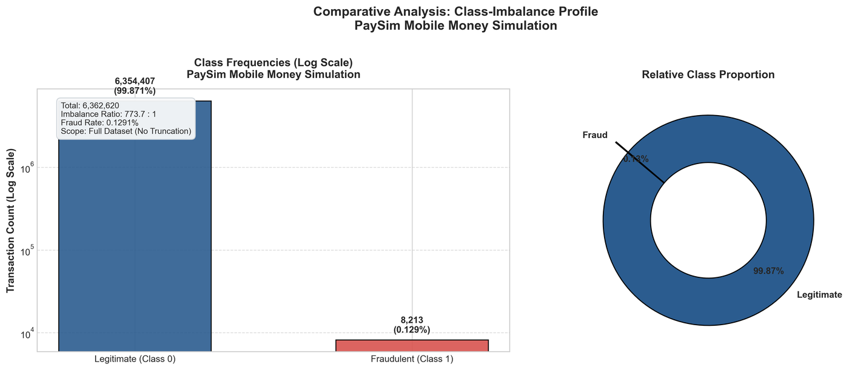
Figure 7.3: Class distribution of the PaySim dataset (6,362,620 records; 8,213 fraud)
Table 7.1: Stratified 60:20:20 split sizes (fraud counts in brackets where recorded)
Dataset / experiment | Training (fraud) | Validation (fraud) | Test (fraud)
Credit Card (all experiments) | 170,235 (284) | 56,745 (94) | 56,746 (95)
E-commerce (baseline and hybrid experiments) | 86,563 | 28,855 | 28,855 (1,462)
E-commerce (imbalance experiments) | 90,667 (8,491) | 30,222 (2,830) | 30,223 (2,830)
PaySim, 100,000-record sample (all experiments) | 60,000 (77) | 20,000 (26) | 20,000 (26)

Note: the baseline and hybrid experiments use 144,273 prepared E-commerce rows, whereas the imbalance experiments use all 151,112 rows with no duplicates removed. The results from the two E-commerce set-ups are therefore not directly comparable (see Section 7.10). PaySim results come from a 100,000-record stratified sample, which contains only 26 fraud cases in the test set, so PaySim metrics are subject to high variance.
7.2 Baseline Model Comparison (Dataset-wise)
Tables 7.2 to 7.4 compare the five baseline models on the untouched test set at the validation-tuned threshold. The baseline models are Logistic Regression, Decision Tree, Random Forest, XGBoost and LightGBM, each trained on the original (imbalanced) training data. The proposed hybrid is reported separately in Section 7.4.
Table 7.2: Baseline models – Credit Card dataset (test set, validation-tuned threshold θ)
Model | θ | Prec. | Recall | F1 | PR-AUC | ROC-AUC | MCC | FPR (%) | Train (s) | Inf. (ms/1k)
Logistic Regression | 0.08 | 0.7957 | 0.7790 | 0.7872 | 0.7447 | 0.9678 | 0.7869 | 0.0335 | 1.135 | 0.51
Decision Tree (CART) | 0.34 | 0.8795 | 0.7684 | 0.8202 | 0.6852 | 0.8630 | 0.8218 | 0.0177 | 7.562 | 0.57
Random Forest | 0.38 | 0.9744 | 0.8000 | 0.8786 | 0.8420 | 0.9720 | 0.8827 | 0.0035 | 21.997 | 1.79
XGBoost | 0.34 | 0.9500 | 0.8000 | 0.8686 | 0.8468 | 0.9784 | 0.8716 | 0.0071 | 2.205 | 0.81
LightGBM | 0.99 | 0.2752 | 0.6316 | 0.3834 | 0.2189 | 0.7860 | 0.4155 | 0.2789 | 1.525 | 1.30

Table 7.3: Baseline models – E-commerce dataset (test set, validation-tuned threshold θ)
Model | θ | Prec. | Recall | F1 | PR-AUC | ROC-AUC | MCC | FPR (%) | Train (s) | Inf. (ms/1k)
Logistic Regression | 0.06 | 0.0671 | 0.2716 | 0.1077 | 0.0630 | 0.5369 | 0.0381 | 20.1365 | 0.256 | 1.07
Decision Tree (CART) | 0.51 | 0.9686 | 0.1053 | 0.1900 | 0.1568 | 0.5607 | 0.3115 | 0.0183 | 0.427 | 1.03
Random Forest | 0.44 | 1.0000 | 0.1053 | 0.1906 | 0.1711 | 0.5594 | 0.3171 | 0.0000 | 1.474 | 2.81
XGBoost | 0.17 | 0.5714 | 0.1094 | 0.1837 | 0.1306 | 0.5527 | 0.2351 | 0.4381 | 0.481 | 1.82
LightGBM | 0.11 | 0.6385 | 0.1088 | 0.1859 | 0.1764 | 0.5569 | 0.2501 | 0.3286 | 0.504 | 1.79

Table 7.4: Baseline models – PaySim dataset (test set, validation-tuned threshold θ)
Model | θ | Prec. | Recall | F1 | PR-AUC | ROC-AUC | MCC | FPR (%) | Train (s) | Inf. (ms/1k)
Logistic Regression | 0.08 | 0.5667 | 0.6539 | 0.6071 | 0.6979 | 0.9986 | 0.6081 | 0.0651 | 0.108 | 0.55
Decision Tree (CART) | 0.04 | 0.8947 | 0.6539 | 0.7556 | 0.6260 | 0.9906 | 0.7646 | 0.0100 | 0.286 | 0.56
Random Forest | 0.12 | 0.7143 | 0.7692 | 0.7407 | 0.8194 | 0.9981 | 0.7409 | 0.0401 | 0.919 | 2.13
XGBoost | 0.28 | 0.9474 | 0.6923 | 0.8000 | 0.8615 | 0.9994 | 0.8097 | 0.0050 | 0.249 | 0.79
LightGBM | 0.99 | 0.1500 | 0.1154 | 0.1304 | 0.0316 | 0.5067 | 0.1306 | 0.0851 | 0.316 | 0.95

Credit Card: XGBoost obtained the highest PR-AUC (0.8468), followed by Random Forest (0.8420); Random Forest had the highest tuned F1-score (0.8786) and MCC (0.8827). Logistic Regression reached a PR-AUC of 0.7447. LightGBM, in its default configuration, performed much worse (PR-AUC 0.2189, MCC 0.4155).
E-commerce: all five models showed weak discrimination (ROC-AUC between 0.54 and 0.56 and PR-AUC at most 0.18). The tree-based models reached very high precision but recalled only about 10–11% of fraud cases. Logistic Regression recalled more fraud (27%) at the cost of a 20.1% false positive rate.
PaySim: XGBoost obtained the highest PR-AUC (0.8615), followed by Random Forest (0.8194). LightGBM in its default configuration was close to random ranking (ROC-AUC 0.5067). Because the test set contains only 26 fraud cases, a single additional detected or missed case changes recall by about 3.8 percentage points.
These are single-split measurements without confidence intervals or significance tests; small differences between models should not be interpreted as a reliable ranking.
7.3 Class-Imbalance Strategy Comparison
The imbalance strategies were evaluated using Random Forest. Each strategy was applied to training data only; validation and test data kept their natural class distribution. Tables 7.5 to 7.7 report the results at the validation-tuned threshold. For the E-commerce dataset, the 1:20 and 1:10 ratios are not applicable because the requested minority-to-majority ratio is not greater than the natural training ratio (about 1:10.6).
Table 7.5: Imbalance strategies with Random Forest – Credit Card dataset (test set, tuned threshold)
Strategy | θ | Prec. | Recall | F1 | PR-AUC | ROC-AUC | MCC | FPR (%) | Train (s)
Original | 0.38 | 0.9494 | 0.7895 | 0.8621 | 0.8443 | 0.9778 | 0.8655 | 0.0071 | 29.015
Class weighting | 0.40 | 0.8605 | 0.7790 | 0.8177 | 0.8291 | 0.9702 | 0.8184 | 0.0212 | 15.013
SMOTE 1:20 | 0.56 | 0.9610 | 0.7790 | 0.8605 | 0.8606 | 0.9821 | 0.8650 | 0.0053 | 27.588
Undersampling 1:20 | 0.79 | 0.9136 | 0.7790 | 0.8409 | 0.8216 | 0.9711 | 0.8433 | 0.0124 | 0.902
SMOTE 1:10 | 0.59 | 0.9610 | 0.7790 | 0.8605 | 0.8618 | 0.9846 | 0.8650 | 0.0053 | 27.667
Undersampling 1:10 | 0.80 | 0.8387 | 0.8210 | 0.8298 | 0.8208 | 0.9746 | 0.8296 | 0.0265 | 0.669
SMOTE 1:5 | 0.61 | 0.8810 | 0.7790 | 0.8268 | 0.8337 | 0.9880 | 0.8281 | 0.0177 | 28.715
Undersampling 1:5 | 0.86 | 0.8706 | 0.7790 | 0.8222 | 0.8030 | 0.9766 | 0.8232 | 0.0194 | 0.548
SMOTE 1:2 | 0.68 | 0.8452 | 0.7474 | 0.7933 | 0.8348 | 0.9889 | 0.7945 | 0.0229 | 36.213
Undersampling 1:2 | 0.88 | 0.8333 | 0.7895 | 0.8108 | 0.7510 | 0.9778 | 0.8108 | 0.0265 | 0.473
SMOTE 1:1 | 0.85 | 0.8947 | 0.7158 | 0.7953 | 0.8258 | 0.9896 | 0.8000 | 0.0141 | 49.818
Undersampling 1:1 | 0.87 | 0.8280 | 0.8105 | 0.8192 | 0.7305 | 0.9807 | 0.8189 | 0.0282 | 0.451

Table 7.6: Imbalance strategies with Random Forest – E-commerce dataset (test set, tuned threshold)
Strategy | θ | Prec. | Recall | F1 | PR-AUC | ROC-AUC | MCC | FPR (%) | Train (s)
Original | 0.51 | 1.0000 | 0.5385 | 0.7000 | 0.6342 | 0.7802 | 0.7169 | 0.0000 | 1.835
Class weighting | 0.75 | 1.0000 | 0.5375 | 0.6992 | 0.6360 | 0.7765 | 0.7162 | 0.0000 | 2.041
SMOTE 1:20 | N/A | N/A | N/A | N/A | N/A | N/A | N/A | N/A | N/A
Undersampling 1:20 | N/A | N/A | N/A | N/A | N/A | N/A | N/A | N/A | N/A
SMOTE 1:10 | N/A | N/A | N/A | N/A | N/A | N/A | N/A | N/A | N/A
Undersampling 1:10 | N/A | N/A | N/A | N/A | N/A | N/A | N/A | N/A | N/A
SMOTE 1:5 | 0.61 | 1.0000 | 0.5385 | 0.7000 | 0.6327 | 0.7724 | 0.7169 | 0.0000 | 4.923
Undersampling 1:5 | 0.55 | 1.0000 | 0.5367 | 0.6986 | 0.6341 | 0.7782 | 0.7157 | 0.0000 | 1.258
SMOTE 1:2 | 0.70 | 0.9980 | 0.5385 | 0.6996 | 0.6333 | 0.7718 | 0.7161 | 0.0110 | 5.712
Undersampling 1:2 | 0.64 | 1.0000 | 0.5385 | 0.7000 | 0.6352 | 0.7823 | 0.7169 | 0.0000 | 0.873
SMOTE 1:1 | 0.75 | 0.9974 | 0.5389 | 0.6997 | 0.6321 | 0.7709 | 0.7161 | 0.0146 | 7.131
Undersampling 1:1 | 0.72 | 0.9974 | 0.5389 | 0.6997 | 0.6335 | 0.7743 | 0.7161 | 0.0146 | 0.785

Table 7.7: Imbalance strategies with Random Forest – PaySim dataset (test set, tuned threshold)
Strategy | θ | Prec. | Recall | F1 | PR-AUC | ROC-AUC | MCC | FPR (%) | Train (s)
Original | 0.13 | 0.6897 | 0.7692 | 0.7273 | 0.8101 | 0.9984 | 0.7280 | 0.0451 | 1.089
Class weighting | 0.44 | 0.8571 | 0.6923 | 0.7660 | 0.7696 | 0.9979 | 0.7701 | 0.0150 | 0.891
SMOTE 1:20 | 0.67 | 0.9474 | 0.6923 | 0.8000 | 0.7927 | 0.9979 | 0.8097 | 0.0050 | 1.081
Undersampling 1:20 | 0.55 | 0.8696 | 0.7692 | 0.8163 | 0.8705 | 0.9995 | 0.8176 | 0.0150 | 0.270
SMOTE 1:10 | 0.73 | 0.9444 | 0.6539 | 0.7727 | 0.7757 | 0.9979 | 0.7856 | 0.0050 | 1.163
Undersampling 1:10 | 0.64 | 0.9500 | 0.7308 | 0.8261 | 0.8513 | 0.9994 | 0.8330 | 0.0050 | 0.238
SMOTE 1:5 | 0.69 | 0.6207 | 0.6923 | 0.6545 | 0.7481 | 0.9978 | 0.6551 | 0.0551 | 1.438
Undersampling 1:5 | 0.80 | 0.8261 | 0.7308 | 0.7755 | 0.7918 | 0.9987 | 0.7767 | 0.0200 | 0.226
SMOTE 1:2 | 0.87 | 0.7083 | 0.6539 | 0.6800 | 0.6837 | 0.9965 | 0.6802 | 0.0350 | 1.743
Undersampling 1:2 | 0.86 | 0.9412 | 0.6154 | 0.7442 | 0.8096 | 0.9988 | 0.7608 | 0.0050 | 0.223
SMOTE 1:1 | 0.89 | 0.6250 | 0.5769 | 0.6000 | 0.6546 | 0.9957 | 0.6000 | 0.0451 | 2.792
Undersampling 1:1 | 0.95 | 0.5600 | 0.5385 | 0.5490 | 0.5974 | 0.9966 | 0.5485 | 0.0551 | 0.242

Credit Card: PR-AUC ranged from 0.7305 to 0.8618. SMOTE at 1:10 gave the highest value (0.8618) compared with 0.8443 for the original data, while stronger undersampling lowered PR-AUC (0.7305 at 1:1). At the default threshold, aggressive undersampling sharply increased false alarms (precision 0.0758 and FPR 1.83% at 1:1); validation-based threshold tuning largely compensated for this.
PaySim: undersampling at 1:20 gave the highest PR-AUC (0.8705) versus 0.8101 for the original data; SMOTE and undersampling at higher ratios reduced PR-AUC, with undersampling at 1:1 the lowest (0.5974).
E-commerce: PR-AUC stayed between 0.632 and 0.636 across all applicable strategies, so imbalance handling had almost no effect in this set-up.
7.4 Proposed Hybrid Model Evaluation
The proposed stacking hybrid uses Random Forest and LightGBM as base learners and Logistic Regression as the meta-classifier (3-fold cross-validated stacking). Table 7.8 gives its test-set results at the default and the validation-tuned threshold.
Table 7.8: Proposed stacking hybrid (RF + LightGBM base learners, Logistic Regression meta-classifier) – test set
Dataset | Threshold | θ | Prec. | Recall | F1 | PR-AUC | ROC-AUC | MCC | FPR (%)
Credit Card | Default | 0.50 | 0.7105 | 0.8526 | 0.7751 | 0.8397 | 0.9714 | 0.7779 | 0.0583
Credit Card | Validation-tuned | 1.0000 | 0.9744 | 0.8000 | 0.8786 | 0.8397 | 0.9714 | 0.8827 | 0.0035
E-commerce | Default | 0.50 | 0.1865 | 0.1395 | 0.1596 | 0.1754 | 0.5571 | 0.1229 | 3.2490
E-commerce | Validation-tuned | 0.9946 | 1.0000 | 0.1047 | 0.1895 | 0.1754 | 0.5571 | 0.3160 | 0.0000
PaySim | Default | 0.50 | 0.2987 | 0.8846 | 0.4466 | 0.8323 | 0.9980 | 0.5131 | 0.2704
PaySim | Validation-tuned | 0.9997 | 0.9444 | 0.6538 | 0.7727 | 0.8323 | 0.9980 | 0.7856 | 0.0050

Table 7.9: Ablation – base learners versus the stacking hybrid (test set, tuned threshold)
Dataset | Model | Prec. | Recall | F1 | PR-AUC | MCC | FPR (%) | Inf. (ms/1k)
Credit Card | Random Forest | 0.9744 | 0.8000 | 0.8786 | 0.8420 | 0.8827 | 0.0035 | 1.84
Credit Card | LightGBM | 0.3295 | 0.6000 | 0.4254 | 0.2189 | 0.4434 | 0.2048 | 1.55
Credit Card | Stacking Hybrid | 0.9744 | 0.8000 | 0.8786 | 0.8397 | 0.8827 | 0.0035 | 2.91
PaySim | Random Forest | 0.7407 | 0.7692 | 0.7547 | 0.8193 | 0.7545 | 0.0350 | 12.50
PaySim | LightGBM | 0.1765 | 0.1154 | 0.1395 | 0.0316 | 0.1418 | 0.0701 | 2.10
PaySim | RF + LightGBM Stacking | 0.9474 | 0.6923 | 0.8000 | 0.8404 | 0.8097 | 0.0050 | 6.91

Compared with the best baseline PR-AUC on each dataset, the hybrid was close to but did not exceed it in these experiments: 0.8397 versus 0.8468 (XGBoost) on Credit Card, 0.1754 versus 0.1764 (LightGBM) on E-commerce and 0.8323 versus 0.8615 (XGBoost) on PaySim. On Credit Card, the hybrid’s tuned confusion matrix (76 TP, 2 FP, 19 FN) was identical to that of Random Forest alone. In the PaySim ablation script, stacking reached a PR-AUC of 0.8404 compared with 0.8194 for Random Forest and 0.0316 for LightGBM; the slightly different PaySim hybrid value in Table 7.8 (0.8323) comes from a separate run of the hybrid workflow. The hybrid also had the longest training time (Section 7.8). Therefore, these results do not show a measured improvement of the hybrid over the individual models. A supplementary soft-voting RF + LightGBM script on the Credit Card dataset (not the proposed hybrid) gave PR-AUC 0.6856, precision 0.9683 and recall 0.6421.
7.5 Stability Analysis
Stability was assessed with five-fold stratified cross-validation, comparing Random Forest with the stacking hybrid (mean ± standard deviation across folds; default decision threshold, no threshold tuning). Table 7.10 shows the results.
Table 7.10: Five-fold stability of Random Forest and the stacking hybrid
Dataset | Model | Precision | Recall | F1 | PR-AUC | Train time (s)
Credit Card | Random Forest | 0.944 ± 0.021 | 0.774 ± 0.036 | 0.850 ± 0.018 | 0.830 ± 0.024 | 37.7 ± 8.7
Credit Card | Stacking Hybrid | 0.354 ± 0.086 | 0.715 ± 0.056 | 0.469 ± 0.083 | 0.711 ± 0.030 | 122.1 ± 25.2
E-commerce | Random Forest | 1.000 ± 0.000 | 0.537 ± 0.007 | 0.699 ± 0.006 | 0.631 ± 0.005 | 5.4 ± 5.8
E-commerce | Stacking Hybrid | 0.991 ± 0.004 | 0.537 ± 0.007 | 0.697 ± 0.006 | 0.631 ± 0.005 | 16.7 ± 7.8
PaySim | Random Forest | 0.958 ± 0.044 | 0.683 ± 0.093 | 0.795 ± 0.062 | 0.809 ± 0.070 | 6.1 ± 6.2
PaySim | Stacking Hybrid | 0.282 ± 0.041 | 0.838 ± 0.078 | 0.421 ± 0.046 | 0.800 ± 0.058 | 23.8 ± 23.6

On E-commerce the two models were almost identical. On Credit Card and PaySim the hybrid had lower mean F1-score than Random Forest (0.469 versus 0.850, and 0.421 versus 0.795), mainly because of lower precision at the default threshold, and it required roughly three to four times the training time. Standard deviations across folds were small for ROC-AUC on all datasets but larger for precision and recall on PaySim, which has few fraud cases.
7.6 Explainability (Feature Importance and SHAP)
SHAP (TreeSHAP) and impurity-based feature importance were computed for the Random Forest model on the Credit Card dataset only; no interpretability result is claimed for the other datasets. Features V14, V17, V12, V10 and V16 are the five most influential features under both measures (Table 7.11, Figures 7.4 and 7.5). Because V1–V28 are anonymised PCA components, these features cannot be mapped to business attributes, and SHAP values describe model behaviour rather than causation.
Table 7.11: Top-5 features for Random Forest on the Credit Card dataset
Rank | Feature | Impurity importance | Mean |SHAP|
1 | V14 | 0.1563 | 0.0533
2 | V17 | 0.1482 | 0.0445
3 | V12 | 0.1307 | 0.0388
4 | V10 | 0.0869 | 0.0224
5 | V16 | 0.0837 | 0.0183

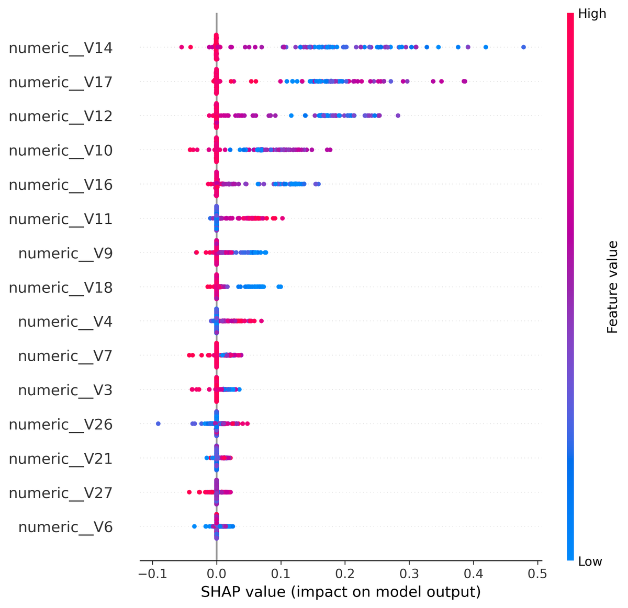
Figure 7.4: SHAP summary plot for Random Forest (Credit Card dataset)
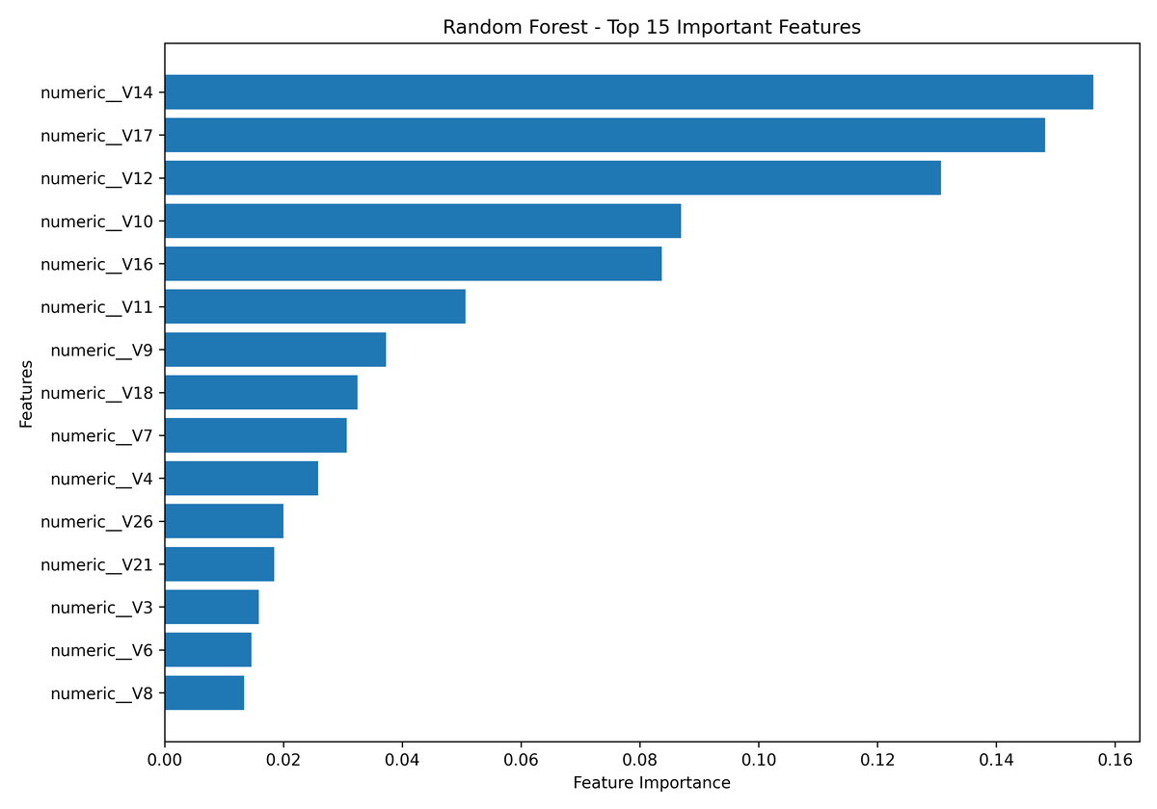
Figure 7.5: Random Forest feature importance (Credit Card dataset)
7.7 Confusion Matrices and Performance Graphs
Table 7.12 lists the confusion-matrix counts on the test set at the validation-tuned threshold for all baseline models and the hybrid. Confusion-matrix heat maps and precision-recall / ROC curve plots are not among the saved result files and are listed below as placeholders.
Table 7.12: Test-set confusion-matrix counts (validation-tuned threshold)
Dataset | Model | TP | FP | FN | TN
Credit Card | Logistic Regression | 74 | 19 | 21 | 56,632
Credit Card | Decision Tree (CART) | 73 | 10 | 22 | 56,641
Credit Card | Random Forest | 76 | 2 | 19 | 56,649
Credit Card | XGBoost | 76 | 4 | 19 | 56,647
Credit Card | LightGBM | 60 | 158 | 35 | 56,493
Credit Card | Proposed stacking hybrid | 76 | 2 | 19 | 56,649
E-commerce | Logistic Regression | 397 | 5,516 | 1,065 | 21,877
E-commerce | Decision Tree (CART) | 154 | 5 | 1,308 | 27,388
E-commerce | Random Forest | 154 | 0 | 1,308 | 27,393
E-commerce | XGBoost | 160 | 120 | 1,302 | 27,273
E-commerce | LightGBM | 159 | 90 | 1,303 | 27,303
E-commerce | Proposed stacking hybrid | 153 | 0 | 1,309 | 27,393
PaySim | Logistic Regression | 17 | 13 | 9 | 19,961
PaySim | Decision Tree (CART) | 17 | 2 | 9 | 19,972
PaySim | Random Forest | 20 | 8 | 6 | 19,966
PaySim | XGBoost | 18 | 1 | 8 | 19,973
PaySim | LightGBM | 3 | 17 | 23 | 19,957
PaySim | Proposed stacking hybrid | 17 | 1 | 9 | 19,973
7.8 Execution Time and Computational Efficiency
Table 7.13 reports training time and inference time per 1,000 transactions, as measured in the project runs (Credit Card: full dataset; PaySim: 100,000-record sample). Timings depend on the machine and on run conditions, so they indicate relative cost only.
Table 7.13: Training and inference time (CC = Credit Card, EC = E-commerce, PS = PaySim)
Model | CC train (s) | CC inf. (ms/1k) | EC train (s) | EC inf. (ms/1k) | PS train (s) | PS inf. (ms/1k)
Logistic Regression | 1.14 | 0.51 | 0.26 | 1.07 | 0.11 | 0.55
Decision Tree (CART) | 7.56 | 0.57 | 0.43 | 1.03 | 0.29 | 0.56
Random Forest | 22.00 | 1.79 | 1.47 | 2.81 | 0.92 | 2.13
XGBoost | 2.21 | 0.81 | 0.48 | 1.82 | 0.25 | 0.79
LightGBM | 1.52 | 1.30 | 0.50 | 1.79 | 0.32 | 0.95
Proposed stacking hybrid | 120.24 | 4.78 | 5.90 | 5.20 | 3.22 | 4.40

Logistic Regression and the Decision Tree were the cheapest at inference, while the hybrid was the most expensive to train on every dataset (120.2 s on Credit Card against 22.0 s for Random Forest). Random Forest and XGBoost training times on Credit Card were 22.0 s and 2.2 s respectively, which shows the cost of the ensemble models without a clear accuracy benefit on that dataset in these runs.
7.9 Cross-Dataset Comparison and Discussion
Table 7.14: Cross-dataset summary (test set, tuned threshold)
Dataset | Fraud rate (full data) | Best baseline PR-AUC (model) | Hybrid PR-AUC | Best baseline MCC (model) | Hybrid MCC
Credit Card | 0.17% | 0.8468 (XGBoost) | 0.8397 | 0.8827 (Random Forest) | 0.8827
E-commerce | 9.36% | 0.1764 (LightGBM) | 0.1754 | 0.3171 (Random Forest) | 0.3160
PaySim | 0.13% | 0.8615 (XGBoost) | 0.8323 | 0.8097 (XGBoost) | 0.7856

Model behaviour differed strongly between datasets. PR-AUC values of about 0.83–0.86 were reached on Credit Card and PaySim by Random Forest, XGBoost and the hybrid, but all models were weak on the E-commerce dataset (PR-AUC below 0.18 in the baseline and hybrid experiments). The reasons were not investigated; differences in feature informativeness, in data origin (PaySim is simulated) and in data preparation may all contribute. LightGBM underperformed on Credit Card and PaySim in its default configuration; in a supplementary PaySim sweep, adding class weighting (scale_pos_weight = 10) raised its PR-AUC from 0.0316 to 0.3643, which is still below Random Forest and XGBoost. Overall, the experiments show that no single model, imbalance strategy or the hybrid is best on every dataset, and that metrics other than accuracy are needed to expose these differences.
7.10 Limitations of the Current Results
• All results are from a single stratified split with random seed 42, without confidence intervals or statistical tests; only the Random Forest and hybrid models have five-fold results.
• PaySim experiments use a 100,000-record sample with 26 fraud cases in the test set, so PaySim metrics are unstable; full-dataset runs have not been performed.
• The baseline models use fixed configurations without cross-validated hyperparameter tuning, and LightGBM’s default configuration performed poorly on two datasets.
• Baseline and imbalance experiments produce slightly different Random Forest values on Credit Card (PR-AUC 0.8420 and 0.8443) and very different values on E-commerce (0.1711 and 0.6342), because they use different data preparation and runs.
• SHAP analysis is available for Random Forest on the Credit Card dataset only.

CONCLUSION AND FUTURE SCOPE
This project implemented and evaluated a comparative framework for fraud detection in digital payment systems using the Credit Card Fraud, E-commerce Fraud and PaySim datasets. The implemented workflow includes dataset validation, duplicate and missing-value checks, stratified 60:20:20 splitting, training-only handling of class imbalance (class weighting, SMOTE and random undersampling at five ratios), five baseline models, a proposed stacking hybrid of Random Forest, LightGBM and Logistic Regression, validation-based threshold selection, and evaluation with Precision, Recall, F1-score, PR-AUC, ROC-AUC, MCC, FPR, confusion matrices and execution time. SHAP-based interpretability, five-fold stability analysis and a Streamlit dashboard were also implemented. The measured results show that performance depends strongly on the dataset: Random Forest, XGBoost and the hybrid achieved PR-AUC of about 0.83–0.86 on Credit Card and PaySim, while all models performed poorly on the E-commerce dataset. In these experiments the hybrid did not exceed the best individual model, so the project does not claim a performance improvement from the hybrid approach. The conclusions are limited by single-split evaluation, the use of a 100,000-record PaySim sample, fixed model configurations, and an unresolved difference in E-commerce data preparation between experiments.

Future work includes verifying and unifying the E-commerce data preparation, running PaySim on the full dataset, repeating experiments over multiple seeds with statistical significance tests, cross-validated hyperparameter optimisation (including LightGBM), probability calibration, extending SHAP analysis to all datasets and to the hybrid model, monitoring changing fraud patterns (data drift), and evaluating real-time inference latency and deployment feasibility.

REFERENCES

- Bodepudi et al. (2025). “Comparative Analysis of Machine Learning Models for Fraudulent Banking Transactions.” Full publication metadata and URL were not supplied in Review-1.
2. IJERT (2025). “A Comprehensive Survey on Machine Learning for UPI and Telecom Fraud Detection.” Full publication metadata and URL were not supplied in Review-1.
3. Springer (2024). “Scalable Fraud Detection in Mobile Payment Transactions.” Full publication metadata and URL were not supplied in Review-1.
4. ScienceDirect (2024). “Comparative Analysis of Machine Learning Algorithms and Data Balancing Techniques for Credit Card Fraud Detection.” Full publication metadata and URL were not supplied in Review-1.
5. Akinnagbe & Akintayo (2025). “Machine Learning Impact on Digital Payment Fraud Detection.” Full publication metadata and URL were not supplied in Review-1.
6. Dastidar, Caelen & Granitzer (2024). “A Survey of Machine Learning for Credit Card Fraud Detection.” Full publication metadata and URL were not supplied in Review-1.
7. Mohaimin et al. (2024). “Comparative Analysis of Anomaly Detection Techniques for Credit Card Fraud.” Full publication metadata and URL were not supplied in Review-1.
8. Springer (2025). “Comparative Analysis of Random Forest, SVM and ANN for Credit Card Fraud Detection.” Full publication metadata and URL were not supplied in Review-1.
9. ScienceDirect (2025). “An Extensive Experimental Comparison of Machine and Deep Learning Methods for Credit and Bank Fraud Detection.” Full publication metadata and URL were not supplied in Review-1.
10. IEEE (2025/2026). “Comparative Analysis of Machine Learning Models, Deep Learning Models and Hybrid Models for Fraud Detection in Online Transactions.” Full publication metadata and URL were not supplied in Review-1.
Dataset documentation: Credit Card Fraud (MLG-ULB), Kaggle, https://www.kaggle.com/datasets/mlg-ulb/creditcardfraud ; PaySim, Kaggle, https://www.kaggle.com/datasets/ealaxi/paysim1 ; Lopez-Rojas, E. A., Elmir, A. and Axelsson, S. (2016), “PaySim: A financial mobile money simulator for fraud detection,” European Modeling and Simulation Symposium (EMSS) – publication details to be verified; E-commerce Fraud (Fraud_Data.csv and IpAddress_to_Country.csv) – source URL, version, licence and access dates to be added. Dataset versions, licences and access dates are to be recorded for all three datasets.
Software documentation: scikit-learn, https://scikit-learn.org/stable/ ; imbalanced-learn, https://imbalanced-learn.org/stable/ ; XGBoost, https://xgboost.readthedocs.io/ ; LightGBM, https://lightgbm.readthedocs.io/ ; SHAP, https://shap.readthedocs.io/ ; Streamlit, https://docs.streamlit.io/ .

