CAPSTONE PROJECT REPORT
BLUESTOCK MUTUAL FUND
ANALYTICS DASHBOARD
Mutual Fund Analytics using Python, SQL & Power BI
Submitted by
Sathvika Naik
Course: Data Analytics Capstone
Date: July 2026
TOOLS USED
Python • Pandas • NumPy • SQLite • SQL • Power BI • Matplotlib • Jupyter Notebook

Table of Contents
1. Introduction 3
2. Objectives 3
3. Technology Stack 3
4. Dataset Description 4
5. ETL Pipeline 4
6. SQLite Database 4
7. Exploratory Data Analysis 5
8. Performance Analytics 7
9. Power BI Dashboard 8
9.1 Page 1: Industry Overview 8
9.2 Page 2: Fund Performance 9
9.3 Page 3: Investor Analytics 9
9.4 Page 4: SIP & Market Trends 10
10. Advanced Analytics 11
10.1 Historical Value at Risk (VaR) 11
10.2 Rolling Sharpe Ratio 11
10.3 Investor Cohort Analysis 11
10.4 SIP Continuity Analysis 11
10.5 Fund Recommendation System 11
10.6 Sector Concentration (HHI) 11
11. Key Findings 12
12. Challenges Faced 12
13. Conclusion 13
14. Future Scope 13
Appendix 14
A.1 Folder Structure 14
A.2 SQL Queries 14
A.3 Data Dictionary 14
A.4 GitHub Repository 14

1. Introduction
Mutual funds have become one of the most popular investment options for retail investors because they provide diversification and professional portfolio management. However, analysing multiple schemes, investor behaviour, and market performance requires effective data processing and visualization.
This project develops a complete mutual fund analytics platform using Python, SQLite, and Power BI. The project covers data ingestion, cleaning, performance metric computation, dashboard development, and advanced analytical techniques including Value at Risk (VaR), cohort analysis, SIP continuity analysis, and a rule-based fund recommendation system.
The end-to-end pipeline transforms raw, disparate financial datasets into a unified, analysis-ready data store, upon which performance metrics and interactive dashboards are built to support data-driven investment decision-making.

2. Objectives
The key objectives of this capstone project are:
- Build an automated ETL (Extract, Transform, Load) pipeline for mutual fund data
- Store cleaned and standardized data in a structured SQLite database
- Perform exploratory data analysis (EDA) to understand fund and investor trends
- Compute advanced fund performance metrics such as CAGR, Sharpe Ratio, Alpha, and Beta
- Build an interactive, multi-page Power BI dashboard
- Develop investor behaviour analytics, including cohort and SIP continuity analysis
- Generate actionable investment insights and fund recommendations

3. Technology Stack
The following tools and technologies were used throughout the project lifecycle, from data engineering to visualization:
Tool | Purpose
Python | Core data processing and scripting
Pandas | Data cleaning, transformation, and manipulation
NumPy | Numerical calculations and statistical operations
SQLite | Lightweight relational database for storage
SQL | Querying and aggregating structured data
Power BI | Interactive dashboard and visualization
Matplotlib | Static charts for analytical notebooks
Jupyter Notebook | Exploratory analysis and prototyping

4. Dataset Description
The project uses seven interconnected datasets that together capture fund-level, market-level, and investor-level information:
Dataset | Description
Fund Master | Scheme-level details such as fund name, category, fund house, and inception date
NAV History | Daily Net Asset Value records for each scheme
Monthly SIP | Industry-wide monthly SIP inflow figures
Category Inflows | Net inflows/outflows aggregated by fund category
Portfolio Holdings | Sector and instrument-level portfolio allocation per scheme
Investor Transactions | Individual SIP, lumpsum, and redemption transaction records
Benchmark Indices | Nifty index values used for relative performance comparison

5. ETL Pipeline
The ETL (Extract, Transform, Load) pipeline automates the conversion of raw, inconsistent source files into a clean, analysis-ready dataset. The pipeline performs the following steps:
- Raw CSV files are imported from the source data folder
- Missing values are identified and handled using appropriate imputation or removal strategies
- Duplicate records are detected and removed
- Fund categories and naming conventions are standardized across datasets
- Cleaned data is loaded into the SQLite database for downstream analysis

6. SQLite Database
A normalized SQLite database schema was designed to store the cleaned datasets efficiently, with primary and foreign key relationships linking fund master data to NAV history, holdings, and transactions. This enables fast, reliable SQL querying for downstream analytics.

6.1 Schema Files
- schema.sql – defines table structures, keys, and relationships
- queries.sql – contains reusable SQL queries for analytics and reporting

7. Exploratory Data Analysis
Exploratory Data Analysis (EDA) was performed to uncover patterns and trends within the mutual fund ecosystem. Key findings include a concentration of Assets Under Management (AUM) among a handful of large fund houses, a strong tilt of investor money toward equity categories, and clearly distinguishable NAV growth trajectories across risk categories.

7.1 Fund House Distribution
Analysis of scheme counts and AUM share across fund houses to identify market concentration.
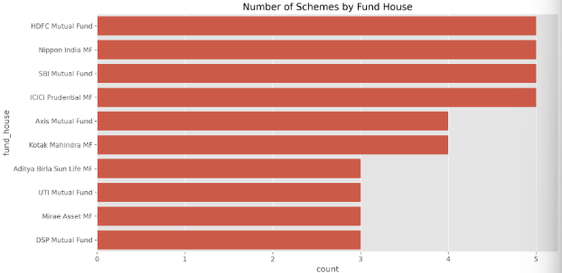
Figure 7.1: Fund house distribution

7.2 Category Distribution
Breakdown of schemes and inflows across Equity, Debt, Hybrid, and other categories.
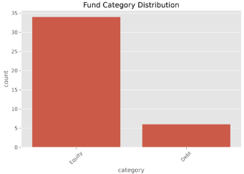
Figure 7.2: Category distribution

7.3 NAV Trend
Time-series visualization of NAV movement for representative schemes across categories.
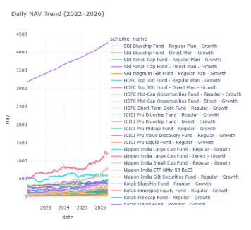
Figure 7.3: NAV trend over time

7.4 Risk Distribution
Distribution of volatility and risk-grade classification across the fund universe.
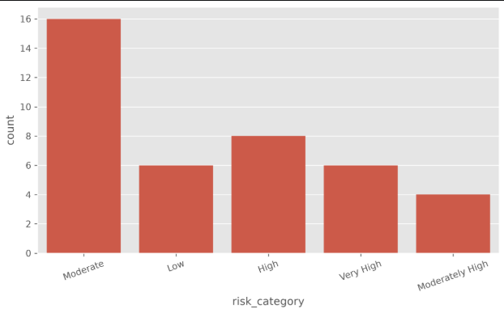
Figure 7.4: Risk distribution across schemes

8. Performance Analytics
A set of standard financial metrics was computed for each scheme to enable objective, risk-adjusted comparison of fund performance.
Compound Annual Growth Rate (CAGR)
CAGR = (Ending Value / Beginning Value)^(1/n) − 1
where n = number of years over which the investment is held
Sharpe Ratio
Sharpe = (Rp − Rf) / σp
where Rp = portfolio return, Rf = risk-free rate, σp = standard deviation of portfolio return
Beta
β = Covariance(Rp, Rm) / Variance(Rm)
where Rp = portfolio return, Rm = market (benchmark) return
Alpha
α = Rp − [Rf + β(Rm − Rf)]
measures excess return of the portfolio relative to the return predicted by the Capital Asset Pricing Model (CAPM)

Maximum Drawdown
Maximum Drawdown represents the largest percentage decline from a peak NAV to a subsequent trough, before a new peak is achieved. It is a key indicator of downside risk.

9. Power BI Dashboard
An interactive, four-page Power BI dashboard was developed to present industry, performance, investor, and market trend insights in a single connected report, supporting filtering, drill-through, and cross-highlighting across visuals.

9.1 Page 1: Industry Overview
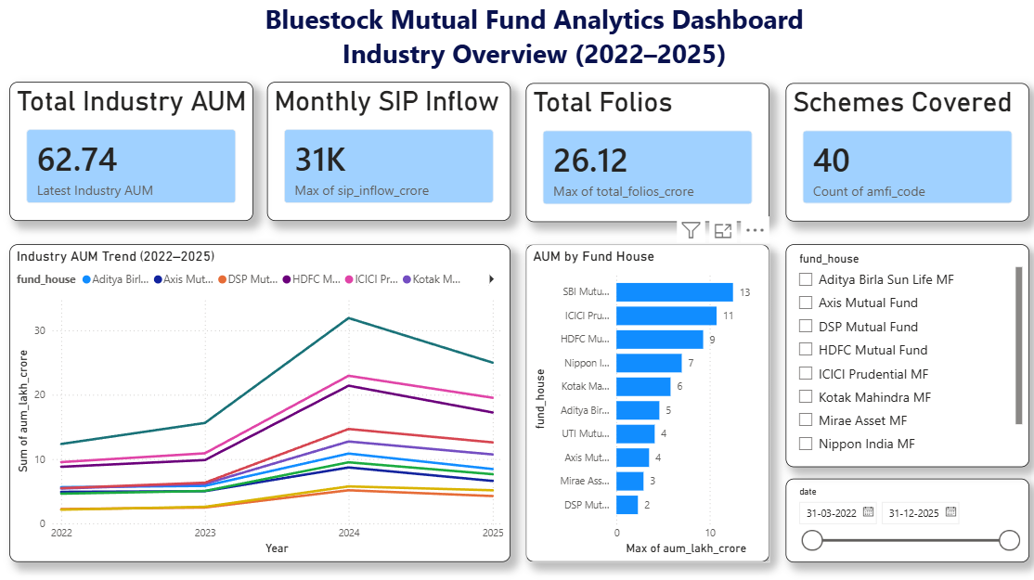
Figure 9.1: Industry Overview dashboard page
This page presents a high-level snapshot of the mutual fund industry, including:
- Total Assets Under Management (AUM)
- SIP inflow trends
- Total investor folios
- Number of active schemes
- AUM growth trend over time
- Fund house comparison by AUM and scheme count

9.2 Page 2: Fund Performance
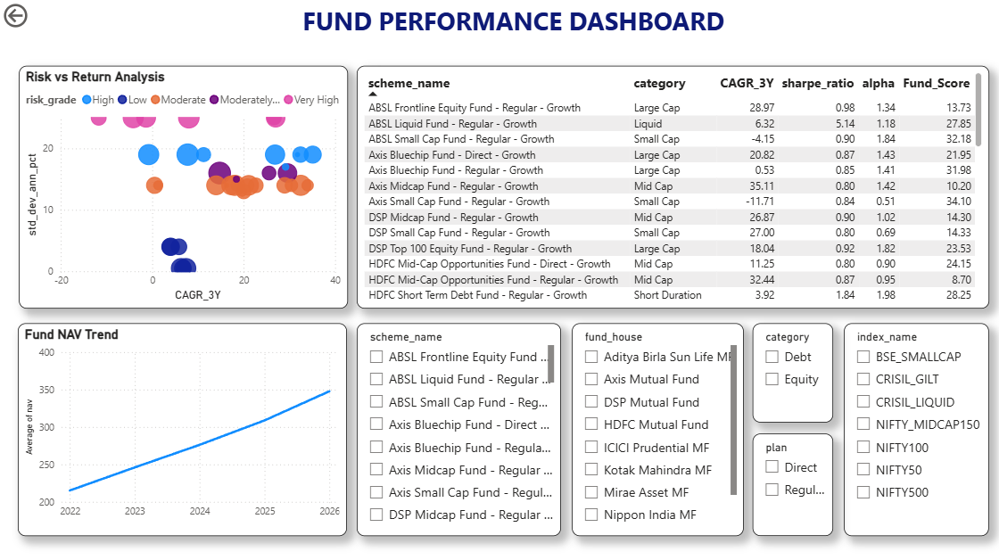Figure 9.2: Fund Performance dashboard page
This page enables comparative fund analysis through:
- Risk-return scatter plot across schemes
- Fund score ranking table
- NAV trend visualization
- Drill-through to scheme-level NAV detail

9.3 Page 3: Investor Analytics
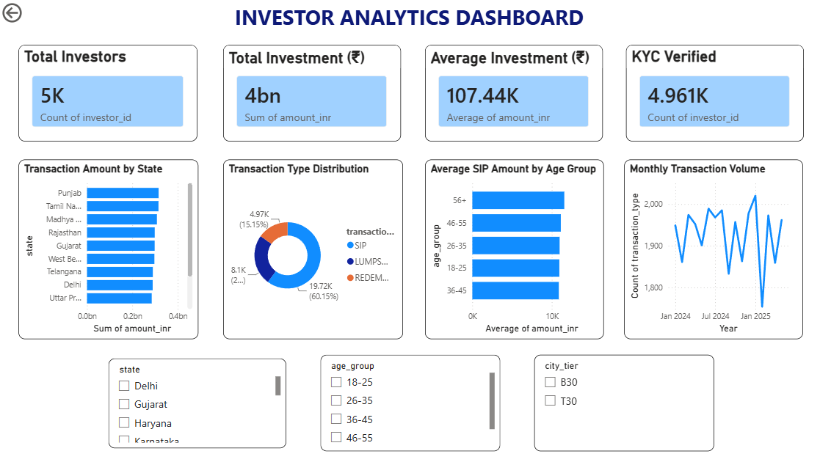
Figure 9.3: Investor Analytics dashboard page
This page focuses on investor behaviour, including:
- Transaction type distribution (SIP / Lumpsum / Redemption)
- State-wise investor analysis
- SIP amount distribution
- Monthly transaction volume trends

9.4 Page 4: SIP & Market Trends
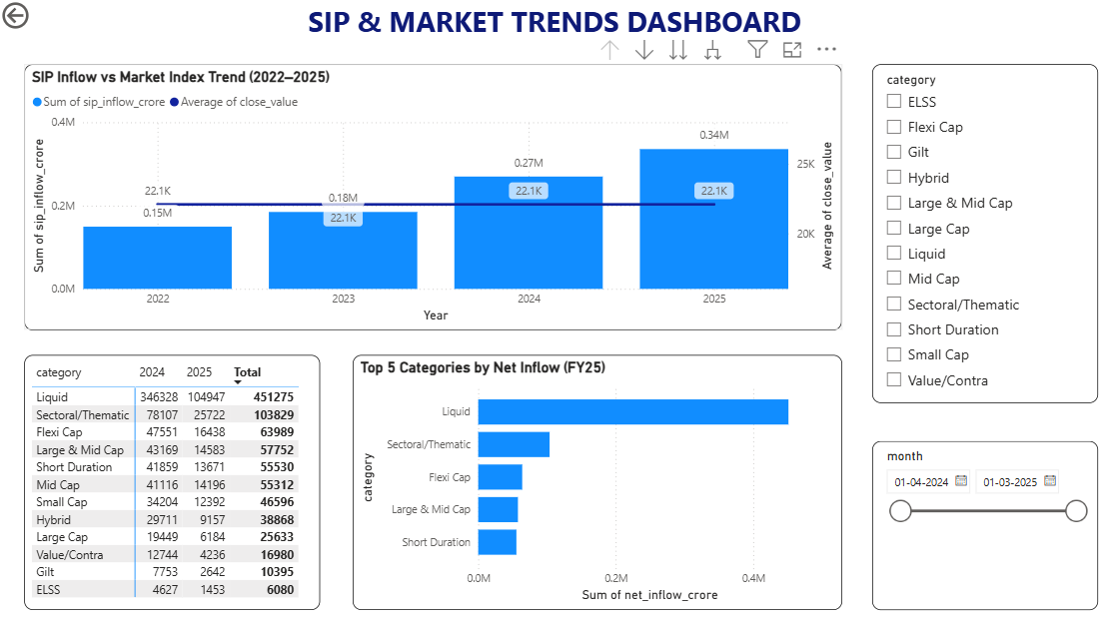
Figure 9.4: SIP & Market Trends dashboard page
This page correlates investor SIP behaviour with broader market movement:
- SIP inflows vs. market index performance
- Category-wise inflow trends
- Top-performing categories by inflow
- Interactive filters for category, time period, and fund house

10. Advanced Analytics
Beyond standard performance metrics and dashboarding, several advanced analytical techniques were applied to deepen the risk and behavioural insights generated by the project.

10.1 Historical Value at Risk (VaR)
Historical VaR estimates the maximum expected loss for a fund over a given time horizon at a specified confidence level, based on historical NAV return distributions. It helps quantify downside risk in a way that is intuitive for investors and fund analysts.

10.2 Rolling Sharpe Ratio
The Rolling Sharpe Ratio recalculates the Sharpe Ratio over a moving time window, revealing how a fund's risk-adjusted performance evolves over time rather than relying on a single static value.

10.3 Investor Cohort Analysis
Cohort analysis groups investors by the period in which they first invested, tracking retention and continued investment behaviour over time to reveal patterns in investor loyalty and engagement.

10.4 SIP Continuity Analysis
This analysis tracks the consistency of SIP contributions by investors over time, identifying rates of SIP discontinuation, pausing, and long-term continuity across different investor segments.

10.5 Fund Recommendation System
A rule-based recommendation engine was built to suggest suitable mutual fund schemes based on an investor's risk profile, matching conservative, moderate, and aggressive risk appetites to appropriate fund categories and risk-adjusted performance scores.

10.6 Sector Concentration (HHI)
The Herfindahl-Hirschman Index (HHI) was used to measure sector concentration within fund portfolios, flagging schemes with high concentration risk in a small number of sectors versus well-diversified schemes.

11. Key Findings

Finding 1
Liquid funds received the highest net inflows during FY25, reflecting investor preference for low-risk, highly liquid instruments amid market uncertainty.

Finding 2
Large Cap funds consistently achieved higher Fund Scores, driven by stable risk-adjusted returns and lower volatility relative to Mid Cap and Small Cap peers.

Finding 3
Most investor transactions were SIPs, confirming that systematic, disciplined investing is the dominant mode of participation among retail investors in the dataset.

Finding 4
Investors aged 26–35 invested the largest average SIP amounts, suggesting this age group represents a key segment for targeted product design and engagement.

Finding 5
Several funds exhibited low Value at Risk while maintaining strong Sharpe Ratios, indicating attractive risk-adjusted performance and making them strong candidates for conservative-to-moderate investor recommendations.

12. Challenges Faced
Several practical challenges were encountered and resolved during the course of this project:
- Missing NAV values across certain schemes and date ranges, requiring careful imputation
- Category inconsistencies across datasets originating from different sources
- Establishing correct relationships between tables within the Power BI data model
- Implementing drill-through navigation from summary to scheme-level detail
- Reconciling multiple datasets with different levels of granularity (daily, monthly, transaction-level)

13. Conclusion
This project successfully demonstrates an end-to-end mutual fund analytics solution using Python, SQLite, SQL, and Power BI. Beginning with raw financial datasets, an automated ETL pipeline was developed to clean and transform the data into an analysis-ready format. Performance metrics such as CAGR, Sharpe Ratio, Alpha, Beta, and Maximum Drawdown were computed to evaluate mutual fund performance.
Interactive Power BI dashboards were designed to provide insights into industry trends, fund performance, investor behaviour, and SIP inflows. Advanced analytical techniques including Historical VaR, Rolling Sharpe Ratio, Investor Cohort Analysis, SIP Continuity Analysis, Fund Recommendation, and Sector Concentration (HHI) further enhanced the analytical depth of the project.
Overall, the project demonstrates practical applications of data engineering, financial analytics, SQL querying, data visualization, and business intelligence, enabling data-driven investment analysis and supporting informed decision-making.

14. Future Scope
The current solution can be extended in several directions to increase its analytical depth and real-world usability:
- Live NAV integration using the MFAPI public API for real-time data updates
- A Streamlit-based web application for interactive, self-service exploration
- Monte Carlo simulation of NAV paths for probabilistic forecasting
- Portfolio optimization using the Markowitz Efficient Frontier
- Automated, scheduled email reports for stakeholders
- A machine learning–based fund recommendation system to replace the current rule-based engine

Appendix

A.1 Folder Structure
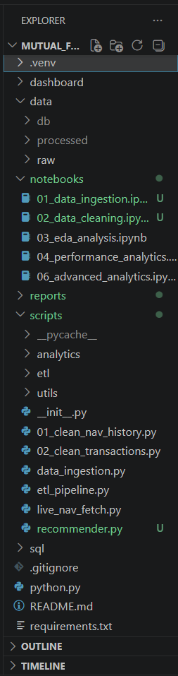
Figure A.1: Project folder structure (VS Code)

A.2 SQL Queries
Refer to queries.sql for the complete list of queries used for aggregation, ranking, and reporting throughout this project.

A.3 Data Dictionary
A complete field-level data dictionary describing each column across the seven datasets is maintained alongside the project source files.

A.4 GitHub Repository
https://github.com/SathvikaGNaik/mutual-fund-analytics

