**Requirement Gathering and Analysis Phase**

**Technology Stack (Architecture & Stack)**

|  |  |
| --- | --- |
| Date | 06-07-2024 |
| Team ID | PNT2022TMIDSWTID1720175019 |
| Project Name | Nexus Learn - Online learning platform |
| Maximum Marks |  |

**Technical Architecture:**

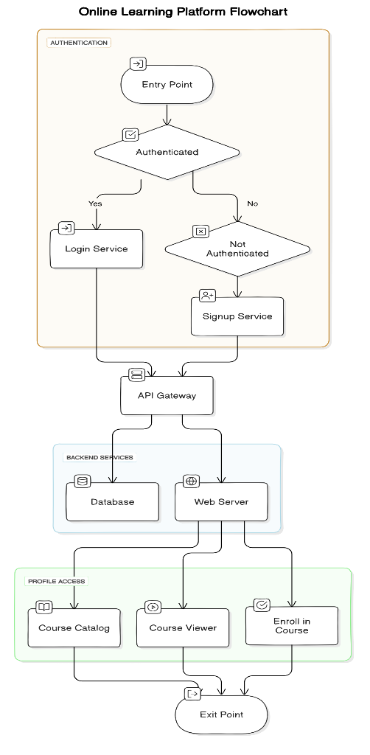

**Table-1: Components & Technologies:**

|  |  |  |  |
| --- | --- | --- | --- |
| **S.No** | **Component** | **Description** | **Technology** |
| 1 | User Interface | Web interface for user interaction | HTML, CSS, JavaScript, React.js, Vue.js |
| 2 | Application Logic - 1 | Core platform logic | Node.js, Python, Ruby on Rails |
| 3 | Application Logic - 2 | User authentication and authorization | OAuth 2.0, JWT |
| 4 | Application Logic - 3 | Payment processing | Stripe API, PayPal API |
| 5 | Database | Primary data storage | PostgreSQL, MongoDB |
| 6 | Cloud Database | Scalable database service on the cloud | Amazon RDS, Firebase Firestore |
| 7 | File Storage | Storage for course materials | AWS S3, Google Cloud Storage |
| 8 | External API - 1 | Email notifications | SendGrid API, Amazon SES |
| 9 | Machine Learning Model | Personalized course recommendations | TensorFlow, Scikit-learn |
| 10 | Infrastructure (Server/Cloud) | Application deployment infrastructure | AWS EC2, Google Cloud Platform |

**Table-2: Application Characteristics:**

| **S.No** | **Characteristics** | **Description** | **Technology** |
| --- | --- | --- | --- |
| 1 | Open-Source Frameworks | List the open-source frameworks used | React.js, Node.js, Express.js |
| 2 | Security Implementations | Security measures and access controls | SSL/TLS, OAuth 2.0, Firewalls |
| 3 | Scalable Architecture | Scalability considerations (e.g., microservices architecture) | Kubernetes, Docker, AWS Lambda |
| 4 | Availability | Ensuring high availability (e.g., load balancing, redundancy) | Nginx, HAProxy, AWS Elastic Load Balancing |
| 5 | Performance | Performance optimization techniques (e.g., caching, CDN) | Redis, Cloudflare CDN, Varnish Cache |