Woxsen University
School of Technology

DBMS PROJECT REPORT
Semester III
EMPLOYEE ATTENDANCE, SHIFT AND LEAVE MANAGEMENT SYSTEM
A DATABASE-DRIVEN WEB APPLICATION FOR EMPLOYEE OPERATIONS
Submitted in partial fulfillment of the requirements for the degree of
B. Tech. in Artificial Intelligence and Machine Learning
Submitted by:
V. Sathwik (25WU0102302)
Y. Aditya Sreekar (25WU0102303)
Vinti Satya Rohan (25WU0102300)
Under the guidance of:
Dr. Kiran Mayee
Woxsen University | 2025–29

CERTIFICATE
This is to certify that the project report entitled “Employee Attendance, Shift and Leave Management System” submitted by V. Sathwik (25WU0102302), Y. Aditya Sreekar (25WU0102303) and Vinti Satya Rohan (25WU0102300), in partial fulfillment of the requirements for the award of the degree of B. Tech. in Artificial Intelligence and Machine Learning from Woxsen University, School of Technology, is a bonafide record of work carried out by the students under my supervision and guidance.
The work embodied in this project report has been carried out by the candidates and has not been submitted elsewhere for the award of any other degree or diploma. The report presents the design, implementation and evaluation of a database-driven system for employee attendance, shift scheduling and leave management.

Signature of Mentor | Designation: | Date
Name: Dr. Kiran Mayee | Faculty / Project Mentor | 7th October 2026

DECLARATION OF THE CANDIDATES
We hereby declare that the project work entitled “Employee Attendance, Shift and Leave Management System” submitted to the School of Technology, Woxsen University, in partial fulfillment of the requirements for the award of the degree of B. Tech. in Artificial Intelligence and Machine Learning, is our original work and has been carried out under the guidance of Dr. Kiran Mayee.
We further declare that the work reported in this project has not been submitted and will not be submitted, either in part or in full, for the award of any other degree or diploma in this institute or any other institute or university. All project implementation details presented in this report are based on the supplied source code, database scripts and application interface.

Student | Roll Number | Signature
V. Sathwik | 25WU0102302 | ________________________
Y. Aditya Sreekar | 25WU0102303 | ________________________
Vinti Satya Rohan | 25WU0102300 | ________________________

ACKNOWLEDGMENT
We would like to express our sincere gratitude to everyone who contributed to the successful completion of the Employee Attendance, Shift and Leave Management System project. First and foremost, we extend our heartfelt thanks to our project mentor, Dr. Kiran Mayee, for guidance, encouragement and constructive feedback throughout the development of the project.
We are grateful to Woxsen University, School of Technology, for providing the academic environment, laboratory facilities and resources required to understand database management systems and develop this application. The project provided an opportunity to apply classroom concepts such as relational modeling, normalization, SQL, constraints, database connectivity and reporting to a practical problem.
We also thank our classmates and friends for their suggestions and discussions during the development and testing stages. Finally, we express our sincere gratitude to our families for their continuous support and encouragement.
V. Sathwik | Y. Aditya Sreekar | Vinti Satya Rohan

ABSTRACT
The Employee Attendance, Shift and Leave Management System is a database-driven web application developed to centralize and simplify employee operations. The system manages departments, employees, shifts, shift assignments, attendance records and leave requests through a relational database. The project was developed as a practical demonstration of Database Management System concepts and combines a MySQL database with a Python Flask web application.
The database, named attendance_db, contains seven core tables: department, employee, shift, shift_assignment, attendance, leave_type and leave_request. Primary keys provide unique identification, while foreign keys establish relationships between related entities. UNIQUE constraints prevent duplicate attendance and duplicate shift assignments. CHECK constraints validate attendance times and leave dates. These rules demonstrate how data integrity can be enforced directly at the database level rather than depending only on application logic.
The web application provides an administrative interface for department management, employee management, shift scheduling, attendance logging, leave approval and SQL reporting. The reporting component demonstrates practical SQL operations including joins, COUNT, SUM, GROUP BY, HAVING and date calculations. Database views are also provided for employee-department information, shift rosters, attendance summaries and leave summaries.
The project additionally includes database verification tests for four important integrity conditions: duplicate attendance, duplicate shift assignment, invalid check-out time and deletion of a referenced department. The application uses MySQL as its primary engine and contains a SQLite fallback for local operation when a MySQL connection is unavailable.
Keywords: DBMS, MySQL, Flask, Attendance Management, Shift Scheduling, Leave Management, Normalization, SQL, Relational Database

TABLE OF CONTENTS
1. INTRODUCTION
1.1 Background
1.2 Motivation
1.3 Problem Statement
1.4 Objectives
1.5 Scope and Limitations
1.6 Organization of the Report
2. LITERATURE / TECHNOLOGY REVIEW
2.1 Employee Management Systems
2.2 Relational Database Management
2.3 Web-Based Database Applications
2.4 SQL and Data Integrity
2.5 Database Normalization
2.6 Technology Gap
3. METHODOLOGY
3.1 System Overview
3.2 Requirement Analysis
3.3 Database Design
3.4 ER Model
3.5 Relational Schema
3.6 Normalization
3.7 Flask Application Design
3.8 User Interface and Key Features
4. RESULTS AND DISCUSSION
4.1 Implementation Outcomes
4.2 Database Contents
4.3 SQL Query Results
4.4 UI Screens and Modules
4.5 Testing and Validation
4.6 Discussion
5. CONCLUSION AND FUTURE WORK
5.1 Summary of Contributions
5.2 Limitations
5.3 Future Work
5.4 Concluding Remarks
REFERENCES
APPENDIX – I
Project Execution and Database Commands
APPENDIX – II
Project Team and Contributions

LIST OF TABLES
- Table 3.1: Technology Stack of the Implemented System
- Table 3.2: Core Database Tables and Purpose
- Table 3.3: Data Integrity Constraints
- Table 4.1: Sample Department Data
- Table 4.2: Sample Employee Data
- Table 4.3: Sample Shift Data
- Table 4.4: Sample Leave Requests
- Table 4.5: SQL Query Results
- Table 4.6: Database Verification Tests
- Table A.1: Project Team and Contributions

LIST OF FIGURES
- Figure 3.1: System Architecture
- Figure 3.2: Entity Relationship Model
- Figure 3.3: Admin Dashboard
- Figure 3.4: Attendance Log
- Figure 3.5: Department Management
- Figure 3.6: Employee Directory
- Figure 3.7: Shift Scheduling and Roster
- Figure 3.8: Leave Approval Center
- Figure 3.9: Administrator Accounts and Audit Interface
- Figure 3.10: SQL Query Console and Reports

1. INTRODUCTION

1.1 Background
Organizations need reliable employee information for day-to-day workforce operations. Attendance records help determine whether employees are present, late, absent or on leave. Shift schedules determine when employees are expected to work, while leave records help managers plan workforce availability. These activities are closely related, but they are often maintained using separate spreadsheets or manual registers.
A database management system provides a structured solution by storing related information in separate tables and connecting those tables through keys. In this project, department information is separated from employee information, shift definitions are separated from shift assignments, and leave types are separated from individual leave requests. This approach reduces repeated data and makes it easier to maintain consistent records.

1.2 Motivation
The motivation for this project is to convert a common administrative process into a practical DBMS application. A simple database should not only store records but also enforce rules. For example, an employee should not have two attendance records for the same date, an employee should not have two shift assignments for the same work date, and a leave request should not end before it starts.
The project therefore focuses on demonstrating the complete path from requirements to relational schema, SQL implementation, web integration and testing. It also provides a user interface so that the database can be used without directly entering every SQL command.

1.3 Problem Statement
The problem is to design and implement a centralized system for managing employee departments, employee records, work shifts, shift assignments, daily attendance and leave requests while maintaining database consistency. The system must support data insertion and modification, provide meaningful reports and prevent invalid relationships and duplicate records.

1.4 Objectives
- Maintain a centralized employee database.
- Manage department information and employee relationships.
- Create and maintain reusable shift definitions.
- Assign shifts to employees for specific dates.
- Record attendance with check-in, check-out and status.
- Manage leave types and leave requests.
- Provide approval and rejection of leave requests.
- Generate SQL reports for roster, attendance, leave and headcount analysis.
- Enforce integrity using keys, UNIQUE constraints, CHECK constraints and referential actions.
- Demonstrate integration between Flask and MySQL.

1.5 Scope and Limitations
The project scope covers the seven core relational tables and their corresponding application modules. The system is designed primarily as an academic/local web application. The supplied implementation contains a SQLite fallback, but MySQL is the intended primary database engine. The interface includes administrator-oriented features, but the core schema does not currently define separate administrator and audit tables; such functionality can be extended in future work.

1.6 Organization of the Report
Chapter 1 introduces the project. Chapter 2 discusses the relevant database and web technologies. Chapter 3 explains the methodology, architecture, ER model, schema and normalization. Chapter 4 presents implementation outcomes, database records, reports, screenshots and testing. Chapter 5 summarizes the work, limitations and future enhancements. References and appendices are provided at the end.

2. LITERATURE / TECHNOLOGY REVIEW

2.1 Employee Management Systems
Employee management systems generally combine employee master data with operational information such as attendance, scheduling and leave. A common requirement is to maintain a single source of truth for employee identity while allowing multiple operational records over time. This project follows that principle by keeping employee master data in one table and storing attendance, shift assignments and leave requests in separate related tables.

2.2 Relational Database Management
Relational DBMS technology organizes information into tables consisting of rows and columns. Relationships are established using keys. The approach is well suited to this project because departments, employees, shifts and leave types are entities with stable attributes, while attendance, shift assignments and leave requests represent repeated transactions associated with those entities.

2.3 Web-Based Database Applications
A web application provides a convenient interface to database operations. In this project Flask is responsible for receiving requests, executing SQL and rendering the resulting information. This separation allows users to interact with forms and tables rather than manually constructing SQL statements for routine operations.

2.4 SQL and Data Integrity
SQL is used for database definition, data manipulation and reporting. However, application validation alone is not sufficient for a reliable database. Constraints such as primary keys, foreign keys, UNIQUE and CHECK conditions provide a second layer of protection. The project deliberately tests these rules to verify that the DBMS blocks invalid operations.

2.5 Database Normalization
Normalization is a design process that organizes data to reduce redundancy and update anomalies. The project uses a 3NF-oriented design. Department details are stored once, employee records reference departments, shift details are stored once, and leave type rules are separated from leave requests. This means a change to a department or leave type does not require editing many unrelated rows.

2.6 Technology Gap
The project demonstrates the connection between academic DBMS concepts and a working web application. Instead of presenting normalization and SQL as isolated theory, it shows how those concepts affect an actual application: keys create relationships, constraints prevent invalid records, views simplify reports and Flask converts user actions into database operations.

3. METHODOLOGY

3.1 System Overview
The methodology follows a database-first approach. Requirements were identified from the employee management problem, entities were derived from those requirements, relationships were established, the relational schema was normalized, constraints and indexes were added, sample data was inserted and the Flask application was connected to the database. Finally, SQL reports and database verification tests were used to validate the implementation.
Layer | Components | Purpose
Presentation Layer | HTML, CSS, JavaScript, Flask templates | Displays forms, tables, dashboard and reports
Application Layer | Python Flask routes and query functions | Processes requests and executes database operations
Database Layer | MySQL attendance_db | Stores normalized relational data
Fallback Layer | SQLite attendance_fallback.db | Local fallback if MySQL connection fails

Figure 3.1: Layered Architecture of the Employee Management System

3.2 Requirement Analysis
Functional requirements include adding and viewing employees, managing departments, defining shifts, assigning shifts, recording attendance, managing leave types and requests, changing leave status and executing reports. Non-functional requirements include data consistency, relational integrity, readable reports and a maintainable application structure.

3.3 Database Design
The database was divided into seven core tables. Each table has a focused responsibility. Department stores organizational units; employee stores employee master data; shift stores reusable work periods; shift_assignment stores date-specific employee schedules; attendance stores daily attendance; leave_type stores leave categories and their limits; leave_request stores individual leave applications.
Table | Primary Responsibility
department | Department master data
employee | Employee master data
shift | Reusable shift definitions
shift_assignment | Date-specific employee shift allocation
attendance | Daily attendance
leave_type | Leave categories and limits
leave_request | Employee leave applications and status

3.4 ER Model
The ER model expresses the relationships among the seven entities. Department has a one-to-many relationship with Employee. Employee has one-to-many relationships with Attendance and Leave Request. Shift and Employee are connected through Shift Assignment, which records the date on which an employee receives a particular shift. Leave Type has a one-to-many relationship with Leave Request.
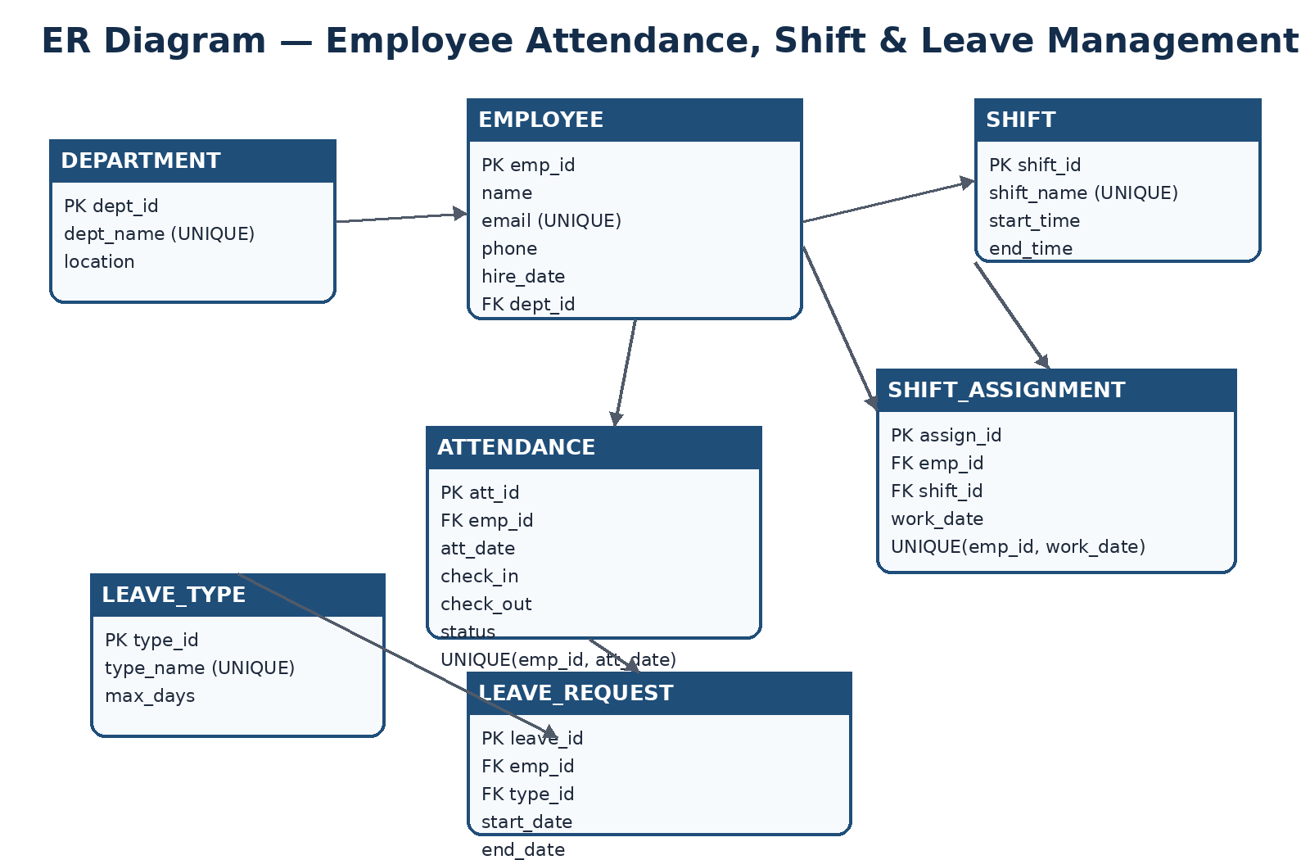
Figure 3.2: Entity Relationship Model of the Core Database

3.5 Relational Schema
DEPARTMENT(dept_id, dept_name, location)
EMPLOYEE(emp_id, name, email, phone, hire_date, dept_id)
SHIFT(shift_id, shift_name, start_time, end_time)
SHIFT_ASSIGNMENT(assign_id, emp_id, shift_id, work_date)
ATTENDANCE(att_id, emp_id, att_date, check_in, check_out, status)
LEAVE_TYPE(type_id, type_name, max_days)
LEAVE_REQUEST(leave_id, emp_id, type_id, start_date, end_date, reason, status)

3.6 Normalization
First Normal Form is achieved because fields contain atomic values and each record represents one entity or relationship. Second Normal Form is supported because attributes such as shift timing and department location are kept with the entity they describe rather than being repeated in assignment or employee records. Third Normal Form is supported because department descriptions depend on department ID and leave rules depend on leave type ID, rather than indirectly depending on an employee or request record.
For example, storing the department name and location in every employee row would create redundancy. Instead, employee stores only dept_id. When the department name is needed, a JOIN retrieves it from department. The same principle applies to shift and leave type information.

3.7 Flask Application Design
The Flask backend uses routes for dashboard, departments, employees, shifts, attendance, leaves, reports and database settings. A centralized run_query function handles database connections and executes parameterized queries. Write operations are committed, while read operations return structured rows to the templates.

3.8 User Interface and Key Features
The interface provides an administrative dashboard, department management, employee directory, shift scheduling, attendance logging, leave approval and SQL reports. The UI is designed to make database information understandable to a user while keeping relational operations behind the application layer.

3.9 USER INTERFACE SCREENSHOTS
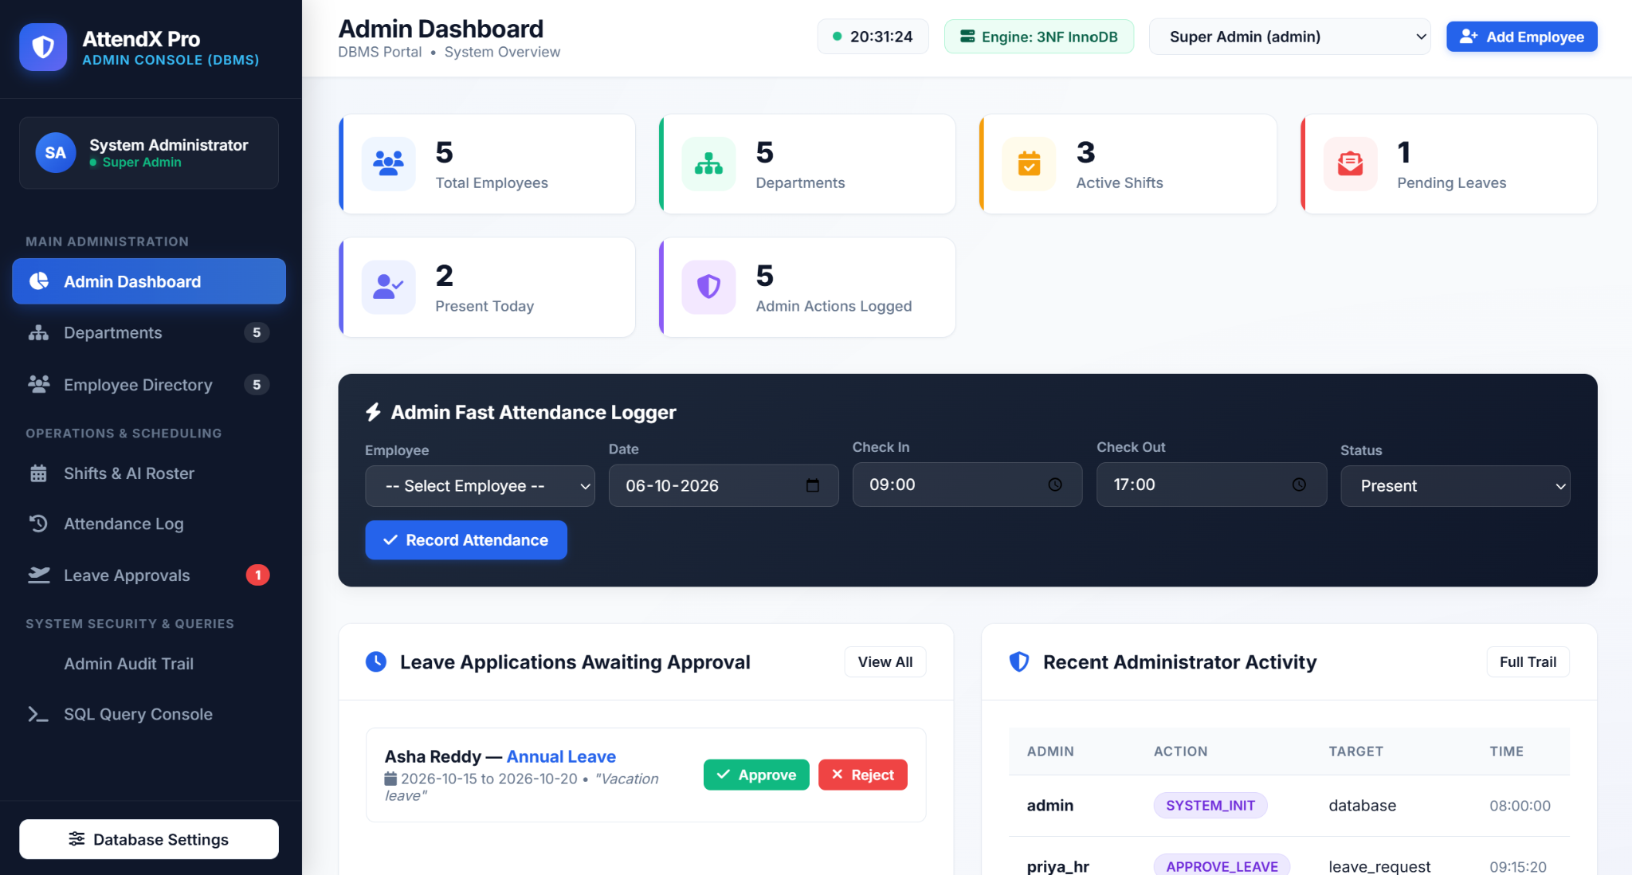
Figure 3.3: Admin Dashboard

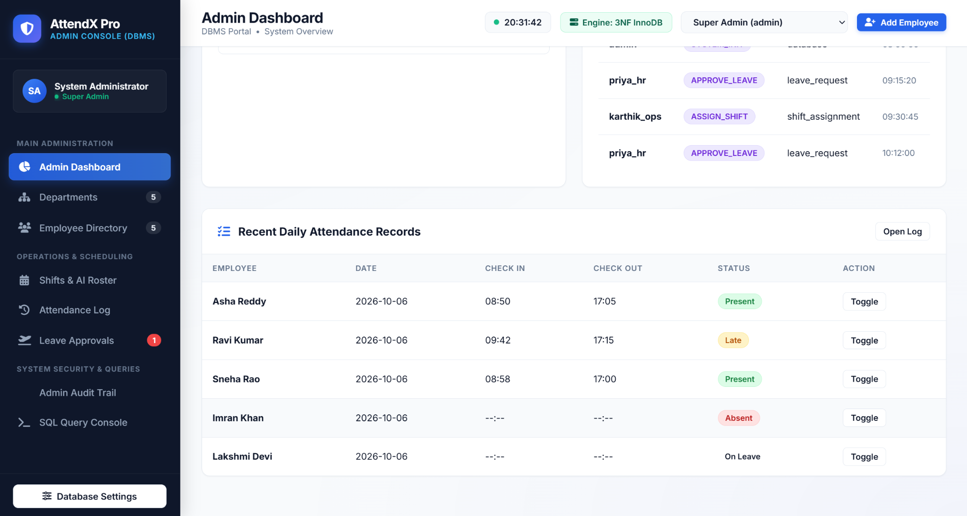
Figure 3.4: Attendance Log

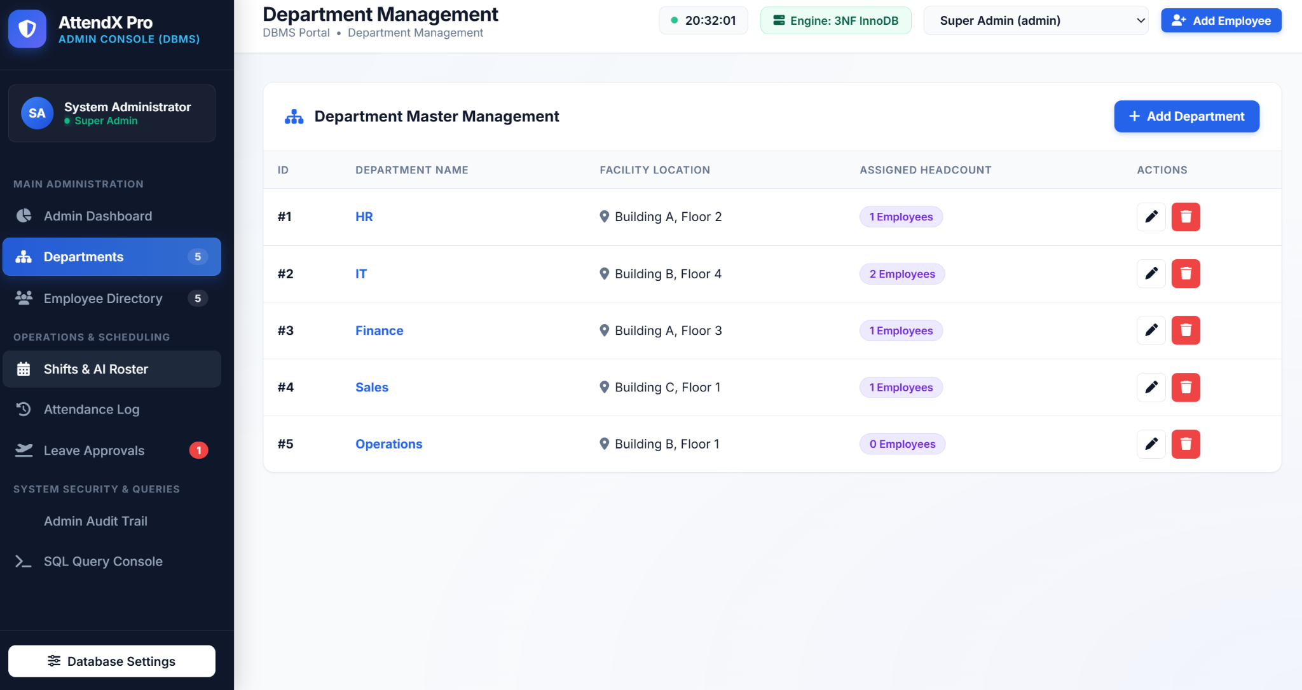
Figure 3.5: Department Management

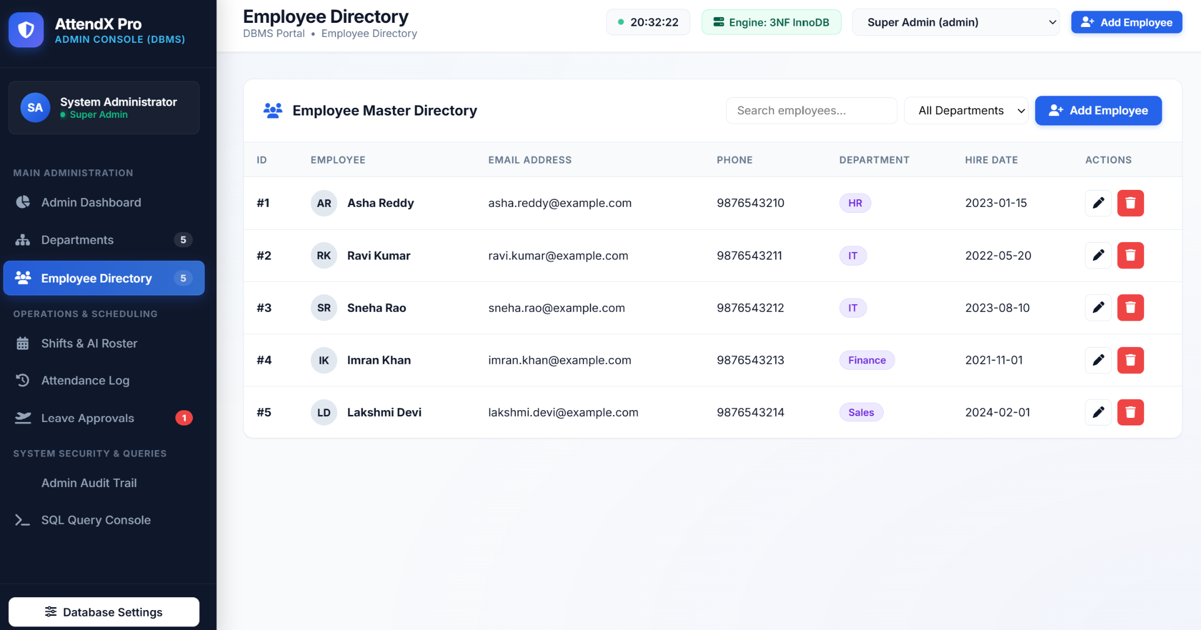
Figure 3.6: Employee Directory

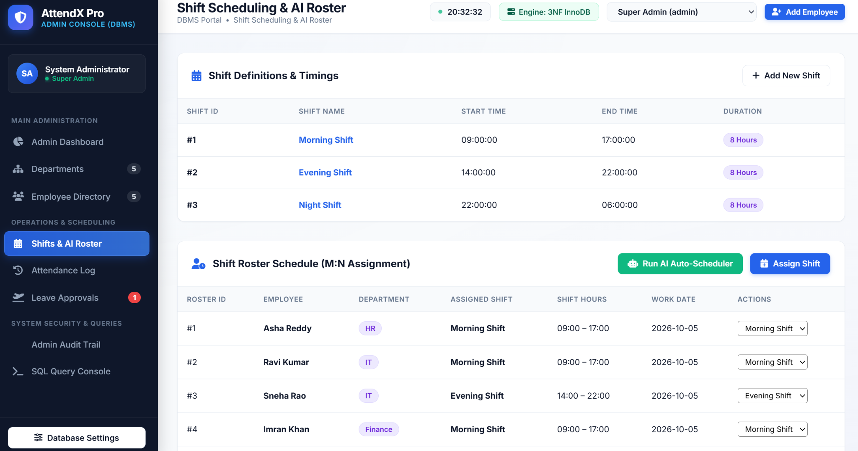
Figure 3.7: Shift Scheduling and Roster

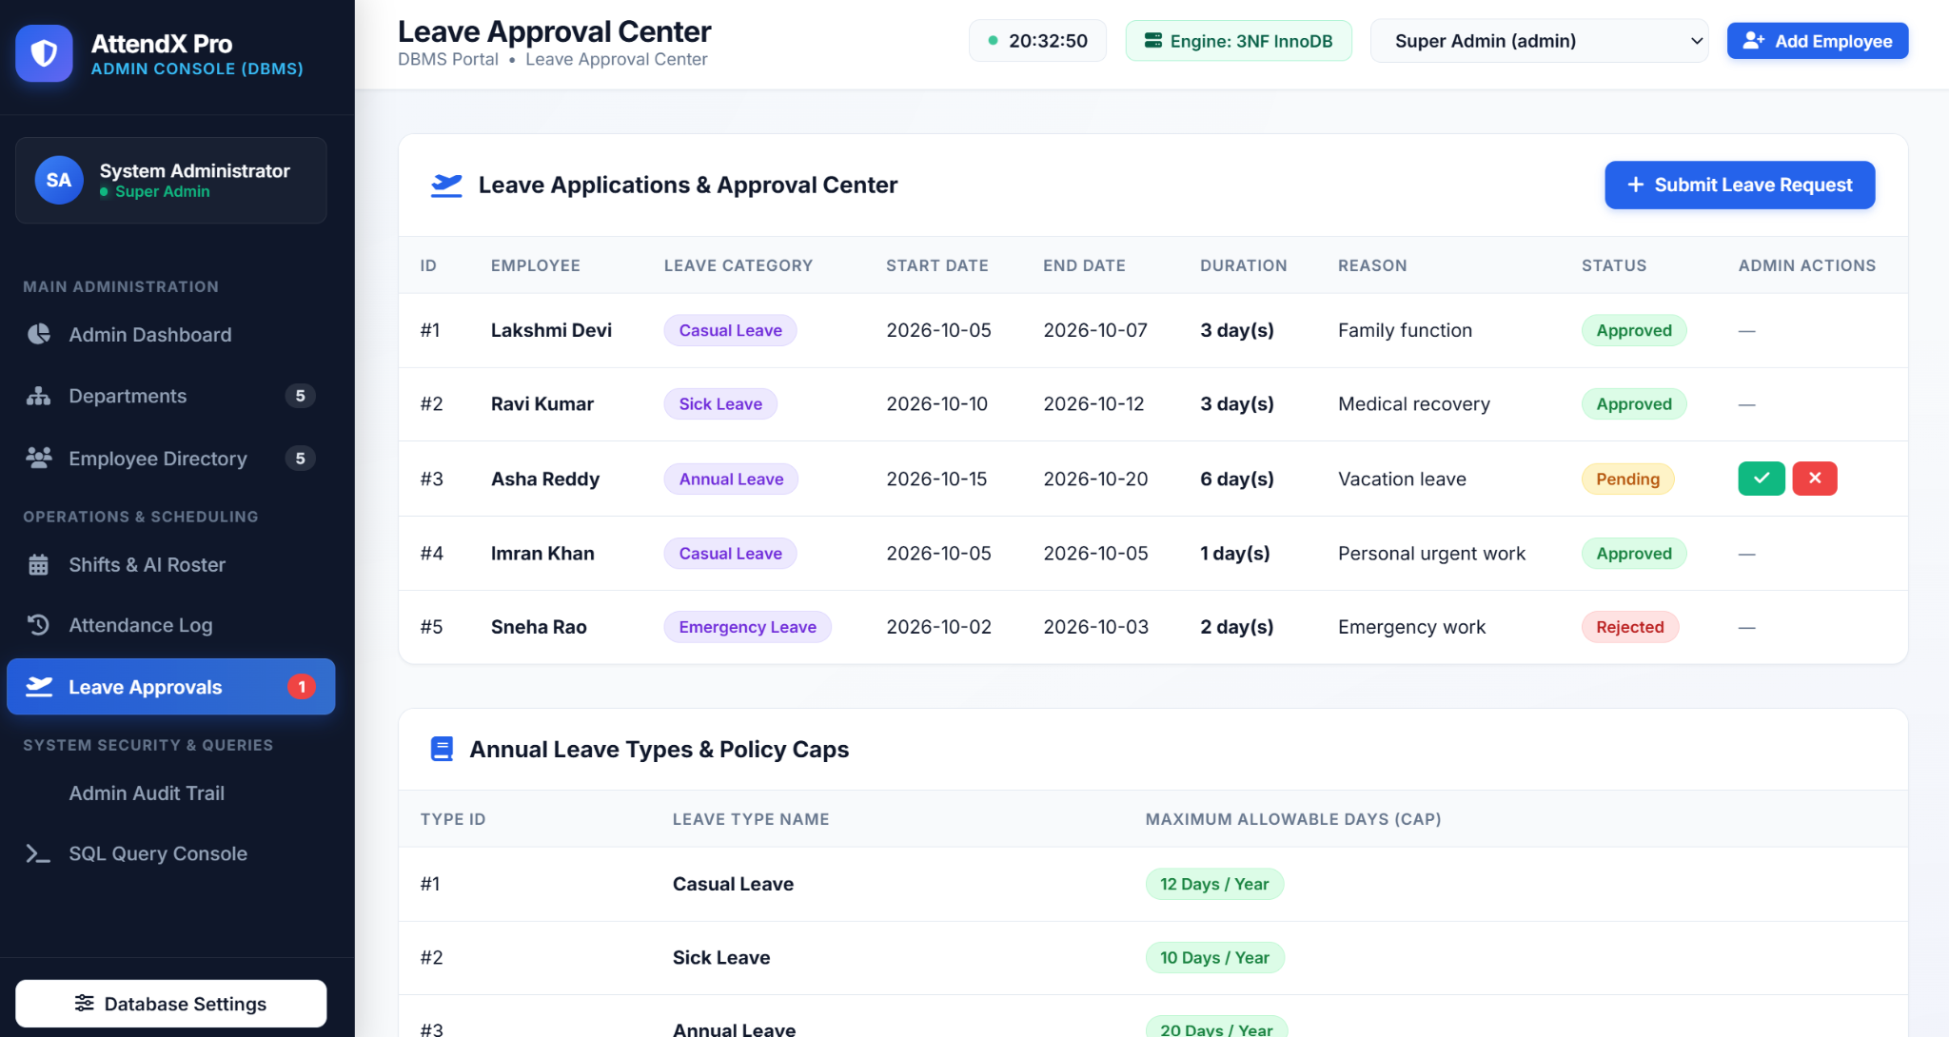
Figure 3.8: Leave Approval Center

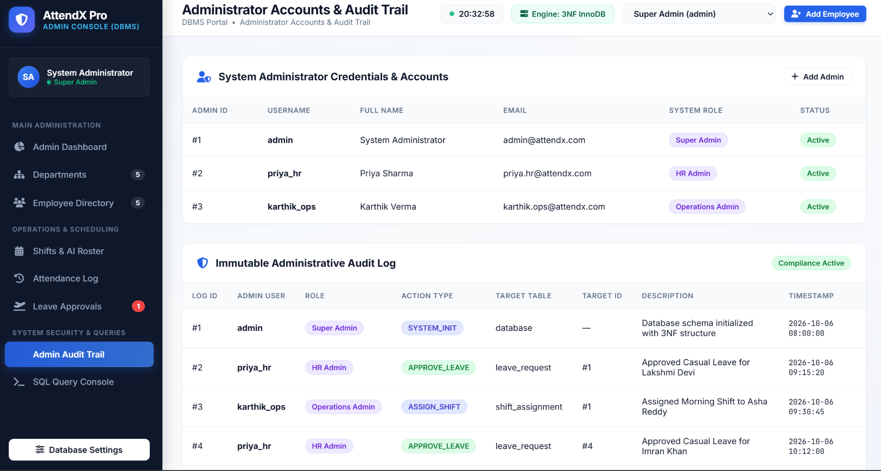
Figure 3.9: Administrator Accounts and Audit Interface

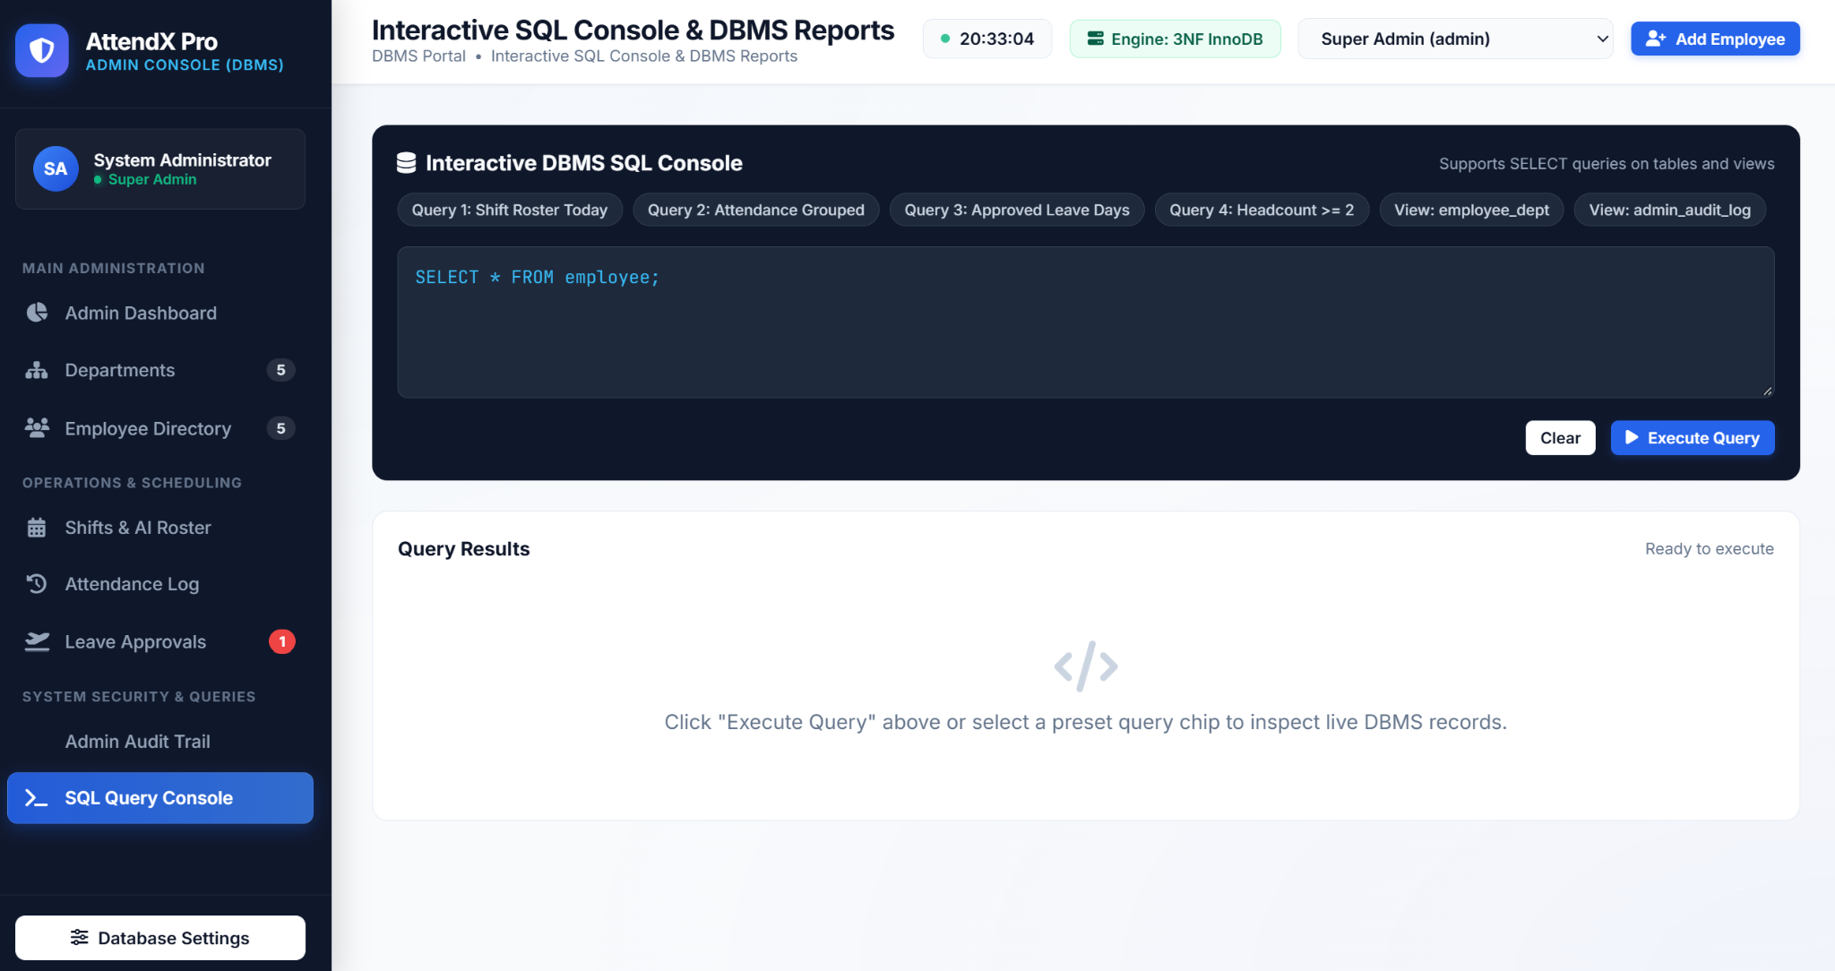
Figure 3.10: SQL Query Console and Reports

4. RESULTS AND DISCUSSION

4.1 Implementation Outcomes
The implemented application successfully connects a Flask web interface to the relational database. The dashboard obtains counts directly from the database, employee and department pages display joined information, the shift page represents date-specific assignments, the attendance page displays daily records and the leave page supports status updates. The reports page demonstrates analytical SQL queries.

4.2 Database Contents
ID | Department | Location
1 | HR | Building A, Floor 2
2 | IT | Building B, Floor 4
3 | Finance | Building A, Floor 3
4 | Sales | Building C, Floor 1
5 | Operations | Building B, Floor 1

Table 4.1: Sample Department Data
ID | Employee | Department | Hire Date
1 | Asha Reddy | HR | 2023-01-15
2 | Ravi Kumar | IT | 2022-05-20
3 | Sneha Rao | IT | 2023-08-10
4 | Imran Khan | Finance | 2021-11-01
5 | Lakshmi Devi | Sales | 2024-02-01

Table 4.2: Sample Employee Data
ID | Shift | Start | End
1 | Morning Shift | 09:00:00 | 17:00:00
2 | Evening Shift | 14:00:00 | 22:00:00
3 | Night Shift | 22:00:00 | 06:00:00

Table 4.3: Sample Shift Data

4.3 Attendance and Leave Results
Employee | Date | Check-in | Check-out | Status
Asha Reddy | 2026-10-06 | 08:50 | 17:05 | Present
Ravi Kumar | 2026-10-06 | 09:42 | 17:15 | Late
Sneha Rao | 2026-10-06 | 08:58 | 17:00 | Present
Imran Khan | 2026-10-06 | — | — | Absent
Lakshmi Devi | 2026-10-06 | — | — | On Leave

Table 4.4: Sample Attendance Records
Employee | Leave Type | Period | Status
Lakshmi Devi | Casual Leave | 2026-10-05 to 2026-10-07 | Approved
Ravi Kumar | Sick Leave | 2026-10-10 to 2026-10-12 | Approved
Asha Reddy | Annual Leave | 2026-10-15 to 2026-10-20 | Pending
Imran Khan | Casual Leave | 2026-10-05 | Approved
Sneha Rao | Emergency Leave | 2026-10-02 to 2026-10-03 | Rejected

Table 4.5: Sample Leave Requests

4.4 SQL Query Results
Query | Result
Shift Roster | 5 assignments returned for 2026-10-05
Attendance Grouping | Present 4; Late 2; Absent 2; On Leave 2
Approved Leave Days | Lakshmi 3; Ravi 3; Imran 1
Headcount >= 2 | IT – 2 employees

Table 4.6: Summary of Analytical SQL Results
The query results demonstrate that the relational design supports both operational and analytical use. Operational queries retrieve specific records, while analytical queries combine multiple rows using aggregate functions. For example, the attendance grouping query does not merely list attendance; it summarizes the distribution of statuses across the database.

4.5 Testing and Validation
Test Case | Expected Database Behaviour | Result
Duplicate attendance | UNIQUE(emp_id, att_date) rejects duplicate | PASS
Duplicate shift assignment | UNIQUE(emp_id, work_date) rejects duplicate | PASS
Invalid checkout | CHECK requires checkout > checkin when both exist | PASS
Delete referenced department | ON DELETE RESTRICT prevents deletion | PASS

Table 4.7: Database Verification Tests
The verification tests are important because they show that data integrity is enforced by the database. A successful application should not depend solely on a developer remembering to validate every case in the user interface. Database constraints provide a persistent rule that applies whenever the table is modified.

4.6 Discussion
The project demonstrates a clear relationship between database theory and implementation. Normalization determines how information is separated. Foreign keys determine how entities are connected. Constraints determine which records are acceptable. Views simplify repeated reporting logic. Indexes support frequently searched columns. Flask then exposes these operations through a user-friendly interface.

5. CONCLUSION AND FUTURE WORK

5.1 Summary of Contributions
The project delivers a working relational database and web interface for employee attendance, shift and leave management. Its main contribution is the integration of multiple DBMS concepts into one practical application. The database contains seven logically separated core tables, while the application provides management screens and SQL reports over those tables.
- Normalized relational database structure.
- Primary-key and foreign-key relationships.
- Duplicate prevention using UNIQUE constraints.
- Logical validation using CHECK constraints.
- Referential integrity using foreign-key actions.
- Reusable database views for reporting.
- Indexes for frequently searched relationship/status columns.
- Flask-based database application.
- Analytical SQL reports.
- Automated verification of critical database rules.

5.2 Limitations
The current project is primarily an academic/local implementation. The core database does not currently include dedicated administrator, role or audit-log tables even though the interface contains administrator-oriented screens. The application also depends on local configuration for MySQL. A production deployment would require stronger authentication, authorization, transaction policies, backup procedures and centralized audit logging.

5.3 Future Work
- Implement role-based authentication for administrators, HR staff, managers and employees.
- Provide employee self-service for attendance viewing and leave application.
- Add monthly and department-wise attendance analytics.
- Add notifications for leave submission and approval.
- Detect shift conflicts and excessive working hours.
- Add a normalized administrator/audit log schema.
- Add report export to PDF and Excel.
- Add database backup and restore management.
- Deploy the application to a secure multi-user environment.

5.4 Concluding Remarks
The Employee Attendance, Shift and Leave Management System demonstrates that a well-designed relational database can provide a reliable foundation for employee operations. The project moves beyond simple record storage by enforcing integrity, supporting reporting and connecting the database to a web application. It therefore serves as a practical demonstration of DBMS concepts and provides a foundation that can be extended into a larger enterprise employee-management platform.

REFERENCES
1. MySQL documentation and relational database concepts.
2. Python Flask documentation and application routing concepts.
3. Project source file: app.py.
4. Project database schema: database.sql.
5. Project sample data: seed.sql.
6. Project analytical queries: queries.sql.
7. Project database verification: verify_db.py.
8. Project documentation: README.md.
9. Woxsen University academic/project documentation guidelines.

APPENDIX – I

Project Execution
The supplied README documents the basic execution sequence for the project. The database scripts are executed first and the Flask application is then started.
mysql -u root -p
SOURCE <project-path>/schema.sql;
SOURCE <project-path>/seed.sql;
SOURCE <project-path>/queries.sql;
python app.py
http://127.0.0.1:5000

Important SQL Examples
CREATE DATABASE IF NOT EXISTS attendance_db;
SELECT status, COUNT(*) AS total_days
FROM attendance
GROUP BY status;
SELECT d.dept_name, COUNT(e.emp_id) AS headcount
FROM department d
JOIN employee e ON d.dept_id = e.dept_id
GROUP BY d.dept_id, d.dept_name
HAVING COUNT(e.emp_id) >= 2;

Core Constraints
Constraint | Purpose
PRIMARY KEY | Uniquely identifies each record.
FOREIGN KEY | Maintains relationships between tables.
UNIQUE | Prevents duplicate values/combinations.
NOT NULL | Requires a value.
CHECK | Prevents logically invalid values.
ON DELETE RESTRICT | Protects referenced department records.
ON DELETE CASCADE | Removes dependent records where defined.

APPENDIX – II

Project Team and Contributions
The exact contribution split should be confirmed by the team before final submission. The following table provides a formal structure for recording the final responsibilities.
Name | Roll Number | Contribution
V. Sathwik | 25WU0102302 | Database design, SQL development, Flask integration and report coordination – to be confirmed
Y. Aditya Sreekar | 25WU0102303 | Application development, UI/module work and testing – to be confirmed
Vinti Satya Rohan | 25WU0102300 | Database testing, documentation and project support – to be confirmed

GitHub Repository
GitHub Repository: https://github.com/Sathwik-V-hub/DBMS-Course-Project

Final Submission Checklist
- Verify all student names and roll numbers.
- Add the final GitHub repository URL.
- Confirm actual individual contributions.
- Insert the final ER diagram if a revised version is approved.
- Check that all screenshots are current.
- Run the SQL scripts before final demonstration.
- Verify that the Flask application opens on the documented local port.
- Confirm the mentor name and submission date.
- Update any placeholders before printing.
— END OF REPORT —

