**Industrial Internship Report on**

**”Project Name”**

**Prepared by**

**Y. Sathwik**

|  |
| --- |
| *Executive Summary* |
| This report provides details of the Industrial Internship provided by upskill Campus and The IoT Academy in collaboration with Industrial Partner UniConverge Technologies Pvt Ltd (UCT).  This internship was focused on a project/problem statement provided by UCT. We had to finish the project including the report in 6 weeks’ time.  My project was (Tell about ur Project)  This internship gave me a very good opportunity to get exposure to Industrial problems and design/implement solution for that. It was an overall great experience to have this internship. |

**TABLE OF CONTENTS**

1 Preface 3

2 Introduction 4

2.1 About UniConverge Technologies Pvt Ltd 4

2.2 About upskill Campus 8

2.3 Objective 9

2.4 Reference 9

2.5 Glossary 10

3 Problem Statement 11

4 Existing and Proposed solution 12

5 Proposed Design/ Model 13

5.1 High Level Diagram (if applicable) 13

5.2 Low Level Diagram (if applicable) 13

5.3 Interfaces (if applicable) 13

6 Performance Test 14

6.1 Test Plan/ Test Cases 14

6.2 Test Procedure 14

6.3 Performance Outcome 14

7 My learnings 15

8 Future work scope 16

# Preface

I’m excited to share a summary of the 6-week internship project that I worked on, which was centered around the prediction of agriculture crop production. This document will provide an overview of my experiences, the relevance of this internship to my career development, our specific problem statement, the opportunities presented by USC/UCT, and how we planned and executed the program.

Summary of the Whole 6 Weeks’ Work:

Throughout the six weeks, my internship project revolved around developing a predictive model for agriculture crop production. This journey involved data collection, analysis, and the application of machine learning techniques to forecast crop yields, contributing to the optimization of agricultural practices.

Relevance of Internship in Career Development:

Participating in this internship has been a significant stepping stone in my career development. It allowed me to gain hands-on experience in data analysis and machine learning, skills that are highly sought after in various industries. Additionally, the project’s agricultural focus aligns with the increasing demand for data-driven solutions in the farming sector.

Project/Problem Statement:

The central problem we addressed in this project was the critical need for accurate crop production predictions. Farmers and stakeholders in the agriculture sector rely on precise forecasts to make informed decisions about planting, harvesting, and resource allocation. Our project aimed to tackle this challenge using data-driven approaches.

Opportunity Given by USC/UCT:

USC/UCT provided us with valuable opportunities, including access to resources, mentorship, and relevant datasets. This collaboration empowered us to apply our theoretical knowledge in a real-world context, allowing for a deeper understanding of data science and its practical applications.

How the Program Was Planned:

The program was meticulously planned with a well-structured timeline. It involved various stages, from data gathering and exploratory data analysis to model development and evaluation. Weekly meetings with mentors and fellow interns facilitated progress tracking and knowledge sharing, which were key to the successful completion of the project.

# Introduction

## About UniConverge Technologies Pvt Ltd

A company established in 2013 and working in Digital Transformation domain and providing Industrial solutions with prime focus on sustainability and RoI.

For developing its products and solutions it is leveraging various**Cutting Edge Technologies e.g. Internet of Things (IoT), Cyber Security, Cloud computing (AWS, Azure), Machine Learning, Communication Technologies (4G/5G/LoRaWAN), Java Full Stack, Python, Front end**etc.

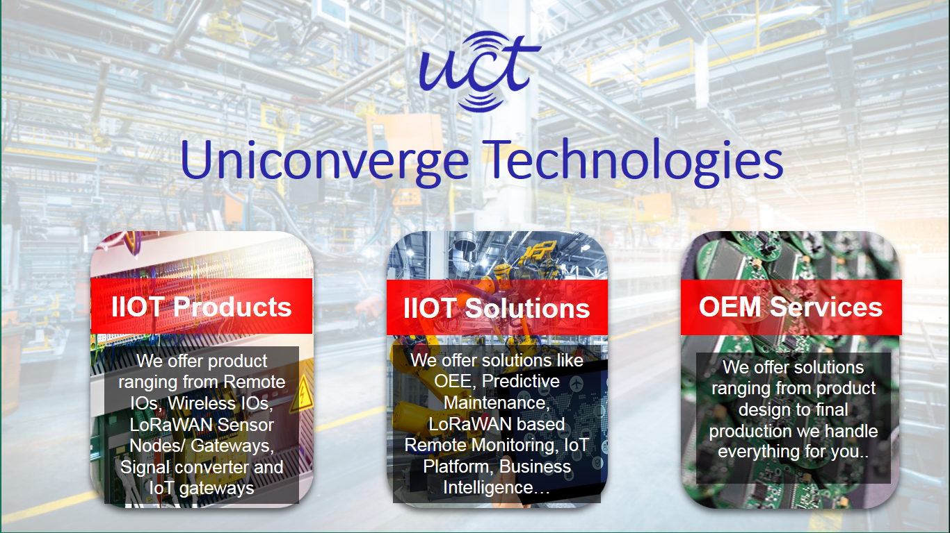

1. **UCT IoT Platform (****)**

**UCT Insight** is an IOT platform designed for quick deployment of IOT applications on the same time providing valuable “insight” for your process/business. It has been built in Java for backend and ReactJS for Front end. It has support for MySQL and various NoSql Databases.

* It enables device connectivity via industry standard IoT protocols - MQTT, CoAP, HTTP, Modbus TCP, OPC UA
* It supports both cloud and on-premises deployments.

It has features to  
• Build Your own dashboard  
• Analytics and Reporting  
• Alert and Notification  
• Integration with third party application(Power BI, SAP, ERP)  
• Rule Engine

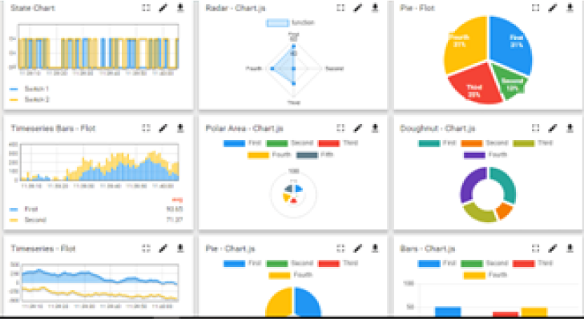 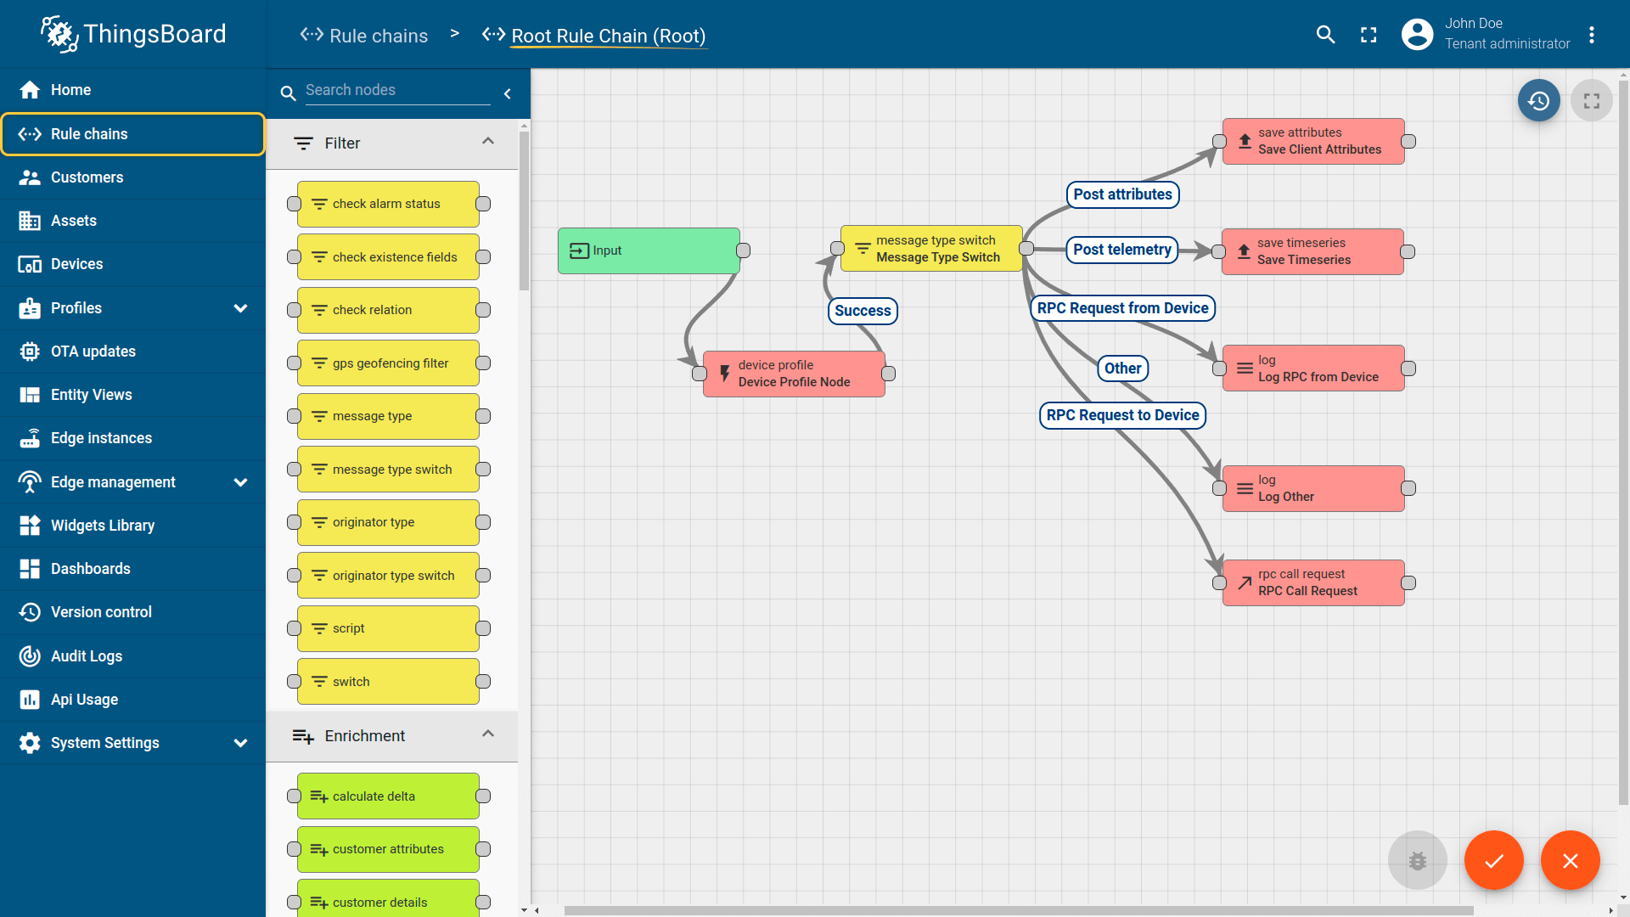

1. **Smart Factory Platform (****)**

Factory watch is a platform for smart factory needs.

It provides Users/ Factory

* with a scalable solution for their Production and asset monitoring
* OEE and predictive maintenance solution scaling up to digital twin for your assets.
* to unleased the true potential of the data that their machines are generating and helps to identify the KPIs and also improve them.
* A modular architecture that allows users to choose the service that they what to start and then can scale to more complex solutions as per their demands.

Its unique SaaS model helps users to save time, cost and money.

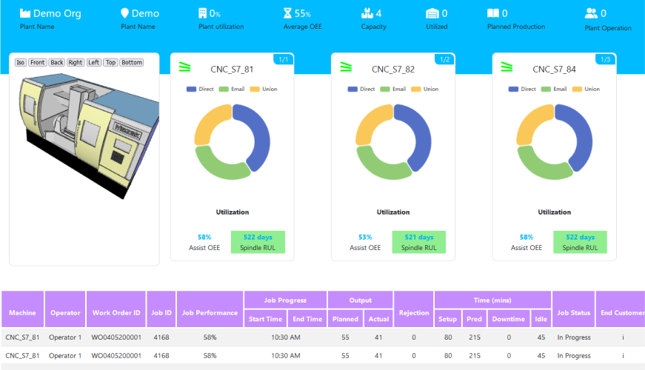 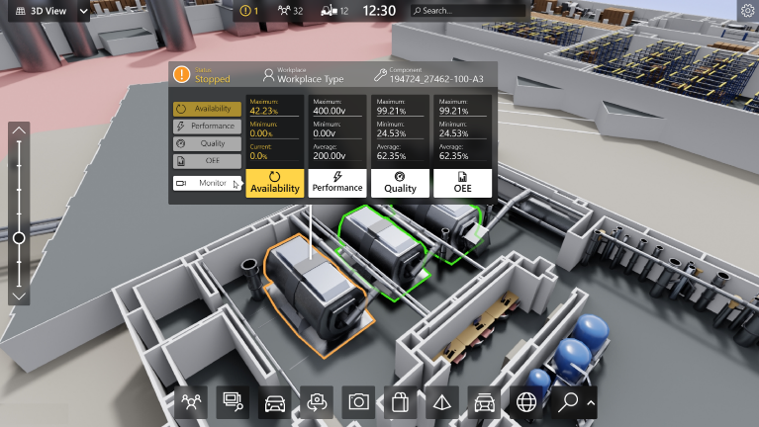

1. 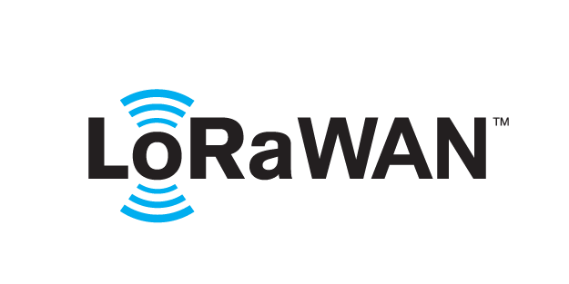 based Solution

UCT is one of the early adopters of LoRAWAN teschnology and providing solution in Agritech, Smart cities, Industrial Monitoring, Smart Street Light, Smart Water/ Gas/ Electricity metering solutions etc.

1. Predictive Maintenance

UCT is providing Industrial Machine health monitoring and Predictive maintenance solution leveraging Embedded system, Industrial IoT and Machine Learning Technologies by finding Remaining useful life time of various Machines used in production process.

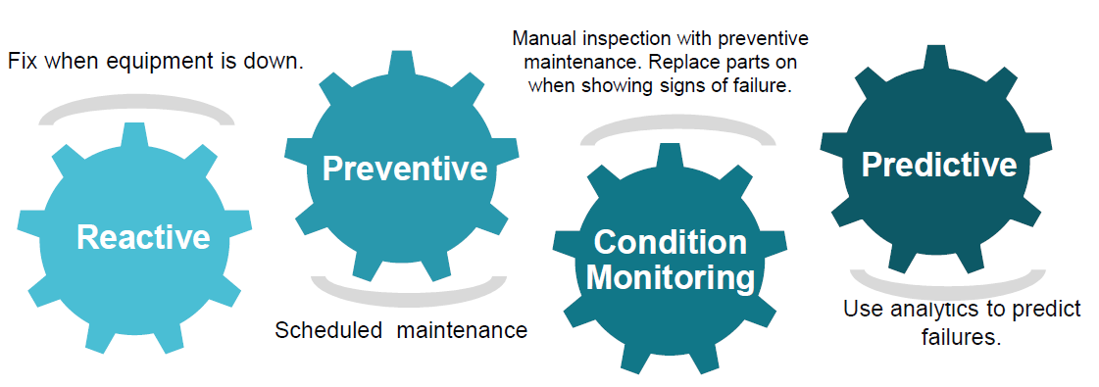

## About upskill Campus (USC)

upskill Campus along with The IoT Academy and in association with Uniconverge technologies has facilitated the smooth execution of the complete internship process.

USC is a career development platform that delivers **personalized executive coaching** in a more affordable, scalable and measurable way.



Seeing need of upskilling in self paced manner along-with additional support services e.g. Internship, projects, interaction with Industry experts, Career growth Services

<https://www.upskillcampus.com/>

upSkill Campus aiming to upskill 1 million learners in next 5 year

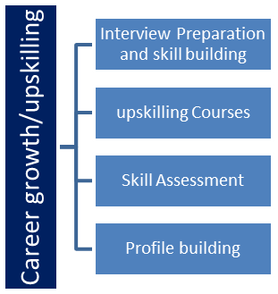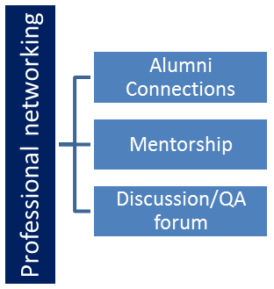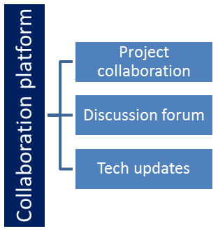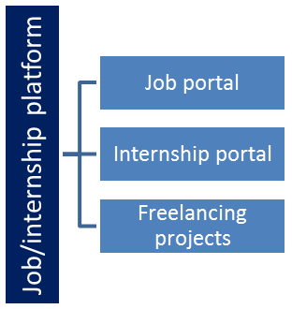

## The IoT Academy

The IoT academy is EdTech Division of UCT that is running long executive certification programs in collaboration with EICT Academy, IITK, IITR and IITG in multiple domains.

## Objectives of this Internship program

The objective for this internship program was to

 ☛ get practical experience of working in the industry.

 ☛ to solve real world problems.

 ☛ to have improved job prospects.

 ☛ to have Improved understanding of our field and its applications.

 ☛ to have Personal growth like better communication and problem solving.

## Reference

[1] https://www.upskillcampus.com/

## 

# Problem Statement

Agriculture is one of the main sources of income in India. There is need to improve the

Sustainability of agriculture with the rate of increase in suicides of farmer due to crop failure

And less yield and losses. Hence, it is a significant contribution towards the economic and

Agricultural welfare of the countries across the world. The Problem Statement revolves

Around prediction of yield of crops considering different climatic conditions of India

Including various attributes. Goal of this project is to help the farmers to choose the suitable

Crop to grow in order to get the required yield and the profit. Need for the crop yield

Prediction is very much essential at this point of time for selecting the right crop.

# Existing and Proposed solution

In case of crop area determination, both subjective and objective methods are currently

Adopted to collect yield statistics in various countries. The subjective methods of

Estimating crop yield include farmers’ assessments, expert opinions and crop cards, while

The objective methods include whole-plot harvesting and crop-cutting experiments. The

Practice of sowing crops in mixture in a single parcel of land is prevalent in many countries,

Particularly where land holdings are small. The growing of crops in mixtures is a common

Practice because it protects farmers from adverse 10 weather conditions such as drought,

Flood, and pest and disease infestation. Further, it enables maximal utilization of the space,

Moisture and nutrients available in the field. Cultivators usually mix crops that cannot

Withstand a particular type of weather with another set of crops that thrive under those

Same conditions.

## Code submission (Github link)

https://github.com/Sathwik102004/test-code

## Report submission (Github link) :

## 

# Proposed Design/ Model

In this project, the system makes use of the Machine Learning techniques to predict rate

of crop yield. The programming language used is Python as it is widely accepted for new

idea implementations in the field of Machine Learning. In this project, collected data set

will be uploaded and prediction for crop yield will be generated by applying Machine

Learning techniques like Random Forest Regressor and Decision Tree Regressor. The

results depend on the information present in the collected data set. Accurate the

information about the parameters in the collected datasets, better the results will be.

## 

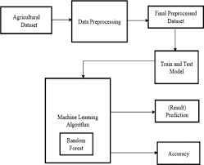

# Performance Test

6 Performance Test

6.1 Test Plan/ Test Cases

The implementation of the project was divided into two i.e crop yield prediction and rainfall

prediction (for fertilizers module).

Crop Yield Prediction: This module returns the predicted production of crops based on the

user's input. If the user wants to know the production of a particular crop, the system takes

the crop as the input as well. Else, it returns a list of crops along with their production as

output.

Fertilizers Module: This module is used to suggest the farmer on usage of fertilizer based

on the rainfall in next few days. To predict the rainfall for the next 15 days we are using an

API service provided by Open Weather‘. If it is likely to rain we suggest the farmer not to

use the fertilizer.

6.2 Test Procedure

• Step 1: Choose the functionality i.e., crop prediction or yield prediction.

• Step 2: If the user chooses crop prediction: Take soil type and area as inputs. These values

are given as input to the random forest implementation in the backend and the corresponding

predictions are returned. The algorithm returns a list of crops along with their production

predicted.

• Step 3: If the user chooses yield prediction: Take crop, soil type and area as inputs. These

values are given as input to the random forest implementation in the backend and the

corresponding crop yield prediction is returned. The algorithm returns the predicted

production of the given crop.

6.3 Performance Outcome

In the final implementation of the application the first screen the user can view is the login

page. Here, the user can register or login using his/her credentials into the application.

The system provides three main functionalities:

i) Yield Prediction: The system takes the required inputs to predict the yield of the given

crop.

ii) Crop Prediction: For this module the system takes the required inputs i.e., soil type and

area.

## 

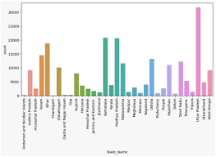

# My learnings

During my 6-week online internship in machine learning and data science, I gained valuable insights and skills. I learned the fundamentals of data preprocessing, including cleaning, imputing missing values, and scaling data for analysis. I also delved into various machine learning algorithms such as regression, classification, and clustering.

I acquired proficiency in Python and its libraries, like NumPy, Pandas, and Scikit-Learn, which enabled me to work with data efficiently and implement machine learning models. Understanding model evaluation metrics, cross-validation, and hyperparameter tuning became second nature to me.

Furthermore, I explored deep learning techniques, including neural networks and deep neural networks, and learned how to use popular frameworks like TensorFlow and PyTorch for these tasks.

My internship allowed me to apply these skills to real-world datasets and projects, which provided me with practical experience and the ability to present my findings effectively. This experience not only expanded my knowledge but also enhanced my problem-solving and critical thinking abilities in the field of machine learning and data science.

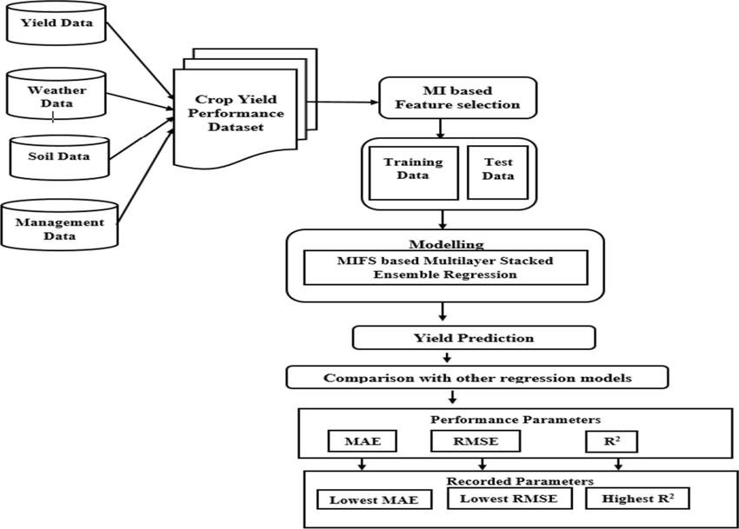

# Future work scope

In the future, I plan to build upon the foundation I’ve developed during my 6-week internship in machine learning and data science. Here are some key areas I intend to focus on:

* + - 1. **Advanced Machine Learning Techniques:** I want to explore more advanced machine learning algorithms, such as ensemble methods, natural language processing (NLP), and reinforcement learning. These areas can open up opportunities for tackling complex problems.
      2. **Deep Learning:** Deep learning is a rapidly evolving field, and I aim to deepen my understanding of neural networks, including recurrent neural networks (RNNs) and transformers. This knowledge will be useful for tasks like image recognition, text analysis, and more.
      3. **Real-world Projects:** I plan to work on real-world projects to apply my knowledge and gain practical experience. Building predictive models, recommendation systems, or computer vision applications can be great ways to learn and contribute to various domains.
      4. **Data Engineering:** A strong foundation in data engineering is essential for handling and processing large datasets efficiently. I’ll explore tools and techniques for data collection, storage, and data pipeline development.
      5. **Ethical AI:** Given the growing importance of ethics in AI, I’ll continue to study and implement ethical AI practices, ensuring fairness, transparency, and accountability in the models I build.
      6. **Collaboration:** Collaborating with others in the field, participating in hackathons, and contributing to open-source projects will provide me with valuable experience and a chance to learn from others.
      7. **Continual Learning:** The field of machine learning and data science is ever-evolving. I’ll stay updated with the latest research, attend conferences, and enroll in online courses to keep my skills and knowledge current.

By focusing on these areas, I aim to become a proficient machine learning and data science practitioner and contribute to meaningful projects that leverage the power of data and AI for various applications.