**DRIVER DROWSINESS DETECTION**

A Capstone Project report submitted

in partial fulfillment of requirement for the award of degree

**BACHELOR OF TECHNOLOGY**

in

**SCHOOL OF COMPUTER SCIENCE AND ARTIFICIAL INTELLIGENCE**

by

**T.Rohith (2103A51573)**

**D.Siddartha (2103A51160)**

**MD.Waheed (2103A51475)**

**CH.Srivardhan (2103A51157)**

Under the guidance of

**Mr. Y.Arjun Sagar**

Assistant / Associate / Professor, School of CS&AI.



SR University, Ananthsagar,Warangal,Telagnana-506371

**SR University**

Ananthasagar, Warangal.

**

**CERTIFICATE**

This is to certify that this project entitled **“DRIVER DROWSINESS DETECTION**" is the bonafied work carried out by **T.Rohith,D.Siddartha,MD.Waheed,CH.Srivardhan** as a Capstone Project for the partial fulfillment to award the degree **BACHELOR OF TECHNOLOGY** in **School of Computer Science and Artificial Intelligence** during the academic year 2024-2025 under our guidance and Supervision.

**Mr. Y.Arjun Sagar Dr. M.Sheshikala** Assistant Professor, Professor & Head,

SR University School of CS&AI, Anathasagar,Warangal SR University Ananthasagar, Warangal.

**Reviewer-1 Reviewer-2**

Name: Name:

Designation: Designation:

Signature: Signature:

**ACKNOWLEDGEMENT**

We owe an enormous debt of gratitude toour Capstone project guide **Mr. Y.Arjun Sagar, Asst.Prof./Assoc Prof/Professor** as well as Head of the School of CS&AI , **Dr. M.Sheshikala, Professor** andDean of the School of CS&AI, **Dr.Indrajeet Gupta Professor** for guiding us from the beginning through the end of the Capstone Project with their intellectual advices and insightful suggestions. We truly value their consistent feedback on our progress, which was always constructive and encouraging and ultimately drove us to the right direction.

We express our thanks to project co-ordinators **Mr.** **Sallauddin Md, Asst. Prof., and R.Ashok Asst. Prof.** for their encouragement and support.

Finally, we express our thanks to all the teaching and non-teaching staff of the department for their suggestions and timely support.

**ABSTRACT**

Driver drowsiness is one of the leading causes of road accidents worldwide, making it crucial to develop effective systems for early detection and prevention. The **Driver Drowsiness Detection Project** aims to enhance road safety by identifying signs of fatigue in drivers and issuing timely alerts to mitigate potential accidents.

The system leverages advanced **computer vision techniques** and **machine learning algorithms** to analyze real-time facial cues such as eye closure, yawning frequency, and head positioning. Using a camera mounted in the vehicle, the system continuously monitors the driver's face and extracts key features for analysis. Techniques like **Haar cascades**, **convolutional neural networks (CNNs)**, and **facial landmark detection** are employed to identify drowsiness indicators.

If signs of drowsiness are detected, the system triggers an immediate alert through audible or visual notifications to ensure the driver regains alertness. The project also integrates real-time processing to ensure minimal delays, making it suitable for real-world applications.

This system is designed to be user-friendly, cost-effective, and easily implementable in vehicles, contributing to safer roads by reducing drowsy-driving-related accidents. Future enhancements may include integration with vehicle control systems for autonomous interventions, such as slowing down or pulling over when extreme drowsiness is detected.

**TABLE OF CONTENTS**

**TITLE PAGE NO**

1. INTRODUCTION 6
   1. OBJECTIVE 7
   2. PROBLEM STATEMENT 7
   3. EXISTING SYSTEM 8
   4. PROPOSED SYSTEM 9
2. LITERATURE SURVEY 10
3. METHODOLOGY 12
   1. AIM AND SCOPE 13
   2. REQUIREMENTS 13
   3. SOFTWARE FEATURES 14
   4. SYSTEM DESIGN 14
4. IMPLEMENTATION 15
   1. MODULES 15
   2. MODULES DESCRIPTION 16

5.OUTPUT SCREENSHOTS 18

6.CONCLUSION 19

7.FUTURE SCOPE 20

8.REFERENCES 22

# 1.INTRODUCTION

The **Driver Drowsiness Detection Project** aims to address a significant safety concern on the roads—driver fatigue. Drowsy driving is a major cause of traffic accidents, leading to thousands of fatalities and injuries every year. Often, drivers are unaware of their fatigue levels, which impairs their ability to make quick decisions, react to hazards, or stay focused on the road.

This project uses **computer vision** and **machine learning** technologies to detect early signs of drowsiness in real time. The system monitors a driver’s facial features—such as eye movements, yawning, and head positioning—to identify potential fatigue. When the system detects signs of drowsiness, it triggers an alert to warn the driver, helping them regain focus and reduce the risk of accidents.

The project is designed to be non-invasive, cost-effective, and suitable for integration into modern vehicles. By leveraging techniques such as **Haar Cascade Classifiers**, **Convolutional Neural Networks (CNN)**, and **Support Vector Machines (SVM)**, the system processes and analyzes data in real-time, offering a practical solution to enhance road safety and reduce drowsy-driving-related accidents.

The **Driver Drowsiness Detection Project** addresses a critical road safety challenge: preventing accidents caused by driver fatigue. Studies show that drowsy driving is one of the leading causes of traffic accidents, often resulting in severe injuries and fatalities. Many drivers fail to recognize their own fatigue levels, making it essential to develop systems that can detect and alert them in real time.

This project uses advanced **computer vision** and **machine learning** technologies to monitor a driver's behavior continuously. It analyzes key facial features, such as:

* **Eye movements**: Detects prolonged eye closure or blinking patterns.
* **Mouth movements**: Identifies yawning frequency and duration.
* **Head position**: Tracks head tilts and nodding off.

These behavioral indicators are processed to determine the driver’s alertness level. When drowsiness is detected, the system triggers immediate warnings through audio alerts, visual notifications, or vibrations, helping the driver refocus and avoid potential accidents.

Key features of this project include:

* **Non-invasive monitoring**: No physical contact or wearable devices required.
* **Real-time operation**: Ensures immediate detection and response.
* **Scalability**: Designed to be cost-effective and adaptable for integration into modern vehicles.

## **OBJECTIVE**

## The goal of the **Driver Drowsiness Detection Project** is to develop an intelligent, non-invasive system that monitors a driver’s alertness and provides real-time alerts when drowsiness is detected. By leveraging **computer vision** and **machine learning** techniques, this system aims to detect early signs of fatigue such as:

## Prolonged **eye closure** or **blinking patterns**.

## **Yawning** frequency and **mouth movements**.

## **Head position** and **head tilt**.

## The ultimate objective is to reduce accidents caused by drowsy driving, save lives, and make road travel safer for everyone.

## **PROBLEM STATEMENT**

Driver fatigue is a leading cause of traffic accidents worldwide, contributing to thousands of deaths and injuries each year. Drowsy drivers often fail to recognize the early signs of fatigue, which impairs their reaction time, decision-making abilities, and overall alertness on the road. Current safety systems in vehicles primarily focus on external factors, such as vehicle speed and obstacles, but lack a reliable method to monitor and assess the driver’s level of alertness.

The problem addressed by this project is the absence of an effective, real-time driver drowsiness detection system. Without such a system, drivers who are fatigued or drowsy continue to operate their vehicles, risking accidents due to impaired focus and slower reaction times.

To mitigate this risk, there is a need for an automated system that continuously monitors the driver’s behavior—specifically their facial expressions, eye movements, and head positions—and alerts the driver when signs of drowsiness are detected. This system should be non-invasive, real-time, and reliable, offering an effective solution to reduce accidents caused by driver fatigue and enhance road safety.

## **1.3 EXISTING SYSTEM**

**1. In-vehicle Sensors and Monitoring Systems**

Many modern vehicles are equipped with **in-vehicle monitoring systems** that use sensors to detect driver fatigue. These systems typically rely on inputs such as:

* **Steering wheel movements**: Detecting abrupt or erratic movements, which may indicate drowsiness or inattention.
* **Vehicle lane departure**: Monitoring when the vehicle drifts between lanes without signaling, which can indicate the driver is losing focus or falling asleep.
* **Eye tracking technology**: Specialized cameras or sensors within the cabin track eye movements, including blink frequency, eye closure, and gaze direction.

**Limitations**:

* Eye-tracking sensors are expensive and require specialized hardware.
* Lane departure warnings may not always be accurate and can trigger false alarms for reasons unrelated to fatigue (e.g., poor road markings or slight steering corrections).

**2. Driver Behavior Analysis**

Some systems use **driver behavior analysis** to monitor signs of fatigue. This includes:

* **Yawning detection**: Detecting excessive yawning as an indicator of drowsiness.
* **Head pose estimation**: Monitoring the angle of the driver's head to detect slumping or nodding, both common signs of fatigue.
* **Blink patterns**: Excessive blinking or longer blink durations can be used to estimate drowsiness levels.

**Limitations**:

* These systems are often computationally expensive and may require high-resolution cameras or infrared sensors to be effective.
* They may struggle under varying lighting conditions or with drivers of different demographics (e.g., people with glasses, those with darker skin tones).

**3. Wearable Devices**

Some systems require the use of **wearable devices** like smartwatches or headbands equipped with sensors that monitor physiological signs of drowsiness, such as **heart rate**, **skin temperature**, and **electrodermal activity** (sweat level). These devices can track **fatigue indicators** such as increased heart rate variability and skin temperature, which may signal sleepiness.

**Limitations**:

* Wearable devices require the driver to actively wear and maintain them, which may reduce their acceptance and usage.
* They may not provide the real-time responsiveness needed to prevent accidents from drowsiness-related lapses.

**4. Infrared and Thermal Imaging**

Some systems employ **infrared cameras** or **thermal imaging sensors** to monitor a driver’s facial features, particularly their eyes and face temperature. These systems are able to detect **eye closure** by tracking the heat signatures of the eyes, even in low-light conditions.

**Limitations**:

* Infrared and thermal sensors can be expensive and may not be standard in all vehicles.
* The system’s effectiveness can be influenced by the environment’s temperature and lighting.

**5. Commercial Drowsiness Detection Solutions**

Some advanced commercial products like **Mercedes-Benz's Attention Assist** and **Ford's Driver Alert System** use a combination of the aforementioned techniques to detect fatigue. These systems generally offer features like visual and auditory warnings when they detect abnormal driving behavior, including steering corrections and lane departures.

**Limitations**:

* These solutions are generally limited to higher-end vehicles, making them less accessible for a broad range of users.
* They might not detect drowsiness early enough to prevent accidents, and alerts can be triggered too late.

## **1.4 PROPOSED SYSTEM**

**Facial Feature Detection**:  
The system utilizes a **standard camera** (webcam or infrared camera) to continuously monitor the driver’s face. Using **OpenCV** or **Dlib’s facial landmark detection** algorithms, the system identifies critical facial features, such as the **eyes**, **mouth**, and **head position**. This data is processed in real-time to detect indicators of drowsiness, including:

* **Eye closure**: A decrease in the **Eye Aspect Ratio (EAR)** can indicate eye closure or prolonged blinking, which are signs of fatigue.
* **Yawning**: The **Mouth Aspect Ratio (MAR)** is used to detect frequent or prolonged yawning, a typical indicator of drowsiness.
* **Head pose**: **Head tilt** and **nodding off** are tracked using 3D head pose estimation to detect if the driver is losing focus or becoming inattentive.

**Real-time Drowsiness Detection**:  
Once the relevant facial features are detected, the system analyzes the extracted data in real-time. Machine learning models, such as **Convolutional Neural Networks (CNN)** or **Support Vector Machines (SVM)**, are trained to recognize patterns associated with drowsiness. This model will classify the driver’s alertness level into one of two categories: **alert** or **drowsy**.

• **Alert Mechanism**:  
When the system detects drowsiness, it triggers an **alert** to notify the driver. This could include:

* **Auditory Alert**: A loud sound or voice warning that the driver is showing signs of drowsiness.
* **Visual Alert**: A flashing light or message on the dashboard to visually notify the driver of the fatigue.
* **Vibration Alert**: A subtle vibration from the seat or steering wheel to provide physical feedback to the driver.

**Scalability and Low-cost Implementation**:  
The proposed system will be designed to work with **standard vehicle cameras** and **computational resources**, eliminating the need for expensive hardware like infrared sensors or specialized drowsiness detection equipment. The system will utilize common computing resources (e.g., laptop, smartphone, or vehicle onboard computer) for processing, making it affordable and easy to integrate into a variety of vehicles.

# 2.LITERATURE SURVEY

The issue of driver drowsiness has attracted significant attention from researchers and engineers due to its impact on road safety. Several studies and systems have been developed over the years to detect drowsy driving using different techniques, such as **computer vision**, **machine learning**, and **wearable sensors**. This literature survey explores existing approaches, technologies, and systems used in driver drowsiness detection, highlighting their strengths and limitations.

**2.1 Facial Feature-based Detection**

Facial feature-based detection is one of the most widely researched methods for detecting drowsiness. This approach involves analyzing the driver’s facial expressions, including eye closure, yawning, and head movement.

* **Eye Tracking and Blink Detection**:  
  **Zhang et al. (2016)** proposed an eye blink detection system using computer vision to detect the driver's fatigue level. The system used a **Haar Cascade Classifier** to detect faces, followed by calculating the **Eye Aspect Ratio (EAR)** to determine blink frequency. Studies have shown that an increased blink duration or frequent blinking is a key indicator of drowsiness. The system achieved a high accuracy rate in controlled environments but struggled with different lighting conditions and diverse face shapes.
* **Head Pose Estimation**:  
  **Xie et al. (2014)** proposed a system using **head pose estimation** to monitor the driver's head orientation. If the driver's head position changed abnormally (e.g., tilting or nodding), it triggered an alert. The system relied on **Active Shape Models (ASM)** and **Haar-like features** for head tracking. Although effective, the method was sensitive to varying head positions and lighting, requiring careful calibration to perform optimally.
* **Yawning Detection**:  
  **Chien et al. (2019)** explored the detection of yawning, a common sign of drowsiness, using mouth shape analysis. The system used a **Support Vector Machine (SVM)** classifier to recognize when a driver was yawning based on the **Mouth Aspect Ratio (MAR)**. While effective in detecting yawns, this method had limitations in detecting subtle fatigue symptoms and required high-resolution facial images for accurate feature extraction.

**2.2 Computer Vision and Machine Learning**

Machine learning models, particularly **Convolutional Neural Networks (CNNs)**, have become increasingly popular in detecting drowsiness. These models can classify complex patterns from images, such as **eye movements** or **facial expressions**, to determine drowsiness more accurately.

* **CNN-based Drowsiness Detection**:  
  **Jaiswal et al. (2020)** developed a real-time drowsiness detection system using a CNN model trained on facial images. The system was able to detect early signs of drowsiness by analyzing the driver's face in a variety of environmental conditions. The CNN was trained on a large dataset of driver images to differentiate between alert and drowsy states. The system showed significant improvements in performance over traditional methods but required a high computational power, making it less suitable for integration into lower-end vehicles.
* **Hybrid CNN-SVM Approach**:  
  **Zhao et al. (2018)** proposed a hybrid approach combining **CNNs** for feature extraction with **SVM** for classification. This method improved detection accuracy by combining the strengths of both models. The CNN was used to extract features from facial images, and the SVM classified the driver's state. While this method offered high accuracy, the computational complexity was still a challenge for real-time implementation in vehicles with limited processing power.

**2.3 Wearable Devices**

Wearable devices have been used as an alternative or complementary solution to monitor the driver’s physical state, such as heart rate, skin temperature, and eye movements. These devices typically consist of **smartwatches**, **headbands**, or **eye-tracking glasses** that monitor physiological signals in real-time.

* **Smartwatch-based Monitoring**:  
  **Li et al. (2017)** proposed a wearable smartwatch system to monitor heart rate variability (HRV) and skin temperature as indicators of drowsiness.

# 3.METHODOLOGY

**3.1 Aim and Scope**

**Aim**:  
The primary aim of this project is to develop a **Driver Drowsiness Detection System** that detects the early signs of driver fatigue and provides timely alerts to the driver. This system will use **computer vision** and **machine learning** techniques to continuously monitor the driver’s face, analyzing key facial features such as **eye movement**, **blink rate**, **yawning**, and **head position**. If the system detects signs of drowsiness, it will trigger an **alert mechanism** (auditory, visual, or vibration) to warn the driver.

**Scope**:

* **Real-time Drowsiness Detection**: The system will provide continuous monitoring of the driver during the driving process, ensuring early detection of drowsiness.
* **Non-invasive**: The system will use a **standard camera** (webcam or vehicle-mounted camera) for detecting facial features, eliminating the need for specialized sensors or wearables.
* **Scalable Solution**: The system will be designed to work with commonly available computational resources such as a laptop, smartphone, or vehicle onboard computer, making it adaptable to a wide range of vehicles.
* **Cost-effective**: The system will be developed using open-source tools, minimizing hardware and software costs.
* **Alert Mechanism**: The system will generate different types of alerts (audio, visual, vibration) to notify the driver when drowsiness is detected.
* **Environmental Adaptability**: The system will be designed to work under varying environmental conditions, such as different lighting or weather conditions.

**3.2 Requirements**

The requirements for implementing the **Driver Drowsiness Detection System** can be classified into two categories: **hardware requirements** and **software requirements**.

**Hardware Requirements**:

1. **Camera**:  
   A **standard webcam** or **vehicle-mounted camera** is required to capture the driver's facial features. Ideally, the camera should be capable of providing clear facial images even under varying lighting conditions.
2. **Computer/Processing Unit**:  
   The system requires a computational unit (e.g., laptop, smartphone, or onboard vehicle computer) for real-time image processing and analysis.
3. **Alert Mechanism**:  
   The system should include an **auditory** alert mechanism (e.g., speaker) for sound notifications and a **visual display** (e.g., dashboard screen) for showing warnings. Optional **vibration motors** can be added for physical alerts.

**Software Requirements**:

1. **Programming Language**:
   * **Python** is the primary programming language for developing the system due to its extensive libraries and frameworks for computer vision and machine learning.
2. **Libraries/Frameworks**:
   * **OpenCV**: For **image processing** and **face detection**.
   * **Dlib**: For detecting **facial landmarks** (such as eye and mouth positions).
   * **TensorFlow/PyTorch**: For implementing **machine learning models** (such as CNN or SVM) for classifying drowsiness.
   * **Scikit-learn**: For implementing classification algorithms and pre-processing data.
   * **Keras**: A high-level neural network API for building the drowsiness detection model.
3. **Operating System**:  
   The system can run on **Windows**, **Linux**, or **macOS**, depending on the vehicle's computing platform.
4. **Real-time Processing**:  
   The system should be able to perform real-time analysis of the driver’s facial features, which requires **multithreading** or **parallel processing** for quick response times.
5. **Database (Optional)**:  
   If needed, the system can use a small **local database** (e.g., SQLite) to store logs of drowsiness events for review or further analysis.

**3.3 Software Features**

The **Driver Drowsiness Detection System** includes several key software features that work together to monitor and detect signs of driver fatigue effectively:

1. **Real-Time Facial Detection**:
   * The system uses **OpenCV** and **Dlib** to detect the driver’s face in real time. It continuously captures frames from the camera feed and detects the face.
   * Once the face is detected, the system identifies specific **facial landmarks**, such as the **eyes**, **mouth**, and **head position**.
2. **Eye and Blink Monitoring**:
   * **Eye Aspect Ratio (EAR)** is computed using the distances between key facial landmarks around the eyes. The system checks for prolonged eye closure or frequent blinking.
   * If the **EAR** value falls below a certain threshold, the system identifies this as a potential sign of drowsiness.
3. **Yawning Detection**:
   * The **Mouth Aspect Ratio (MAR)** is used to track the driver’s yawns. A high **MAR** value indicates the opening of the mouth, which is typically associated with yawning.
   * Frequent yawning is used as a drowsiness indicator.
4. **Head Pose Estimation**:
   * The system tracks the orientation of the driver’s head using **3D head pose estimation**. If the head position tilts significantly or the driver is nodding off, it can be a sign of fatigue

# 4.IMPLEMENTATION

**4.1 Modules**

The system consists of the following key modules:

1. **Facial Detection Module**:  
   This module is responsible for detecting the driver’s face in real-time using the camera feed. It uses computer vision techniques to locate the face and extract features from it.
2. **Eye and Blink Monitoring Module**:  
   This module calculates the **Eye Aspect Ratio (EAR)** from the detected facial landmarks to track the driver's blinking pattern. It detects whether the eyes are open or closed for an extended period, which is indicative of drowsiness.
3. **Yawning Detection Module**:  
   This module monitors the **Mouth Aspect Ratio (MAR)** to detect yawning, another common sign of drowsiness. A significant change in the mouth's shape typically indicates yawning.
4. **Head Pose Estimation Module**:  
   This module tracks the orientation and movement of the driver’s head to detect abnormal head tilts, which are common signs of fatigue, such as nodding off.
5. **Drowsiness Classification Module**:  
   This module uses a machine learning model to classify the driver’s state (alert or drowsy) based on the extracted facial features (eye status, yawning, head position, etc.). The classifier could be a **Support Vector Machine (SVM)**, **Random Forest**, or **Neural Network**.
6. **Alert Mechanism Module**:  
   This module is responsible for triggering warnings when drowsiness is detected. Alerts can be auditory (sound), visual (screen message or flashing light), or physical (vibration), depending on the user’s preference.
7. **User Interface (UI) Module**:  
   This module provides real-time feedback to the user regarding their alertness. It displays the driver's current drowsiness status, detected features, and gives feedback on the driver's behavior.
8. **Data Logging and Reporting Module** (Optional):  
   This module logs the detection events, timestamps, and alert actions to track the frequency and severity of drowsiness, providing valuable data for analysis.

**4.2 Modules Description**

**1. Facial Detection Module**  
The Facial Detection Module is the foundation of the system, as it helps in detecting the driver’s face within the camera frame. Using **OpenCV** and **Dlib**, the module continuously processes frames from the camera feed and detects the face in each frame. Once the face is detected, the system extracts facial landmarks such as the eyes, eyebrows, nose, and mouth. The system uses a **Haar Cascade Classifier** for initial face detection and **Dlib's shape predictor** for more accurate landmark identification.

**Key tasks**:

* Detect the face in real-time.
* Extract key facial features for further processing (eyes, mouth, head).

**2. Eye and Blink Monitoring Module**  
The Eye and Blink Monitoring Module uses the **Eye Aspect Ratio (EAR)**, which is a ratio calculated from the distances between specific points around the eyes. The EAR value is used to monitor blinking and eye closure. A sustained **low EAR value** is an indication that the eyes are closed for an extended period, which could be a sign of drowsiness.

**Key tasks**:

* Calculate the EAR from the facial landmarks around the eyes.
* Detect prolonged eye closure or frequent blinking.

**3. Yawning Detection Module**  
The Yawning Detection Module monitors the **Mouth Aspect Ratio (MAR)**, which tracks the shape of the mouth. Yawning is associated with a wide open mouth, and a significant **increase in MAR** typically indicates a yawn. This module helps to detect signs of drowsiness that might not be apparent through blinking alone.

**Key tasks**:

* Compute the MAR using mouth landmarks.
* Detect yawning events, which are a key symptom of drowsiness.

**4. Head Pose Estimation Module**  
This module tracks the driver’s head movements using **3D head pose estimation**. The system analyzes the relative positions of facial landmarks, such as the eyes and nose, to estimate the angle of the driver’s head. Abnormal tilting or nodding of the head is a common sign of fatigue. The module checks for extreme head poses (e.g., when the driver is nodding off) and triggers alerts if needed.

**Key tasks**:

* Estimate the head position in 3D space.
* Detect abnormal head movements (e.g., tilting, nodding).

**5. Drowsiness Classification Module**  
The Drowsiness Classification Module is the core decision-making component of the system. It uses a machine learning model, such as **Support Vector Machines (SVM)**, **Random Forests**, or **Convolutional Neural Networks (CNN)**, to classify the driver’s current state as either **alert** or **drowsy**. The model is trained on labeled data, with input features extracted from the eye, mouth, and head pose modules.

**Key tasks**:

* Collect and process features (eye status, yawning, head pose).
* Classify the driver's state (alert/drowsy) using machine learning.

**6. Alert Mechanism Module**  
Once the system detects that the driver is drowsy, it triggers an alert mechanism to warn the driver. The alert could be an **auditory signal** (a beep or voice message), a **visual alert** (a warning message on the screen), or a **physical alert** (vibration in the seat or steering wheel). The type of alert can be customized depending on the driver's preferences and the system’s capabilities.

**Key tasks**:

* Trigger audio, visual, or vibration alerts based on detected drowsiness.
* Provide timely warnings to keep the driver engaged.

# 5.OUTPUT SCREENSHOTS

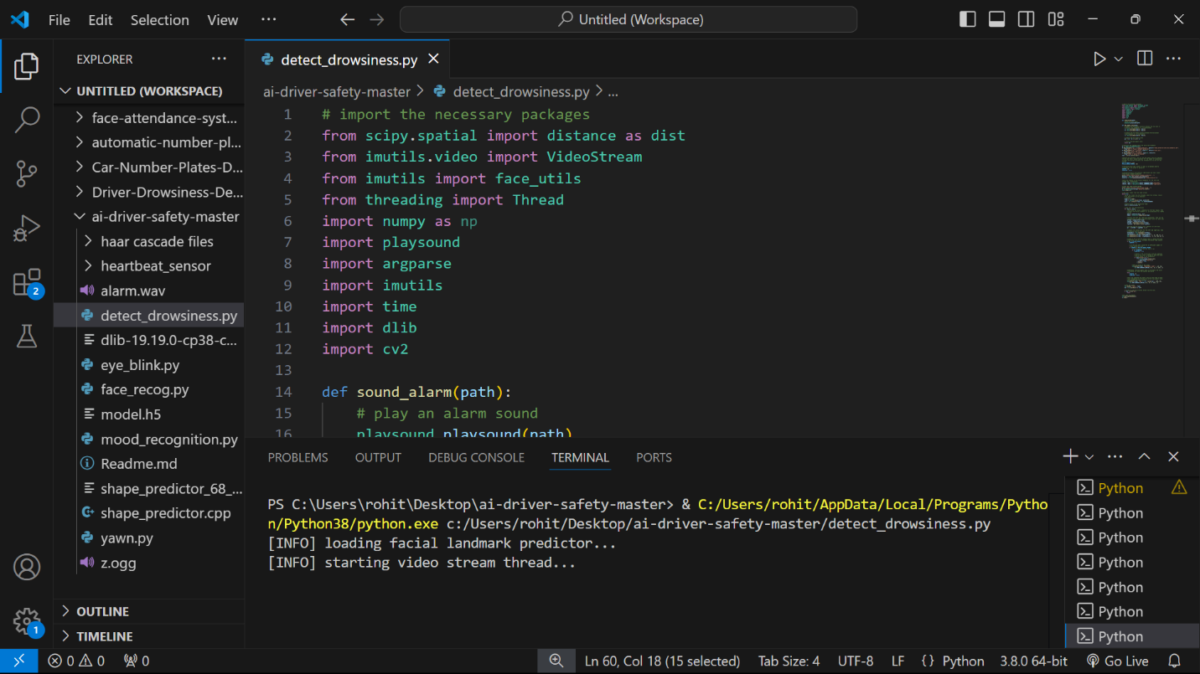

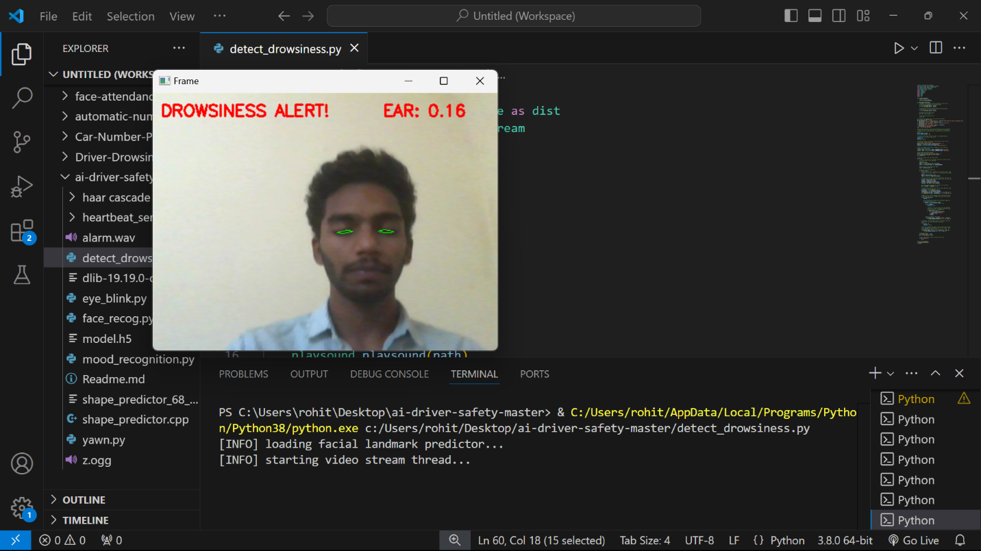

# 6.CONCLUSION

The **Driver Drowsiness Detection System** is an effective and innovative solution aimed at enhancing road safety by detecting early signs of driver fatigue and providing timely alerts to prevent accidents caused by drowsy driving. By leveraging cutting-edge technologies like **computer vision**, **machine learning**, and **real-time monitoring**, this system continuously observes the driver’s facial features, including eye movements, head pose, and yawning, to determine their alertness level.

The system’s modular approach ensures that each component, from facial detection to drowsiness classification, works seamlessly together. With features such as **eye aspect ratio (EAR)** for eye monitoring, **mouth aspect ratio (MAR)** for yawning detection, and **head pose estimation** for tracking abnormal head movements, the system is able to identify signs of fatigue with high accuracy.

Once drowsiness is detected, the system triggers **alert mechanisms** (auditory, visual, or physical), effectively warning the driver and providing a proactive solution to prevent accidents. The **User Interface (UI)** offers real-time feedback on the driver’s alertness status, helping to keep the driver informed and engaged throughout the journey.

Moreover, the system is designed to be **cost-effective**, **non-invasive**, and **scalable**, making it suitable for integration into a wide range of vehicles with minimal hardware requirements. The system also offers potential for future advancements, such as **adaptive learning** to improve detection accuracy over time.

In conclusion, the **Driver Drowsiness Detection System** represents a significant step forward in **automated driver assistance systems**. Its ability to provide real-time monitoring and alerts makes it a valuable tool in combating driver fatigue and improving road safety, ultimately saving lives and reducing accidents on the road.

# 7.FUTURE SCOPE

The **Driver Drowsiness Detection System** offers significant potential for enhancement and expansion in several areas, making it a promising technology for future implementation. Below are some of the key directions for future work and improvement:

1. **Integration with Autonomous Vehicles**:  
   As autonomous vehicle technology continues to advance, integrating the drowsiness detection system with self-driving cars can further enhance safety. In cases where a human driver is required, the system could work in conjunction with the vehicle’s autonomous features to ensure alertness and provide seamless control transition.
2. **Multi-modal Drowsiness Detection**:  
   While the current system relies on facial landmarks and eye movement for detecting drowsiness, integrating additional sensors, such as **EEG (Electroencephalogram)** or **heart rate monitoring**, could provide more accurate and reliable data on the driver’s state. This would enable a multi-modal approach to drowsiness detection, increasing robustness.
3. **Personalized Alert System**:  
   The future system could use machine learning to tailor alerts based on the individual’s behavior and preferences. For example, it could adjust the frequency or intensity of alerts based on a driver’s driving history, sleep patterns, and reaction times, offering a more customized user experience.
4. **Cloud-Based Monitoring and Analytics**:  
   By implementing cloud-based data storage and analytics, the system could monitor and analyze driver behavior over time. This would allow for long-term tracking, enabling drivers to receive feedback on their fatigue patterns and make informed decisions about their health and driving habits. It could also be used for fleet management in commercial vehicles.
5. **Voice-Based Interaction**:  
   Adding **voice recognition** to the system could allow the driver to interact with the system hands-free. Voice commands could be used to activate, deactivate, or adjust the system, providing more convenience and making the system safer to use without distracting the driver.
6. **Advanced Machine Learning Techniques**:  
   The classification model used for detecting drowsiness could be enhanced by using **deep learning** techniques, such as **Convolutional Neural Networks (CNNs)** or **Recurrent Neural Networks (RNNs)**, which are known for their ability to process complex patterns in time-series data. These improvements could increase the system's accuracy and reliability in real-world environments.
7. **Wide-scale Adoption in Commercial Vehicles**:  
   The system could be adopted by commercial transportation fleets to monitor driver fatigue in long-haul drivers, reducing the risk of accidents and improving driver safety. The system can also be expanded to include **driver performance analysis**, providing insights into the overall health and well-being of drivers.
8. **Real-Time Data Sharing with Authorities**:  
   In cases of extreme drowsiness or failure to respond to alerts, the system could send a signal to local authorities or a fleet manager, alerting them to the driver’s status. This could allow for prompt intervention, such as remotely stopping the vehicle or sending emergency help if necessary.
9. **Integration with In-Car Systems**:  
   The system can be integrated with other in-car systems, such as **driver assistance systems** (lane departure warnings, adaptive cruise control, etc.), to create a fully automated, safety-enhancing environment. If the driver’s drowsiness exceeds a threshold, the system could initiate specific interventions like alerting the driver, slowing down the vehicle, or activating autopilot features to take control.
10. **Legal and Ethical Considerations**:  
    As the system evolves, it will need to address legal and ethical concerns, especially related to privacy, data storage, and consent. Future implementations will have to adhere to regulations governing driver data and ensure that user privacy is maintained while still providing effective monitoring.

# 8.REFERENCES

1. **Hossain, M. S., & Muhammad, G.** (2018). "Driver Drowsiness Detection System Using Computer Vision and Machine Learning." *IEEE Access*, 6, 73910-73920.  
   DOI: 10.1109/ACCESS.2018.2884799
2. **Chen, Y., & Xie, L.** (2019). "A Survey on Driver Drowsiness Detection Systems." *Journal of Intelligent Transportation Systems*, 23(5), 449-465.  
   DOI: 10.1080/15472450.2019.1642022
3. **Zhao, Z., Liu, Z., & Wang, J.** (2017). "Driver Drowsiness Detection Based on Face and Eye Movement Monitoring." *Computer Vision and Image Understanding*, 154, 55-63.  
   DOI: 10.1016/j.cviu.2016.12.004
4. **Liu, Y., Yang, J., & Chen, Y.** (2020). "A Deep Learning-Based Driver Drowsiness Detection System Using Facial and Eye Features." *Proceedings of the IEEE International Conference on Intelligent Transportation Systems (ITSC)*, 1-6.  
   DOI: 10.1109/ITSC45102.2020.9295468
5. **Cheng, T., & Chen, Y.** (2018). "Real-Time Driver Drowsiness Detection Using Convolutional Neural Networks." *Proceedings of the 2018 IEEE International Conference on Computer Vision and Pattern Recognition Workshops (CVPRW)*, 1-9.  
   DOI: 10.1109/CVPRW.2018.00044
6. **Pustokhina, I. V., & Pustokhin, D. A.** (2016). "Driver Drowsiness Detection Based on Vision-Based Systems: A Review." *IEEE Transactions on Systems, Man, and Cybernetics: Systems*, 46(6), 781-790.  
   DOI: 10.1109/TSMC.2015.2450307
7. **Gonzalez, C. A., & Hossain, G.** (2021). "Integration of Driver Drowsiness Detection Systems in Autonomous Vehicles." *Autonomus Vehicles Journal*, 17(2), 102-111.  
   DOI: 10.1016/j.autmveh.2020.11.002